Karyotypic diversity of some tilapia species

Sofy H.I. ¹, Layla A.M. ², Iman M.K.A. ²

¹Head of Veterinary Division, National Research Centre, Egypt.

² Department of Hydrobiology, National Research Centre, Egypt.

imankam_2@yahoo.com

Abstract: This study present cytogenetic analyses of three fish species in Egypt, Oreochromis niloticus, sarotherodon galilaeus and Tilapia zillii belonging to cichlids, with a mean objective of contributing for a better understanding of the relationships between these species and the probability of their hybridization. The karyotypes of these species have been investigated by examining metaphase chromosomes spreads obtained from headkidney cells. The diploid chromosome numbers of all three species were 2n=44. The karyotypes of Oreochromis niloticus were one pair of submetacentric; 13 pairs of subtelocentric and 8 telocentric ; Sarotherodon galilaeus showed one pair of metacentric, 6 pairs of submetacentric; 7 pairs of subtelocentric and 8 pairs of telocentric chromosomes . The chromosomes of Tilapia zillii were,10 pairs of submetacentric ;5 pairs of subtelocentric and 7 pairs of telocentric chromosomes . There was a significant difference between the mean lengths of the haploid sets of chromosomes of fishes under investigation. The cytogenetic characteristics partaken by the species analyzed in the present study reinforce and the probability of hybridization between Oreochromis niloticus and sarotherodon galilaeus ,but less chance between Tilapia zillii and Oreochromis niloticus or , sarotherodon galilaeus. [Nature and Science. 2008;6(1):19-27]. ISSN: 1545-0740.

Keywords: karyotypic diversity, tilapia, chromosomes.

Introduction
The importance of fish taxonomy is not only with description of new forms, but also with placing each form within taxonomic system that shows it’s relationships to other forms .For more than a century, systematists have sought to organize this diversity by studying aspects of their external and internal morphology which have been especially successful in defining species and in organizing these species into genera. These groupings have usually been confirmed when examined with cytogenetically approaches.
Tilapia is a generic term used to designate a group of commercially important food fish belonging to the family Cichlidae; Cichlids are classified in the large order Perciformes, which consists of three aquacultural important genera- Oreochromis niloticus, sarotherodon and Tilapia, they inhabit the fresh and brackish waters .
Tilapia have been receiving increased scientific study as they have important species in tropical aquaculture. The classification of the Tilapiines relies heavily on the differences in breeding and brooding behavior to discriminate between species at the generic or subgeneric level.
Karyological studies of fishes can contribute significantly to the solution of many problems in areas of research ranging from taxonomy, systematic or genetics to phylogenetics, or environmental toxicology (Alsabti ,1985) .

In the last few decades works have been focused on the field of cytogenetic investigation of fishes, especially in the area of systematics, mutagenesis and aquaculture. The karyotype is the chromosome complement of an individual or related group of individuals, as defined by chromosome size, morphology and number. Though for all somatic cells of all individuals of species, the number of chromosomes is used as an indicator of classification of species of chromosomes and interrelationships within families. The studies of these characters help to investigate the aquatic structure for the investigate the aquatic structure for the population of each species population in each habitat, so it can determine what species are related to each other in an accurate manner?. This may help to facilitate the hybridization between them in the future to improve the strains.
As a first step in establishing the fish taxonomy for this important aquaculture species we have analyzed the chromosomal karyotype in three common tilapia species, Oreochromis niloticus, sarotherodon galilaeus and Tilapia zillii

Material and methods
I- Chromosomal preparation
A- Collection of samples:
Twenty individuals from each species (Oreochromis noiloticus, sarotherodon galilaeus and Tilapia zillii) were collected from the freshwater canals at Giza and Kafr El- Sheikh governorates in Egypt. Each specimen was injected intrapertioneally with 0.01% of freshly prepared colchicine solution per gram of body weight of fish. The specimen was then placed in a well aerated holing tank for 2-4h (The fish larger than 20cm was held for at least 6hrs. after injection).
B- Slide preparation and Cell Harvest:
Clean slides are critical for high quality preparation. dipped in 95 % ethanol and then swirled in distilled water (Yu et al., 1981).
The specimen was killed by pithing, or decapitation, The anterior headkidney was taken after sacrificing the specimen, then washed with isotonic solution of NaCl. Small pieces of tissues were) transported to hypotonic solution of (0.56% Kcl) using Pasteur pipette in centrifuge tube and homogenized, then centrifuged for 5-7 minutes at about 1000 rpm, then, the supernatant was removed.
Fixation was carried out by the addition of 8 ml of cold mixture of absolute methanol acetic acid (3:1) at 4°C for about 30 minutes. Then centrifugation was carried out at 800 - 1000 rpm for 10 min. and the supernatant was removed. Refixation for about 10 minutes was carried out twice as above (Bertollo, 1978).

C- Spreading of cells and Staining :
Cells suspension were concentrated, and spread by Pasteur pipette on slides. Slides were dried on flame, after 24 hr, they were stained with 10% Giemsa (10 ml Giemsa stock solution and 90 ml Sorensen's buffer pH = 6-8) for 40 minutes.

Examination, photography, and chromosomes karyotypc:

50 fields from each specimen were examined, photographed on light microscope (Dialux model 22B ), with an oil immersion leitez magnifying lens (1000x), and photographed by an automatic camera (wild photoautomate, modal Mps 45) fixed on the microscope. The total length of each chromosome was measured, and finally chromosomes were arranged descendly in pairs according to their length, where the longest pair at first and the shortest one at last. Classification of chromosomes followed Levan, et al.,(1964).Metacentric (C.I. > 0.39 %); submetacentrics (C.I.>0.27%) are described as two arm chromosomes, and subtelocentrics (C.I. > 0.09 %); teloacentrics (C.I. < 0.009 %) as one arm chromosomes.

Results
The metaphase spread of the chromosomes of three species under investigation
(Fig.1, 2, 3 ), showed that the diploid chromosome numbers of all three species were 2n=44. The karyotypes of Oreochromis niloticus (Fig.4-A) were one pair of subetacentric (chromosome no. 2); 13 pairs of sub-telocentric (1, 3, 4, 5, 6, 7, 8, 9, 10, 11, 12, 13, 14 ( and 8 pairs telocentric chromosomes (numbers15,16,17,18,19,20,21,22).
The type of chromosomes of Sarotherodon galilaeous (Fig.4-B) was submetacentric (numbers 3, 4, 5, 6, 8, 9); 7 pairs are subtelocentric (l, 2, 10, ll, 12, 14, 15) and 8 pairs of telocentric chromosomes (13, 16, 17, 18, 19, 20, 21 and 22).
The karyotypes of Tilapia zillii (Fig.4-C) were, 10 pairs of submetacentric ;5 pairs of subtelocentric and 7 pairs of telocentric chromosomes .
The length of the haploid set of the chromosomes in Oreochromis niloticus ranged between 3.46 µ m to 0.59 µ m for the longest and the shortest chromosomes respectively, the arm ratio ranged between 0.19 µ m to 0.00 µ m for the longest and the shortest chromosomes respectively ( Table 1), where table 2 shows the length of the haploid set of chromosomes which ranged between 3.92 to 0.63µ m for the longest and shortest chromosomes respectively; the arm ratio ranged between 0.13µ m and 0.00 µm for the longest and shortest chromosomes respectively; and table (3) shows the length of the haploid set of chromosomes which ranged between 3.27 to 0.59µ m for the longest and shortest chromosomes respectively; and the arm ratio ranged between 0.23 μm and 0.00 μm for the longest and shortest chromosomes respectively.
These results revealed a significant difference between the mean length of the haploid sets of chromosomes of sarotherodon galilaeus and Tilapia zillii in chromosome numbers 11 and 21 only while no difference was found between other chromosomes, they are longer in sarotherodon galilaeus .In case of Oreochromis niloticus and sarotherodon galilaeus there is a significant difference in mean length of chromosomes numbers 1,2,4,5,17,18 and 22, they were longer in sarotherodon galilaeus while other chromosomes were longer in oreochromis niloticus, chromosomes numbers 15,19,20 and 21 were equal in the two species .
In case of Tilapia zillii and Oreochromis niloticus ,the difference was in chromosomes numbers 6,8,11,14 and 21, they were longer in Oreochromis niloticus than T ilapia zillii . These results led to the probability of hybridization between Oreochromis niloticus and sarotherodon galilaeus ,but less chance between Oreochromis niloticus and Tilapia zillii .

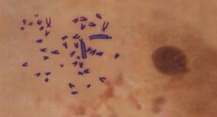

Fig.(1): Chromosome metaphase spread
Of Oreochromis niloticus

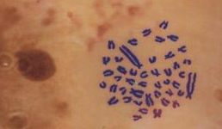

Fig.(2): Chromosome metaphase spread
Of sarotherodon galilaeus

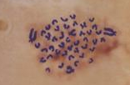

Fig.(3): Chromosome metaphase spread
Of Tilapia zilli

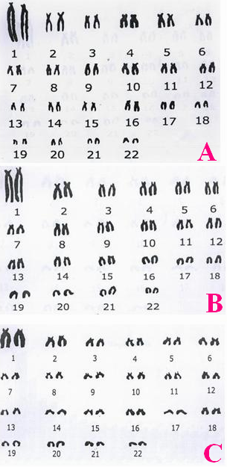

Fig. 4: Giemsa-stained karyotypes of:
A (Oreochromis niloticus); B(sarotherodon
galilaeus); and C( Tilapia zilli

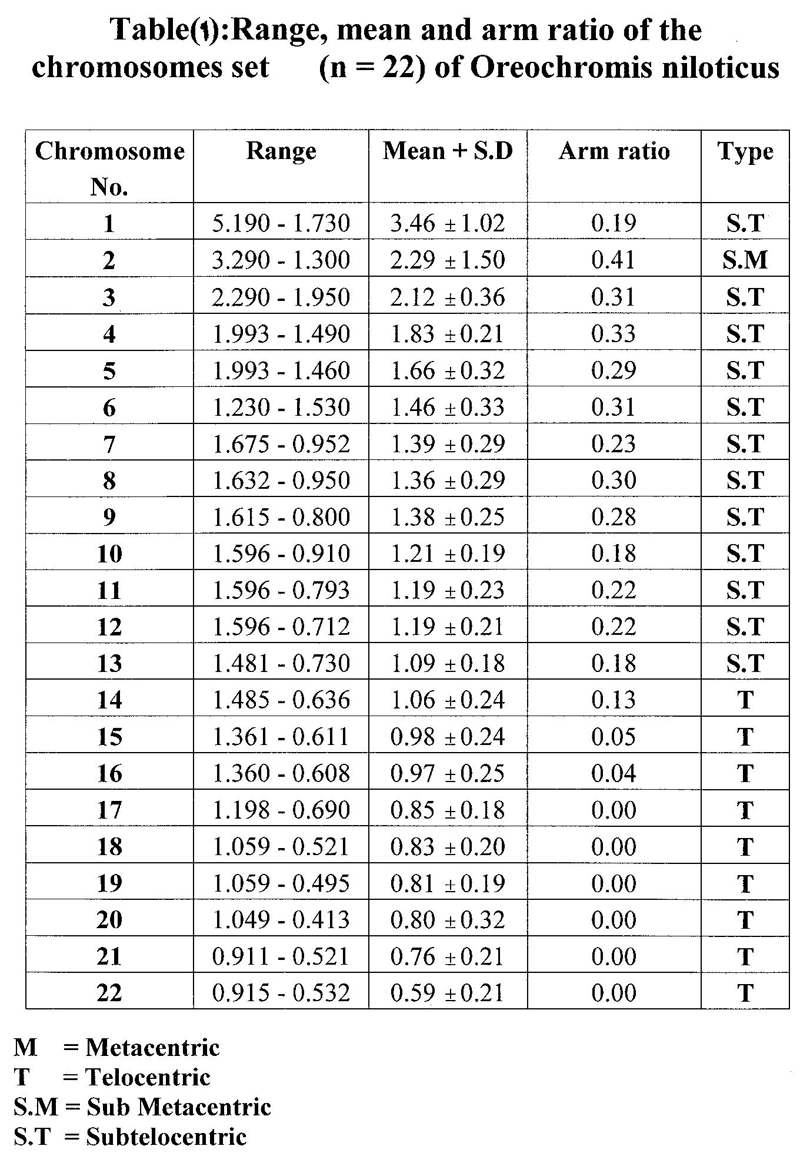

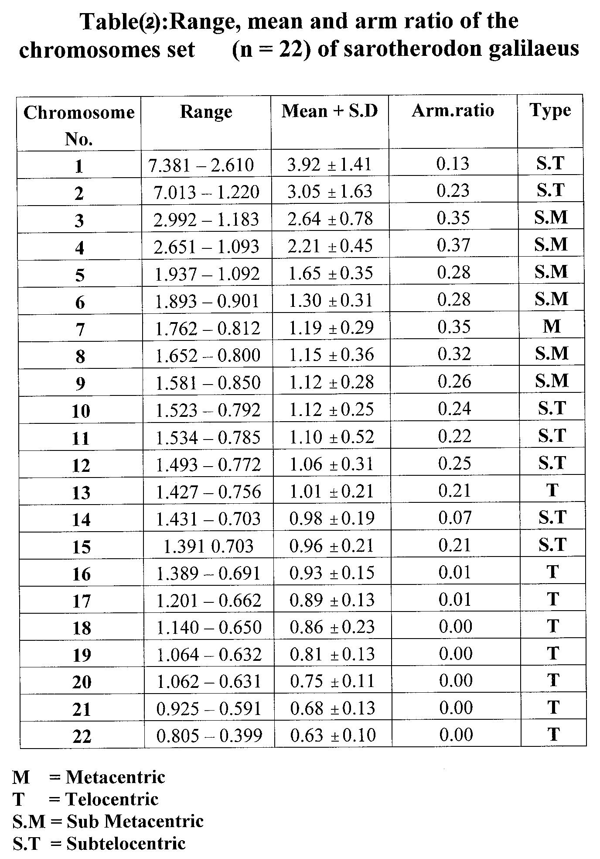

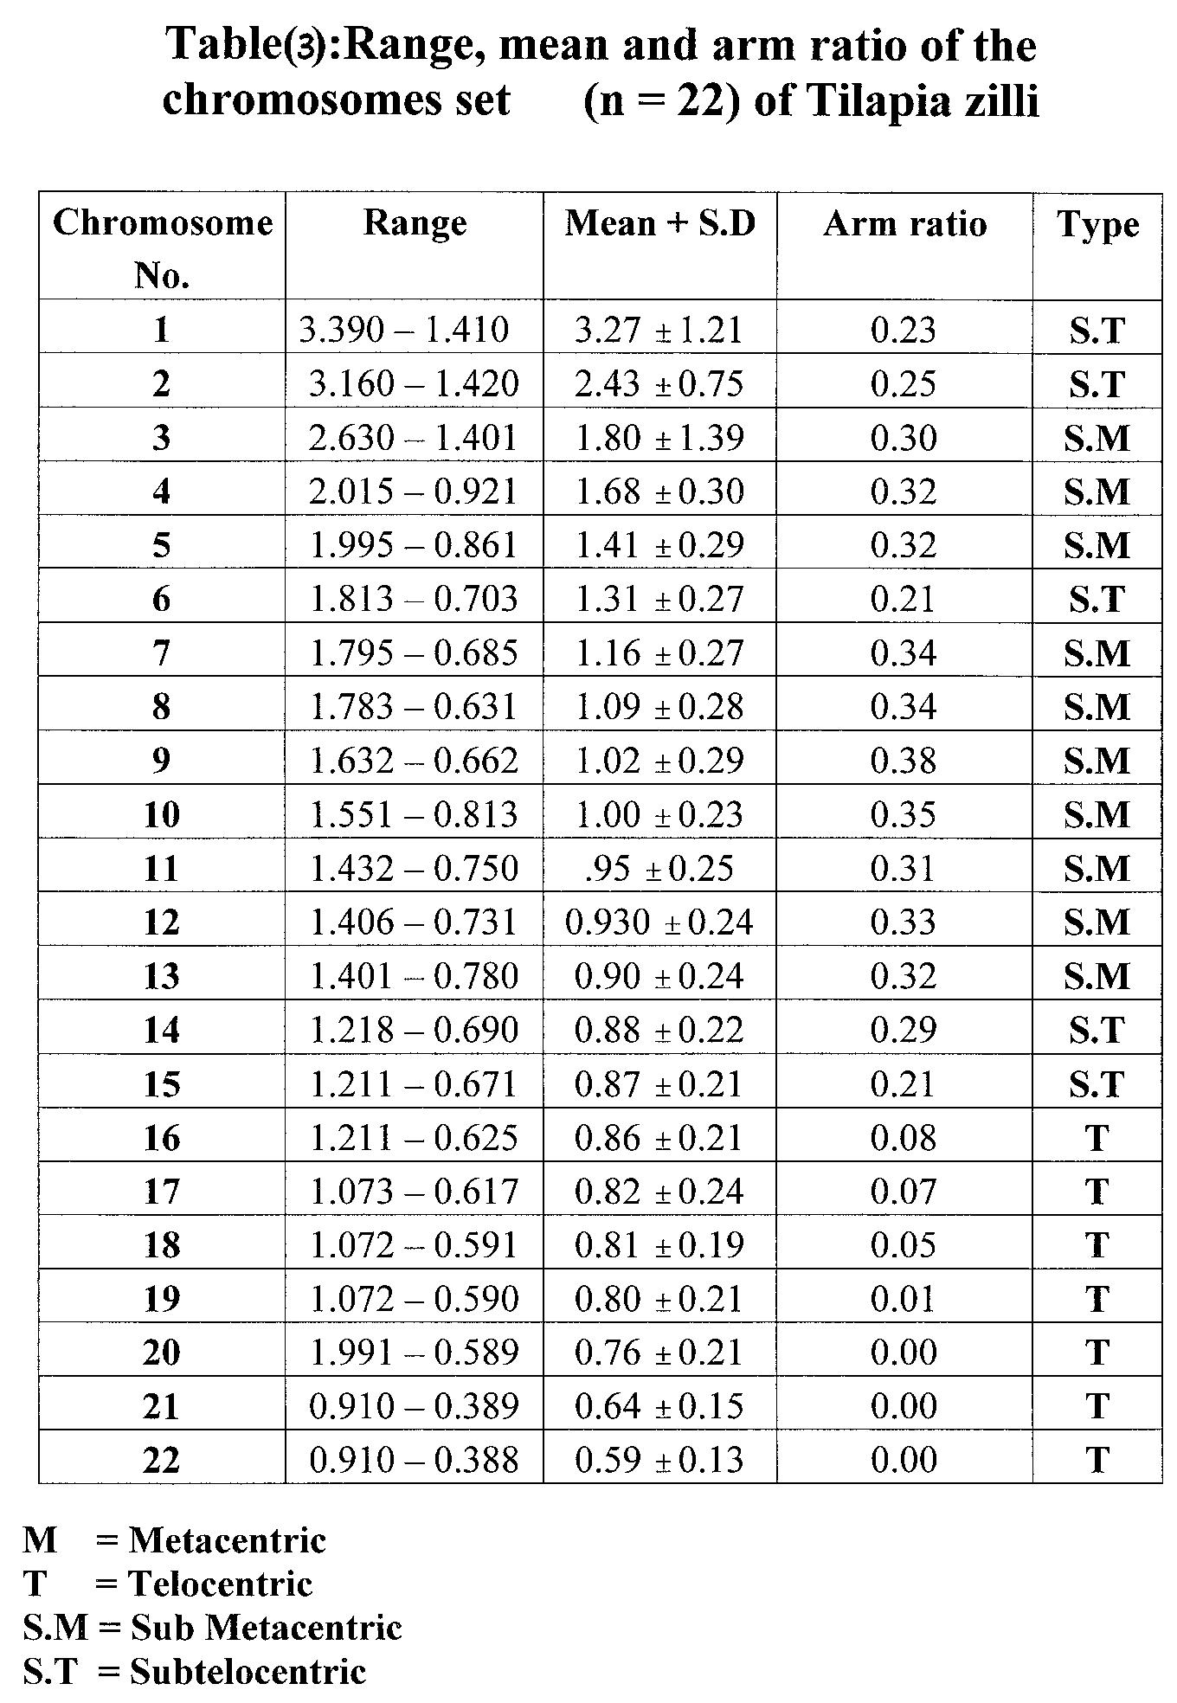

DISCUSSION

Among the various fish groups, the family Cichlidae occupies the fourth place in number of species comprising about 85 genera and 700 species (El serafy et al.,1993), the greatest diversity is encountered in Africa . Techniques such as chromosomal analysis, DNA sequencing, amino acid sequencing and protein electrophoresis have made it possible for systematic to utilize new sets of data for phylogenetic studies for this diversity (Duellman, 1985).

Tilapia are a group of Cichlid fishes of major economic importance in aquaculture, their uncontrolled and prolific breeding at a small size in mixed sex culture constitutes a constraint on their efficient production. Although interspecific hybridization of these species leading to all made stocks has been proposed as a possible solution to this problem (Beveridge and McAndrew,2000). In general, these fish are appropriate for both intensive and extensive piscicultre because one of there positive aquacultural characteristics of tilapia are their tolerance to poor water quality and the fact that they eat a wide range of natural food organisms, therefore, the present work is planned to study the cytological characteristics of three species of fishes , Oreochromis niloticus; Sarotherodon galilaeus, and Tilapia zillii, to elucidate the genetic relationship, similarity between them and the probability of their hybridization.

The study of chromosomes receives the interest for classification of species and understanding of evolution. In spite of being used extensively in taxonomic research of invertebrates and even in vertebrates, it is incomplete in most animals because of technical difficulties. Among vertebrates, fishes from the group for which cytologically data are mostly lacking (Alves, 2000; Artoni and Bertollo, 2001), in this concept we utilized the cytogenetic and karyotypic study to examine the similarity relationship among three tilapia species and the probability of there hybridization.

The cytogenetic data obtained from this study suggesting that this group has a conservative karyotypic structure , the diploid number of Oreochromis niloticus, Sarotherodon galilaeus and Tilapia zillii was 2n= 44 which is in agreement with Kornfield et al., (1979), and Sherwood & Patton (1982).

On comparing the mean length of the haploid set of chromosomes in both Sarotherodon galilaeus and Tilapia zillii showing no significant difference in the mean length of all chromosomes with the exception to chromosomes numbers 11& 21, where there was a significant difference between the two species was found. Also, the comparison between Oreochromis niloticus and Sarotherodon galilaeus showed no significant difference between chromosome pair number, where the chromosomal numbers 1, 2, 4, 5, 17, 18 & 22 those of Sarotherodon galilaeus were longer than another of Oreochromic niloticus. and the chromosomal mean length 3, 6, 7, 8, 9, 10, 11, 12, 13 & 14 of oreochrorms. niloticus were longer than other ones of Sarortherodon galilaeus and other numbers 15,19, 20, 21 are equal in both species but in comparing the range and mean length of chromosomes of Oreochromis niloticus, and Tilapia zillii its clear that there is a significant difference of the mean length of chromosomal numbers 6, 8, 11, 14 and 21 and there is no significant difference was found between the remaining chromosome pairs numbers.

Nijjhar et al., (1983) in his study on twenty species of Tilapia were analyzed karyologically ,there was a high homogeneity appeared, 2n =44 with 2 pairs of marker chromosomes , much larger than the others, and minor differences in the number of biarmed chromosomes, he demonstrated that the 1st longer pair. Of chromosome in the karyotypes of Tilapia was suspected to be the sex chromosomes. On the other hand, El serafy et al.,1993, found that male Oreochromis niloticus has seven submetacentric and fifteen subtelocentric from Serow and four submetacentric and eighteen subtelocentric from Kanater and Manzalla regions .While the female has three submetacentric and nineteen subtelocentric , six submetacentric and sixteen subtelocentric at the same regions .
In the studied species the relative length of the individual chromosomes between the species, show that the chromosome length varies little except in chromosome number one which is the longest in the whole karyotype
It is suggested from this study that, some of the observed intraspecific karyotype differences resulted from the evolutionary modification in genetically isolated populations , there are some evidence for inter-population variation having occurred at the molecular levels for a number of tilapia species ,so, further studies on a molecular level is important to establish this suggestion, this in agreement with Majumber ,1984.
Chew et al.,2002 suggested that chromosome number 1 , which is larger than all other chromosomes in the karyotype, was produced by the fusion of three chromosomes and explain the overall reduction of chromosomal number from ancestral teleost karyotype 2n=48 to 2n=44 observed in tilapia . Harvey et al.,2002, suggests that the difference in chromosome number dose not prevent the production of interspecific hybrids between Oreochromis niloticus 2n=44 and Oreochromis karongae 2n=38 under the suggestion that these consists of Robertsonian fussions of a more complex nature .
From this study , it can be concluded that there is a close similarity between Sarortherodon galilaeus and oreochromis niloticus giving a probability of hibridization ,where the comparison between tilapia zilli and Sarortherodon galilaeus ,or oreochromis niloticus put a less chance of hybridization due to less similarity between them .

References
- Artoni RF & Bertollo LAC. (2001) Trends in the karyotype evolution of Loricariidae fish (Siluriformes). Hereditas 134: 201−210.
- Al- Sabti, K. (1985): Chromosomal studies by blood leukocyte culture technique on three Salmonids from Yugoslavian waters. J. Fish., Biol., 26: 5-12
- Alves AL. (2000) Análise da evolução dos gêneros da subfamília Hemipsilichthiinae (Ostariophysi, Siluriformes, Loricariidae) com base em caracteres cromossômicos e de DNA mitocondrial. MSc Thesis, Universidade Estadual Paulista 129 pp.
- Bertollo, L.A.C.(1978): Estudos citogeneticos nogenero Hoplias Gill, 1903 (pisces – Erythrinidae). Tese de doutorado. Universidade de sao Paulo, faculdade demedicina de Ribeivao preto. 164 p.+tabst Figs.
- Bevridge, M.C.M. and McAndrew,B.J.(ed.)(2000): Out of Africa: the story of tilapias. Env. Biol.of fishes, 64: 461-464.
- Chew,J.S.,Oliverira C., wright ,J.M.,Dobson,M.J.(2002): Molcular and cytogenetic analysis of the telomers(TTAGGG)n repetitive sequences in the nile tilapia ,Oreochromis niloticus (Teliostei:cichlidae) Genetica, 13:154-173.
- Duellman, W.E.(1985): Systematic zoology: slicing the Gordonknot with ockham's razor. Syst. Zool., 25: 751- 762.
- El-serafy,S.C.,Al-Zahaby. E.S. ; Zowail , M.E.M. ; Dawood , W. and Badway , E.A.Al ( 1993 ) : comparative cytogenetic studies on two Tilapia sp. From different localities . bull . Fac . Sci . Zagazig univ. , 14 ( 2 ) : 449 – 471 .
- Greenwood, P.N.; Rosen, D.E.; Witzman, S.H. and Meyer, G.S. (1996): Phyletic studies of Teleostean fishes with a provisional classification of living forms. Bull Amer. Mus. Nat. Hist., 131: 339-445.
- Harvey,S.C.,Campos.Ramos,R.,Kennedy,D.D.,Ezaz,M.T.,Bromage,N.R.,Griffin,D>K.,Penman,D.J.(2002):Karyotype evolution in tilapia:Mitotic and meiotic chromosome analysis of oreochromis karongae and oreochromis niloticus× oreochromis karongae hybrids.Cytologia 67:314-325.
- Kornfield, I.L; Rette, U.; Richler, C. and Wahrman, J. (1979): Biochemical difference among Cichlid fishes of the sea Galilae. Evolution,3:1-14.
- Levan,A.,;Fredga,K and Sandberg,A.A.(1964) :Nomenclature for centromeric position on chromosomes .Hereditas,52:201-220 .
- Nijjhar, B.; Netag, C.K. and Amedjo, S.D. (1983): Chomosome studied on Sarotherodon niloticus, sarotherodon rnultifasciatus and Tilapia busumana (Cichlidae, pisces) P, 256 - 260. International symposium on Tilapia, Aquaculture. Proceedings 424 P. Tel Aviv Univ. Tel A viv, Israel
- Sherwood, S.W. and Patton, J.I.. (1982): Genome evolution in pocket gophers (Genus, Thompmys). 11 variation in cellular DNA content. Chromosoma (Beri) 85: 163 -179.
- Yu, R.L.;Aronson,M.M. and Nichols, W.W. (1981): High - resolution bands in .human fibrobast chromosomes induced by Ictinomycin D. Cytogenet. Cell Genet., 31, 111-114.

