Ultrastructural study of some helminth parasites infecting the Goatfish, Mullus surmuletus (Osteichthyes: Mulldae) from Syrt coast, Libya

Elsayed M. Bayoumy^{1*}, Sayed Abd El-Monem² and Khalaf Abd el-Wahed Ammar³
¹ National Research Center, Hydrobiology Department, and Department of Zoology, Faculty of Science, ²Cairo University; ³South Valley University, Qena, Egypt.
Bayoumy2004@yahoo.com

ABSTRACT: In this study a total of 68 live fishes caught from Syrt Coast, Libya dissected and examined for helminth parasites, out of them 46(67.6%) showed the presence of parasites. Four species of helminth parasites have been collected and identified during the present investigation. First species of them belongs to Digenea (Opecoelides furcatus Odhner, 1928), one Cestode in larval stage (Nybelinia sp.), one species of Acanthocephala (Echinorhynchus gadi Zoega in Muller, 1776) and one to Nematoda (Cucullanus longicollis Stossich,1899). Light and SEM observations revealed some differences between the present species and other related helminthes detected before. [Nature and Science. 2008;6(2):51-63]. ISSN: 1545-0740.

Key words: Opecoelidae- Nybelinia sp - Mullus surmuletus- Echinorhynchidae - Cucullanus - Syrt Coast, Libya- Marin fish

INTRODUCTION
Although, the striped red mullet Mullus surmuletus Linnaeus, 1758 (Order: Perciformes; Family: Mullidae) is very common in Syrt Gulf and is a commercially important species its parasites are scarcely known. In this regard, Jousson & Bartoli (2000) recorded decapod crustaceans as second intermediate host of two species of Opecoeloides parasitic on goatfishes from the Mediterranean Sea. While, the high diversity of digenean species in goatfishes was documented by Le pommelet et al. (1998), who listed 18 digenean species parasitic in goatfishes, however, many of these species have a restricted distribution to the western Mediterranean and the Adriatic Seas.
According to Williams and Bunkley (1996), adult forms of tapeworms are not very common in bony fishes, but larval forms of cestodes use bony fishes as intermediate host. Many species of larval tapeworms are found in the intestinal tract, often in large numbers, and few are encapsulated in tissues of marine bony fishes including big game fishes (Schmidt, 1986 and Williams and Bunkley, 1996). Palm & Walter (1999) and Palm (1999) described or re-described 17 species from genus Nybelinia and erected two new genera, Heteronybelinia and Mixonybelinia. Forty-eight species of Nybelinia, Heteronybelinia and Mixonybelinia are considered valid (Palm, 1999).
Acanthocephalans have few stable characters that are useful for family-level taxonomy. Recently, the specificity of the intermediate hosts was shown to be useful in taxonomy but, at genus-level (Nickol et al. 1999). Generally, no single character state serves to define echinorhynchidan families alone.
Cucullanidae Cobbold, 1864 includes intestinal nematodes characterized by a highly developed buccal cavity formed by the oesophagus (oesophastome) (Berland 1970), and males with or without a precloacal sucker and harboring 10–15 pairs of caudal papillae (Maggenti 1971). Most of about 100 species of Cucullanus have been described from fishes of different orders of which at least 70 were collected from marine or brackish-water fishes (González-Solís et al. 2007). Williams and Bunkley (1996) reported Cucullanus carangis from the intestine of a Crevalle jack at the New York Aquarium that was described as Dacnitis cangris, and Cucullanus pulcherrimus Barreto from a Black Jack in Brazil. In addition, In Egypt, the same genus was recorded in fresh water fishes like Barbus bynni and Mormyrus kannume (El- Naffar, 1970; 1983; Fahmy et al. 1976 and Soliman, 2000).
Parasites of the commercial inshore fishes of the Syrt Coast were rarely studied; hence, the present investigation aims to give some information on some helminthes infecting the goatfish Mullus surmuletus by light and SEM microscopy.

MATERIALS AND METHODES
Sixty-eight fish were collected in Syrt Coast, from May to October 2006. Fish were taken to the laboratory alive where they were serially pithed and autopsied. All fish were examined for helminth infection within 24 hrs of capture. The isolated helminthes were washed in saline solution (0.9%) and fixed in 4% buffered formalin. Except nematodes, specimens were stained in Acetic-Carmine, dehydrated and mounted in Canada balsam. The collected nematodes were cleared in glycerin for examination. Drawings were made with the aid of a Camera Lucida, connected to a Wild bright field microscope. All measurements are given in millimeters except otherwise mentioned.
For SEM studies, recovered species were washed in phosphate buffered saline and fixed overnight in 2.5% gluteraldehyde (pH 7.4) at 4 ºC. Specimens were washed three times in phosphate buffer and post fixed in 1% Osmium tetraoxide in 0.1% M Phosphate buffer and dehydrated through a graded series of ethanol. Complete dehydration was performed in two changes of absolute ethyl alcohol. Specimens were then mounted on stubs with double adhesive tape, coated with gold. Coated samples were examined with a high-resolution scanning electron microscope (JEOL SEM T330) operating at 20 Kev.

RESULTES
Out of 68 fishes examined, 46 showed the presence of parasitic helminth (67.6%). The distribution of such parasitic was as follows: Opecoeloides furcatus in 9 specimens (2.9%), Nybelinia sp. in 10 specimens (5.9%), Echinorhynchus gadi in 15 specimens (16.2%) and Cucullanus longicollis in 12 specimens (8.8%); The collected parasites were described and classified up to the level of species as follows:
І- Opecoeloides furcatus Odhner, 1928 (Fig.1A-B and 2)
Family: Opecoelidae Ozaki, 1925
Site of infection: intestine
The body elongate, slender, unspined and measures 6.3 –7.4. It has a ventral sucker (V.S.) with four papillae, separated from the body on peduncle, which is close to the anterior end of the body. It appeared as a projection arising from the body, measuring 4.5 –6.2 X 1.7 –2.2 length by width. The oral sucker (O.S.) and pharynx (Ph.) are similar in size and the ventral sucker slightly larger, 0.53-0.61X0.41-0.49, 0.31-0.41X0.21-0.24 length by width, respectively. The prepharynx is short, but the oesophagus long. The caeca extend to near the posterior end of the worm; the vitellaria fill the posterior 3/4 of the body. The testes tandem in the posterior body in-between the cecae, the anterior testis (A.T.) tetra-lobed, inter-caecal and well separated and measures 0.47-0.45X0.23-0.25 length by width. While the posterior testes (P.T.) penta –lobed, larger and measure 0.57-0.61X0.30-0.33 length by width. The ovary (O.) is of median position, situated at a considerable distance in front of the anterior testis, and measures 0.21- 0.25X0.19-0.23 length by width. The uterus is relatively long, intercaecal, winding between the ovary and acetabulum. The eggs (E.) are few in number, oval, moderately large, and measure 130-160 X50-80 µm length by width.

II- Nybelinia sp. (Figs. 1 C-D and 3).
Order: Trypanorhyncha Dollfus, 1942
Family: Tentaculariidae Poche, 1926
Genus: Nybelinia Poche, 1926
Site: gills, oesophagus, stomach wall.

The post larvae were found free in the gills or encapsulated in the oesophagus and the stomach wall. The present post larvae possess long and slender bothridia with free lateral margins and characteristic marginal, hook-like microtriches in a V –shaped pattern the presence of sensory fossettes on the bothridia. A basal tentacular swelling is absent. The tentacle sheaths straight, the armature homeoacanthous, homeomorphous and a characteristic basal armature present, consisting of about 10 rows. The tentacular hook form changes towards the metabasal part of the tentacle from compact to rounded rose-thorn shaped hooks (Plate 1d), with a slight anterior extension of the basal plate (uncinate). Bothridia 4, widely spaced, lateral margins free, longer than half scolex length. Measurements of the postlarva as follows, Scolex length 0.75-0.88., width 0.35-0.47; proboscis 0.826-0.938 (0.770-1.005); basal 0.052-0.055, 0.038-0.041. Tentacles (T) emerging pairwise, 0.29 long, slender, diminishing in size toward tip; TW 25 (basal) and 17 (apical); Tentacle sheaths straight; Prebulbular organs lacking, muscular rings around basal part of tentacle sheath not visible. Retractor muscles were originating in basal part of bulbs.

III – Echinorhynchus gadi Zoega in Muller 1776. (Figs.1 F-H and 4).
Class: Palaeacanthocephala Meyer, 1931
Order: Echinorhynchidea South well and Macfie, 1925
Family: Echinorhynchidae South well and Macfie, 1925

All worms had a milk-white color, the sex of adult E. gadi clearly distinguishable. The trunk elongate, sub-cylindrical, somewhat swollen anteriorly, aspinose.
Male: 7- 9 mm length by 0.3-0.5 mm width, Proboscis cylindrical, stout, claviform, densely armed with numerous rows of strongly recurved hooks, which vary in size according to their position, they are bigger on the top of the proboscis but become progressively smaller as we go backwards. Worms's posses 18-19 longitudinal rows, with 4 hooks per row, In the middle of the trunk, two elliptical testes arranged linearly. Posterior to the testes, 6 cement glands, psyriform in shape arranged linearly, with ducts leading into the sperm duct. Proboscis measures 0.8X0.2, proboscis sheath 0.9-1.1X0.2-0.3 length by width, lemnisci length 1.1- 1.5, testis 0.63 X0.16 length by width.
Female: usually larger than the males, possess 14- 18 longitudinal rows, with 6-10 hooks per row. Each worm contained a uterine bell. Body 8- 11 by 0.4-0.6, proboscis 1.1 by 0.4, proboscis sheath 1.3-1.5 by 0.4-0.5, lemnisci length 1.6 –1.8, eggs were 0.27 by 0.06. Generally length of apical blade 70- 80 µm, prebasal 38-40µm and the basal 45-50µm. Proboscis followed by a short neck measuring 0.08-0.10µm in length. Proboscis receptacle double walled, about twice as long as proboscis. The hooks are terminals, very sharp and their roots simple and round. In each worms, two lateral claviform protrusions, lemnisci, from the body wall at the base of neck. The shapes of the proboscis hooks are similar to those of the males. The body cavity of the female worms filled with fusiform shape eggs, where each showing a polar prolongation of the middle shells. The uterine bell and the uterus present in the posterior portion of body.

IV- Cucullanus longicollis Stossich, 1899 (Figs.5 - 7).
Order: Ascaridida
Superfamily: Seuratoida
Family: Cucullanidae Cobbold, 1864
Genus: Cucullanus Muller, 1777
They are medium sized nematodes, with very thick cuticle and longitudinal lateral alae absent. Oral opening dorsoventrally elongated, surrounded by narrow membranous ala (collarette) supported by raw of numerous minute teeth. Four submedian cephalic papillae and pair of small lateral amphids present. Muscular oesophagus consisting of two distinct portions: anterior with sclerotized lining expanded anteriorly to form a pseudobuccal capsule, narrowing immediately below nerve ring; and posterior with a claviform aspect and strong muscular structure, opening into intestine through valves. Deirids and excretory pore situated at level of posterior half of oesophagus. Cuticular transverse striae are occurring along the entire body seen posterior to the excretory pore (Plate, 7A &B). The width of these striae was 20 µm. They appear highly corrugated towards the posterior end giving the body a general rough appearance.
Male (Figs. 5 A-C and 6): length of body 12.3, width 0.17; entire oesophagus 0.93; oesophastome 0.08 X0.16 length by width. Nerve ring (N.R.) 0.36, excretory pore (Ep) and deirids (D) 0.91, 0.89, respectively; from anterior extremity, equal alate spicules observed, length of spicules 0.64. Gubernaculum (G) is well developed and sclerotised (S), 0.06 is long. Preanal sucker (P.S) well developed and without a chitinous rim measured 0.17 long and 0.57 away from cloaca. Caudal alae was absent. Caudal papillae (P) were distributed as follows: 5 pairs preanal, 1 pair adanal and 5 pair postanal (3 subventral and 2 lateral). Tail is smooth and pointed. Cloaca was 0.31 from posterior extremity. Males with a spirally coiled posterior portion, demonstrated on the ventral surface of the coils, a rugose area, cloacal aperture and caudal papillae (Plate5 B). The rugose area is a modification of the cuticular striation pattern, composed of long stripes of cuticular ridges obliquely placed in a longitudinal band at the ventral posterior coiled region.
Female (Figs. 5 D-F and 7): Body long and slender 16.76 long and 0.21wide. Dorsoventral elongate stoma; pseudobuccal capsule (oesophastome) 0.087 X 0.176 length by width. Total oesophagus 1.4 distances of nerve ring, excretory pore and deirids from anterior extremity 0.44, 0.96 and 1.1 respectively. Vulva (V.) near the middle of the body, vulvular lips prominent. Vagina directed anteriorly; uteri opposed, containing immature eggs. Anterior ovary almost extends beyond junction of oesophagus and intestine (I), posterior ovary almost reaches anus. Tail conical in shape, Apair of phasmids (Ph.) situated midway between the anus and posterior end. Eggs 114 X68 µm, thin- shelled and with small polar protruberance.anus 0.51 from posterior extremity. Phasmids measured 0.12 from tip of tail.

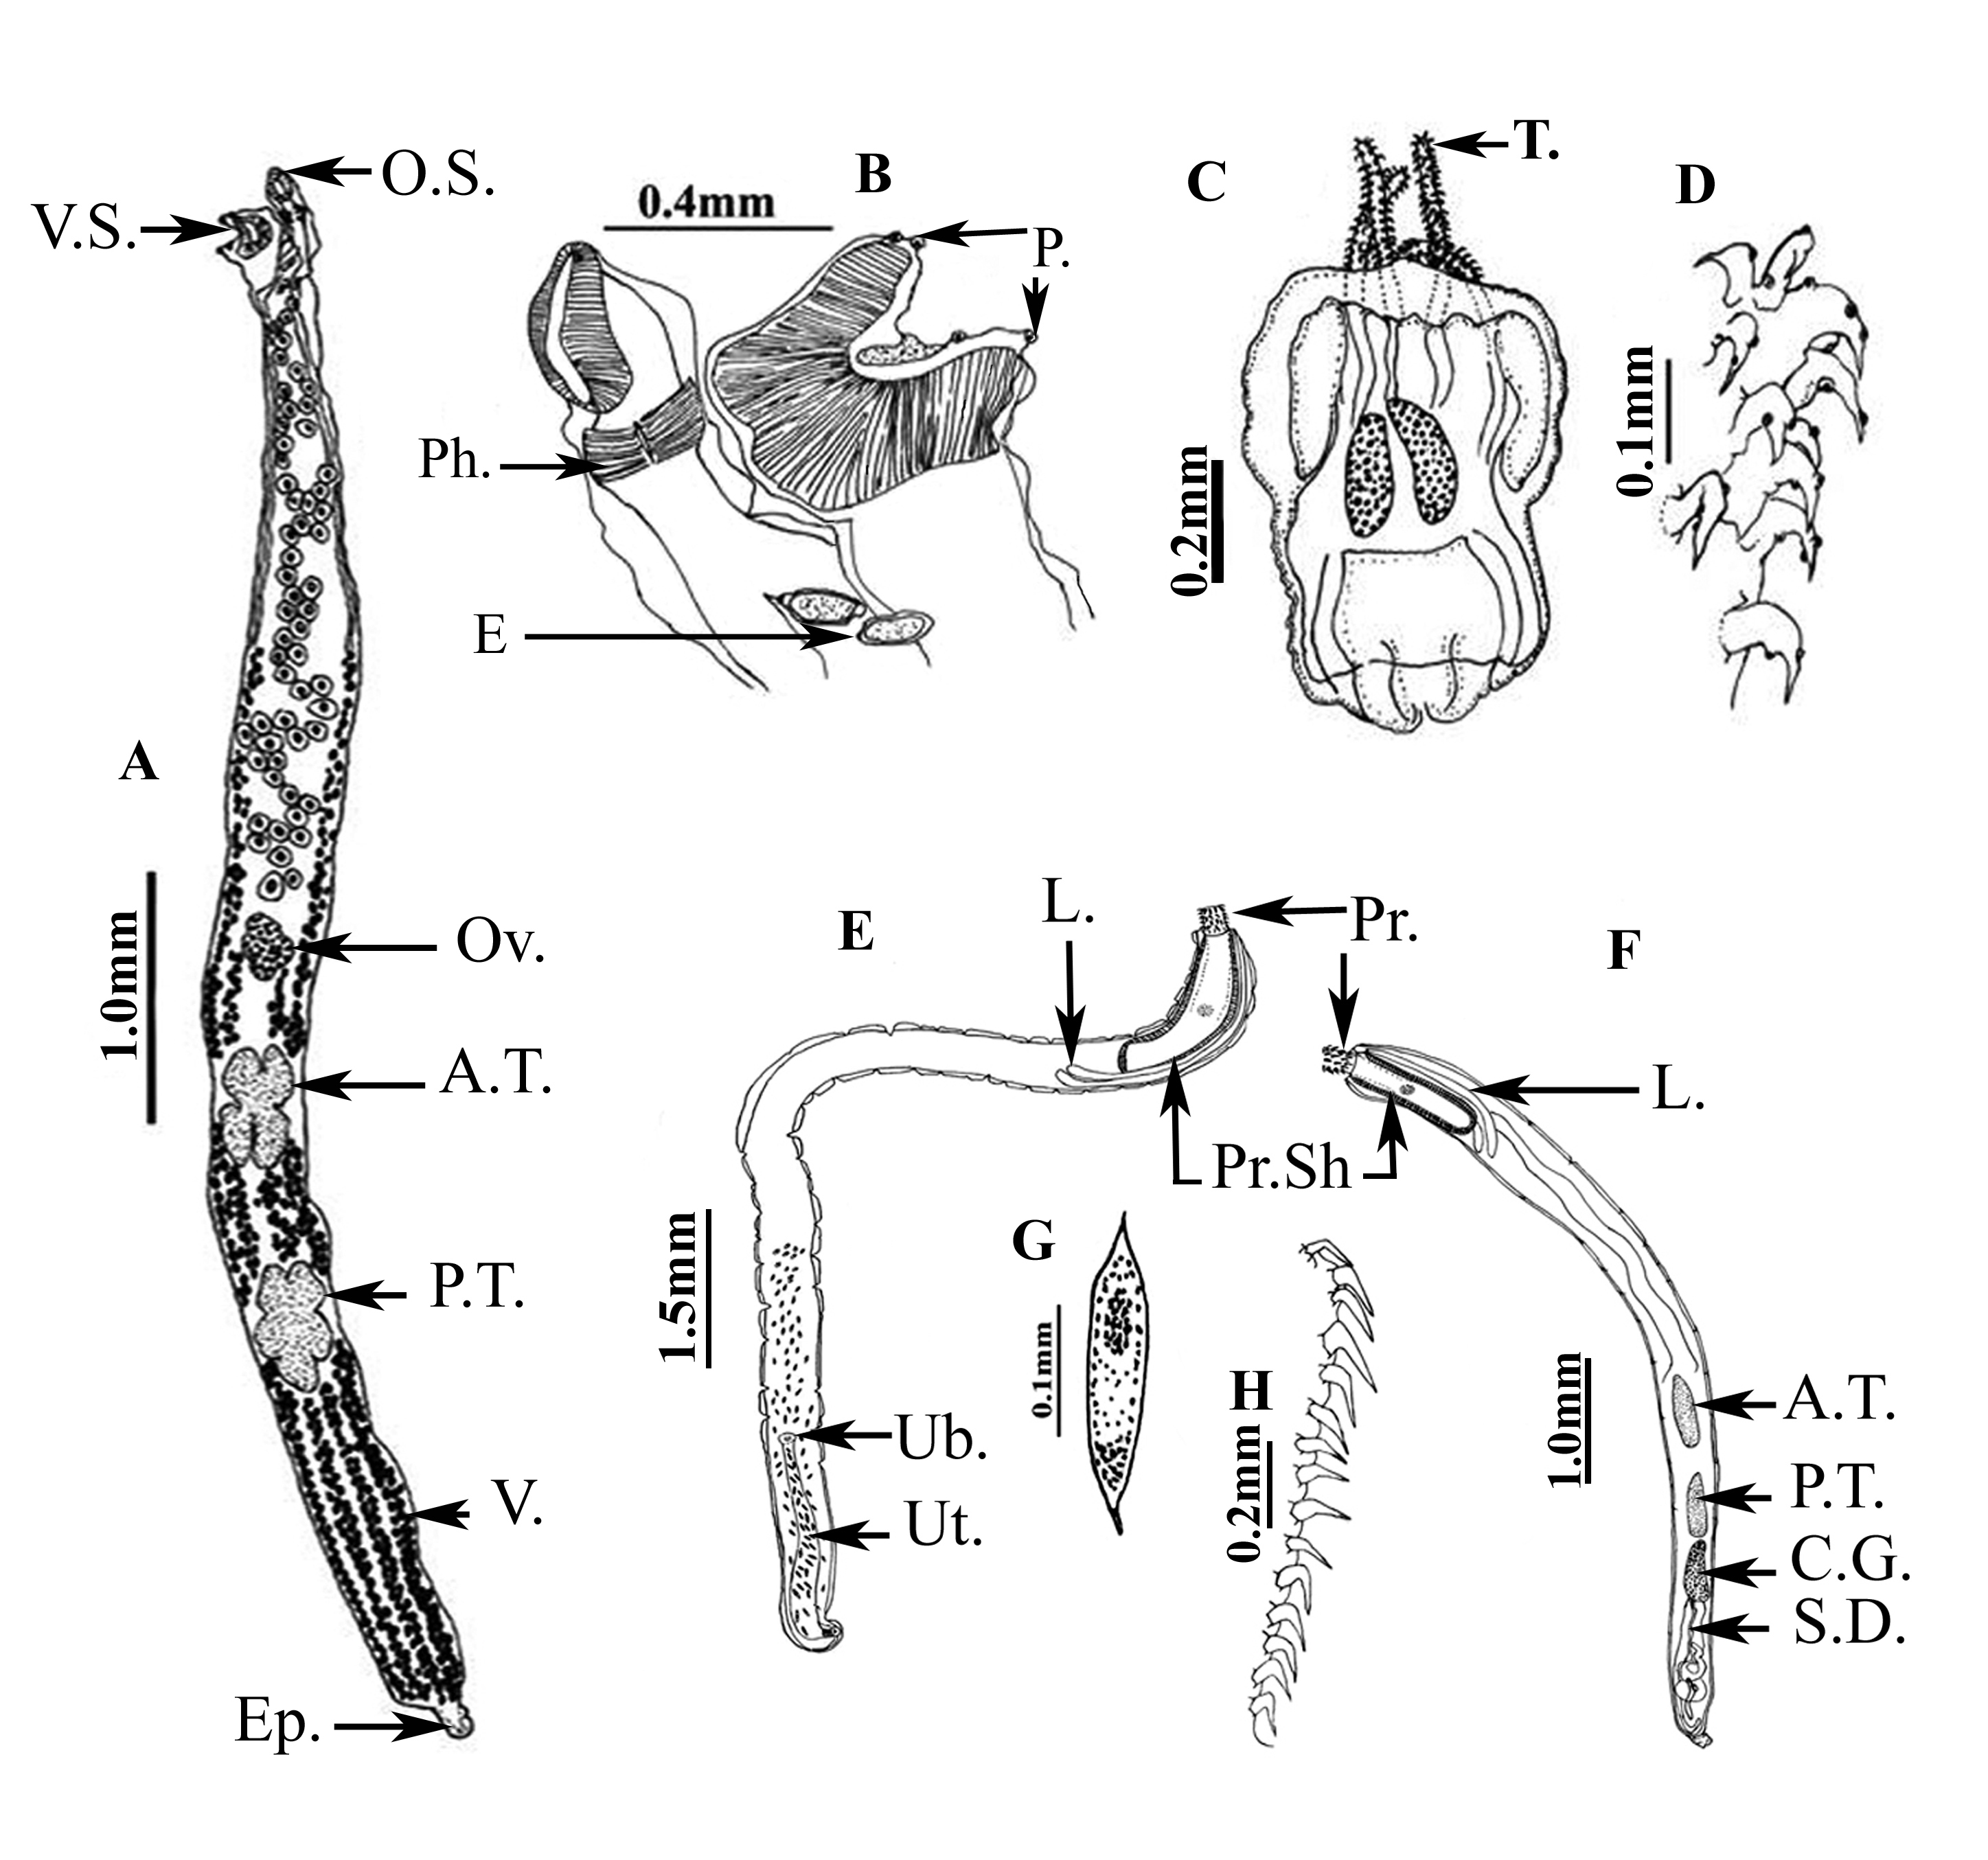

Fig. 1: Camera lucida drawing of A: Opecoelides furcatus. B: ventral and oral suckers of O. furcatus. C: Larval stage of Nybelinia sp. D: hooks of tentacles of Nybelinia sp. E: female Echinorhynchus gadi, F: male E. gadi, G: egg H: hooks

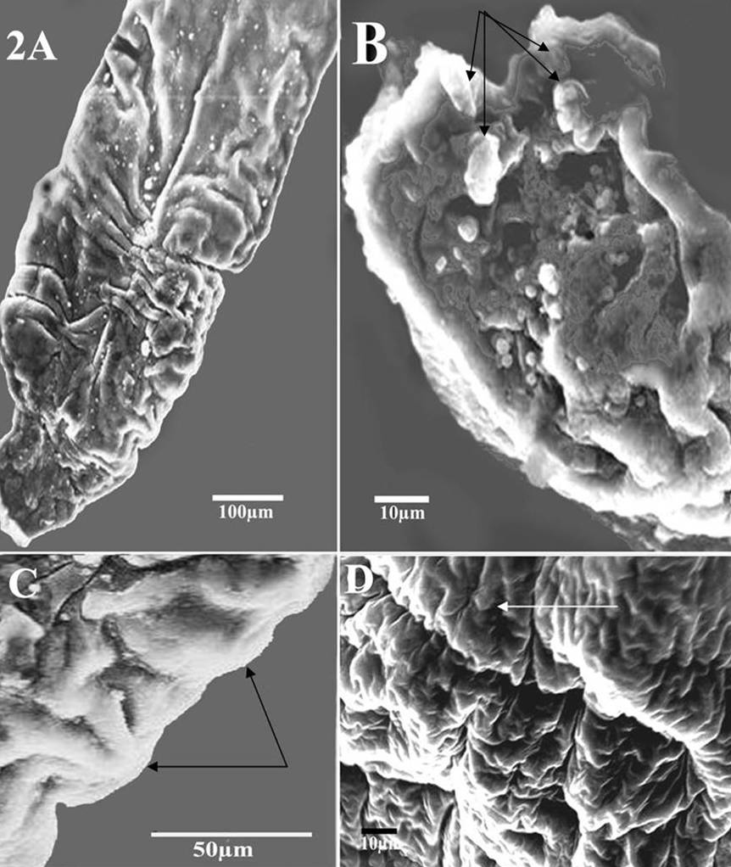

Fig. 2: SEM. Micrographs of Opecoelides furcatus A- posterior end B- ventral sucker with 4 papillae (arrows); separated from the body on peduncle; C- cuticular projections in the form of needle-like spines (arrows). D- Tegument of the body with longitudinal ridges;

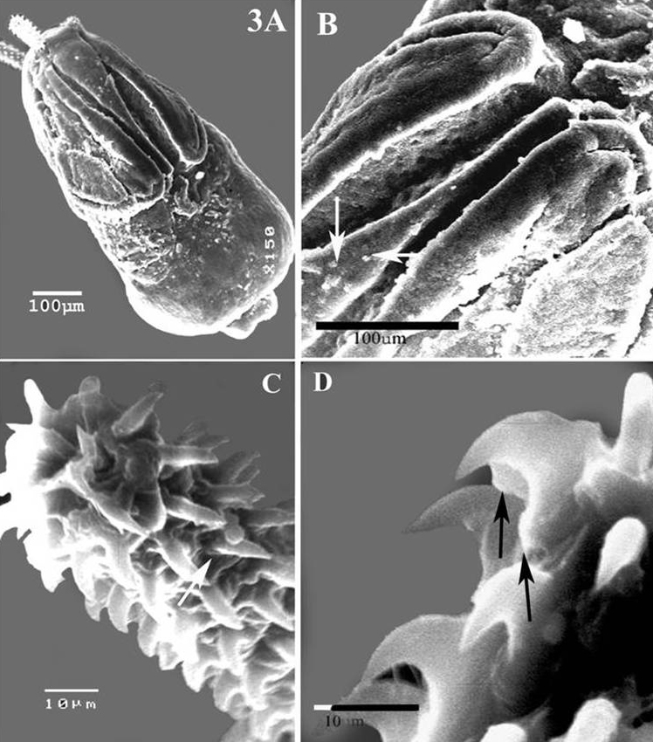

Fig. 3: SEM .Micrographs of larval stage of Nybelinia sp. A- larva with 4 bothridia;B- hooks supported by small nodules or buds ;C- sensory fossettes; D- slender rose-thorn-shaped metabasal hooks.

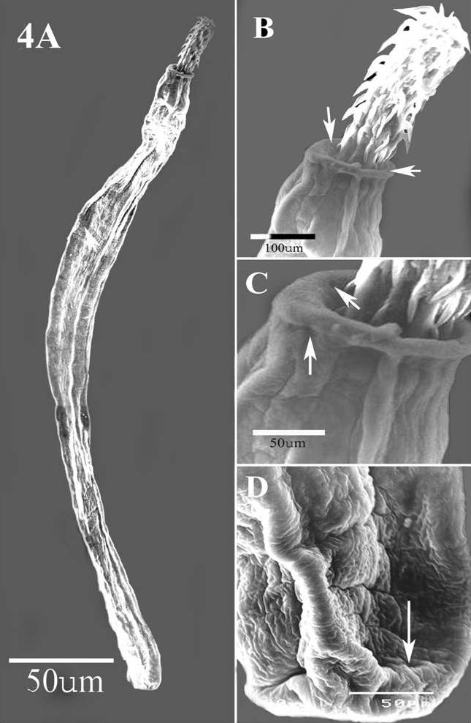

Fig. 4: Echinorhynchus gadi. SEM micrographs A-entire body, B- proboscis with numerous rows of hooks, C- neck showed 2 small pits, D- tail tip, e-excretory pore.

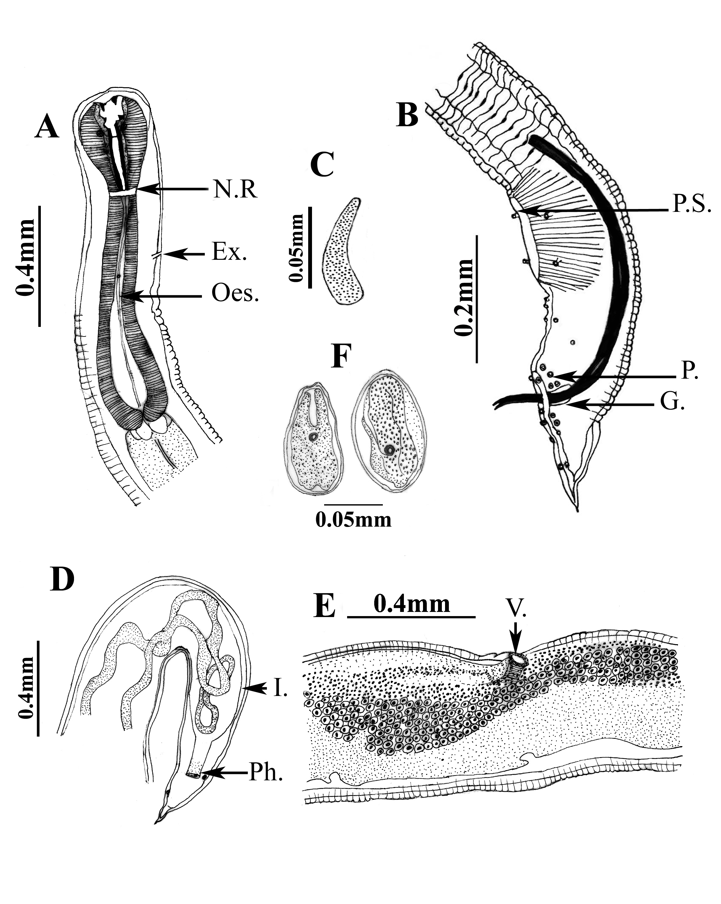

Fig. 5: Camera lucida drawing of Cucullanus longicullus A & B: anterior and posterior ends of male. C: gubernaculums. D: posterior end of female. E: vulvular region. F: egg.

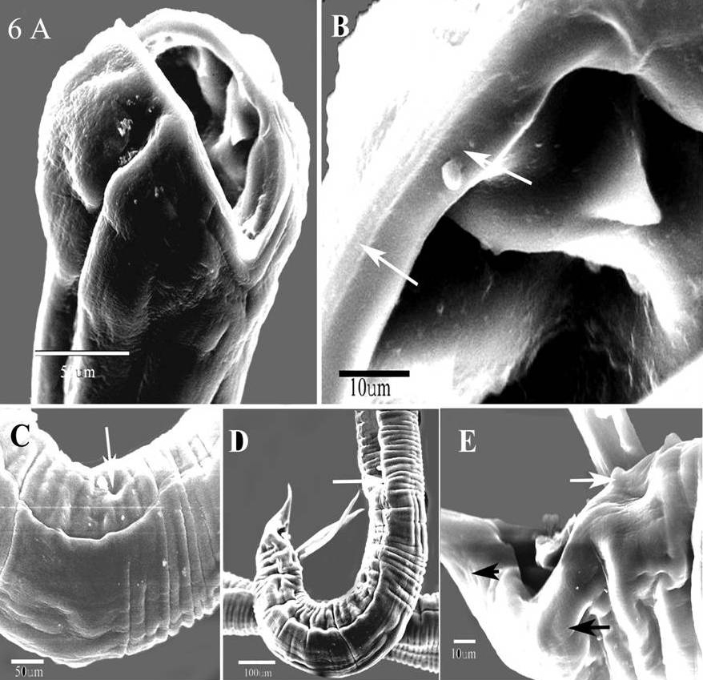

Fig. 6: SEM micrographs of male C. longicollis. A – cephalic end showing triangular teeth and cephalic papillae; B- detail of cephalic teeth, papillae; C- preanal sucker; D- posterior end, lateral view; D- detail of caudal papillae.

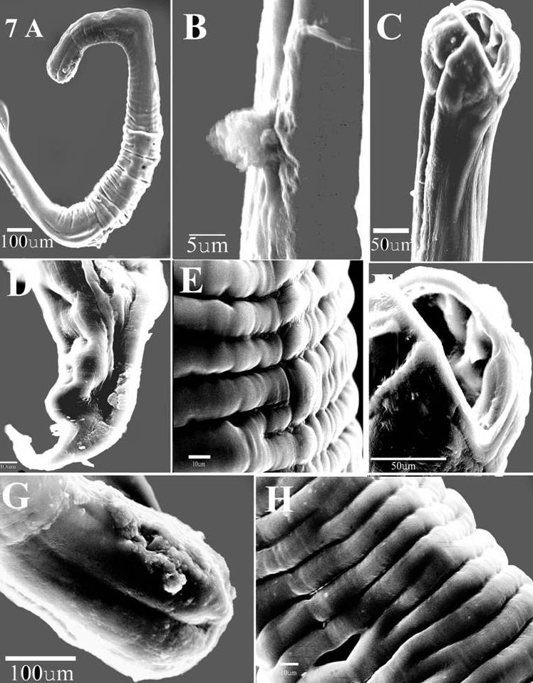

Fig. 7: SEM micrographs of female C. longicollis. A- anterior portion; B- deirids; C- anterior extremity, ventral view; D- caudal extremity,phasmide; E- sensitive papillae along the body; F- pseudobuccal capsule with collarette, apical view; G- anterior end with amphids; H- valvular region, branched and interrupted cuticle.

DICUSSION
The Opecoelidae Ozaki, 1925 constitute a large and cosmopolitan family of digeneans, which includes about 51 genera and 465 species (Yamaguti, 1971). SEM showed that tegument is provided with longitudinal ridges, sharp cuticular projections in the form of needle-like spines and corrugations, which spread on the outer surface, these modifications might explain the tight attachment and penetration of the flukes to the intestinal mucosa of infested fishes.
Dollfus (1960) described a specimen of Nybelinia riseri with incompletely evaginated tentacles. The present specimens had completely evaginated tentacles revealed a characteristic armature consisting of compact, rounded rose-thornshaped basal hooks, lacking an anterior extension of the basal plate, and more slender rose-thorn-shaped metabasal hooks semelar observations were reported on Nybelinia riseri (Dollfus, 1960). However, in N. lingualis, the apical hook form remains similar to that seen on the metabasal part of the tentacle, and the hooks increase slightly in size. SEM observations revealed the presence of a sensory receptor“sensory fossettes” or “ciliated pits,” within tufts of microtriches on the bothridial surface. Also, hooks are supported by small nodules or buds. These structures possibly enabling the worm to attachement and orientate within the host may explain the abundance of the ciliated receptors within the trypanorhynch bothridial tegument. These results are in agreement with Palm et al. (1998). Palm and Overstreet (2000) renamed these structures bothridial pits, as they could not detect any cilia but documented microtriches within the pits of O. cysticum. In addition, Heteronybelinia estigmena and H. microstoma burrowed their scoleces deeply in the mucosa of the host and attached via hooked tentacles and unciniform microtriches of the scolex (Bounska and Caira, 2006).
However, the functional specialization of the cestode tegument for sensory reception is not well understood and the sensory nature of these receptors has not been demonstrated in experimental and behavioral studies (Palm et al. 1998). Nevertheless, several different functions have been attributed to ciliated receptors, such as chemoreception (Allison, 1980), osmoregulation, (Hess and Guggenheim, 1977), and mechanoreceptor, (Webb & Davey, 1974 and Andersen, 1975). Furthermore, Lumsden and Murphy (1980) proposed that the tapeworm tegument might be an example of an “epidermal” tissue exerting a modulating effect on muscle tissue. On the other hand, retractile sensory receptors on the bothridial surface of the trypanorhynch Bombycirhynchus sphyraenaicum had a mechano-receptory function (Palm et al. 1998).
Echinorhynchus gadi Zoega in Muller, 1776 is the most common acanthocephalan infecting marine fish and is found in more than 60 species (Arai, 1989 and Omar, 1987). In the present work, the morphological characteristic features of each organ of the worms corresponded to those listed before. The size, arrangement, number and morphological characters of the body, eggs, and hooks were also correspond to those listed ones (Yamaguti, 1963; and David, 1986 and Arai, 1989). In the present species, the neck showed 2 small pits which could be openings of solitary gland cell ducts and 2 sensory papillae, helping the proboscis in participating in the attachment and nourishment as well as a defensive role.
The nematode family Cucullanidae Cobbold, 1864, comprises several genera, including many species parasitizing various fresh, brackish and marine fishes worldwide. Most cucullanids are representatives of the genera Cucullanus Miiller, 1777 and Dichelyne Jiigerskiold, 1902. The genus Cucullanellus Tornquist, 1931 is characterized mainly by a ventral intestinal caecum and the ventral sucker lacks the prominent papilliform projection with description given by Yamaguti (1961).
An Ultrastrucure study revealed that pseudobuccal capsule (oesophastome) as wide as posterior part of oesophagus and contains 2 pairs of triangular large teeth. The lips of the vulva are Y shaped and considerably elevated. The surface of parasites seems to be important in the intricate relationship between these organisms and their hosts. The cuticle has rugae or folds that described as transverse ridges and external raised incomplete annulations; branched and interrupted on the cuticle surface. The female tail has a pair of sensory papillae situated in a ventro lateral position, which represent the phasmids and they are considered to be comparable to the amphids seen on the head and may have both a glandular and sensory function (Melarn, 1976). The ventral sucker helps in attachment during copulation.
Johnston & Mawson (1945) described Cucullanellus cnidoglanis from catfish Cnidoglanis megastomus. Brunsdon (1956) recorded this parasite from Pagrus auratus in New Zealand. According to Petter (1974), the genus Dichelyne includes three subgenera: Dichelyne Jiigerskiold, 1902 (precloacal sucker absent; 11 pairs of caudal papillae), Cucullanellus Tornquist, 1931 (precloacal sucker present; 11 pairs of caudal papillae), and Neocucullanellus Yamaguti, 1914 (more than 11 pairs of caudal papillae).
According to Moravec et al. (1993), the genus Cucullanus Müller, 1777 includes several species that bear many similarities. The original descriptions of these are often poor, making comparisons between them difficult.
The main distinguishing characters of C. heliomartinsi are markedly short spicules that correspond to 2.5% of the total body length; deirids and excretory pore situated posterior to the oesophago-intestinal junction; marked sclerotizations in the oesophago-intestinal junction; marked sclerotizations in the oesophegastome, and oesophagus divided in two distinct portions(Moreira et al. 2000). Although possessing a similar ratio of spicule/body length to the present species, C. brevispiculus (Moravec et al. 1993) it differs mainly from C. heliomartinsi in the position of deirids and the excretory pore. Both are located in the posterior half of the oesophagus.
The present Cucullanus longicollis species has markedly longer alate spicules; 2 pairs of triangular teeth and row of sensitive papillae along the body, which not observed in the parasites recorded from freshwater fishes (González-Solís et al. 2007 ).
The chitinous triangular teeth are probably used during penetration into and migration through the intestinal wall of the fish host; while the raw of sensitive papillae served for orientation during sexual intercourse.

Corresponding to:
E. M. Bayoumy
Hydrobiology Department
National Research Center
Giza, Egypt
Bayoumy2004@yahoo.com

REFERENCES
1. Allison, F.R. (1980): Sensory receptors of the rosette organ of Gyrocotyle rugosa. Int J Parasitol 10: 341-353.
2. Andersen, K.I. (1975): Ultrastructural studies on Diphyllobothrium ditremum and D. dendriticum (Cestoda, Pseudophyllidea), with emphasis on the scolex tegument and the tegument in the area around the genital atrium. Z. Parasitenkd 46: 253-264.
3. Arai, H.P. (1989): Acanthocephala, In Guide to the parasites of fishes of Canada. Part III, L. Margolis and Z. Kabata (Eds.). Canadian Special Publication of Fisheries and Aquatic Sciences, 107, 1-90.
4. Berland, B. (1970): On the morphology of the head in four species of Cucullanidae. Sarsia 43: 15–64.
5. Borucinska, J.D and Caira, J.N. (2006): Mode of attachment and lesions associated with trypanorhynch cestodes in the gastrointestinal tracts of two species of sharks collected from coastal waters of Borneo. Journal of Fish Diseases. 29: (7).395.
6. Brunsdon, R.V. (1956): Studies on nematode parasites of New Zealand fishes. A systematic and parasitological study of the nematodes occurring in New Zealand marine and fresh-water fishes, including biological studies on the genus Anisakis Dujardin 1845. Unpublished Ph.D. thesis, lodged in the Library, Victoria University of Wellington.
7. David, J. M. (1986): Aeginina longicornis (Amphipoda: Caprellidea), New Intermediate Host for Echinorhynchus gadi (Acanthocephala: Echinorhynchidae). J. Parasitoll., 80(6): 1043-1045.
8. Deardorff, T.L., Raybourne, R.B. and Mattis, T.E. (1984): Infections with trypanorhynch plerocerci (Cestoda) in Hawaiian fishes of commercial importance. Sea Grant Quart 6: 1-6.
9. Dollfus, R.P. (1942): Études critiques sur les tétrarhynques du Museum de Paris. Arch Mus Hist nat Paris 19: 1-466.
10. Dollfus, R.P. (1960): Su rune collection de Tetrarhynques homeacanthes de la famille des Tentaculariidae recoltees principalement dans la region de Dakar. Bull. Inst. Fr. Afr. Noire, Ser. A 22: 788-852.
11. El-Naffar, M.K., Saoud, M.E. and Hassan, I.M. (1983): Ageneral survey of the helmith parasites of some fishes from Lake Nasser at Aswan.A.R.Egypt, Assiut. Vet.Med.J.11, (21):141-148.
12. El-Naffar, M.K. (1970): Studies on parasites of Nile fishes in Assiut Province of Egypt. Ph.D.Thesis, Fac.of Sc., Assiut Uni.Egypt.
13. Fahmy, M.A.M., Mandour, A.M. and El-Naffar, M.K. (1976): On some digenetic trematodes from Nile fishes of Assiut Province. J. Egy.Soc.Parasit., 1, 1-20.
14. González-Solís, D., Tuz-Paredes, V.M. and Quintal-Loria, M.A. (2007): Cucullanus pargi sp. n. (Nematoda: Cucullanidae) from the grey snapper Lutjanus griseus off the southern coast of Quintana Roo, Mexico. Folia Parasitologica, 54: 220–224.
15. Hess, E. and Guggenheim, R. (1977): A study of the microtriches and sensory processes of the tetrathridium of Mesocestoides corti Hoeppli, 1925, by transmission and scanning electron microscopy. Z Parasitenkd 53: 189-199.
16. Johnston, T.H. and Mawson, P.M. (1945): Some parasitic nematodes from South Australian fish. Transactions of’the Royal Society of South Australia 69: 1]4-117.
17. Jousson, O. and Bartoli, P. (2000): The life cycle of Opecoides columbellae (Pagentecher, 1863) n. comb. (Digenea, Opecoelidae): Evidence: from molecules and morphology. International Journal for Parasitology, 30:747-760.
18. Le Pommelet, E.L. and Silan, P. (1998): Gut of goatfishes, a heterogeneous biotope for intestinal mesoparasites: variations in pyloric caeca number and growth models of colonizable digestive surface area. J. Fish Biology, 53:866-878.
19. Lumsden, R.D. and Murphy, W.A. (1980): Morphological and functional aspects of the cestode surface. In: Cook CB, Pappas PW, Rudolph ED (Eds) Cellular interactions in symbiosis and parasitism. Ohio State University, Columbus, Ohio, pp 95-130.
20. Melaren, D.J. (1976): Sense organs and their sections.In: The organization of nematodes (Edn.A.Coll) PP.139-161.Academic Press.
21. Moravec, F., Kohn A. and Fernandes B.M.M. (1993): Nematode parasites of fishes of the parana river, brazil. Part 2. Seuratoidea, Ascaridoidea, Habronematoidea and Acuarioidea. Folia Parasitol. 40: 115-134.
22. Moreira, N.IB, Rocha, G.N. and Costa, H.MA. (2000): Anew nematode species (Seuratoidea, Cucullanidae) parasitizing Parauchenipterus striatulus (steindachner, 1876) (Pisces, Auchenipteridae) in Brazil. Mem.Inst.Oswaldo Gruz, Rio de Janeiro, V.95 (1):39-41.
23. Nickol, B.B., Crompton, D.W.T. and Searle, D.W. (1999): Reintroduction of Profilicollis Meyer, 1931, as a genus in Acanthocephala: significance of the intermediate host. J. Parasitol. 85: 716-718.
24. Omar, M. A. (1987): Key to the families and subfamilies of Acanthocephala, with the erection of a new class (Polyacanthocephala) and a new Oder (Polyacanthorhynchida). J. Parasitol .73(6): 1216-1219.
25. Palm H. W. and Overstreet R. (2000): New records of Trypanorhynch cestodes from the Gulf of Mexico, including Kotorella pronosoma (Stossich, 1901) and Heteronybelinia palliata (Linton, 1924) comb. n. Folia Parasitologica 47: 293-302.
26. Palm, H.W. (1999): Nybelinia Poche, 1926, Heteronybelinia gen. novo and Mixonybelinia gen. novo (Cestoda: Trypanorhyncha): in the collections of The Natural History Museum, London. Bull. Nat. Hist. Mus. Lond. (Zool.) 65: 133-153.
27. Palm, H.W., Poynton S. L. and Rutledge P. (1998): Surface ultrastructure of Bombycirhynchus sphyraenaicum (pintner, 1930) (Cestoda: Trypanorhyncha). Parasitol. Res. 84: 195204.
28. Palm, H.W. and Walter T. (1999): Nybelinia southwelli sp. Novo (Cestoda: Trypanorhyncha) with the re-description of N. perideraeus (Shipley and Homell, 1906) and synonymy of N. herdmani (Shipley and Homell, 1906) with Kotorella pronosoma (Stossich, 1901). Bull. Nat. Hist. Mus. Lond. (Zool.) 65: 123-131.
29. Palm, H.W., Walter T., Schwerdtfeger, G. and Reimer, I.W. (1997): Nybelinia Poche, 1926 (Cestoda: Trypanorhyncha) from the Moltambique coast, with description of N. beveridgei sp. Novo and systematic considerations of the genus. South Afr. J. Mar. Sci. 18: 273-285.
30. Petter, A.J. (1974): Essai de classification de la famille des Cucullanidae. Bull. Mus. Natl. Hist. Nat., Paris, 3” ser., Zoologie 177: 1469-1491.
31. Schmidt, G.D. (1986): Handbook of tapeworm identification. Boca Raton: CRC Press, 675 pp.
32. Soliman, I.S.G. (2000): Asurvey on parasites of some Nile fishes around Helwan area in Egypt.M.Sc. Thesis, Fac.of Sc., Cairo Uni.Egypt 119-126.
33. Webb, R.A. and Davey, K.G. (1974): Ciliated sensory receptors of the unactivated metacestode of Hymenolepis microstoma. Tissue Cell 6: 587-598.
34. Williams, E.H., Jr. and Bunkley –Williams, L. (1996): Parasites of off shore big game fishes of Puerto Rico and the Western Atlantic. Puerto Rico Department of Natural and Environmental Recourses, San Juan, PR, and the University of Puerto Rico, Mayagüez, PR, 382 p., 320 drawings.
35. Yamaguti, S. (1961): Studies on the helminth fauna of Japan. Pt 57. Nematodes of fishes III. Journal of helminthology R. T. Leiper supplement: 217-228.
36. Yamaguti, S. (1971): Synopsis of digenetic trematodes of vertebrates. Tokyo: Keigaku Publishing.
Yamaguti, S. (1963): Systema helminthum.Vol.V.Acanthocephala.Interscience, New York and London.

Jan 27, 2008 12:23 PM

