Synthesis, Characterisation and Preliminary Anion complexation studies of a nuetral novel 2,7-diacetamido fluorene molecular tweezer receptor
R. C. Jagessar*
*R.C.Jagessar, Senior Lecturer, Department of Chemistry, Faculty of Natural Sciences, University of Guyana, Turkeyen campus, Greater Georgetown, South America.
raymondjagessar@yahoo.com
Abstract: A novel 2,7-diacetamido fluorene receptor has been synthesized and characterized via ¹H NMR, ¹³ C NMR, DEPT 135, ¹H-¹H COSY, HMQC, HMBC experiments. Preliminary anion binding studies via ¹ H NMR indicate recognition and complexation of bromide anion. There are only a few neutral amide receptors reported to date. [Nature and Science. 2008;6(2):80-89]. ISSN: 1545-0740.

______________________________________________________________________________________
Research in Anions coordination Chemistry is increasing, considering the versatile role anions play in nature, medicine, laboratory and industrial processes etc. Several concepts of anion binding motifs have been explored over the years. These include the synthesis of acyclic and macrocyclic ligands incorporating a positively charged centre or a Lewis acidic centre in close proximity and in tandem with amide hydrogen bonds¹⁻⁴. For example, porphyrin (1) was shown spectrally and electrochemically to sense, Cl⁻, Br⁻, NO₃⁻, HSO₄⁻ and H₂PO₄⁻ anions with selectivity trend: H₂PO₄⁻ > HSO₄⁻ > Cl⁻ > Br⁻ > NO₃⁻. A similar selectivity trend was noted for compound (2) ⁴. Other receptors have use neutral urea motifs to complex anions with large binding constants and excellent selectivity⁴⁻⁸. For example, a series of highly potent and remarkably highly selective free base “Picket fence” porphyrin urea receptors (3)-(6) and their Zn(II) complexes (7)-(9) were synthesized, characterized⁵⁻⁶ and anion binding studies investigated. The Cis-5,10,15,20-tetrakis(2-(arylurea)phenyl)porphyrins bind strongly (K (M⁻¹) > 10³-10⁵) to chloride anion in DMSO-d₆ and also in the more competitive solvent system DMSO-d₆/D₂O (88:12, v/v) as revealed by ¹H NMR titration studies. To the very best of knowledge, it is the largest stability constant reported to date for any anion receptors complexing chloride in a highly competitive DMSO-d₆ solvent and also the best chloride selective receptor reported. The selectivity trend Cl⁻ > Br⁻ H₂PO₄⁻ > HSO₄⁻ > NO₃⁻ is also novel for any neutral urea-anion binding system. Of great significance, X-ray crystallography revealed Cis-5,10,15,20-tetrakis(2-(4-chlorophenylurea)phenyl)porphyrin to be the first coordination complex of an anion (chloride and bromide) bound by a neutral free-base porphyrin. Still other anion binding motifs include the use of Lewis acid centres such as boron and mercury to complex anion such as fluoride⁸. The design and synthesis of neutral receptors is receiving increasing attention, considering the prevalence of amide hydrogen bond in nature⁷⁻⁸. There are only a few neutral amide receptors reported to date.
Anion binding and transport has a unique role in nature: In membrane transport for example, the selective flow of ions into and out of cells occurs via anion transport mechanisms. Such processes have been regulated by ion binding proteins whose main mechanism of transport rely on extensive hydrogen bonding in the binding sites complementary to the anion being transported. Phosphate chelation is said to involve the formation of twelve complementary hydrogen bonds with the protein, five from the main chain and seven from side chain residues. Amide hydrogen bonding are also involved in sulphate binding^{9,10} with selectivity ratios of phosphate over sulphate or sulphate over phosphate greater than 10⁵. Also, in nature, the selective binding for anion is achieved via the positional alignment of amide hydrogen bonds⁴. In Biochemistry, 70% of naturally occurring enzymes require an anion either as a substrate or as a cofactor¹². For example, the enzyme carbonic anhydrase has as its cofactor Zn²⁺, a Lewis acid which coordinates OH⁻ and thus allowing it to perform its catalytic function. The genetic encoded material DNA and RNA, essential in cell replication and organism growth and ATP which provides the energy required for growth and metabolism are polyanions. Their negative charges are conferred by phosphate ester groups¹³. In the laboratory, anions act as nucleophiles (CN⁻), redox active agents (S₂O₈²⁻) in titrations, bases (⁻OR) and as phase transfer catalysts. In pursuit of neutral receptors, exhibiting strong and selective complexation for anions in highly competitive solvents, receptor (11), 2,7-diacetamido fluorene was synthesized and characterised. Such a receptor present convergent amide binding sites to host anions, Fig. 2.0 i.e –CO-NH---- anion hydrogen bonds. In such a neutral system, it might also be possible that the positive induced carbonyl carbon may assist in some form of induced dipole---anion interaction, Fig.3.0. Compound (11) was synthesized via the addition of the requisite acid chloride, acetyl chloride to the amine: 2,7- diamino fluorene, dissolved in CH₂Cl₂ in the presence of ET₃N and stirred under nitrogen, Scheme 1.0. The crude sample after work up was purified via flash column silica gel chromatography to gave compound (11) as a white solid in 65 % yield . Compound (11) was characterized via ¹ HNMR, ¹³ CNMR, , Dept 135, ¹H-¹H COSY, HMBC, HMQC, FAB MS spectra and IR spectroscopy and these are presented in the experimental sections.

Fig. 1.0. Positively charged cobalticinium amido phenyl functionalised porphyrins: Cis-5,10,15,20-meso tetrakis (ortho cobaltocenium) amido phenyl porphyrin(1) and 5-(ortho-(cobaltocenium amido phenyl)-10,15,20-triphenyl porphyrin(2)
Fig. 2.0. Neutral “Picket fence” Porphyrin urea anion receptors: (α,α,α,α)-5,10,15,20-meso tetrakis(2-(arylurea)phenyl) porphyrins.

Fig. 3.0. Proposed mode of anion binding by the molecular Tweezer (11)

Scheme 1.0. Synthesis of compound (11)

The ¹ H NMR spectrum, Fig. 4.0, recorded in DMSO-d₆ indicates that the amide protons H-14 and H-17 resonate as a broad singlet downfield at 9.98 ppm. Aromatic protons resonate as a singlet, doublet and double of doublets in the region 7.47 to 7.86 ppm. The singlet at 7.86 ppm is due to H-1=H-8 protons. H-4 = H-5 protons couple with H-3 =H-6 protons. As such they resonate as a doublet at 7.69 ppm. However, H-3=H-6 protons are split into a doublet by H-4 protons which is further split by H-1(J=1.6Hz) resulting in a doublet of doublets. The CH₂ protons that bridge the two benzene rings resonate as a singlet at 3.85 ppm. The CH₃ protons of the acetyl group is seen as a conspicuous sharp singlet at 2.05 ppm, Fig. 4.0. The ¹³ C NMR spectrum indicates the presence of nine different signals due to nine different carbons of the structure. DEPT-135 experiments were used to differentiate the CH₃, CH and CH₂ protons. Accordingly, the only CH₃ proton resonate at 24.42 ppm, whereas the bridged methylene CH₂ protons resonate at 36.9 ppm. The CH aromatic carbons resonate at 119.76, 118.06 and 116.11 ppm. Quaternary carbons were seen at 136.46, 138.13, 143.79 ppm whereas the carbonyl carbons resonate at 168.48 ppm. The complete spectral assignment was furnished via ¹ H NMR, ¹³ CNMR, ¹³ CNMR-DEPT -135, HMQC, HMBC and ¹H-¹H COSY experiments and are summarized in Table 1.0.

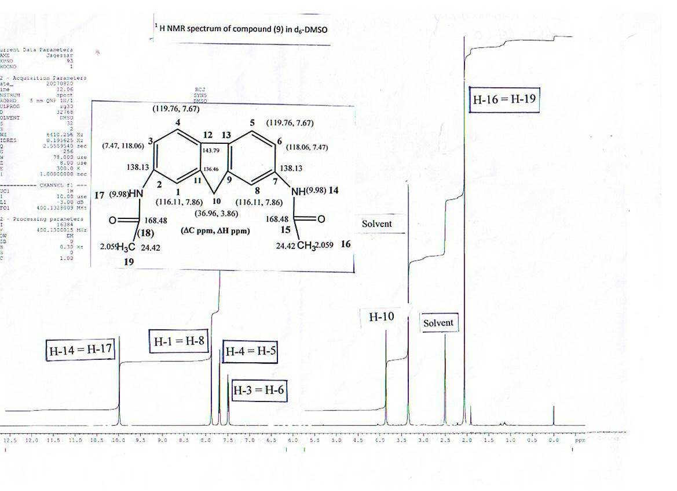
Fig. 4.0 ¹ H NMR spectrum of compound (11) in DMSO-d₆

Fig. 5.0 (¹³ CNMR and ¹ H NMR chemical shifts for respective carbons and protons of compound (11)

Table 1. NMR DATA for compound 11 (CDCl₃) ª
Position | δC |       δH (jHH, HZ) | ¹H-¹H COSY | HMBC
1 = 8 | 116.11 | 7.86 (s) | H-3, H-4, H-10 | 118.06(C-3), 136.46(C-11)
2 = 7 | 138.13 | QC | QC | QC
3 = 6 | 118.06 | 7.47 (dd, J =1.6Hz) | H-1, H-4 | 116.11(C-1), 118.06(C-3), 119.76(C-5), 136.46(C-11)
4 = 5 | 119.76 | 7.67 (d, J =8.4 Hz) | H-3, H-1, H-10 | 118.06(C-3), 136.46(C-11), 143.79(C-12)
5 =4 | 119.76 | 7.67 (d, J =8.4 Hz) | H-1, H-3, H-10 | 118.06(C-3), 136.46(C-11), 143.79(C-12)
6 = 3 | 118.06 | 7.47 (dd, J=1.6Hz), | H-1, H-4 | 116.11(C-1), 118.06(C-3), 119.76(C-5), 136.46(C-11)
7 = 2 | 138.13 | QC | QC | QC
8 = 1 | 116.11 | 7.86 | H-3, H-4, H-10 | 118.06(C-3), 136.46(C-11)
9 = 11 | 136.46 | ---------- | QC
10 | 36.96 | 3.86 | H-1, H-3, H-4 | 136.46(C-11), 116.11(C-1), 143.79(C-12)
11= 9 | 136.46 | QC | QC | QC
12=13 | 143.79 | QC | QC | QC
13=12 | 143.79 | QC | QC | QC
14=17 | --------- | 9.98 (s) | --------- | 116.11(C-1), 118.06(C-3), 168.48(C-15)
15=18 | 168.48 | QC | QC | QC
16 = 19 | 24.42 | 2.059 | --------- | --------
17 =18 | NH | 9.98 (s) | --------- | --------
18 =15 | 168.48 | --------- | --------- | --------
19 =16 | 24.42 | 2.059 (s) | --------- | 168.48(C-15)
ª 400 MHz for ¹H NMR and 100 MHz for ¹³ C NMR. All Chemical shifts (relative to TMS) are given in δ (ppm) and coupling constants expressed in Hertz.
QC: Quaternary carbon

Preliminary Anion complexation studies:
Preliminary anion binding studies for (11) were investigated via the stepwise addition of tetrabutylammonium halide to solution of compound (11) in deuterated DMSO- d₆ at room temperature. Before, any addition took place, the ¹ H NMR spectrum of the free ligand was recorded . Addition of stepwise equivalents of anion resulted in significant shifts in the host protons. The ¹ H NMR spectrum was recorded after each addition. For example, after the addition of 1 equivalent of bromide, the amide protons, -NH-CO- at 9.994 ppm exhibited downfield shift of δS = 0.13 ppm suggesting -CO-NH---Anion complexation. Aromatic protons have also responded to complexation. A new peak at 8.3 ppm is evident. The singlet resonance due to aromatic proton, H-1 shifted downfield from 7.86 to 7.98 ppm (δS = 0.12 ppm) after the addition of two equivalents. Also, the aromatic doublet at 7.64, H-5 exhibited an upfield shift of 0.07 ppm and remained broad. The other doublet at 7.496 exhibited a downfield shift of 0.06 ppm. However, the fluorene methylene protons, H-10 exhibited an insignificant downfield shift of 0.007 ppm.. These shifts are significant, considering that complexation was done in the polar DMSO-d₆ solvent. These results are summarized in the table below:

Table 2.0 ¹ HNMR chemical shifts of ligand (10) protons after the addition of two equivalents

Protons | Chemical Shifts  Free Ligand | Chemical Shifts  After the addition of two equivalents of Br- | δS
Methyl protons, H-16 = H-19 | 2.061 | 2.088 | 0.027 ppm
Fluorene methylene protons, H-10 | 3.858 | 3.851 | 0.007 ppm
Aromatic doublet, H-6 | 7.496 | 7.56 | 0.06 ppm
Aromatic doublet, H-5 | 7.639 | 7.71 | 0.07 ppm
Aromatic singlet, H-1 | 7.862 | 7.98 | 0.12 ppm
Amide NH proton, H-14= H-17 | 9.994 | 10.13 | 0.13 ppm

Conclusions: A novel 2,7-diacetoamido fluorene receptor has been synthesized and characterized via ¹H NMR, ¹³ C NMR, DEPT 135, ¹H-¹H COSY, HMQC, HMBC experiments. Preliminary anion binding studies via ¹ H NMR indicate recognition and complexation of bromide anion. There are only a few neutral amide receptors reported to date. Future work will investigate coordination with other anions.

Acknowledgement: This research was funded through a grant to purchase chemicals to Dr. R.C. Jagessar from the University of Guyana Publication Agency. NMR spectroscopic characterization using a 400MHZ NMR spectrometer was done overseas. The syntheses, characterization and preliminary anion complexation studies were all done by Dr.R.C.Jagessar.

General: 2,7-diaminofluorene and acetyl chloride were purchased from Aldrich in the USA. Melting points were measured on a Geahaka model PF 1500 version 1.0 apparatus and are uncorrected. ¹H and ¹³C NMR COSY, HMQC and HMBC spectra were recorded on a Bruker DRX-500 spectrophotometer, using CDCl₃ as the solvent. Chemical shifts are quoted in δ ppm and coupling constants expressed in Hertz (Hz). Silica gel 60A (70-230 mesh) was used for flash column chromatography. TLC analyses were done on precoated Kieselgel 60 F₂₅₄ plates.

Experimental: 2,7-diamido fluorene receptors: The amine(0.22 g, 1.1 x 10⁻³ mol ) was dissolved in dried CH₂Cl₂ and stirred for 15 minutes under nitrogen. This was followed with the addition of Et₃N, leaving a brown solution . To that solution was added acetyl chloride, CH₃COCl (0.19g, 2.4 x 10⁻³ mol)stepwise. The reaction mixture was left stirring for 24 hours under nitrogen. Solvents were removed in vacuo, yielding a brown crude product. After workup, a pale brown solid was obtained. The latter was purified via flash column chromatography on silica gel to yield compound (2) as the major product in yield of 65% (0.2g).
Compound (11) C₁₇H₁₆O₂N₂:M.P: 43.4-43.6˚C ¹ H NMR (CDCl₃) δ: 9.978 (s, br; 2H; NH), 7.864 (s, 2H; ArH), 7.68 (d, 2H; J = 8.4Hz; ArH), 7.49 (dd, 1H; J =1.6Hz, ArH), 7.47(dd, J = 1.6Hz, 1H; ArH) 3.85 (s, 2H; CH₂), 2.06(s, 6H; CH₃); ¹³ CNMR (CDCl₃, 400MHz) : 168.47, 143.79, 138.14, 136.48, 119.76, 118.05, 116.11, 38.95, 24.42. DEPT 135: C=O (168.48) QC: 143.75, 138.13, 136.46, ArH CH: ( 119.76, 118.05, 116.11), 36.958 (CH₂), 24.42(CH₃); COSY:H-1/H-3,H-4,H-10; H-3/H-1,H-4;H-4/H-3,H-1,H-10; H-5/H-1,H-3,H-10;H-6/H-1,H-4;H-8/H-3,H-4,H-10;H-10/H-1,H-3/H-4; HMBC correlations: H-1/C-3, C-11;H-3/C-1,C-3,C-5,C-11;H-4/C-3,C-11,C-12,H-5/C-3,C-11,C-12,H-6/C-1,C-3,C-5,C-11,H-8/C-3,C-11,H-10/C-11,C-1,C-12,H-14/C-1,C-3,C-15;H-19/168.48.

References:

- Beer P.D, Drew M.G.B, Hazelwood C, Hesek D, Hodacova J, Stokes, S.E. J.Chem.Soc.Chem.Commun., 1993; 229.

- Beer P.D, Drew M.G.B, Hesek D. Jagessar. R.C. J.Chem.Soc., Chem.Commun., 1995; 1187.

- Beer P.D, Drew M.G.B, Jagessar R.C, J.Chem.Soc., Dalton Trans. 1997; 881-886.

- Jagessar, R.C. PhD Thesis, University of Oxford Bodlean Library, 1995.

- Jagessar R.C, Burns. D.H. Chem. Commun., 1997; 1685.

6. Jagessar, R.C, Shang M, Scheidt R.W, Burns D.H. J. Am. Chem. Soc.,1998; 120 (45), 11684 -11692.
7. Fan. E. V, Arman S.A, Kincaid S, Hamilton A.D. J.Am.Chem. Soc.1993; 115, 369- 370.
8. Choi K, Hamilton A.D. Coordination Chem.Rev. 2003; 240, 101.
9. Lee H.M, Gabbar P. F; Inorg. Chem. 2007; 46, 8132-8138.
10. Luecke H, Quiocho F.A. Nature, 1990; 347, 402.
11. Pflugrath J.W, Quicho F.A. J.Mol.Biol. 1990; 200, 163.
12. Lange L.G, Riordan J.F, Valle B.L, Biochemistry; 1974; 13, 4361.
13. Stryer. L. Biochemistry, W.H. Free man and Co., New York, 3rd edition, 1988.

Correspondence to: Dr. R.C. Jagessar, BSc, PhD, PDF, CChem (RSC).
Department of Chemistry,
Faculty of Natural Sciences,
University of Guyana,
Turkeyen Campus
South America
raymondjagessar@yahoo.com

