Optimization of flavonoids extraction from the leaves of Tabernaemontana heyneana Wall. using L₁₆ Orthogonal design
T. Sathishkumar^{1*}, Baskar.R¹, Shanmugam.S¹, Rajasekaran.P¹, Sadasivam.S¹ and Manikandan.V¹
¹Department of Biotechnology, Kumaraguru College of Technology, Coimbatore – 641 006, Tamil Nadu, India.

^{1*} Corresponding author: sathishkumart29@gmail.com
Abstract: The study has been carried out to investigate the effects of single factors such as temperature, extraction time, concentration of ethanol, material ratio and no. of extractions on the contents of flavonoids present in the leaves of Tabernaemontana heyneana Wall. were investigated in this study. On this basis, an L₁₆ orthogonal design of experiment was adopted to determine the optimal conditions for the extraction of flavonoids. The amount of flavonoids extracted reached its maxima when extracted at 85ºC for 2hrs by using 75%ethanol with a material ratio of 1:05 and 4 times of extraction. The TLC performed for the optimized extracts showed the presence of rutin, quercetin related compounds. The PTLC of the optimized extracts also proved the presence of flavonoids, especially high levels of rutin related compounds. [Nature and Science. 2008;6(3):10-21]. ISSN: 1545-0740.

Keywords: Flavonoids, orthogonal experiments, Single-factor experiments,
Tabernaemontana heyneana Wall.

1. INTRODUCTION

Humans have gathered food and medicinal herbs ever since their arrival on earth and were guided then by instinct, followed by experience, and also by rational thought (Havsteen, 2002). For millions of years, mankind has fared quite well using this approach, but after the development of science and technology, people felt that the current state of affairs was quite satisfactory and hence, they failed to support research and education adequately (Harborne, 1988). Therefore, it is time to examine more closely what we are eating, how diseases can be treated more efficiently, and how we can effectively conserve our natural resources. One of our natural resources is the plants in remote forests, some of which may contain compounds of potential medical use. One such compound is flavonoids which appear to play a major role in the successful medical treatments of ancient times and their use has persevered till date (Dixon et al., 1998). Flavonoids are a group of polyphenolic compounds possessing low molecular weight that exhibit a common benzo-γ-pyrone structure. They are categorized into various subclasses including flavones, flavonols, flavanones, isoflavanones, isoflavanoids, anthocyanidins, and catechins (Hodnick et al., 1988; Cook and Samman, 1996). The average human diet contains a considerable amount of flavonoids and the major dietary sources are fruits (i.e., orange, grapefruit, apple, and strawberry), vegetables (i.e. onion, broccoli, green pepper and tomato), soybeans and different herbs.

One of the prominent and medically most useful properties of many flavonoids is their ability to scavenge free radicals (Van Acker et al., 1996). A free radical is molecule containing one or more unpaired electrons in atomic or molecular orbitals that includes super oxide (O₂^{.−}), hydroxyl radicals (OH⁻) and H₂O₂, collectively known as reactive oxygen species (ROS) (Sathishkumar et al., 2008). These ROS may induce oxidative damage to various macromolecules like polyunsaturated fatty acids in cell membranes, carbohydrates, proteins and DNA which results in homeostatic imbalance. The flavonoids are essential constituents of the cells of all higher plants (Brouillard and Cheminat, 1988). They resemble in their regulatory properties most of the lipid-soluble vitamins, but serve in addition, due to their color and odor, as communicators with the environment (Middleton and Teramura, 1993). The effect of flavonoids on plant growth, which is known, is atleast partly indirect and associated with the action of the auxins. It was reported that flavonoids can improve the blood circulation and lower the blood pressure (Yaqin Xu et al., 2005).

Tabernaemontana heyneana wall. (Apocynaceae) known as kundalam paalai in Tamil, is known to possess antimicrobial activity against skin diseases, venereal diseases, respiratory problems, nervous disorders and various other diseases (Ignacimuthu and Ayyanar, 2005; Ignacimuthu et al., 2006). The stembark decoction is used for cleaning cuts and wounds before dressing them (Chandrashekar et al., 1995). The mixture of leaf and stem powder of this plant along with the stem bark of Ficus racemosa, Ficus benghalensis, Madhuca longifolia, is heated with coconut oil and applied externally to cure skin diseases (Ignacimuthu and Ayyanar, 2005; Ignacimuthu et al., 2006). Similarly the same mixture along with the stem bark of Strychnos nux-vomica and fruits of Carica papaya were taken internally to induce abortion (Ignacimuthu and Ayyanar, 2005; Ignacimuthu et al., 2006).

In many cases, it is difficult to find quickly suitable experimental conditions for a given separation task. Prediction of separation conditions is not yet straightforward. Therefore, good experimental design becomes increasingly important. Orthogonal design which only focuses on the main effects of the factors, allows the number of experiments to be drastically reduced. In separation science, this kind of experimental design has already shown its usefulness in liquid chromatography and capillary electophoresis (Hu Zhide et al., 2002).

At present, there are no scientific reports on the extraction of flavonoids from the leaves of Tabernamontana heyneana Wall. In this study, the optimal conditions to extract flavonoids from the leaves of Tabernamontana heyneana Wall. were investigated systematically in order to explore a proper process to utilize the Tabernamontana heyneana Wall. leaves in the area of healthcare.

2. MATERIALS AND METHODS

2.1 Plant material
The plant was collected from the medicinal garden of Kumaraguru College of Technology, Coimbatore, India and the species was identified, confirmed by Botanical Survey of India (BSI), Southern Circle, Coimbatore, India and a voucher specimen (No. DBT 001) was deposited at Department of Biotechnology, Kumaraguru College of Technology, Coimbatore, India.

2.2 Extraction process
The main factors that affect the extraction of flavonoids like temperature, extraction time, materials ratio (weight of the leaves: volume of the extracting agent), extracting agent (%) and the no. of extraction were studied individually. The optimum extraction conditions were then determined by L₁₆ (4⁵) orthogonal design of experiments i.e., four levels and five different parameters. A single factor analysis of variance (One way ANOVA) was adopted to investigate the effect of each factor in the extrcation of flavonoids.

2.3 Estimation of total flavonoids (TFC)
TFC was estimated spectrophotometrically (Zhishen et al., 1999) with slight modifications (Beckman DU 530 UV/ Vis spectrophotometer, USA). About 0.1ml of the diluted sample added distilled water to make the volume to 5ml and 0.3 ml 5% NaNO₂ was added to this. 3ml of 10% AlCl₃ was added 5 minutes later. After 6 minutes, 2 ml of 1 M NaOH was added and the absorbance was measured at 510 nm. Rutin was used as a standard for constructing a calibration curve. Data were reported as mean ± SD for three replicate measurements.

2.4 Identification of flavonoids by thin layer chromatography (TLC)
Chromatographies of the optimized extracts were run one dimensionally in the mobile phase solvent (ethyl acetate - ethanol - water, 5:1:5, v/ v/ v) at room temperature of 20-25ºC. The concentrated extracts were spotted on the lower left of the TLC plate and the diameter of the spot in each chromatogram was normally about 5mm. Authentic markers of flavonol (quercetin) and flavonoid glycoside (rutin) obtained commercially were co-chromatographed. Identification of the flavonoids in the extracts was identified under UV light after the application of ammonia (Adam et al., 2002; Guorong Fan et al., 2006). A similar preparative thin layer chromatography (PTLC) was also performed to confirm the results of TLC.

3. RESULTS AND DISCUSSIONS

Flavonoids are a broad group of secondary metabolites with varied and important roles in plant physiology as well as they have gained recent interest because of their broad pharmacological activity. Putative therapeutic effects of many traditional medicines may be ascribed to the presence of flavonoids (Saskia Van Acker et al., 1996; Schultz et al., 2008). Flavonoids and other plant phenolics are reported, in addition to their free radical scavenging activity, to have multiple biological activities including vasodilatory, anticarcinogenic, antiinflammatory, antibacterial, immune-stimulating, antiallergic, antiviral, and estrogenic effects, as well as being inhibitors of phospholipase A2, cyclooxygenase, and lipoxygenase (Catherine Rice-Evans et al., 1996). Plant flavonoids usually occur in plants as glycosides, although in some circumstances they may occur as free aglycones. Most glycosides are O-glycosides, with the most common monoglycoside being at the 7-position.

Prevoius reports for the extraction optimization of rutin, a flavonoid glycoside from the leaves of buck wheat revealed that a Solid:liquid ratio of 1:20 for 4 hours at 60ºC was required for higher rutin yield. In this methanol is used as a solvent for extracting the rutin. Huo (Chinese Patent 1217329, 1999) described an extraction of rutin from tartary buckwheat seeds by washing with water, coarse grinding, coarse screening, soaking in water, drying in the air, fine grinding, soaking in edible alcohol, extracting below 60ºC. Balandina et al., (1982) extracted rutin from buckwheat seeds with hot water to remove the desired product and crystallized it. In general, a full evaluation of the effect of five different parameters at four levels on the yield would require 1024 (4⁵) experiments. In order to reduce the number of experiments, an L₁₆ (4⁵) orthogonal design graph was used. In this way, only 16 experiments were necessary to run (Chen et al., 2007).

3.1 Effect of temperature on the extraction of flavonoids
Fig.1 showed the contents of raw flavonoids tended to increase gradually with a rise in the temperature range from 55ºC to 85ºC. The contents of flavonoids gradually increased with a rise in the temperature in a range of 55ºC to 85ºC with a 10ºC temperature interval. It may be probable that the greater speed of the molecule movements in higher temperature so that flavonoids diffused more quickly from cell to extracting agent. But the flavonoids could be oxidized at temperature of surpassing 80° so that the contents of flavonoids extracted started to decrease gradually (Yaqin Xu et al., 2005). Temperature’s effect on extraction is dual. On one hand, higher temperature can accelerate the solvent flow and thus increase the flavonoids content and on the other hand, higher temperature can decrease the fluid density that may reduce the extraction efficiency (He Guo-qing et al., 2005). Hence, it was found that 85ºC was the optimum temperature for extracting the raw flavonoids.

3.2 Effect of flavonoids extraction time
The result of Fig.2 showed that the contents of flavonoids extracted for 2h reached maxima and prolonged extraction may not yield an increased content. The contents of flavonoids extracted for 2hrs reached its maxima. Furthermore a decrease in the flavonoids content was noticed for 3hrs extraction and a sudden increase in their content was observed for 4hrs extraction time. This increase in the flavonoids content may be due to the synergistic effect of other parameters involved. A similar report by Chen et al., (2007) revealed that 2hrs was the optimal extraction time for the extraction of a hypotensive drug geneposide from the bark of Eucommia ulmoides tree.

3.3 Effect of material ratio on the extraction of flavonoids
Fig.3 showed the contents of raw flavonoids extracted were maxima at 1:05 materials ratio. Further increase in the material ratio leads to a gradual decrease in the flavonoids content revealing a saturated condition. A significant rise in the flavonoids content was observed with the material ratio of 1:05. However, a gradual decrease in the flavonoids content was noticed when there is an increase in the material ratio. This decrease might be due to the fact that when the material ratio reached a certain level, the extract has well dissolved in the solution that may lead the contents of the extract become saturated and prevent further increase (Yaqin Xu et al., 2005).

3.4 Effect of extracting agent (ethanol) on the extraction of flavonoids
The result of Fig.4 revealed that the contents of raw flavonoids extract increases with the concentration of ethanol i.e., 55% to 75%. A decrease in the flavonoids content was noticed further more, i.e., beyond 75%. Considering one of the aims of this work is to propose a suitable solvent for extracting the raw flavonoids. Among various solvents, ethanol was selected as a right choice because it is environmentally benign and relatively safe to human health (He Guo-qing et al., 2005). Ethanol interacts with the flavonoids probably through non-covalent interactions and promotes a rapid diffusion into the solution (Luque de Castro and Tena, 1996). Various concentration of ethanol used exhibited different effect in changing the fluid polarity and thus had diverse effect on the solubility enhancement of the flavonoids (He Guo-qing et al., 2005). The optimal extraction yield may be fulfilled when the polarity of the fluid and its flavonoids are coincident. In this study, the results indicated that the optimal ethanol concentration for extraction flavonoids was found to be 75%.

3.5 Effect of no. of extractions on flavonoids
The contents of raw flavonoids extract increases with the no. of extractions i.e., a gradual rise is noticed from 1 time to 4 times. Obviously, when the no. of extraction times increased the yield of the respective bioactive principle may be increased (Chen et al., 2007). In this investigation, the raw flavonoids content was increased by 4 times of the extraction.

3.6 Optimization of flavonoids extraction using L₁₆ orthogonal design

The parameters and the orthogonal design of experiment for the extraction of flavonoids were given in the Table 1 and Table 2. The results were made in the form of range analysis and one way ANOVA by SPSS software. The results were depicted in Table 3 and Table 4. The order of the effect of factors on flavonoids extraction was A>D>E>B>C. The temperature had the greatest effect on the extraction procedure and it was found to be significantly different at 5% level. An equivalent effect was observed in the material ratio change, even though it was not proved to be significant difference at 5% level. The other factors such as solvent (%), extraction duration and no. of extractions did not play a vital role in extracting the flavonoids to a higher yield. The optimum extraction conditions obtained from the statistical analysis wereA₄B₂C₃D₁E₄. It means that 85°C, 2hrs extraction duration, a material ratio 1:05, 75% ethanol concentration and 4 times of extraction were the optimum conditions for flavonoids recovery.

3.7 TLC and PTLC results
The results of TLC and PTLC revealed the presence of flavonoid glycosides, flavonols and phenolic acids in the optimized extracts (Fig.5 and Fig.6).

Fig.5 Identification of flavonoids from optimized extract by TLC under UV light

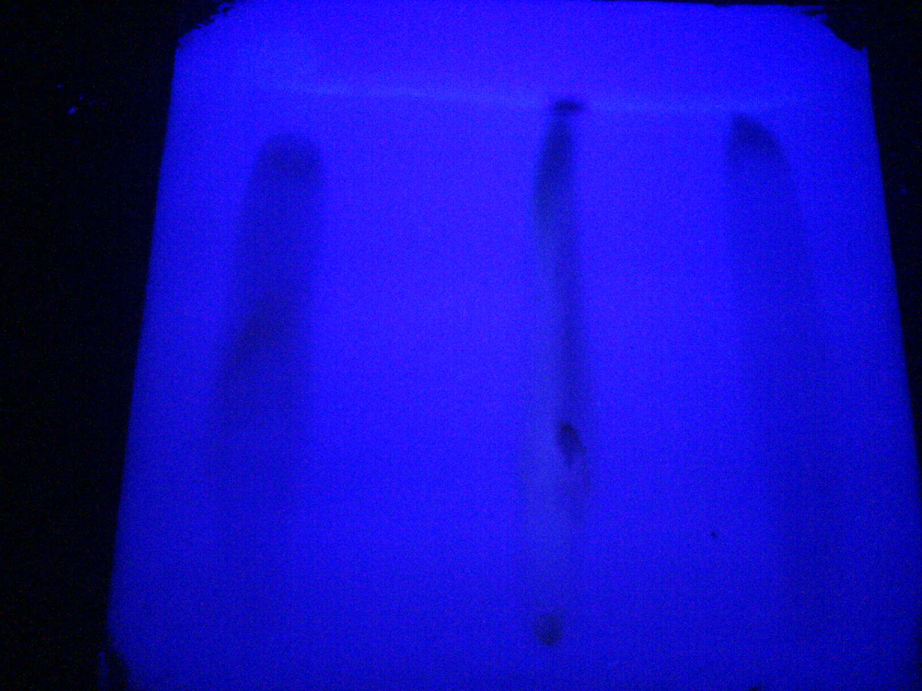 Lane 1 = Quercetin
Lane 2 = Optimized extract
Lane 3 = Rutin

Fig.6 Identification of rutin related compounds by PTLC

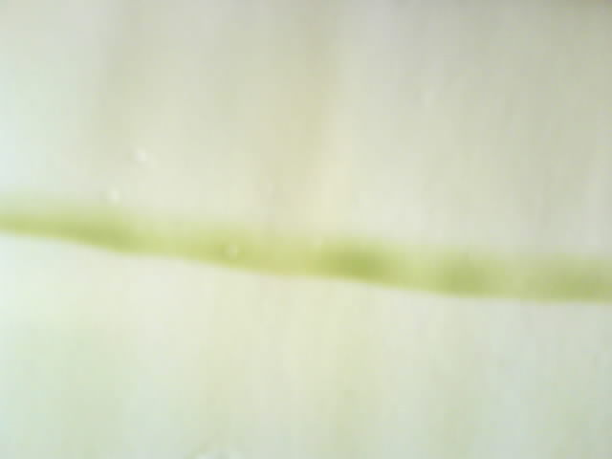

Table 1 Factors for the extraction of flavonoids

 | A | B | C | D | E
Levels | Temp. (ºC) | Ext.tim.  (hrs) | Solvent  (%) | Sol : liq  (W:V) | No.of ext.
1 | 55 | 1 | 65 | 1:5 | 1
2 | 65 | 2 | 75 | 1:10 | 2
3 | 75 | 3 | 85 | 1:15 | 3
4 | 85 | 4 | 95 | 1:20 | 4

Table 2 L₁₆ orthogonal design of experiment
(Wu et al., 2007)

Exp. | A | B | C | D | E
1 | 1 | 1 | 2 | 3 | 4
2 | 1 | 2 | 1 | 4 | 3
3 | 1 | 3 | 4 | 1 | 2
4 | 1 | 4 | 3 | 2 | 1
5 | 2 | 1 | 1 | 1 | 1
6 | 2 | 2 | 2 | 2 | 2
7 | 2 | 3 | 3 | 3 | 3
8 | 2 | 4 | 4 | 4 | 4
9 | 3 | 1 | 3 | 4 | 2
10 | 3 | 2 | 4 | 3 | 1
11 | 3 | 3 | 1 | 2 | 4
12 | 3 | 4 | 2 | 1 | 3
13 | 4 | 1 | 4 | 2 | 3
14 | 4 | 2 | 3 | 1 | 4
15 | 4 | 3 | 2 | 4 | 1
16 | 4 | 4 | 1 | 3 | 2

Table 3 Experimental results and range analysis

Exp. | A | B | C | D | E | Flav. (mg/g)
1 | 1 | 1 | 2 | 3 | 4 | 71.5
2 | 1 | 2 | 1 | 4 | 3 | 32.6
3 | 1 | 3 | 4 | 1 | 2 | 39.4
4 | 1 | 4 | 3 | 2 | 1 | 69.2
5 | 2 | 1 | 1 | 1 | 1 | 107.2
6 | 2 | 2 | 2 | 2 | 2 | 51.2
7 | 2 | 3 | 3 | 3 | 3 | 51.3
8 | 2 | 4 | 4 | 4 | 4 | 43.7
9 | 3 | 1 | 3 | 4 | 2 | 52.9
10 | 3 | 2 | 4 | 3 | 1 | 100.5
11 | 3 | 3 | 1 | 2 | 4 | 91.1
12 | 3 | 4 | 2 | 1 | 3 | 134.7
13 | 4 | 1 | 4 | 2 | 3 | 110.6
14 | 4 | 2 | 3 | 1 | 4 | 137.4
15 | 4 | 3 | 2 | 4 | 1 | 84.0
16 | 4 | 4 | 1 | 3 | 2 | 107.7
K₁ | 53.2 | 64.8 | 84.6 | 104.7 | 90.2
K₂ | 63.3 | 80.4 | 85.3 | 80.5 | 62.8
K₃ | 94.8 | 66.4 | 77.7 | 82.7 | 82.3
K₄ | 109.9 | 88.8 | 73.5 | 53.3 | 85.9
k₁ | 13.3 | 16.2 | 21.2 | 26.2 | 22.6
k₂ | 15.8 | 20.1 | 21.3 | 20.1 | 15.7
k₃ | 23.7 | 16.6 | 19.4 | 20.7 | 20.6
k₄ | 27.5 | 22.2 | 18.4 | 13.3 | 21.5
R | 14.2 | 6.0 | 2.8 | 12.9 | 6.9

Table 4 One way ANOVA

Levels | Sum of squares | Degrees of freedom | Mean square | F-values
A | 8443.84 | 3 | 2814.61 | 4.89
B | 1168.31 | 3 | 389.44 | 0.37
C | 386.99 | 3 | 128.99 | 0.12
D | 5316.78 | 3 | 1772.26 | 2.26
E | 1761.59 | 3 | 587.2 | 0.58
 |  | 15

4. CONCLUSION

In conclusion, the extraction conditions for flavonoids were optimized to find that the extraction temperature 85ºC, 2hrs extraction duration, 75%ethanol, 1:05 material ratio and 4 times of extraction were the optimal conditions. Moreover, temperature was found to be a significant factor that affects the extraction procedure. The TLC/ PTLC results of the optimized extracts were found to contained rutin, quercetin related compounds and also certain unknown phenoilc acids. More research on flavonoids biological activity should be done in the future research.

Acknowledgements
The authors are grateful for the financial support by Kumaraguru College of Technology, Coimbatore, Tamil Nadu, India, for carrying out the above research work.

Correspondence to:
T.Sathishkumar
24, Anbunagar, 2nd Street
Edayarpalayam
Velandipalayam (PO)
Coimbatore – 641 025
Tamil Nadu
India.

REFERENCES
Adam JH, Ramian Omar, Wilcock CC. Phytochmeical screening of flavonoids in three hybrids of Napenthes (Napenthaceae) and their putative parental species from Sarawak and Sabah. Online J biol sci. 2002; 2(9):623-625.

Balandina IA, Glyzin VI, Grinkevich NI, Gorodestakii LS, Kristal, ZB, Shemerenkin BV. Rutin Production Russian Patent SU904709 (issued Feb. 15, 1982).
Brouillard R, Cheminat A. Flavonoids and plant color. Prog Clin Biol Res 1988; 280:93– 106.

Catherine A. Rice-Evans, Nicholas J. Miller, George Paganga. Structure-Antioxidant Activity Relationships of Flavonoids and Phenolic Acids. Free Rad Biol Med 1996; 20(7):933-956.

Chandrashekar KR, Bhandary M.J, Kaveriappa KM. Medical ethnobotany of the Siddis of Uttara Kannada district, Karnataka, India. J. Ethno pharm 1995; 47:149-158.

Chen XQ, Wu SD, Jiang XY, Chen QY. Comparison of Techniques for the Extraction of the Hypotensive Drugs Geniposidic Acid and Geniposide from Eucommia Ulmoides. J. Iran. Chem. Soc 2007; 4(2):205-214.

Cook NC, Samman S. Flavonoids-Chemistry, metabolism, cardioprotective effects, and dietary sources. Nutritional Biochemistry 1996; 7:66-76.

Dixon RA, Howles PA, Lamb C, He XZ, Reddy JT. Prospects of the metabolic engineering of bioactive flavonoids and related phenylpropanoid compounds.Adv Exp Med Biol 1998; 439:55–66.

Guorong Fan, Jinyong Peng, Yutian Wu. Preparative Separation and Isolation of Three Flavonoids and Three Phloroglucinol Derivatives from Hypericum japonicum Thumb. using High-Speed Countercurrent Chromatography by Stepwise Increasing the Flow Rate of the Mobile Phase. J Liq Chrom Tech, 2006; 29: 1619–1632

Harborne JB. Flavonoids in the environment: structure-activity relationships. Prog Clin Biol Res 1998; 280:17– 27.

Havsteen BH. The Biochemistry and medical significance of flavonoids. Pharmacol Therapeu 2002; 96:67–202.

He Guo-qing, Xiong Hao-ping, Chen Qi-he, Ruan Hui, Wang Zhao-yue, Traore Lonseny. Optimization of conditions for supercritical fluid extraction of flavonoids from hops (Humulus lupulus L.). J Zhejiang Univ SCI. 2005; 6B (10):999-1004.

Hodnick WF, Milosavljevic EB, Nelson JH, Pardini RS. Electrochemistry of flavonoids: Relationships between redox potentials, inhibition of mitochondrial respiration and production of oxygen radicals by flavonoids. Biochem Pharmacol. 1988; 37: 2607-2611.

Huo X. Production process of extracting rutin from Polygonum tataricum. Chinese Patent CN1217329 (issued May 06, 1999).

Hu Zhide, Liu Huitao, Wang Ketai, Xu Hongping, Chen Xinggu. Application of Experimental Design and Artificial Neural Networks to Separation and Determination of Active Components in Traditional Chinese Medicinal Preparations by Capillary Electrophoresis. Chromatographia 2002; 55:579-583.

Ignacimuthu S, Ayyanar M. Traditional knowledge of Kani tribals in Kouthalai of Tirunelveli hills, Tamil Nadu, India. J Ethno pharm 2005; 102:246–255.

Ignacimuthu S, Duraipandiyan V, Ayyanar M. Antimicrobial activity of some ethnomedicinal plants used by Paliyar tribe from Tamil Nadu, India. BMC Complementary and Alternative Medicine 2006; 6:35- 41.

Luque de Castro MD, Tena MT. Strategies for supercritical fluid extraction of polar and ionic compounds. Trends Anal Chem 1996; 15:32-37.

Middleton EM, Teramura AH. The role of flavonol glycosides and carotenoids in protecting soybean from ultraviolet-B damage. Plant Physiol 1993; 103:741–752.

Sathishkumar T, Shanmugam S, Rajasekaran P, Rameshkumar S, Rajavelan G, Haridoss V. In vitro antioxidant assessment of saliva from non smokers and smokers. Adv biotech 2008; 6(12):21-25.

Saskia A. B. E. Van Acker, Dirk-Jan Van Den Berg, Michel N. J. L. Tromp, Desiree H. Griffioen, Wout P. Van Bennekom, Wim J. F. Van Der Vijgh, Aalt Bast. Structural Aspects of Antioxidant Activity Of Flavonoids. Free Rad Biol Med 1996; 20(3):331-342.

Schultz SC, Bahraminejad S, Asenstorfer RE, Riley IT. Analysis of the antimicrobial Activity of Flavonoids and Saponins Isolated from the Shoots of Oats (Avena sativa L.). J. Phyto path 2008; 156: 1–7.

Van Acker SA, De Groot MJ, Van den Berg DJ, Tromp MN, Donne Op den Kelder G, Van der Vijgh WJ, Bast A. A quantum chemical explanation of the antioxidant activity of flavonoids. Chem Res Toxicol. 1996; 9:1305–1312.

Wu SD, Jiang XY, Chen QY, Chen XQ. Comparison of Techniques for the Extraction of the Hypotensive Drugs Geniposidic Acid and Geniposide from Eucommia Ulmoides. J. Iran. Chem. Soc 2007; 4 (2):205-214.

Yaqin Xu, Rui Zhang, Hong Fu. Studies on the optimal process to extract flavonoids from red-raspberry fruits. Nature and Science 2005; 3(2):43-46.

Zhishen J, Mengcheng T, Jianming W. The determination of flavonoids contents in mulberry and their scavenging effects on superoxide radicals. Food Chem 1999; 64:555–559.

