Diversity Of Water Borne Conidial Fungi As Root Endophytes In Temperate Forest Plants Of Western Himalaya

S. C. Sati, M. Belwal and N. Pargaein
Department of Botany, Kumaun University, Nainital-263002
(M. Belwal)

DST Young Scientist
Department of Botany
Kumaun University
Nainital
e mail: manish_belwal@yahoo.co.in

ABSTRACT: Diversity of water borne conidial fungi occurring as root endophytes was studied. Twenty one species were recorded as root endophytes in healthy roots of forest plants of Western Himalaya. Three species viz., Camposporium pellucidum, Diplocladiella scalaroides and Helicomyces roseus are being reported for the first time as root endophytes whereas 8 species viz., Acaulopage tetraceros, Alatospora acuminata, Anguillospora longissima, Campylospora purvula, Cylindrocarpon aquaticum, Heliscus lugdunensis, Tetracladium marchalianum and Tetracladium setigerum are recorded with their new host record. Maximum host diversity was represented by Cylindrocarpon aquaticum and Tetracladium setigerum as the former endophyte was isolated from 14 host plants followed by latter which was isolated from 12 host plants. [Nature and Science. 2008;6(3):59-65]. ISSN: 1545-0740.

Key words: Diversity, Water borne conidial fungi, Endophyte

INTRODUCTION
Microbes living with interior tissues of healthy plants without causing disease symptoms are called endophytes. Wide occurrence of endophytic fungi on many plants including bryophytes and Botrychium have been explored from all parts of the world (Clay, 1989; Petrini, 1986; Petrini et. al. 1992; Carroll and Carroll, 1978 and Sati and Belwal, 2005). The role of endophytic hyphomycetes has now been suggested by various workers as promoters of plant growth (Bills and Polishok, 1992; Petrini, 1991and Dreyfuss and Chapela 1992).
The water borne conidial fungi were described previously by Ingold (1942) as these complete their life cycle on submerged substrate in well-aerated waters but Waid (1954) reported some of these water borne conidial fungi from root surface also. The observation of Waid (1954) provided a pavement to various workers who further reported some more water borne conidial fungi from aquatic and terrestrial roots (Gourley, 1969; Nemec, 1969 and Watanabe, 1975). Fisher et al (1986) recognized a separate group of water borne conidial fungi as endophytic hyphomycetes and later Fisher et al (1991) confirmed their occurrence on plant roots of aquatic habitats through experimental basis by examining the bark and xylem of aquatic roots of Alnus gluitinosa. Similar reports have been made by other mycologists on endophytic aquatic hyphomycetes (Marvanova and Fisher, 1991; Marvanova et. al., 1992 and Sridhar and Barlocher, 1992a).
Endophytic fungi are also known to be a rich source of antibiotic, secondary metabolites and it has been postulated that endophytic fungi may be beneficial to their host plant by antagonizing pathogens and / or by inducing plant defense responses. Webber (1981) was the pioneer to report plant protection by an endophytic fungus Phomopsis oblonga protected elm trees against the beetle. This was confirmed by Claydon et al (1985) who showed that endophytic fungi synthesize secondary metabolites in host which affect the beetle larvae.
The present study provides an assessment of species diversity of endophytic hyphomycetes associated with the roots of temperate plants growing nearby areas of water bodies of Western Himalaya.

METHODOLOGY
‘Three step sterilization’ method of Fisher and Petrini (1989) was followed for the systematic study of root endophytic fungi. Living roots of different tree plant species including herbs and shrubs growing in the ravine and wet areas located at Nainital and Almora districts in Western Himalaya were collected in 3 replicates of each. Nearly 10-15 cm long roots were cut off with a sharp knife and washed with sterile water. These root samples were then keep in sterile polythene bags, brought to the lab and processed within 4-5 hours after collection. Root samples were washed under running tap water for about 10 minute to remove extraneous adhering soil particles and cut into 3-4 cm size segments. These were then rinsed with sterile water after surface sterilization with 90% alcohol for 2-3 minutes. The segments were incubated at 20 ± 2⁰C for 5-20 days in sterile petri-dishes containing 30 ml of sterile water. Incubated dishes were observed periodically to detect the conidia of endophytic fungi under low power of microscope.
Simultaneously, some of the surface sterilized root segments were placed in 2% Malt Extract Agar, supplemented with streptopenicillin or tetramycin solution (250mg/l) and incubated for a few days depending upon the growth of emerging fungi. Fungal mycelia growing on agar blocks were transferred into another petri dishes containing sterile water for sporulation and identification.

RESULTS
The incubated root segments of different host plants revealed a total of 21 species of water borne conidial fungi belonging to 15 genera as root endophytes (Table 1 and Fig. 1). A perusal of available literature indicates that Camposporium pellucidum, Diplocladiella scalaroides and Helicomyces roseus are being reported for the first time as root endophytes.
As seen in table 1, Alatospora acuminata, Campylospora purvula, Cylindrocarpon aquaticum, Heliscus lugdunensis, Tetracladium marchalianum and Tetracladium setigerum were the most commonly occurring endophytes while four species viz., Alatospora pulchella, Campylospora chaetocladia, Camposporium pellucidum and Diplocladiella scalaroides occurred in only one host species. Similarly all the reported species of Lemonniera, as root endophytes, showed their occurrence restricted to Lyonia ovalifolia. The maximum host diversity was reported in Cylindrocarpon aquaticum as it was colonized on 14 host plants followed by Tetracladium setigerum (13), T. marchalianum (9), Heliscus lugdunensis (8), Campylospora purvula (8), Alatospora acuminata (6) and Anguillospora longissima (6). The remaining species viz., Acaulopage tetraceros, Anguillospora crassa, Campylospora chaetocladia, Clavariopsis aquatica, Camposporium pellucidum, Diplocladiella scalaroides, Helicomyces roseus, Lemonniera cornuta, L. pseudofloscula, L. terrestris, Lunulospora curvula, Pestalotiopsis submerses and Tetrachaetum elegans showed little host diversity.
Among the 24 host plants studied, the roots of Lyonia obvalifolia were colonized by maximum number of endophytes, followed by Botrychium (8) and Machillus duthiei (6) while Artemisia vulgaris, Rosa moschata, Debregeasia species, Aesculus indica, Valeriana wallichei, Myrseine semiserrata, Nepeta leucophyla and Salix tetrasperma were colonized by less number of root endophytes. As evident from Table-2, the relative contribution to diversity of fungal endophytes in different host plant, maximum relative contribution was found to Lyonia ovalifolia i.e. 47.6% and minimum relative contribution of fungal root endophytes was confined to Aesculus indica, Geranium nepalenses, Murraya koengii and Salix tetraspera (4.7%each).

DISCUSSION
Of all the water borne conidial fungi recorded in this study, 8 species were also reported by earlier mycologists. Two species namely, Anguillospora longissima and Tetracladium marchalianum, reported earlier by Nemec (1969) from Strawberry plant roots, were recorded here on roots of an Unidentified grass, Botrychium sp., Geranium nepalense, Barberis sp., Machilus duthiei, Symplocos chinensis, Eupatorium adenophyllum, Equisetum sp., Lyonia ovalifolia, Quercus floribunda, Salix tetrasperma, unidentified fern and Viburnum mullaha. Campylospora purvula earlier reported by Fisher and Petrini (1989, 1990) was isolated from Botrychium sp., Lyonia ovalifolia, Barberis sp., Acer pictum, Machilus duthiei, Symplocos chinensis, Vibrunum mullah and Strobilanthus dalhousianus, . Heliscus lugdunensis was isolated from Acer pictum, Barberis sp., Botrychium sp., Delbergeasia sp, Lyonia ovalifolia, Machilus duthiei, Rosa moschata and Symplocos chinensis. It was also reported by Fisher et al (1991) and Sridhar and Barlocher (1992) from the roots of species of Alnus, Acer and Betula. Lunulospora curvula, earlier reported by Sridhar and Barlocher (1992a) on Alnus species, in present study it was isolated from Eupatorium adenophyllum and Botrychium sp. Tetracladium setigerum recorded earlier from strawberry roots by Watanbe (1975) was isolated from Alnus nepalensis, Eupatorium adenophyllum, Lyonia ovalifolia, Murraya koenegii, unidentified fern, Equisetum sp., Machilus duthiei, Botrychium sp., Quercus floribunda, Artemisia vulgaris, Valeriana wallichii and Delbergeasia sp. In the present study, Clavariopsis aquatica was isolated from Botrychium sp. and Quercus floribunda, whereas, Sridhar and Barlocher (1992a) reported it from roots of Alnus and Picea sp. Fisher et al (1991) have also found this species as an endophyte. Cylindrocarpon aquaticum, found as a most frequently colonizing fungus, was collected from plant roots of Aesculus indica, Acer pictum, Barberis sp., Artemisia vulgaris, Strobilanthus dalhousianus, Valeriana wallichii, Geranium nepalense, Nepta leucophylla, Rosa moschata, Vibrunum mullah, Alnus nepalensis and Delbergeasia sp. It was also earlier reported by Sridhar and Barlocher (1992a, 1992b) from maple and spruce roots.

ACKNOWLEDGEMENT
The authors thank head, Department of Botany, Kumaun University Nainital, for providing lab facilities.

REFERENCES
- Clay K. Clavicipitaceous endophytes of grasses: Their potential as biocontrol agents. Mycol. Res. 1989; (92): 1-12.
- Petrini O. In Microbiology of the phyllosphere. In Fokkema, N.J. and Van den Heuvel, J. eds. Cambridge University Press, Cambridge. 1986. 175-187.
- Petrini O, Fisher PJ and Petrini LE. Fungal endophyte of bracken (Pteridium aquilinum), with some reflections on their use in biological control. Sydowia 1992; (44): 282-293.
- Carroll GC and Carroll FE. Studies on incidence of coniferous needle endophyte in the Pacific Northwest. Can. J. Bot. 1978; (56): 3034- 3043.
- Sati SC and Belwal M. Aquatic hyphomycetes as endophytes of riparian plant roots. Mycologia, 2005; (97) 45-49.
- Bills GE and Polishok JD. Recovery of endophytic fungi from Chamaecyparis thyoides. Sydowia 1992; (44): 1-12.
- Petrini O. Fungal endophytes of tree leaves. In: Andrews JA and Hirano SS eds. Microbial Ecology of Leaves. Springer, New York. 1991 :79-197.
- Dreyfuss MM and Chapela IH. The potential of fungi in discovery of novel, low molecular weight Pharmaceuticals. In the 'Discovery of Novel Natural Products with Therapeutic Potential', Butterworth Publications, Biotechnology Series, London. 1992
- Ingold CT. Aquatic Hyphomycetes on decaying alder leaves. Trans. Brit. Mycol. Soc. 1942; (25):339-417.
- Waid JS. Occurrence of aquatic hyphomycetes upon the roots surface of beech grown in woodland soil. Trans. Brit. mycol. Soc. 1954; (37): 420-421.
- Gourley CO. Microfungi of crowns and roots of apparently healthy dormant strawberry plants. Can. J. Bot., 1969; (47): 945-949.
- Nemec S. Sporulation and identification of fungi isolated from root rot diseased Strawberry plants. Phytopathology 1969; (59): 1552- 1553.
- Watanabe T. Tetracladium setigerum, an aquatic hyphomycetes associated with gentian and Strawberry roots. Trans. Mycol. Soc. Japan 1975; (16): 348-350.
- Fisher PJ, Anson AE and Petrini O. Fungal endophytes in Ulex europaeus and Ulex gallii. Trans. Br. mycol. Soc. 1986; (86): 153-156.
- Fisher PJ, Petrini O and Webster J. Aquatic hyphomycetes and other fungi in living aquatic and terrestrial roots of Alnus glutinosa. Mycol. Res. 1991; (95): 543-547.
- Marvanova L and Fisher PJ. A new endophytic hyphomycetes from alder roots. Nova Hedwigia 1991; (52): 33-37.
- Marvanova L, Fisher PJ, Aimer R and Segedin BC. A new Filosporella from alder roots and foam water. Nova Hedwigia 1992; (54): 151-158.
- Sridhar KR and Barlocher F. Aquatic hyphomycetes in spruce roots. Mycologia 1992 a; (84): 580-584.
- Webber J. A natural control of Dutch elm disease. Nature London; 1981 (292): 449-459.
- Claydon N, Groove J F and Pople M. Elm bark beetle boring and feeding deterrents from Phomopsis oblonga. Phytochemistry 1985; (24): 937-943.
- Fisher PJ and Petrini O. Two aquatic hyphomycetes as endophytes in Alnus glutinosa roots. Mycol. Res. 1989; (92): 367-368.
- Fisher PJ and Petrini O. A comparative study of fungal endophytes in xylem and bark of Alnus species in England and Switzerland. Mycol. Res. 1990; (94): 313-319.
- Sridhar KR and Barlocher F. Endophytic aquatic hyphomycetes of roots of Spruce, Birch and Maple. Mycol. Res. 1992b; (96): 305- 308.

Table 1. Occurrence of water borne conidial fungi as endophytes from temperate forest plant roots in Western Himalaya

S. No | Endophyte | Host | Frequency of Occurrence (%)*
1. | Acaulopage tetraceros Derchsler | Mk / Lo / Ea | 12.5
2. | Alatospora acuminata Ingold | UG / E / Md / Vm / Id / An | 25.0
3. | A. pulchella Marvanová | UG | 4.2
4. | Anguillospora crassa Ingold | E / B | 8.3
5. | A. longissima(Sacc.and Therry) Ingold | UG / Bm / Gn / B / Md / Sc | 25
6. | Camposporium pellucidum(Grove) Hughes | Sd | 4.2
7. | Campylospora chaetocladia Ranzoni | Mk | 4.2
8. | C. purvula Kuzuha | Bm / Lo / B / Ap / Md / Sc / Vm / Sd | 33.0
9. | Clavariopsis aquatica de Wildeman | Bm / Qf | 8.3
10. | Cylindrocarpon aquaticum(Nils.)  Marvanova and Descals | Ai / Ea / Md / Ap / B / Av / Sd / Vw / Gn/ Nl /  Rm / Vm / An / D | 58.3
11. | Diplocladiella scalaroides Arnaud | Gn | 4.2
12. | Helicomyces roseus Link | Qf / Ap | 8.3
13. | Heliscus lugdunensis Ingold | Ap / B / Bm / D / Lo / Md / Rm / Sc | 33
14. | Lemonniera cornuta Ranzoni | Lo | 4.2
15. | L. pseudofloscula Dyko | Lo | 4.2
16. | L. terrestris Tubaki | Lo | 4.2
17. | Lunulospora curvula Ingold | Ea / Bm | 8.3
18. | Pestalotiopsis submersus Sati and Tiwari | E / F/ Lo | 12.5
19. | Tetrachaetum elegans Ingold | Lo / Bm | 8.3
20. | Tetracladium marchalianum de Wildeman | Ea / E / Lo / Ms / Bm / Qf / St / UG / F | 37.5
21. | T. setigerum(Grove) Ingold | An/Ea/LO/ Mk/ F / E / Md / Bm / Qf / Av / Vw / D | 50.0
Mk = Murraya koenegii, Lo = Lyonia ovalifolia, UG = Unidentified grass, E = Equisetum sp., B = Barberis sp. , Bm = Botrychium sp., Ai= Aesculus indica, Ea = Eupatorium adenophyllum, F = Unidentified Fern, Md = Machilus duthiei, Vm = Vibrunum mullah, Id = Ilex diphyrena, An = Alnus nepalensis, Gn = Geranium nepalense, Sc = Symplocos chinensis, S = Strobilanthes sp., Ap = Acer pictum, Qf = Quercus floribunda, Av = Artemisia vulgaris, Vw = Valeriana wallichii, Nl = Nepta leucophylla, Rm = Rosa moschata, D = Debregeasia sp., St =Salix tetrasperma
* Calculated against 24 studied host species (Table 2)
Table 2: Colonization of endophytes on roots of different host plants

S. No. | Host | Percent contribution to diversity - o
 |  | of fungal endophyte(%) *
 | Acer pictum Thunb | 19.0
 | Aesculus indica Colebr | 4.7
 | Alnus nepalensis D. Dori | 14.3
 | Artemisia vulgaris Linn | 9.5
 | Berberis sp. Roxb. | 23.8
 | Debregeasia sp Gaud. | 14.3
 | Equisetum sp. Linn. | 23.8
 | Eupatorium haterophyllum Linn. | 23.8
 | Unidentified Fern | 14.3
 | Geranium nepalense Sw. | 19.0
 | Ilex diphyrena all. | 4.7
 | Lyonia ovalifolia Wall | 47.6
 | Machilus duthiei King | 28.5
 | Murraya koenegii Spreng. | 14.3
 | Nepeta leucophylla Benth. | 4.7
 | Botrychium sp. | 38.1
 | Quercus floribunda Wall. | 19.0
 | Rosa moschata J. Herrm. | 9.5
 | Salix tetrasperma Roxb. | 4.7
 | Strobilanthes sp Blume. | 19.0
 | Symplocos chinensis ochinchinewis(Lour) | 14.3
 | Unidentified grass | 19.0
 | Valeriana wallichii . DC. | 9.5
 | Viburnum mullaha Buch- Ham. Ex . D. Don | 14.3
* Calculated against 21root endophytes altogether recorded (Table 1)

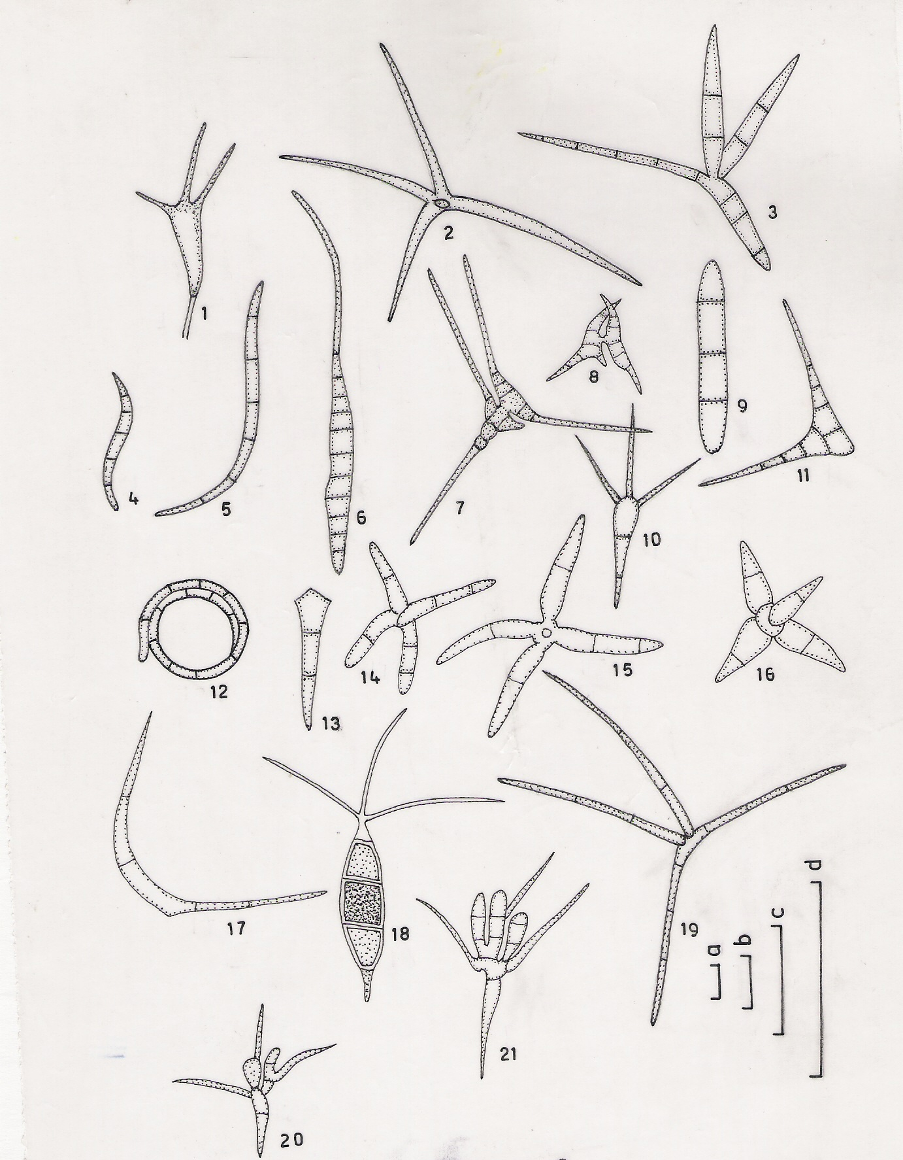

Fig.1

Figs. 1,7, 8, 9,11,13,14-18, 20 and 21 in scale c; 4-5 in scale a; 6, 10, 12 and 19 in scale b and 2-3 in scale d. (Fig. Nos. are corresponding to Table No. 1)

29-05-08

