Biodesulfurization of Kerosene by Desulfobacterium indolicum

¹ Aribike D S, ¹A A Susu, ²S C U Nwachukwu* & ³S A Kareem

¹Department of Chemical Engineering, University of Lagos, Akoka Yaba
Lagos Nigeria
²Department of Botany & Microbiology, University of Lagos, Akoka Yaba
Lagos Nigeria
³Department of Chemical Engineering, Federal University of Technology Yola Nigeria
simoncyrill@yahoo.com

ABSTRACT: Recalcitrant organosulfur compounds such as Dibenzothiophene (DBT) and its derivatives in real petroleum fractions such as kerosene cannot be removed by convectional hydrodesulfurization (HDS) treatment using metallic catalysts as well as extremes of conditions of high pressure and temperature. The desulfurizing bacterium Desulfobacterium indolicum was isolated and subsequently identified by the Department of Botany & Microbiology; University of Lagos, Nigeria exhibited very high desulfurizing ability towards kerosene at 30°C and normal atmospheric pressure. The biodesulfurization of kerosene by Desulfobacterium indolicum resulted in reduction of sulfur from 48.68 ppm to 13.76 ppm over a period of 72 hours. Gas chromatography analysis with a pulse flow photoatomic detector revealed that the peaks of Thiophene and 2, 5 - dimethyl Thiophene significantly decreased after biodesulfurization. Therefore, Desulfobacterium indolicum could effectively desulfurized kerosene and thus may be a promising biocatalyst for practical biodesulfurization of kerosene. [Nature and Science. 2008;6(4):55-63]. ISSN: 1545-0740.

INTRODUCTION
The problem with fossil fuels is that the combustion products are harmful to the planet. Carbon dioxide emissions have been implicated in global warming. Nitrogen oxides and sulfur oxides emissions have been shown to be responsible for acid rain, which destroys buildings, kills forests and poison lakes. Governments throughout the world have recognized the problems associated with these emissions and moved to reduce them through legislation. Regulations for the sulfur level in diesel oil have become increasingly strict and it is planned to reduce the level to 50 ppm by 2005 in the European Union and Japan. The sulfur content in diesel will probably be less than 10 or 15 ppm (w/w) in the United States and Europe by 2010 (Constants et al, 1994).
The concentration of sulfur in crude oil is typically between 0.05 and 5.0% (by weight), although values as high as 13.95% have been reported (Speight 1981). In general, the distributions of sulfur increase along with the boiling point of the distillate fraction. As a result, the higher the boiling range of the fuel, the higher the sulfur content will tend to be. Upon combustion, the sulfur in fuels can contribute to air pollution in the form of particulate material and acidic gases, such as sulfur dioxide. To reduce sulfur-related air pollution, the level of sulfur in fuels is regulated, and to meet these regulations sulfur must be removed from fuels during the refining process. The availability of low-sulfur crude has decreased over the last decade as a consequence of the increasing reserves of heavy crude (Grossman et al, 2001).
Refineries remove organic sulfur from crude oil-derived fuels by hydrodesulfurization (HDS). HDS is a catalytic process that converts organic sulfur to hydrogen sulfide gas by reacting crude oil fractions with hydrogen at pressures between 1 and 20 MPa and temperatures between 290 and 455 °C, depending upon the feed and level of desulfurization required. Organic sulfur compounds in the lower-boiling fractions of petroleum, e.g., the gasoline range, are mainly thiols, sulfides and thiophene, which are readily removed by HDS. However, middle-distillate fractions, like diesel, kerosene and some fuel oil range, contain significant amounts of benzothiophenes and dibenzothiophenes (DBTs), which are considerably more difficult to remove by HDS (Chang et al, 1998). Among the most refractory of these compounds are DBTs with substitutions adjacent to the sulfur moiety. Compounds of this type are referred to as sterically hindered compounds because the substitutions are believed to sterically hinder access of the sulfur atom to the catalyst surface due to their resistance to HDS; sterically hindered compounds represent a significant barrier to reaching very low sulfur levels in middle and heavy-distillate-range fuels (Kirimura et al, 2003). The high cost and inherent chemical limitations associated with HDS make alternatives to this technology of interest to the petroleum industry. Moreover, current trends toward stricter regulations on the content of sulfur in fuels provide incentive for the continued search for improved desulfurization processes. The hydrogen sulfide produced as a result of HDS is a corrosive gaseous substance, which is stripped from the fossil fuel by known techniques. Elevated or persistent levels of hydrogen sulfide are known to poison (inactivate) the HDS catalyst, thereby complicating the desulfurization of petroleum crude and products that are high in sulfur. Organic sulfur in petroleum fossil fuels is present in a myriad of compounds, some of which are unstable in that they cannot readily be desulfurized or refractory because they do not easily yield to conventional desulfurization treatment by HDS. Increasing the severity of HDS also elicits undesirable effects on fuel quality as other chemical components are reduced at the higher temperatures and pressures needed to achieve low sulfur levels.

MATERIALS AND METHODS
The microorganism Desulfobacterium indolicum with the ability to desulfurize oil was isolated from oil contaminated soil by enrichment culture. It was suspended in 9 ml of 0.1M phosphate buffer solution (pH 7.0) and 1 ml of diesel for the biodesulfurization experiment in a 100 ml Erlenmeyer flask (Rhee et al, 1998). The optical density at 510 nm (OD₅₁₀) was 1.5 the experiment was performed at 30°C with a moderate shaking of 180 rpm. Also, the growth of the sulfur bacterium Desulfobacterium indolicum in the experimental tube was monitored as described previously (Chukwu and Nwachukwu, 2005).
Thiophene, 2,5- dimethyl thiophene, benzothiophene and Dibenzothiophene were analyzed using gas chromatography 5890 Hewlett Packard, equipped with a pulse flow photoatomic detector (PFPD).

RESULT AND DISCUSSION
Desulfobacterium indolicum is a motile, oval to rod like, gram negative, non spore forming anaerobic microorganism. Biochemical test has shown that it is capable of utilizing various kinds of sugar as a source of carbon. In the biodesulfurization experiment, the organism was suspended in a sulfur free phosphate medium and the kerosene. It is easier for the organism to utilize carbon in glucose which is in aqueous state in which the organism is also suspended if available than kerosene which is oil. Thus one may conclude that the biodesulfurization of thiophene and 2, 5 - dimethyl thiophene took place via a sulfur-specific degradation pathway.
The GC analysis revealed that the kerosene contained 6.955 mg/l of thiophene and 41.724 mg/l of 2, 5 - dimethyl thiophene. No benzothiophene and dibenzothiophene were found in kerosene. Figures 1 and 2 below show

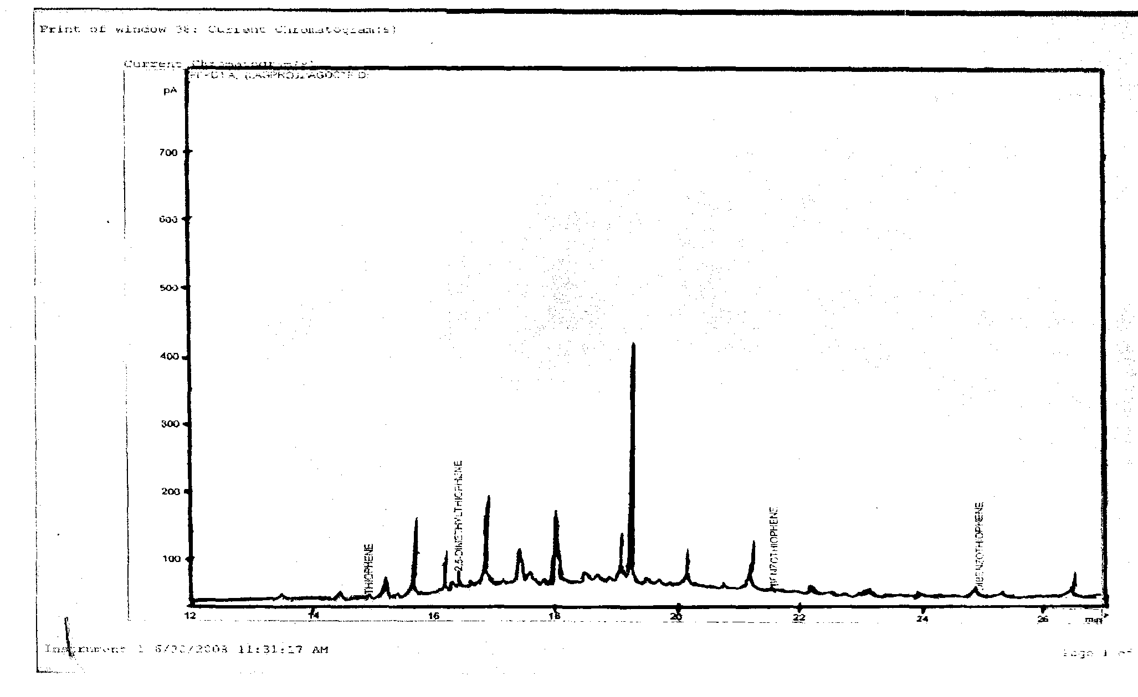

Figure 1: GC-PFPD Chromatograms for Kerosene before Biodesulfurization. the GC-PFPD peaks for all of the sulfur compounds in the kerosene (approximately 48.679 mg/l sulfur initially) before the biodesulfurization by Desulfobactenum indolicum. after treatment of the kerosene for 72 hours, all of the peaks significantly decreased. It is important to note that the sulfur compounds with retention times longer than 5 minutes nearly disappeared. Such characteristics of desulfurization by cells of Desulfobactenum indolicum are opposite or complimentary to those of hydrodesulfurization, in which sulfur compounds with a shorter residence time are more easily desulfurized (Dzidic with a shorter residence time are more easily desulfurized (Dzidic et al, 1988). Based on these results, cells of Desulfobacterium indolicum are considered to have a sufficiently broad substrate specificity to desulfurize major organic sulfur compounds contained in diesel.

Figure 3 below shows the concentration-time profile for the biodesulfurization of benzothiophene. It showed that Desulfobacterium indolicum steadily desulfurized the benzothiophene decreasing its concentration to 1.72 mg/l at the end of 72 hours.

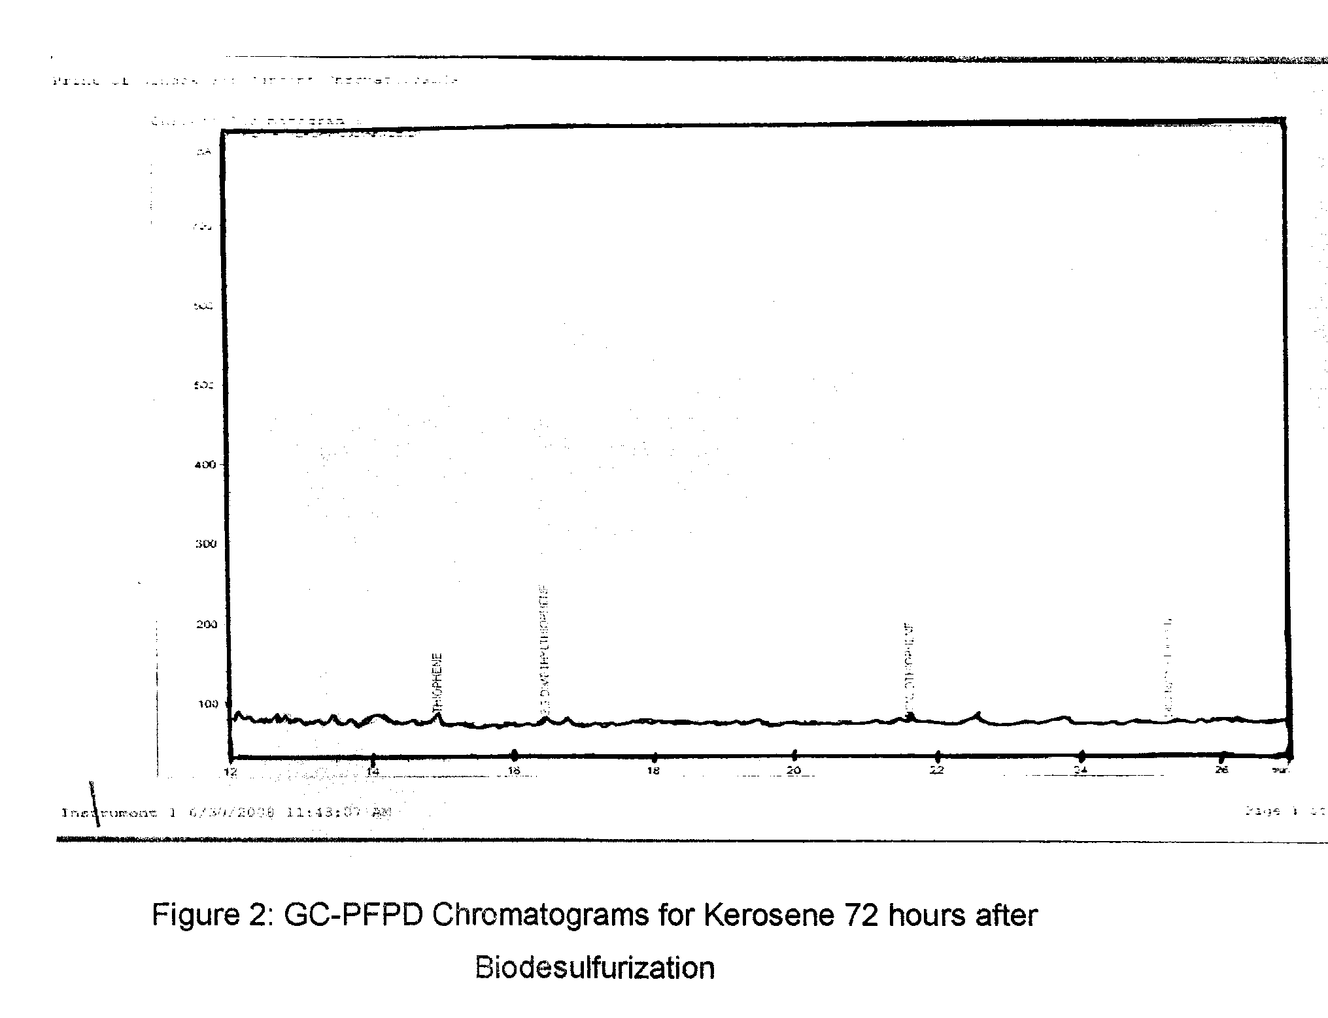

This is a remarkable feat at a reaction temperature of only 30°C, extremes of reaction conditions would have been employed in hydrodesulfurization to attain the same level of desulfurization.
Similarly, Figure 4 below shows that Desulfobacterium indolicum also desulfurized dibenzothiophene steadily reducing its concentration to 31.692 mg/l at the end of 72 hours.

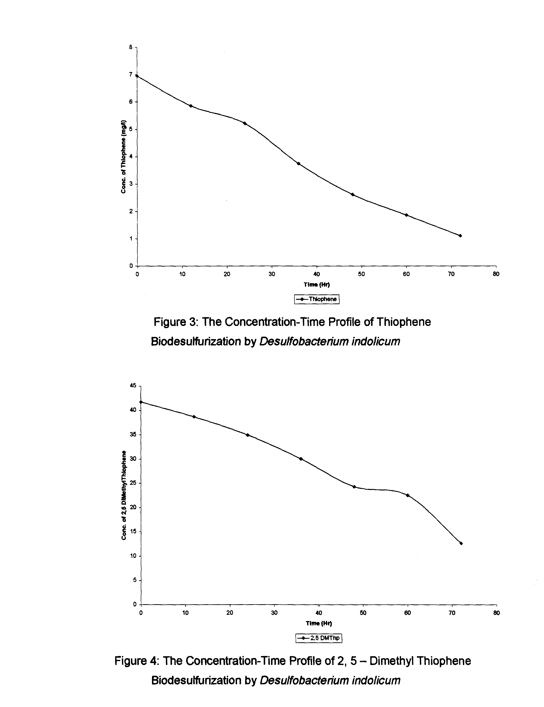

From the viewpoint of a practical process, biodesulfurization at ambient temperature and pressure of kerosene containing various types of thiophene derivative is advantageous, since cooling treatment of the oil to ambient temperature would be unnecessary.
Figures 3 and 4 above show the concentration-time of biodesulfurization of thiophene and 2, 5 - dimethyl thiophene in kerosene. It was observed that at all times, the percentage of thiophene desulfurized is higher than 2, 5 - dimethyl thiophene. This is expected because the methyl substituents at positions 2 and 5 would constitute a steric hindrance to the organism from reaching the sulfur atom in the thiophene ring. At the end of 72 hours, 84% of thiophene has been desulfurized while 70% of 2, 5 - dimethyl thiophene was desulfurized. This is shown in figure 5 below.

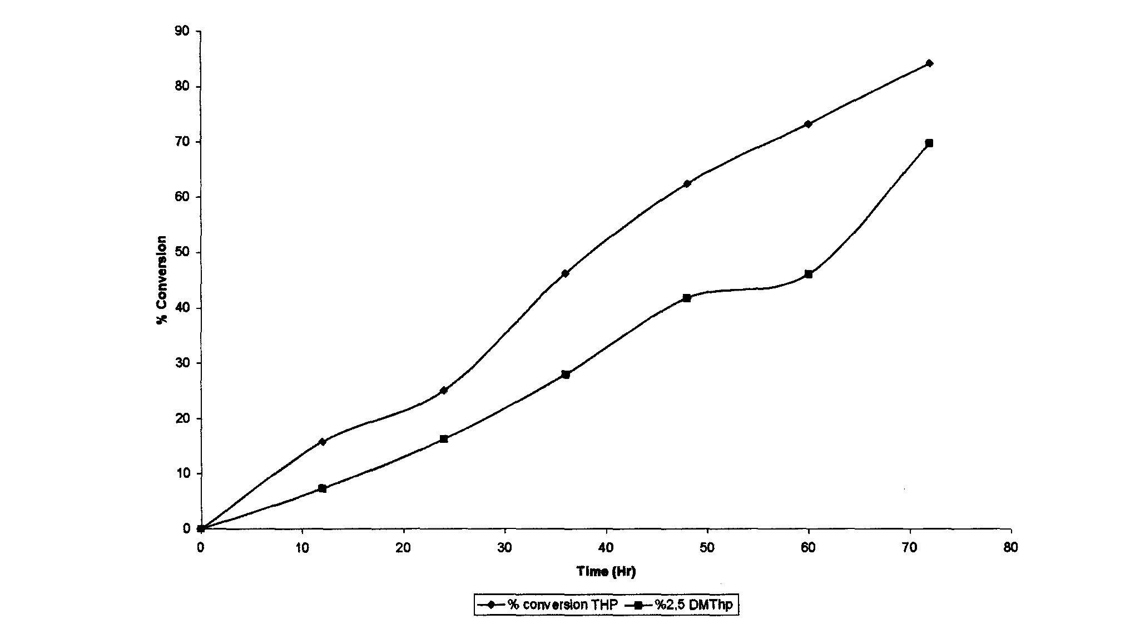

Figure 5: The Percentage Desulfurization -Time Profile of Thiophene & 2, 5 - Dimethyl Thiophene Biodesulfurization by Desulfobacterium indolicum The population density of Desulfobacterium indolicum is increasing as biodesulfurization of kerosene progresses. The Log™ of the population of the cells of A versus time is shown in figure 6 below.

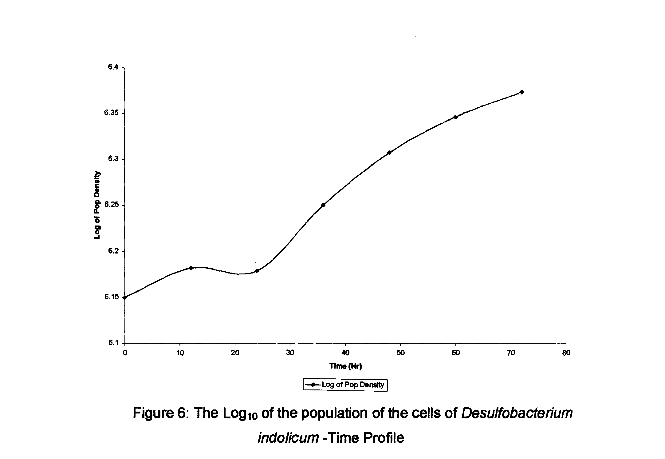
The population of the cells of Desulfobacterium indolicum increases steadily as biodesulfurization of kerosene progresses, showing that the cells use the sulfur in the fuel for metabolism leading to both growth and increase in population.
Goswami et al, (1991) in their work mentioned that two different biological mechanisms are known for the degradation of water-insoluble hydrocarbons and aromatic compounds. The first involves the case in which the microorganisms use emulsifiers to overcome poor solubility of hydrocarbons and aromatic compounds, whilst the other is to increase cell surface hydrophobicity so that adherent capacity to the hydrocarbon is enhanced. According to them, in many cases, microorganisms use both mechanisms with one mechanism acting dominantly. The dominant mechanism can be easily figured out by centrifugation of the cell broth after cultivation using hydrocarbons or oils. If the increase of cell surface hydrophobicity were the dominant mechanism, most of the cells would exist in the interface of aqueous and oil phase after centrifugation. Most of the cells would be in the bottom of the aqueous phase in the opposite case. In this work, the cells of Desulfobacterium indolicum were observed at the interface of the aqueous and oil phase.
The first step in the biodesulfurization of these molecules is the transfer of the molecules from the oil to the cells. It appears that these molecules are transferred directly from the oil into the cells. Many microorganisms have been shown to metabolize many insoluble molecules in this fashion. The PASHs appear to partition to the water before being brought into the cell. The enzyme responsible for the first two oxidations are to reflect the reaction it catalyzes and has been coded DszC. It catalyzes the oxidation by transferring an electron from flavin mononucleotide (FMNH2) to the organosulfur (the thiophene and 2,5- dimethyl thiophene) to produce FMN an oxidized (FMNH2) and sulfoxides of thiophene and 2,5- dimethyl thiophene and also the oxidation of sulfoxides by transferring an electron from flavin mononucleotide (FMNH2) to produce FMN an oxidized (FMNH2) and the
corresponding sulfones.
The first cleavage of the C-S bonds is catalyzed by sulfone Monooxygenase (FMN hfc XO2 oxidoreductase); DszA codes this enzyme. It Transfers another electron from FMNH2 to XO2. Where X is the organosulfur.
The production of sulfite & subsequently sutfate and an intact hydrocarbon molecule is the last reaction in the pathway. This is catalyzed by a desulfinase coded by the DszB gene and leads to the release of the sulfur as sulfite and the production of the corresponding hydroxyl phenyl.
In nature, the cell has achieved its goal. It has the sulfur it needs to grow. The sulfite can be reduced to sulfide and incorporated into sulfur-containing amino acids and vitamins necessary for growth.
It is worthy of note that this study focused on real fuel rather than modeled media of organosulfur compounds. This implies that the organism can survive in the fuel till it removes all the sulfur in it.
In conclusion, it has been confirmed that A could effectively desulfurize organosulfur compounds, thiophene and 2, 5 - dimethyl thiophene through a sulfur-specific degradation pathway with the selective cleavage of C-S bonds at ambient temperature and pressure conditions. Therefore, Desulfobacterium indolicum may be a useful desulfurizing biocatalyst possessing broad substrate specificity toward organosutfur compounds.

Correspondent author
Aribike D S,, S C U Nwachukwu
Department of Chemical Engineering,
University of Lagos,
Akoka Yaba, Lagos Nigeria
simoncyrill@yahoo.com

8/8/2008

REFERENCE
- Chang J. H., S. K. Rhee., Y. K. Chang and H. N. Chang, (1998), Desulfurization of Diesel Oils by a Newly Isolated Dibenzothiophene-Degrading Nocardia sp. strain CYKS2. Biotechnol. Prog. 14, 851 - 855.
- Chang J. H., Y.K. Chang, K. S. Choi and H. N. Chang (2000), Desulfurization of Model and Diesel Oils by Resting Cells of Gordona sp. Biotechnol. Lett, 22, 193 - 196.
- Chang J. H., Y. K. Chang, H. K. Ryu and H. N. Chang, (2000), Desulfurization of Light Gas Oil in Immobilized-Cell Systems of Gordona sp. Strain, CYKS 1 and Norcordia sp. Strain CYKS2, FEMS Microbiol. Lett. 182, 309-312.
- Chukwu L O and S C U Nwachukwu (2005). Impact of Refined Petroleum Spills on Water Quality, Macro-Invertebrate and Microbial Communities of a Typical Aquatic Environment. J Environ. Biol. 26(3), 449-458. Constant!
- M., A., Bordons and G. Jaume, (1994), Degradation of Dibenzothiophene by Pseudomonas putida Lett. In mtcrobiol. 18, 107—111.
- Denome S. A., C. Oldfield, L. J. Nash and K. D. Young, (1994), Characterization of the Desulfurization Genes from Rhodococcus strain IGTS 8, J. Bacteriol., 176, 6707-6717.
- Grossman M. J, M. K. Lee, R. C. Prince, V. Minak-Bemero, G. N. George and I. J. Pickering, (2001). Deep Desulfurization of Extensively Hydrodesulfurized Middle-Distillate Oil by Rhodococcus sp. ECRD-1. Appl. Environ. Microbiol, 67, 4, 1948 — 1952.
- Hou C. T. and A. I. Laskin, (1976), Microbial Conversion of Dibenzothiophene. Dev. Ind. Microbiol, 17, 351 -362.
- Kirimura K., T. Furuya, I. Yoshitaka, K. Kuniki and N. Ken-ichi, (2003) Thermophilic Biodesulfurization of Hydrodesulfurized Light Gas Oils by Mycobacterium phlei WU-F1, FEMS Microbiol Lett, 221, 137-142.
- Kodama K., K. Umehara, K. Shimizu, Y. Minoda and K. Yamada, (1973), Microbial Conversion of Petro-Sulfur Compounds, Final Part, Isolation of microbial products from Dibenzothiophene and its proposed oxidation pathway. Agr. Biol. Chem., 37, 1, 45 - 50.
- Kodama K., S. Nakatani, K. Umehara, K. Shimizu, Y. Minoda and K. Yamada, (1970), Isolation and Identification of Products from Dibenzothiophene. Agr. Biol. Chem., 34, 9, 1320 - 1324.
- Kraweic S. and P. Wang, (1996), Kinetic Analyses of Desulfurization of Dibenzothiophene by Rhodococcus eiythropolis in Batch and Fed-batch Cultures. Appl. Environ Microbiol, 62, 8, 1670—1675.
- Monticello D. J., (1998), Riding the Fossil Fuel Biodesulfurization Wave, Chem. Tech., 28, 7, 38 - 45.
- Monticello D. J., D. Bukker and W. R. Finnerty, (1985), Plasmid Mediated Degradation of Dibenzothiophene by Pseudomonas species, Appl & Environ Microbiol., 756-760.
- Nakatani S., T. Akasaki, K. Kodama, Y. Minoda and K. Yamada, (1968). Microbial Conversion of Retro-Sulfur Compounds, Part II, Culture Conditions of Dibenzothiophene Utilizing Bacteria, Agr. Biol. Chem., 32,10,1205-1211.
- Omori T., T. Kodama, M. Lisa and S. Yuko, (1992), Desulfurization of Dibenzothiophene by Corynebactehum sp. strain SY 1 Appl. Environ. Microbiol, 911-915.
- Piddington C. S., B. R. Kuvacevich and J. Rambosek, (1995), Sequence and Molecular Characterization of a DNA Region Encoding the Dibenzothiophene Desulfurization Operon of Rhodococcus sp. IGTS 8, Appl. Environ. Microbiol, 61, 468 - 475.
- Rail H. T., C. J. Thompson, H. J. Coleman and R. L. Hopkins, (1972), Sulfur Compounds in Crude Oil, Bulletin 659, US Bureau of Mines, Washington DC.
- Rhee S K, J H Chang, Y K Chang and H N Chang (1998). Desulfurization of Dibenzothiophene and Diesel oils by a Newly Isolated Gordona strain CYKS Appl. Environ. Microbiol. 64(6), 2327 - 2331.
- Speight J G 1981. The Desulfurization of heavy oil and residua. Marcel Dekker, New York N Y

