Physico-chemical analysis of ground water of selected area of Ghazipur city-A case study

Sandeep K.Pandey¹ *, Shweta Tiwari²

1. Lecturer, Deptt. of Environmental Science, P.G.College, Ghazipur-232329 U.P. India.
2. M.Sc. Fellow, Deptt. of Environmental Science, P.G.College, Ghazipur-232329 U.P. India.
environ_disaster53@rediffmail.com

Abstract: A laboratory study was conducted to monitor the ground water quality of selected sites of Ghazipur city by examining the various physico-chemical parameters like pH, T.D.S., D.O.& CO₂ etc.. A comparision with ICMR standard shows that the water is nearly suitable for drinking purpose, the DBPs (Disinfection by products) analysis is required to corroborate the present study. [Nature and Science. 2009;7(1):17-20]. (ISSN: 1545-0740).

Key words: Physico-chemical parameters, Water characteristics, Ground water analysis, Potable water.

1. Introduction
Ground water is ultimate, most suitable fresh water resource with nearly balanced concentration of the salts for human consumption. Over burden of the population pressure, unplanned urbanization, unrestricted exploration policies and dumping of the polluted water at inappropriate place enhance the infiltration of harmful compounds to the ground water. Studies regarding the ground water quality analysis has been made by many authors like B. K. Gupta and R. R. Gupta (1999), M. Rajasekara et al. (2005), M. R. Rajan and I. Paneerselvam. (2005), S. B. Thakare et al. (2005), Shikha Bisht et al.(2007).They concluded that it is the high rate of exploration then its recharging, inappropriate dumping of solid as well as liquid wastes, lack of strict enforcement of law and loose governance are the cause of deterioration of ground water quality. Municipal Corporation of Ghazipur facilitates the drinking water in limited area, in alternate to this people keeps option as hand pumps and jet pumps etc. from last few years it has been seen that the water quality of the alternative sources like hand pumps, wells has been deteriorating and its responses are in the form of yellowish and uncommon odor of the water people in this area using chlorine tablets for disinfect the drinking water. The objective of this work is to assess the quality of drinking water in Ghazipur city.

2. Materials and Methods:
2.1 Study area:
The experiment was conducted at Deptt. of Environmental Science, P.G.College,Ghazipur. This is suburban area and district head quarter, located in the eastern gangetic plain of the Indian sub continent at 25⁰19`and 25⁰54`N latitude, 83⁰4`and 83⁰58`E longitude and 67.50 m above the sea level. The coldest months here are December-January and the hottest months are May-June. The Temperature varies from 5° to 17° centigrade in winters and 30° to 42° in summers. But some times winter temperature ebbs to 3° C and summer temperature shoots up to 45° C. In the summers, which begin from March and last till Mid June the temperature starts rising and sometimes it reaches 45° C. The annual rainfall in the district was between 800 mm. and 1200 mm and in 1997 the rainfall was 1034 mm. On the average there are 49-55 rainy days ( days with rain fall of 2.5 mm or more ) in a year in the district July and September the relative humidity are high being over 70 %. During the Post-Mansoon and winter season the humidity is high in the morning. By summer, the relative humidity become very low i.e. less than 25 %.Anonymous (2007).It having 25 wards with some extension areas of the city five sites are selected for the study as mentioned in Fig.:-1 Map View. The average boring depth of the city is 45-60 meter

2.2 Sampling and sampling sites:
A fluorinated plastic bottle of capacity 2 litre has been used to collect the sample, before sampling evacuation of the stored water in the pipelines has been made to take the fresh ground water sample the selected sampling sites are populated and urban areas of the city depicted in the Fig.:1 A map view of ghazipur city as site 1 to 5.The sampling has been carried out in the month of April year 2007.

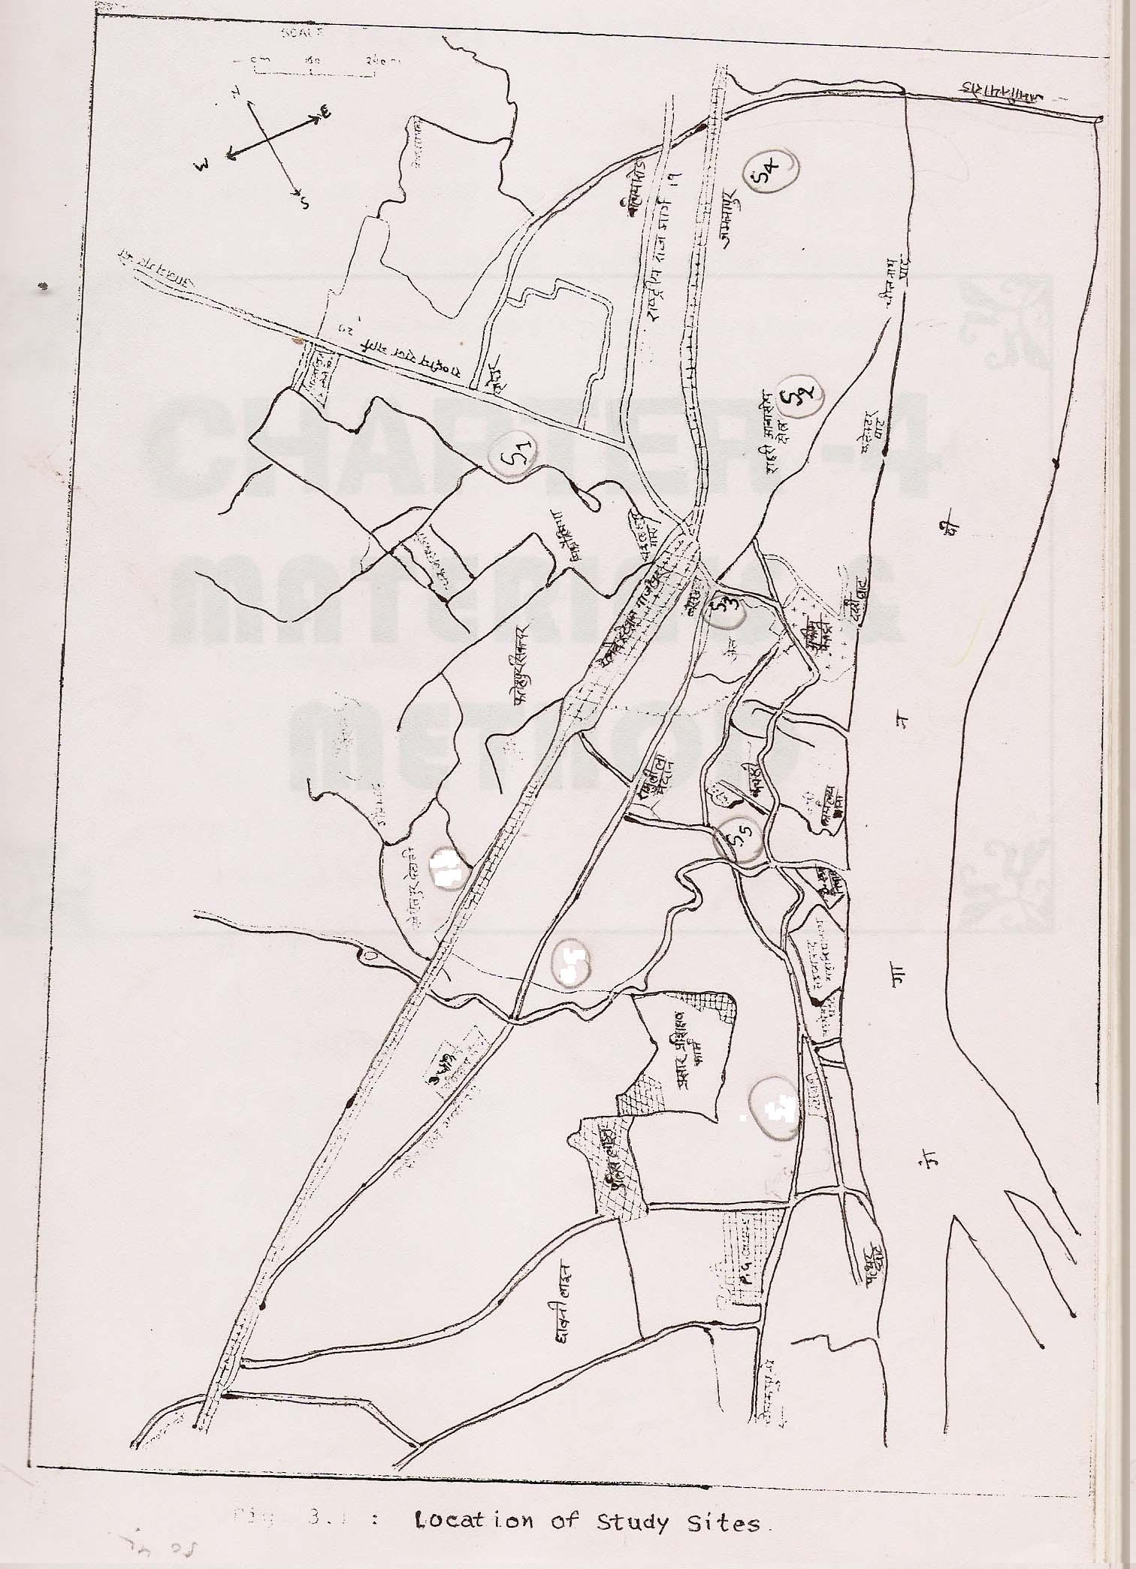

Figure 1: A map view of study site Ghazipur city.

2.3 Methodology:
pH was measured with the help of pH meter (Model no. 101 E) of Electronic India , standardized with pH buffer 4,7 and 9.2. TDS was estimated by evaporation method at 180⁰C, Alkalinity, Hardness, D.O., Chloride, CO₂ and all parameters were analyzed by standard procedure mentioned in APHA (1995). The elemental analysis carried out by digital flame photometer.

2.4 Statistical analysis:
The data were subjected to one way ANOVA analysis of variance using SPSS ver. 10 software Ducan’s multiple range test performed to test the significance difference among the treatments.

3. Result:

Table 1: Reading of water quality parameters at different sites in Ghazipur city.

Parameters S1 S2 S3 S4 S5 ICMR

pH 7.4±.00^{c} 7.2±.00^{c} 6.8±.12^{d} 8±.11^{b} 8.3±.00ª 7.0-8.5

T.D.S. 200±6.5^{c} 175±2.5^{d} 145±2.8e 225±2.8^{b} 245±7.6ª 500

T. H. 256±.1^{c} 235±.11^{d} 240±4.04^{d} 266±1.15^{b} 304±3.05ª 300

Cal. Hard. 108±.11^{c} 99±.7^{d} 106±2.3^{c} 140±.35^{b} 158±3.05ª -

D.O. 3.4±.005e 4.1±.006^{b} 3.6±.00^{d} 4±.00^{c} 5±.00ª 4-6

Cl 78±.30e 100±1.5^{b} 83±1.1^{d} 91±.57^{c} 106±.17ª 200

Alk. 120±.10^{b} 140±7.5ª 110±5.77^{b} 140±.17ª 149±1.7ª 200

Co₂ 7.42±.009^{c} 7.84±.003ª 7.92±.002ª 7.02±.002^{d} 7.67±.00^{b} -

Na 23±.17^{b} 28±.005^{b} 25±.00^{b} 42±6.7ª 46±2.3ª -

K 4±.00e 4±.00^{d} 6±.00^{c} 8±.00^{b} 10±.00ª 75

Different letters in each group shows significant difference at P<0.05 levels.(Mean ± stand. error)
S1- Rauza, S2-AamGhat, S3-Vishweshwar Ganj, S4-Shastri Nagar, S5-GoraBazar.

4. Discussion:
The value of pH range among 6.8 to 8.3. It is in the prescribed limit of ICMR. A little bit increase in pH level may depress the effectiveness of the disinfectants like chlorinations thereby requiring the additional chlorines. The value of total dissolved solid ranges from 145-245 mg/l all the values of total dissolved solid is in the prescribed limit of ICMR it is due to high dissolved salts of Ca, Mg and Fe it requires specific cation and anion analysis. Total hardness ranges from 235-304 mg/l, total hardness is with in the prescribed limit of ICMR except the site-5 which is 304 it fall in hard water category it means it contains appreciable amount of Calcium and Magnesium ions. Calcium hardness ranges from 99-158 mg/l. Dissolved Oxygen ranges from 3.4-5 mg/l, D.O. indicating the nearly pure symptoms. Chloride content is 78-106. Chloride content is also in the limit of ICMR. Alkalinity ranges from 110-149 mg/l. Alkalinity is the cause of carbonate and bicarbonate ion and its salts. It is in the prescribed limit of ICMR. Cabon dioxide content is from 7.02-7.92 ppm. According to Henry’s law the gaseous dissolution has been determined by partial pressure of gases, soluble salt content and ambient temperature. Increase in CO₂ content may be by high dissolved salt contents. One more possibility is there that is the degradation of DOC (dissolved organic carbon).Higher DOC on post disinfectant application causes some DBPs (Disinfection byproducts) like THM (Trihalomethanes),HAA (Haloaceticacids) etc. Some of them are potential carcinogens, and a short-term exposure can lead to dizziness, headaches, as well as to problems associated with the central nervous system. so it is more relevant for those areas where OM contaminations are high with high use of disinfectants. Quality of ground water under study is nearly fit for drinking purpose, but it is recommended that ground water analysis should be carried out from time to time to monitor the rate and kind of contamination along with analysis of DBPs to corroborate the present study.

Author for all Correspondence:
Sandeep K. Pandey
Lecturer,
P.G. Department of Environmental Science,
P.G. College, Ghazipur-233001 (U.P.).
E-mail: environ_disaster53@rediffmail.com
# Communication: +91-9918561915, Res: +91-5497-252764.Fax:+91-548-222087

8/13/2008

References:
- Anonymous (2007) http://ghazipur.nic.in.
- APHA. (1995). Standard Methods for the examination of water and wastewater, Pg 2-4, 29-179. American Public Health Association.
- Bisht Shikha, Patra, B. A., Gupta N. C., Arora Saurabh, and R. A. Singh.(2007)Assessment of Drinking Water Quality of Delhi, India .In:12th ISMAS-WS-2007, March 25-30, Cidade de Goa, Dona Paula, Goa.
- Gupta, B. K. and R. R. Gupta. (1999). Physio-chemical and biological study of drinking water in Satna, Madhya Pradesh. Poll. Res. 18: 523-525.
- http://www.ICMR.nic.in
- Rajan M. R. and I. Paneerselvam. (2005). Evaluation of drinking water quality in Dindigul city, Tamil Nadu. Indian J. Environ. and Ecoplan. Vol. 10, No.3: 771-776.
- Rajas Kara Pandian, M., G. Sharmila Banu, G. Kumar and K. H. Smila. (2005). Physico-chemical characteristics of drinking water in selected areas of Namakkal town (Tamil Nadu), India. Indian J. Environmental Protection, Vol. 10, No. 3: 789-792.
- Thakare S. B., A. V. Parvate and M. Rao. (2005). Analysis of fluoride in the ground water of Akola district. Indian J. Environ. and Ecoplan. Vol. 10 No.3: 657-661.

Note: This article was primarily published in [Nature and Science. 2008;6(4):25-28]. ISSN: 1545-0740.

