A Simple Geometry for Obtaining a Gas Discharge at Low Pressure

Djamel Boubetra
LMSE, Centre Universitaire de Bordj Bou Arreridj, El Anasser 34265, Algeria
E-Mail: boubetra@gmail.com

Abstract: A new geometry for obtaining a gas discharge has intended for the general experiments ion sources laboratories .This geometry is based on the use of a magnetic hollow cathode in which one introduces a permanent magnet in order to increase the probability of ionization gas atoms by the method of crossing electric and magnetic fields. [Nature and Science. 2009;7(1):36-38]. (ISSN: 1545-0740).

Key words: gas discharge, cold hollow cathode, ionization

Introduction:
A permanent magnet is mounted coaxially on the inside of the cathode and creates a magnetic field. The cathode has an internal open chamber or space filled with a gas and with the applying of a voltage between the cathode and anode the gas discharge starts (Pessoa et al. 2006). The ions are extracted from the gas discharge plasma through the emission opening cathode which has a fixed diameter and a variable height h i.e. a variable volume.
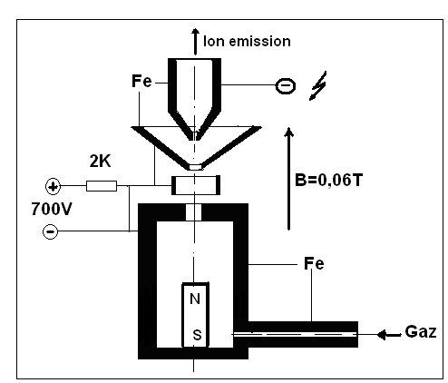

Figure 1: Arrangement of a magnetic hollow cathode

Results and Discussion
A crossed-field cold-hollow-cathode arc is stable at low working gas pressures of 10⁻²–10⁻¹ Pa, magnetic-field-and gas-dependent arcing voltages of 600-700 V, and discharge currents of 100–200 A (Boubetra et al., 2008). This is because electrons come from a cathode spot produced on the inner cathode surface by a discharge over the dielectric surface. The magnetic field influences the arcing voltage and discharge current most significantly. When the plasma conductivity in the cathode region decreases in the electric field direction, the magnetic field increases, causing the discharge current to decline and the discharge voltage to rise. The discharge is quenched when a critical magnetic field depending on the type of gas is reached. Because of the absence of heated elements, the hollow cathode remains efficient for long when an arc is initiated in both inert gases, what was already concluded in other work (Gavrilov et al., 2003)and (Goebel et al ,1992).

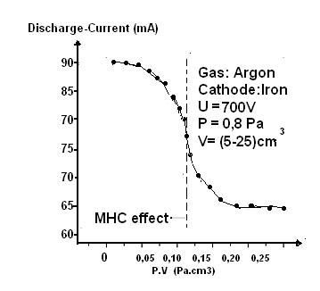
Figure 2

The MHCM discharge proprieties were obtained taking into account the effect of the gas pressure and the volumes cathode. When the volume is reduced, keeping the discharge voltage constant (700V) the discharge current is seen to rise according to figure 2 at optimized values of P.V the discharge current is higher than an other conventional sputtering discharge.

Conclusion:
According to the results obtained one can say that this geometry can be used for an arrangement magnetron to the beams extraction of plasma which could be useful like a tank of the ions and by there one of the ions beams which working with a low pressure and a small volume of hollow cathode.

Author:
Djamel Boubetra
LMSE, Centre Universitaire de Bordj Bou Arreridj
El Anasser 34265, Algeria
E-Mail: boubetra@gmail.com

References:
- Boubetra, Dj.,N.Y.Sci. Journal 1(4) 4-13 (2008).

Gavrilov United States Patent 5569976 (1996).
- Goebel et al., United States Patent 5132597 (1992).
- Pessoa R.S., Brazilian. J. of Physics , Vol 36 2A (2006).

