Prunus Cerasoides D. Don (Himalayan Wild Cherry): A Boon To Hill- Beekeepers In Garhwal Himalaya

Prabhawati Tiwari*, J. K. Tiwari* and Radha Ballabha*

* Department of Botany, H.N.B. Garhwal University, Srinagar Garhwal, Uttarakhand-246 174 (India). E. mail: ptiwari29@rediffmail.com

Abstract: This article describes Prunus Cerasoides D. Don (Himalayan Wild Cherry): A Boon To Hill- Beekeepers In Garhwal Himalaya. [Nature and Science. 2009;7(7):21-23]. (ISSN: 1545-0740).

INTRODUCTION
Prunus cerasoides (Family Rosaceae) the Himalayan Wild Cherry is a sacred plant in Hindu mythology. It is found in Sikkim, Nepal, Bhutan, Myanmar, West China and India (Collett, 1921; Gaur, 1999 and Polunin & Stainton, 1984). In India the plant is restricted to sub-montane and montane Himalaya ranging from 1500-2400 m asl. In Garhwal Hills it is distributed abundantly in temperate zones of Pauri, Tehri, Chamoli and Uttarkashi districts. Locally it is known as ‘Panyyan’. It is worshipped in all auspicious occasions by the inhabitants. People never cut the whole tree and use only its twigs in rituals as the wood are forbidden to be used as fuel. Thus it is common to observe quite old trees of Prunus cerasoides in the area. But the potential of the plant as rich source of pollen and nectar for honey bees is not tapped adequately.
As the winter starts, restricted patches in the hilly regions impart a spring look due to this plant. It blooms in October and lasts up to mid -December. Its pinkish- white flowers are the rich source of nectar and pollen for bees (Sharma, 1970; Crane et. al., 1984; Gaur and Nawani, 1989; Pratap, 1997 and Gaur and Tiwari, 2001). In this period the swarms of honey bees can be observed gathering nectar and pollen heavily from these trees. In Garhwal Himalaya, November and December is a period when flowering is minimum, only few wild and ornamental herbs bloom which hardly fulfill the need of honey-bees. Thus beekeepers are compelled to use artificial feeding to bees. Hence Prunus cerasoides can serve as a boon for beekeepers. Its plantation is the need of people, bees and plant itself. The apicultural value of the plant is non-comparable as it blooms in hills during the dearth period and is visited by the three native Asian honey-bees (Apis cerana indica, A. dorsata and A. florae) and also by introduced European species Apis mellifera. In this way artificial feeding is not necessary for those beekeepers whose colonies are in the surroundings of Prunus cerasoides.

The botanical description of the plant, features of pollen and properties of honey are as follows.

Botanical Description: D. Don, Prodr. Fl. Nepal 239, 1825; Naithani, Fl Chamoli 1:201, 1984; Gaur, Fl Garhwal, 226, 1999; Collett Fl. Simlensis 156, 1921; Osmaston, A Forest Flora for Kumaun, 202, 1927.
Deciduous trees, up to 10 m high; bark reddish brown, exfoliating in thin circular strips. Leaves conduplicate in bud, elliptic or ovate-lanceolate, 3.5-8.5 cm, apex acuminate, both surfaces glabrous, dark glossy, shining above, finely simple or double serrate, with gland tip teeth; petioles 1.2-2 cm long; stipules long, subulate. Flowers pinkish white 1.2-2.5 cm across, appearing before the leaves in umbellate fascicles (figure 3); pedicels 0.5-2cm long. Calyx bell shaped, 5-lobed; lobes ovate-acute. Petals 5, obovate. Fruits red or yellow, ovoid, 1.2-1.5 cm long, glabrous, shining, supported by base of calyx tube; 1- seeded. Flowering period October to December and fruiting, Febuary to November.

Pollen: Grains 3 – zonicolporate, colpus broad, lip pointed, endocolpium indistinct. Exine surface finely straite, straie thick. Exine 2.5 µm thick, ecto exine as thick as endoexine; columella indistinct; AMB circular, triangulate 39x28 µm. Shape sub-prolate. Figures (4-6).

Honey:
Physical Properties: Colour, reddish brown; appearance shining; aroma strong and pleasant; flavor slightly bitter.
Chemical Constituents : Water-8.80%, Nitrogen 0.022%, Ash 0.08%, Minerals , Na-14 ppm, K 195 ppm, Ca-47 ppm, reducing sugars-63.97 %.

Apicultural Value: All the four species of Apis present in India namely Apis cerana indica, A. dorsata, A. florae and A. mellifera visit the flowers of Prunus cerasoides for its rich nectar (N1) and pollen (P1). The honey is slightly bitter in taste but medicinal in properties. Inhabitants of this region use Prunus cerasoides honey to treat eye ailments.

Other Uses: Although the plant is conserved for religious purposes, used in rituals by the local inhabitants, yet have some other uses such as for making walking sticks, leaves for fodder, and fruits for making sauces. A gum exuding from trunk and branches is used by honeybees as honeydew. The bark paste is applied on contusions (Gaur, 1999).

Propagation: Natural regeneration of the plant is by seeds and it prefers temperate climate. Regeneration can be achieved by direct sowing or by transplanting nursery raised seedlings.
The plant is strongly recommended for plantation as rich source of pollen and nectar to honeybees besides its religious value. It needs to be brought under afforestation programmes in gardens, avenues and in dry waste lands.
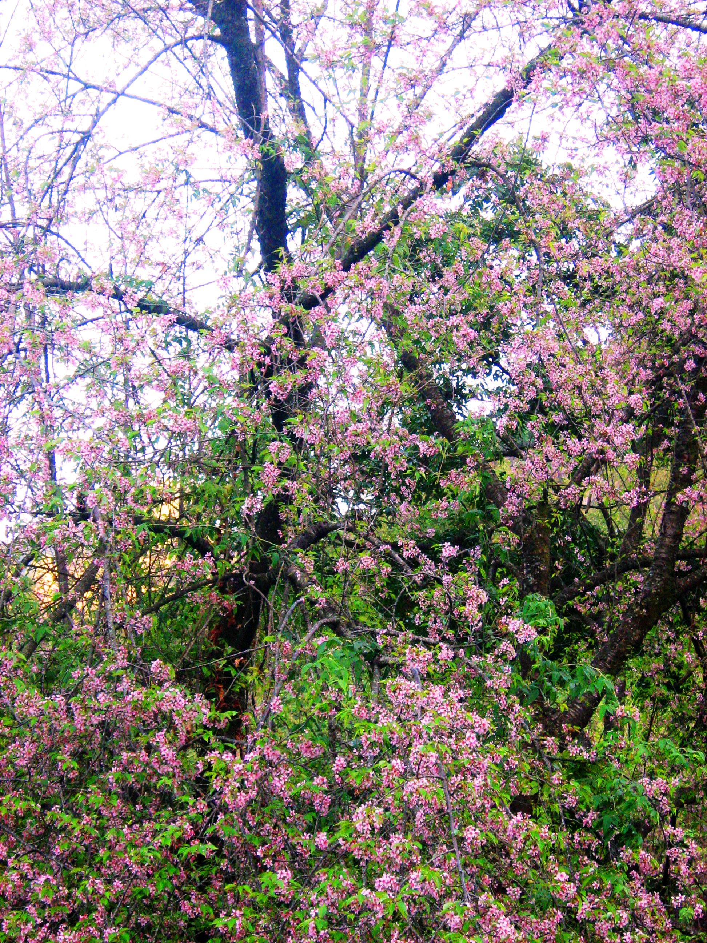
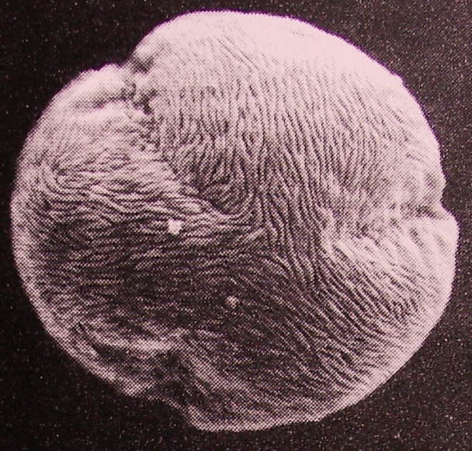
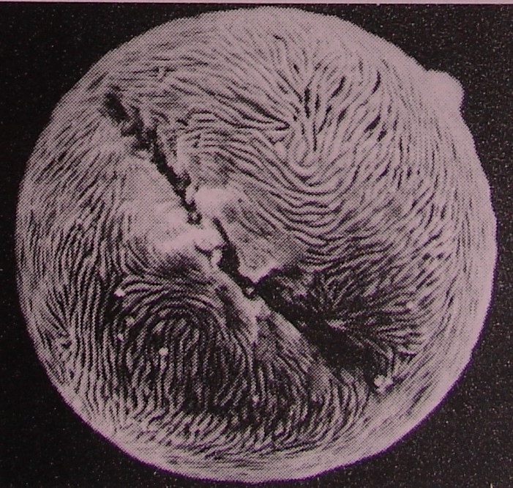
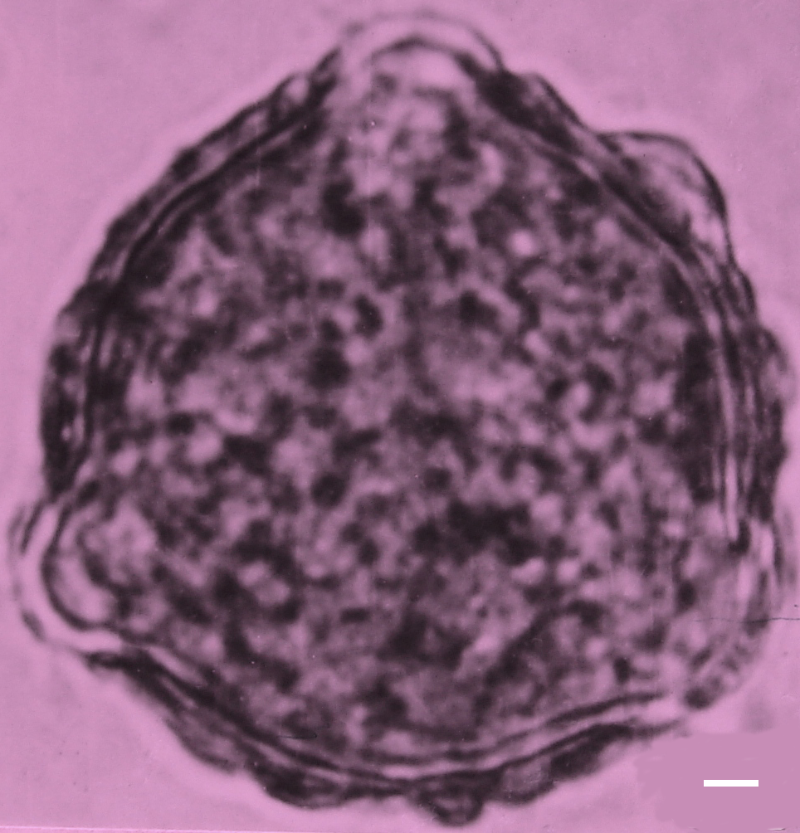
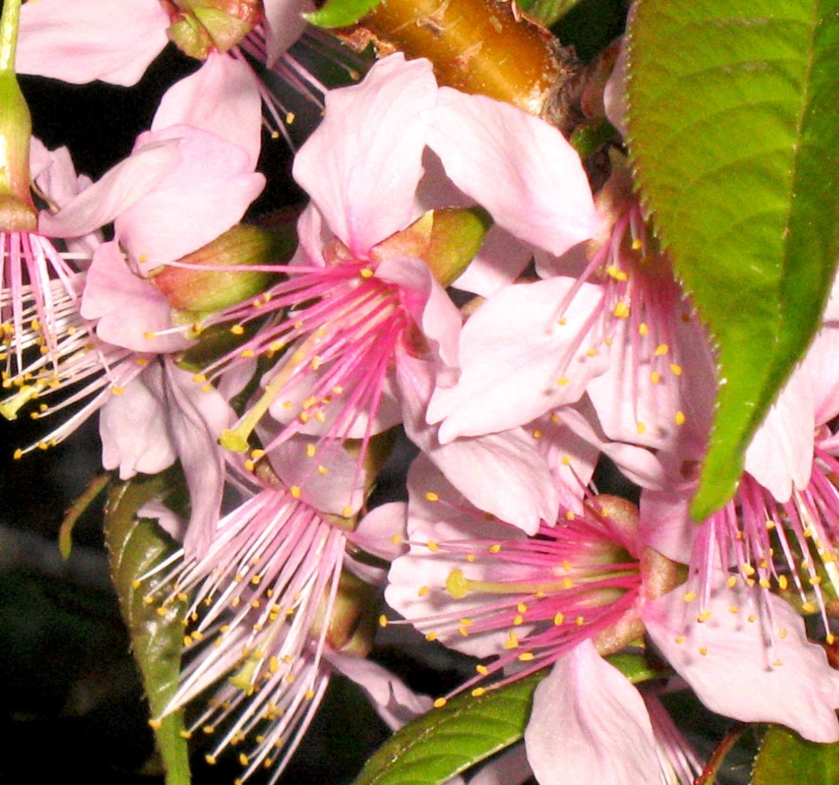
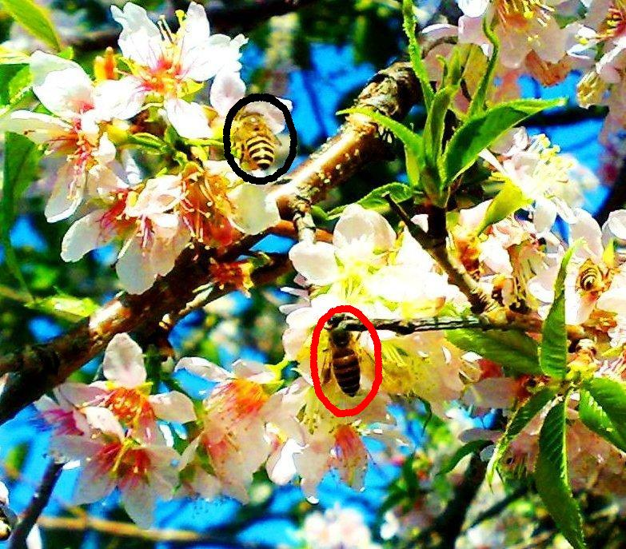

PLATE 1: Figure 1-6. 1: The tree in full bloom. 2: Inflorescence with Apis dorsata (red circled) and A. cerana indica (black circled) worker bees gathering nectar. 3: Flowers. 4: Light microphotograph of pollen (polar view). 5: SEM microphotograph in polar view. 6: SEM microphotograph in equatorial view.

References

Collett, H. Flora Simlensis: A Handbook of Flowering Plants of Simla and the neighbourhood. Thacker, Spink & Co., London 1921.

Crane, E., Walker, P. and Rosemary, D. Directory of Important World Honey Sources. IBRA, London. 1984.

Gaur, R. D. and Nawani, P. A melittopalynological analysis of apiary honey from Pauri Garhwal, U.P. India. Indian Bee Journal 1989; 51(1): 12-14.

Gaur, R. D. and Tiwari, P. Determination of floral origin of some Himalayan honey. The Journal of the Indian Botanical Society 2001; 80(I-IV): 19-23.

Gaur, R. D. Flora of the District Garhwal North West Himalaya (With EthnobotanicalNotes) Transmedia: Srinagar Garhwal, India. 1999.

Gaur, R. D. Resource Development through Bee-Farming in Garhwal Himalaya. 3rd Botanical Congress Lucknow. J. Indian Bot. Soc. 1984; 8: 51-59.
Naithani, B. D. Flora of Chamoli. Vols. I. Botanical Survey of India, Howrah 1984.
Osmaston, A. E. Forest Flora for Kumaun. Reprint 1990, Bishen Singh Mahendra Pal Singh, Dehradun 1927.
Polunin, O. and Stainton, A. Flowers of the Himalaya, Oxford University Press, Delhi, India 1984.

Pratap, U. Bee Flora of the Hindu-kush Himalaya. Inventory and Management. International Centre for Integrated Mountain Development (ICIMOD), Kathmandu, Nepal 1997.

Sharma, M. An analysis of pollen loads of honey bees from Kangra, India. Grana 1970; 10: 35-42.

5/1/2009

