Nature and Science, 2009;7(7), ISSN 1545-0740, http://www.sciencepub.net, naturesciencej@gmail.com

In the search for a new field of mathematics

S.Kalimuthu

211,Kanjampatti P.O,PollachiVia,TamiNadu642003,India Email: postulate.kalimuthu0@gmail.com

Mobile: 91 97885 49996

Abstract: Needless to say, mathematics is the mother of all of science. Algebra and geometry were the first two branch of mathematics. Primitive man started to pronounce 1, 2, 3, …. etc. nearly 30000 years ago. Today, there are more than 50 branches of mathematics. In this submission, the authors propose a new idea for the origin of a new field of mathematics. A preliminary result and an open problem are discussed. [Nature and Science. 2009;7(7):33-40]. (ISSN: 1545-0740).

Key Words: : number theory, algebra, geometry, Euclidean postulates, non-Euclidean geometries and physical applications to geometry.

PACS:02.40.Dr

Journey through Euclid

Euclid’s 5th Postulate states that lines will always intersect at some point unless they are parallel. However, this is an axiom, not a theorem. In other words, Euclid just assumed this to be a geometric truth, without proof. Many subsequent mathematicians believed this Postulate was independent of the other 4 Postulates; one could prove it as a Theorem using only the other Postulates. However, nobody was ever able to complete such a proof, and in 1868, the mathematician Beltrami formally proved that the ‘Axiom of Parallels’ was completely independent of the other Postulates.

What does this mean? Apart from Euclid’s Postulate, there is no guarantee that parallel lines cannot meet. Thus the several varieties of ‘non-Euclidean’ Geometry (where parallel lines can meet) can be entirely consistent.

Why did mathematicians feel the need to deduce the parallel postulate from the other axioms of geometry? After all, if you are going to start from some axioms, it doesn't much matter how many there are. Nobody seemed to mind that the other axioms were independent of each other.

Suspicion of the parallel postulate goes back to Euclid, who was the first person to notice (in writing at any rate) that it was needed for some arguments. Whenever he could, he avoided using it, even if that meant producing longer proofs. Did people have some inkling of non-Euclidean geometry, some premonition that the parallel postulate might be false?

No, they certainly did not. However, they felt uneasy about the parallel postulate because it was more complicated to state than the other axioms, and not quite as obviously true. If you have a line L and a point x not on it and claim that there is a line M through x that does not meet L, then you are making a statement about the whole, infinite line M and are therefore on dodgier ground than you are with the other axioms. It seems strange to have to deduce that the angles of a triangle add to 180 by appealing to what goes on unboundedly far away.

Incidentally, there were some serious attempts at proofs of the parallel postulate, but they all turned out to depend on hidden assumptions that were themselves equivalent to the parallel postulate (as is obvious if one bears hyperbolic geometry in

33

Nature and Science, 2009;7(7), ISSN 1545-0740, http://www.sciencepub.net, naturesciencej@gmail.com

mind). For example, one proof used the fact that for every triangle there is a similar triangle of any given size - which is false in the hyperbolic plane.

The development of non-Euclidean geometry caused a profound revolution, not just in mathematics, but in science and philosophy as well.

The philosophical importance of non-Euclidean geometry was that it greatly clarified the relationship between mathematics, science and observation. Before hyperbolic geometry was discovered, it was thought to be completely obvious that Euclidean geometry correctly described physical space, and attempts were even made, by Kant and others, to show that this was necessarily true. Gauss was one of the first to understand that the truth or otherwise of Euclidean geometry was a matter to be determined by experiment, and he even went so far as to measure the angles of the triangle formed by three mountain peaks to see whether they added to 180. (Because of experimental error, the result was inconclusive.) Our present-day understanding of models of axioms, relative consistency and so on can all be traced back to this development, as can the separation of mathematics from science.

The scientific importance is that it paved the way for Riemannian geometry, which in turn paved the way for Einstein's General Theory of Relativity. After Gauss, it was still reasonable to think that, although Euclidean geometry was not necessarily true (in the logical sense) it was still empirically true: after all, draw a triangle, cut it up and put the angles together and they will form a straight line. After Einstein, even this belief had to be abandoned, and it is now known that Euclidean geometry is only an approximation to the geometry of actual, physical space. This approximation is pretty good for everyday purposes, but would give bad answers if you happened to be near a black hole, for example.

Even before Beltrami proved the independence of the Parallel Postulate, mathematicians were still able to work on Projective Geometry. In the early 17th Century, Kepler suggested the notion of ‘points at infinity’ where parallel lines would intersect; meanwhile Desargues and Pascal began to study Geometry using only intersections. Once Kepler’s idea was taken seriously, Geometers saw that the Geometry of intersections (incidence relations) could be made into a wholly consistent theory. As suggested above, if all lines are guaranteed to meet at one point, the study of intersections does not have to make any exceptions (a flaw of Euclidean Geometry). Finally, in 1871, Klein proved that the entire theory of Projective Geometry is independent of the Parallel Postulate.

Hyperbolic geometry

Two important geometries alternative to Euclidean geometry are elliptic geometry and hyperbolic geometry..

These three geometries can be distinguished by the number of lines parallel to a given line passing through a given point. For elliptic geometry, there is no such parallel line; for Euclidean geometry (which may be called parabolic geometry), there is exactly one; and for hyperbolic geometry, there are infinitely many.

It is not possible to illustrate hyperbolic geometry with correct distances on a flat surface since a flat surface is Euclidean. Poincaré, however, described a useful model of hyperbolic geometry where the "points" in a hyperbolic plane are taken to be points inside a fixed circle (but not the points on the circumference). The "lines" in the hyperbolic plane are the parts of circles orthogonal, that is, at right angles to the fixed circle. And in this model, "angles" in the hyperbolic plane are angles between

34

Nature and Science, 2009;7(7), ISSN 1545-0740, http://www.sciencepub.net, naturesciencej@gmail.com

these arcs, or, more precisely, angles between the tangents to the arcs at the point of intersection. Since "angles" are just angles, this model is called a conformal model. Distances in the hyperbolic plane, however, are not measured by distances along the arcs. There is a more complicated relation between distances so that near the edge of the fixed circle a very short arc models a very long "line."
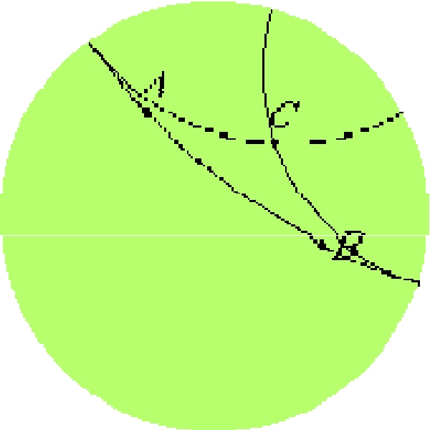

Once this model is accepted, it is easy to see why there are infinitely many "lines" parallel to a given "line" through a given "point." That is just that there are infinitely many circles orthogonal to the fixed circle which don't intersect the given circle orthogonal to the fixed circle but do pass through the given point.

In the diagram, AB is a "line" in the hyperbolic plane, that is, a circle orthogonal to the circumference of the shaded disk which represents the hyperbolic plane. A "point" C lies in that plane. Two "lines" are shown passing through C, one gets close to the line AB in the direction of A, the other gets close in the direction of B. But these two "lines" don't intersect AB since the arcs representing them only intersect on the circumference of the disk, and points on the circumference don't represent "points" in the hyperbolic plane.

These two parallel "lines" are called the asymptotic parallels of AB since they approach AB at one end or the other. There are infinitely many parallels between them. (In much of the literature on hyperbolic geometry, the word "parallels" is used for what are called "asymptotic parallels" here, while "nonintersecting lines" is used for what are called "parallels" here.)

Elliptic geometry

Plane elliptic geometry is closely related to spherical geometry, but it differs in that antipodal points on the sphere are identified. Thus, a "point" in an elliptic plane is a pair of antipodal points on the sphere. A "straight line" in an elliptic plane is an arc of great circle on the sphere. When a "straight line" is extended, its ends eventually meet so that, topologically, it becomes a circle. This is very different from Euclidean geometry since here the ends of a line never meet when extended.

35

Nature and Science, 2009;7(7), ISSN 1545-0740, http://www.sciencepub.net, naturesciencej@gmail.com

The illustration on the right shows the stereographic projection of one hemisphere. Since only one hemisphere is displayed, each "point" is represented by one point except those "points" such as D, E, and F on the blue bounding great circle which appear twice.
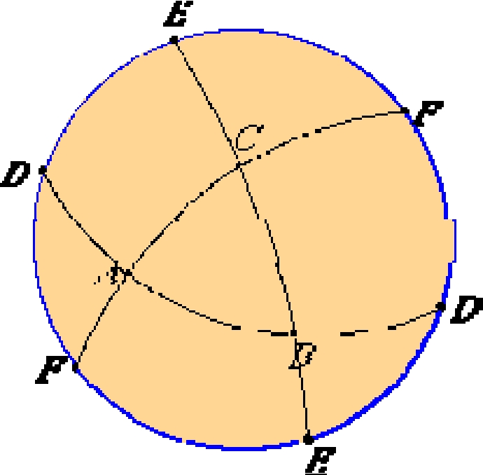
A "triangle" in elliptic geometry, such as ABC, is a spherical triangle (or, more precisely, a pair of antipodal spherical triangles). The internal angle sum of a spherical triangle is always greater than 180°, but less than 540°, whereas in Euclidean geometry, the internal angle sum of a triangle is 180° as shown in Proposition I.32.

Elliptic geometry satisfies some of the postulates of Euclidean geometry, but not all of them under all interpretations. Usually, Post.1, to draw a straight line from any point to any point, is interpreted to include the uniqueness of that line. But in elliptic geometry a completed "straight line" is topologically a circle so that any pair of points on it divide it into two arcs. Therefore, in elliptic geometry exactly two "straight lines" join any two given "points."

Also, Post.2, to produce a finite straight line continuously in a straight line, is sometimes interpreted to include the condition that its ends don't meet when extended. Under that interpretation, elliptic geometry fails Postulate 2.

Elliptic geometry fails Post.5, the parallel postulate, as well, since any two "straight lines" in an elliptic plane meet. That is, any two great circles on the sphere meet at a pair of antipodal points.

Finally, a completed "straight line" in the elliptic plane does not divide the plane into two parts as infinite straight lines do in the Euclidean plane. A completed "straight line" in the elliptic plane is a great circle on the sphere. Any two "points" not on that "straight line" include two points in the same hemisphere, and they can be joined by an arc that doesn't meet the great circle. Therefore two "points" lie on the same side of the completed "straight line."

The proof of this particular proposition fails for elliptic geometry, and the statement of the proposition is false for elliptic geometry. In particular, the statement "the angle ECD is greater than the angle ECF" is not true of all triangles in elliptic geometry. The line CF need not be contained in the angle ACD. All the previous propositions do hold in elliptic geometry and some of the later propositions, too, but some need different proofs.

Another way to describe the differences between these geometries is as follows: consider two lines in a plane that are both perpendicular to a third line. In Euclidean and hyperbolic geometry, the two lines are then parallel. In Euclidean geometry, however, the lines remain at a constant distance, while in hyperbolic geometry they "curve away" from each other, increasing their distance as one moves farther from the point of intersection with the common perpendicular. In elliptic geometry, the
36
Nature and Science, 2009;7(7), ISSN 1545-0740, http://www.sciencepub.net, naturesciencej@gmail.com

lines "curve toward" each other, and eventually intersect; therefore no parallel lines exist in elliptic geometry.
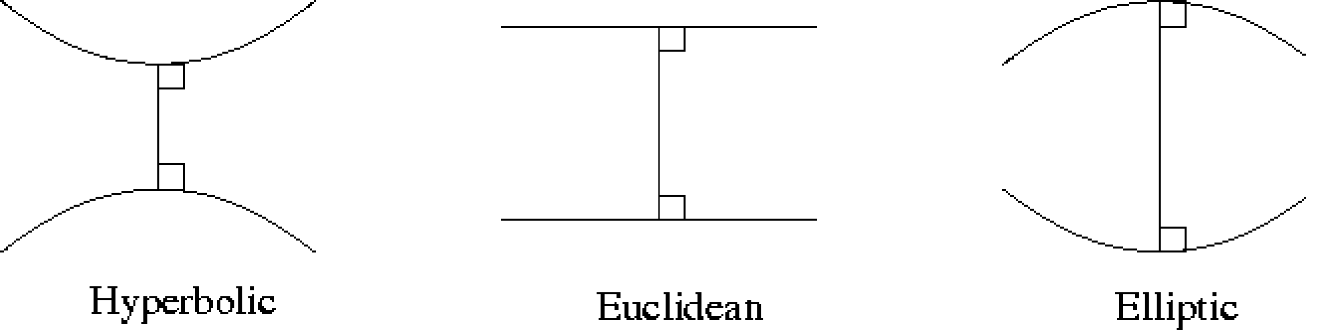

Behavior of lines with a common perpendicular in each of the three types of geometry

In a nutshell:

Euclid (circa 300 BC) produced the definitive treatment of Greek geometry and number theory in the 13 volume Elements.

Ptolemy (circa 130 AD) assumed that there was at least one line parallel to a line through a given point which is equivalent to Euclid's postulate-circular reasoning

Proclus (410-485) assumed parallel lines are always equidistance which is an added assumption about parallel lines.

Wallis (1616-1703) proved the Parallel Postulate assuming a postulate about Similar Triangles which is equivalent to Euclid's postulate-circular reasoning.

Saccheri (1667-1733) worked with quadrilaterals, now called Saccheri quadrilaterals, where the base angles are rights angles and the sides adjacent to the base are congruent.

The question is: what can be proven about the summit angles, <D and <C? Without assuming the Parallel Postulate, it can be proven that the two summit angles are congruent. Then, there are three distinct possibilities:
The summit angles are acute angles.

the summit angles are right angles.

the summit angles are obtuse angles.

What Saccheri Finally Wrote Was: "The hypothesis of the acute angle is absolutely false, because [it is] repugnant to the nature of the straight line!" (Greenberg, p.155)

Clairaut (1713-1765) proved the Parallel Postulate assuming a postulate about the Existence ofRectangles which is equivalent to Euclid's postulate-circular reasoning.

Legendre (1752-1833) worked with the Parallel Postulate assuming a postulate about angle sum of a triangle being equal to 180o which is equivalent to Euclid's postulate-circular reasoning.

37

Nature and Science, 2009;7(7), ISSN 1545-0740, http://www.sciencepub.net, naturesciencej@gmail.com

\Lambert (1728-1777) worked with quadrilaterals, now called Lambert quadrilaterals, which have three right angles. The question is what can be said about the fourth angle?

Since so many mathematicians had tried to prove Euclid's Parallel Postulate, Klügel did his doctoral thesis in 1763 finding the flaws in 28 different proofs of this postulate. The thesis led d'Alembert to call Euclid's Parallel Postulate "the scandal of geometry." (Greenberg, p.161)
The Hungarian Farkas Bolyai wrote to his son János:

You must not attempt this approach to parallels. I know this way to its very end. I have traversed this bottomless night, which extinguished all light and joy in my life. I entreat you, leave the science of parallels alone. I thought I would sacrifice myself for the sake of truth. I was ready to become a martyr who would remove the flaw from geometry and return it purified to mankind. I turned back when I saw that no man can reach the bottom of the night. I turned back unconsoled, pitying myself and all mankind.

I have traveled past all reefs of this infernal Dead Sea and have always come back with broken mast and torn sail. The ruin of my disposition and my fall date back to this time. I thoughtlessly risked my life and happiness. (Greenberg, pp: 161-162) The son János Bolyai (1802-1860)wrote back:

It is now my definite plan to publish a work on parallels as soon as I can complete and arrange the material. When you, my dear Father, see them, you will understand; at present I can only say nothing except this: that out of nothing I have created a strange new universe. All that I have sent you previously is like a house of cards in comparison to a tower.(Greenberg, p. 163)

When János's father send his work to Gauss (1777-1855), Gauss wrote back that he, in essence, had done this work but would never publish it since: Most people have not the insight to understand our conclusions and I have encountered only a few who received with any particular interest what I comcated to them.

(Greenberg, p. 178)

C Lobachesky (1792-1656) was the mathematician first to publish an account of non-Euclidean geometry in 1829. However, the original was published in Russian. It was not until 1840 that the work was published in German and received some recognition. Since his work openly challenged Kant's view of space as "a priori" knowledge, he was fired 1846 from his university post.

- In 1868, Beltrami settled the question about Euclid's Parallel Postulate by proving that no proof was possible.

- Riemann (1826-1866) developed elliptic geometry starting in 1854.

- Klein, Beltrami and Poincaré worked in the last half of the 19th century in developing models for hyperbolic geometry.

38

Nature and Science, 2009;7(7), ISSN 1545-0740, http://www.sciencepub.net, naturesciencej@gmail.com

- In 1882, Pasch developed one of the first modern set of axioms for Euclidean geometry.

- In 1902, Hilbert, a great champion of the axiomatic method, published a set of axioms which filled the gaps for Euclidean geometry.

- In 1932, Birkhoff developed a new set of axioms for geometry, based totally on the connections between geometry and real numbers and include distance and angle as undefined terms.

- Gödel, in 1940, proved that no mathematical system can be complete.

Equivalent Statements for Hyperbolic Geometry:

- Given a line and a point P not on, there are at least two distinct lines through P parallel to.

- Every triangle has angle sum less than 180o

- If two triangles are similar, then the triangles are congruent.

- There exist an infinite number of lines through a given point P parallel to a given line.

- In the Saccheri quadrilateral, the summit angles are congruent and less than 90o

- In the Lambert quadrilateral, the fourth angle is less than 90o.

- Rectangles do not exist.

Geometry is the second field of mathematics. It is the extension of number theory. There is no exact period for the origin of classical geometry. Euclid of Alexandria was the first mathematician who compiled Elements which contains propositions and constructions. In Elements, Euclid assumed five postulates. Euclid could not prove the parallel postulate. After Euclid almost all the mathematician attempted to deduce the fifth postulate from the first four postulates. But unfortunately all of them failed. The studies on this famous historical problem gave birth to two consistent models of non-Euclidean geometries. These affine geometries are widely used in quantum physics and relativistic mechanics. Also, the surveys and research led to a number of propositions equivalent to the fifth postulate. One among them is Saccheri’s similar triangle proposition. In this work the authors derive the preliminary result and sincerely propose the open problem by using a physical phenomena.

Preliminary Result

In classical and Riemannian geometries we can construct similar triangles. But it is impossible to draw a triangle similar to the given triangle in Lobachevskian geometry. Let ABC be the given Lobachevskian triangle. By using computer technology and software magnify this triangle. And let A’B’C’ be the magnified triangle of the given Lobachevskian triangle ABC. It is well known that in magnification the angles are preserved. So, the Lobachevskian triangles ABC and A’B’C’ are similar. Without assuming Euclid’s fifth postulate, we have derived this preliminary result. This establishes Saccheri’s above said theorem [1,2,3,4]. But it has been shown once and for all that the fifth postulate is a specialcase. The author has proved this impossibility and published his paper [6]. This computer- cum-mathematical work has no equations at all.

39

Nature and Science, 2009;7(7), ISSN 1545-0740, http://www.sciencepub.net, naturesciencej@gmail.com

Conclusion

Magnification is a Universal phenomenon. This technique is applied in physics, astronomy, biology, medicine, architecture, particle physics, genetics, microbiology and in chemistry. Without magnification deep studies and research in the above said fields are impossible. For the first time in the history of mathematics, the authors applied magnification technology and obtained a solution for a nearly 4300 year old parallel postulate problem. To put it in a layman’s language, an impossible has been shown to be possible. This is a problematic problem. Further studies will give birth to a new branch of mathematical science.

ACKNOWLEDGEMENTS

The author wishes to thank the late Professor Palaniappan Kaliappan of Mathematics Department,nallamuthu Gounder Mahalingam College,Pollachi,Tamil nadu 642001,India for his kind encouragement for the preparation of this paper.

Dicsussion:

Since we have derived (21) without assuming the parallel postulate. (21) establishes the fifth Euclidean postulate.[ 2 - 7 ] Our construction,i.e figure 1 can be extended to both hyperbolic and elliptic spaces also.Through out this work, we have applied only the fundamental operations of number theory and algebra.So, (21) is consistent.If it is inconsistent, immediately it implies that one plus two is NOT equal to three.This is absurd.Similarly to brand that (21) is incorrect is also absurd.Only God is the Number One expert.The almighty reveals some message through (21).We have to probe into (21) which will definitely give birth to a new field of science.

References:

Euclid: Elements I, prop. 10
Effimov,NV: Higher Geometry,mir publishers,Moscow,1972, pp 1-30
Courant & Robbins: What is mathematics?,Oxford University Press,1941
Smilga: In the search for the beauty,Mir Publishers,Mosow,1972,pp 1 - 50
Eves,H: An introduction to the history of mathematics,Holt,Rinechart and Williams,New York,1976

Kalimuthu,S; Pretty Algebra,Nature and Science,Marsland Press,New York,2009,Vol. 7, No.6, pp 86 - 89

www.groups.dcs.standac.uk/~history/HisTopics/Non.Euclidean_geometry
www.cut-the-knot.org
http://www.softsurfer.com/history.html

40

