Evaluation of Disease Intensity of Some Rust Fungi at Nainital Hills

- Dr. Anwesha Sah - Research Associate, Office of Silviculturist, Uttarakhand, Forest Division, Nainital (Uttarakhand), India, Pin code 263002, Mob.+919412017438
E mail; anwesha.sah@goggle.com, anweshar200017@yahoo.com
- Prof Uma Tiwari Palni – Prof. & Head, Department of Botany, D.S. B Campus, Nainital, Uttarakhand, India , Pin code 263002, E mail;- umapalni@rediff mail.com, Mob.No.+919837229479, 05942 – 238 963
- Dr. Y. P. S Pangtey- Emeritor fellow, Department of Botany, D.S. B Campus, Nainital, Uttarakhand , India, Pin code 263 002. Email;-y_pangtey@yahoo.com, Mob. no. +91 -9837852569, +91-5946-284546.

Abstract: Eight common disease causing rust fungi of the study area were selected for the evaluation Disease Intensity study. These were Aecidium deutziae on Deutzia aecidium, Coleosporium clematidis on Clematis buchananiana, Melampsora ciliata on Populus nigra, Phragmidium incompletum on Rubus nivens, Puccinia nepaleesis on Rumex nepalensi, Puccinia oxalidis on Oxalis dehradunensis, Puccnia padwickii on Cyathula tomentosa and Ravenalia mitteri on Indigofera hetarantha in three selected localities in different attitudinal range i.e. Tallital (1800-2100), Ayarpatta (2100-2300 m) and Mallital (2300-2500 m) during 2006 & 2007. Results of Analysis of Variance indicated that both locality and year had the significant impact to influence the disease development by the rust fungi when considered together. Melampsora ciliata showed maximum disease development (38.72%) followed by Puccinia padwickii (37.20), Puccinia oxalidis (34.92%), Puccinia nepalensis (34.55), Phragnidium incompletum (28.87%), Coleosporium clematidis (17.97) and Aecidium deutizae (17.20%) and Ravenalia mitteri (15.88%). The data recorded at Mallital and Ayarpata localities did not differ significantly compared to Tallital locality. The average disease intensity during 2006 & 07 did not differ significantly and it was 28.47% in 2006 and 27.85 in 2007. [Nature and Science. 2009;7(7):67-72]. (ISSN: 1545-0740).

Key words – Rust fungi, Disease Intensity, Uredinales, Basidiomycetes, Nainital

INTRODUCTION
The rust fungi are a unique and interesting group of fungi traditionally classified in the order Uredinales of the class Basidiomycetes, which are characterized by the presence of basidia and basidiospores (Cummins & Hiratsuka, 2003). The word rust fungi originates from the fact that rust sori are often reddish-orange and can be identified easily to family and generic levels. (Hiratsuka and Sato,1982).In the natural habitat, rust fungi are obligate parasites on living plants, although a few species have now been cultured successfully on artificial media (axenic culture). Rust fungi cause diseases in a wide range of host plants ranging from Pteridophytes (mainly ferns), Gymnosperms (particularly conifers) and flowering plants (both monocotyledons and dicotyledons).
Since there are very few reports dealing with rust fungi of Nainital hills, the present study was undertaken to evaluate the rust disease intensity of most common rust fungi or this area.

Materials and Methods

STUDY AREA
Collections of rust fungi were made from 2006 to 2007 between the altitudes ranging from 1800 to 2611m throughout the year the entire study area, but for more detailed study, collections were made from the selected localities during March to December. Since September to November is the peak season for the growth and development of the rust fungi, both uredinial and telial stages were collected during this period. However, in many cases, uredinial stages associated with aecial stages usually predominate during pre-peak season, while telial stages in the post-peak season. The disease intensity was studied in three selected localities in different altitudinal ranges i.e. Tallital (1800-2100m), Ayarpatta (2100-2300m) and Mallital (2300-2500m).

FIELD SURVEY
Detailed field surveys were undertaken to select out the most common disease causing rust fungi throughout the study area in different altitudinal ranges and finally eight common disease causing rust fungi were selected for the disease intensity study. They are: Aecidium deutziae Dietel, Coleosporium clematidis Barclay, Melampsora ciliata Barclay, Phragmidium incompletum Barcaly, Puccinia nepalensis Barclay & Dietel, P. oxalidis Dietel & Ellis, P. padwickii Cummins and Ravenelia mitteri H. Sydow in three selected localities in the study area (Mitter & Tondon,1932, 1938). The assessment of disease rating was done during September to October when the maximum disease development was exhibited by these selected rust fungi during the years 2006 and 2006.
For assessing disease intensity, the scale used is based on the method of Elliott and Jenkins (1946) in the disease appraisal of leaf blight of corn caused by Helminthosporium turcicum Pass., Ahmed (1976) of til disease caused by Synchytrium sesamicola, Lacy.and Pangtey (1979) of Dolichos biflorus L. caused by Collectotrichum capsicum (Sydow) Butler & Bibsy, Phoma medicaginea Malbr. ex Roum. and Pyrenochaeta dolichi Mohanty.
The diseased leaves were classified into five categories on the basis of total present area covered by the spots i.e. (i) 10(ii) 25 (iii) 50(iv) 75 and (v) 100. Five random samples were taken from each site and in each sample 100 leaves were observed. In case of Indigofera heterantha and Oxalis dehradunensis, each leaflet was considered as one leaf. Thus 500 leaves were picked up from one locality. All the leaves were examined and classified according to their grade of infection by comparing with the diagrammatic scale prepared and illustrated in Fig. 1.

The disease intensity was calculated by the formula given below following Naumov (1924), Ahmed (1976) and Pangtey (1979).
Degree of disease intensity per infected leaf = d

Number of infected leaves studied per site = x

Average disease intensity per infected leaf (F) = d₁ + d₂+ d₃+ d₄+ d₅…..d_{x}
x

Total number of leaves studied per site =m

Average disease intensity per site (P) = F. x /m

No. of site examined in the locality = y
Average disease intensity in the locality (I) = P₁ + P₂ + P₃+ P₄ + P₅……P_{x} Y

RESULTS
The results of disease intensity of rust fungi recorded during 2006 and 2007 are presented in Tables 1, 2, 3, 4 and 5.
The data of Table 3 showed that the disease intensity of Aecidium deutziae ranged from 12.20% to 24.03% in three localities. Coleosporium clematidis, Puccinia nepalensis and Ravenelia mitteri did not differ significantly in three localities. Melampsora ciliata had maximum disease intensity at Mallital locality and minimum at Ayarpatta locality. Similarly Phragmidium incompletum exhibited maximum disease intensity at Mallital locality, followed by Ayarpatta and Tallital localities. Puccinia oxalidis showed more or less same disease intensity at Ayarpatta and Mallital localities than the Tallital locality. Puccinia padwickii had the highest disease intensity at Ayarpatta locality, followed by Mallital locality and lowest at Tallital locality.
The data of Table 4 showed that the mean disease intensity was slightly higher in 2007 than in 2006 as shown by Coleosporium clematidis, Melampsora ciliata, Puccinia oxalidis and Ravenelia mitteri, while Aecidium deutizae, Phragmidium incompletum, Puccina nepalensis and Puccinia padwickii accounted for slightly higher in 2006 than in 2007. However, the average higher disease intensity in 2006 and 2007 was recorded in Melampsora ciliata (38.59% and 38.86%), followed by Puccinia padwickii (41.09% and 33.31%), Puccinia nepalensis (35.39% and 33.71%), Puccinia oxalidis (32.99% and 36.82%) and Phragmidium incompletum (29.09% and 28.64%), Aecidium deutziae (17.22% & 17.17%), The remaining two rust fungi viz Coleosporium clematidis. and Ravenelia mitteri, showed lower average disease intensity in 2006 and 2007 varied respectively (17.90% &18.03%) , (15.83% and 16.21%).
The data of Table 5 revealed that the average disease intensity during 2006 and 2007 did not differ significantly and it was 28.47% in 2006 and 27.85% in 2007. The mean disease intensity recorded at Tallital, Ayarpatta and Mallital localities was found, to be 24.43%, 29.36% and 30.68%.respectively; However, Mallital and Ayarpatta localities appeared to be more prone to the disease infection than the Tallital locality.
Similarly, three localities when considered together, the average disease intensity exhibited by individual rust fungi found to be highest in Melampsora ciliata (38.72%) followed by Puccina padwickii (37.20%), Puccina oxalidis (34.92%), Puccinia nepalensis (34.55%), Phragmidium incompletum (28.87%), Coleosporium clematidis (17.97%), Aecidium deutziae (17.20%), Ravenalia mitteri (15.88%).These results indicated that in the same prevailing environment conditions of the study area, Melampsora ciliata, Puccinia padwickii, Puccinia oxalidis and Puccinia nepalensis had stronger potential in causing higher disease intensity as compared to other rust fungi.

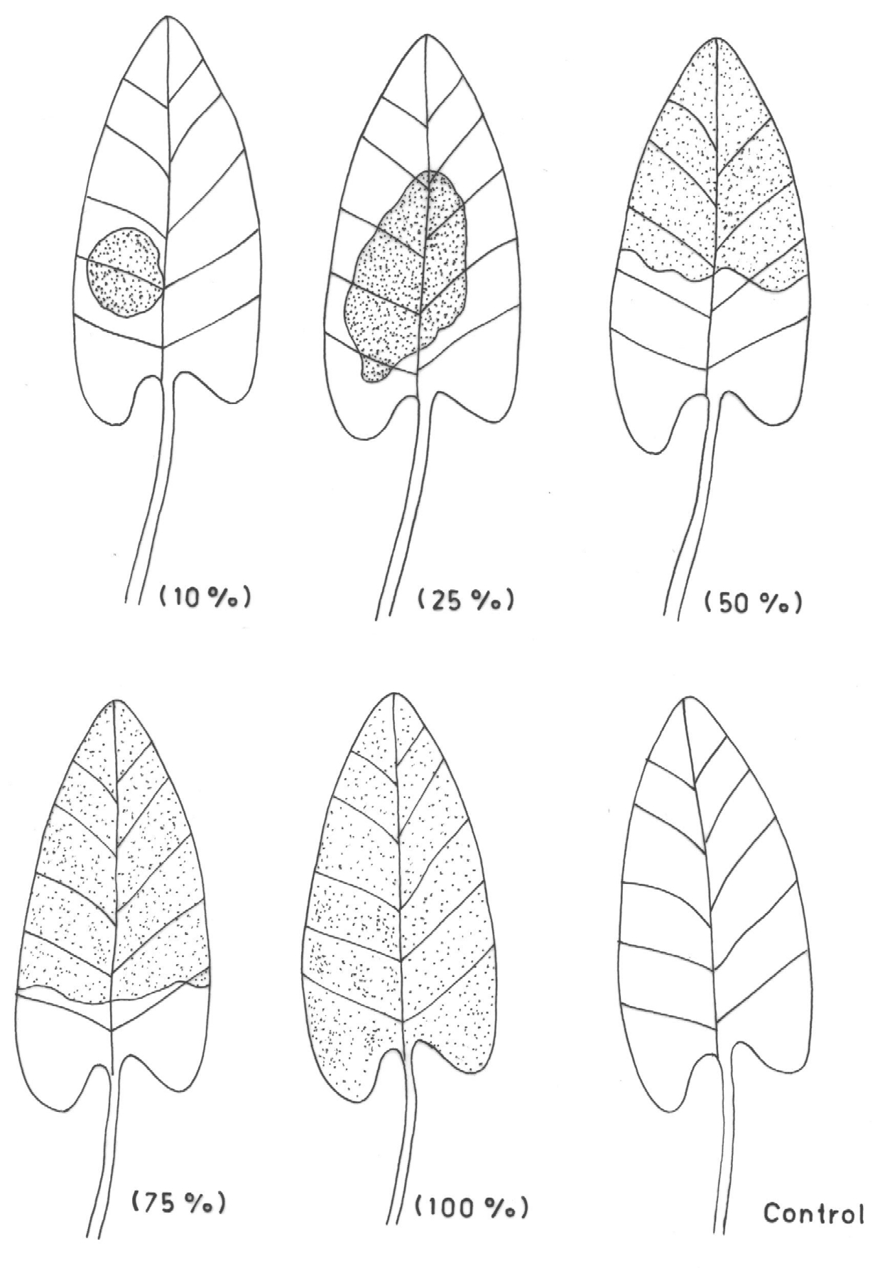

“Figure1. The comparative disease intensity due to the various rust fungi in three localities”

Results of analysis of variance have been given in Table1 which indicated that both locality and year had the significant impact to influence the disease development by the rust fungi in the study area when considered together.*

Table 1. “Analysis of variance on data for disease causing rust fungi on different host species ”
Source of variation | Sum of squares | Degree of freedom | Mean Square | F | Significance  level
 | (ss) | (df) | (Mss)
Fungus | 19684.035 | 7 | 2812.01 | 103.27 | P < 0.001
Locality | 1737.48 | 2 | 868.74 | 31.9 | P < 0.001
Year | 23.23 | 1 | 23.23 | 0.85 | NS
Fungus × Locality | 6206.48 | 14 | 443.32 | 16.28 | P < 0.001
Fungus × Year | 568.54 | 7 | 81.22 | 2.98 | P < 0.01
Locality × Year | 458.45 | 2 | 229.23 | 8.42 | P < 0.001
Fungus × Locality ×Year | 908.42 | 14 | 64.89 | 2.38 | P < 0.01
Error | 5228.06 | 192 | 27.23

Table 2. “ Disease rating of different disease causing rust fungi at Tallital, Ayarpatta & Mallital localities during 2003 and 2004. ”

S. N. | Disease causing fungi | Tallital  (1800-2100m) |  | Ayarpatta  (2100-2300m) |  | Mallital  (2300-2500m) |  | Mean
 |  | 2006 | 2007 | 2006 | 2007 | 2006 | 2007
1 | Aecidium deutziae | 12.13 | 12.28 | 14.55 | 16.19 | 25.02 | 23.03 | 17.21
2 | Coleosporium clematidis | 18.95 | 17.99 | 15.55 | 15.75 | 19.25 | 20.35 | 17.97
3 | Melampsora ciliata | 43.95 | 42.61 | 35.91 | 38.84 | 35.91 | 35.12 | 38.72
4 | Phragmidium incompletum | 15.75 | 15.92 | 29.6 | 27.88 | 41.92 | 42.13 | 28.87
5 | Puccinia nepalensis | 28.39 | 35.35 | 37.33 | 38.57 | 40.44 | 27.22 | 34.55
6 | Puccinia oxalidis | 20.66 | 27.01 | 37.53 | 43.27 | 40.82 | 40.23 | 34.92
7 | Puccinia padwickii | 38.84 | 38.25 | 43.95 | 42.61 | 40.47 | 19.07 | 37.2
8 | Ravenalia mitteri | 11.09 | 11.74 | 15.52 | 16.71 | 19.74 | 20.19 | 15.83
 | Average | 23.72 | 25.14 | 28.74 | 29.98 | 32.95 | 28.42 | 28.16
 | Average of two years | 24.43 |  | 29.36 |  | 30.68

NOTE: Figures are expressed in percentage and mean of five replicates.

Table 3. “Disease rating of different disease causing rust fungi at three different localities”

S. N. | Disease causing fungi | Tallital  (1800-2100m) | Ayarpatta  (2100-2300m) | Mallital  (2300-2500m) | Mean
1 | Aecidium deutziae | 12.20 | 15.37 | 24.03 | 17.20
2 | Coleosporium clematidis | 18.47 | 15.65 | 19.80 | 17.97
3 | Melampsora ciliate | 43.28 | 37.38 | 35.52 | 38.72
4 | Phragmidium incompletum | 15.84 | 28.74 | 42.03 | 28.87
5 | Puccinia nepalensis | 31.87 | 37.95 | 33.83 | 34.55
6 | Puccinia oxalidis | 23.82 | 40.40 | 40.53 | 34.92
7 | Puccinia padwickii | 38.55 | 43.28 | 29.77 | 37.20
8 | Ravenalia mitteri | 11.42 | 16.12 | 19.97 | 15.88
 | Average | 24.43 | 29.36 | 30.69 | 28.16

Standard error of Fungus species (S) 0.953

Standard error of Locality (L) 0.583

Standard error of Species × Locality (S × L) 1.650

NOTE: Figures are expressed in percentage and mean of five replicates.

Table 4. “Disease rating of different disease causing rust fungi during years 2006 and 2006”

S. N. | Disease causing fungi | 2006 | 2007 | Mean
1 | Aecidium deutziae | 17.22 | 17.17 | 17.20
2 | Coleosporium clematidis | 17.92 | 18.03 | 17.98
3 | Melampsora ciliata | 38.59 | 38.86 | 38.73
4 | Phragmidium incompletum | 29.09 | 28.64 | 28.87
5 | Puccinia nepalensis | 35.39 | 33.71 | 34.55
6 | Puccinia oxalidis | 32.99 | 36.84 | 34.92
7 | Puccinia padwickii | 41.09 | 33.31 | 37.20
8 | Ravenalia mitteri | 15.45 | 16.21 | 15.83
 | Average | 28.47 | 27.85 | 28.16

Standard error of Fungus species (S) 0.953, Standard error of Year (Y) 0.476, Standard error of Species x Year (S x Y) 1.347
NOTE: Figures are expressed in percentage and mean of five replicates

Table 5 “Disease rating of different disease causing rust fungi at three different localities, viz. Tallital, Ayarpatta & Mallital during years 2006 and 2007”

Agroclimatic localities | 2006 | 2007 | Mean
Tallital | 23.72 | 25.14 | 24.43
Ayarpatta | 28.74 | 29.98 | 29.36
Mallital | 32.95 | 28.42 | 30.69
Average | 28.47 | 27.85 | 28.16

Standard error of Locality (L) 0.583, Standard error of Year (Y) 0.476, Standard error of Locality × Year (L × Y) 0.825
NOTE: Figures are expressed in percentage and mean of five replicates

DISCUSSION
Results of the study conducted indicated that both locality and year had significant impact in influencing the disease development by the rust fungi in the study area. The average disease intensity during 2006 and 2007 did not differ significantly and it was 28.47% and in 2006 and 27.85 in 2007. The data recorded at Mallital and Ayarpatta localities did not differ as significantly compared to Tallital locality.

REFERENCES
- Ahmed I, Studies on the seed mycoflora and Synchytrium disease of til (Sesamum indicum L.). 1976 Ph. D. Thesis, Agra University, Agra.
- Cummins G.B and Hiratsuka, Y. Illustrated Genera of Rust Fungi. Minnesota 2003.
- Elliott, C. and Jenkins, M.T. Helminthosporium turcicum leaf blight of corn. Phytopath. 1946, 36:660-668.
- Hiratsuka, Y. and Sato, A. Morphology and taxonomy of rust fungi. In: The Rust Fungi, eds. Scott, K.J. and Chakravarty, A.K., 1982, New York, 1-36 pp..
- Mitter, J.H. and Tandon, R.N.Fungi of Nainital-I. J. Indian Bot. Soc. 1932 11:178-180.
- Mitter, J.H. and Tandon, R.N. Fungi of Nainital-II. J. Indian Bot. Soc. 1938, 17:177-182.
- Nauvov, N.A. On the question of the possibilities for determining the degree of plant infection by fungus parasites Trudy IV. Entom. Phytopath. Congr. Moscow. 1924. 22:217-228,
- Pangtey, Y.P.S. Ivestigations on Seed-borne Fungi of Dolichos biflorus L. and Glycime hispida Maxinm. Two Common Legumes of Kumaun. (1979). Ph.D. Thesis, Kumaun University, Nainital

5/10/2009

