Thermal decomposition kinetics of peanut shell
Bibhesh K. Singh^{1*},Priti Kumari², Anant prakash¹, Devjani Adhikari¹
¹Inorganic & Bio-inorganic Research Lab, Govt. Postgraduate College, Ranikhet-263645(Uttarakhand), India.
²Department of Botany, DSB Campus, Kumaun University, Nainital - 263002 (Uttarakhand) India.
*Corresponding Author, E-mail: bibheshksingh@yahoo.co.in ;
Phone: +91-9410311467. Fax:+91-5966220372

Abstract: A great importance was attached to harness of plant tissue because of resource and energy crisis. Through biologic and thermal chemistry technique, nature plant tissue as peanut shell shoot could be transferred to gaseous, liquid fuel used as fuel or chemical raw material. The thermal decomposition of peanut shell was composed of three step TG weight loss. Effects of temperature scanning rate, grain size and purge- gas flow rate on peanut shell decomposition character have been studied. Thermodynamic activation parameters were computed from the thermal data using Coats and Redfern methods, which confirm first order kinetics. This result could be used in peanut shell gasification process or thermal decomposition optimization. [Nature and Science. 2009;7(7):73-78]. (ISSN: 1545-0740).
Keywords: Coats & Redfern Method, Kinetics, Peanut Shell, Thermal Analysis, Thermal Decomposition,

1. Introduction
Today, great importance was attached to harness of plants tissue because of resource and energy crisis. Plant tissue was yielded through plant photosynthesis,it is a kind of transformed solidified,dposited solar energy.It is a kind of steady energy and it could be regenerated by plant. Compare to wind energy,solar energy,plant tissue energy do not confined by weather.It is of high energy density and could be transferred,stored,,transported just like normal mineral fuel.Through biologic or thermal chemistry technique nature plant tissue such as cane,peanut shell,short could be transferred to gaseous,liquid fuel used as fuel or chemical raw material.
Thermogravimetric technique has been an important research method on thermal stablisation & thermal decomposition.TG could provide theory assistance for material heating treatment and applications [1,2]. TG is an easy,quick,precise measure method. By mathematical analyzing TG data, thermal decomposition activation parameters can be obtained [3,4].This paper discusses thermal decomposition of peanut shell & its thermal decomposition effectors were studied kinetic functions was obtained and kinetic parameters were calculated. The result can be used in peanut shell thermal decomposition optimization.
2.Experimental
Peanut shell washed, dried & porphyrised to 120 μm - 380 μm before using thermal decomposion. Rigaku model 8150 thermoanalyser(Thermaflex) was used for simultaneous recording of TG-DTA curves at a heating rate of 5-10 min⁻¹ .For TG, the instrument was calibrated using calcium oxalate while for DTA, calibration was done using indium metal, both of which were supplied along with the instrument. A flat bed type aluminum crucible was used with α – alumina (99% pure) as the reference material for DTA. Purge gas was used as N₂ with varying rate 15-70 min⁻¹. The number of decomposition steps was identified using TG curves. The activation energy and Arrhenius constant of the degradation process was obtained by Costs and Redfern method [5].
3. Result & Discussion
3.1 Effects of thermal gravity analysis condition on peanut shell decomposition
3.1.1. Peanut shell thermal decomposition
The peanut shell was thermally decomposition in three decomposition steps (Fig.1 is the curve of peanut shell thermal decomposition). The first decomposition step of estimated mass loss 6% occurred at 8⁰-120ºC due to dehydration process. The DTA curve also confirms endothermic peak at peak temp. 94ºC (Maximum peak temperature The second decomposition step of estimated mass loss of 54% and occurred at 200-380ºC.Major mass loss shows this step was the Main thermal decomposition process. The DTA curve again shows endothermic peak at 330ºC. The third decomposition step of estimating mass loss mass 16% occurred at 380-700ºC,it was the thermal decomposition of residual.
3.1.2 Effects of Grain Size on Peanut Shell Thermal Decomposition
The curves of three grain size thermal decomposition were almost the same trends in fig. 2 the same purge gas flow rate and temperature scanning rate, the smaller the grain size was the lower the thermal decomposition beginning temperature was the bigger the grain size was, the higher the thermal decomposition beginning temperature was, it was explain on the basis of the heat transmission. The bigger grain size was, the heat transmission was slower, so the beginning thermal decomposition was delayed.
3.1.3 Effect of temperature scanning rate on Peanut shell thermal decomposition
Effect of temperature scanning rate on peanut shell thermal decomposition was similar to that of grain size. The thermal decomposition curves of three temperature rising rate were almost shows the same trend. At the same grain size and purge gas flow rate, the faster the temperature rising rat was the higher the beginning thermal decomposition temperature was. This was because of heat transmission. The samples temperature was always lower than the heating temperature. So the beginning of thermal decomposition was delayed.
3.1.4 Effect of Purge- gas rate on peanut shell thermal decomposition
The thermal decomposition curves (fig.3) of three purge-gas flow rate have been indicated. At the same grain size & temperature scanning rate, the faster purge-gas flow rate was, the lower the residual gravity was when the purge-gas flow rate was fast, gaseous product of thermal decomposition could be departed quickly, this promote the thermal decomposition process undergoing thoroughly, so the residual gravity was low.
3.2. Kinetics of thermal decomposition
In recent years there has been increasing interest in determining the rate – dependent parameters of solid-state non-isothermal decomposition reactions by analysis of TG curves. Several equations [5-11] have been proposed as means of analyzing a TG curve and obtaining values for kinetic parameters. Many authors [5-10] have the advantage of this method over the conventional isothermal method. The rate of a decomposition process can be described as the product of two separate functions of temperature and conversion [7], using
dα/dt=k(T)f(α) (1)
Where α is the fraction decomposed at time t, k (T) is the temperature –dependent function and f(α) is the conversion function dependent on the mechanism of decomposition. It has been established that the temperature – dependent function k(T) is of the Arrhenius type and can be considered as the rate constant k. k=Ae^{E*/RT} (2)
Where R is the gas constant in (kJ deg-¹mol⁻¹). Substituting Eq. (2) into Eq.(1), we get
dα/dt= A/θe^{E*/RT} f(α) (3)
where θ is the linear rate dT/dt. On integration and approximation, this equation can be obtained in the following form
log g(α)= -2.303E*/RT+ log[AR/θE*] (4)
Where g(α) is a function of α dependent on the mechanism of the reaction. The integral on the right hand side is known as temperature integral and has no closed for solution. So, several techniques have been used for the evaluation of temperature integral. Most commonly used methods for this purpose are the differential method of Freeman and Carroll [6], integral method of Coats and Redfern [5], the approximation method of Horowitz and Metzger [10]. The kinetic parameters calculated by the Horowitz-Metzger method revealed no significant difference with that evaluated by the Coats-Redfern method. So integral method of Coats-Redfern and using this method various kinetic parameters calculated.
The kinetic analysis parameters such as activation energy (∆E*), enthalpy of activation (∆H*), entropy of activation (∆S*), free energy change of decomposition (∆G*) were evaluated graphically by employing the Coats –Redfern relation (5):
Log [-log (1-α)/T²] = log[AR/θE*(1-2RT/E*)] - E*/2.303RT (5)
Where α is the mass loss up to the temperature T, R the gas constant, E* is the activation energy in J mol⁻¹, θ the linear heating rate and (1-2RT/E*) = 1. A plot of left hand side of Eq. (5) against 1/T gives a slope from which E* was calculated and A (Arrhenius constant) was determined from the intercept. From relevant data, linearization plots have been drawn in fig. 4 confirms first order kinetics.
The entropy of activation (S*) and the free energy change of activation (G*) were calculated using Eqs. (6) & (7):
∆S* (JK⁻¹mol⁻¹) = 2.303 R [log(Ah/kT) (6)
∆G* (Jmol⁻¹) = ∆H*-T∆S* (7)
Where k and h are the Boltzmann and Planks constant, respectively. The values of E*,A, ∆S*,∆H*and ∆G*for the decomposition steps of the peanut shell has been calculated(Table 1). The negative values of the entropies of activation are compensated by the values of the enthalpies of activation, leading to almost the same values for the free energies of activation [2]. This result could be used in peanut shell gasification process or thermal decomposition optimization.
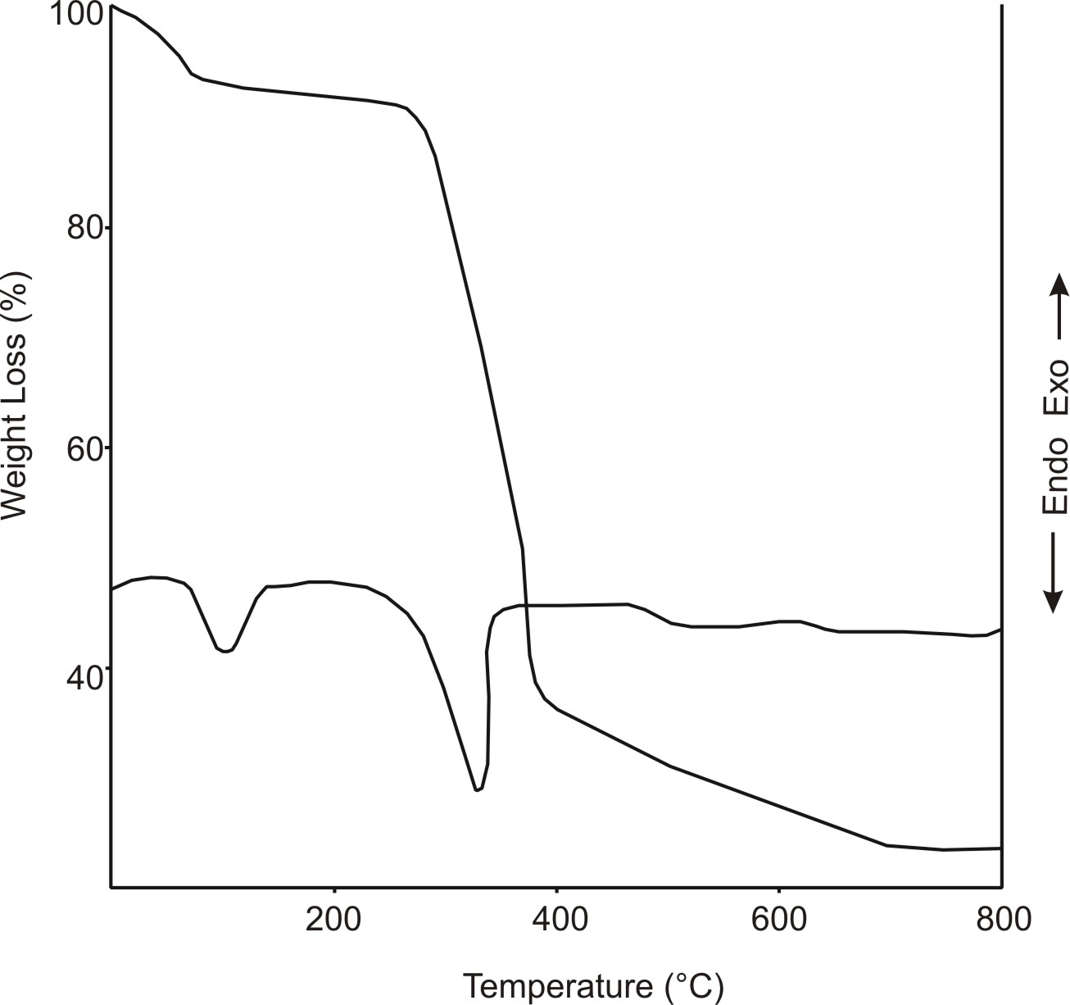
Fig 1: TG/ DTA curves of peanut shell thermal decomposition

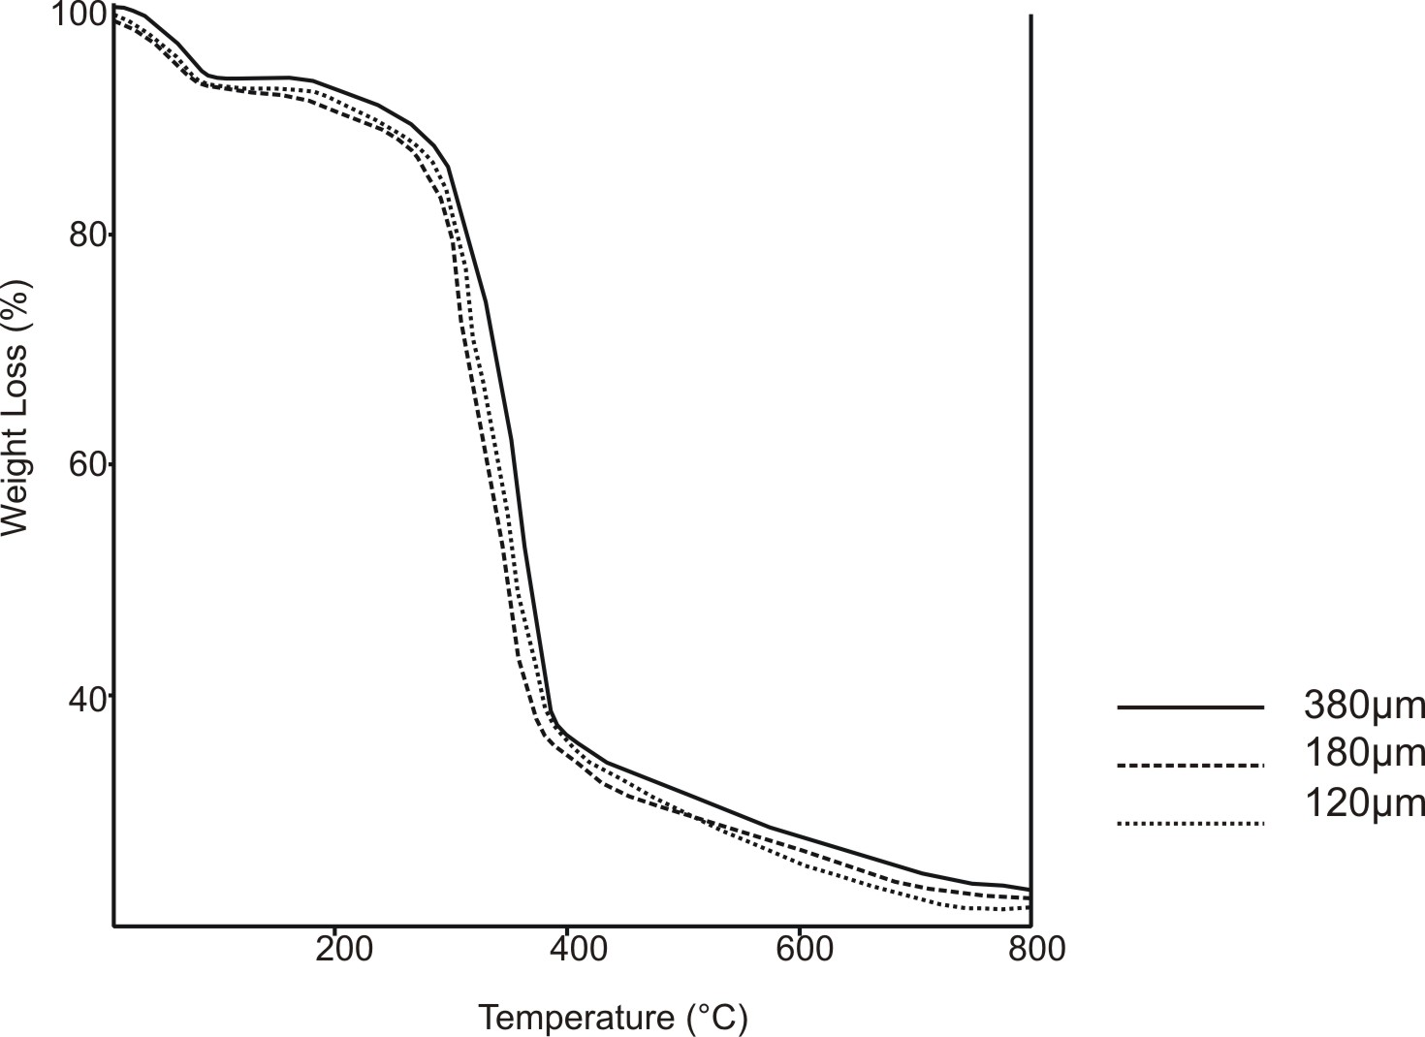
Fig 2: Effect of grain size on peanut shell decomposition

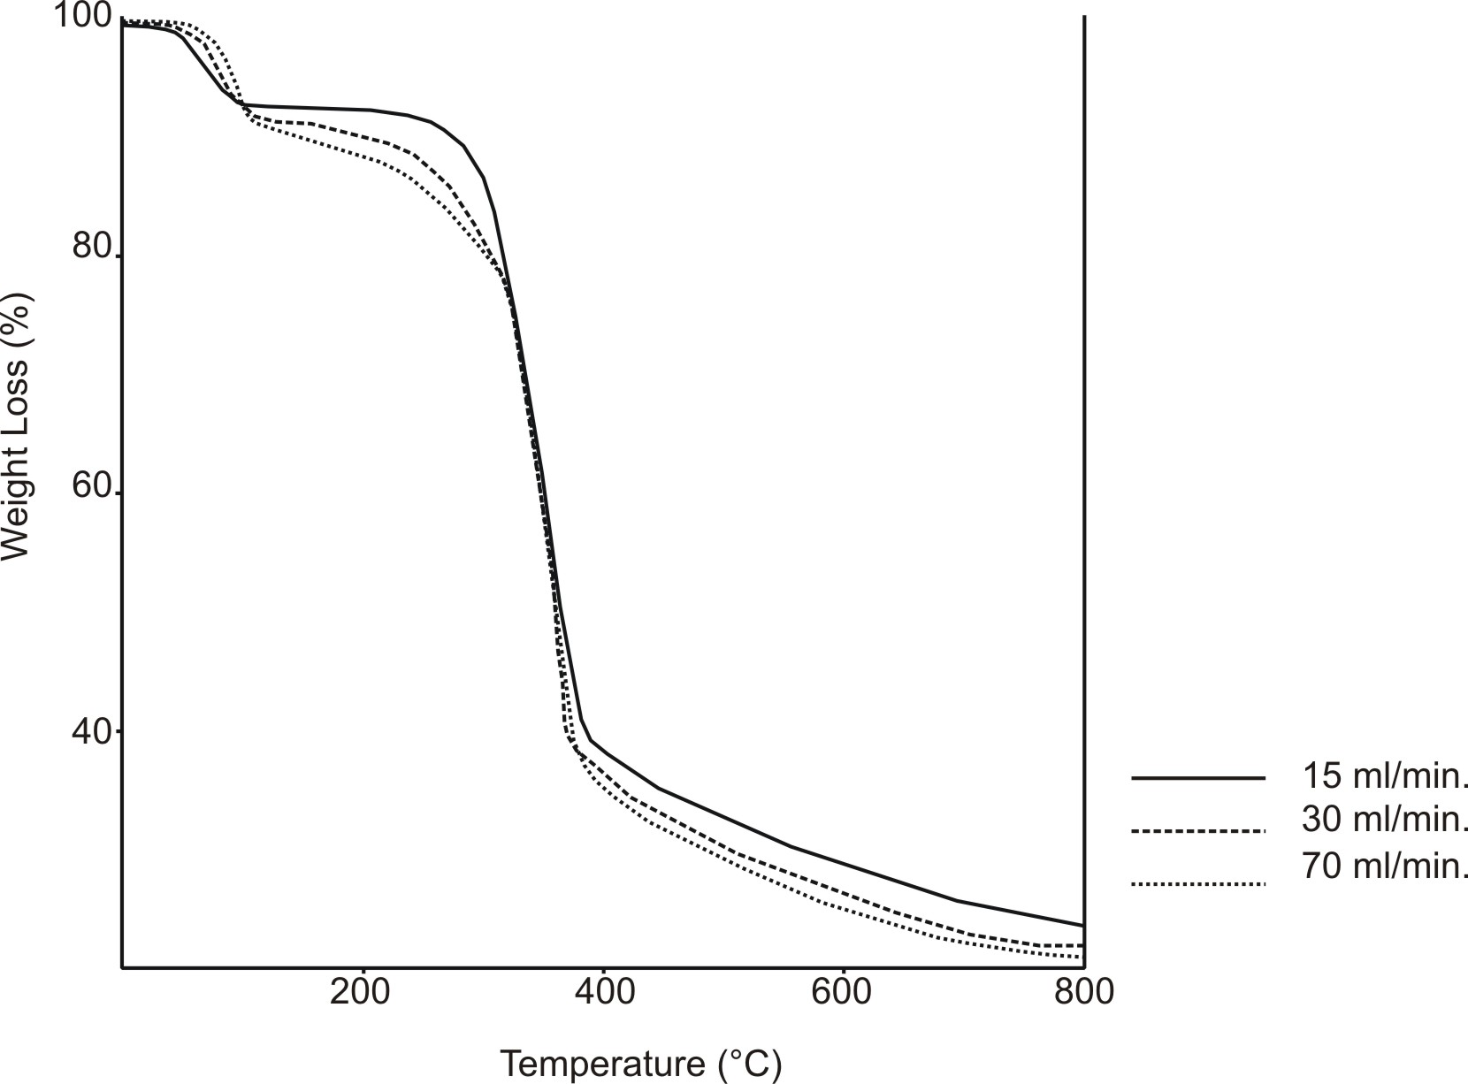

Fig 3: Effect of purge-gas flow rate on peanut shell decomposition

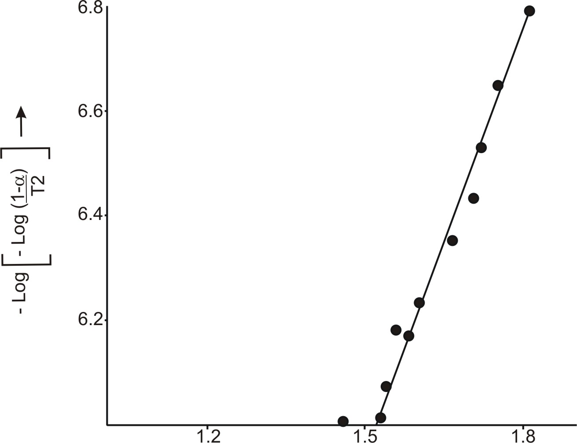
1/T×10³
Fig 4: Coats and Redfern Linearization plot of peanut shell thermal decomposition

Table 1: Thermodynamic activation parameters of the peanut shell
S.No | Step | E*(Jmol⁻¹) | A(×10² s⁻¹) | ∆H*(Jmol⁻¹) | ∆S*(JK⁻¹mol⁻¹) | ∆G*(kJmol⁻¹)
1 | I | 59.86 | 5.18 | 21.32 | -197.76 | 110.17
2 | II | 50.97 | 4.24 | 48.75 | -199.93 | 117.40
3 | III | 54.95 | 4.57 | 19.25 | -199.91 | 126.36

Acknowledgements
B K Singh is thankful to Council of Scientific and Industrial Research (CSIR) and University Grants Commission(UGC), New Delhi, India for financial assistance.

References
[1] R.Sharma, N.K.Kaushik,J.Therm.Anal.Cal.78 (20004) 953.
[2] B.K.Singh,R.K.Sharma, B.S.Garg, J.Therm.Anal. Cal. 84 (2006)593.
[3] D.N.Kumar B.S.Garg, J.Therm.Anal.Cal. 69(2004) 607.
[4] B.K.Singh,P.Mishra,B.S.Garg, Spectrochim. Acta A 67 (2007) 719.
[5] A.W.Coats, J.P.Redfern, Nature 201(1964) 68.
[6] E. S. Freeman, B. Carroll, J. Phys. Chem.. 62(1958) 394.
[7] J. Sestak, V. Satava, W. Wendlandt, Thermochim. Acta 7 (1973) 333.
[8] T. Ozawa, Bull. Chem. Soc Jpn. 38 (1965) 1881.
[9] W.W. Wendlandt, Thermal methods of Analysis, Wiley, New York, 1974.
[10] H. W. Horowitz, G. Metzger, Anal. Chem. 35 (1963) 1464.
[11] J. H. Flynn, A. Wall, Polym. Lett. 4 (1966) 323.

5/11/2009

