Staphylococcus aureus - A Cause of Fatal Toxic Shock Syndrome
In Egyptian Horses (First record)

Sherein* I. Abd El-Moez¹, Ahmed F.Y.^{2,} Omaima H. Ezzo ²
- Department of Microbiology and Immunology and 2. Department of Animal Reproduction and A.I. - National Research Center, Giza, Egypt.

Dr. Sherein Ismail Abd El-Moez* Corresponding author: shereinabdelmoez@yahoo.com

Prof. Dr. Youssef Fawzy Ahmed: yfahmed54@yahoo.com
Prof. Dr. Omaima Ezzo Hamed: Ezzo25sh@yahoo.com.

Abstract
Our study investigated the cause of an outbreak in Arabian and foreign breed equine farm with mortality rate 18.82%, the animals showed acute watery diarrhea and colic followed by death. However the animals were treated with multiple broad spectrum antibiotics. Postmortem and histopathological findings indicate generalized toxaemia in the form of severe congestion in all vital organs, pneumonia, endocarditis, gastroenteritis and nephritis. Bacteriological examination showed isolation of S. aureus from all cases which were tested for their sensitivity toward different antibiotics. Results reveals that all S. aureus isolated from infected and dead animals were 100% resistant to all tested antibiotics with an exception for vancomycin which was used to control the progress of cases in the farm. The excessive nonspecific antibiotics treatment leads to propagation of opportunistic multiple drug resistant S. aureus which release enterotoxins leading to toxic shock syndrome that end fatally after development of signs of toxemia and septicemia leading to increased morbidity and mortality rates. In Egypt this study was the first record for multiple drug resistant S. aureus toxic shock syndrome as a cause of an outbreak in equine stable subjected to multiple stressful conditions. In conclusion, Staphylococcus isolates were biochemically identified and their sensitivity against different antibiotics as well as their pathological lesions indicated that this type of S. aureus may be MRSA and the strains need further detection of the toxic genes by using molecular biology techniques. [Nature and Science. 2009; 7(7):79-87]. (ISSN: 1545-0740).

Keywords: S. aureus / Toxic Shock Syndrome / Equine / Pathology.

Introduction
S. aureus is a bacterium, frequently living on the skin or in the nose of a healthy human and animals that can cause illnesses ranging from minor skin infections and abscesses, to life-threatening diseases such as pneumonia, meningitis, endocarditis, toxic shock syndrome (TSS) and septicemia which may be rapidly fatal [1, 2]. They tend to cause different types of infections and differ in their typical antibiotic resistance profiles. The importance of methicillin resistant S.aureus (MRSA) in veterinary medicine is not well established [3]. However, MRSA outbreaks in horses suggest that this organism might be an emerging problem in the equine population [4, 5]. MRSA infection has been reported in different animal species; sheep, goat and cows [2], dogs [6] and hospitalized horses [7] and their transmission between infected horses and veterinary personnel has been documented.
In this investigation S. aureus multiple drug resistant was isolated form all cases in infected equine farm. The strains were identified by bacterial isolation, identification, antibiotic resistance test and pathological examination indicating an outbreak of toxic shock syndrome caused by multiple drug resistant S. aureus (MRSA) .To our knowledge this study considered the first record of toxic shock syndrome (TSS) in Egyptian equine.

Materials and method
Animals and clinical sampling:
Total number 17 cases out of 93 cases of horses (3cases pure Arabian and 14 cases mixed breed) at the private stable in Cairo, Egypt were dead after suffering from acute severe watery diarrhea and colic, stiffness in gate, congestion of external mucous membrane, loss of appetite with slight transient fever (39˚C - 40˚C), severe sweating and sudden death shortly 1-2 days after the onset of clinical symptoms. The sick animals showed no response for treatment using multiple broad spectrum antibiotics (Oxytetracycline, Sulphaguanidine, Streptomycin and Cephadrine). Full clinical examination of the animals were carried out, 11 blood samples were collected for virological examination, 12 fecal samples for parasitic infection, 5 vaginal, 10 nasal and 12 fecal swabs were collected for bacteriological examination. Food samples from infected farm were collected for mycotoxin evaluation and total bacterial count, also drinking water samples were collected for examining water quality.

Post mortem examination:
Post mortem and clinical examination of internal organs were carried out after death directly. Specimens were taken form different internal organs including liver, kidney, spleen, heart, lung, ceacum, intestine for bacteriological examination and other samples from the same organs were fixed in 10% neutral buffer formalin for pathological examination, processed routinely and sectioned at 4-5 micron thick, then stained with haematoxyline and eosin for microscopic examination [8].

Bacteriological sampling and monitoring bacterial profile:
Bacterial swabs were collected under aseptic conditions, including nasal swabs [3] vaginal swabs and rectal swabs [9]. Cultivation of samples, isolation and purification of the isolates were carried out using media purchased from (Oxoid); swabs were inoculated into a tube containing 10 ml Tryptic soy broth. The broth was incubated at 37ºC for 24 hrs then streaked from the enriched broth onto Nutrient, Mannitol, Blood and MacConkey agar plates. The swabs were also inoculated into Selenite-F-broth for 16 hrs then sub cultured onto Salmonella- Shigella agar medium then plates were incubated at 37°C for 16-18 hrs according to [10, 11]. Identification of isolates includes morphological examination by Gram’s Method [12]. Biochemical identification carried out according to [13,14] including catalase, oxidase, indole, methyl red, Voges Proskauer, Simmon's citrate, urease test, hydrogen sulphide production on triple sugar iron agar medium, sugar fermentation test using different sugars, arginine hydrolysis test, hippurate hydrolysis test, nitrate reduction test, coagulase test were carried out.

S.aureus identification and characterization:
Staphylococcus isolates were streaked onto Mannitol salt agar with 2 µg/mL oxacillin and incubated aerobically at 35°C for 48 hrs. Colonies identified as S. aureus were diagnosed according to [14, 15] as Gram positive, non-spore forming cocci, arranged in form of single, pairs, short chains or in irregular clusters. The colonies are circular, smooth and glistening. On blood agar, they are beta-hemolytic. Colonies are colorless to yellow. Biochemically, they are coagulase positive and are maltose fermenter to differentiate S. aureus from other Staphylococci. Confirmation of strains was carried out using Staphytect plus dry spot (Oxoid) as latex identification for S. aureus. Agar diffusion antibiotic sensitivity test was carried out for all isolated strains during the outbreak according to [16, 17, 18, 19], Antibiotic discs were obtained from Oxoid including B-lactams [penicillin-G (10 units), amoxicillin/clavulinic acid (20/10 µg/ml), cefotaxime (30 µg/ml)] , macrolides [erythromycin (15 µg/ml)], aminoglcosides [gentamicin (10 µg/ml)], fluoroquinolones [ciprofloxacin (5 µg/ml), ofloxacin (5 µg/ml)] cefadroxil (30 µg/ml), cefoperazone(75 µg/ml), tetracycline (30 µg/ml), tobramycin (10 µg/ml), sulpha/ trimetho (23.75+1.25 µg/ml), amikacin(30 µg/ml) , amoxy/fluclox (25 µg/ml) and vancomycin (30 µg/ml).

Results
Water samples were free from pathogenic bacteria. Food samples were free from mycotic infection and mycotoxins contamination; aflatoxins, ochratoxins and fumonisin. Virological as well as parasitological examinations showed negative results.
Clinical findings of infected animals showed dullness, dehydration and depression of a horse just before death Fig. [1].Horse suffering from severe watery diarrhea, colic, stiffness in gate, slight fever (39-40˚C) , congestion of mucous membranes, loss of appetite followed by a short period of severe sweating ending with tremors and death Fig. [2]. Postmortem examination was carried out showing severe congestion and hemorrhages in intestine and caecum Fig. [3]. Severe congestion and hemorrhages in the heart and lung as shown in Fig.[4]. Histopathological examination showed signs of generalized toxemia in the animal tissue. The lung showed alveolar emphysema, edema and interstitial lymphocytic infiltration in the lung tissue as shown in Fig. [5] and hemorrhages as in Fig .[6], kidney tissue showed severe degenerations and interstitial hemorrhages as shown in Fig.[7] as well as hyaline cast in the renal tubules as shown in Fig. [8]. Severe gastritis with mononuclear cellular infiltration and congestion of blood capillaries was shown in Fig. [9]. Caecum showed congestion and hemorrhages of the blood capillaries in the caecal mucosa Fig. [10]. Lesions of the heart showed degeneration and severe oedema between the cardiac muscle bundles Fig. [11].These clinical and pathological changes indicate signs of toxemia.
Bacteriological studies revealed the presence of S. aureus isolates completely identified in all tested samples as Gram-positive cocci, grape-like, large, round, golden-yellow colonies, β-hemolysis on blood agar plates. Biochemical identification revealed; catalase positive, coagulase positive test S. aureus, isolates were subspecies: S. aureus aureus. The incidence of isolation of S. aureus was reached 100% from examined samples; nasal, vaginal and rectal swabs as well as tissue samples; liver, kidney, spleen, heart, lung, ceacum, intestine. Other isolates recovered from examined samples with lower incidence as streptococcus spp. (20%) from nasal swabs only, salmonella (17.65%) and (20.00%) from rectal and nasal swabs respectively. E. coli (11.76%) from rectal swabs only. Table [I] showed highest rate of isolation was from the rectal swabs followed by vaginal swabs then nasal swabs and finally internal organs of dead case. The total number of isolates showed that the highest incidence was S.aureus followed by salmonella then streptococcus and E.coli. All isolated strains were tested for their sensitivity toward different antibiotics. Results reveals that all S.aureus isolated from infected and dead animals were 100% resistant to all tested antibiotics as shown in Table [II] and Fig. [12, 13]. The previous multiple drug resistant S. aureus isolates were then tested against vancomycin showed high sensitivity.

Discussion
Our study investigated the cause of an outbreak in equine farm with mortality rate 18.82% showing severe watery diarrhea, colic, loss of appetite with slight transient fever (39˚C - 40˚C), severe sweating and sudden death. However the animals were treated with multiple broad spectrum antibiotics. These results agree with [20] who stated that several problems in which diarrhea is one of the symptoms can be quickly fatal in equine, diarrhea caused by bacteria will usually elevate the horse’s temperature a degree or two for a short time during invasion of the intestinal lining, after that temperature may drop back to normal.
Postmortem examination was carried out showing severe congestion in all vital organs, these findings indicate generalized toxaemia. Histopathological examination showed signs of generalized toxemia in the animal tissue in the form of pneumonia, endocarditis, gastroenteritis and nephritis. These results agree with bacteriological findings which indicate multiple drug resistant S. aureus from all examined samples which was accused of causing toxic shock syndrome in equine. These findings agree with [21] who found that clinical MRSA infection in horses ranges from simple skin and soft tissue infections to bacteriaemia/ septicemia, pneumonia, septic arthritis, endocarditis and osteomyelitis. Also, Results agree with [22] which reported that some strains of S. aureus carry exotoxins; toxic shock syndrome toxin 1 (TSST-1) which are superantigen cause toxic shock syndrome if they are released systemically. They added that, S. aureus can produce several enterotoxins which cause staphylococcal gastroenteritis (food poisoning) causing symptoms including nausea, vomiting, diarrhea, abdominal cramps and muscle cramps.
The incidence of isolation of S.aureus reached 100%. All isolated strains were tested for their sensitivity toward different antibiotics. Results reveals that all S.aureus isolated from infected and dead animals were 100% resistant to all tested antibiotics. This agree with [23] who reported that the majority of MRSA isolates were multidrug resistant. Also, it agree with [24] who mentioned that Fluoroquinolone-resistant S. aureus strains should be suspected of being MRSA. Also, [24, 25, 26] proved that antibiotic susceptibility tests can also be used to identify MRSA. Also, these results agree with [11] who proved that MRSA either produce potent toxins or resist a wide range of antibiotics. Also, results agree with [21] who reported that Methicillin resistance in S. aureus are resistant to all penicillins, cephalosporins and members of their classes. They added that, resistance to methicillin represents resistance to all Β-lactam antimicrobials. Results also agree with [27] who proved that the antimicrobial therapy is not required for eradication and control of MRSA colonization in horse's farm.
Our study proved that the previous multiple drug resistant S. aureus isolates showed sensitivity toward vancomycin. Results agree with [28] who mentioned that MRSA is multiple drug resistant to different antibiotics as well as Beta lactams and are only susceptible to vancomycin. Results agree with [29, 30] who mentioned that S. aureus is an opportunistic pathogen which can cause diseases ranging from superficial soft-tissue infections to life-threatening bacteremia and toxic shock syndrome. Our investigation proved that the horses highly affected in the outbreak were a mixture of imported horses from different localities and Arabian breed, Case history revealed that horses were completely exhausted due to massive training program for race, high environmental temperature (40-43˚C), excessive antibiotics treatment and high mortality (18.82%) without proper identification and antimicrobial sensitivity test, such treatment can result in prolonged delay in the administration of effective therapy and subsequent propagation of opportunistic multiple drug resistant S. aureus which release enterotoxins leading to toxic shock syndrome end fatally after developing signs of toxemia and septicemia leading to increased morbidity and mortality rates. These findings agree with [3, 5, 31] who proved that MRSA infection may be an emerging disease in horses, its infection become endemic on horse farms because of the extensive movement of horses, especially thoroughbreds and standard breeds. Also results agree with [11] who abuse MRSA of being a critical pathogen responsible for a great morbidity and mortality especially among immunosuppressed cases. Also, results agree with [21] mentioned that animals at high-risk of MRSA infection are the immunosuppressed, antimicrobial-treated, and surgically incised animals. They added that the most significant problems associated with the emergence of MRSA is treatment failure caused by empirical treatment of presumed S. aureus infections with Β-lactam antimicrobials and added that without proper identification of the MRSA isolate by culture and antimicrobial-sensitivity testing, such treatment can result in a prolonged delay in administration of effective therapy and subsequent increase in morbidity and mortality.
In our study MRSA was isolated from the nares of healthy animals after the end of outbreak. These finding agree with [3] who proved that Animals can be colonized with MRSA for variable periods of time without developing clinical disease and added that there are no proven options to eradicate MRSA from horse's nares.
The horse stable where the outbreak occurred was closely situated near a large dog farm and as the dogs are asymptomatic carriers for MRSA therefore they might be accused of being the source of infection for the nearest horses stable. This agrees with [32] who mentioned that S. aureus recovered from less than 10% of dogs and cats in most studies, although carriage rates are as high as 90%. [5, 33] had evidence that some MRSA strains may be spreading in equine populations, most canine and feline. They added that these strains might be particularly well-adapted to transmission in horses. [6] Isolated MRSA from 133 animal cases, 131 were isolated from equine and 2 from canine. These results agree with [34] who isolated MRSA from 69 dogs and one horse. Also, [3] reported that MRSA was found in 13% of horses on one farm in the province and in 5% of horses on another farm. [33] Found that MRSA infections become more common in horses. Results also agree with [35] who isolated MRSA from 16% of horses tested at a university equine clinic in the U.K.
In Egypt this study was the first record for multiple drug resistant S.aureus toxic shock syndrome as a cause of an outbreak in equine stable suffering from multiple stressful conditions. This study needs further investigation of bacterial toxin by molecular biology as an accurate tool of bacterial toxin identification. This agree with [36] who mentioned that diagnosis of MRSA in horses depend on laboratory identification of S. aureus from clinical specimen but identification of MRSA required additional testing to identify phenotypic resistance or the presence of mec-A gene using molecular technique.

Table [I]: Incidence of bacterial isolation from different sites of infected living and dead equine cases.
Isolated strains | Rectal swabs (17) |  | Vaginal swabs (5) |  | Nasal swabs (10) |  | Internal organs of dead case (8) |  | Positive samples (40)
Isolated strains | No | % | No | % | No | % | No | % | No | %
S.aureus | 17 | 100.00 | 5 | 100.00 | 10 | 100.00 | 8 | 100.00 | 40 | 100.00
streptococcus | 0 | 0.00 | 0 | 0.00 | 2 | 20.00 | 0 | 0.00 | 2 | 5.00
salmonella | 3 | 17.65 | 1 | 20.00 | 0 | 0.00 | 0 | 0.00 | 4 | 10.00
E.coli | 2 | 11.76 | 0 | 0.00 | 0 | 0.00 | 0 | 0.00 | 2 | 5.00
Mean ±SE | 1.29 ±0.31 |  | 1.20 ±0.54 |  | 1.20 ±0.38 |  | 1.00 ±0.35 |  | 1.20 ± 0.19

Table [II] Antibiotic sensitivity test of S.aureus isolates, salmonella and E.coli recovered from rectal swabs of healthy and infected groups.
Isolated strains | S.aureus |  | Salmonella spp. | E.coli
Animal group  Antibiotics | Infected group  (40) | Healthy group  (6) | Infected group  (3) | Infected group  (2) | Healthy group  (8)
Amikacin (30) | 100.00% R | 66.67%S  33.33% R | 66.67%I  33.33% R | 100.00% S | 100.00% S
Amoxicillin/ clavulinic acid (20/10) | 100.00% R | 66.67%S  33.33% R | 100.00% S | 100.00% S | 100.00% S
Amoxy/fluclox (25) | 100.00% R | 50.00%S  16.67% I  33.33% R | 100.00% S | 100.00% S | 100.00% S
Cefadroxil (30) | 100.00% R | 66.67%S  33.33% R | 100.00% S | 100.00% S | 100.00% S
Cefoperazone (75) | 100.00% R | 66.67%S  33.33% R | 100.00% S | 100.00% S | 100.00% S
Cefotaxime (30) | 100.00% R | 66.67%S  33.33% R | 100.00% S | 100.00% S | 100.00% S
Ciprofloxacin (5) | 100.00% R | 66.67%S  33.33% R | 100.00% S | 100.00% S | 100.00% S
Erythromycin (15) | 100.00% R | 66.67%S 33.33% R | 66.67%S  33.33% I | 100.00% S | 100.00% S
Gentamicin (10) | 100.00% R | 50.00%S  16.67% I  33.00%R | 100.00% S | 100.00% S | 100.00% S
Ofloxacin (5) | 100.00% R | 66.67%S 33.33% R | 100.00% S | 100.00% S | 100.00% S
Oxytetracycline (30) | 100.00% R | 66.67%S  33.33% R | 100.00% S | 100.00% S | 100.00% S
Penicillin-G (10 units) | 100.00% R | 33.33% R 33.33% I 33.33% S | 66.67%I  33.33% R | 50.00% S 50.00% I | 100.00% S
Sulpha/trimetho (23.75+1.25) | 100.00% R | 50.00%S  16.67% I  33.00%R | 100.00% S | 100.00% S | 100.00% S
Tobramycin (10) | 100.00% R | 66.66%S 33.33% R | 100.00% S | 100.00% S | 100.00% S

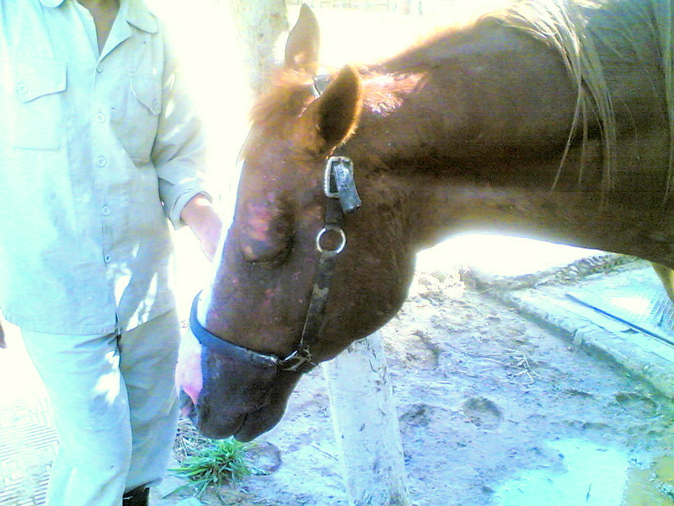
Figure [1] sick horse, showing dullness, dehydration and depression just before death.
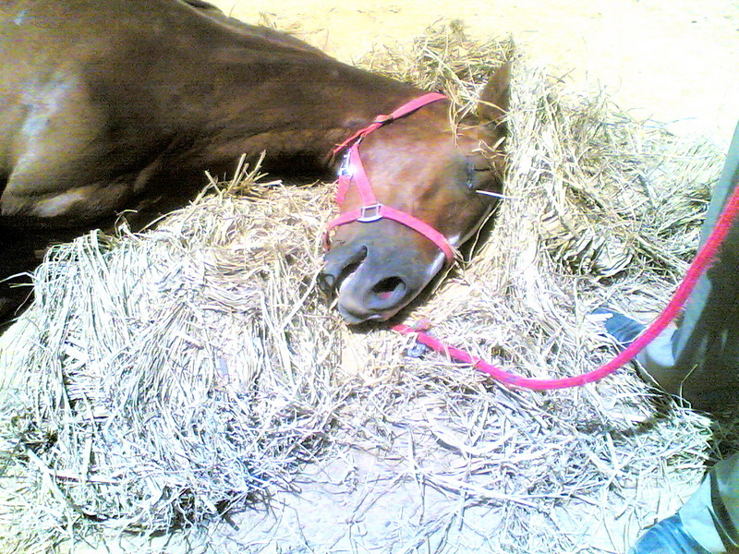
Figure [2] the same horse after death.

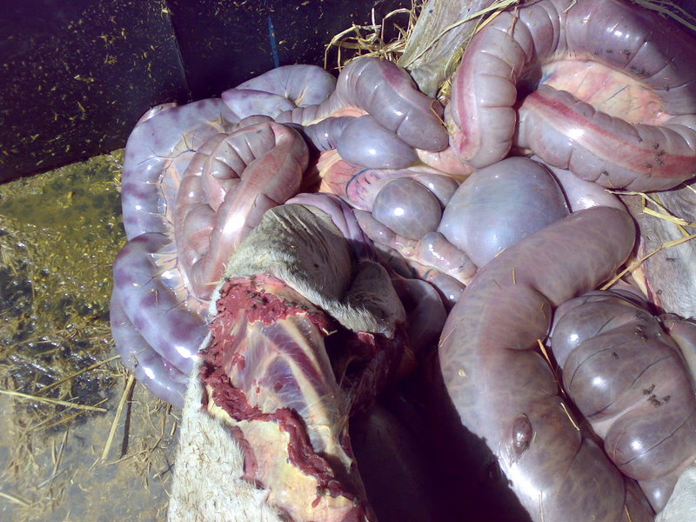
Figure [3] severe congestion and hemorrhages in intestine and ceacum.

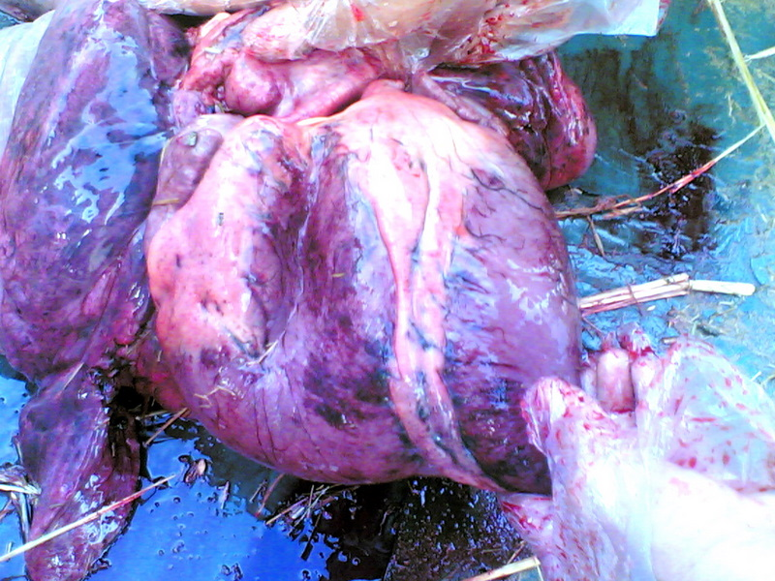
Figure [4] severe hemorrhages in the heart.

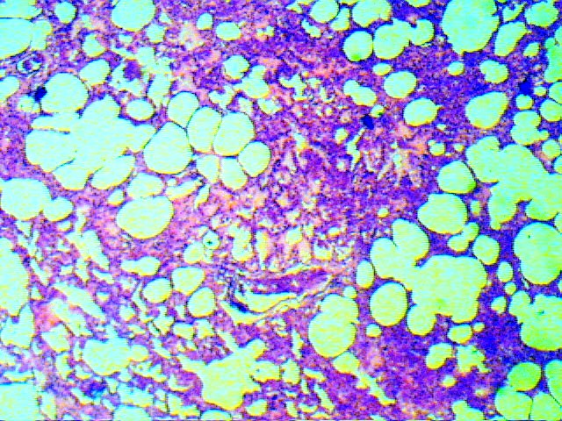
Figure [5] alveolar emphysema and lymphocytic infiltration. H&E (x 100)

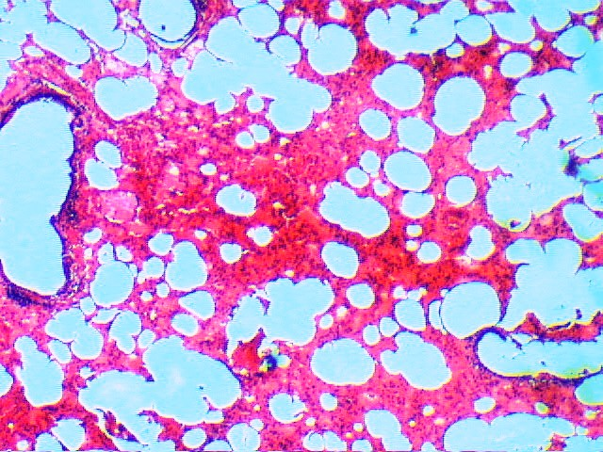
Figure [6] alveolar emphysema and interstitial edema and hemorrhage. H&E (x 100)

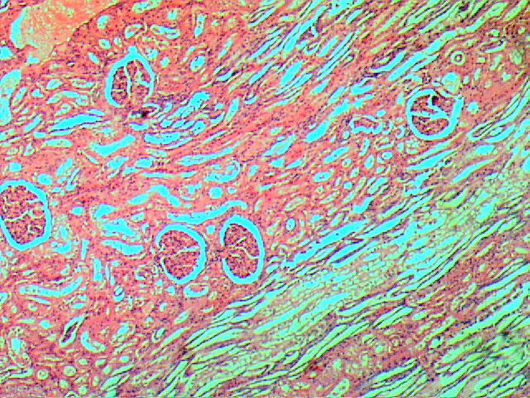
Figure [7] kidney tissue showed severe degenerations and interstitial hemorrhage. H&E (x 100)
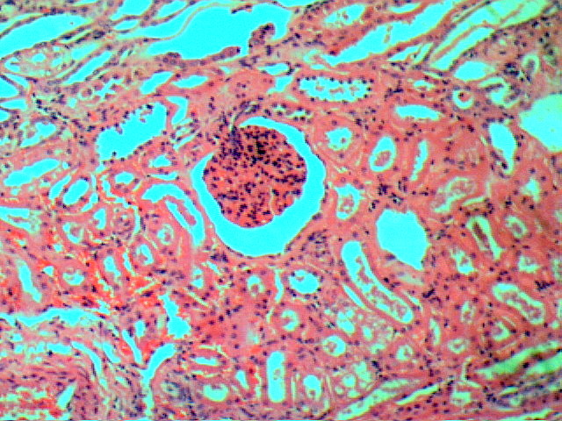
Figure [8] kidney tissue showed severe degenerations and hyaline cast. H&E (x 100)

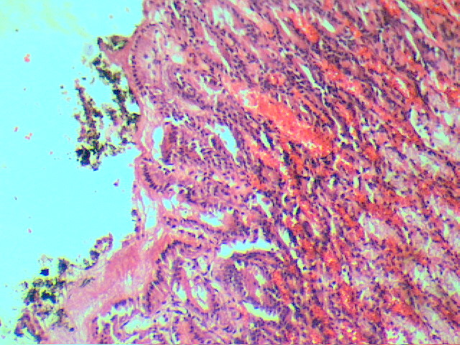
Figure [9] severe gastritis with mononuclear cells infiltration and congestion of blood capillaries. H&E (x 100)

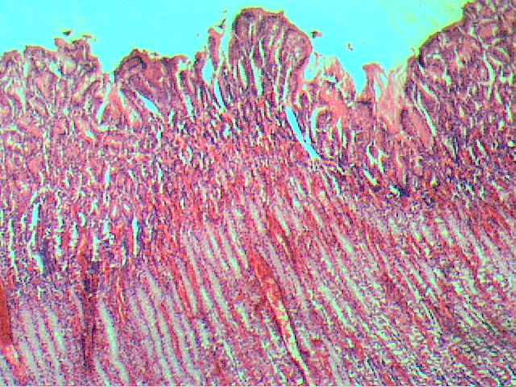
Figure [10] severe hemorrhages in the caecal mucosa. H&E (x 100)

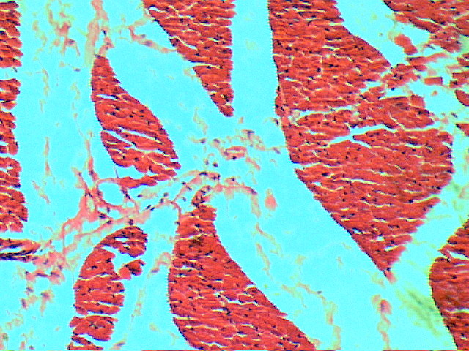
Figure [11] severe edema in the heart tissue. H&E (x 100)

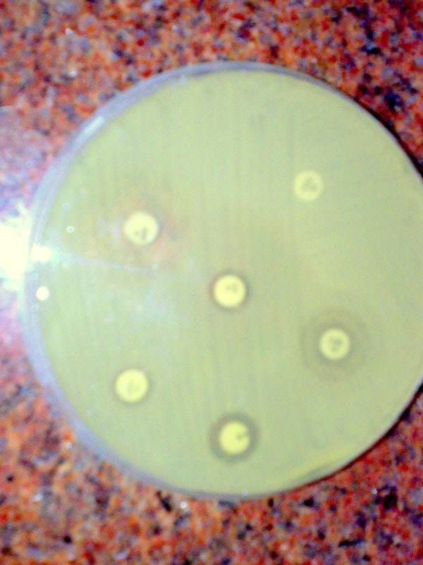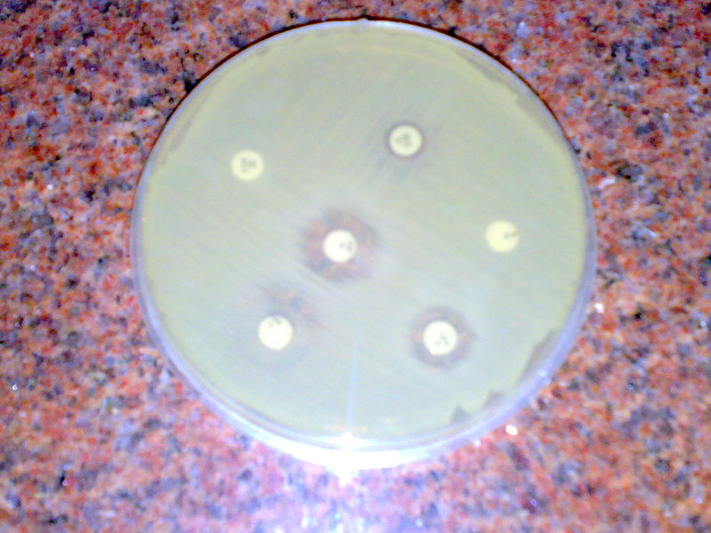
Figure [12] and figure [13] Agar diffusion antibiotic sensitivity test showing multiple drug resistant S. aureus.

Conclusion and Recommendations
-Misuse of antibiotics must be forbidden as it might be the real cause of outbreaks due to their immunosuppressive effect on infected animals due to prolonged nonspecific treatment. Rapid diagnosis in outbreaks should be carried accurately and should include screening of unusual causes and not only for suspected diseases. Researchers recommended that veterinary hospitals initiate surveillance programs for MRSA infections including rapid screening using PCR or Real time PCR, particularly in horses to clarify the role of MRSA in equine outbreaks.

References
[1] Enright M.C., Robinson .DA., Randle G., Feil E.J., Grundmann H., Spratt B.G., The evolutionary history of methicillin-resistant Staphylococcus aureus (MRSA). PNAS (2002) 99:7687-7692.
[2] Ho G., Campbell M. S., Bergdoll M. S., Carlson E., Production of toxic shock syndrome toxin variant by Staphylococcus aureus Strains associated with sheep, goats and cows. J. Clin. Microbiol. (1989) 72:1946-1948.
[3] Weese J.S., Archambault M., Willey B.M., Hearn P., Kreiswirth B.N., Said-Salim B., McGeer A., Likhoshvay Y., Prescott J.F., Low D.E., Methicillin-resistant Staphylococcus aureus in horses and horse personnel, 2000-2002. Emerg. Infect. Dis. (2005) 11(3):430-435.
[4] Cuny C., Kuemmerle J., Stanek C., Willey B., Strommenger B., Witte W., Emergence of MRSA infections in horses in a veterinary hospital: strain characterisation and comparison with MRSA from humans. Euro. Surveill., (2006) 20; 11(1).
[5] Weese J.S., Caldwell F., Willey B.M., Kreiswirth B.N., McGeer A., Rousseau J., and Low D.E., An outbreak of methicillin-resistant Staphylococcus aureus skin infections resulting from horse to human transmission in a veterinary hospital. Vet. Microbiol. (2006a) 16; 114(1-2):160-164.
[6] Bassim H., El Maghraby M., Methicillin-Resistant Staphylococcus aureus (MRSA) A Challenge for Infection Control ASJOG, (2005) 2: 277-279.
[7] Hartmann F.A., Trostle S.S., Klohnen A.A.O. Isolation of methicillin-resistant Staphylococcus aureus from a postoperative wound infection in a horse. J. Am. Vet. Med. Assoc. (1997) 211:590–592.
[8] Drury R.A.B., Wallington E.A., "Carleton's histological technique." 5th ed., Oxford Univ. Press. New York, 1980.
[9] Youngquist R.S., Current Therapy in Large Animals. Theriogenology, .W.B. Sounders CO., USA, 1997.
[10] Finegold S. M., Baron E.J., “Diagnostic Microbiology” 7th Ed. The C.V. Mosby Co. St. Louis, London. 1986.
[11] Quinn P. J., Markey B. K., Carter M. E., Donnelly W. J. C., Leonard F. C., Veterinary Microbiology and Microbial Diseases. Black well Scientific Publications, Oxford, London, 2002.
[12] Cruickshank R., Dugid T.P., Marmion B.P., Swain R.H., Med. Micro. The Practice of Medical Microbiology. 12th Ed. vol., 11 Edinburgh, London and New York, 1975.
[13] Collee J.G., Fraser A.G., Marmion B.P., Simmons A., Practical Medical Microbiology, 14th ed. Churchill, Living Stone, NewYork, 1996.
[14] Centers for Disease Control and Prevention [CDC]. Healthcare- associated methicillin resistant Staphylococcus aureus (HA-MRSA) [on line]. CDC; 2005 June. Available at: http://www.cdc.
[15] Bottone E.J., Girolami R., Stamm .J.M., Schneierson’s atlas of diagnostic microbiology. 9th ed. Abbott Park IL: Abbott Laboratories; Staphylococcus; (1984) p 10-13.
[16] Konman E. W., Allen S. D. Dowell V. R., Sommers H. M., Colour Atlas and Text Book of Diagnostic Microbiology 2nd edition. Lippincott, Co. N. Y., London, 1983.
[17] NCCLS. Methods for dilution antimicrobial susceptibility tests for bacteria that grow aerobically. Approved standard M7-A5. Wayne (PA): NCCLS; 2000.
[18] NCCLS Performance standards for antimicrobial susceptibility testing. Informational supplement. M100-S12. Villanova (PA): NCCLS; 2002.
[19] NCCLS. Fourteenth Informational Supplement M100-S14. Wayne (PA): NCCLS; 2004.
[20] Thomas H.S., Diarrhea in Adult Horses. Horse care. California Thoroughbred. (2001): 36-37.
[21] Anderson M.E.C., Weese J.S., Review of Methicillin-Resistant Staphylococcus aureus (MRSA) in Horses. 52 Annual Convention of the American Association of Equine Practitioners San Antonio, TX, USA, Internet Publisher: International Veterinary Information Service, Ithaca NY (www.ivis.org), (2006) 5351-1206.
[22] Public Health Agency of Canada, Office of Laboratory Security. Material Safety Data Sheet: Staphylococcus aureus [online]. Office of Laboratory Security; 2001 March. Available at: http://www.phac-aspc.gc.ca/msds-ftss/msds143e.html. Accessed 16 Apr 2006.
[23] Fluit A. C., Wielders C. L. C., Verhoef J., Schmitz F.J., Epidemiology and Susceptibility of 3,051 Staphylococcus aureus Isolates from 25 University Hospitals Participating in the European SENTRY Study. J.Clin. Microbiol. (2001) 39: 3727-3732.
[24] Van Duijkeren E., Wolfhagen M.J., Box A.T., Heck M.E., Wannet W.J., Fluit A.C., Human-to-dog transmission of methicillin- resistant Staphylococcus aureus. Emerg. Infect. Dis. (2004) 10(12):2235-7.
[25] Lee J.H., Methicillin (Oxacillin)-resistant Staphylococcus aureus strains isolated from major food animals and their potential transmission to humans. Appl. Environ. Microbiol. (2003) 69(11): 6489-94.
[26] Lee J.H., Jeong J.M., Park Y.H., Choi S.S., Kim Y.H., Chae J.S., Moon J.S., Park H., Kim S., Eo S.K., Evaluation of the methicillin- resistant Staphylococcus aureus (MRSA)-Screen latex agglutination test for detection of MRSA of animal origin. J. Clin. Microbiol. (2004) 42(6):2780-2.
[27] Weese J.S., Rousseau J., Attempted eradication of methicillin-resistant Staphylococcus aureus colonisation in horses on two farms. Equine Vet. J. (2005) 37: 510-514.
[28] Fitzgerald J.R., Sturdevant D.E., Mackie S.M., Musser J.M., Envolutionary genomics of Staphylococcus aureus: in sights into the origin of methicillin- resistant strains and toxic shock syndrome epidemic. Proc. Natl Acad. USA. (2001) 17; 98 (15):8821-8826.
[29] Gomez-Lucía E., Goyache J., Orden J. A., Blanco J. L., Ruiz Santa-Quiteria J. A., Domínguez L., Suárez G., Production of enterotoxin A by supposedly nonenterotoxigenic Staphylococcus aureus strains. Appl. Environ. Microbiol. (1989) 55:1447–1451.
[30] Kloos W.E., Bannerman T.L., Staphylococcus and Micrococcus. In: Murray PR, ed. Manual of clinical microbiology, 7th ed. Washington, DC: American Society for Microbiology (1999) 264-282.
[31] Weese J.S., Rousseau J., Willey B.M., Archambault M., McGeer A., Low D.E., Methicillin-resistant Staphylococcus aureus in horses at a veterinary teaching hospital: frequency, characterization, and association with clinical disease. J. Vet. Intern. Med. (2006b) 20(1):182-186.
[32] Duquette R.A., Nuttall T.J., Methicillin-resistant Staphylococcus aureus in dogs and cats: an emerging problem? J. Small Anim. Pract. (2004) 45(12): 591-597.
[33] O’Rourke K., Methicillin-resistant Staphylococcus aureus: an emerging problem in horses? J Am. Vet. Med. Assoc., (2003)15; 223(10):1399-1400.
[34] Rich M., Roberts L., Methicillin-resistant Staphylococcus aureus isolates from companion animals. Vet Rec. (2004) 6; 154(10): 310.
[35] Baptiste K.E., Williams K., Willams N.J., Wattret A., Clegg P.D., Dawson S., Corkill J.E., O’Neill T., Hart C.A., Methicillin-resistant staphylococci in companion animals. Emerg. Infect. Dis. (2005) 12:1942-1944.
[36] Warren D.K., Liao R.S., Merz L.R. Detection of methicillin- resistant Staphylococcus aureus directly from nasal swab specimens by real-time PCR assay. J. Clin. Microbiol. (2004) 42: 5578-5581.

5/13/2009

