Beautiful Geometry

S.Kalimuthu, SF 211 & 212/4, Kanjampatti P.O, Pollachi Via, Tamil Nadu 642003, India

Email: postulate.kalimuthu0@gmail.com

Abstract: In this work, without assuming the fifth Euclidean postulate, the following theorem was proved: There exist a number of spherical quadrilaterals whose interior angle sum is equal to 360 degrees. [Nature and Science. 2009;7(7):88-89]. (ISSN: 1545-0740).
.
Key Words: Euclid, elements, postulates ,non-Euclidean geometries, spherical triangles

MSC: 51 M04
PACS: 02.40.Dr, 02.40Ky

1. Construction

Let NA’, NB’, NC’ be the segments of a sphere S whose north pole is N as shown in fig.1 Choose a ponit A on NA’. With center N, radius NA, describe an arc cutting AB’ at B and AC’ at C.

2. Result

So, NA = NB = NC (1)

Take a point F on NA. With center N, radius NF draw an arc meeting NB at E

And NC at D. So, NF = NE = ND (2)
From (1) in triangle NAC, angle NAB = angle NCB (3)
And in triangle, NBC, angle NBC = angle NCB (4)
From (3) and (4) we obtain that angles NAB=NBC=NCB = 90 degrees (5)
Similarly from (2) we can show that angles, NFE= NEF= NED=NDE = 90 degrees (6)

From (5) and (6) we get that the sum of the interior angles of spherical

quadrilateral BCDE is equal to 360 degrees (7)

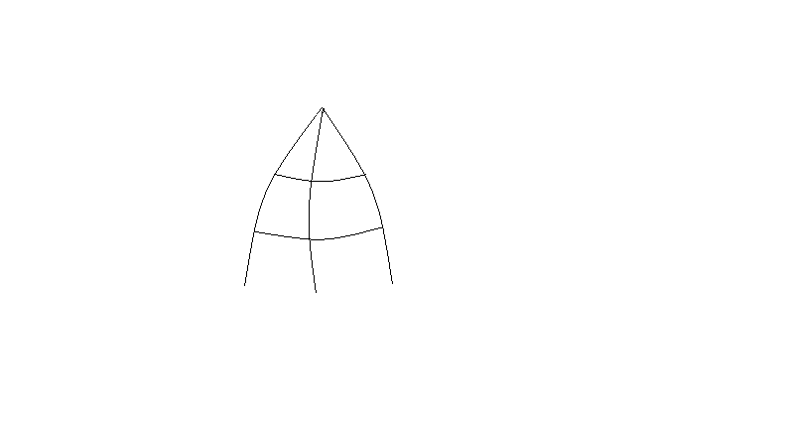
N
F
D
E
A
B
C
A’
B’
C’
Figure 1 [Spherical ]

Discussion Needless to say, (7) is controversial but consistent.Construction of a number of quadrilaterals such as BCDE is very easy. How is it possible? What is the mystery? There is something hidden treasure of physical geometry. The classical geometry is widely used in mechanics. The principles of non - Euclidean geometries are applied in quantum mechanics and general theory of relativity. A turning point in geometry always influenced theoretical physics. There are many burning problems in physics. Further investigations to be devoted on this mystery will unlock this problematic problem and give rise to a new field of physical geometry.

References:

Kalimuthu, S Pretty Algebra, Nature and Science, New York, Marsland Press, 6 (7), pp 86-89
Wikipedia [Parallel Postulate] Section2,Proposition 7

