Rare metal (Ta-Sn-Li-Be) distribution in Precambrian pegmatites of Keffi area, Central Nigeria

Olugbenga A. Okunlola¹ and Onesimus O. Ocan²
1 Department of Geology, University of Ibadan
2 Department of Geology, Obafemi Awolowo University, Ile Ife
gbengaokunlola@yahoo.co.uk

Abstract: Rare metal bearing pegmatite occurring in two major structural forms; as vertically dipping and low lying pegmatites around keffi area, central Nigeria have been studied with a view to elucidate their petrographic features and rare metal (Ta-Sn-Li-Be) distribution. Geological mapping, first on a scale of 1:50,000, then on a larger scale of 1:5000 reveal that these pegmatite bodies which intrude older lithologies of Schist and Older Granite have varied and distinct mineralogical zones. The vertically dipping type exhibit more mineralogical zonations with five distinct zones identified. These are Muscovite-Quartz- Microcline- Albite- Tourmaline (MQMAT), Lepidolite-Muscovite-Tourmaline (LMT), Microcline-Albite (MIA), Quartz-Muscovite-Albite (QMA) and Quartz–Beryl-Muscovite-Albite-Tourmaline (QBMAT) zones respectively. However, the low lying bodies exhibit less zonal complexity with only two distinct mineralogical zones, viz the Quartz- Microcline- Tourmaline zone (QMIT) and the Quartz- Albite- Microcline (QAM) zones. Chemical analysis for rare metal Ta-Nb –Sn –Li-Be content of the pegmatite bodies using the inductively coupled plasma (ICP AES) Instrumentation technique show that these rare metals have preference for specific mineralogical zones. For example, Ta has affinity for the albite and tourmaline rich zones while Li concentration is greater in zones of Lepidolite and microcline enrichment. Sn, which has the highest values generally, shows preference mainly for the LMT zone. Generally however, the pegmatite bodies are more of a Sn-Li prospect with subordinate Ta-Nb enrichment. The distinct compositional preference of rare metal content and mineralogical zones is thus a veritable exploration guide for rare metal exploration in the pegmatite of the study area. [Nature and Science. 2009;7(7):90-99]. (ISSN: 1545-0740).

Key words: Pegmatite , raremetal, mineralogical, analysis, zonations

Introduction
Pegmatite bodies of Nigeria, intrude generally discordantly, older lithologies of the Schist belt, the Gneiss migmatite complex and the Older granite suites. These pegmatite bodies were hitherto thought to be restricted to a 400 Km NE-SW trending belt from the southwestern part around Abeokuta to the north central parts around Jos (Jacobson and Webbs, 1946; Kainnard, 1984). (Fig.1) Recently however, Garba (2002), Okunlola and King (2003), Okunlola, (2005), Okunlola and Somorin (2006) have shown evidence that they may not be restricted to only this confine. Also, in a recent study, Okunlola (2005) revealed at least 3000 sizeable bodies ranging between 10-1500m in length and sometimes up to 50m in width distributed across and beyond the earlier defined belt with diverse structural orientation, and varied morphological composition. The increase in global demand for these rare metals notably Ta, Nb, and Sn has led to renewed interest in the search for viable deposits especially in Nigeria (Okunlola, 1998). Consequently, this study aims at ascertaining the mineralogical characteristics and rare metals (Ta-Nb-Sn-Li) distribution in the pegmatite bodies around Keffi area with a view to elucidating their possible economic potentials and serve as an exploration guide for raremetal mineralization in the pegmatites of the area.

Method of study:
The study involved systematic geological mapping initially on a scale of 1: 50,000 covering a total area of about 475Km² extending from Lat.8⁰ 40"N and 8⁰ 50"N, and Long. 7⁰ 51"E and 8⁰ 05"E. This was followed by a large scale deposit mapping of two identified pegmatite bodies at Angwan Doka and Angwan Mallam area of the study area respectively on a scale of 1: 5000. The reason for the latter large scale mapping is to study closely the pegmatite bodies and possibly use the identified petrographic and chemical features as basis for evaluating the rare metal potentials of the other pegmatite bodies in the area. During the mapping on a scale of 1:50.000, lithological relationships with other rock units were established. However, during the large scale mapping, identified mineralogical zones was sampled and the representative samples were studied petrographically and composite samples also analyzed for rare metals Ta, Sn, Li, and Be using Inductively Coupled Plasma Atomic Spectro-Photometry (ICP-AES) method at the Activation laboratories Canada.

Field relationship and Petrography
Rocks of the Nigerian Basement Complex of Precambrian age underlie the project area. The Nigerian Basement Complex lies east of the West African Craton and North West of the Congo Craton in a Mobile Belt affected by mainly the Pan African Orogeny. (Rahaman,1976, 1992). Three main groups are identified namely: The Migmatite gneiss complex, the Schist belts and the Pan African Older Granites (Okunlola, 2001)( Fig.2)
The pegmatite which are believed to be late intrusive members of the Pan African Older Granite suite in this study area intrude the rocks of the Toto-Gadabuike Schist belt earlier described by Onyeagocha (1984).
In this study area, (Fig. 3) the schistose rocks are pelitic to semi-pelitic schists. Calc-gneiss, amphibolite and dolerite are the minor rocks present. The schists are fine to medium-grained, strongly foliated rocks. Some of them contain numerous porphyroblasts of staurolite, garnet, kyanite, and andalusite. The dominant foliation, which is defined by a mineralogical and lithological banding is essentially flat lying and it is axial planar to flat –lying fold. It also defines the major structure of the area. Field and petrographic studies showed that they were affected by an early episode of medium pressure metamorphism that at its peak attained the kyanite grade. This was followed by an episode of low pressure metamorphism during which there was widespread development of andalusite and. /or cordierite. Areas underlain by these rocks are characterized by low relief and form extensive pediplain broken by occasssional low lying hills and inselberg of Older granites.
Members of the Older granite suites are intrusive into the schist and vary in composition from tonalite to granodiorite to true granite. They are coarse grained, structurally isotropic rock except where they have been affected by a late episode of shearing. In these shear zones the rocks have augen to mylonitic texture.
Pegmatite veins varying in sizes from only a few centimeters to 0.5km in length and about 30-60m wide are abundant in the area (Fig 3). These are coarse grained rocks rich in quartz, feldspar and micas. The main accessory minerals are tourmaline, beryl columbotantalite, cassiterite and garnet. Mineralogical zoning is common in larger bodies with two types of pegmatite distinguished on the basis of their structural inclination. The first and most abundant type occur as concordant intrusions in areas underlain by schist thus forming near flat lying bodies (Fig. 4) while the second type occurs as steeply dipping to nearly vertical bodies intruding mainly members of the Older granite suites. At Angwan Doka for example, excavations of these pegmatite veins (Fig. 5) up to a depth of 15 m in most cases by informal miners have exposed the structural attitude and mineralogical zonations of these pegmatite bodies. The initial mapping on a scale of 1: 50,000 reveal about 12 pegmatite bodies in the study area. Two out of these bodies located at Angwan Mallam and Angwa Doka were then closely studied on a scale of 1:5000 (Figs 4 and 5) because of their relatively large size and because they represent the flat lying bodies in the case of Angwan Mallam vein and the steeply dipping type in the case of the Angwan Doka vein respectively
The Angwan Mallam pegmatite exhibits some form of crude mineralogical zoning. Located between Latitudes 7⁰ 56.8’ E and 7⁰ 57.2’E, and Longitudes 8⁰ 45.0N and 8⁰ 45.3N, it is about 400m long and 300m wide (Fig ). Its contact with the schist is well exposed. The Angwan Doka Pegmatite vein on the other hand is mineralogically more complex than the Angwan Mallam vein and occurs between Latitudes 8⁰0.5″N and 8⁰1.58″N, and Longitudes 8⁰45″E and 8⁰45.66″E of the study area. It is a 1.5Km long and 400m wide steeply dipping pegmatite dyke with a strike of 120⁰. It is intrusive into the granodiorite and forms a low-lying ridge.
Two mineralogical zones can be recognized in the Angwan Mallam vein. These are (i) the quartz-muscovite-microcline-tourmaline (QMAT) and (ii) quartz-albite-microcline (QMA) zones (Fig 4). However, excavations of the body show that the zoning is irregular (Fig8)
The quartz-muscovite-microcline (QMAT) zone consists of very coarse aggregate of light green muscovite, microcline and quartz. The books of muscovite can be as thick as 10cm sometimes, while tourmaline occurs usually in minor amounts as small crystals usually intergrown with muscovite but coarser crystals are found in the portions rich in quartz and microcline. The quartz-albite-microcline (QMA) zone is composed of large crystals of microcline, and quartz with abundant pockets of fine-grained albite and muscovite. (Fig.6) This zone is more susceptible to weathering than the former with pockets of fine-grained aggregates of albite and quartz being common.
The Agwan Doka pegmatite body on the other hand is generally coarse grained. However, pockets fine-grained albite-rich portions with saccharroidal texture with small flakes of muscovite and/or lepidolite are also present. They are generally milky white to buff coloured except for the lepidolite-rich portions that are purplish in colour.
Five mineralogical zones were recognized within the vein (Fig 5, 10). These are:
i. Muscovite- Quartz-Microcline-Albite-Tourmaline (MQMIAT) zone
ii. Lepidolite-Muscovite-Tourmaline (LMT) zone
iii. Microcline-Albite (MIA) zone
iv. Quartz-Muscovite-Albite (QMA) and
v. Quartz-Beryl-Muscovite-Albite-Tourmaline (QBMAT) zone.

The MQMIAT zone which is the most extensive forms the outer border zone of the intrusion. It is composed of large books of muscovite measuring up to 8 x 5cm, milky-white and sometimes smoky cobbly quartz, and an aggregation of albite and microcline which is found in the lower parts. (Fig. 7) Pockets rich in fine-grained albite and muscovite are also present in the zone. Black tourmaline associated with quartz is common in this zone and indeed some portions are composed almost entirely of an aggregate of black tourmaline and quartz.
The LMT zone extends for about 100m along the strike and has a maximum width of about 40m. Lepidolite in this zone occurs as small, purple flakes intergrown with albite. Cobbles composed of coarse-grained aggregate of quartz; muscovite, tourmaline, and occasionally beryl are present as inclusions in this zone. This zone weathers very easily and fresh rocks are rare even in deep pits.
The MIA zone comprises mainly of microcline and albite. Microcline occurs as large milky white to slightly brownish grains intergrown with finer-grained quartz, albite and minor muscovite. Pockets of white fine-grained albite are also present. In the case of the Quartz-Muscovite-Albite (QMA) zone, it is composed of a fine-grained aggregate of quartz, muscovite and albite. The quartz is often clear and colourless while the muscovite occurs as small flakes. The QBMAT zone on the other hand is limited to the south eastern portion of the intrusion. Beryl occurs together with quartz and minor amounts of muscovite, albite and tourmaline. The Beryl grains are euhedral, light bluish green crystals varying in size from small (2 x 3cm) to large (10-20cm) or more .

Rare metal distribution
Channel samples collected from pits sunk into the Angwan Mallam and Doka pegmatite veins during the second phase of the exploration work were analysed for their rare metal Ta, Nb, Sn, Li and Be content. The summaries of the analytical results of composite whole rock samples in ranges and means are presented in Tables 1 and 2. Table 1 shows that generally, the analysed samples of the Angwan Mallam pegmatite vein are enriched in Sn and to some extent Ta and Nb, but are poor in Li and Be. Mineralogically, they are deficient in Lepidolitic mica and Beryl minerals. Average Sn concentration is 760 ppm but some samples have values as high as 6000 ppm, while Ta values range from 5 – 418 ppm with an average of 65 ppm. More than 66% of the samples have Ta values higher than 33ppm and about 20% of the samples have values > 200ppm. Nb values are generally lower than those of Ta (5-376 ppm) with highest concentration also in zones of Ta enrichment. Ta/Nb ratio range from 1 - 1.5 which are low compared to the Ta/Nb ratios in pegmatite bodies from adjacent Nassarawa (Udegi) area where average Ta/Nb ratio is about 3.5 but are as high as 10 in places. (Okunlola and King, 2003). Average Li and Be values are 27 ppm and 13 ppm respectively.
The Angwan Doka vein on the other hand is enriched in Li and to some extent Sn, relative to the Angwan Mallam body (Table 2). Li values are particularly high (range 17 – 11,000 ppm, average 731 ppm). This value reflects the enriched presence of lepidolite in the Angwan Doka pegmatite. Average Sn content is 870 ppm, therefore the Angwan Doka pegmatite seem to be a better Li-Sn prospect.
The vein also has pockets of Ta enrichment with values as high as 328 ppm. Only 7% of the samples have Ta values > 200 ppm. The areas that are considered as having high values of Ta are highlighted in Figures. Ta/Nb ratio range from 1 – 1.5 which shows that relative to Nb, there is marginal Ta enrichment. The average Be concentration (11 ppm) is low generally in the vein.
In terms of specific distribution of the rare metals relative to the mineralogical zones (Tables 3 and 4), in the Angwan Mallam pegmatite, Ta is noticeably enriched in the Quartz- Muscovite- Albite (QMA) zone while Sn concentration is highest in the (QMAT). Nb values also are highest in the QMA zone.
In the Angwan Doka pegmatite body, Ta concentration is highest in the Microcline, Albite, (MIA) zone (235 ppm) and Quartz- Beryl- Muscovite- Albite- Tourmaline (QBMAT) zone (174 ppm). Sn on the other hand is more in the Lepidolite- Muscovite- Tourmaline, (LMT) zone with an average concentration of 1056 ppm and also the MIA (100 ppm). Highest Li concentration is also recorded in the LMT zone (3580 ppm) followed bythe Muscovite- Quartz-Microcline-Albite-Tourmaline (MQMAT) zone. Nb is generally low with highest values (15 ppm) in the MIA zone.
From the mineralogical and rare metal compositional features of the Angwan Doka pegmatite therefore, it could be classified as a complex type, lepidolite sub type pegmatite. (Cerny, 1986). It is also compositionally similar to the Broen Derby pegmatite, Colorado, the Phanga pegmatite, Thailand and Wodgina pegmatite. The Agwan Mallam pegmatite on the other hand is an Albite type with compositional similarities to the Heng Shen pegmatite Grand gong, China. (Pollard, 1989).

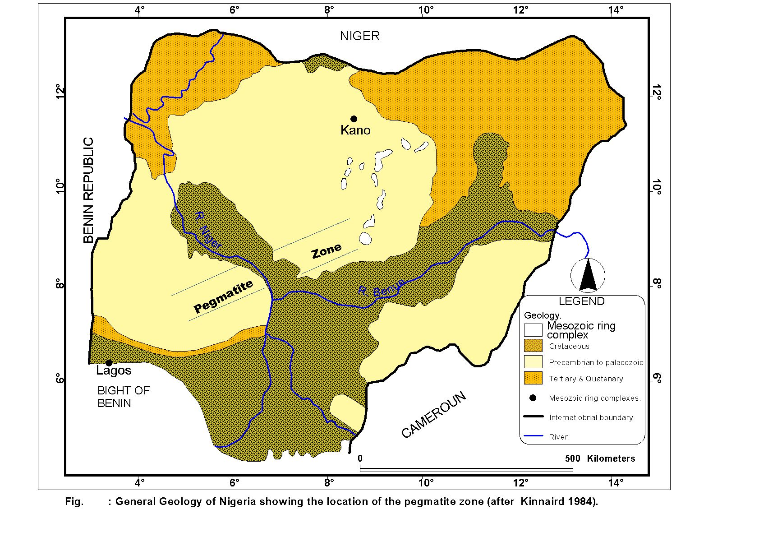
Fig1 General geological map of Nigeria showing location of pegmatite zone

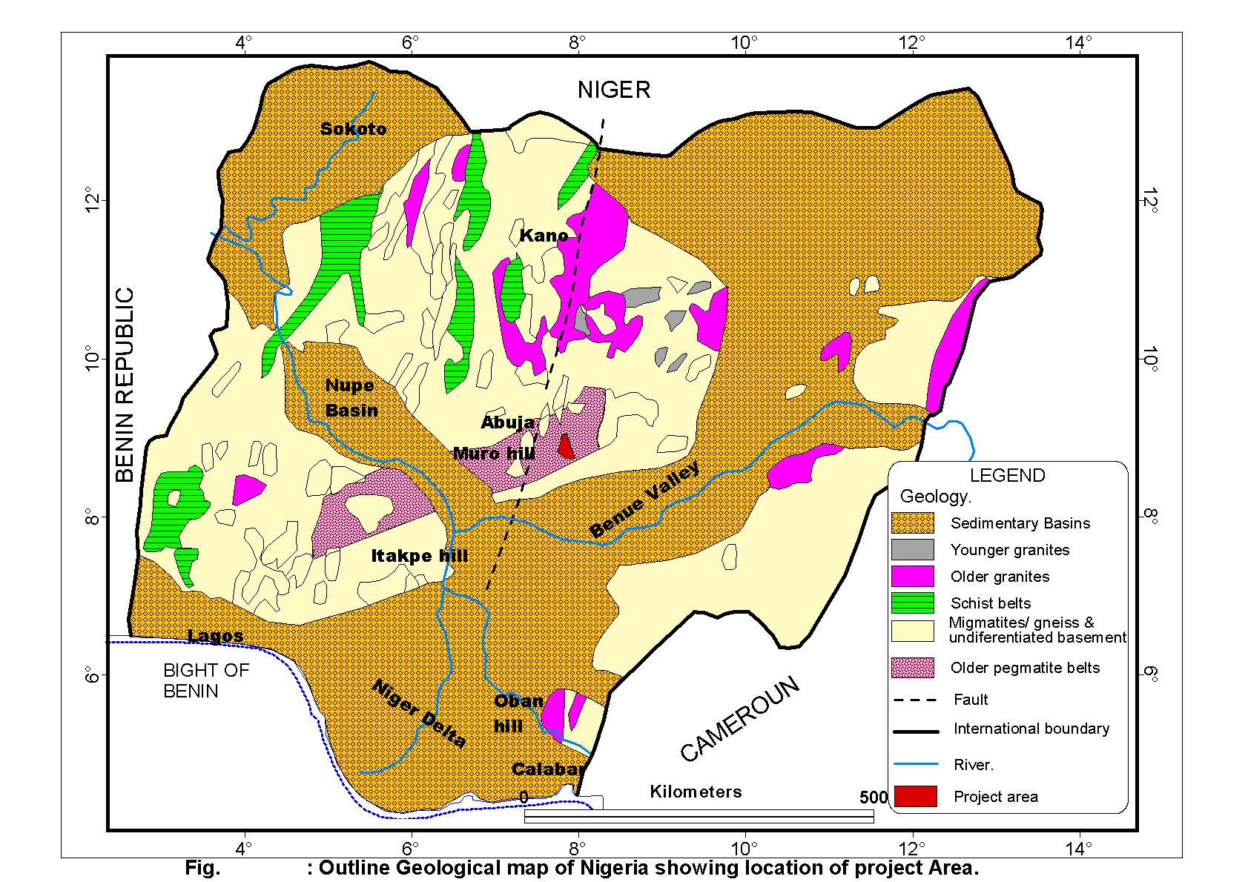
Fig 2 Outline Geological map of Nigeria showing location of project area
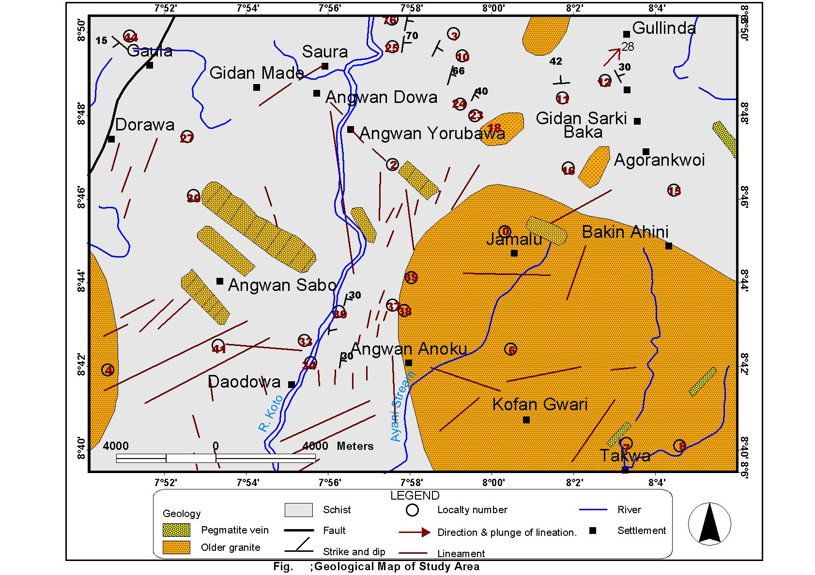
Fig 3 geological map of study area

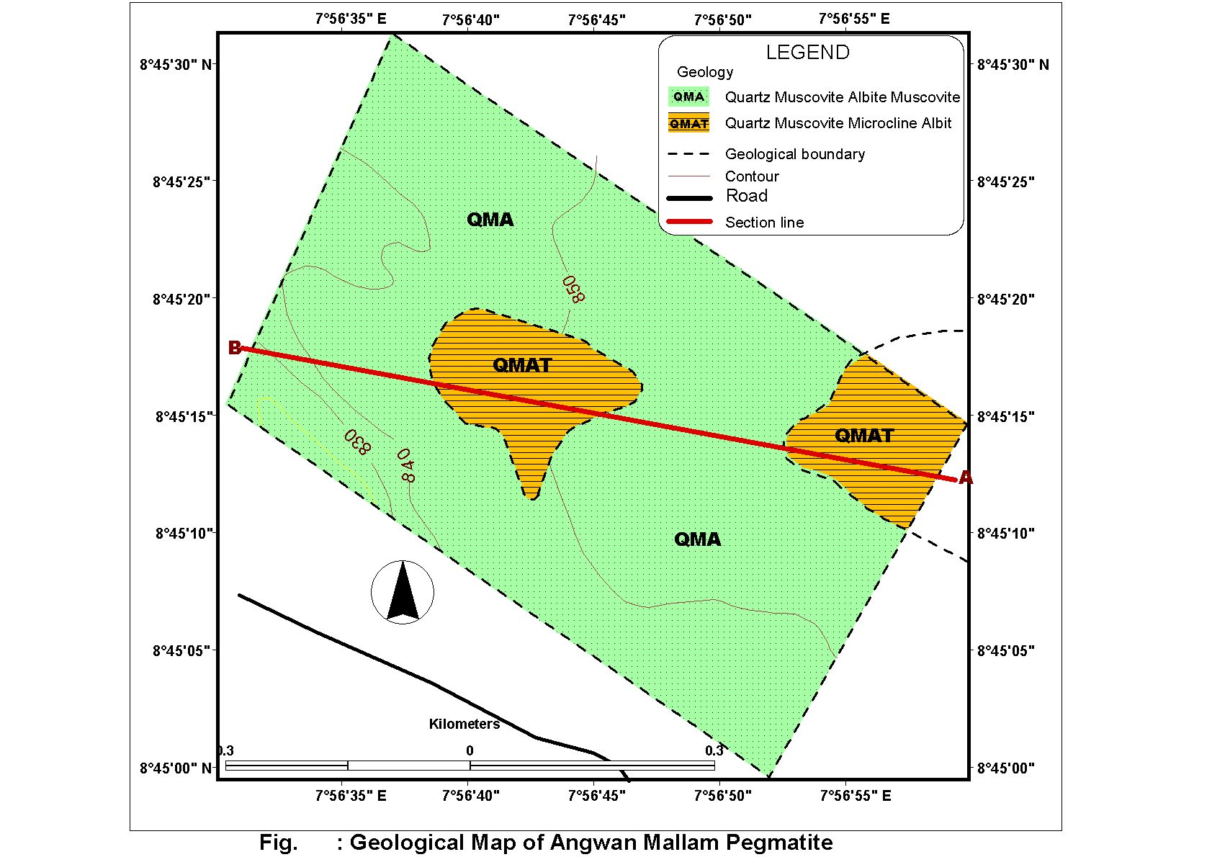

Fig 4 geological map of Agwan mallam pegmatite

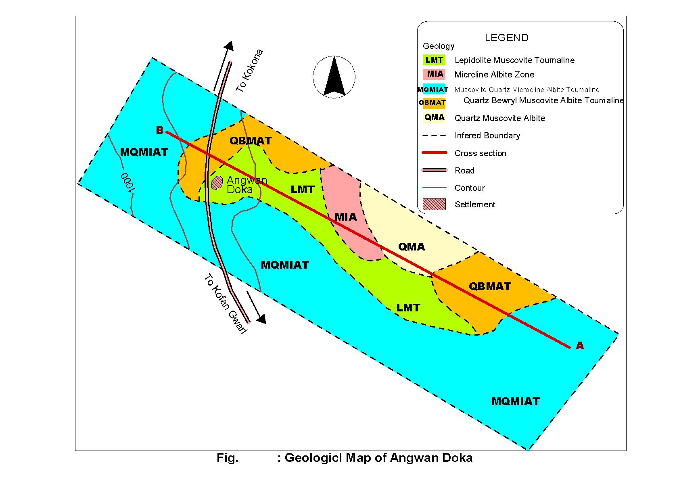

Fig 5 Geological map of Angwan Doka area

Fig 6 Photomicrograph of Quartz-Microcline Albite zone in transmitted light of the Agwan Mallam pegmatite body
Bar scale :2mm

Fig 7 Photomicrograph of Quartz-Muscovite –Albite -Tourmaline zone of the Agwa Mallam pegmatite body
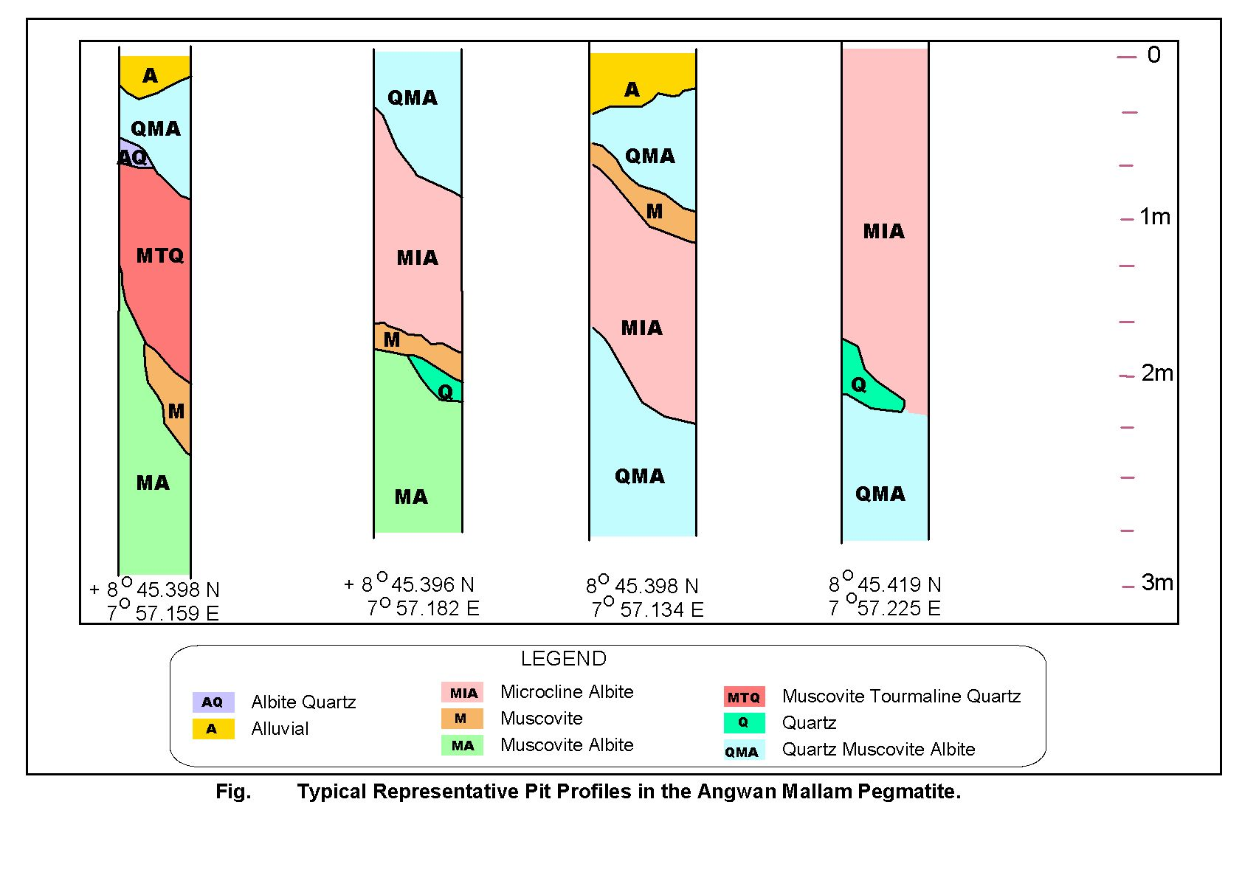
Fig 8 Typical representative pit profile of the Agwan Mallam pegmatite

Fig 9
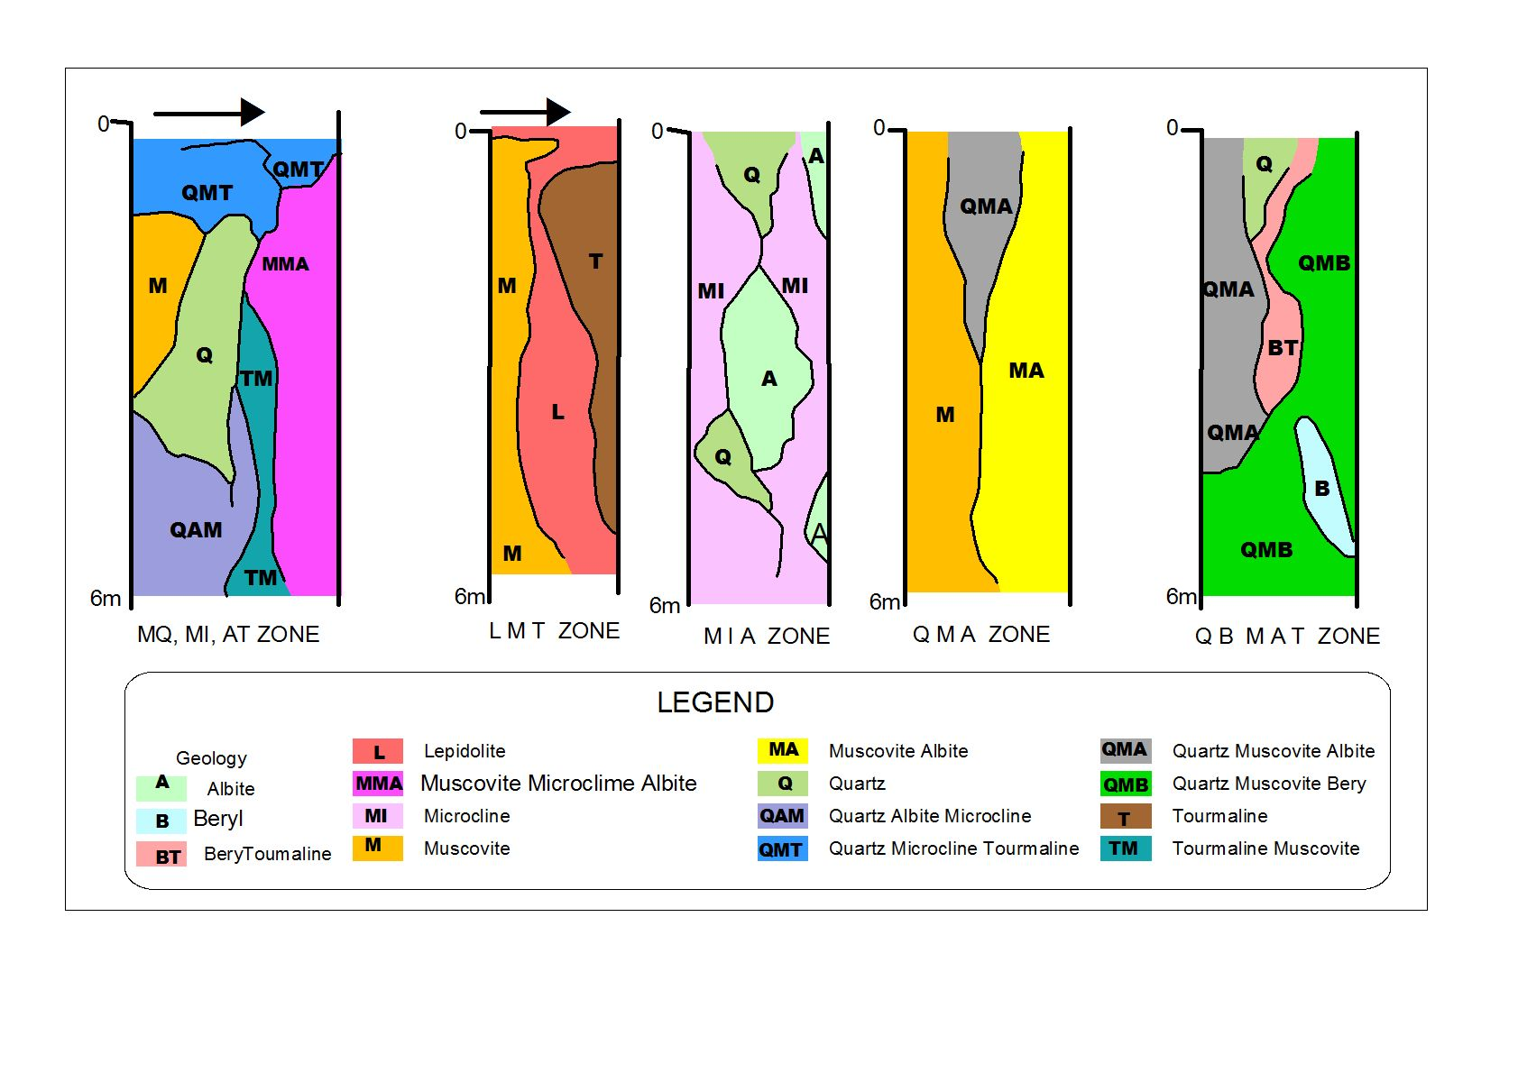
Fig10 Typical representative pit profile of the Agwan Doka pegmatite body

TABLE 1: Summary of Raremetal distribution of the Angwan Mallam and Agwan Doka pegmatite veins (ppm) ( n=10)

Agwan Mallam AgwanDoka

Element | Range | Average Range Average
Ta | 5 – 418 | 65 5-328 39
Nb | 5 – 376 | 51 6-355 40
Sn | 5 – 6000 | 760 5-3373 638
Li | 5 – 111 | 27 7-6000 731
Be | 5 - 58 | 13 4-212 11

TABLE 2: Average rare metal distribution in relation to mineralogical zones in the pegmatite bodies

Mineralogical zones (Agwan Doka) | Ta | Sn | Li | Nb
MQMIAT | 5 | 15 | 850 | 5
LMT | 32 | 1056 | 3580 | 5
MIA | 235 | 900 | 282 | 15
QMA | 174 | 158 | 421 | 6
QBMAT | 15 | 76 | 185 | 5

Mineralogical zones (Agwan mallam) | Ta | Sn | Li | Nb
QMAT | 35 | 1522 | 28 | 18
QMA | 320 | 150 | 32 | 105

Conclusions
The study area which comprises mainly schist and older granite rocks have been intruded by vertical and low lying horizontally dipping pegmatites. These Pegmatite bodies which vary in sizes have been shown to be complex with varied mineralogical zonations. Attempts have been made to study on a larger scale these two types. These have revealed different levels of mineralogical compositional complexities.
The flat lying Agwan Mallam Pegmatite is the less complex with two main mineralogical zones while the vertically dipping pegmatite type as typified by the Agwan Doka outcrop is more complex with five distinct mineralogical zones. Results of the chemical analysis of the samples of pegmatites for rare metals-Ta-Nb-Li-Be content show enrichment of these metals in preferred zones. For instance, Ta is associated more with zones rich in albite and muscovite in both pegmatite types specifically, QMA zone in the Agwan mallam pegmatite, and MIA zone in the Angwa Doka pegmatite. Li, on the other hand is associated with lepidolite, muscovite and tourmaline rich zones especially in the Agwan Doka body where the LMT and the QMIAT zones are preffered prospects.
Generally, the two pegmatite types are Sn-Li rich pegmatite with subordinate Ta- Nb concentration. The Sn enrichment is noticeably associated with lepidolite, muscovite, and albite rich zones. The flat lying pegmatites have also been shown to be poorer Li prospects compared to the vertical dipping type. The knowledge of the distribution of the rare metals and their enrichment in known mineralogical zones as shown in this study will thus be a veritable tool in exploring preferentially,these rare metals in the pegmatite bodies of this study area

Acknowledgements
The authors are grateful to the management of Global minerals Nigeria Limited, Patrick de St Simmons, Dr. M.O. Ojo, former Director, Geological Survey of Nigeria and numerous friends, relations and colleagues for varied assistances during the course of this study.

References

Cerny, P., 1986. Characteristics of pegmatites deposits of tantalum. Proceedings of Berlin workshop of Lanthanides, Tantalum and Niobium Moller P., Cerny P., Sanpe F.,
(Eds) Society of mineral explorationists. p65

De st simmons, P., 1999. Are there world class tantalite deposits in Nigeria? Proceedings of 2nd Mining in Nigeria conference. Federal Ministry of Solid minerals. p3

Garba, I., 2002. Late Pan African tectonics and origin of Gold mineralization and rare metal pegmatites in the Kushaka schist belt, north western Nigeria, Journal of Min and Geol. Vol 38 (1) pp 1-12

Kainnard J.A 1984 .contrasting styles of Sn- Nb- Ta-Zn mineralization in Nigeria.Journal of African and earth sciences Vol.2 No2 pp81-90

Ocan, O.O., Okunlola, O.A. and Rahaman, M.A. 2000. Metamorphic evolution of part of Toto Gadabuike Schist belt. Indication from metapelites in Keffi Nassarawa area, north central Nigeria. Book of Abstracts, N.M.G.S conf. Enugu, Nigeria. p15

Okunlola, O. A. 1998. Specialty metal Potential of Nigeria. In: Uche, J., Ohiwherei F. and Bassey E. (eds) Proceedings first mining in Nigeria conf. Fed. Min. of Solid Minerals, Nigeria publication. 67-90.

okunlola, O.A. and King, P. 2003. Process test work for the recovery of Ta205 concentrates from rare meal bearing pegmatites of Nasarawa area, central Nigeria. Global journal of Geology. vol 1. no1. p10-15

Okunlola, O. A. 2005. Metallogeny of Tantalum-Niobium mineralization of Precambrian pegmatites of Nigeria. Mineral Wealth 137/2005. p38-50

Okunlola, O. A. and Somorin, E. B. 2006. Compositional features of Precambrian Pegmatites of Itakpe Area, Central Nigeria. Global Journal of Geological Sciences 4.2: 2006.

Onyeagocha, A.C., 1984. Petrology of Geologic history of Akwanga area in Northern Nigeria, journal of African earth sciences, vol. 2. pp 41-50

Pollards, C., 1989. Geochemical potential of tantalum mineralization. Proceedings of Berlin workshop of Lanthanides, Tantalum and Niobium. Moller,P., Cerny,P., Sampe, F. (Eds) Society of mineral explorationist. Pp 67-98

Rahaman, M.A. 1976. Review of basement geology of southern Nigeria. In Kogbe, C.A. (ed) Geology of Nigeria Elizabethan Publications. Co. Lagos. Pp 41-58

Rahaman, M.A. 1992. Recent advances in the study of basement complex of Nigeria. In: Oluyide, P.O., Mbonu, W.C., Ogezie, A.E., Egbuniwe, I.G., Ajibade, A.C and Umeji, A.C. (eds) Precambrian Geology of Nigeria. G.S.N. pp 11-41.

5/14/2009

