Optimization Of 2, 4 Dichlorophenol Degradable Crude Extracts Produced by Pseudomonas aeruginosa Using Box Behnken Design

R. Manikandan*, H. Janardhana Prabhu†, P. Sivashanmugam†, CN Pratheeba‡ and Pankaj Sah*
†Department of Chemical Engineering, NITT (India), ‡Department of Chemical Engineering, Kalasalingam University, TN (India), *Department of Applied Sciences, Higher College of Technology, Muscat (Sultanate of Oman).
drpankaj_sah2002@yahoo.com; ramachandran@hct.edu.om; pankaj@hct.edu.om; drpankajsah1@gmail.com

ABSTRACT: Pseudomonas aeruginosa was grown on mineral medium containing 2, 4 dichlorophenol as a sole source of carbon and energy. Process optimization was carried out by developing 17 combinations using Box Behnken design to identify the best combinations of the parameters which involved in the production biomass to obtain high yield of crude extract. The highest protein concentration in biomass from 17 combinations obtained from the experiment is 4.99 mg/ml (35 ml of medium, 6 ml of inducer and 6 ml of inoculum). The point prediction from the analysis of variance for response surface cubic model for the production of protein concentration (4.88 mg /ml) is 35 ml of medium, 4.5 ml of inducer and 4 ml of inoculum. [Nature and Science. 2009;7(7):117-128]. (ISSN: 1545-0740).

Keywords: 2, 4 Dichlorophenol, Crude extract, Pseudomonas aeruginosa, Optimization, ANOVA and Box Behnken design
1. INTRODUCTION
Tabak et. al., (1964) described microbial metabolism of aromatic carbon compounds. The purpose of this investigation was to determine the ability of specifically adapted bacteria to degrade phenol and substituted phenols, and to study the relationship between the chemical structure of phenol derivatives and cyclic hydrocarbons and their susceptibility to decomposition by organisms adapted to related aromatic compounds.

Walter Reinke et. al., (1984) isolated 2,4 dichlorophenol-degrading bacterium (, strain WR1306) by continuous enrichment from a mixture of soil and sewage sample & grown in a chemostat on a mineral medium with 2,4 dichlorophenol. Respiration data and enzyme activities in cell extracts as well as the isolation of 3-chlorocatechol from the culture fluid are consistent with the degradation of 2,4 dichlorophenol. Michel Rutgers et. al., (1993) used nutristat to grow pentachlorophenol (PCP)-degrading microorganisms. Rebecca M Goldstein et. al., (1985) explained the reasons for possible failure of inoculation to enhance biodegradation.

Ayami Nakagawa et. al., (2006) found 32% of DCP was degraded within 1h.He is the first one to prove dechlorination pathway by Zygomycetes. Khadar valli et. al., (1991) examined the degradative pathway of 2,4-dichlorophenol by P. chrysosporium. They showed that this pathway involves several cycles of oxidation and subsequent quinone reduction and hydroquinone methylation.

Mohammad Edrissi and Nima Razzaghi asl (2007) discussed the application of RSM method in optimizing complexation of iron with piroxicam. A response surface methodology (RSM) based on a Box-Behnken design was applied for study on ferrous ions binding ability to piroxicam in aqueous solution as a function of three numerical factors (extraction time, pH, piroxicam concentration) and extractant type as a categorical variable each in three levels.

Experimental designs nowadays have been regarded as one of the most favorable techniques in covering a large area of practical statistics and obtain unambiguous results with the least expense. Response surface method (RSM) designs help to quantify the relationships between one or more measured responses and the vital input factors. The most popular response surface methodologies are Central Composite, Box-Behnken designs.
Box-Behnken design is an efficient and creative three-level composite design for fitting second-order response surfaces. It is an independent quadratic design. The methodology is based on the construction of balance designs which are rotatable and enable each factor level to be tested several times. Each factor or independent variable can be placed at one of three equally spaced values (coded as –1, 0, and +1). In this design the treatment combinations are at the midpoints of edges of the cubical design region and at the center.. Box-Behnken designs provide excellent predictability within the spherical design space and require fewer experiments compared to the full factorial designs or central composite designs. The number of required experiments for Box-Behnken design can be calculated according to N = k² + k + c_{p} , where k is the factor number and c_{p} is the replicate number of the central point.
In the present investigation, crude cell extracts from the enriched strain P. aeruginosa on 2,4 dichlorophenol was immobilized on sodium alginate beads and the beads were packed in a glass column to study the degradation. Seventeen sets of combinations of process parameters were developed to produce crude extracts. The experiment was carried out in different concentrations 2,4 dichlorophenol in the immobilized beads which contains crude extracts of P. aeruginosa.

2. MATERIALS AND METHODS

2.1 Maintenance and cultivation of microorganism

The strain P. aeruginosa was obtained from NCIM, Pune, India. The strain was sub cultured in nutrient broth. The broth was incubated in the shaker with 175 rpm and at 37ºC overnight. Sterile plates containing nutrient agar of specified composition were streak plated with the overnight cultures. The culture on the plates was used as the source for the entire experiment. The mineral medium with specified composition (Table 1) of chemical substances was prepared to conduct the experiment. The pH of the mineral medium was adjusted to 7.0 by using 2 NH₂SO4 or 2N NaOH solution. 50 ml of the medium was taken in each of 250 ml Erlenmeyer flasks and were sterilized at 1.5 kg/cm² (gauge) for 20 min. After cooling to room temperature, the medium was added with 2, 4 dichlorophenol and inoculated in a laminar flow chamber. The flasks were then incubated on a rotary shaker for 48 h at 30ºC and 175 rpm, for full growth of the strain. The sub cultured strains were stored at 5ºC.

Table 1 Composition of Medium
Ingredients | Concentration (g/l)
NH₄NO₃ | 1.0
(NH₄)₂SO₄ | 0.5
NaCl | 0.5
K₂HPO₄ | 1.5
KH₂PO₄ | 0.5
Mgso₄.7H₂O | 0.5
CaCl₂ | 0.01
Double distilled Water | 1 l

2.2 Suspension of washed cells and cell extracts

Cells grown on 2,4 dichlorophenol as the sole carbon source, were harvested in the mid-exponential growth phase by centrifugation (8,000 rpm for 10 min at 4°C), washed with sodium phosphate buffer (pH 7.0, 50 mM), and suspended in the same buffer. The cell extracts were prepared by disrupting the cells by ultrasonic disintegration (Labsonic-P of Labsonic-Germany). The resulting cell lysate was centrifuged at 8,000 rpm for 10 min at 4°C, and the supernatant, containing approximately 10 to 20 mg of protein ml⁻¹, was the crude cell extract (containing 2,4 dichlorophenol degrading enzyme). The concentrations of protein content in the crude extracts were measured using UV Visible Spectrophotometer (Hitachi UV 2800).

2.3 Optimization of the process parameters

Process optimization was carried out by conducting 17 experiments (Table 2) to identify the best combinations of the parameters which involved in the production biomass to obtain high yield of crude extract. The parameters, the volume of mineral medium (20,35 and 50 ml), inducer (3 -6 ml) and inoculum ( 2 - 6 ml) were selected. The mineral medium, Inducer (2, 4 dichlorophenol) and inoculum were processed as mentioned different cultures were obtained by varying the three parameters and processed to obtain its crude extract. The concentration of the crude extract was measured at 280 nm. The data obtained from 17 experiments, were used to find out the optimum point of the process parameters by using Box Behnken Design in Response surface methodology. All the data were treated with the aid of Design Expert from Stat-Ease.

3. RESULTS AND DISCUSSION

3.1 Analysis of variance

Based on design of experiment, 17 combination were developed (Table 2) and processed to obtain crude extracts as mentioned in this paper. The data obtained from the experiments were used to the analysis of variance (Table 3 and 4). The Model F-value of 6.366E+007 implies the model is significant. There is only a 0.01% chance that a "Model F-Value" this large could occur due to noise. Values of "Prob > F" less than 0.0500 indicate model terms are significant. In this case A, B, C, AB, AC, BC, A², B², C², A²B, A²C, AB²are significant model.

Table 2 Combination of process variables

Run | A:Medium  (ml) | B:Inoculum  (ml) | C:Inducer  (ml) | Crude extract  (mg/ml)
13 | 35 | 6 | 6 | 4.99
6 | 35 | 2 | 6 | 4.88
7 | 35 | 4 | 4.5 | 4.74
8 | 35 | 4 | 4.5 | 4.74
9 | 35 | 4 | 4.5 | 4.74
10 | 35 | 4 | 4.5 | 4.74
11 | 35 | 4 | 4.5 | 4.74
4 | 20 | 6 | 4.5 | 3.57
1 | 20 | 2 | 4.5 | 2.97
5 | 35 | 2 | 3 | 2.05
2 | 20 | 4 | 3 | 1.98
3 | 20 | 4 | 6 | 1.34
15 | 50 | 4 | 3 | 0.96
17 | 50 | 6 | 4.5 | 0.56
16 | 50 | 4 | 6 | 0.31
12 | 35 | 6 | 3 | 0.23
14 | 50 | 2 | 4.5 | 0.15
Table 3 Analysis of variance (ANOVA):
Source | Sum of  Squares | df | Mean  Square | F Value | p-value  Prob > F
Model | 60.13575 | 12 | 5.011312 | 6.366E+007 | < 0.0001 | significant
A-Medium(ml) | 1.05401 | 1 | 1.05401 | 6.366E+007 | < 0.0001
B-Inoculum(ml) | 0.727097 | 1 | 0.727097 | 6.366E+007 | < 0.0001
C-Inducer(ml) | 14.42253 | 1 | 14.42253 | 6.366E+007 | < 0.0001
AB | 0.008603 | 1 | 0.008603 | 6.366E+007 | < 0.0001
AC | 2.72E-06 | 1 | 2.72E-06 | 6.366E+007 | < 0.0001
BC | 0.920256 | 1 | 0.920256 | 6.366E+007 | < 0.0001
A² | 24.39735 | 1 | 24.39735 | 6.366E+007 | < 0.0001
B² | 1.120969 | 1 | 1.120969 | 6.366E+007 | < 0.0001
C² | 5.894329 | 1 | 5.894329 | 6.366E+007 | < 0.0001
ABC | 0 | 0
A²B | 0.925412 | 1 | 0.925412 | 6.366E+007 | < 0.0001
A²C | 9.87168 | 1 | 9.87168 | 6.366E+007 | < 0.0001
AB² | 1.790021 | 1 | 1.790021 | 6.366E+007 | < 0.0001
AC² | 0 | 0
B²C | 0 | 0
BC² | 0 | 0
A³ | 0 | 0
B³ | 0 | 0
C³ | 0 | 0
Pure Error | 0 | 4 | 0
Cor Total | 60.13575 | 16

Table 4 Regression Analysis

Std. Dev. | 0 | R-Squared | 1
Mean | 2.804 | Adj R-Squared | 1
C.V. % | 0 | Pred R-Squared | N/A
PRESS | N/A | Adeq Precision | 3.1E-308

Values greater than 0.1000 indicate the model terms are not significant.
If there are many insignificant model terms (not counting those required to support hierarchy), model reduction may improve your model.

The application of response surface methodology (Kenneth et.al, 1995, Khuri, A.I.,) yielded the following regression equation, which is an empirical relationship between the logarithmic values of protein yields and test variables in coded unit.

Final equation in terms of coded factors with coefficients values (Table 5):

Y (Crude extract mg/ml) = + 4.74 - (0.51 * A) - (0.43 * B) + (1.90 * C) - (0.046* A * B) –( 8.250E-004 * A * C) + (0.48 * B * C ) - (2.41 * A² ⁾ - ( 0.52 * B²⁾ - (1.18 * C²⁾ + (0.68 * A² * B ) – ( 2.22 * A² * C) – ( 0.95 * A * B²)
Where Y is response that is the protein concentration is expressed in logarithmic values and A, B, and C are the coded values of the test variable medium, inducer and inoculum respectively.

Table 5 Coefficients obtained from regression analysis
Factor | Coefficient Estimate | df | Standard Error | 95% CI Low | 95% CI High | VIF
Intercept | 4.737 | 1
A-Medium(ml) | -0.513 | 1 |  |  |  | 2
B-Inoculum(ml) | -0.426 | 1 |  |  |  | 2
C-Inducer(ml) | 1.899 | 1 |  |  |  | 2
AB | -0.046 | 1 |  |  |  | 1
AC | -0.001 | 1 |  |  |  | 1
BC | 0.480 | 1 |  |  |  | 1
A² | -2.407 | 1 |  |  |  | 1.0058
B² | -0.516 | 1 |  |  |  | 1.0058
C² | -1.183 | 1 |  |  |  | 1.0058
A²B | 0.680 | 1 |  |  |  | 2
A²C | -2.222 | 1 |  |  |  | 2
AB² | -0.946 | 1 |  |  |  | 2
AC² ALIASED A, AB²
B²C ALIASED C, A²C
BC² ALIASED B, A²B
A³ ALIASED A
B³ ALIASED B
C³ ALIASED C

3.2 Analysis of process variables by response surface plots
The optimum values of the selected variables were obtained by solving their regression equation and analyzing response surface contour plots. Response Surface plots as a function of two factor at a time maintaining all other factors at a fixed level (zero for instance) are more helpful in understanding both the main and interaction effects of the two factors. The plots can be easily obtained by calculating the data from the model. The values were taken by one factor, where the second varies with constant of a given Y -values. The yield values of the different concentrations of the variable can also be predicted from respective response surface plots. Figures 1 to 6 shows the relative effects of the two variables with protein concentration level. The coordinates of the central point within the highest contour levels in each of these figures corresponded to the optimum concentrations of the respective components.

Figure 1 and 2 show their contour and response surface plot obtained as a function of volume of inoculum vs. medium with protein concentration, while all other variables are maintained at zero level (coded units). Figure 3 and 4 show their contour and response surface plot obtained as a function of volume of inducer vs. medium with protein concentration. Figure 5 and 6 show their contour and response surface plot obtained as a function of volume of inducer vs. inoculum with protein concentration.
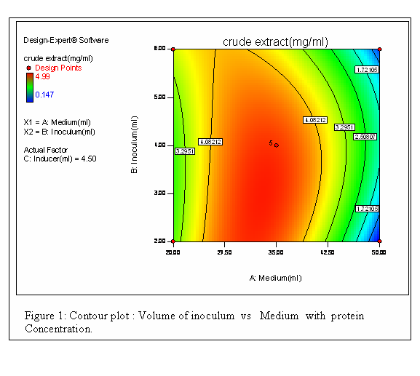

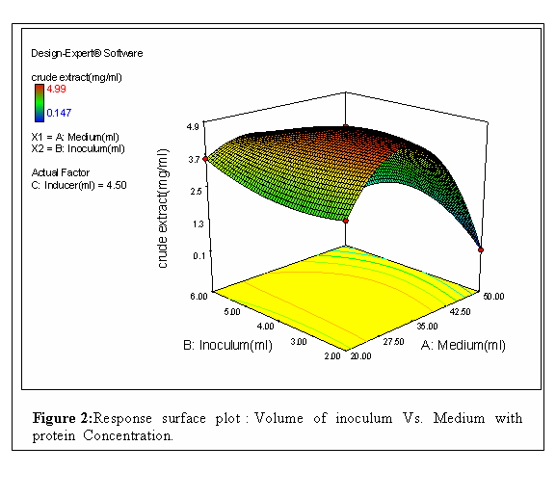
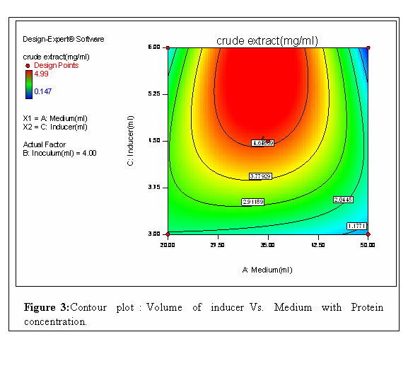

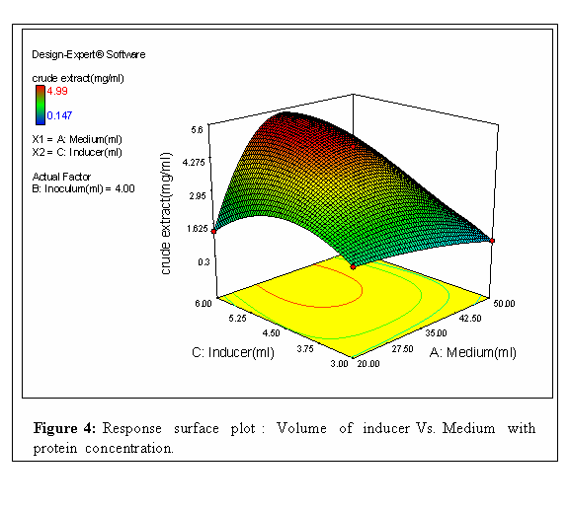

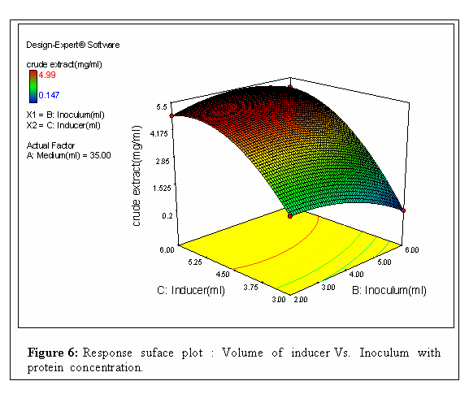
3.3 Optimum Values

The protein production was predominantly influenced by medium and inducer concentration. From the Contour plots the red color shows the region of the desirability for the production of protein. The point prediction from the analysis of variable for response surface cubic model for the production of protein concentration (4.88 mg /ml) is 35 ml of medium, 2 ml of inducer and 6 ml of inoculum.

Table 6 Predicted value from Box -Behnken design

Factor | Name | Level | Low Level | High Level | Std. Dev. | Coding
A | Medium(ml) | 35 | 20 | 50 | 0 | Actual
B | Inoculum(ml) | 2 | 2 | 6 | 0 | Actual
C | Inducer (ml) | 6 | 3 | 6 | 0 | Actual
Response | Prediction | SE Mean | 95% CI low | 95% CI high | SE Pred | 95% PI low | 95% PI high
Crude extract(mg/ml) | 4.88 | 0 | 4.88 | 4.88 | 0 | 4.88 | 4.88

PI - Prediction interval
CI - Confidence interval
SE Mean – Standard error of the mean.
SE Pred – Standard error of prediction

4 Conclusion

2,4 Dichlorophenol can induce the synthesis of enzymes in Pseudomonas aeruginosa that are able to break down hydrocarbons including 2,4 dichlorophenol. In this work the process conditions were optimized to produce crude extracts. Immobilization of the crude extracts obtained from Pseudomonas aeruginosa increases the efficiency of the extract and they have been used to study the degradation of 2,4 dichlorophenol in a packed bed column. Thus it has been concluded that this study will yield good results if extended to large-scale applications.

5 References:

Ahmed, M., Focht, D.D., 1973 “Degradation of polychlorinated biphenyls by two species of Achromobacter”.Can. J. Microbiol, 19:47-52.
Box, G.N., in: 1987 “Empirical Model Building and Response Surfaces, John Wiley and Sons”. New York.
Chaudhry, R.G., Chapalamadugu, S., 1991 “Biodegradation of halogenated Organic compounds”. Microbiological Reviews, 59-79.
Dorn, E., Knackmusst, H., 1978 “Chemical structure and biodegradability of halogenated aromatic compounds two catechol 1,2-dioxygenases from A 3-chlorobenzoate-grown Pseudomonad”. J. Biochem, 174, 73-84.
Goldstein, RM., Lawrence, M., Alexander M., 1985 ”Reasons for Possible Failure of Inoculation to Enhance Biodegradation”. Applied and Environmental Microbiology, p. 977-983.
Haigler, B.E., Pettigrew, C.A., Spain J.C., 1992 “Biodegradation of mixtures of substituted benzenes by Pseudomonas sp. Strain JS150”. Applied and Environmental Microbiology, 58 (7), 2237-2244.
Henry, H.T., Cecil, W.C., Paul W.K., 1964 “ Microbial metabolism of aromatic compound I. Deconposition of phenolic compounds and aromatic hydrocarbons by phenol-adapted bacteria“. J .Bacteriol, 87(4):910-9.
Kuhm, A.E., Schlomann, M., Knackmuss, H., 1990 “Purification and characterization of dichloromuconate cycloisomerase from Alkaligenes eutrophus JMP 134”. J. Biochem. 266, 877-883.
Larsson, P., Okla., L., Tranvik, L., 1988 “Microbial degradation of xenobiotic, aromatic pollutants in humic water”. Applied and Environmental Microbiology. 54 (7), 1864-1867.
Manikandan, R., Sivashanmugam, P., Prabhu, H.J., 2005 “Biodegardation of Monochlorobenzene by Pseudomonous aeruginosa, Nocardia Hydrocarboxydanse and Mycoplana dimorpha and fitting biomass data to the logistic equation. Proceedings of a National Symposium.
Mohn, W.W., Tiedje J. M., 1992 “Microbial reductive dehalogenation”, Microbiological Reviews, 56 (3), 482-507.
Nakagawa, A.,Osawa, S., Hirata, T., 2006 ”2,4 –Dichlorophenol Degradation by the soil fungus Mortierlla sp.”. Biosci. Biotechnol. Biochem,70(2), 525 – 527.
Okpokwasili, G.C., Nweke, C.O., 2005 “Microbial Growth and Substrate Utilization Kinetics”. African J . Biotechnology, 5 (4), 305-317.
Reinekelt, W., Knackmuss, H.J., 1984 “Microbial Metabolism of Haloaromatics: Isolation and Properties of a Chlorobenzene-Degrading Bacterium”. Applied and Environmental Microbiology, 47 (2), 395-402.
Rutgers, M., Bogte, J.J., 1993 “Growth and Enrichment of Pentachlorophenol-Degrading Microorganisms in the Nutristat, a Substrate Concentration-Controlled Continuous Culture”. Applied and Environmental Microbiology,p. 3373-3377
Valli, K., Gold, M.H., 1991 ”Degradation of 2,4-Dichlorophenol by the Lignin-Degrading Fungus Phanerochaete chrysosporium”. J . Bacteriology, p.345 - 352.

5/19/2009

