Efficient in vitro multiplication of Syrian Rue (Peganum harmala L.) using 6-benzylaminopurine pre-conditioned seedling explants

Neha Goel*, Narender Singh* and Raman Saini**

*Department of Botany, **Department of Biotechnology
Kurukshetra University Kurekshetra -136119, India.
**Email: ramanksaini@rediffmail.com)

Abstract
The frequency of multiple shoot regeneration of two seedlings explants i.e. shoot apex and cotyledonary node with both cotyledons of Peganum harmala was affected by the concentration of benzylaminopurine (1.11 - 15µM) in the regeneration medium as well as significantly influenced by the preconditioning of seeds with 0.5 - 11.1µM benzylaminopurine prior to excision of explants. Among the untreated explants, average number of 4 shoots per explant was observed on MS medium supplemented with 4.44µM BAP in shoot apex and cotyledonary node explants with 100% and 92% frequency of regeneration respectively. While among the explants excised from the seedlings raised on MS medium containing 11.1µM BAP, the average number of shoot formation per explant was increased up to 6 in case of shoot apex and 6 - 7 in cotyledonary node explants cultured on MS medium supplemented with 4.44µM BAP, with in four weeks of culture. Regenerated shoots were rooted on MS medium containing half strength salts, 3% sucrose and 5µM IBA with 80% efficiency. The plantlets were successfully established in soil where 90% of them survived into morphological normal plants. [Nature and Science. 2009;7(7):129-134]. (ISSN: 1545-0740).

Abbreviations: BAP- 6-Benzylaminopurine, IBA- Indole-3-Butyric Acid, MS- Murashige and Skoog

Key words: Cotyledonary node; In vitro regeneration; Micropropagation; Peganum harmala; Shoot apex; Syrian Rue.

1. Introduction
Peganum harmala L. (Syrian Rue), a medicinally important perennial herb of family Zygophyllaceae (Ananymous, 1986; Stewart, 1972). But recently it has been placed in Nitrariaceae family (Sheahan and Chase, 1996). Peganum is distributed over semi arid areas of North-West India, North-Africa and central Asia.
The plant is having biochemical, pharmaceutical (Baytop, 1999) and ornamental importance and used as abortifacient, aphrodisiac, emmenagogue, galactogogue and diuretic. It enriches the blood and is useful in weakness of muscles and brain (Chatterjee, 1997; Kiritikar, 1995; Sharma, 1988). Carboline alkaloids like harmine, harmaline, harmalol, peganine, vasicine, vasicinon, deoxyvasicione, peganone-1 (3-6-dihydroxy-8-methoxy-2methyl anthraquinone), peganone-2 (8- hydroxy – 7 methoxy – 2 methyl anthraquinone) obtained from various parts of this plant are used against a number of diseases (Aarons, 1977; Sobhani et al 2002).
Medicinally the fruits and seeds are digestive, diuretic, hallucinogenic, hypnotic, antipyretic, antispasmodic, nauseant, emetic, narcotic and uterine stimulant (Chatterjee, 1997; Kiritikar, 1995; Sharma, 1988). A red dye obtained from seeds is widely used in Turkey and Iran for colouring carpets (Baytop, 1999). Leaves are useful in asthma, colic, dysmenorrhea, hiccup, hysteria, neuralgia and rheumatism (Chatterjee, 1997; Kiritikar, 1995; Sharma, 1988). The plant has also been used as antimicrobial (Adday et al 1989; Alkofahti et al 1990; Prashanth et al 1999), antitumoral (Prashanth et al 1999), in curing malaria (Kiritikar et al 1995) and has insecticidal potential (Ahmed et al 1981).
Peganum harmala is propagated by seeds (Saini and Jaiwal, 2000). One of the constraints of this conventional propagation is of very short span of seed viability. No reliable data are available about seed germination, growth and fruiting of the plant in domesticated or natural settings (Khawar et al 2005). Because of increasing exploitation of the natural population for its wide use in traditional medicine and since the plant grows as wild and not cultivated; it is facing the problem of extinction (Saini and Jaiwal, 2000). There is no alternative mode of multiplication to propagate and to conserve the genetic stock of this medicinal plant. Some preliminary work on micropropagation of this species has been done by a few workers (Saini and Jaiwal, 2000; Khawar et al 2005). But the frequency of regeneration as well as number of shoots per explants was low with lesser efficiency of establishment of plants in soil. Hence the present study was designed to develop efficient in vitro procedure for multiple shoot formation using shoot apex and cotyledonary node explants so that such explants could be used as storage tissue for cryo-preservation and rapid propagation of this plant stock. Besides it, the effect of different dose of 6-benzylaminopurine growth regulator preconditioning of seeds before the harvest of seedling explants was also studied.

2. Materials and Methods
The seeds of Peganum harmala were collected from the plants growing wild in Haryana, state of India. Uniform and healthy seeds were selected and surface sterilized first by washing with liquid detergent (Tween-20) and rinsing gently under tap water this is followed by sterilization with 0.2% mercuric chloride (HgCl₂) solution for 5 - 6 minutes under the sterile conditions and finally were thoroughly washed seven to eight times with sterilized distilled water to remove traces of mercuric chloride.

2.1 Inoculation of seeds without pretreatment
The surface sterilized seeds were germinated aseptically on MS basal medium containing 3% (w/v) sucrose and 0.8% (w/v) agar. Explants like shoot apex (0.5-1.0 cm) and cotyledonary node with cotyledons (1.0-1.5cm) were excised from 10-15 days old seedlings with the help of sharp sterilized blade and cultured in vertically upright position on MS medium containing 3% (w/v) sucrose, 0.8% (w/v) agar and supplemented with different concentrations of BAP (1.11µM, 2.22µM, 4.44µM, 11.1µM).

2.2 Inoculation of seeds with pretreatment
The surface sterilized seeds were germinated aseptically on MS medium supplemented with different concentration of BAP (0.5 µM, 2.0 µM, 11.1 µM and 15.0 µM). The shoot apex (0.5-1.0 cm) and cotyledonary node with cotyledons (1.0-1.5cm) explants were excised from 10-15 days old pre-cultured thickened seedlings with the help of sharp sterilized blade and cultured on MS medium supplemented with 4.44µM BAP.
In all the cases, the pH of medium was adjusted to 5.8 by adding 0.1 N HCl or 0.1 N NaOH before adding agar-agar and autoclaving. The media was poured and equally distributed in the cultural tubes (25x150 mm). These cultural test tubes were plugged with non-absorbent cotton plugs (cotton wrapped in muslin cloth) and sterilized in an autoclave at 1.05 atmospheric pressure at 121ºC for 15-20 minutes. At least 24 cultures for each treatment and all experiments were repeated three times. All the cultures were maintained under a 16hr/day photoperiod (80µE m⁻¹s⁻¹) of cool- white fluorescent light at 25⁰±2⁰C.
The elongated multiple shoots (2-3 cm) formed in various media were excised individually and implanted in culture tubes containing MS medium (half strength salts and 3% sucrose) with 2.5µM, and 5.0µM IBA under aseptic conditions for rooting. The cultures were maintained under the similar physical culture conditions as above for shoot regeneration.
The plantlets with well developed roots were thoroughly washed in tap water to remove agar medium from roots and transferred to earthen pots containing sterilized soil and sand mixture in the ratio of 1:1. Each pot was covered with a polythene bag containing small holes, to maintain high humidity around the plants and was kept in culture room. The pots were irrigated with 1/4 MS salt solution on alternate days. The polythene bags were removed after about two weeks for 3-4h daily to expose the plants to the conditions of natural humidity. After further one week, the plants were transferred to bigger pots containing sand and garden soil in 1:3 ratios, and were maintained under natural conditions of day length and temperature in the green house.

3. Results and Discussion
The seeds collected freshly from the fields showed 60% germination on MS basal medium with in 8 -10 days while 2 year old stock showed only 25% germination on MS medium. The concentrations of cytokinins are known to be critical in shoot regeneration under in vitro conditions and among the various cytokinins BAP is the most widely used and most effective cytokinin for in vitro regeneration in various plant species such as Plumbago rosea (Harikrishan and Hariharan, 1996), Alinia galangal (Anand and Hariharan, 1997), Vigna mungo (Saini and Jaiwal, 2002), Vigna radiata (Sonia et al 2007), Vigna unguiculata (Chaudhary et al 2007). Therefore, in the present study the effect of different concentrations of BAP supplied at the time of regeneration either alone or in combination of different dose of BAP during germination was assessed using two seedlings explants viz: shoot apex and cotyledonary node with cotyledons. The shoot apices cultured on MS basal medium directly elongated into single shoots without callus formation at the cut ends, and the shoots gradually developed roots at the basal end, resulting into complete plantlets in 100% of the cultures. The cotyledonary node explants when cultured on MS basal medium produced an average of 1.5 shoots per explant from the axils of the cotyledons in 98% of the cultures without much callus formation at the basal cut end. It was found that MS medium without growth regulator failed to induce callus and multiple shoots from the explants, probably due to the insufficient level of endogenous growth regulators in explants and therefore required an exogenous supply of growth regulators for the response.
When the explants shoot apex and cotyledonary node with cotyledons excised from the aseptically raised seedlings germinated on MS basal medium were inoculated on MS medium fortified with different concentration of BAP (1.11µM - 11.1µM) induced a variable amount of callus at the base of explants with in 8-10 days and followed by multiple shoot differentiation within 15 days of culture (Table-1). Initiation of the callus was perhaps due to the exogenous supply of growth regulators which disturbed the established polarity and induced the callus formation. Similar observations have been made in hypocotyls and cotyledon explants of Sesbania grandiflora (Khattar and Mohan Ram, 1983) and Leucaena leucocephala (Singh and Lal, 2007). Shoot apex and cotyledonary node with cotyledon showed maximum number of shoots 4.00±0.40 and 4.05±0.40 per explant with 100 % and 92% regeneration respectively on MS medium fortified with 4.44µM BAP (Table-1, Figure1a, 1b). At this concentration of BAP, the in vitro regenerated shoots showed an average shoot length of 1.1 cm. The length of the shoots showed an inverse relationship with the concentration of BAP (Table 1).
When the explants harvested from the aseptically raised seedlings germinated on MS medium fortified with various concentration of BAP (0.5µM - 15.0 µM) were inoculated on MS medium supplemented with 4.44µM BAP showed the significant enhancement in shoot regeneration efficiency (Table-2). Preconditioning of shoot apex and cotyledonary node with cotyledons explants at 11.1µM BAP was the most effective in increasing the number of shoots with an average of 6.04±0.61 and 7.01±0.70 number of shoots per explant with 98% and 90% regeneration frequency, respectively than those without preconditioning treatment (an average of 4 shoots / explant) (Table 2, Figure1c, 1d). However, no significant difference in the shoot length was observed due to preconditioning of explants. Similar work of BAP pretreatment has been reported by different workers on different plants such as Vigna mungo (Saini and Jaiwal, 2002, 2005, 2007), Linnum usitaissium (Yildiz and Ozgen, 2004; Burbulis et al 2005).
The in vitro regenerated shoots (2 – 3 cm long) implanted on half strength MS basal medium without growth regulator showed very less profuse rooting in only 1%. While the shoots implanted on MS medium containing half strength salts, 3%sucrose and fortified with the IBA (5.0µM) was found effective in regeneration of the profuse roots with 80% efficiency (Table-3, Figure1e)
Rooted shoots were planted in pots having sterilized soil and sand mixture in the ratio of 1:1. These plantlets irrigated with 1/4 strength MS salt solution. High humidity was maintained for initial 15 days with the help of polythene bags. After this, pots were regularly exposed to natural conditions for 3-4 hours daily for acclimatization of plantlets. After about a week these acclimatized plants were shifted to the greenhouse where they grew normally with 90% survival rate (Figure1f).
Form the present study we can conclude that after giving the preconditioning to the explants, there was an efficient increase in the multiple shoot formation rather than without preconditioning. Therefore, the protocol could be used for the mass multiplication of this highly important medicinal plant species in a short duration as well as the phenomenon of preconditioning of seedlings with cytokinin like BAP prior to excision of explants may be exploited for the efficient multiplication of other plant species.

Table-1 Effect of different concentration of BAP on multiple shoot formation from shoot apex and Cotyledonary node with cotyledons explants of Peganum harmala cultured on MS medium.**
Explant | Plant growth regulator(µM) | % regeneration | No. of shoots per explant  (mean±SE)* | Mean length of shoot (cm)
Shoot apex | 0.0 | 100 | 1.00±0.10ª | 2.95
Shoot apex | 1.11 | 100 | 1.75±0.17ª | 2.11
Shoot apex | 2.22 | 100 | 1.21±0.12ª | 1.52
Shoot apex | 4.44 | 100 | 4.00±0.40^{b} | 1.14
Shoot apex | 11.1 | 85 | 1.77±0.17ª | 0.82
Cotyledonary node with cotyledons | 0.0 | 98 | 1.50±0.15ª | 2.41
Cotyledonary node with cotyledons | 1.11 | 96 | 1.75±0.17ª | 2.22
Cotyledonary node with cotyledons | 2.22 | 96 | 2.36±0.23ª | 1.30
Cotyledonary node with cotyledons | 4.44 | 92 | 4.05±0.40^{b} | 1.12
Cotyledonary node with cotyledons | 11.1 | 92 | 2.09±0.20ª | 0.75
*For different explants separately, mean values followed by same letter are not significantly different according to Newman-Keul’s multiple range test (p=0.05)
**Data based on 72 explants per treatment and taken after 28 d of culture

Table-2 Effect of BAP pretreatment of shoot apex and cotyledonary node with cotyledons explants of Peganum harmala on MS medium supplemented with different concentration of BAP before cultured on MS medium containing 4.44µM BAP.**
Explant | BAP(µM) Pretreatment | % regeneration | No. of shoots per explant  (mean±SE)* | Mean length of shoot (cm)
Shoot apex | 0.0 | 100 | 4.00±0.40ª | 1.14
Shoot apex | 0.5 | 100 | 4.22±0.46ª | 1.16
Shoot apex | 2.0 | 100 | 4.55±0.47ª | 1.12
Shoot apex | 11.1 | 98 | 6.04±0.61^{b} | 1.10
Shoot apex | 15.0 | 90 | 5.67±0.57^{b} | 1.00
Cotyledonary node with cotyledons | 0.0 | 98 | 4.05±0.40ª | 1.12
Cotyledonary node with cotyledons | 0.5 | 96 | 4.30±0.46^{ab} | 1.12
Cotyledonary node with cotyledons | 2.0 | 96 | 5.07±0.52^{b} | 1.09
Cotyledonary node with cotyledons | 11.1 | 90 | 7.01±0.70^{c} | 0.98
Cotyledonary node with cotyledons | 15.0 | 80 | 6.92±0.75^{c} | 0.98
*For different explants separately, mean values followed by same letter are not significantly different according to Newman-Keul’s multiple range test (p=0.05)
**Data based on 72 explants per treatment and taken after 28 d of culture

Table-3 Effect of different concentration of IBA on rooting of in vitro regenerated shoots cultured on MS medium half strength salts and 3% sucrose.**
IBA concentration (µM) | % of shoot rooted
0.0 | 1.0ª
2.5 | 45.0^{b}
5.0 | 80.0^{c}
* Values followed by same letter are not significantly different according to Newman-Keul’s multiple range test (p=0.05)
** Data recorded after 20 days of culture.

Acknowledgement
Authors are grateful to Kurukshetra University, Kurukshetra for providing financial assistance and laboratory facilities.

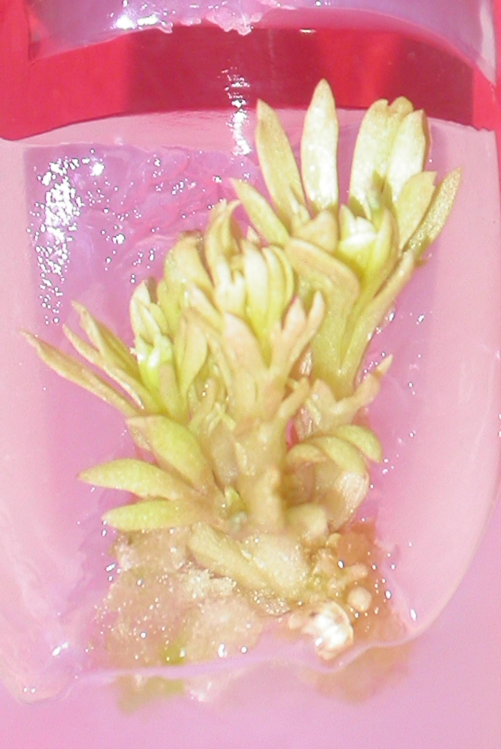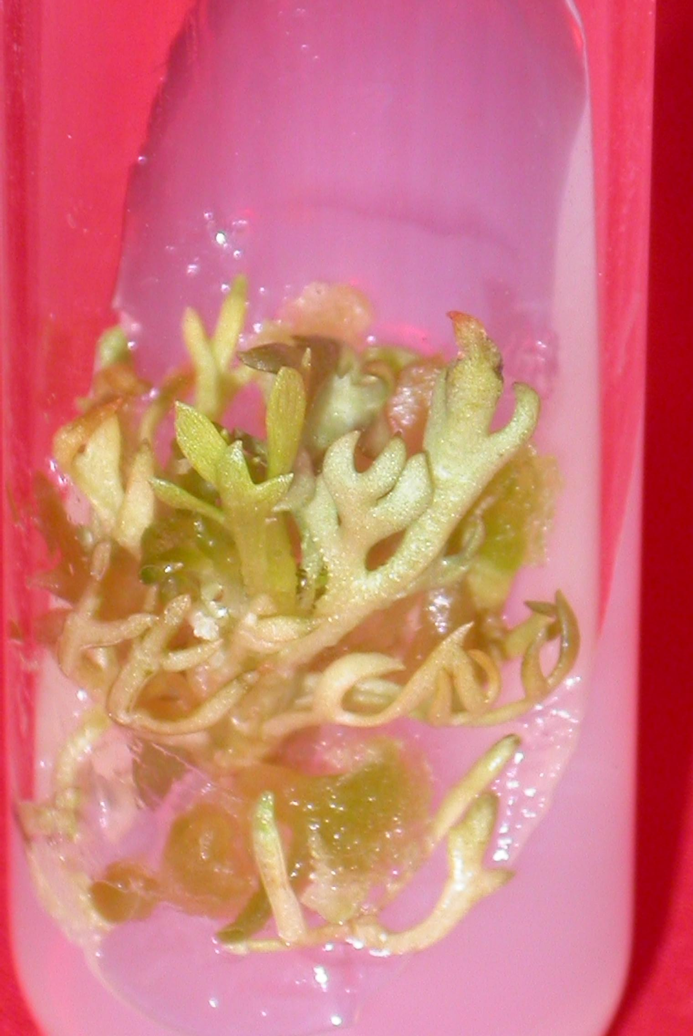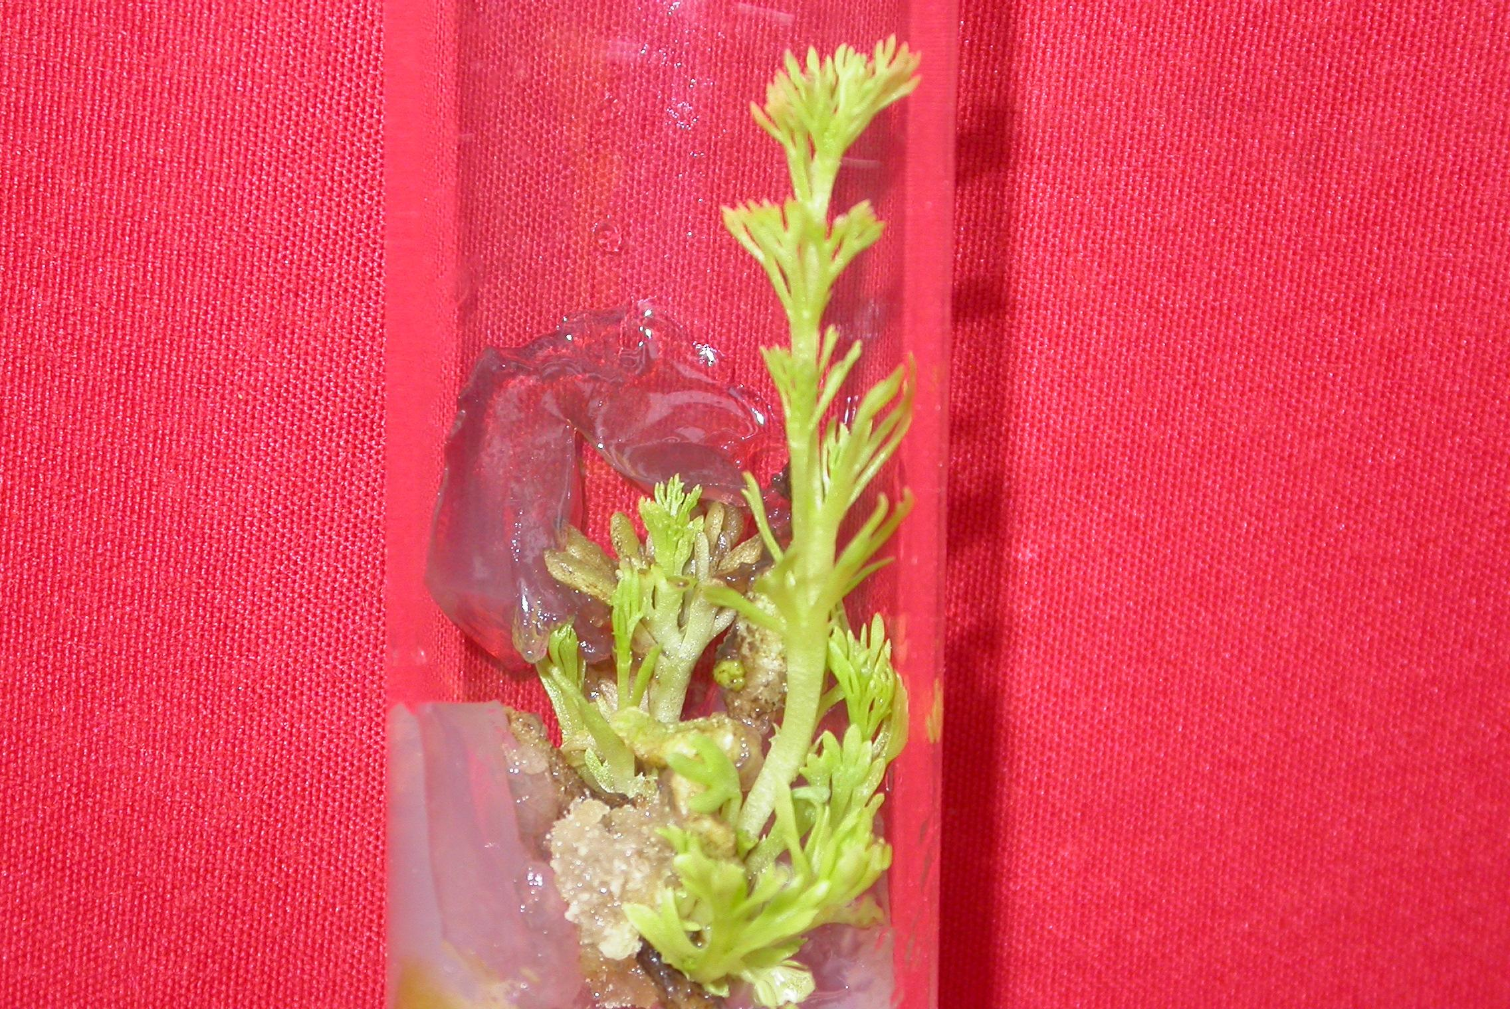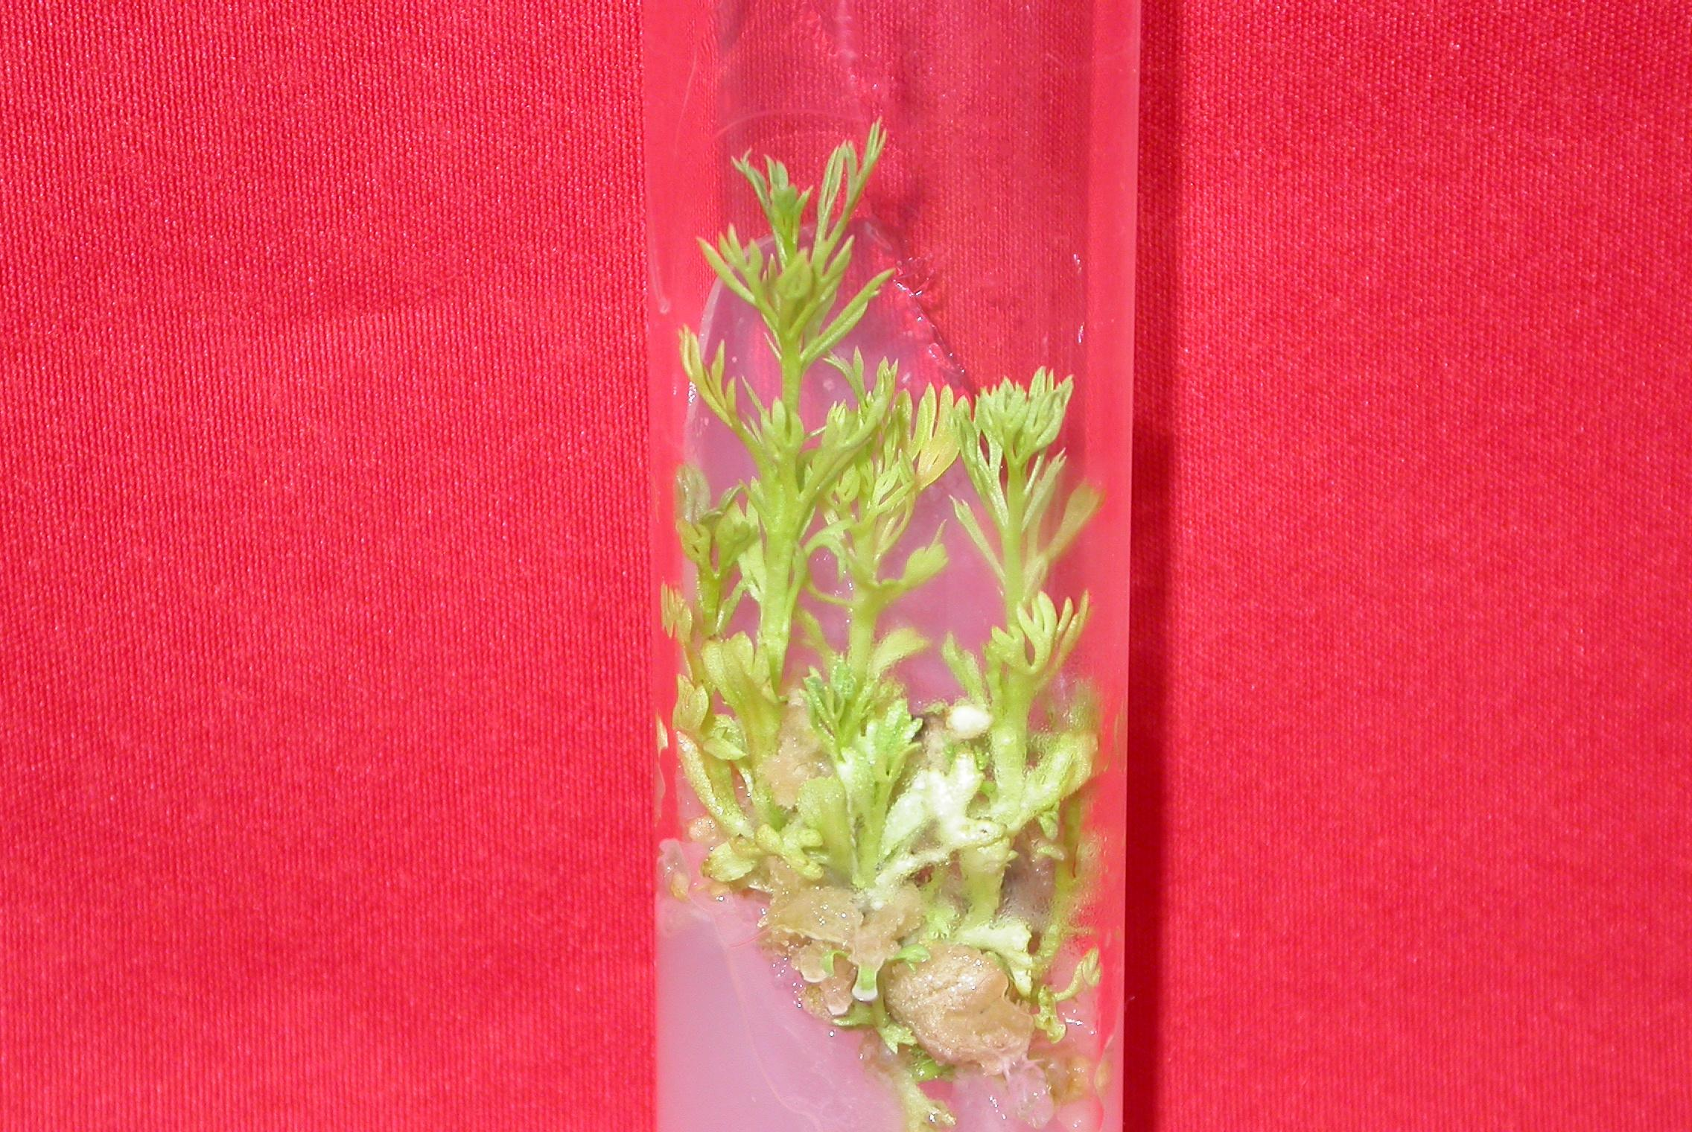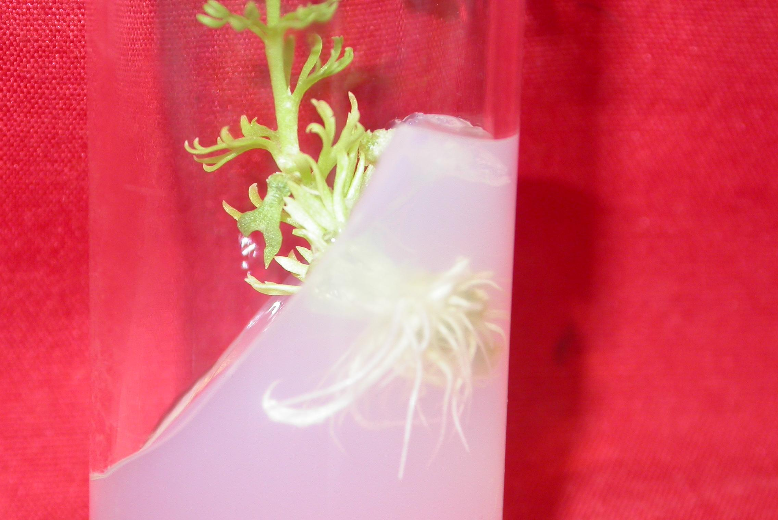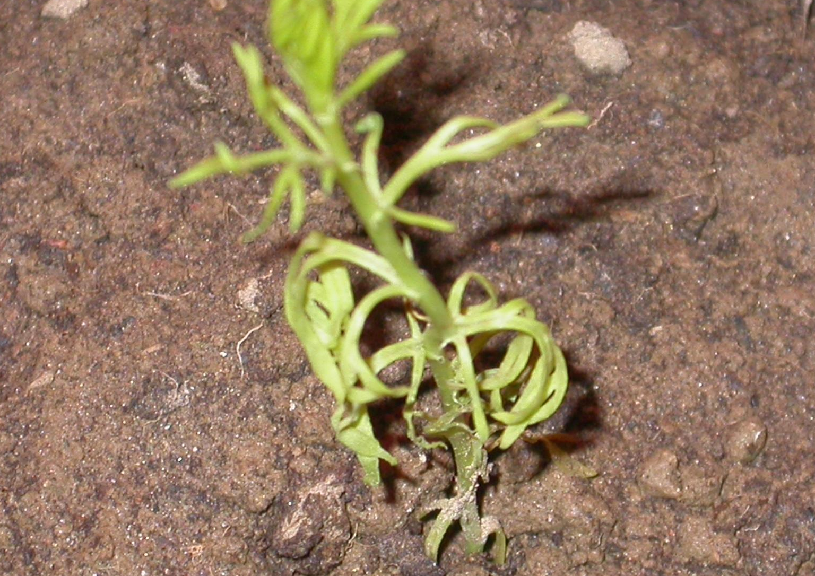
a
b
c
d
e
f

Figure1 (a-f): In vitro regeneration of Peganum hamrala. a, Regeneration of multiple shoots from shoot apex on MS+4.44µM BAP; b, Shoots developed from cotyledonary node with cotyledons on MS+4.44µM BAP; c, Regeneration of multiple shoots from preconditioned shoot apex at 11.1µM on MS+4.44µM BAP; d, Regeneration of multiple shoots from preconditioned cotyledonary node with cotyledons at 11.1µM on MS+4.44µM BAP; e, Regeneration of roots from shoot on ½ MS+5.0µM IBA; f, Transplanted plantlets in pots containing garden soil.

References
Aarons, D. H., Rossi, G. V. and Orzechowski, R. F. Cardiovascular action of three harmala alkaloids: harmine, harmaline, and harmalol. Journal of Pharmaceutical Science 1977; 6: 1244-1248.
Adday, M. H., Rashan, L. J., Sulayman, K. D., Abaar, M. Al and Ayoub, T. Antimicrobial activity of different extracts from the seeds of Peganum harmala. Fitoterapia 1989; 60: 363.
Ahmed, S. M., Chander, H. and Pereira, J. Insecticidal potential and biological activity of Indian indigenous plants against Musca donestica L. International Pest Control 1981; 23: 174.
Alkofahi, A. S., Abdelaziz, A., Mahmoud, I., Abuirejie, M., Hunaiti, A. and Oqla, A. El. Cytotoxicity, mutagenicity and antimicrobial activity of forty Jordanian medicinal plants. International Journal of Crude Drug Research 1990; 28: 139-144.
Anand, P. H. M. and Hariharan, M. In vitro multiplication of greater galangal (Alpinia galangal (Linn.) Willd)- a medicinal plant. Phytomorthology 1997; 47: 45-50.
Ananymous. The useful Plants of India. (Ed. Ambasta, S. P.) Publishers HRD, CSIR, New Delhi1986:60-70.
Baytop, T.,. Herbal treatments in Turkey, (Past and Present) 2. Baski, [Tükiye’de Bitkilerle Tedavi (Gecmiste ve Bugün)] Nobel Tip Kitapevleri Ltd. Sti., Istanbul Turkey, (In Turkish) 1999: 35-90
Burbulis, N., Blinstrubiene, A., Sliesaravicius, A., Sliesaravičius, A., Venskutoniene, E. Influence of genotype, growth regulators, sucrose level and preconditioning of donor plants on flax (Linum usitatissimum L.) anther culture. Acta Biologica Hungarica 2005; 56: 323-331.
Chatterjee, A. and Prakshi, S. C. The treatise on India medicinal plants. NISCOM, CSIR, New Delhi 1997; 3:109.
Ehsanpour, A. A. and Sa-Adat, E. Plant regeneration from hypocotyl culture of Peganum harmala. Pakistan Journal of Botany 2002; 34: 253-256.
Harikrishan, K. N. and Hariharan, M. Direct shoots regeneration from nodal explants of Plumbago rosea (Linn.) -a medicinal plant. Phytomorphology 1996; 46: 53-58.
Khattar, S. and Mohan Ram, H. Y. Organogenesis and plantlet formation in vitro in Sesbania graniflora (L.) Pers. Indian Journal of Experimental Biology 1983; 21: 251-253.
Khawar, K. M., Ozel, C. A., Balci, S., Ozcan, S. and Arslan, O. Efficient shoot regeneration in Syrian Rue (Peganum harmala L.) under in vitro condition. International Journal of Agriculture and Biology 2005; 7: 790-793.
Kirtikar, K. R. and Basu, B. D. Indian medicinal plants (International book distributors, Deharadun, India, 1995:1- 456.
Prashanth, D. and John S. Antimicrobial Activity of Peganum harmala. Fitoterapia 1999; 70: 438-439.
Saini, R. and Jaiwal, P. K. In vitro multiplication of Peganum harmala an important medicinal plant. Indian Journal of Experimental Biology 2000; 38: 499-503.
Saini R, Jaiwal P. K. Age, position in mother seedling, orientation, and polarity of the epicotyl segments of blackgram (Vigna mungo L. Hepper) determines its morphogenic response. Plant Science 2002; 163:101-109
Saini, R. and Jaiwal, P. K. Transformation of a recalcitrant grain legume, Vigna mungo L. Hepper, using Agrobacterium tumefaciens-mediated gene transfer to shoot apical meristem cultures. Plant Cell Reports 2005; 24: 164-171.
Saini, R. and Jaiwal, P. K. Agrobacterium tumefaciens- mediated transformation of blackgram an assessment of factors influencing the efficiency of uid A gene transfer, 2007. Biologia plantarum 2007; 51: 69-74.
Sharma, P. V. The Ayurvedic series-(3) - Dravyaguna-vijnana, 2 (Chukhambha Bharti Academy, Varanasi, India 1988: 607.
Sheahan, M. C. and Chase, M. W. A phylogenetic analysis of Zygophyllacae R. Br. Based on morphological anatomical and rbcl DNA sequence data. Botanical Journal of the Linnean Society 1996; 122: 279-300.
Singh, N. and Lal, D. Growth and organogenetic potential of calli from some explants of Leucaena leucocephala (Lam.) de Wit. International Journal of Tropical Agricultural 2007; 25: 389-399.
Sobhani, A. M., Ebrahimi, S. A. and Mahmoudian, M. An in vitro evaluation of human DNA topoisomerase I inhibition by Peganum harmala L. seeds extract and its beta carboline alkaloid. Journal of Pharmacy and Pharmaceutical Science 2002; 5: 19-23.
Stewart, R. R. Flora of West Pakistan, (Ed. Nasir, E. and Ali, S. I.), Publisher Fakhri Printing Press Publisher, 1972: 434.
Yildiz, M. and Ozgen, M. The effect of a submersion pretreatment on in vitro explant growth and shoot regeneration from hypocotyls of flax (Linnum usitaissimum). Plant Cell, Tissue and Organ Culture 2004; 77: 111-115.

