Veterinary Ethno-Medicinal Plants in Uttarakhand Himalayan Region
Priti Singh^{1&3}, Bibhesh K. Singh², Girish C. Joshi^{3*}, Lalit M. Tewari¹

1 Department of Botany, DSB Campus, Kumaun University, Nainital-263002(Uttarakhand) India
2 Department of Chemistry, Govt. Postgraduate College, Ranikhet-263645(Uttarakhand)India
3 Regional Research Institute (Ayurveda), Central Council for Research in Ayurveda & Siddha, Tarikhet,Ranikhet(Uttarakhand)-263663(India).
gcjoshi57@yahoo.com , pritiksingh78@yahoo.com

Abstract: Drug research has enriched human life in many ways. The health care and resulting social and economic benefits of new drugs to society are most remarkable, are quite well recognized. Drug research has been the driving force for many basic scientific developments, such as that of many new synthetic methods, of the understanding of the physiology and pharmacology of biological systems and has contributed much too molecular recognition. The Uttarakhand Himalayas have a great wealth of medicinal plants and traditional medicinal knowledge. The medicinal plant that has been widely used as veterinary ethno-medicine in Uttarakhand(India) region has been studied. These do not either occur elsewhere or have not so far been exploited commercially. Attempts have been made to explore the new possible species having medicinal importance especially for veterinary and to grow them in suitable areas so as to meet national industrial demands. The present paper deals with the traditional uses of 100 plant species employed in ethno-medicine and ethno-veterinary practice in Uttarakhand(India) Himalayan region.
[Nature and Science.2009;7(8):44-52].(ISSN: 1545-0740).

Key Words: Ethno-Medicinal Plants, Traditional knowledge, Uttarakhand Himalaya, Veterinary

1.Introduction
The Himalayas have a great wealth of medicinal plants and traditional medicinal knowledge. The Central Himalayan Region covers the new state of India, provides excellent opportunities for studying the Traditional Knowledge Systems. The Indian Himalayan region alone supports about 18,440 species of plants (Angiosperms: 8000 spp., Gymnosperm: 44 spp., Pteridophytes: 600 spp., Bryophytes: 1736 spp., Lichens: 1159 spp. and Fungi: 6900 spp.) of which about 45% are having medicinal properties. According to Samant et al., out of the total species of vascular plants, 1748 spp. species are medicinal. Uttarakhand is a storehouse of a rich variety herbs and medicinal and aromatic plant species. The Government intends to exploit this advantage. Uttarakhand has observed an increase in the area under cultivation of aromatic and medicinal plants. The number of farmers engaged in cultivation of aromatic plants in Uttarakhand has dramatically increased from 301 in 2003-04 to 2714 in 2006-2007 and the area under aromatic plants has increased ten fold.
2. Traditional Knowledge
United Nations University proposal defines Traditional Knowledge System (TKS) as "Traditional Knowledge or 'local knowledge' is a record of human achievement in comprehending the complexities of life and survival in often unfriendly environments. Traditional knowledge may be technical, social, organizational, or cultural was obtained as part of the great human experiment of survival and development." Traditional knowledge provides the basis for problem-solving strategies for local communities, especially the poor. Traditional Himalayan medicine is a good example of TKS, which has affected the lives of poor people around the globe. TKS is of particular relevance to the poor in the following sectors: agriculture, animal husbandry and ethnic veterinary medicine, management of natural resources, primary health care (PHC) and preventive medicine, psycho-social care, saving and lending, community development, poverty alleviation, etc. According to an estimate of the World Health Organization, approximately

80% of the people in developing countries depend on traditional medicine for primary health care needs; a major portion of these involves the use of medicinal plants.
The Traditional Himalayan Medicine System (THMS) is a living example of TKS where small communities fight even incurable diseases through the traditional methods. They also cure their animals through these traditional methods. These traditional methods are totally oral and non-documented. They use generally herbal products like resin, bark, root, leaves, fruits etc., minerals, animal products and tantric practices. For millennia human societies have been depending on plants and plant products for various remedies. In certain areas these folk medical prescriptions are endemic and have survived through ages from one generation to the next through the word of mouth. They do not exist as written knowledge. Generally these systems of medicine depend on old people's experiences. Indigenous systems of medicine are specially conditioned by the cultural heritage and myths.
2.1 History of medicine
Search for drugs to improve the quality of life and cure diseases has been a part of human life right from its beginning. In many of the well developed ancient civilizations this knowledge was evaluated, codified, recorded and formed an essential part of the texts of their traditional systems of medicine, such as Ayurveda in India. Drug research is a well structured and organized endeavor. The starting point of the story of modern era of drug research could actually be the observation by Paul Ehrlich around the turn of last century that dye stuffs stain some cells selectively and destroy them. He exploited this idea and increased the toxicity of a dye towards a pathogen by introducing a toxic element like arsenic leading to the antisyphilis agent ‘salvarasan’ in 1907, the first designed drug and coined the word ‘chemotherapy’ for this selective toxic action of chemicals on parasites. The search for Domagk for azo dyes that might be effective antibacterial agents ultimately/resulted in 1935 in the discovery of prontosil which protected mice against lethal streptococcal infections leading to widespread clinical use of a variety of sulphonamides for a wide range of bacterial infections. This was the beginning of the modern era of chemotherapy. The discovery of the powerful antimicrobial activity of a ‘penicillium notatum’ by Flaming in 1928, followed by isolation by Florey in early 1940’s highlighted the microbes as an important source of new drugs and of molecular diversity, and the interest in this resource has continued unabated ever since. The demonstration in early 1950s of the tranquillising and hypotensive activity of Reserpine obtained from ‘Rauwolfia Sepentina’ a drug commonly used in traditional systems of medicine for insanity, focussed attention on plant especially those used in traditional system of medicines.
2.2 Himalayan Therapies
In Uttarakhand(India), people uses magico-religious therapies as Bhbhuti, Tantra-mantra and Jagar to placate the local gods and supernatural powers but in natural therapies , like Ayurveda they use herbal products. According to the mode of application, the natural therapies have three categories:
1. Herbal products used in systematized system of medicine like Ayurveda, Siddha.
2. Herbal products used in ethno-medicine or indigenous medicine like HMS based on oral tradition.
3. Herbal products used in modern medicine, based on active chemical principles of the herbal products.
Despite significance development of rural health services, village people still use herbal folk medicines to a good extent for treatment of common ailments like cough, cold and fever, headache and body-ache, constipation and dysentery, burns, cuts and scalds, boils, ulcers, skin diseases and respiratory troubles and others.

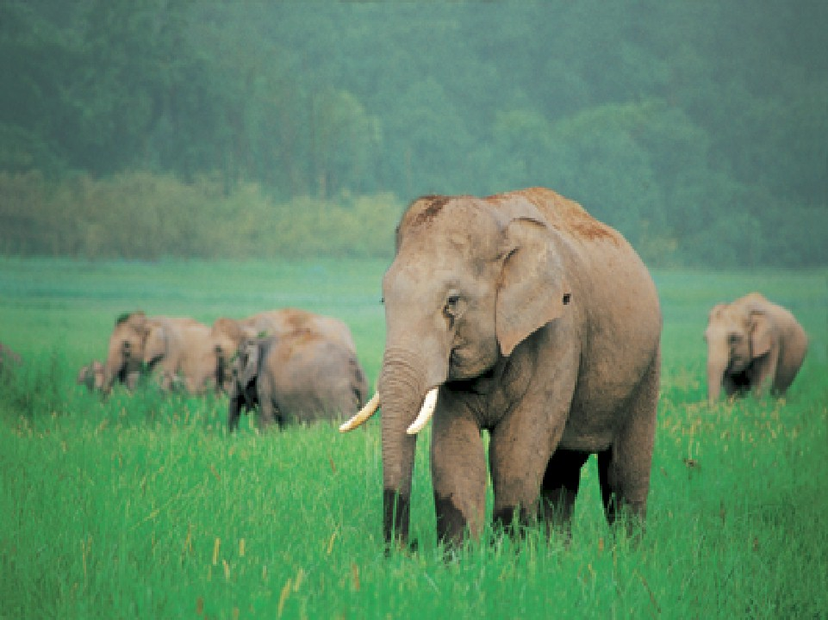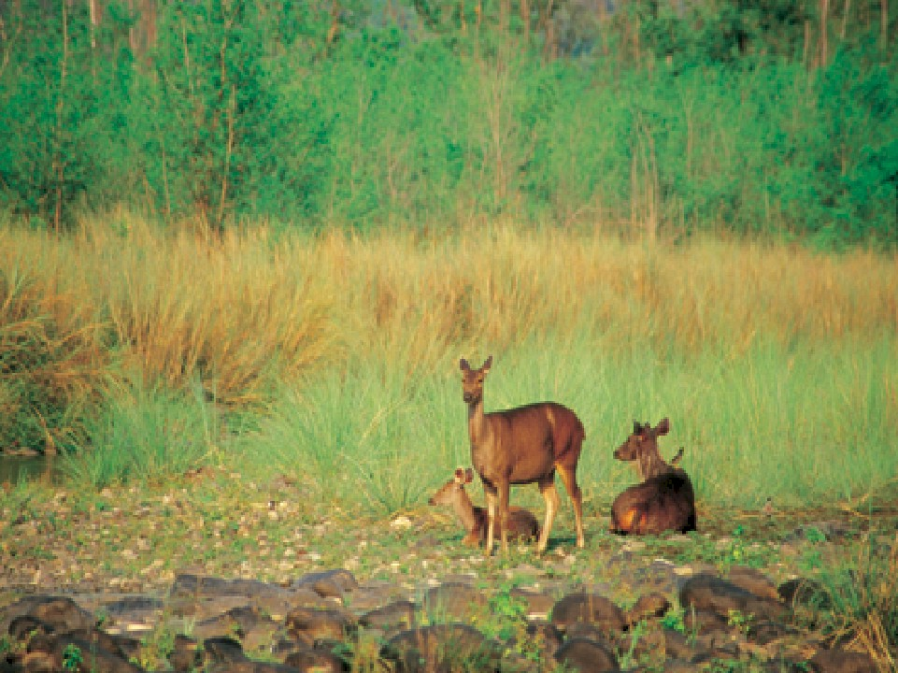
Figure 1. Showing Elephants and Dear in Jim-Corbet park at Uttarakhand(India)

2.3 Challenges
The hill districts of Uttarakhand have tremendous potential. The vast natural resources add to the state’s attractiveness as an investment destination, especially for tourism( Jim Corbett park, Uttarakhand is especially rich with elephants and Dear in Fig. 1) and agriculture and forest- based industries. Horses and mules are the backbone of the rural transport system in Uttarakhand(Fig.2). Sheep-rearing for wool can be good opportunity for alternative livelihood, whereas Yak which is used for tourism in few districts of Uttrakhand. Buffaloes are the main milch animals, contributing 62 per cent in milk production.(State Focus Paper 2006-07, NABARD). Attempts should, therefore, be made to explore the new possible species having medicinal importance especially for veterinary and to grow them in suitable areas so as to meet national demands. It is now well established that one major potential area, amongst some others where botanist can make a positive contribution, in the field of molecular medicines and drug research, is that of topological and topographical analyses and system analysis. Development of such analyses leads to a fundamental understanding of the mechanisms of action of biochemically important compounds, including their side effects.

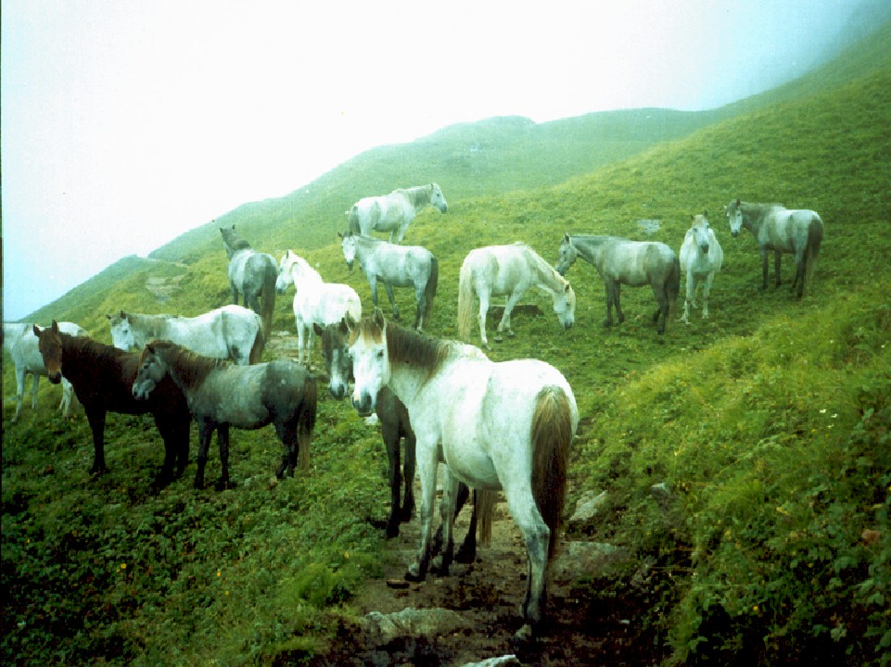
Figure 1. Horses are the backbone of the rural transport system in Uttarakhand(India)

3. Discussion
Table includes the medicinal plants that have been widely used as veterinary ethno-medicine in Uttarakhand region. Such aromatic plants which occur locally in the Uttarakhand himalaya and their medicinal importance for veterinary. These do not either occur elsewhere or have not so far been exploited commercially.

Table: Ethno-Medicinal Plants used as Veterinary Medicine
S. No | Botanical Name | Local Name | Parts Used | Uses | Mode of treatment
1 | Capsella bursa-pastoris, Moench. | Torighash | Whole plant | For Sikka Rog | Two palmful whole plant decoction in water given two times for vigor
2 | Cardamine impatiens, Linn. | - | Whole plant | For Tantrka in calf | One palmful whole plant decoction in one liter water given two times for vigor
3 | Viola biflora, Linn. | Banpansa | Whole plant | In calf for heart & faint problem | Two palmful whole plant two times a day for attack. Three/four parts of two palmful whole plant & a spoon honey given two times for heart & skin problem
4 | Viola patrinii, DC | - | Root | For liver | Two palmful root decoction in one liter water given two times for vigor
5 | V.serpens, Wall. | - | Root | For Liver | Two palmful root decoction in one liter water given three times with honey
6 | Hypericum cernum, | Vaya, Culi | Whole plant | For Hoskins, For wound | Two palmful whole plant decoction in one liter water given two times for vigor
7 | Linum usitatissinum,Linn. | Alsi | Whole plant | For strength | Two palmful whole plant decoction in 1& 1/4 liter water given two times for strength
8 | Melilotus alba, Lamk. | Banmethi | Whole plant | For stomach problem and Indigestion | One palmful whole plant given three times in a day for vigor
9 | Trifolium repens, Linn. | Garila | Whole plant | For Satrika | Four palmful whole plant given two times a day
10 | Agrimonia pilosa, Ledeb. | Kafliya | Whole plant | For purification of blood | Half palmful whole plant decoction in three/ four liter water given one fourth part with gur in morning
11 | Fragaria vesca, Linn. | Pudalia Kafal | Leaf | To protect abortion | Two palmful leaves given daily
12 | Potentilla argyrophylla, | Danti, Brajdanti | Leaf/Root | For stomach problem | One palmful leaves/two matured root decoction in 3/4 liter water given thrice in a day.
13 | Rhamnus virgata, Roxb. | Chaitula | Fruit | In Leg swelling | Five matured fruit decoction in ¼ liter water given daily
14 | Rosa moschata, Herrm. | Kunj pani | Fruit | For leucorrhea, bleeding,Pregnancy termination. | Two palmful fruit with one spoon honey given daily
15 | Rubus paniculatus,Sm. | Kala Hisalu(Kadula) | Leaf | In pregnancy | Two palmful leaves decoction in ½ liter water given its one cup twice a day
16 | R. lasiocarpus, Sm. | Kala Hisalu | Leaf | In pregnancy | Leaf is useful for cow specially in pregnancy pain
17 | Bergenia ciliata, Moench. | Silfhora | Root | For Hydrophobia | Two palmful root decoction in ½ liter water given its one cup thrice a day
18 | Ribes grossularia,Linn. | Caktu | Whole plant | For preventing abortion | One palmful whole plant given daily
19 | Punica granatum, Linn. | Darim | Skull of fruit | As antimicrobials | One palmful skull of fruit decoction in ½ liter water given its one cup three times a day with gur
20 | Woodfordia floribunda, Salisb. | Dhow | Flower | As energy syrup | One palmful dry flower decoction in water is useful for animals
21 | Centella asiatica, (Linn.)Urban | Brahmi | Leaf | For brain fever | Apply Paste of green leaves on forehead during fever
22 | Cuminum cyminum, L. | Jeera | Seed | For indigestion | One palmful seed in ¼ liter water given daily
23 | Foeniculum vulgare, Mill. | Saup | Seed | For Hookworm | One palmful seed in 1/8 liter water given before morning meal
24 | Pimpinella diversifolia, Dc | Dhanjari | Seed | For Lactation | One palmful seed given daily
25 | Abina cordifolia, Hook. F | Haldu | Bud& leaf | For Wound & fever | Applying paste of new bud on the wound. Decoction of leaves in ½ liter water given thrice a day in fever
26 | Valeriana hardwichii, wall. | Samyo, Dhup | Root | For titaini | Four matured root decoction in two liter water given ¼ liter twice a day
27 | Aesculus indica, Colebr. | Pangar | Fruit | In stomach problem | One palmful fruit decoction in ½ liter water given with gur
28 | Artemisia maritime,Linn. | - | Bud/Leaf | For Indigestion | One palmful bud/leaves decoction in one liter water given one cup daily
29 | A. nilagirica, Pampanini. | Patti,Kunj | Whole Plant | For urinary tract infection | One palmful whole body decoction in one liter water given one cup with gur
30 | Artemisia parviflora, Roxb. | Patti, Dhopani | Leaf/ Bud | For round worm | One palmful leaves/ bud decoction in a liter water given 1/8 liter in one hour interval
31 | A. sacrorum, Ladeb. | Kapar Patti,Jholpatti | Leaf/Bud | For hair fall | One palmful leaves & bud decoction in two liter water given one cup twice a daily
32 | Senecio chrysanthemoides, DC. | Ratpatia | Whole plant | For skin disease | Two palmful whole plant decoction in 3/4 liter water given one cup daily
33 | S. rufinervis, DC. | - | Seed | For wound | Three palmful seed given twice a daily
34 | G. pretense, Linn. | Chalmori | Whole plant | In fever, urine problem, eye problem | Two palmful whole plant decoction in 3 /4 liter water given one spoon thrice daily
35 | Tanacetum nubigenum, Wall. | - | Leaf/ Fruit | As energy syrup, anti microbes. | One palmful leaves/ fruit decoction in one liter water given one spoon with honey
36 | Lobelia pyramidalis, Wall. | Bran tambacoo | Whole Plant | For liver disease | Two palmful whole body decoction in 3 / 4 liter water given one spoon with honey thrice a daily
37 | Anagallis arvensis, Linn. | Vish Khaparia | Fruit/Leaf | As pain killer | Two palmful fruit/ leaves given daily
38 | Primula denticulate, Smith. | Vish Khaparia | Fruit | In cough, useful for mammary glands | Two palmful flower given with gur
39 | P. macrophylla, D. Don. | - | Whole Plant | As painkiller | This plant works as painkiller
40 | Holarrhena antidysenterica, Wall. | Quiar, Indraw | Seed & bark | In fever, Gastric & dysentery | One palmful powder of bark/ seed decoction in one liter water given one cup with gur
41 | Calotropis procera, R. Br. | Ank | Root | In indigestion | One palmful powder of root decoction in one liter water given one cup twice a day
42 | Gentiana tenella,(Roltb) H. Smith. | Kutuki, Katuwi | Fruit | In hysteria, In weakness | 25g of bark of fruits decoction in one liter water given one cup with honey per day
43 | Swertia purpurascens, Wall. | Ciraita | Whole Plant | In fever, In weak appetite. | Two palmful whole plant decoction in one liter water given one cup thrice a day
44 | Capsicum annum, Linn. | Khusane, Marac | Fruit | As oil massage. | One palmful fruit decoction in three liter water gives one cup twice a day
45 | Datura metal, Linn. | Dhatura | Seed | As pain killer (for external use only) | 25g roasted seed in one liter oil is used for massage
46 | Hyoscyamus niger, Linn. | Bran juwan | Leaf , Seed | As pain killer | Paste of leaves and seed is used as ointment
47 | Digitalis purpurea,Linn. | Prawasit Degitelis tilpushpi | Leaf | In burning | One palmful leaves is roast with oil is used as ointment
48 | Verbascum thapsus, Linn. | Akalvir | Leaf | In bronchitis | One palmful leaves decoction in 3/4 liter water given one cup thrice a day
49 | Clerodendrum infortunatum, Gaertn. | Aranyo | Bark | In Efra | Powdered bark decoction in 2 liter water given one cup thrice a day
50 | Ajuga parviflora, Benth. | Ratpatia | Whole plant | In arthritis | One palmful whole plant decoction in 3/4 liter water given one cup daily
51 | Mentha arvensis, Linn. | Pudina, Eliachi | Whole plant | In post pregnancy problems | Two palmful whole plant decoction in a liter water given ¼ part thrice a day
52 | Ocimum sanctum, Linn. | Tulsi | Whole plant | In fever | Two palmful whole plant twice a day
53 | Origanum vulgare, Linn. | Jangali tulsi | Whole plant | Indigestion | Four palmful whole plant with fibrous food twice a day
54 | Salvia lanata, Roxb. | Sania, Sunip | Whole plant | For vomiting, painkiller | Two palmful whole plant with gur and fibrous food thrice a day
55 | Scutellaria angulosa, Benth. | Karuijhar | Whole plant | In acidity | One palmful whole plant decoction in ½ liter water given one spoon with honey thrice a day
56 | Thymus serpyllum, Linn. | Van ajmain | Whole plant | In chest pain | One palmful whole plant decoction in ½ liter water given one cup twice a day
57 | Plantago major, Linn. | Vrantank | Leaf | In Injury, teeth problem, fever | Paste of leaves in water useful for injury & teeth pain. Two bunch of leaves decoction in one liter water given 1/6 part thrice a day for fever
58 | P. orata, Forsk. | Esabgol | Seed | In dysentery | One palmful seed in ½ liter water makes a semisolid paste given thrice a day
59 | Boerhaavia diffusa, Linn. | Parnata | Leaf | In blood dysentery, In dropsy | Juice of leaves thrice a day
60 | Achyranthes aspera, Linn. | Chirchira | Whole plant | For teeth problem | One palmful whole plant in ½ liter water is useful in teeth problem
61 | A. bidentata, Blume. | Dansh | Root | As Laxative | One palmful root decoction in one liter water given two times for vigor
62 | Chenopodium album, Linn. | Bethuwa | Leaf/ seed | For worm | Two palmful seed is given before breakfast
63 | Rheum emodi, Wall. | Dolu, Archa | Root | For blood purification, for energy | One matured root decoction in one liter water given three times for vigor
64 | Rumex hastatus, D. Don | Bhilmora | Whole plant | For skin disease, In fever | One palmful whole plant decoction in 3 / 4 liter water given one cup thrice a day
65 | Piper longum, L. | Pipal | fruit | In Low appetite, As oil massage | Powder of fruit is useful for low appetite. Oil with powder massage is useful
66 | Cinnamomum tamala, Ness. | Kiriya, karkiriya, Dalchini | Leaf | In stomach problem, in gastric problem | Powder of Leaves and bark with half palmful fiber food is useful
67 | Litsaea polyantha, Juss. | Cirira | Leaf | In injury | Powder of bark & leaves in cold water as ointment
68 | L. umbrosa, Ness. | Circira | Leaf | In bone injury | Paste of leaves in water as ointment in bone injury
69 | Viscum album, Linn. | Bana | Fruit | In pregnancy problem | Six fruits with milk twice a day
70 | Emblica officinalis,Gaertn. | Aula, Awla | Fruit | In eye disease/ good health | Two palmful fruits powder with fibrous food
71 | Euphorbia prolifera, Buch. Ham.,ex.Don. | Duwila | Fruit | Used in dog bite | Powder of fruit is useful
72 | Mallotus philippinensis, Muell. & Arg. | Roli, Kasela | Fruit | To protect from worm | Fruit extract with one palmful fibrous food is given once a day
73 | Ricinus communis, Linn. | Erind | Leaf | For internal injury | Oil of this plant is useful. Use of leaves in heat therapy
74 | Betula utilis,Don. | Bhuj, Bhojpatra | Seed | To protect from worm | Two small pinch is useful
75 | Quercus dilatata, Lindl. | Banj | Bark | In dysentery | Two palmful powder of bark decoction in one liter water given one cup twice a day
76 | Q. semecarpifolia, Sm. | - | Bark | In dysentery | Two palmful bark powder decoction in one cup water given twice a day
77 | Salix elegans, Wall. | Garbainsh | Fruit | In rickets | Three palmful fruits decoction in one liter water given one cup thrice a day
78 | Ephedra gerardiana, Wall. | Gidjing | Stem | In pain | One bunch of stem pieces decoction in 2 liter water given one cup in early morning
79 | Juniperus communis ,Linn. | Jhora, khichiya | Fruit | In liver disease | Twelve fruits daily
80 | Abies webbiana, Lindl. | Raisal barmi radha | Bud | In Cough | One palmful bud decoction in 3 liter water given thrice a day
81 | Cassoa absus, Linn. | Banar, Chakwar | Seed | In urine problem | One palmful seeds decoction in ½ liter water given one cup thrice a day
82 | Satyrium nepalense, D. Don. | - | Root | As tonic | Two palmful roots decoction in 3 / 4 liter water given ½ parts twice a day
83 | Zingiber officinals | Banhaldi | Root | Internal injury, As anti worm | Paste of root
84 | Cureuma angustifolia, Roxb. | Banhaldi | Root | In gastric problem, anti worm | Paste of root
85 | Acorus calamus, Linn. | Banj | Root | Fever, pain | Two matured root with fibrous food given daily
86 | Allium stracheyi,Baker. | Jambu | Whole Plant | For stomach problem | Two palmful whole plant given thrice a day
87 | Allium wallichii, Kunth. | Jangali Lasun | Root | In infection | Two node given daily
88 | Asparagus racemosus, willd. | Kairuwa | Bud | In liver problem & To enhance Lactation | One palmful bud given twice a day
89 | Aloe vera, Linn. | Patquar | Leaf | Stomach problem | Juice of leaves given ½ cup a day
90 | Adiantum venusthum,G. Don. | Hanshraj | Seed | For Chest problem and hair fall | One palmful seed given with fibrous food
91 | Equisetum arvense, Linn. | Horsetel | Whole plant | For urinary problem | Half palmful whole plant decoction in one liter water given
92 | Althaea officinalis, Linn. | Jangalihauli | Root | For termination of pregnancy | Three/ four matured root decoction in one liter water is given
93 | Reinwardtia trigyna, Planch. | Pyuli | Root | In wound | One bunch of root decoction in ½ liter water given one cup in a gap of two days
94 | Tagetes arecta, Linn. | Hazari | Fruit | In vomiting, In healing wound | One palmful fruit is given with fibrous food at the time of vomiting. Its external use is in filling wound
95 | Calendula officinalis, Linn. | Ganda(Tokar) | Leaf | In bleeding | Juice of leaves is helping in bleeding
96 | Atropa belladonna, Linn. | Dhatur Jahar | Leaf | In injury as pain killer | Paste of one palmful leaves burns in oil acts as ointment
97 | Datura stramonium, Linn. | Dhatura | Leaf | In injury as pain killer | Paste of one palmful leaves acts as ointment
98 | Urtica dioica, Linn. | Sisauna | Leaf | Skin disease, For lactation | One palmful leaves is given with fibrous food in 1h interval
99 | Juglans regia, Linn. | Akhore | Leaf/ fruit | In stomach problem, As anti worm | Two palmful leaves or two green fruits decoction in 1 liter water is given one cup with two spoon honey thrice a day
100 | Hedychium spicatum,Ham.ex. Smith | Kapur Kachari | Root | For fever & cough | Root is given with gur
101 | Canna indica, Linn. | Kewara | Root | In disinterest, In afra | Powder of one bunch of root is given with gur
102 | Anemona obtusiloba Don. | Kakaria | Leaf | In sinus | A cotton bud is made of Paste of leaves with Ghee for cleaning sinus
103 | Delphinium denudatum, Wall | Nirwishi, Munel | Seed | In tics | One palmful seed decoction in ½ liter water is given
104 | Aconitum balfouria, stapf. | Bishjahar | Root | In wound | One matured root burns in one liter oil gives a ointment
105 | Paeonia emodi, Wall. | Bhoi Pawin | Root | In stomach problem | One matured root decoction in 3 / 4 liter water is given one cup with 100g gur thrice a day
106 | Berberis aristata, DC | Kilmori | Root & stem | In fever, weakness | One palmful root/ stem decoction in ½ liter water given one cup daily
107 | Fumaria parviflora, Lamk. | Pitpapara | Whole plant | In skin etching(disease) | One palmful whole plant decoction in one liter is given
108 | Brassica napus, Linn. | Kali sarso | Seed | In poor appetite | Two palmful seed is given with fibrous food and gur twice a day
109 | Geranium ocellatum, Camb. | Bhiljari | Whole plant | As insecticide | Four whole plant with fibrous food twice a day. Powder of whole plant is given as insecticide
110 | Acacia catechu, Wild. | Khair | Stem | In Urine problem, dysentery | One palmful stem decoction in ½ liter water given one cup four times a day
111 | Butea frondosa, Koen. | Dhank | Flower, Seed | As painkiller | Paste of flower and seed is given

3.1 Special emphasis is on R&D.
An integrated action plan has been drawn up for this purpose in coordination with the Government of India and other concerned agencies in the State and elsewhere in the country. R&D in the area of Medicinal Plants and commercial production of applications and formulations will be developed in conjunction with Research Institutions and reputed companies. A Medicinal and Aromatic Plants Export Zone has been set up covering seven districts of Uttarakhand and Specialized Herbal Parks are in the offing.
The salubrious climate, pollution free environment and the availability of a wide range of flora and fauna in the mountainous terrain, make Uttarakhand an ideal location for developing centres for alternative medicine and health care facilities. A significant portion of Uttarakhand is under forest cover (almost 70 percent). There is, thus, excellent potential for the development of forest resources based Industries in the State. In addition, there is ample scope to develop industries based on forest and agro-wastes such as lantana, pine needles, plant and vegetative fibres such as Rambans, etc.

4. Conclusion
Himalyan people have close relationship with nature. Generally, they believe that diseases are caused by the supernatural powers and they treat them through natural products like plants, herbs, trees, soil etc. Himalayan veterinary medicine system is totally non-systematized. The person, prescribing these medicines has no so-called scientific knowledge about the disease. So, discoveries coming from diverse backgrounds laid down the broad canvas for drug research to follow. Most of the basic concepts and approaches to modern drug discovery research were established. These developments aroused worldwide interest and offered great hope and prospects.

Correspondence to:
Girish C. Joshi
Regional Research Institute (Ayurveda), Central Council for Research in Ayurveda & Siddha, Tarikhet,Ranikhet(Uttarakhand)-263663(India).

Phone: +91-9412809019: Fax: +91-5966220372.
E-mails: gcjoshi57@yahoo.com; pritiksingh78@yahoo.com

References
[1] Ahuja, P. S.Current status of propagation of medicinal plants in India Himalaya.In:Himalayan Medicinal Plants: Potential and Prosepects(Eds. S. S. Samant, U. Dhar and L. M. S. Palani) Gyanodaya Prakhasan, Nainital(India).2001:207-31.
[2] Gaur, R. D, Bhatt, K. C. and Tewari, J. K. An ethno-botanical study of Uttar Pradesh Himalaya in relation to veterinary medicines. J. Indian Bot. Soc.1992;72:139-44.
[3] Issar, R. K. Traditionally important medicinal plants and folklore of Uttaranchal Himalaya for animal treatment. J. Sc. Res. Pl. Med. 1981;2:61-6.
[4] Joshi, G. C., Tewari, K. C. & Pandey, G. A review of indigineous system of medicine with special reference to herbal drugs. Aryvaidyan.1992; 3(3):173-9.
[5] Mishra, P. L.The medicinal plants of Himalaya. Himalayan J. Sci.1985; 4&5:65-80.
[6] Mittal, S,Tripathy, G., Sethi D. Development strategy for the Hill districts of Uttrakhand ICRIER,India. July 2008; 17.

6/6/2009

[7] Samal, P. K.,Shah Anubha, Tiwari, S.,Mehara, B.,Agarwal, D. P. Indigenous animal health care practices in India Central Himalaya: Empirical evidence. Indian J. Traditional Knowledge, 2003;2(1):40-50.
[8] Samant,S.S,Dhar,U,Palini, L.M.S. Medicinal Plants of Indian Himalaya: Diversity, distribution and potential value. Gyanodaya Prakashan, Nainital India.1998;13.
[9] Sati, V. P. Natural Resource Conditions and Economic Development in the Uttaranchal Himalaya, India, Journal of Mountain Science.2005; 2 (4):336-50.
[10] Shah,N.C. Herbal folk medicines in Northern India. J. Ethnopharmcol. 1982;6:293-301.
[11] Proceeding of the National Workshop on Joint Forest Management, Ministry of Environment and Forest (2005).
[12] State of Forest Report. Forest survey of India, Ministry of Environment & Forest, Dehradun, 2005;140-2.

