Effect of Growth Regulators on Meristem-tip Development and in vitro Multiplication of Potato Cultivar ‘Kufri Himalini’

Anoop Badoni* and J. S. Chauhan**
*Researcher and Young Scientist (UCOST), Seed Biotechnology Laboratory, Department of Seed Science and Technology,
H. N. B. Garhwal Central University, Srinagar- 246 174, Uttarakhand, India
*For Correspondence: annabadoni@yahoo.co.in

**Associate Professor and Head, Department of Seed Science and Technology, H. N. B. Garhwal Central University, Srinagar- 246 174, Uttarakhand, India
_____________________________________________________________________________________________________

Abstract
In the present study meristem tips of potato (Solanum tuberosum) were cultured on Murashige and Skoog (MS) medium, supplemented with different hormonal combinations i.e. MSGN1 (0.25 mg/l GA₃ and 0.01 mg/l NAA), MSGN2 (0.25 mg/l GA₃ and 0.03 mg/l NAA), MSGN3 (0.25 mg/l GA₃ and 0.04 mg/l NAA), MSKN1 (0.01 mg/l Kinetin and 0.1 mg/l NAA), MSKN2 (0.001 mg/l Kinetin and 0.1 mg/l NAA) and MSKN3 (1 mg/l Kinetin and 0.1 mg/l NAA), which affected in vitro propagation of potato. After 35-40 days of culture shoot height, number of nods, root length, shoot and root fresh weight were measured. Shoot height in M.S. medium with GA₃ and NAA combination showed better result in comparison to M.S. medium with Kinetin and NAA. Shoot height in MSGN1 combination reached 8.28 (±0.5) cm. with 11.9 (±1.1) cm. root length and 9.4 (±1.0) nodes while in MSKN1 shoot height reached 6.4 cm. (±0.6) with 8.2 (±0.5) cm. root length and 5.0 (±0.7) nods. MSKN2 and MSKN3 reached low shoot height respectively 5.3 cm. (±1.2) with 4.2 (±0.8) nods and 4.0 cm. (±0.6) with 2.7 (±0.7) nods in comparison to all combinations. MSGN2 and MSGN3 combinations reached respectively 7.15 (±0.5) cm. with 8.2 (±1.0) nodes and 6.15 (±0.6) cm. with 6.3 (±0.9) nodes. Result showed that lower concentration of auxin (0.01 mg/l NAA) with Gibberelic Acid (0.25 mg/l GA₃) is best for development of complete plantlets and multiplication from meristem tips. [Nature and Science, 2009;7(9):31-34]

Keywords In vitro, meristem tip, Solanum tuberosum and Kufri Himalini

Introduction
The ICAR has identified a new hybrid variety of potato Kufri Himalini. Nearly 8% of the total area under Potato in the country lies in the hills, where potato is an important cash crop. This species is best for commercial cultivation in hilly regions. The new variety, with medium maturity of 110-120 days has been recommended for cultivation in the north- western and eastern hills during summer. It provides a yield advantage of over 10% over Kufri Jyoti and Kufri Giriraj. In the plains and its keeping quality is better then all the cultivars develop so far for hill regions (Anonymous, 2005).
Micro propagation is the alternative to conventional propagation of potatoes (Chandra et al., 1994). In vitro propagation methods using meristem tips, nodal cuttings and micro tubers are more reliable for maintaining genetic integrity of the multiplied clones since de-differentiation and the subsequent organogenesis/ embryo genesis with the accompanying genetic changes have been reported (Wang and Hu, 1982). Meristem culture provides a reproducible and economically viable method for producing pathogen free plants. As meristem tips are free from viruses, elimation and generation of virus free plants are possible through meristem culture (Jha and Ghosh, 2005). Through several workers have reported the use of MS medium without hormones during proliferation stage (Aburkhes et al., 1984; Rosell et al., 1987; Gopal et al., 1980) but the growth was slow and it took 3-4 weeks to grow 30-50 high shoots (Hussey and Stacey, 1981). Improvement has been made possible by addition of growth regulators to the medium. Gas stimulated development of nodal cutting on MS but at high concentration it produce narrow and elongated shoot (Novak et al., 1980) depending on genotypes. Longest main shoot and highest node numbers are reported to be obtained in medium containing NAA and BAP (Yousef et al., 1997). Pennazio and Vecchiate (1976) used MS medium supplemented with GA and NAA for proliferating meristem tip. The main aim of this study was to see the effect of different hormonal combinations of GA₃: NAA and Kinetin: NAA with MS medium on in vitro shoot regeneration of potato cv. Kufri Himalini using meristem tips.

Material and Method
The present investigation was carried out with the objective; to study the effect of two hormonal combinations i.e. GA₃+ NAA and Kinetin + NAA with MS medium on shoot regeneration and multiplication using meristem tips of potato cv. Kufri Himalini.
For obtaining sprouts, the tubers were cut into pieces; these pieces were dipped in a solution of 0.1% Bavistin, for 2-3 minuts and sown in sand filled plastic pots. These were grown under poly house conditions following optimum cultural practices. After 25-30 days of growth meristem tips were ready for inoculation. For inoculation of explants different media with hormonal combinations were prepared properly. MS media supplemented with different combinations of GA₃+ NAA and Kinetin + NAA (Table-1), were autoclaved at 15 psi for 20 minute. The hot medium was immediately dispensed in to culture flask (30 ml medium in each flask) and covered with autoclaved cotton plug in Laminar Air Flow Cabinet. The segment of about 0.5-1 cm. size were collected in a water filled beaker from the mother plant of Kufri Himalini, and kept under running water prior to sterilization in the laminar air flow cabinet. The explants were treated by sodium hypochlorite with 8 minutes, followed by 5 minute wash of savolon, and 30 second wash of alcohol, at last 6-7 wash of distil water was done. After sterilization, explants were inoculated in MS medium supplemented with different hormonal combinations and shifted to culture growth room at 25⁰ + 1⁰ c and 16 h photoperiod. Best combination of GA₃+ NAA and Kinetin + NAA with MS medium was selected on the basis of cultures growth performance i.e. shoot height, number of nodes, root length, shoot and root fresh weight, after 35-40 days. The mean values were calculated of cultures growth of all the combinations. The selected combination was used for sub culturing of plantlets also.
The shoot development was studied in terms of the parameter given above. The best combination of hormones with MS medium was selected and which cultures showed higher growth were further sub-cultured on its parent medium by cutting it in to small pieces in a way that each subsection have at least 1-2 nodes.

Result and Discussion
In hilly regions, late blight in potato crop has become more frequent and intends last few years and the resistance to late blight was found eroding in existing varieties Kufri Jyoti and Kufri Giriraj. To overcome this, the new hybrid variety Kufri Himalini has been developed which has high level of resistance to late blight was used in the study. Indian Council of Agriculture Research (ICAR) has identified Kufri Himalini for commercial cultivation in hilly regions, a new variety with medium

maturity of 110-120 days has been recommended for cultivation in the northwestern and eastern hills during summer. Kufri Himalini provides a yield advantage of 10% over Kufri Jyoti and Kufri Giriraj (Anonymous, 2005).
Different combinations of GA₃+ NAA and Kinetin + NAA with MS medium influenced in vitro shoot regeneration from meristem tip culture. Shoot height in M.S. medium with GA₃ and NAA combination showed better result in comparison to M.S. medium with Kinetin and NAA (Table- 1).

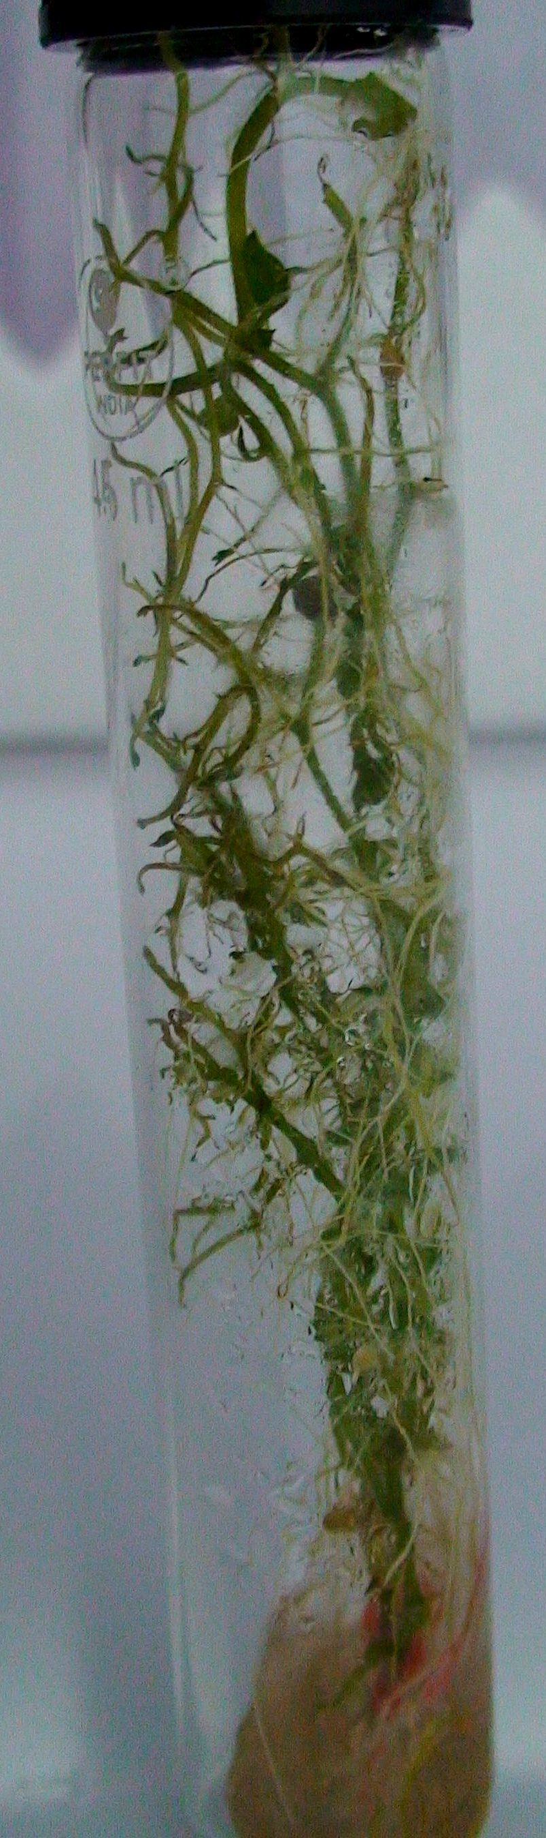(a) 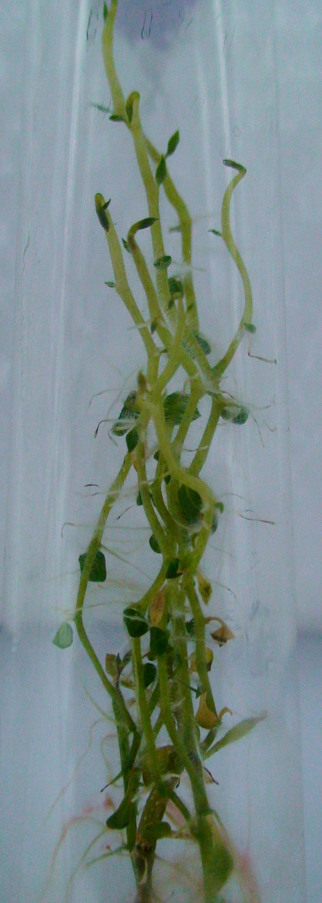(b) 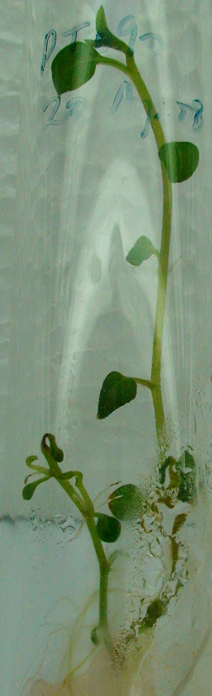(c)

Fig. 1 (a) to (c): Meristem development on different hormonal combinations with M. S. medium (a) and (b): MS+ 0.25 mg/l GA3 +0.01 mg/l NAA (c): MS+0.01 mg/l Kn +0.1 mg/l NAA

The combination of Kinetin and NAA had consistently given good result for improving shoot height. The MSKN2 (0.001 mg/l Kinetin and 0.1 mg/l NAA) having low concentration of Kinetin and NAA and MSKN3 (1 mg/l Kinetin and 0.1 mg/l NAA) combinations having higher concentration of Kinetin (1 mg/l) and low concentration of NAA, responded the least mean Shoot height and number of nodes. Low concentration of Auxin (0.1 mg/l NAA) plus moderate concentration of Cytokinine (0.01 mg/l Kinetin) showed good development of complete plantlets from meristem tips.
After 35-40 days of incubation, shoots in MSH1 (0.25 mg/l GA₃ and 0.01 mg/l NAA) reached 8.28 cm with 9.4 nodes. These results are comparable or even better than the most rapid node production (x8 to x10 per month) reported earlier using agar (Hussey and Stacey, 1981). The combination of GA₃ + NAA showed best result for

improving all the parameters of the study (Table-2). The MSGN2 (0.25 mg/l GA₃ and 0.03 mg/l NAA) and MSGN3 (0.25 mg/l GA₃ and 0.04 mg/l NAA) combinations respectively having higher concentration of NAA responded the least mean Shoot height and number of nodes. This could be attributed to the fact that higher concentration of NAA inhibit root and shoot growth (Pennazio and Vecchiati, 1976). Result showed that lower concentration of auxin (0.01 mg/l NAA) with Gibberelic

Acid (0.25 mg/l GA₃) is best for development of complete plantlets from meristem tips with avoiding callus and satisfactory root formation.
In the present comparative study the conclusion is that GA₃ + NAA (MSGN1) combination is best for shoot regeneration and multiplication of potato cv. Kufri Himalini in comparison to the combination Kinetin + NAA with M. S. medium.

Table-1: Effect of different hormonal combinations with MS media on shoot height, node number, and root length after 35-40 days of culture:

Growth regulators (mg/l) Shoot height (cm) Node number Root length (cm)
GA₃ NAA Kn Symbol used

0.25 0.01 0 MSGN 1 8.2 ± 0.5 9.4 ± 1.0 11.9 ± 1.1
0.25 0.03 0 MSGN 2 7.1 ± 0.5 8.2 ± 1.0 10.6 ± 1.0
0.25 0.04 0 MSGN 3 6.1 ± 0.6 6.3 ± 0.9 9.4 ± 1.0
0 0.1 0.01 MSKN 1 6.4 ± 0.6 5.0 ± 0.7 8.2 ± 0.5
0 0.1 0.001 MSKN 2 5.3 ± 1.2 4.2 ± 0.8 6.8 ± 0.8
0 0.1 1 MSKN 3 4.0 ± 0.6 2.7 ± 0.7 5.3 ± 0.9

Table-2: Effect of different hormonal combinations with MS media on shoot and root fresh weight and root: shoot ratio after 35-40 days of culture:

Hormonal Combination Shoot fresh weight Root fresh weight Root: Shoot ratio

MSGN 1 0.501 ± 0.05 0.296 ± 0.05 1.76 ± 0.5
MSGN 2 0.364 ± 0.04 0.234 ± 0.01 1.56 ± 0.2
MSGN 3 0.348 ± 0.04 0.212 ± 0.008 1.64 ± 0.2
MSKN 1 0.226 ± 0.01 0.144 ± 0.01 1.57 ± 0.1
MSKN 2 0.171 ± 0.03 0.120 ± 0.07 1.42 ± 0.2
MSKN 3 0.141 ± 0.05 0.112 ± 0.08 1.27 ± 0.5

References

- Aburkhes, M., N. Fahmi, A. Benhemida, M. Nafali and A. Zeiglem 1984. Virus free potatoes by tissue culture in Libya. Acta horticulture 289: 77-79.
- Anonymous 2005. The Hindu India 29: 5-6.
- Chandra, R. and R. K. Birhman 1994. In vitro micro propagation in relation to pedigree in potato. Journal of Indian Potato Association. 21:87
- Gopal, J., J. L. Minocha and H. S., Dhaliwal 1980. Microtuberization in potato (Solanum tuberosum L.). Plt. Cell. Rep. 17: 794-798.
- Hussey G., and N. J. Stacey 1981. In vitro propagation of potato (Solanum tuberosum L.). Ann. Bot. 48(6): 787-796
- Jha, T. B. and Biswajit Ghosh 2005. Plant Tissue Culture: Applied and Basic. Universities Press (India) pvt. Lit.
- Novak, F. J., J. Zadina, V. Horockava, and I. Maskova 1980. The effect of growth regulators on meristem tip development and in vitro multiplication of Solanum tuberosum L. plants. Potato Research 23: 155-166
- Pennazio, S., and M. Vecchiati 1976. Effect of naphthalene acetic acid on meristem tips development. Potato Research, 19(3): 232-234

- Rosell, G., F. G. De Bestoldi and R. Tizio 1987. In vitro mass tuberization as a contribution to potato micro propagation. Potato Research 30(1): 111-116.
- Wang, P. J. and C. V. Hu 1982. In vitro mass tuberization and virus free seed potato production in Tiwan. Amer. Pot. Journ. 59: 33-39.

- Yousef, A. A. R., M.A. Suwwan, A. M. Musa, and H. A. Abu-Qaoud, In vitro culture and microtuberization of spunta potato (Solanum tuberosum). Dirasat Agri. Sci. 24: 173-181

Correspondence to:
Anoop Badoni
annabadoni@yahoo.co.in

8/5/2009

