INVOLUTION SIGNS DURING THE POSTNATAL LIFE IN THE PINEAL TISSUE OF BUFFALO AND CAMEL

Khalil Abou-Easa¹; Ehab Tousson² and Mesbah Abd-El-Gawad³

1. Dept. of Cytology and Histology, Faculty of Vet. Med., Kafr-El-Sheikh University, Egypt.
2. Zoology Department, Faculty of Science, Tanta University, Egypt
3. Dept. of Anatomy and Embryology, Faculty of Vet. Med., El-Mansoura University, Egypt.
ehabtousson@yahoo.com khalil_aboueasa@hotmail.com

Abstract: The regressive changes of pineal tissue in buffalo and camel were not studied before. The signs of involution in the form of calcium deposit or brain sand seemed curious in the buffalo pineal. Calcium deposit started early after birth but it was few. Calcium infiltration increased by age where the highest level was reached at the ages of 1 - 10 years. The calcium precipitation occurred within the walls of blood vessels and inside it and increased gradually leading to complete calcification of some blood vessels. Therefore the structure that was so called brain sand in the past not more than completely calcified blood vessels and indicating involution of the pineal. This will decrease the blood supply of the pineal and directly affecting its growth and function. The involution features in the camel pineal, including a striking physiological degeneration and hyalinization of blood vessels and accumulation of melanin pigment in all samples of all ages. The degeneration and hyalinization were moderate and usually happen in the smaller blood vessels. However high extent of hyalinization including large blood vessels sometimes occurred at the ages of 3-10 years; it was associated with severe depletion of pinealocytes. Blood vessels were lost by hyalinization. It is supposed that the function and growth of the pineal will be reduced. The regressive changes of the pineal may refer to that its main function is carried out during the prenatal life. [Nature and Science. 2009;7(9):35-44]. (ISSN: 1545-0740).

Key words: Pineal; Involution; Brain sand; Hyalinization; Buffalo; Camel

1. Introduction
Any attempt to summarize the confusing features of pineal tissue of different species and its relation to the pineal role is fraught with perils (Golan et al., 2002; Nimmagadda et al., 2006). This is because papers may simply not be able to draw any convincing conclusions in that respect. Also the most commonly encountered information was concluding that the pineal is fundamentally involved in nearly many functions in the postnatal life through its melatonin hormone (Hales and Fawcett, 1993; Miguez et al., 1996; Guimaraes et al., 1997; Khan et al., 1997; Pacchierotti et al., 2001; Lewczuk et al., 2004; Kus et al., 2004) on the other side pinealectomy in sheep seemed to be not serious (McCloghry et al., 1992; Regodon et al., 2001). itself as a hormone was studied with many biological functions (Omer et al., 2004; Claustrat et al., 2005; Jaworek et al., 2005, Maertroni et al., 2005, Peters et al., 2005). Light photoperiod was still a field of interest of some scientists in the last decade (Tosini et al., 2000; Engel et al., 2005). Brain sand or corpora arenacea was considered as one of the landmarks of the pineal tissue of mammals (Vigh et al., 1998; Koshy and Vettivel 2001). Brain sand or calcium deposit was also found in buffalo (Lalitha and Seshadri, 1992). Moreover it was found as excretory plugs in the cerebrospinal fluid of dog (Garma - Avina, 2000). Structure of camel pineal was also studied (Taher et al., 1975; Abbas and Ewais, 1982). There were no study could be obtained clarifying the role of brain sand and other features of blood vessels in pineal involution in animals. So the present investigation selected two species as an example of ruminants, the buffalo and camel to study that respect which will indicate indirectly when the pineal show its main function.

2. Materials and methods
The pineals of 18 males of both buffalo (Bos bubalis L.) and camel (Camelus dromedarius) were obtained from Damanhour and Kom-Hamada abattoirs in winter. All animals were living under natural light conditions. After slaughter the head was removed then dentition was applied according to Miller and Robertson (1959) and Banerjee (1991). The ages of the buffaloes were 1- 6 months, 1 - 3 years and age of 7 - 10 years. The ages of camels were 1 year, 2 years, 3 years, 5 years, 7 years, and 10 years. The brain was dissected and 2 pineals were collected for each age. The pineals were fixed in neutral buffered formalin, and then processed. Paraffin serial sections of 4-5 micrometers (μm) were prepared and stained by Harris Hematoxylin and Eosin (H&E), Tungsten Hematoxylin (PTAH), Modification of von Kossa's method for calcium with counterstaining by Van Gieson and Masson Trichrome and Dimethylaminobenzaldehyde - Nitrite method (DMAB-Nitrite method) for tryptophan the raw material of melatonin. Bleaching with hydrogen peroxide was carried out to confirm melanin. The average weight of the pineal was obtained. All the methods were reported by Woods and Ellis (1994).

3. Results
3.1. Buffalo
The pineal of buffalo was roughly pea-shaped in young animals with slight elongation in older ones (Fig. 1). It is situated in the deep mid-depression between the two thalami cranially and rostral colliculi caudally. The average weight of buffalo pineal was about 110 mg in 1- 6 months, 337.5 mg in 1- 3 years and 160 mg in 7-10 years. The size of the buffalo pineal quantitatively did not increase widely by age however it was variable and sometimes seemed to be regressed (Fig.1). Generally the cells of buffalo pineal were including pinealocytes and glial cells occasionally astorcytes. The pinealocytes had pale stained cytoplasm; the prominent euchromatin and the presence of several nucleoli were characteristic (Fig. 2). The astrocytes nuclei were smaller and with darker chromatin (Fig. 2). Cell processes were of the characters of the cellular elements of the pineal (Fig. 12).
The signs of involution in the form of calcium deposit or brain sand seemed curious in the buffalo pineal. Sometimes the amount of calcium showing great differences even within the same age. Calcium deposit started so early at 1-6 months age after birth but it was few (Fig. 3). Calcium infiltration increased by age where the highest level was reached at the ages of 1-10 years (Figs. 4 & 5).
The calcium precipitation occurred within the walls of blood vessels associating its collagen fibers in a manner exhibiting a correlation (Figs. 6 & 7). The calcium deposit started by formation of small calcium granules then the granules increased gradually in number and size (Fig.7). The granules coalesced with each other resulting in complete calcification of the walls of some blood vessels (Fig. 8). The calcification progressed till cluttering up such blood vessels completely (Fig. 9). In some cases calcification started inside the lumen of blood vessels hence calcium masses appeared attached into the internal walls of blood vessels (Fig. 10). Then the calcium masses increased in size until partially or fairly obliterating such blood vessels (Figs. 2, 10 & 11).
Therefore the calcium deposit appeared in the form of patches and elongated well identifiable structures in the same locations and courses of blood vessels. Hence the structure that was so called brain sand in the past not more than completely calcified blood vessels and indicating involution of the pineal. This will decrease the blood supply of the pineal and directly affecting its growth. The pineal function is suggested to be affected.
Occasionally the blockage of blood vessels by brain sand was associating with decrease of pinealocytes amount. So the amount of pinealocytes decreased by age because they were crowded at the ages of 1-6 months but loosely arranged at the ages of 1-10 years (Figs. 6, 8 & 12). The pigment granules could not be observed in buffalo pineal.
The cytoplasm of pinealocytes was showing neither characteristic elements nor reaction of tryptophan the raw material of melatonin (Fig. 13).
3.2. Camel
The average weight of camel pineal were 90, 300, 130 mg at the ages of 1-3, 5 and 7-10 years. The quantitative characters of size, shape, situation and basic cellular elements of camel pineal were not far differ than those of buffalo, however the nuclei of camel pinealocytes may be more primitive. The involution features were including a striking physiological degeneration and hyalinization of blood vessels and accumulation of melanin pigment in all samples of all ages.
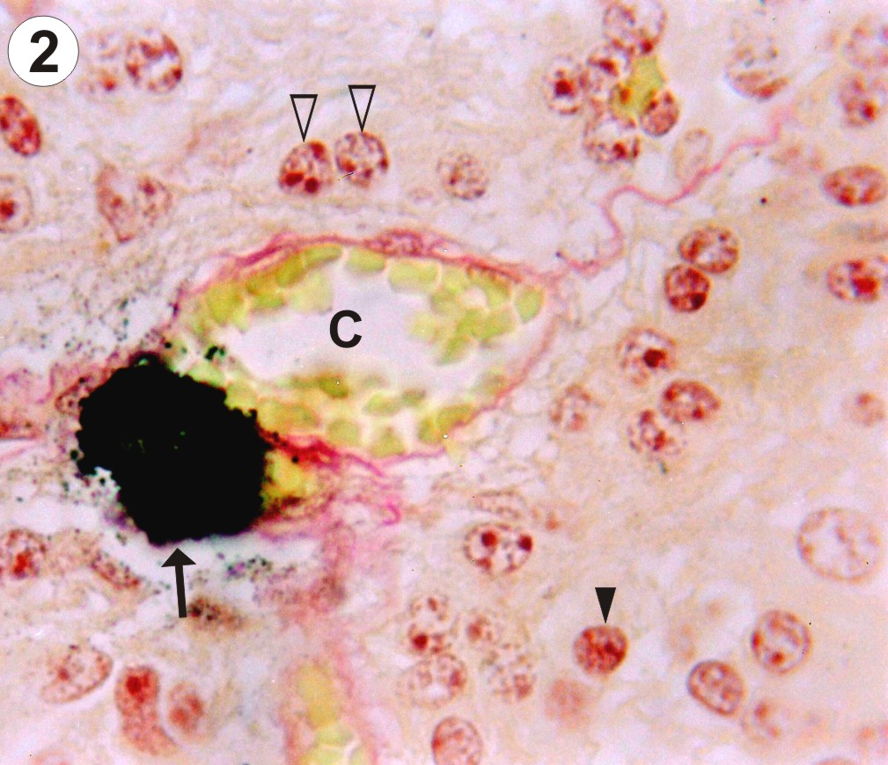
The degeneration and hyalinization were in the form of foci in crossly cut blood vessels or extend along with the direction of blood vessels (Fig. 15). Firstly dissolution of the wall of blood vessel and its content of blood cells occurred (Fig. 14) and then hyalinization started (Fig. 15). Hyalinization began at the center of the dissolute blood vessels and could be seen surrounded by remnants of the degenerated wall (Fig. 15). Blood vessels were lost as in buffalo, but with a new method, the degeneration and hyalinization. The quantity of degeneration and hyalinization was moderate at the age of 1 year (Fig. 14). However areas of high extent of hyalinization occurred by advancement of age, at 3 - 10 years; these areas elaborated severe depletion of pinealocytes (Fig. 16). Occasionally small intermittent areas showing few or even free from pinealocytes were recognized at all ages (Fig. 14 & 15). Generally the amount of pinealocytes decreased by age concomitantly with the lost of blood vessels (Figs. 15 & 16). So it is supposed that the pineal function and growth are reduced actually.
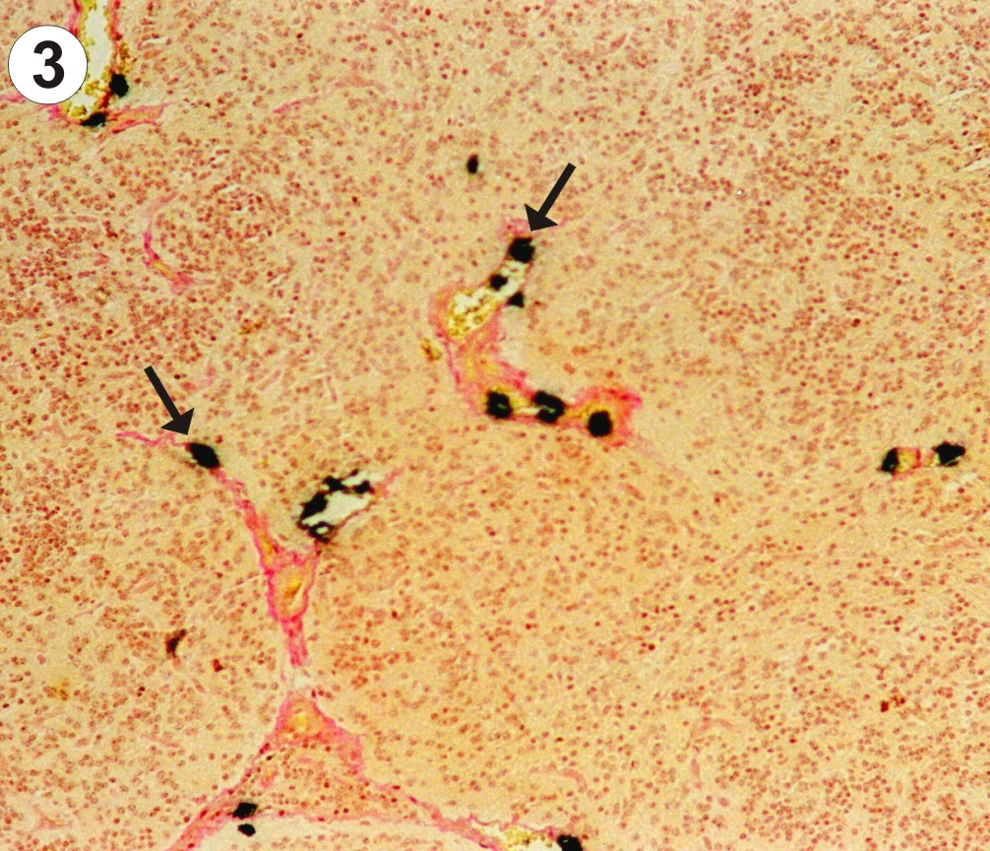
The melanin pigment were scattered allover the cellular elements of pineal tissue. They were more frequent in the periphery of the pineal and around the blood vessels. Most of the pinealocytes of all ages had melanin pigment. Some pinealocytes, glial cells and even fibroblasts were so packed with the pigment granules that they obscure the nuclei (Fig. 17). Aggregations of pigment granules may be observed in the intercellular spaces (Fig. 17), they may be for degenerated pinealocytes. Melanin pigment was confirmed by bleaching method. Heretofore no functional role has been assigned to the pineal pigment, so it may indicates non specialization of pinealocytes or a function regression. Calcium deposit was rare and the reaction of tryptophan did not differ than that of buffalo. The early regressive changes of the pineal may refer to that its main function is carried out during the prenatal life.
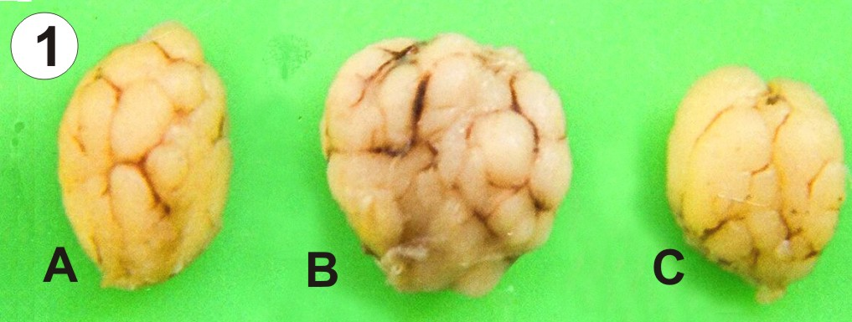
Fig. 1: Buffalo pineal at the age of 1 month (A); 2 years (B) and 7 years (C). The shape can be recognized. Regression seemed at the age of 7 years.

Fig. 2: Buffalo pineal at the age of 1 month showing pinealocytes (white arrow head), astrocytes (black arrow head) and partially obliterated blood vessel (C) by a calcium mass (arrow). (von Kossa's method & Van Gieson; x 1000).

Fig. 3: Buffalo pineal at the age of 1 month showing few calcium deposits (arrows). (von Kossa's method & Van Gieson; x 100).

Fig. 4: Buffalo pineal at the age of 1 year showing highest level of calcium infiltration (arrows). (von Kossa's method & Van Gieson; x 100).

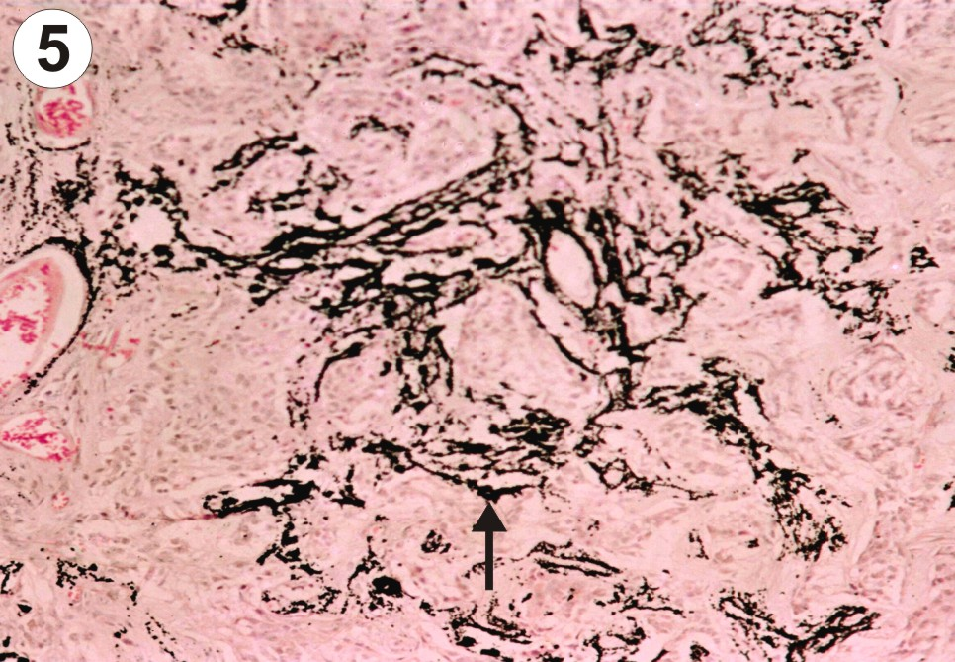

Fig. 5: Buffalo pineal at the age of 10 years showing highest level of calcium infiltration (arrows). (von Kossa's method & Van Gieson; x 100).
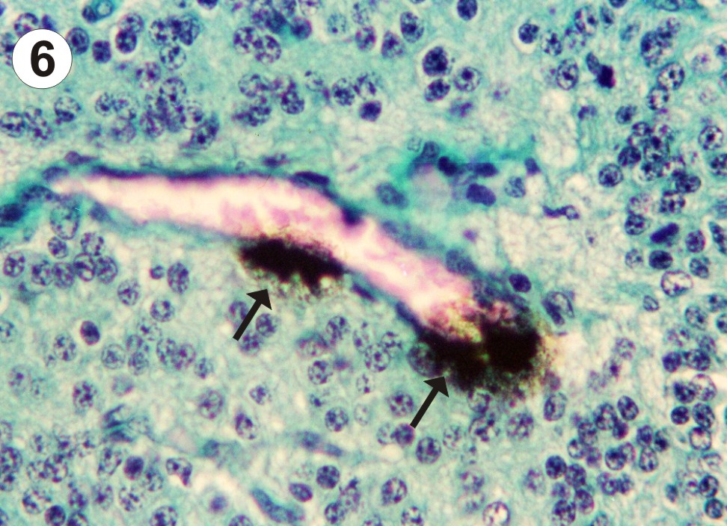

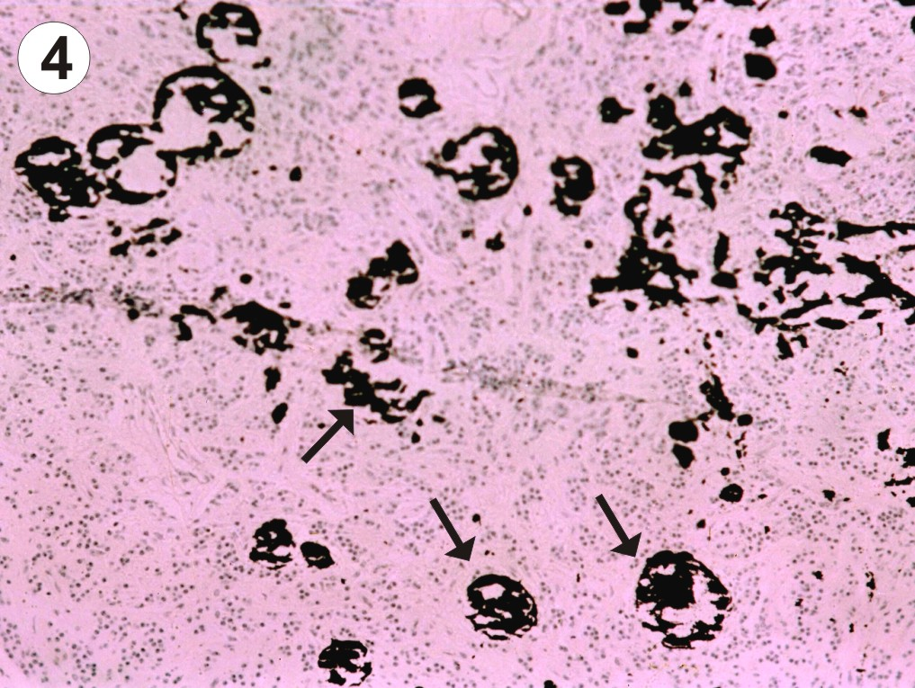
Fig. 6: Buffalo pineal at the age of 1 month showing calcium precipitation (arrows) within the wall of blood vessel, the pinealocytes are crowded. (von Kossa's method & Masson trichrome; x 400).

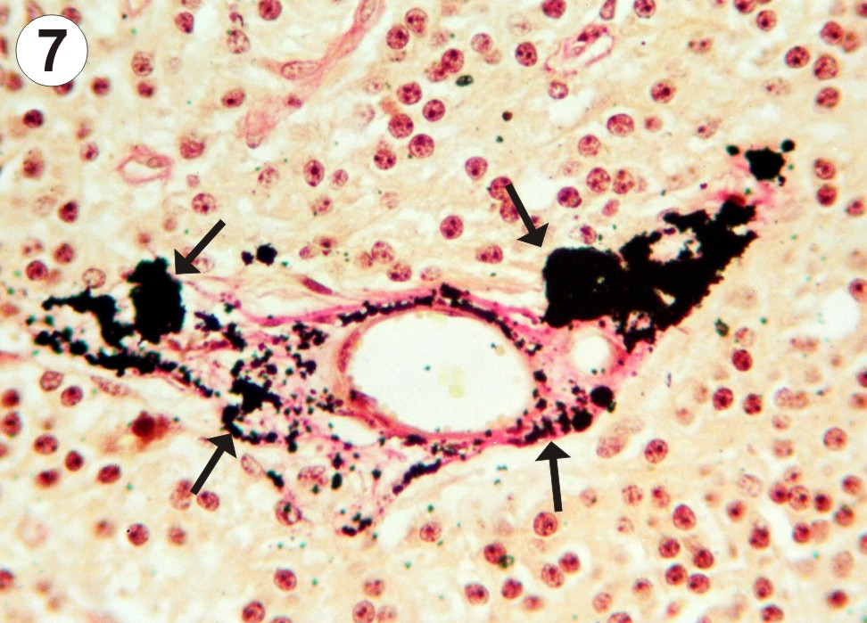

Fig. 7: Buffalo pineal at the age of 2 years showing increased calcium granules in number and size (arrows) associating the collagen of blood vessel wall. (von Kossa's method & Van Gieson; x 400).

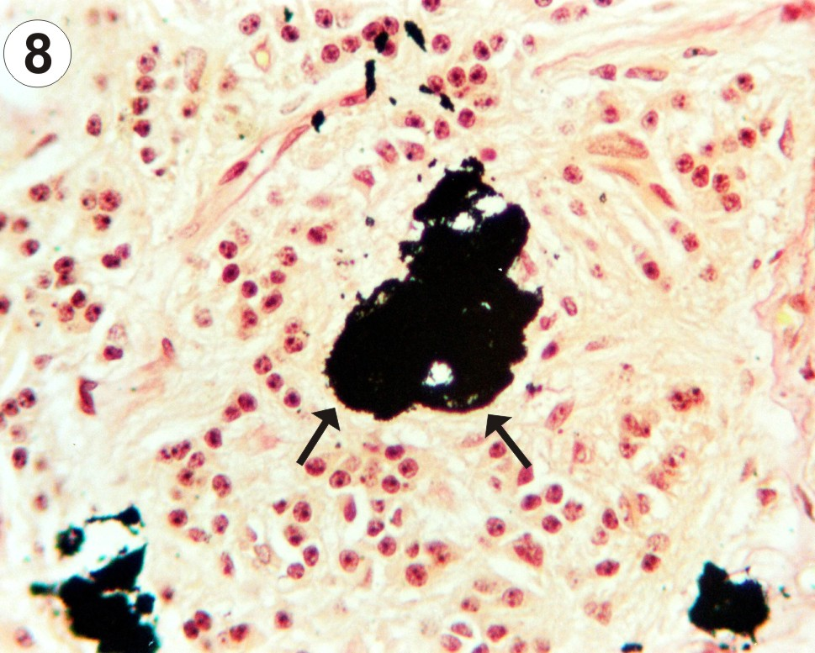

Fig. 8: Buffalo pineal at the age of 2 years showing complete calcification of blood vessel's wall (arrows); the amount of pinealocytes decreased. (von Kossa's method & Van Gieson; x 400).

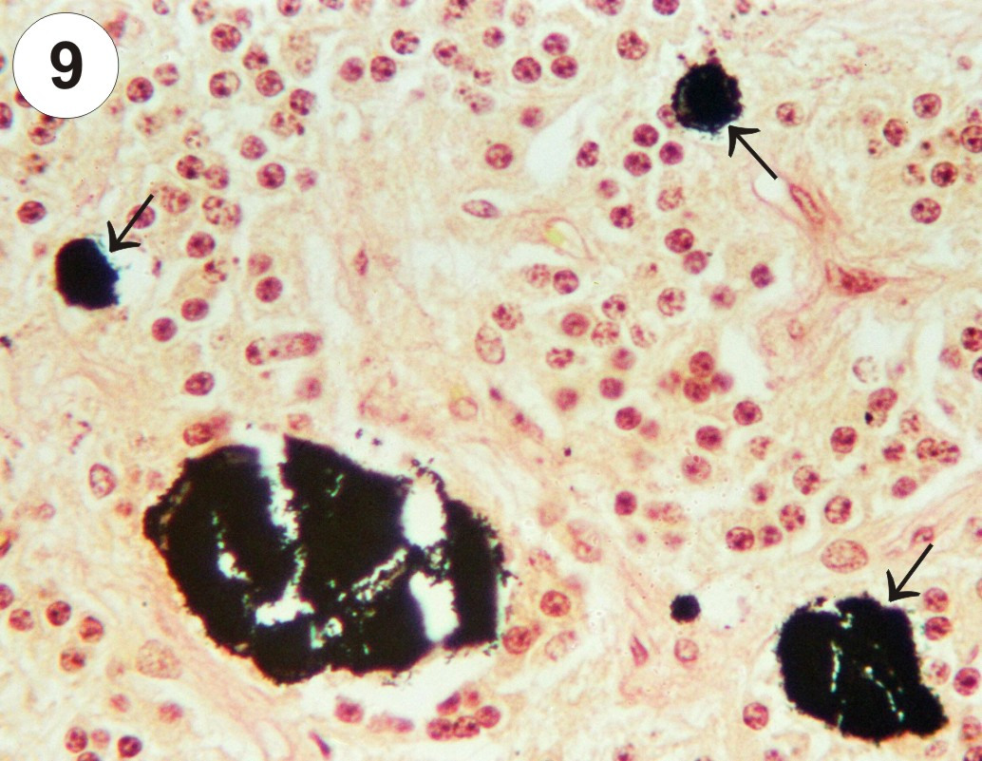

Fig. 9: Buffalo pineal at the age of 2 years showing calcification cluttering up some blood vessels completely (arrows). (von Kossa's method & Van Gieson; x 400).
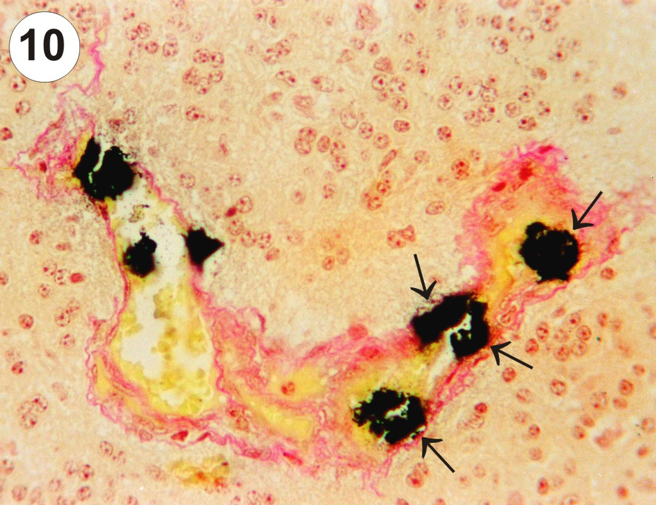

Fig. 10: Buffalo pineal at the age of 1 month showing calcium masses in the internal wall of blood vessel (arrows) and partial obliteration. (von Kossa's method & Van Gieson; x 400).
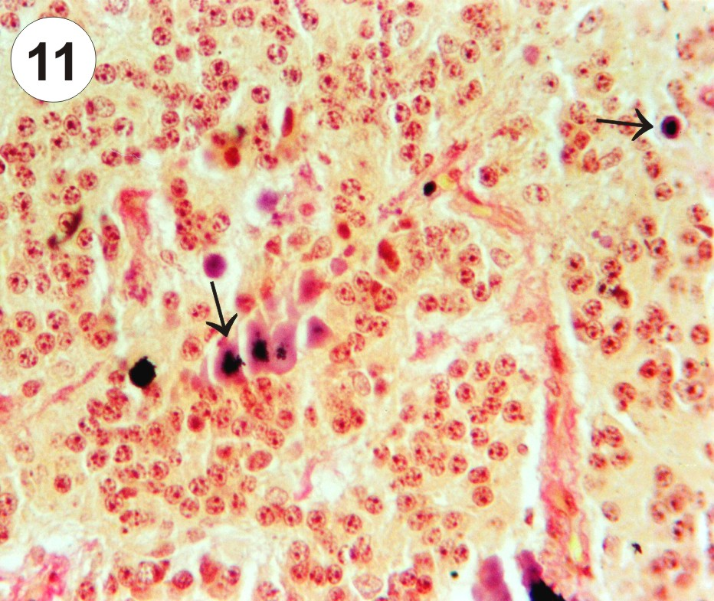

Fig. 11: Buffalo pineal at the age of 6 months showing completely obliterated blood vessels (arrows) by calcium masses. (von Kossa's method & Van Gieson; x 400).

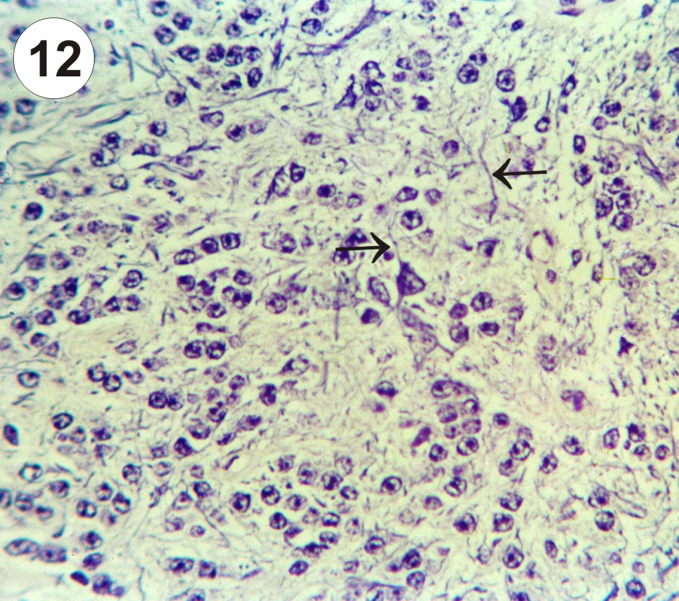

Fig. 12: Buffalo pineal at the age of 3 years showing loosely arranged pinealocytes and cell processes (arrows) (PTAH,x 400).
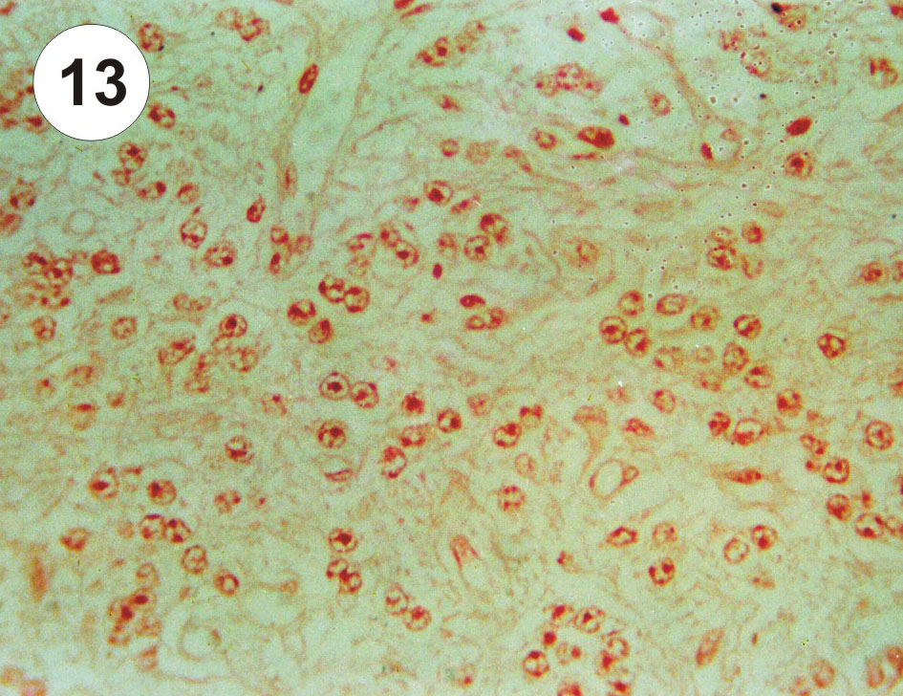

Fig. 13: Buffalo pineal at the age of 2 years showing no reaction of tryptophan. (DMAB-Nitrite method; x 400).
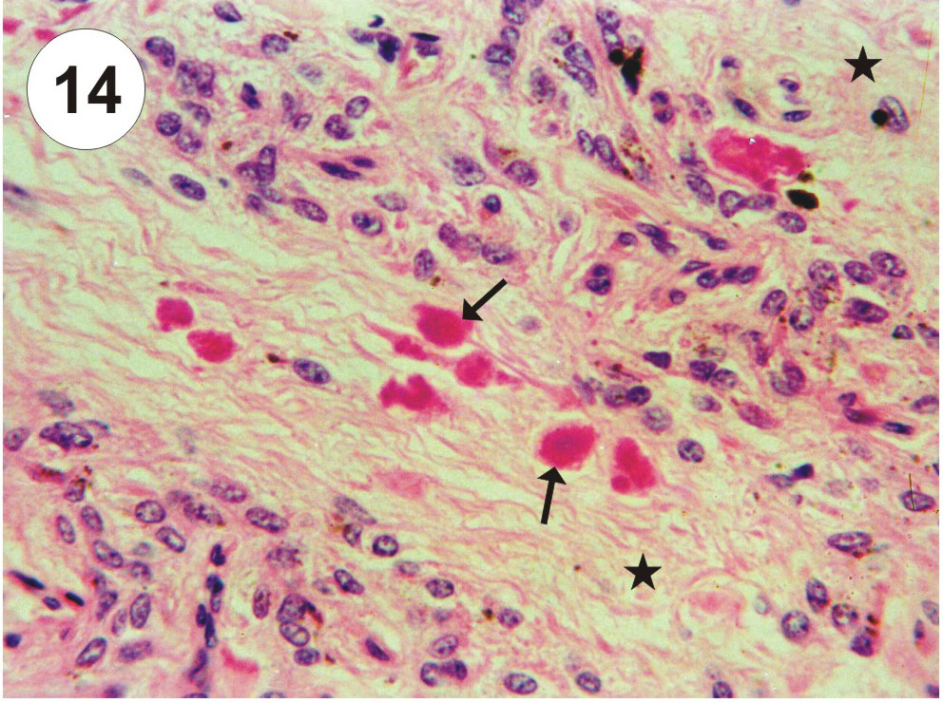

Fig. 14: Camel pineal at the age of 1 year showing dissolute blood vessels (arrows) and intermittent areas free from pinealocytes (asterisks). The quantity of degeneration is moderate. (H & E; x 400).
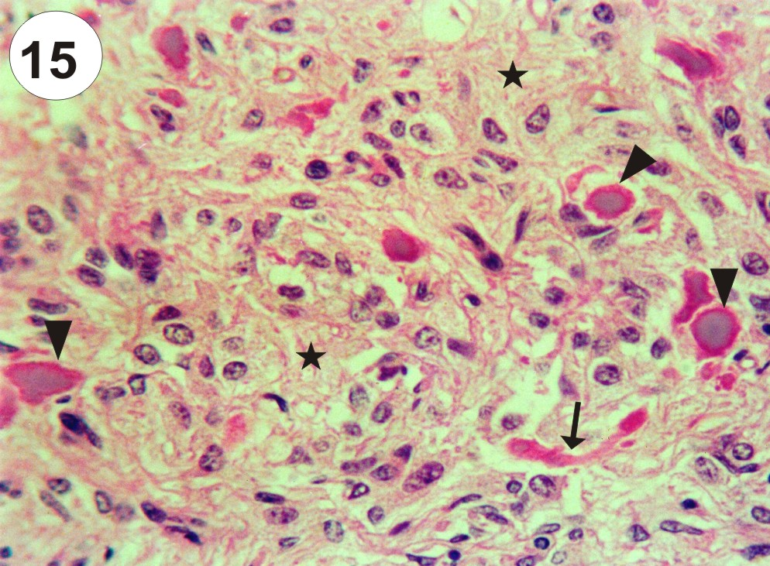

Fig. 15: Camel pineal at the age of 3 years showing hyalinized crossly cut blood vessels (arrow head) surrounded by remnants of degenerated wall; degeneration extends along with the direction of blood vessel (arrow); intermittent areas free from pinealocytes (asterisks), the amount of pinealocytes decreased. (H & E; x 400).
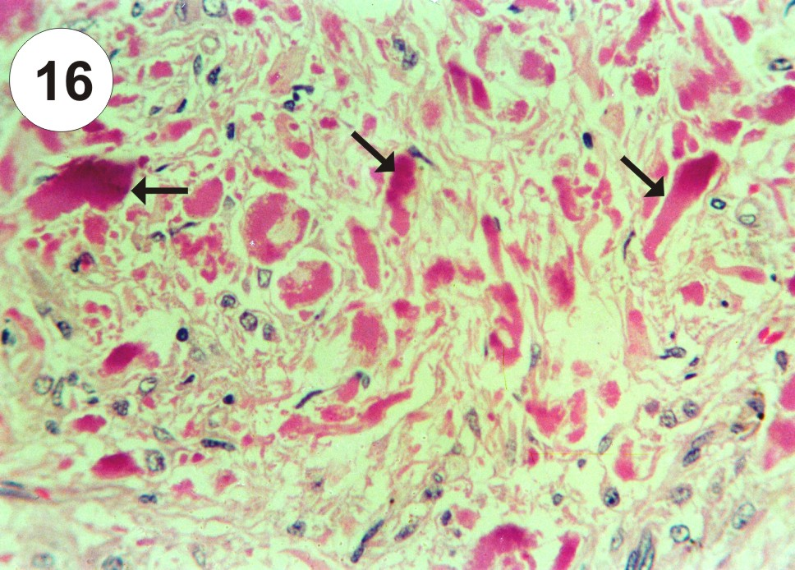

Fig. 16: Camel pineal at the age of 10 years showing high extent of hyalinization (arrows) with severe depletion of pinealocytes. (H & E; x 400).
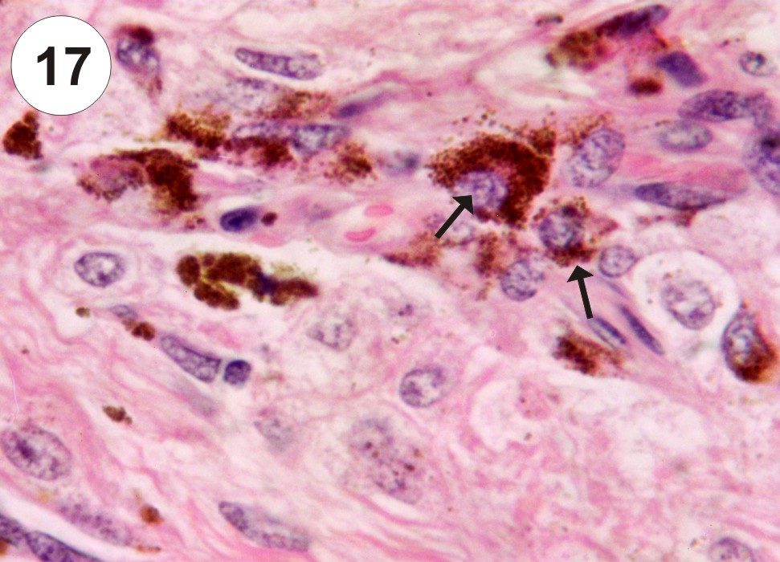

Fig. 17: Camel pineal at the age of 5 years showing packed pinealocytes with pigment granules (arrows) and pigment in the intercellular space. (H & E; x 1000).

Fig. 17: Camel pineal at the age of 5 years showing packed pinealocytes with pigment granules (arrows) and pigment in the intercellular space. (H & E; x 10004.
Discussion
Involution of the pineal was not studied on a large scale except very few papers in the past and it was restricted to morphometric data of some species, where involution was stated to occur periodically during the months of july and august, however the statistical weight study of the human pineal body was indicating that involution nearly inexistent (Legait and Legait, 1980). In the present study the size of the buffalo and camel pineals quantitatively did not increase widely by age however it was variable and sometimes seemed to be regressed. In addition the weight of the pineal increased in the middle aged animal and decreased in older ages which in a line with that recorded by Venzke (1975) in ruminants.
Brain sand or concretions was considered one of the familiar structures of pineal of many mammals including buffalo (Kawamura et al., 1986; Lalitha and Seshadri, 1992). Pinealocytes were shown to have a role in the start point of progressive steps of concretion in gerbil (Milin, 1998). The results of some investigations suggested that the cell organelles were involved in the genesis of the concretion (Welsh, 1984; Humbert and Pévet, 1995 b). Krstic (1986) explained the steps of concretion where the initial intracellular calcification sites occur in the cytoplasmic matrix, vacuoles, mitochondria and the endoplasmic reticulum of certain pinealocytes. These loci and particularly those within the cytoplasmic matrix, transform into acervuli (concretion) by further addition of hydroxyapatite crystals. The cells gradually degenerate, die, break down, and the acervuli reach the extracellular space. Galliani et al., (1989) suggested another idea that the cytoskeleton has a possible role to promote the brain sand. The intracellular calcium concentration is evoked by noradrenergic and cholinergic receptors resulting the release of calcium from the intracellular stores and by the influx of calcium from the external medium (Marin et al., 1996; Korf et al., 1997). So there are data suggesting that sympathetic impute to the pineal is necessary for the formation of pineal concretion (Vaughan et al., 1986). The present study described the brain sand in the pineal of buffalo as a curious signs of involution. This is because the calcium precipitation occurred within the wall or inside the lumen of some blood vessels; started by formation of small calcium granules which increased gradually in number and size, coalesced and progressed till cluttering up such blood vessels completely. Therefore the calcium deposit appeared in the form of patches and elongated well identifiable structures in the same locations and courses of blood vessels, this will decrease the blood supply of the pineal and directly affecting its growth. The findings of Nikonorov and Makarov (1990) that during the pineal involution in human, the volume of its intraorganic vascular bed decreases essentially support the present study. The association of calcium with the collagen fibers of blood vessels wall in buffalo pineal, exhibiting a manner of correlation. This correlation was accorded by Humbert et al., (1997) where they suggest that collagen fibrils are involved in the genesis and growth of extra cellular concretion located in the connective tissue. The involution signs in camel including a striking physiological degeneration and hyalinization of blood vessels. Firstly dissolution of the wall of blood vessel and its content of blood cells occurred then hyalinization started at the center of dissolute blood vessel and could be seen surrounded by remnants of the degenerated wall. Blood vessels were lost by dissolution and hyalinization and this is shown as a new method of involution. In human the cause of decrement of vascular bed was the sclerosing process; this results in certain disturbances of blood supply and affects functional activity of the organ (Nikonorov and Makarov, 1990).
The present study denied some papers (Welsh, 1984; Galliani et al., 1989) and we reported new information wherethrough the structure which was so long termed brain sand in the past is completely calcified and blocked blood vessels and indicating involution of the buffalo pineal. Although, our results, were in accordance with recent investigations (Humbert and Pévet, 1995 a; Vigh et al., 1998; Luke, 2001) wherewith the calcification (brain sand) process is interpreted as being as age-related phenomenon. Hence we stated the beginning of calcium infiltration in buffalo to be as early as 1-6 months age after birth and the highest level was reached at the age of 1-10 years. Consequently the degree of degeneration and hyalinization of blood vessels in camel was moderate at the age of 1 year however areas of high extent of hyalinization occurred at the ages of 3-10 years. On the contrary the brain sand and calcium an ion in Mongolian gerbil and human does not appear to be age related and its involvement in the secretory activity rather than in gland atrophy is also suggested (Krstic, 1986; Galliani et al., 1989, Redecker et al., 1996).
Occasionally the lost of blood vessels in buffalo and camel was associating with decrease of pinealocytes amount. So the amount of pinealocytes decreased by age because they were crowded at the ages of 1-6 months but loosely arranged at the ages of 1-10 years in buffalo. Also in camel, severe depletion of pinealocytes was elaborated in the areas of high extent of hyalinization in advanced ages (at 3-10 years). The degeneration that was apparent in the parenchymal cells of buffalo pineal (Lalitha and Seshadri, 1992) potentiate the present study. Moreover similar features of pinealocytes number were recorded in rat (Humbert and Pévet; 1995 a). Also in human pineal an age related phenomena were studied (Luke, 2001). On the other side no important difference between pineals of young and advanced aged rats were found (Prosenc and Cervós - Navarro, 1994) and the human pineals do not necessarily degenerate progressively after involution (Hasegawa et al., 1987).
Pigment cells were usually found in the pineal body of the dromedary and also its fetus (Taher et al., 1975). In addition the pigment granules were constant elements of the dog pineal in both puppies and adult (Abou-Easa, 1997). Ultrastructurally the pigment cells were identified as a special type of pinealocytes (Calvo et al., 1988). The pineal pigment was histochemically identified as melanin (Calvo et al., 1992). These data support the present study that the melanin pigment were scattered allover the cellular elements of pineal tissue of camel. Most of the pinealocytes of all ages had contained melanin pigment. According to the species, the pigment-containing cells increase in number with increasing age in goat pineal (Ohshima and Matsuo, 1987). Some pinealocytes, glial cells and even fibroblasts in camel were so packed with the pigment granules that they obscure the nuclei, but no pigment granules could be observed in buffalo. Melanogenesis was attributed to the multipotency of the pineal cells (Orii et al., 1994). Also the multipotency of pinealocytes may be proved by the presence of striated muscle fibers in the pineal of some domestic animals, e. g. swine (Hayano et al., 1976) and rat (Prosenc and Cervós- Navarro, 1994). Heretofore no functional role has been assigned to the pineal pigment, so it may indicates non specialization of camel pinealocytes. It was known that pineal hormone, melatonin is biologically active derivative of tryptophan (Devlin, 1986) but we could not detect tryptophan.
The involution signs of pineal in buffalo and camel will decrease the blood supply of the pineal and directly affecting the pineal growth and it is strongly hypothesized to reduce its function. The same hypothesis was accomplished in rat (Humbert and Pévet, 1995 a) and human (Nikonorov and Makarov, 1990). Therefore we affiliate to Redondo et al., (1996) who had suggested in a prenatal study of sheep pineal, that the pineal has a secretory function in uterine life). Some more recent study try to find the function of certain genes in the camel pineal (El Allali et al., 2008). But also some recent studies interested in the relation of the pineal function and melatonin to brain (Lahiri et al. 2004; Yun et al., 2004; Engel et al., 2005; Kim et al., 2005; peters et al., 2005).
Finally the present findings suggesting that the main function of the pineal is still doubtful; if the main function of the pineal is ever carried out in the postnatal life, it should not showing any sign of involution. So we suggest that the main function of the pineal may be in the prenatal life and may be related to maturation of neurons.

Correspondence to:
Ehab Tousson
Zoology Department, Faculty of Science, Tanta University, Egypt ehabtousson@yahoo.com
Tel: 00218927812793 Fax: 002453353800

References
[1] Abbas AA, Ewais MS. Histological and histochemical studies of the pineal gland of the one humped camel (Camelus dromedarius). Journal of Egyptian Veterinary Medical Association 1982; 42 (2): 117-124.
[2] Abou-Easa KF. Tissue changes in the pineal retina and thymus of male dog before and after sexual maturity. Alexandria Journal of Veterinary Science 1997; 13 (4): 333-344.
[3] Banerjee GC. A textbook of animal husbandry. 7th Ed. Oxford & Ibh Publishing Co. Pvt. Ltd. New Delhi, Bombay, Calcutta, 1991.
[4] Claustrat B, Brun J, Chazot G. The basic physiology and pathophysiology of melatonin. Sleep Medical Review 2005; 9 (1):11-24.
[5] Calvo J, Boya J, Garcia-Maurino JE, Lopez-Carbonell A. Structure and ultrastructure of the pigment cells in the adult dog pineal gland. Journal of Anatomy1988; 160: 67-73.
[6] Calvo JL, Boya J, Garcia-Maurino JE, Rancano D. Presence of melanin in the cat pineal gland. Acta Anatomia 1992; 145: 73-78.
[7] Devlin TM. Textbook of biochemistry, with clinical correlations. 2nd Ed. A Wiley Medical Publication; John Wiley & Sons. New York, Chichester, Brisbane, Toronto, Singapore, 1986.
[8] El Allali K, Sinitskaya N, Bothorel B, Achaaban R, Pevet P, Simonneaux V. Daily Aa-nat Gene Expression in the Camel (Camelus dromedarius) Pineal Gland. Chronobiology International 2008; 25 (5): 800-807.
[9] Engel L, Lorenzkowski V, Langer C, Rohleder N, Spessert R. The photoperiod entrains the molecular clock of the rat pineal. European Journal of Neuroscience. 2005; 21 (8): 2297-304.
[10] Galliani I, Frank F, Gobbi P, Giangaspero F, Falcieri, E. Histochemical and ultrastructural study of the human pineal gland in the course of aging. Journal of Submicroscopic Cytology and Pathology 1989; 21 (3): 571-578.
[11] Garma-Avina, A. Excretory plugs from the choroid plexus in the cerebrospinal fluid of dogs with neurological disease possible role in the formation of corpora arenacea. Journal of Comparative Pathology 2000; 123 (2-3): 146-151.
[12] Golan J, Torres K, Grzegorz JS, Opielak G, Maciejewski R. Morphometric parameters of the human pineal gland in relation to age, body weight and height. Folia Morphologica. 2004; 61: 111-113.
[13] Guimaraes MA, Lunardi LO, Pellizzon CH, Kempinas WG, Rosa AA. Male gonadal denervation by guanethidine at pre-puberty: different doses, different results. The intervention of the pineal differentiation. Cell and Molecular Biology 1997; 43 (3): 383-391.
[14] Hales JR, Fawcett AA. Wool production and blood supply to skin and other tissues in sheep. Journal of Animal Science 1993; 71 (2): 492-498.
[15] Hasegawa A, Ohtsubo K, Mori W. Pineal gland in old age; quantitative and qualitative morphological study of 168 human autopsy cases. Brain Research 1987; 409 (2): 343-349.
[16] Hayano M, Sung JH, Mastri AR, Hill EG. Striated muscle in the pineal gland of Swine. Journal of Neuropathology and Experimental Neurology 1976; 35 (6): 613-621.
[17] Humbert W, Pévet P. The pineal gland of the aging rat: Calcium localization and variation in the number of pinealocytes. Journal of Pineal Research 1995 a; 18: 32 - 40.
[18] Humbert W, Pévet, P. Calcium concretions in the pineal gland of aged rats: an ultrastructural and microanalytical study of their biogenesis. Cell and Tissue Research 1995 b; 279 (3): 565-573.
[19] Humbert W, Cuisinier F, Voegel JC, Pévet P. A possible role of collagen fibrils in the process of calcification observed in the capsule of the pineal gland in aging rats. Cell and Tissue Research 1997; 288: 435-439.
[20] Jaworek J, Brzozowski T, Konturek SJ. Melatonin as an organoprotector in the stomach and the pancreas. Journal of Pineal Research 2005; 38:73-83.
[21] Kawamura N, Ishibashi, T, Miyamoto H. Scanning electron microscopy of brain sand in the bovine pineal gland. Japan Journal of Zootechnical Science 1986; 57 (12): 1043-1045.
[22] Khan JR, Dang AK, Mahendera S, Singh M. Role of pineal in lactation. International Journal of Animal Science 1997; 12 (2): 209-212.
[23] Kim MJ, Kim HK, Kim BS, Yim SV. Melatonin increases cell proliferation in the dentate gyrus of maternally separated rats. Journal of Pineal Research 2004; 37(3):193-7.
[24] Korf HW, Kroeber S, Schomerus C. Regulation of the intracellular concentration of free calcium ions in pinealocytes of the rainbow trout and the cat. Biological Signals 1997; 6 (4-6): 201-211.
[25] Koshy S, Vettivel SK. Varying Appearances of Calcification in Human Pineal Gland: A Light Microscopic Study. Journal of Anatomical Society of India 2001; 50: 17-18.
[26] Krstic R. Pineal calcification: its mechanism and significance. Journal of Neural Transm Suppl 1986; 21: 415-432.
[27] Kus I, Sarsilmaz M, Aslan O, Ozdem T, Pekmez H, Songur A, Kelestimur H. Light and electron microscopic examination of pineal gland in rats exposed to constant light and constant darkness. Neuroendocrinology Letters 2004, 25: 102-108.
[28] Lahiri DK, Chen D, Lahiri P, Rogers JT, Greig NH, Bondy S. Melatonin, metals, and gene expression: implications in aging and neurodegenerative disorders. Annuels N Y Acad Science 2004; 1035:216-230.
[29] Lalitha PS, Seshadri VK. Histology and histochemistry of degenerative changes in the pineal gland of adult Indian buffaloes (Bubalus bubalis). Indian Veterinary Journal 1992; 69 (5): 427-430.
[30] Legait H, Legait JF. Statistical weight study of the human pineal body, hypophysis and brain. Bull Assoc Anat. 1980; 64: 399-414.
[31] Lewczuk B, Nowicki M, Prusik M and Przybylska-Gornowicz B (2004): Diurnal rhythms of pinealocyte ultrastructure, pineal serotonin content and plasma melatonin level in the domestic pig. Folia Histochemica Et Cytobiologica 2004; 42: 155-164.
[32] Luke J. Fluoride deposition in the aged human pineal gland. Caries Research 2001; 35 (2): 125-128.
[33] Maestroni GJ, Cardinali DP, Esquifino AI, Pandi-Perumal SR. Does melatonin play a disease-promoting role in rheumatoid arthritis? Journal of Neuroimmunology 2005; 158 (1-2):106-111.
[34] Marin A, Urena J, Tabares L. Intracellular calcium release mediated by noradrenaline and acetylcholine in mammalian pineal cells. Journal of Pineal Research 1996; 21: 15-28.
[35] McCloghry E, Foldes A, Hollis D, Rintoul A, Maxwell C, Downing J, Baker P, Kennedy J, Wynn P. Effect of pinealectomy on wool growth and wool follicle density in merino sheep. Journal of Pineal Research 1992; 13 (3): 139-144.
[36] Miguez JM, Martin FJ, Lema M, Aldegunde M. Changes in serotonin level and turnover in discrete hypothalamic nuclei after pinealectomy and melatonin administration to rats. Neurochemistry International 1996; 29 (6): 651-658.
[37] Milin J. Stress-reactive response of the gerbil pineal gland: concretion genesis. Gen Comparative Endocrinology 1998; 110 (3): 237-251.
[38] Miller WC, Robertson EDS. Practical animal husbandry. 7th Ed. Oliver and Boyd. Edinburgh, London, 1959.
[39] Nikonorov SG, Makarov FA. Age - related dynamics of blood supply and vascular-tissue interrelations in the human pineal body. Arkh Anat Gistol Embryology 1990; 98 (2): 25-30.
[40] Nimmagadda A, Sandberg DI, Ragheb J. Spontaneous involution of a large pineal region hemorrhagic cyst in an infant. Case report. Journal of Neurosurgery. 2006; 104 (4): 275-278.
[41] Ohshima K, Matsuo S. Histological changes with age in the pineal glands of the domestic goat and the Japanese Serow (Capricornis crispus). Japan Journal of Zootechnical Science 1987; 58 (11): 937-945.
[42] Omer H, Kus I, Öner1 J, Ögetürk M, Ozan M, Ayar A. Possible effects of melatonin on thymus gland after pinealectomy in rats. Neuroendocrinology Letters 2004; 25: 115-118.
[43] Orii H, Hyuga M, Mochii M, Kosaka J, Eguchi G, Watanabe K. Predominant melanogensis and lentoidogenesis in vitro from multipotent pineal cells by dimethyl sulfoxide and hexamethylene bisacetamide. International Journal of Biology 1994; 38: 397-404.
[44] Pacchierotti C, Iapichino S, Bossini L, Pieraccini F, Castrogiovanni P. Melatonin in psychiatric disorders: a review on the melatonin involvement in psychiatry. Front Neuroendocrinology 2001; 22: 18–32.
[45] Peters JL, Cassone VM, Zoran MJ. Melatonin modulates intercellular communication among cultured chick astrocytes. Brain Research 2005; 1031: 10-19.
[46] Prosenc N, Cervós - Navarro J. Ultrastructural morphology of the aged pineal. Ann NY Acad Sci 1994; 719: 64-76.
[47] Redecker P, Cetin Y, Korf HW. Differential immunocytochemical localization of calretinin in the pineal gland of three mammalian species. Journal of Neurocytology 1996: 25: 9-18.
[48] Redondo E, Franco AJ, Regodon S. Prenatal development of the sheep pineal gland: an ultrastructural study. Journal of Pineal Research 1996; 21 (3): 140-148.
[49] Regodon S, Franco A, Masot J and Redondo E. 2001: Immunohistochemical and ultrastructural study of interstitial cells during postnatal development of the sheep pineal gland. International Journal of Developmental Biology 45: S87-S88.
[50] Taher S, Al-Shaikhly AK, Lawand S. Morphological and micromorphological studies of the epiphysis cerebri of the dromedary Camelus dromedarius. Sonderdruck aus "Säugetierk-undliche Mitteilungen" BLV Verlagsgesellschaft mbH München 1975; 40: 223-230.
[51] Tosini G, Doyle S, Geusz M, Menaker M. Induction of photosensitivity in neonatal rat pineal gland. PANS 2000; 97:11540-11544.
[52] Vaughan MK, Joshi BN, Reiter RJ. Daily Propranolol administration reduces pineal concretion formation in the Mongolian gerbil. Proceeding Society of Experimental Biology and Medicine 1986; 182 (3): 372-374.
[53] Venzke WG. In Sisson and Grossman's. The anatomy of the domestic animals. 5th Ed. WB. Saunders Company. Philadelphia, London, Toronto, 1975.
[54] Vigh B, Szel A, Debreceni K, Fejer Z, Manzano MJ, Vigh-Teichmann I. Comparative histology of pineal calcification. Histological Histopathology 1998; 13 (3): 851-870.
[55] Welsh MG. Cytochemical analysis of calcium distribution in the superficial pineal gland of the Mongolian gerbil. Journal of Pineal Research 1984; 1 (4): 305-316.
[56] Woods AE, Ellis RC. Laboratory histopathology, a complete reference. 1st Ed. Churchill Livingstone. Edinburgh, Hong Kong, London, Madrid, Melbourne, New York, Tokyo.1994.
[57] Yun AJ, Bazar KA, Lee PY. Pineal attrition, loss of cognitive plasticity, and onset of puberty during the teen years: is it a modern maladaptation exposed by evolutionary displacement? Medical Hypotheses. 2004; 63(6): 939-50.

8/8/2009

