Landscape change and sandy desertification monitoring and
assessment: a case study in Northern Shaanxi Province, China
Eltahir. M. Elhadi. ¹², Nagi. Zomrawi²
1-China University of Geosciences Faculty of Resources, Wuhan, 430074, China,
2-Sudan University of Science and Technology Faculty of Engineering, Khartoum,Sudan,
tahirco2006@yahoo.com, nagizomrawi@yahoo.com

Abstract The objective of this study is to develop techniques for assessing and analyzing sand desertification in the northern part of Shaanxi Province, China. In order to reveal the process of land degradation, especially the latest situation of sandy desertification, a method integrating remote sensing, Geographic Information System (GIS) and field survey was employed to build a sandy desertification dataset for analysis. Remote Sensing images included the Landsat Thematic Mapper (TM) images in 1987 and Landsat Enhanced Thematic Mapper Plus () images in 1999). Eight land- cover classes, including active sand dunes, fixed sand dunes, semi-fixed sand dunes, grass land, farm land, wet land, built up area and unused land and Normalized Difference Vegetation Index (NDVI), were identified.Results showed that the active sand dunes and semi-fixed sand dunes have increased with a change rate of 128.70 km².yr⁻¹ and 55.65 km².yr⁻¹, respectively, in the meantime the fixed sand dunes has decreased with a decreasing rate of 182.14 km².yr⁻¹. During the 1987s, the area of sandy desertiﬁed land reached 12,006.11 km² (57.17% of the total sandy area), of which severely desertiﬁed, medium desertiﬁed, and slightly desertiﬁed land areas were 4,442.23, 4,253.45and 3,310.43 km² , respectively. By the year 1999, the area of desertiﬁed land was increased to 13,782.30 km² (65.63% of the total sandy area), of which severely desertiﬁed, medium desertiﬁed, and slightly desertiﬁed land areas were 5,169.89, 4,918.15and 3,694.26 km², respectively increasing by 1,776.19 km². Spatial change detection based on active sand dunes showed that the expansion area was much larger than the reversion in the past two decades, and that several active sand belts has been formed, suggesting that sandy desertification of northern part of Shaanxi Province, China, will be a long-term task.
[Nature and Science. 2009;7(9):83-90]. (ISSN: 1545-0740).

Keywords: assessment; sandy desertification; NDVI; active sand dunes; GIS;China

1. Introduction

The term “desertification” should be used side by side with the term “land degradation”. Hence “desertification” in the context of assessment is land degradation in arid; semi-arid; and sub-humid areas resulting from adverse human impact. According to the United Nations Conference on Environment and Development (UNCED, 1992), defines desertification as “land degradation in arid, semi-arid and dry sub-humid areas resulting from various factors including climatic variations and human activities.
Sandy desertification is one of the main form of land degradation in China, especially in northern China (Wang, 2001), which has kept expanding since the 1950’s and has exerted severe impacts on regional socio-economic development and environmental security (Wang, 2006) .Harsh physiographic conditions (sparse vegetation coverage, sandy soil and water deficiency), irrational land-use practice and population augmentation are regarded as the forces of triggering sandy desertification (Zhu et al ,1994.Chen et al, 2005). Therefore, the sandy desertification assessment and monitoring are always concerned by researchers, the public and the policy-makers.
Desert and sandy decertified land occupy about 1.67 million km², or 17% of the total land area of China (Wang, 2003). Decertified sandy land increased by 25,200 km for the period from 1975 to 1987 about 40.5% of which was distributed in the semi-arid agro-pastoral regions of northern China (Zhu and Wang, 1993).
The objective of this study is to develop techniques for assessing and analyzing sand desertification in the northern part of Shaanxi Province, China, in the past decades. A method of integrating remote sensing (RS), geographic information system (GIS) and field survey was employed to generate a sandy desertification dataset of this region. Then change detection and land degradation process were performed based on the dataset. This study intends to provide useful information for sandy desertification controlling and environmental management of the northern part of Shaanxi Province, China.

- Study area

The study area, located in the northern part of Shaanxi province, lies within longitude 108 33 to 111 24 E and from 36 97 to 39 58 N with total area of 29416.6 km², accounting for 18.6% of the total Shaanxi province (Figure 1).In order to study the development of sandy desertification, the counties of Dingbian, Jingbian, Hengshan, Yulin, and Shenmu have been selected as study area. Counties are situated in the northern part of Shaanxi province. Geographically, the study area is located in the transitional zone, in south and east of Mu Su Desert (Inner Mongolia) and the Loess Plateau of northern Shaanxi province in China. This area has atypical continental semi-arid climate .Annual precipitation ranges from 440 mm in the south-east to 250 mm in the north-west, of which 60-80% is concentrated in the period from June to August. The annual mean temperature is about 6.0-8.5, with monthly mean temperature of 22 in July and -11 in January (Department of Geography of Peking University, 1983) .The main prevailing wind is north-westerly, with a speed of more than 5 ms⁻¹ on over 200 days of the year. The elevation is between 1000 and 1907 m a.s.l (Song l (Song and Chen ，1991).

3. Material and Methods
3.1 Data sources

Satellite remote sensing, in conjunction with geographic information system (GIS), has been widely applied and been recognized as a powerful and effective tool in detecting landscape change (Liu et al ., 2003; Li, 1996; Cai, 2001 ; Paul et al., 1992; Allen S Hope and Douglas A Stow, 1993; Anthony Gar-On Yeh and Li ,1999). Four kinds of data were used in this study, i.e., socioeconomic data, topographic data, remote sensing data, and ancillary data. Socioeconomic data were the annual statistical data released by the National Bureau of Statistics. The data published in 1986 and 2001 were acquired. All data were amalgamated to the county level. Tow topographic maps had a scale of 1: 100,000 and 1: 50,000, respectively. The remote sensing data are landsat TM images record in 1987 and 1999.Two types of ancillary data were used, a vegetation map at a scale of 1: 500,000(Lei, 1999),and a current land use map supplied Yulin Land and Resources Bureau(2000).

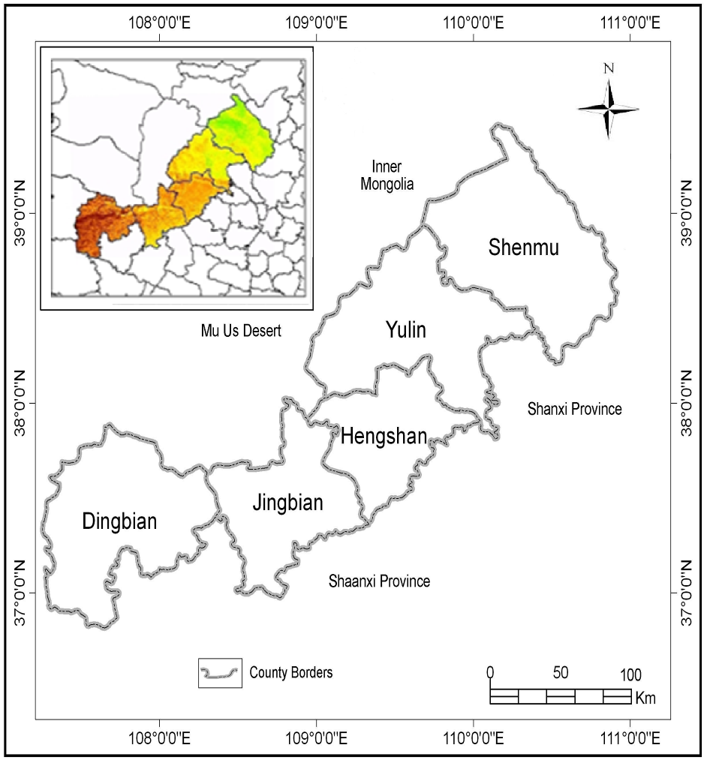
Figure 1. General location map of study area.

3.2 Data and Pre-processing

Remote Sensing images used in this study include the Landsat-5 Thematic Mapper (TM) image, and Landsat-7 Enhanced Thematic Mapper Plus () image, which were acquired in 24 October 1987 and 15 October 1999, respectively, the pre-processing of this dataset included geometric corrections .All images were geometrically corrected not only to eliminate geometric distortions present in the images but also to register the satellite images to ground data.. The nearest-neighbor resampling method was used in datum WGS 84 and projection UTM (49N) all images resampled to a 30 m pixel grid. In order to remove or normalize the reflectance variation between images acquired at different times, relative radiometric correction was performed to yield normalize radiometric data on a common scale (Paolini et al.,2006).Here, the histogram normalization, a simpler and more effective technique, was used to carry out the relative radiometric correction (Ding et al.,2005).

3.3 Determination of NDVI threshold

The Vegetation index can reflect a series of physics quantity of he plants, such as index of leaf's area, plant overlays degree, amount of living creature and plant category (Qingjiu et al., 1998). The index of vegetation contain many different expression methods, among them NDVI is applied in the fixed amount research of plant overlays. Therefore TM data were used to produce Normalize Difference Vegetation Index (Kidwell 1990; Dall’Olmo et al. 2002 ; Rouse et al .1974), which is defined as:

NDVI = (TM4-TM3)/ (TM4+TM3)

Where TM4 and TM3 are channels in the near infrared(NIR) and the red(R) wavelength of landsat TM data, respectively, was applied for monitoring vegetation changes in the study area within the year 1987 and 1999.
Determining the threshold of NDVI is the first step in extraction of sand desertification. Then we can use the threshold to separate vegetation information and non-vegetation information from land cover. Through comparative analysis of the NDVI images and the research area, select NDVI = 0.05 as the threshold, which can separate vegetation information and non-vegetation information from the research land cover. That is: if NDVI> 0.05, the area was considered as vegetation; instead, considered as no vegetation information.
The land desertification monitoring was performed and implemented in the GIS. Through the GIS, land desertification maps can be produced and this method can monitor areas prone to land desertification using spatial patterns from land cover classes, NDVI and main prevailing wind direction.
The correlation between NDVI and vegetation cover percentage, the selection of potential desertification areas where the vegetation cover (e.g., usually grasslands and farmlands) less than 30%, the classification of potential areas based on their position in relation to the main prevailing wind direction, and the production of land desertification areas and then the identification of land desertification changes with time.
NDVI is a greenness index and an argument can be made that greenness and vegetation cover are correlated. The vegetation cover is a primary indicator of land desertification. Before the data modelling, NDVI was density sliced. We defined that if NDVI was less than 0.078, vegetation cover percentage was less than15%; if NDVI was between 0.079 and 0.102, vegetation cover percentage was between 15–30%; If NDVI was between 0.103 and 0.138, vegetation cover was between 30–50%.
The NDVI and vegetation cover classification criteria were defined as follows: NDVI<0.079 and vegetation cover <15% as active sandy land and it is severe desertified, NDVI=0.079–0.102 and vegetation cover=15–30% as semi-fixed sandy land and it is medium desertified, and NDVI=0.103–0.138 and vegetation cover=30–50% as fixed sandy land and it is slightly desertified (Table 1). This NDVI classification was calibrated by field work and was also supported by previous studies (Guo 1990; van Genderen et al. 1993;Guo 1994; Zhang 1994).
The image pattern, tone and texture were considered to classify the land types of sandy desertiﬁcation. The following four types were mapped:

1. Land severely aected by sandy desertiﬁcation. This is characterized by a grayish bright color, and represent mobile sandy dunes with sickle-like shapes and high undulation which has <15% vegetation cover. The active sand dunes are widespread, covering up to 50–70% of the total area of sandy land. The inter-dune areas are characterized by wind erosion and sand covering.
2. Land showing a medium amount of sandy desertiﬁcation. This type of sandy land has a gray or grayish red color and exhibits semi-ﬁxed sand dunes with a wave-like shape. The vegetation cover varies from 15 to 30%. The shifting sand is widespread and there are visible patches of wind erosion in farmland and grassland.
3. Land slightly aected by desertiﬁcation. Grayish green and grayish red in color, it refers to ﬁxed dunes with little shifting sand and has a vegetation cover of 30–50%
4. Land unaected by desertiﬁcation. This has a uniforml saturated red color, and has no patches of shifting sand and a vegetation cover of more than 50%.

4.Results and discussion

4.1Landscape change

Generally speaking, from the 1987s to the 1999s, there was a remarkable ecological change occurred in the study area sandy land during the study period (twelve years). The sandland landscape changed significantly and desertified land has expanded rapidly .From 1987 to 1999, the fixed sand dunes, which, covered (9669.24 km²; 32.87%) of the total area in 1987, sharply shrank to 7483.58 km² (25.44%) in 1999 with a decreasing rate of 182.14 km².yr⁻¹.The semi-fixed sand dunes, however, increased from 4121.27 km² (14.01%) in 1987 to 4789.02 km² (16.28%) in 1999 with a growth rate of 55.65 km².yr⁻¹.The active sand dunes ,following the same trend as the semi-fixed sand dunes, increased from 5674.46 km² (19.29%) in 1987 to 7218.83 km² (24.54%) in 1999 with a change rate of 128.70 km².yr⁻¹.The grasslands decreased from 4244.82 km² (14.43%) in 1987 to 2541.60 km² (8.64%) in 1999 with a decreasing rate of 141.94 km².yr⁻¹,while the farmlands, increased rapidly from 1723.81 km² (5.86%) in 1987 to 3403.50 km² (11.57%) in 1999 with a growth rate of change 139.97 km².yr⁻¹.The built up area increased from 1106.05 km² (3.76) in 1987 to 1741.46 km² (5.92)in 1999 ,while the unused land decreased from 2100.35 km² (7.14) in 1987 to 1582.61 km² (5.38) in 1999 ,whereas wetlands had kept with no changed mentioned during the study period. (Table 2 and Figures 2, 3, and 4). Policies have played an important role in controlling sandy desertification, this mainly happened in the study area as we can see in the rapidly increasing of farmland from 2017.98 km² (6.86%) in 1987 to 3697.67 km² (12.57%) in 1999 of the total area, on the other hand we can see the decreasing of grassland from 4244.82 km² (14.43%) in 1987 to 2541.60 km² (8.64%) in 1999 of the total area of the study area. Although land desertification has been to some extent controlled in the study area, the issue is still serious.

4.2 Severity of sandy desertification
The sandy desertiﬁcation land in the study area during the two different time intervals is indicated in Fig.5.During the 1987s, the area of sandy desertiﬁed land reached 12,006.11 km² (57.17% of the total sandy area), of which severely desertiﬁed, medium desertiﬁed, and slightly desertiﬁed land areas were 4,442.23, 4,253.45and 3,310.43 km² , respectively. By the year 1999, the area of desertiﬁed land was increased to 13,782.30 km² (65.63% of the total sandy area), of which severely desertiﬁed, medium desertiﬁed, and

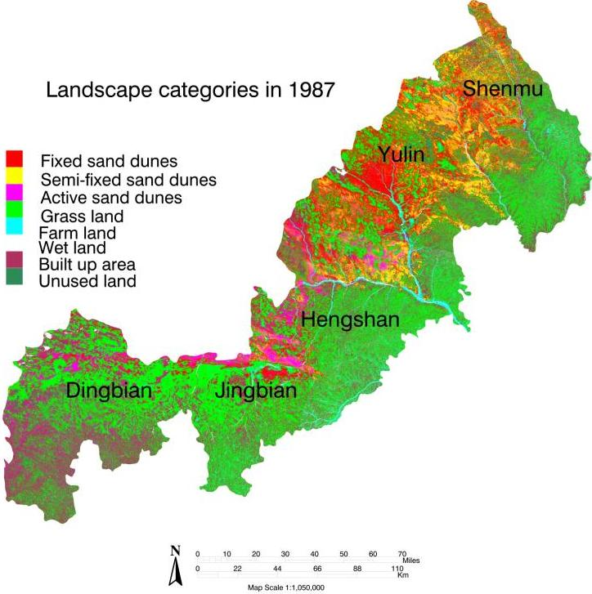
Figure 2: Landscape of the study area in 1987

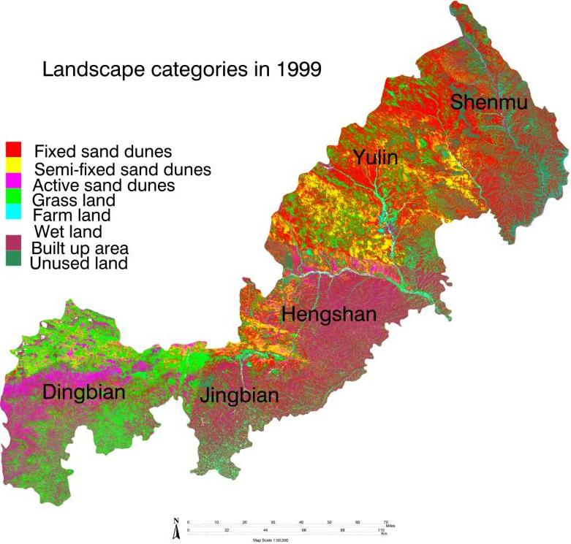

Figure 3: Landscape of the study area in 1999

slightly desertiﬁed land areas were 5,169.89, 4,918.15and 3,694.26 km², respectively increasing by 1,776.19 km². The statistics indicate that the unchanged region for the type of sandy desertiﬁcation in 1987 reached 8,993.89 km², accounting for 42.83% of the sandy area. While in 1999 it was reached 7,217.70 km², accounting for 34.37% of the sandy area. It is indicated by the above data that the land desertiﬁcation process was not steady and showed a trend of developing. The developed region of sandy desertiﬁcation was directed mainly from the northwest towards the southeast, especially in the desert-adjacent areas.

4.3 Spatial imbalance of sandy desertification

Table 3 shows the spatial imbalance of sandy desertiﬁcation during the 12 years from 1987 to 1999. The regions with serious sandy desertiﬁcation are in northwestern parts whereas those slightly inﬂuenced by desertiﬁcation are in the southeastern parts belonging to loess hills. This imbalance of spatial distribution varied little during the 12-year study period, and could be accounted for by the difference of physical factors and by the diversity of land-use practices. Compared to the southeast, the northwest, which is closer to the inner part of the MU US Desert, mainly under the inﬂuence of wind erosion and eolian accumulation, has an abundant sand source.

5. Conclusions

During the 1987s, the area of sandy desertiﬁed land reached 12,006.11 km² (57.17% of the total sandy area), of which severely desertiﬁed, medium desertiﬁed, and slightly desertiﬁed land areas were 4,442.23, 4,253.45and 3,310.43 km² , respectively. By the year 1999, the area of desertiﬁed land was increased to 13,782.30 km² (65.63% of the total sandy area), of which severely desertiﬁed, medium desertiﬁed, and slightly desertiﬁed land areas were 5,169.89, 4,918.15and 3,694.26 km², respectively increasing by 1,776.19 km². The statistics indicate that the unchanged region for the type of sandy desertiﬁcation in 1987 reached 8,993.89 km², accounting for 42.83% of the sandy area. While in 1999 it was reached 7,217.70 km², accounting for 34.37% of the sandy area.
The results also demonstrate that land cover changes during the past twelve years have been caused by land desertification on farmland and grassland in the area. Such changes may not only include the development of land desertification, but also explain the causes of land desertification in the study area due to over-exploitation and inappropriate land use, as well as by the invasion of wind-blown sand.
We can conclude from the results that the sandy desertification process of the northern part of Shaanxi Province, China, during the study period (twelve years) was a severe sandy desertification, characterized by the fixed sand dunes decreasing at a high speed, and the semi-fixed and active sand dunes increasing remarkably. In most of the sand land, desertification has developed rabidly, while rehabilitation of vegetation has occurred only in marginal areas in the east and south.

Acknowledgement:
Many thanks to Professor Hu Guangdao at the Institute of geology and Remote Sensing ,faculty of earth resources ,china university of geosciences For providing the data .

Correspondence to:

Eltahir Mohamed Elhadi
China University of Geosciences, Faculty of Resources, Wuhan, 430074, China
Telephone: 00862763962740.
Emails:tahirco2006@yahoo.com, nagizomrawi@yahoo.com

References
[1]Allen S Hope, Douglas A Stow, 1993. An analysis of tree mortality in southern California using high spatial resolution remotely sensed spectral radiances: a climatic change scenario. Landscape and Urban Planning, 24(1-4): 87-94.
[2]Anthony Gar-On Yeh, Li Xia, 1999. Economic development and agricultural land loss in the Pearl River Delta, China . Habital International, 23, 3: 373-390.
[3] Cai Yunlong, 2001. A study on land use/cover change: the need for a new integrated approach, Geographical Research, 20, 6: 645-652. (in Chinese).
[4]Chen Y F, Tang H P.Desertification in north China: background, anthropogenic impacts and failures in combating it. Land Degradation and Development, 2005, 16: 367-376.
[5]Dall’Olmo, G., & Karnieli, A.2002. Monitoring phenological cycles of desert ecosystem using NDVI and LST data derived from NOAA-AVHRR imagery .International Journal of Remote Sensing, 23: 4055-4071.
[6] Department of Geography of Peking University, Commission for Integrated Survey of Natural Resources of Chinese Academy of Sciences Lanzhou Institute of Desert Research of Chinese Academy of Sciences & Lanzhou Institute of Glacier and Frozen Soil of Chinese Academy of Sciences.(1983) .Natural Conditions and Its Improvement and Utilization in the Mu Us Sandland.Beijing, China: Science Press.210pp.
[7] Ding L X, Zhou B,Wang R C.Comparison of five relative radiometric normalization techniques for remote sensing monitoring .Journal of Zhejiang University (Agriculture and Life Sciences), 2005, 31, 3: 269-276.
[8]Kidwell, K. B, 1990 .Global Vegetation Index User’s Guide, US Department of Commerce/National Oceanic and Atmospheric Administration/National Environmental Satellite Data and Information Service/National Climatic Data Center/Satellite Data Services Division.
[9] Li Xiubin, 1996.A review of the international researches on land use/cover change .Acta Geographic Sinica, 51, 6: 553-558(in Chinese).
[10]Liu Y S, Gao J, Yang Y F, 2003. A holistic approach towards assessment of severity of land degradation along the Great Wall in northern Shaanxi Province,China.Environmental Monitoring and Assessment, 82,2: 187-202.)
[11] Guo, S. L. (1994). Resources development and environmental planning in Shanxi–Shaanxi–Inner Mongolia. In Z. Chen (Ed.) Monitoring and management of fragile ecosystems using remote sensing (pp. 119–142). Beijing, China: Astronavigation (in Chinese).
[12] Rouse, J.W., R.W.Hass, J. A. Schell, D.W. Deering, and. C. Haralan, 1974.Monitoring the Vernal Advancement and Retrogradation (Greenwave Effect) of Natural Vegetation. NASA/GSFCT Tybe111 Final report, Greenbelt, MD, USA.
[13] Paolini L, Crings F, Sobrino J A, et al .Radiometric correction effects in Landsat multi-date/multi-sensor change detection studies. International Journal of Remote Sensing, 2006, 27: 685-704.
[14]Paul M Treitz Philip J Howarth, Roger C Suffling et al., 1992. Application of detailed ground information to vegetation mapping with high spatial resolution digital imagery. Remote Sensing of Environment, 42, 1: 65-82.
[15] Qingjiu Tian and Xiangjun Min. 1998. the progress of thevegetation index research, the progress of earth science,13,4:327-333.
[16] Song, G., & Chen, C.1991. Assessment of land resources using remote sensing in the Loess Plateau. In Z. Chen (Ed.) Remote sensing application in the Loess Plateau of Northern China (pp.157-169) .Beijing, China: Academia Sinica (in Chinese).
[17] Wang Tao, Wu Wei, Chen Guangting, 2003. Study of spatial distribution of land desertification in North China in recent 10 years. Science in China (Series D), 34 (suppl.): 73-82 (in Chinese).
[18]Wang T,Chen G T, Zhao H L,et al. Research progress on Aeolian desertification process and controlling in north of China . Journal of Desert Research, 2006, 26, 4: 507-516.
[19] Wang Tao, 2002. Sandy desertification in the north China .Science in China (Series D), 45(suppl.): 23-34
[20]UNCED, 1992.Managing Fragile Ecosystems: Combating Desertification and Drought United Nations Conference on Environment and Development.
[21] Van Genderen, J. L., Chen, Z., & Zhang, Y. (1993). Monitoring and management of fragile ecosystems using remote sensing and GIS in Shanxi−Shaanxi−Inner Mongolia. Proceedings of the 1st International Symposium Operationalization of Remote Sensing, ITC, Enschede, The Netherlands, 19–23April, 4: 213–221.
[22]Zhang, X.S.1994. Ecological background, principles of management and optimized models of the Mu Us sandy grsslands.Acta Phytoecologica Sinica, 18: 1-16
[23] Zhu Z, Chen G (1994) Sandy desertification in China. Sciences Press, Beijing.
[24] Zhu Z, Wang T.1993. Trends in desertification and its rehabilitation in China. Desertification Control Bulletin 22: 27-30.

Table 1: Extent of desertification hierarchical list in the study area
Desertification type | Vegetation coverage | NDVI | Classification criteria
Slight desertification | 30–50% | 0.103–.138 | No obvious blown sand activities and land surface is covered by fixed or semi-fixed sand dunes
Medium desertification | 15–30% | 0.079–.102 | Blown sand activities are controlled significantly, and sand movement ripples exist on sand dunes
Severe desertification | <15% | <0.079 | Gobi, sand dunes and sand land denuded interdunes, denuded dune residuals, , clay mounds and wind blowouts.

Table 2: Change rate of the 6 landscape patterns from 1987 to 1999
Land cover type | 1987 |  | 1999 |  | 1987-1999 |  | Change rate  (+Gain,-Loss)  1987-1999
 | (km²) | (%) | (km²) | (%) | (km²) | (%) | (km².yr⁻¹)
Fixed sand dunes | 9669.24 | 32.87 | 7483.58 | 25.44 | 2185.66 | 7.43 | -182.14
Semi-fixed sand dunes | 4121.27 | 14.01 | 4789.02 | 16.28 | -667.75 | -2.27 | +55.65
Active sand dunes | 5674.46 | 19.29 | 7218.83 | 24.54 | -1544.37 | -5.25 | +128.70
Grasslands | 4244.82 | 14.43 | 2541.60 | 8.64 | 1703.22 | 5.79 | -141.94
Farmlands | 1723.81 | 5.86 | 3403.50 | 11.57 | -1679.69 | -5.71 | +139.97
Wetlands | 776.60 | 2.64 | 655.10 | 2.23 | 121.50 | 0.41 | -10.125
Built up area | 1106.05 | 3.76 | 1741.46 | 5.92 | -635.41 | -2.16 | +52.95
Unused land | 2100.35 | 7.14 | 1582.61 | 5.38 | 517.74 | 1.76 | +43.15
Total | 29416.60 | 100% | 29416.60 | 100%

. 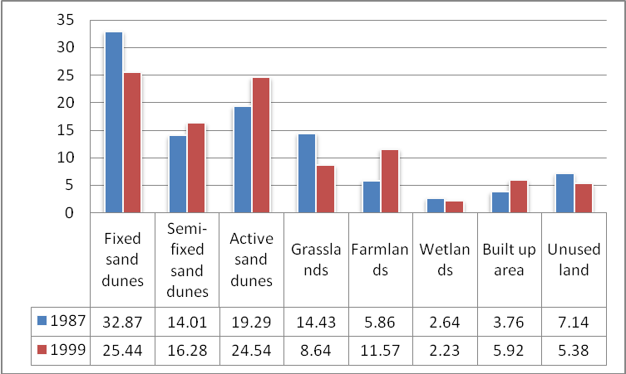
Figure 4: Area percentage of the eight landscape patterns in 1987 and 1999
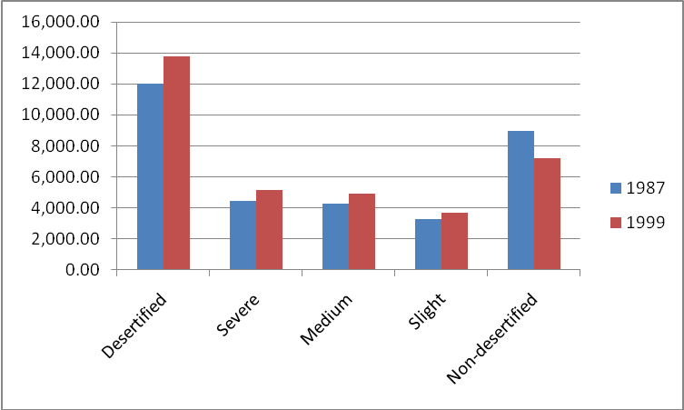
Figure 5: Area of desertiﬁed land

Table 3: Desertiﬁed land area during the study period
year | Severe desertiﬁcation |  | Medium desertiﬁcation |  | Slight desertiﬁcation |  | Land unaffected by  desertiﬁcation
 | (km²) | (%) | (km²) | (%) | (km²) | (%) | (km²) | (%)
1987 | 4,442.23 | 36.99 | 4,253.45 | 35.43 | 3,310.43 | 27.57 | 8,993.89 | 42.83
1999 | 5,169.89 | 37.51 | 4,918.15 | 35.68 | 3,694.26 | 26.80 | 7,217.70 | 34.37

8/26/2009

