Adaptation And Improvement Of A Simple Solar Tent Dryer To Enhance Fish Drying

Olokor, Julius Oghenekaro and Omojowo, Funso Samuel

National Institute for Freshwater Fisheries Research (NIFFR), P.M.B. 6006, New-Bussa, Niger-state. Nigeria.
oghenekaroolokor@yahoo.com; jowosam@yahoo.com

Abstract: Kainji Solar Tent Dryer (KSTD) was constructed as an improvement of Doe’s tent and the two solar tent dryers were used to dry fish. The fish used for the study was Bagrus bayad of high quality which was divided into two portions and each of the solar tent dryers was used to dry each portion. After drying the indices for comparison were based on the performance of the two dryers, materials used for construction and conditions for fish drying such as temperature, relative humidity as well as the number of occurrences of flies in the tent. Results from each dryer was computed and analysed using one-way analysis of variance followed by the least significant difference (LSD) for comparisons among means. KSTD was better in operation; it recorded the least number of flies that gained access to the dryer, Temperature recorded for both dry and rainy seasons were higher and consequently a lower humidity. Finally for the KSTD, organoleptic study show that the output of fish dried in KSTD was far better than in Doe’s tent. [Nature and Science. 2009;7(10):18-24]. (ISSN: 1545-0740).

Key words: KSTD, Doe’s tent, Bagrus bayad, Temperature, Humidity and fish drying.

Introduction
Drying or dehydration is used to describe any process involving the removal of water from fish or fish product by evaporation (Eyo, 2001). Fish drying is presumably the oldest method of fish preservation using heat from the sun and atmospheric air although it has been limited to certain climatic areas and seasons. In the Lake Chad area where wood is relatively scarce and air temperatures remarkably high for prolonged periods, sun drying is a tradition (Ogali and Eyo, 1996).
Sun drying is fraught with problems such as contamination by dust and insect infestation because the fishes are dried on mats spread on bare ground (BOSTID), 1988 due to spoilage. To arrest these problems, many designs of solar dryers have been developed for the preservation of fish. One of such dryers is the one designed by Doe et al. (1977) in Bangladesh.
The Solar tent dryer is made up of a polythene sheet worn over a wooden frame. It works through evaporative drying using the green house principle. When set up in the sun, solar energy passes through the transparent polythene but gets trapped within it thereby raising the internal temperature. Cool air flowing in through an opening gets heated up and moves out moisture from fish laid on racks in the dryer. Solar dryer speeds up the drying process considerably, resulting in a high quality product with extended shelf life. Even under high humid conditions, solar dryers could have other advantages such as: (i) it is rain-proof and hence can be kept in continuous operation even in bad weather. (ii) Drying in an enclosed environment protects the products from dust, dirt, attack by birds, rodents and insect infestation.
This study shows results of trials and modification of Doe’s tent and its comparison with the Kainji Solar tent dryer.

Materials and Methods
Materials used for the construction of Doe’s (1977) tent include: polythene tent, wooden frames, PVC (black) polythene spread out on the based of the tent and a drying rack. Materials used for Kainji Solar tent dryer are: Transparent polythene tent, wooden frames, mosquito net, black igneous rocks, zip and drying rack. In constructing the Doe type, sticks were simply dug into the ground, tied together and the polythene sheet fastened around the sticks using stapling pins. A flap was left under the tent to serve as access to the fish and also as air inlet. The frame work of Doe’s Tent is shown in Figure 2.
The KSTD (Figure 3) was constructed by obtaining five pieces of straight wooden poles each measuring 180 cm. Two of the poles were tied or nailed together at one end and the two other ends were dug 10cm into the ground at 160 cm apart. The same was done for the third and fourth wooden frames which are dug in an opposite direction at a distance of 194 cm apart. The fifth wooden frame was placed across the two pairs of wooden poles and fastened at both ends to form a tent-like structure. About 10 yards (50 µ thickness) transparent polythene was sewn into shape of the wooden framework above. The polythene tent was sewn to a height of 180 cm, top length of 184 cm and bottom length of 227 cm to fit and worn over the wooden framework . On one of the longer sides of the polythene cover, an opening was cut into the tent and screened with mosquito net. This opening serves as air inlet into the solar tent. At the extreme narrow tops of the triangular part of the tent, openings of 15 cm x 15 cm were made and screened with mosquito net to serve as outlet of the hot air from the dryer. On the opposite side of the net with the air inlet, a ½ meter zip length was sewn to serve as an access opening into the tent for the processor to handle and inspect the fish on the drying rack during the drying process. A fiber rope is passed around the base of the tent for tying the polythene tent firmly on the wooden structure, to prevent wind and insects from escaping into the tent. About 30 pieces of rocks with an average weight of 10 kg each were stacked within the base of the wooden framework. The rocks are painted black hence they serve as capacitor by absorbing, retaining and releasing radiant energy needed for the fish drying. The drying rack is a wire mesh framed with wood (70 x 150 cm) and suspended by two ropes of 150 cm each from the wooden frame above.

Setting-up the Dryers
The two dryers (Doe’s Tent and KSTD) were set-up side by side. The dryers were exposed to the sun from sunrise to sunset. The tents were positioned facing the direction of the prevailing wind, to allow air readily into the tents, since the drying process is a combination of air movement and heat. The dryers were set-up 30 minutes before fish were put inside.

Preparing the Fish for Drying
Fish used for this study was Bagrus bayad of high quality. This fish was selected because of its semblance to the imported stock fish. The fish was gutted and washed thoroughly in portable water. It was then split open from the dorsal region, then salted and allowed to drain before it was laid on the drying racks. Indices for comparison were based on the performance of the two dryers, materials used for construction and conditions for fish drying such as temperature, relative humidity as well as the number of occurrences of flies in the tent. Results from each dryer was computed and analysed using one-way analysis of variance followed by the least significant difference (LSD) for comparisons among means.

Results and Discussion
Table 1 shows comparison of Doe tent (Doe, 1977) and Kainji Solar tent designs. Components of the two dryers were used to compare the structural make up of the tents. Transparent polythene tent was not sewn but wrapped around the wooden frame in Doe’s tent while it was sewn to shape in Kainji Solar tent dryer with rope hemmed around the tent to protect it against the wind. Wooden frames that hold the tent were dug into the ground in both tents. In the Kainji Solar tent dryers, the outlet was screened against flies with mosquito net, while in Doe’s tent; the outlet was not screened but was wrapped up, thus allowing flies and pest to have access into the tent (Doe, 2002).

Air exit of the former was screened. In the latter, the tent had no screened exit for air but cut-out openings. One major characteristics of Kainji Solar tent dryer is the use of black igneous rocks that generate heat while in the Doe’s tent, PVC black polythene was spread out on the base of the tent. In the former, a zip was attached to serve as access into the tent while in the latter a section of the tent has to be carried up to gain access into the tent to check the fish. Drying rack is fixed rigidly into the ground in Doe’s tent, while in Kainji Solar tent dryer, drying rack is adjustable and removable.
Figure 1. Shows the occurrence of flies in Doe and Kainji Solar tent dryers in March and August 1999 and 2000 respectively. Results show that an average of 14 flies was counted in Doe tent while 3 flies were counted in Kainji Solar tent dryer in August 1999. Similarly, by March an average of 11 flies were seen in Doe’s tent while in Kainji Solar tent dryer, an average of 1 fly was seen.

Table 1: Comparison of Doe (1977) and the Kainji (2003) Solar Tent design

Doe (1977) Solar Tent | Kainji (2003) Solar Tent
Polyethylene tent not sewn but wrapped around the wooden frames. | Polyethylene tent sewn to shape with roped hemmed around the tent to protect it against wind
Wooden frames are dug into the ground and not movable | Wooden frames are dug into the ground as with Doe’s design
Outlet of Polyethylene tent not screened but wrapped up, thus allows in flies and pests. | Outlet screened against flies with mosquito net
Tent has no screened exit for air but cut out openings. | Tent has screened exit for air sewn
Tent has no black rocks but PVC (black) Polyethylene spread out on the base of the tent. | Tent has black rocks to generate heat
A section of the tent has to be carried up to gain access into the tent to check fish. | Tent has zip attached to serve as access into the tent
Drying rack is fixed rigidly to the ground | Drying rack is adjustable and removable

Table 2 shows the mean temperatures inside Kainji Solar tent dryer (KSTD) and Doe’s dryer and outside within the trial period. Temperatures for dry season (March) and rainy season (August) were recorded respectively. Results show that temperature in KSTD was 49°C and 38°C for March and August 1999 and 47°C and 38.8°C for March and August 2000 while 43.9°C 34.4°C, 42.8°C and 35.1°C was recorded for Doe’s tent for the same months and years respectively. Similarly, temperature recorded for the ambient was 37.7°C, and 38°C and 31.3°C for the same months and years respectively.

Table 2. Mean temperatures inside and outside solar dryers within trial periods
 | March 1999 | August 1999 | March 2000 | August 2000
Kainji Solar Tent | 49.8ºC | 38.5ºC | 47.3ºC | 38.8ºC
Doe Tent | 43.9ºC | 34.4ºC | 42.8ºC | 35.1ºC
Outside | 37.7ºC | 30.5ºC | 38ºC | 31.3ºC

Table 2 shows that KSTD had high temperatures than both Doe and the ambient conditions. Analysis of the data shows that KSTD had temperatures significantly different at 5% significant level from those of Doe. The relative humidity taken at intervals of 2 hours during the trials of March and August 1999 and 2000 are shown in Table 3. The lowest readings were obtained in KSTD followed by Doe tent and outside conditions. March and August have contracting humidity conditions in the study area because of the influence of rain in August and complete absence of rain in March, coupled with the prevalence of harmattan winds. The lowest humidity of 10.5% was obtained inside KSTD dryer in March 2000.

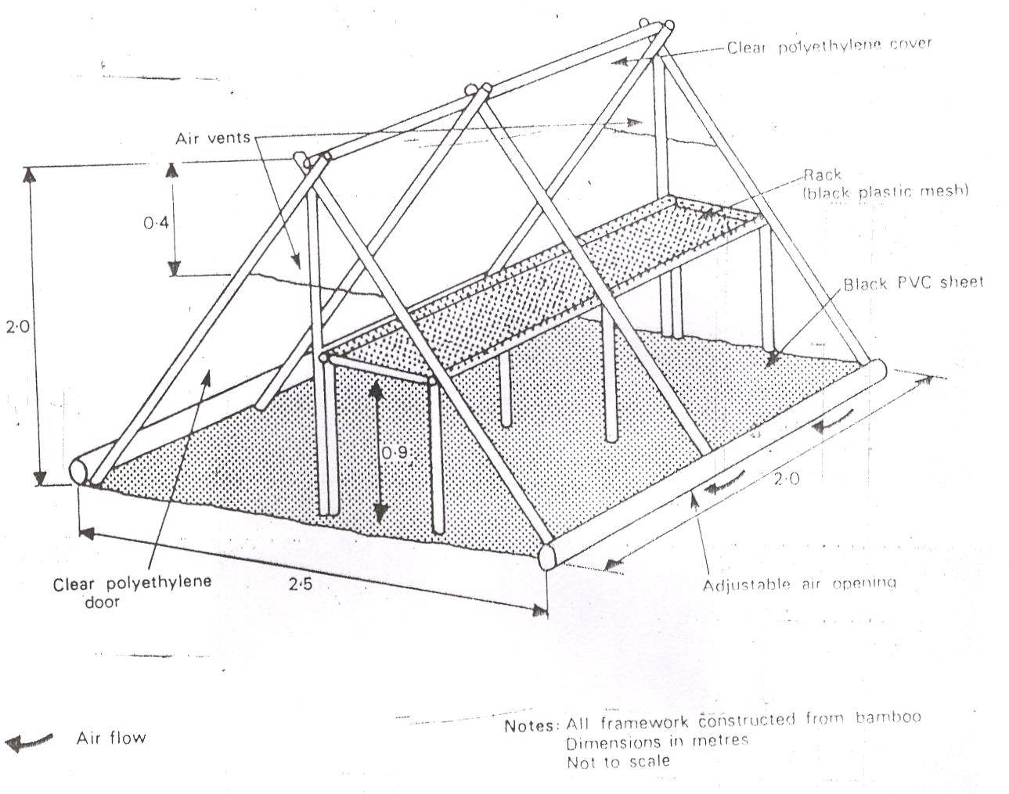
Figure 2. Schematic Diagram of the Framework of Doe’s Tent

Ambient conditions were significantly high in August but relatively lower in March. This explains why artisanal fish processors engage in fish drying more at this time.

Table 3. Mean Relative Humidity over a 3-day period inside and outside solar dryers
 | March 1999 | August 1999 | March 2000 | August 2000
Kainji Solar Tent | 13.5% | 27.9% | 10.5% | 25.3%
Doe Tent | 18.9% | 38.9% | 17.7% | 35.8%
Outside | 26.1% | 72% | 24.8% | 70.8%

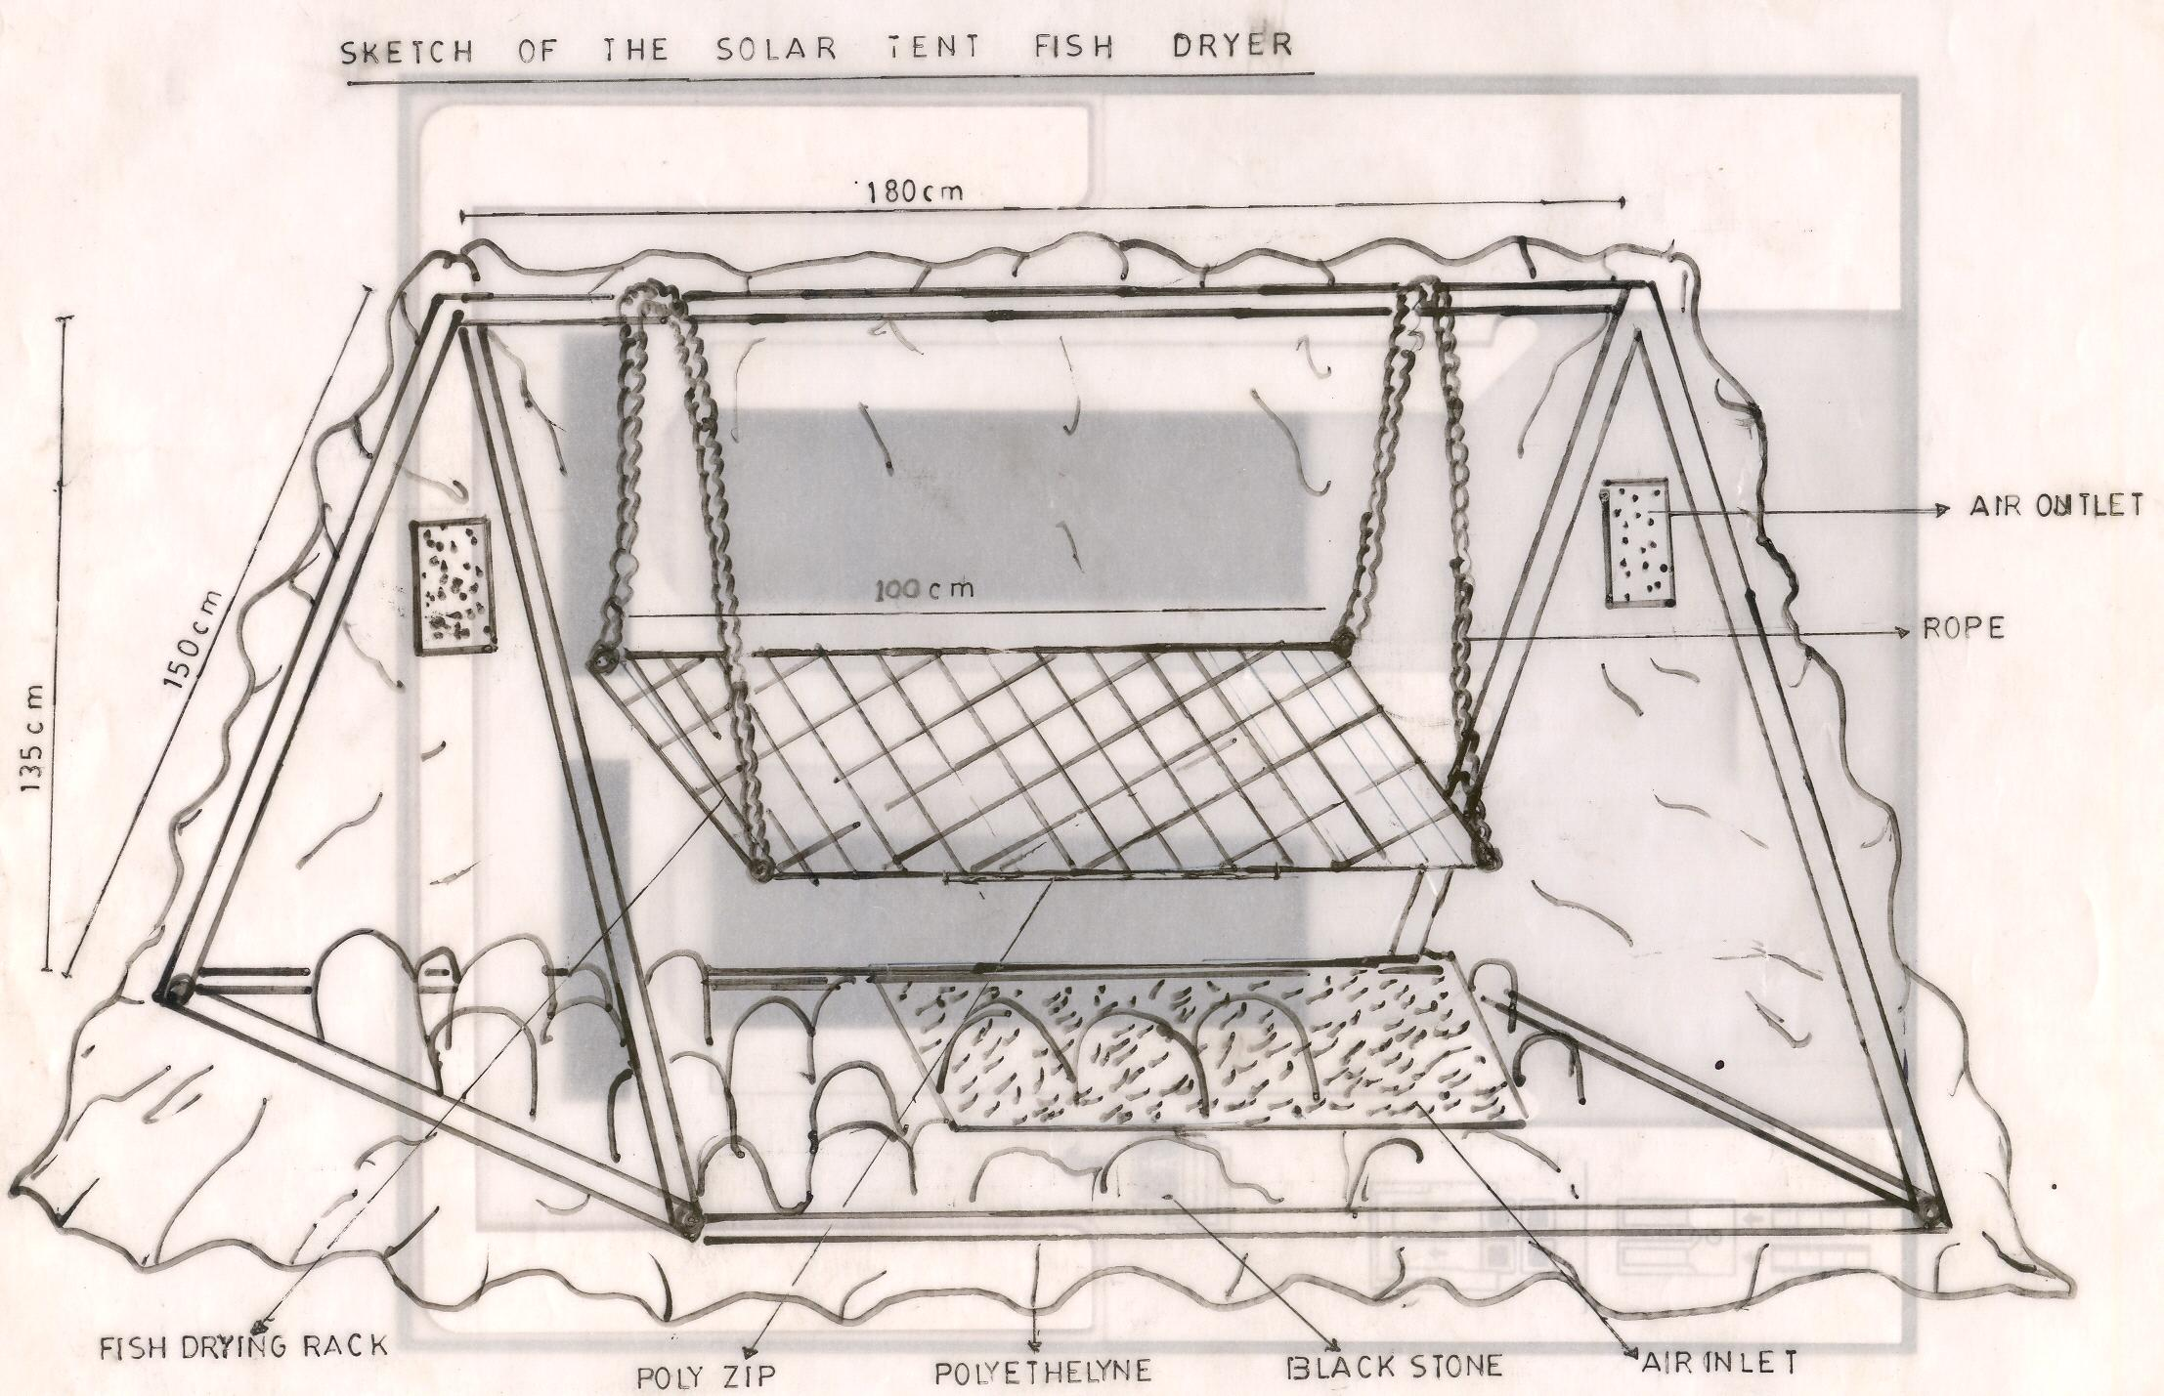
Figure 3. The Sketch of Kainji Solar Tent Dryer

The low incidence of flies in the KSTD was due to the fact that both the inlet and outlets of the polythene were screened which prevented flies from entering the dryer, unlike the Doe’s design, which had no screens and flies were observed to move in and out freely. The implication of this is that the flies lay their eggs on the fish during the drying process (Okaeme, 1986) thereby facilitating spoilage.
The internal temperature in KSTD was higher and consistent than Doe’s and the outside conditions because of the black igneous rocks, which absorbs and retain solar energy despite hourly fluctuation due to cloud cover prevalent at this time (Olokor, et. al., 1997), while the Doe’s design is more responsive to changes in ambient conditions. This result confirms that it is better to use black rocks as solar absorbers instead of black polythene sheet used in the Doe’s design. The black rocks intensify the green house effect within the dryer through its capability to store solar energy (Charney, 1975).
The low humidity recorded in KSTD was because of its consistent high temperature of 49.8°C and 38°C for March and August 1999 (Barnett, 1988). Humidity is the strongest factor for fish drying either within or outside a Solar dryer (Ajisegiri, 2001). This is because it determines the rate and speed of drying. Thus, it can be seen that humidity varied throughout the day, generally higher in the mornings and evenings and lowest late afternoons when ambient temperatures is highest. As temperature rises, relative humidity decreases.

SUMMARY AND CONCLUSION
The study revealed that Kainji Solar Tent Dryer which was constructed as an improvement of Doe’s tent and the two solar tent Dryers were used to dry fish. The fish used for the study was Bagrus bayad of high quality which was divided into two portions and each of the Solar Tent Dryer was used to dry each portion. One major characteristics of Kainji Solar tent dryer is the use of black igneous rocks that generate heat while in the Doe’s tent, PVC black polythene was spread out on the base of the tent. After drying the indices for comparison were based on the performance of the two dryers, materials used for construction and conditions for fish drying such as temperature, relative humidity as well as the number of occurrences of flies in the tent. Results show that an average of 14 flies was counted in Doe tent while 3 flies were counted in Kainji Solar tent dryer in August 1999. Similarly, by March an average of 11 flies were seen in Doe’s tent while in Kainji Solar tent dryer, an average of 1 fly was seen. Temperature recorded for both dry and rainy seasons were higher and consequently a lower humidity. Finally the study revealed that Kainji Solar Tent dryer was better in terms of structural make up, quality of the products and it dried faster than the Doe’s tent. It is therefore recommended for artisanal fish processors in Kainji Lake and Lake Chad areas.

Correspondence to:
Omojowo Funso Samuel
National Institute for freshwater Fisheries Research (NIFFR).
P.M.B. 6006, New-Bussa, Niger-State, Nigeria
E-mail: jowosam@yahoo.com
G.S.M: 08073536126

REFERENCES
[1] Ajisegiri ES Solar Energy in
Agricultural and Food Preservation.
(First Edition). Jameson Publishers,
Minna 2001. ISBN: 978 34122-5-6. 147p

[2].BOSTID (Board of Science and
Technology for International
Development) / Office of
International Affairs, National Research
Council (1988): Fisheries Technologies
For Developing countries. National
Academy Press Washington DC 1988.
pp 215 – 237.

[3] Barnett TP. Global sea level change. In
NCPO, Climate variations over the
past Century and the Green house
Effect. National Climate Program
Office/NOAA, Rockville, M.D. pp
112 – 119.

[4] Charney JG. Dynamics of deserts and
drought, in the Sahel. Quart. J. Roy.
Met. Soc 1975. 101, 193 – 202.

[5] Doe PE, Ahmed M, Muslemuddin
Sachithanathan, K. A polyethylene tent
Dryer for improved Sun drying of fish ,
Food technology in Australia 1977, 29,
437 – 441.

[6] Doe PE. Drying, Safety and Quality
Issues in Fish Processing; Woodhead
Publishing Ltd. Cambridge, 2002,
ISSN: 1-85573-552-0 Pp 350-359.

[7] Eyo AA. Fish Processing Technology in
the Tropics. UNILORIN Press 2001. Pp
130-152.

[8] Ogali EL, Eyo AA. Evaluation of the
effectiveness of box- type solar Dryer in
drying freshwater fish in Kainji lake
area.NIFFR, Annual Report 1996. P. 126-130.

[9] Olokor JO, Eyo AA, Mdaihli M,
Okomoda JK. Ayanda JO. Promotion
of fish drying using Solar energy in
villages around Kainji Lake. In: S.A.
Garba (ed) Biotechnology and
Sustainable Development in Nigeria.
Proc. Of 10th Annual Conference of
Bio. Tech. Soc.of Nigeria. Nov. 1997.
Minna. Pp 212 – 220.

[10] Okaeme AN. Flies (diptera) infesting
landed freshwater fishes of the Kainji
Lake area, Nigeria. Int. J. Zoon 1986.
49-53.

7/5/2009

