Evaluation of Citric Acid and Potassium Sorbate as Preservatives on the Safety and Shelf-Life of Smoked Catfish

Omojowo, Funso Samuel *, Omojasola, Patricia Folake **, Idris Garba Libata * and Ihuahi Josiah Adoga *

*NIFFR, P.M.B. 6006, NEW-BUSSA, NIGER STATE, NIGERIA.
** DEPT. OF MICROBIOLOGY, UNIVERSITY OF ILORIN, ILORIN. NIGERIA.
jowosam@yahoo.com; folakejasola@yahoo.co.uk; idrisgarbalibata@yahoo.com and joeihua@yahoo.co.uk.

ABSTRACT: Forty-four sample of catfish (Clarias gariepinus) were obtained from a fish pond in NIFFR divided into 11 portions of 4 each where 5 portions was treated with 1-5% Potassium sorbate respectively, the next 5 portions was treated with 1-5% citric acid (both are antimicrobial agents) prior to smoking and the last portion was not treated (it serve as control). All treated smoked samples were dominated with Bacillus coagulans and Klebsiella ozanae but negative for E. coli and Streptococcus sp. Unlike the 3% citric acid concentration, 3% potassium sorbate reduced the staphylococcus count to 0 throughout the 8th week of storage. Generally microbial counts were lower in the potassium sorbate treatment. All treated sample had higher protein and amino acid content than the control at the end of 8th week of storage with the highest in Potassium sorbate. Potassium sorbate proved to be more efficient in controlling microbial quality and extending shelf life of smoked catfish. [Nature and Science. 2009;7(11):1-8]. (ISSN: 1545-0740).

Key words: Potassium sorbate, Citric acid, Catfish, Quality and Safety

INTRODUCTION
Fish is becoming increasingly important in the diet of the Nigerian as there is an increase awareness that regular red meat intake in adult above 40 years of age is not healthy. Fish constitutes 40% of animal protein intake in Nigeria at present (Olatunde, 1989). This is because fish are a cheap source of animal protein with little or no religious rejection of it, which gives it an advantage over pork or beef. Fish are a very perishable commodity, more than cattle, sheep, and poultry, and get spoiled very easily even in temperate climates. So unless it is disposed of quickly after capture, it must be preserved in some way. World fish production was estimated at 100 million tons in 1989, 15% of which was cured in one or another way. One third of the cured fish was smoked and about 20% of the smoked fish goes into international trade (Ward, 1995). Increasing consumer awareness of the nutritional value of seafood especially smoked fish has stimulated a strong demand from consumers (Pigott and Tucker, 1990). To satisfy the consumer demand, it is necessary to produce good quality and safe smoked fish. Smoked fish and shellfish products can be a source of microbial hazards. Human infections may be caused by bacteria endogenous to fish. Bacterial pathogens, which may be transferred from fish to human beings include: A. hydrophila (septicemia, diarrhea), Campylobacter jejuni (gastroenteritis), Clostridium botulinum type E (botulism), Edwardsiella tarda (diarrhea), Leptospira interrogans (leptospirosis), Mycobacterium fortuitom marinum (mycobacteriosis), Plesiomonas shigelloides (gastroenteritis), Pseudomonas aeruginosa (wound infections), Salmonella sp. (food poisoning), and vibrio parahaemolyticus (food poisoning) (Austin and Austin, 1989).
Delay or prevention of microbial spoilage of fish may be achieved by different preservative methods that include the use of smoking and chemical preservatives like sorbates and citric acid. Sorbates are the most effective preservatives against a wide spectrum of food spoilage microorganisms; they include sorbic acid and potassium sorbate. They are among the safest, most efficient and versatile preservatives used in the food industry today. Sorbates are tasteless and odourless. Because they are non-toxic, they are used in a wide variety of foods, including cheese, yogurt, sour cream, bread, cakes, baking mixes, icing, beverages, margarine, fermented vegetables, fruit products, salad dressing, smoked and salted fish and mayonnaise. The antimicrobial activity of sorbates against molds, bacteria and fungi has been reported by researchers Sofos and Busta, 1993; Sofos, 2000). Also citric acid is vitamin C’s close cousin and it is a natural additive. It works to help keep bacteria and mold from growing on foods. It is found in citrus fruits, such as lemons and limes. However, most of the citric acid manufacturers’ use isn’t derived from citrus fruits. It is artificially made by a mold called aspergillus niger. The mold produces citric acid as long as it has a supply of sucrose (sugar). citric acid is also found naturally in the human body, so it causes no side effects. This ingredient is used extensively in soft drinks as a preservative and to enhance flavour (US FDA, 1978).
Considering the preservatives effects of sorbates and citric acid this study was therefore carried out to determine the microbial, organoleptic and nutritional quality changes of smoked catfish preserved with these antimicrobial agents at different concentration during storage at room temperature.

MATERIAL AND METHODS
Fresh catfish (Clarias gariepinus) were obtained from a private Fish pond in National Institute for Freshwater Fisheries Research (NIFFR) Housing Estate, New Bussa, Niger State in November, 2007. The fish samples measuring 17-28cm in length and weighing 180-250g were transferred within 30 minutes to the laboratory in a sterile polythene bags and then killed by severing the spinal cord with a sterile scalpel and aseptically eviscerated, washed and rinsed in sterile water. The fish samples were randomly chosen and divided into 11 groups of 4 fish for each of the catfish subjected to treatments. The treatments were as follows; (1) control (untreated samples); (2, 3, 4, 5 and 6) are treated with 1, 2, 3, 4 and 5% potassium sorbate and 7, 8, 9, 10 and 11 are treated with 1, 2, 3, 4 and 5% citric acid for 5 minutes, A sample from each group were separated from each treatment and smoked. Smoking was done according to the methods described by Omojowo and Ibitoye (2005). After smoking, the fish were allowed to cool down and were stored in different boxes. This was done to mimic commercial practices. The samples were drawn after two, four, six and eight weeks of storage; then subjected to analysis.

Microbiological Analysis
A 25g representative sample (excluding the head and tail) of each fish sample was obtained aseptically to prepare serial dilution using 0.1% peptone water as diluents. Total bacteria counts and coliform counts were determined according to the method of Sneath et. al. (1986). Faecal streptococci and E. coli in samples were determined employing the methods described by speak (1984). Staphylococcus aureus counts in samples were determined by employing the method of Bennett (1984). Moisture contents, fat and Crude protein were estimated as per AOAC (1980). All samples were done in duplicates. Sensory evaluation was carried out according to the method of Afolabi et. al. (1984). Statistical analysis was according to SAS, Institute, Inc, (1992) at P < 0.05.

RESULTS AND DISCUSSION
Total Viable count (TVC), Coliform, Staphylococci and Fungi count in log CFU/g of fresh and smoked Catfish samples are shown in Tables 1 and 2. TVC of the fresh the control catfish was 6.60 log CFU/g but after the sample were subjected to treatments with 1-5% Citric acid and 1-5% Potassium sorbate the TVC, Coliform, Staphylococcus and fungi count were reduced however, the reduction was higher in the treatment with Potassium sorbate also as the concentration is increases.
Smoking sharply reduced the total viable count (Table 1 and 2) in all samples, but the sample treated with 5% Potassium sorbate showed the greatest reduction and maintained a low level throughout 8 weeks of storage, especially on day 0 with 2.13 log CFU/g as shown in Table 2 while after 8-week storage the TVC was 4.60 log CFU/g. The TVC of the control samples were the highest throughout the period of storage where the sample were completely covered by mold after the 6th week of storage; therefore, no further microbial analysis was conducted. The results obtained were similar to those reported by Efiuvwevwere and Ajiboye (1996), where the samples treated with 0.4% potassium sorbate showed the lowest microbial load and maximum shelf stability. Similar to TVC, the coliform count (of the smoked samples treated with 5% Potassium sorbate had the highest reduction of 0.93 log CFU/g on day 0 and remain the lowest of the treatments throughout the period of storage. Significant increases in coliform population of all samples occurred after 4 weeks of storage. Coliform count of all treated samples was less than 3.0 log CFU/g throughout the 8-week storage. In the control samples, the Coliform population was 5.17 log CFU/g on the 6th week while the sample was completely covered by mold on the 8th week of storage.
This result was similar to that reported by Virginia, (2002) where the coliform in the control sample showed 2.6 log CFU/g on the 4th week and the sample was completely covered by mold on the 6th week of storage. The high coliform count recorded in this report may be due to contamination from the animal manure used in fertilizing the ponds at one time or the other. Furthermore, the smoked sample treated with 3-5% potassium sorbate had no staphylococcus count throughout the period of storage while only 4 and 5% citric acid was able to reduce the staphylococcus count to 0 and remained 0 until the end of 8th week storage. Generally, potassium sorbate showed the lowest count throughout the 8th week of storage.

Table 1: Microbial Load of Catfish Treated With Citric Acid (Log10)
 | Microbial  group | Control | 1% | 2% | 3% | 4% | 5%

Day 0 – A | TVC | 6.60 ± 0.4ª | 5.32 ± 0.2^{b} | 5.24 ± 0.3^{b} | 5.24 ± 0.6^{b} | 5.25 ± 0.4^{b} | 5.16 ± 0.5^{b}
Day 0 – B | TVC | 4.59 ± 1.2ª | 3.98 ± 0.4^{b} | 3.91 ± 0.1^{bc} | 3.79 ± 0.3^{c} | 3.34 ± 0.1^{d} | 3.10 ± 0.3e
2nd wk | TVC | 6.04 ± 0.3ª | 4.41 ± 0.7^{b} | 4.36 ± 0.7^{bc} | 4.24 ± 0.2^{cd} | 4.09 ± 0.8^{d} | 3.87 ± 0.5e
4th ,, | TVC | 6.52 ± 0.8ª | 5.10 ± 0.5^{b} | 5.16 ± 0.9^{b} | 5.12 ± 0.3^{b} | 5.08 ± 0.4^{b} | 4.63 ± 0.7^{c}
6th ,, | TVC | 7.35 ± 0.2ª | 6.03 ± 0.6^{b} | 5.88 ± 0.2^{bc} | 5.84 ± 0.9^{c} | 5.41 ± 0.3^{d} | 4.96 ± 0.3e
8th ,, | TVC | Mouldy | 6.90 ± 1.0ª | 6.71 ± 0.8^{b} | 6.67 ± 0.2^{b} | 6.48 ± 0.5^{c} | 6.26 ± 0.9^{d}

Day 0 – A Coliform | 4.60 ± 0.9ª | 4.06 ± 0.9^{b} | 4.00 ± 0.6^{bc} | 3.88 ± 0.2^{cd} | 3.80 ± 0.02^{d} | 3.74 ± 0.4^{d}
Day 0 – B Coliform | 3.54 ± 1.0ª | 1.75 ± 0.1^{b} | 1.60 ± 0.5^{b} | 1.38 ± 0.4^{c} | 1.25 ± 0.5^{cd} | 1.10 ± 0.3^{d}
2nd wk Coliform | 4.10 ± 0.1ª | 1.91 ± 0.7^{b} | 1.80 ± 0.5^{b} | 1.48 ± 0.3^{c} | 1.34 ± 0.7^{cd} | 1.28 ± 0.5^{d}
4th ,, Coliform | 4.43 ± 0.4ª | 2.10 ± 0.4^{b} | 2.06 ± 1.3^{b} | 1.67 ± 0.7^{c} | 1.76 ± 0.8^{c} | 1.63 ± 0.1^{c}
6th ,, Coliform | 5.17 ± 1.0ª | 2.60 ± 0.6^{b} | 2.42 ± 0.6^{c} | 2.18 ± 0.4^{d} | 2.32 ± 0.4^{cd} | 2.19 ± 0.3^{d}
8th ,, Coliform | Mouldy | 3.14 ± 0.5ª | 2.90 ± 0.3^{b} | 2.72 ± 0.8^{c} | 2.65 ± 0.2^{cd} | 2.52 ± 0.4^{d}

Day 0 - A | Staph. | 4.55 ± 0.6ª | 4.21 ± 0.4^{b} | 4.20 ± 1.1^{b} | 3.85 ± 0.2^{c} | 3.80 ± 0.5^{c} | 3.68 ± 0.4^{c}
Day 0 - B | Staph. | 3.17 ± 0.3ª | 0.64 ± 0.5^{b} | 0.40 ± 0.3^{c} | 0.40 ± 0.7^{c} | 0.0 ± 0.0^{d} | 0.0 ± 0.0^{d}
2nd wk | Staph. | 5.06 ± 0.6ª | 0.61 ± 0.3^{b} | 0.57 ± 0.2^{b} | 0.50 ± 0.3^{b} | 0.0 ± 0.0^{c} | 0.0 ± 0.0^{c}
4th ,, | Staph. | 5.32 ± 1.2ª | 1.20 ± 0.7^{b} | 1.10 ± 0.4^{bc} | 1.02 ± 0.8^{c} | 0.0 ± 0.0^{d} | 0.0 ± 0.0^{d}
6th ,, | Staph. | 5.52 ± 0.4ª | 1.70 ± 0.9^{b} | 1.62 ± 0.7^{b} | 1.33 ± 0.1^{c} | 0.0 ± 0.0^{d} | 0.0 ± 0.0^{d}
8th ,, | Staph. | Mouldy | 2.50 ± 1.5ª | 2.30 ± 0.1^{b} | 1.82 ± 0.4^{c} | 0.0 ± 0.0^{d} | 0.0 ± 0.0^{d}

Day 0 - A | Fungi | 4.52 ± 0.2ª | 4.55 ± 0.3^{b} | 4.56 ± 0.2^{b} | 4.60 ± 0.3^{b} | 4.62 ± 0.4^{b} | 4.50 ± 0.5^{b}
Day 0 - B | Fungi | 3.11 ± 0.4ª | 1.80 ± 0.7^{b} | 1.68 ± 0.4^{b} | 1.24 ± 0.1^{c} | 1.10 ± 0.6^{c} | 0.67 ± 0.6^{d}
2nd wk | Fungi | 5.28 ± 0.7ª | 2.20 ± 0.6^{b} | 2.17 ± 0.6^{b} | 2.14 ± 0.3^{b} | 1.71 ± 0.2^{c} | 1.24 ± 0.1^{d}
4th ,, | Fungi | 5.41 ± 1.1ª | 2.82 ± 0.2^{b} | 2.86 ± 0.8^{b} | 2.71 ± 0.7^{b} | 2.46 ± 0.8^{c} | 1.60 ± 0.3^{d}
6th ,, | Fungi | 5.70 ± 1.3ª | 3.30 ± 0.4^{b} | 3.24 ± 0.5^{b} | 3.26 ± 0.4^{b} | 2.98 ± 0.9^{c} | 2.18 ± 0.1^{d}
8th ,, | Fungi | Mouldy | 3.94 ± 0.3ª | 3.85 ± 0.7ª | 3.85 ± 0.8ª | 3.67 ± 0.3^{b} | 2.74 ± 0.4^{c}

Mean ± standard deviation of triplicate experiments and 2 replicates of each sample (6 readings of each Sample) Using superscript ^{a, b, c, d, e, f}., means in the same rows with different superscript are significantly different (p < 0.05).
KEY:
A = before smoking
B = after smoking

The isolation of Staphylococcus in smoked samples on day 0 may be attributed to post processing contamination. However, Staphylococcus was killed by the treatments 3-5% potassium sorbate and 4-5% citric acid. Fungi counts were also reduced in all the treatments and at the end of the 8-week storage time; however, the sample treated with 5% potassium sorbate showed 0 counts till the 4th and 6th weeks of storage. The control samples were high throughout the period of storage and the sample was even completely covered by mould at the end of the 8-week storage. This result were similar to those reported by Efiuvwevwere and Ajiboye (1996), where the samples treated with 0.4% potassium sorbate showed the minimum fungal load during storage and presence of profuse mould growth after day 8 in the control.
It is of interest to observe that in spite of the slightly reduced moisture contents (from 2nd to 6th week) in almost all the samples microbial load still increases dramatically. This suggests that one single factor may not account for these microbial changes. Cross contamination, pH, purity of preservatives are among other factors that can influence microbial changes. The bacterial contamination of hot smoked fish just out of the smokehouse is usually below 10³ per gram (Doe, 1998). The TVC of the most of the treated samples were all below 5x10⁵ CFU/g to the 6th week which is below m in a three-class attribute plan and signifies good quality. Low levels of coliform bacteria were detected and the pathogens S. aureus counts were below 10³ in all the treated samples The control however, has TVC higher than 5x10⁵ CFU/g in the second week and higher than the recommended limit 7.0 log CFU/g (ICMSF, 1986) after the 4th week. In addition the coliform count already exceeded 10³ even immediately after smoking. This finding is of concern as a result of the associated public health implications. For example, generally, hot smoked fish are consumed in the tropics with little or no further processing, thus, they fall into the high-risk category of foods (ICMSF, 1986; FDA, 2001). Hence there is a need for the use of appropriate percentage of choice antimicrobial agent.

Table 2: Microbial Load of Catfish Treated With Potassium Sorbate Log10)
 | Microbial  group | Control | 1% | 2% | 3% | 4% | 5%

Day 0 - A | TVC | 6.60 ± 0.4ª | 5.48 ± 0.4^{b} | 5.46 ± 0.3^{b} | 5.42 ± 1.6^{b} | 5.12 ± 0.4^{c} | 5.07 ± 0.9^{c}
Day 0 - B | TVC | 4.59 ± 1.2ª | 3.61 ± 0.7^{b} | 3.50 ± 0.8^{b} | 3.47 ± 0.5^{b} | 3.10 ± 0.3^{c} | 2.04 ± 1.3^{d}
2nd wk | TVC | 6.04 ± 0.3ª | 4.14 ± 0.8^{b} | 4.06 ± 0.1^{b} | 3.98 ± 0.7^{b} | 3.65 ± 0.5^{c} | 2.72 ± 0.3^{d}
4th ,, | TVC | 6.52 ± 0.8ª | 5.00 ± 0.3^{b} | 5.01 ± 0.4^{b} | 4.84 ± 0.3^{c} | 4.30 ± 0.2^{d} | 3.43 ± 0.7e
6th ,, | TVC | 7.35 ± 0.2ª | 5.71 ± 0.1^{b} | 5.68 ± 0.2^{b} | 5.50 ± 0.2^{c} | 4.71 ± 0.8^{d} | 3.90 ± 0.1e
8th ,, | TVC | Mouldy | 6.72 ± 0.2^{b} | 6.64 ± 0.9^{b} | 6.35 ± 0.3^{c} | 6.21 ± 1.4^{c} | 4.54 ± 0.4^{d}

Day 0 - A | Coliform | 4.60 ± 0.9ª | 3.95 ± 0.7^{b} | 3.76 ± 0.1^{c} | 3.74 ± 0.8^{cd} | 3.61 ± 0.5^{cd} | 3.58 ± 0.2^{d}
Day 0 - B | Coliform | 3.54 ± 1.0ª | 1.55 ± 0.5^{b} | 1.40 ± 0.4^{bc} | 1.32 ± 0.3^{c} | 1.24 ± 0.4^{c} | 0.93 ± 0.4^{d}
2nd wk | Coliform | 4.10 ± 0.1ª | 1.72 ± 0.3^{bc} | 1.88 ± 0.6^{b} | 1.61 ± 0.7^{c} | 1.55 ± 0.7^{c} | 1.10 ± 0.2^{d}
4th ,, | Coliform | 4.43 ± 0.4ª | 2.08 ± 0.2^{b} | 2.00 ± 1.4^{b} | 1.76 ± 0.3^{c} | 1.62 ± 0.8^{c} | 1.27 ± 0.3^{d}
6th ,, | Coliform | 5.17 ± 1.0ª | 2.50 ± 0.8^{b} | 2.42 ± 0.5^{b} | 2.23 ± 0.5^{c} | 2.11 ± 0.1^{c} | 1.92 ± 0.7^{d}
8th ,, | Coliform | Mouldy | 2.81 ± 0.1^{b} | 2.42 ± 0.2^{c} | 2.54 ± 0.2^{c} | 2.50 ± 0.3^{c} | 2.20 ± 0.1^{d}

Day 0 - A | Staph. | 4.55 ± 0.6ª | 3.88 ± 0.1^{b} | 3.74 ± 0.5^{bc} | 3.71 ± 1.0^{c} | 3.74 ± 0.2^{bc} | 3.65 ± 0.5^{c}
Day 0 - B | Staph. | 3.17 ± 0.3ª | 0.40 ± 0.7^{b} | 0.32 ± 0.7^{b} | 0.0 ± 0.0^{c} | 0.0 ± 0.0^{c} | 0.0 ± 0.0^{c}
2nd wk | Staph. | 5.06 ± 0.6ª | 0.60 ± 0.4^{b} | 0.45 ± 0.3^{b} | 0.0 ± 0.0^{c} | 0.0 ± 0.0^{c} | 0.0 ± 0.0^{c}
4th ,, | Staph. | 5.32 ± 1.2ª | 1.0 ± 0.3^{b} | 0.84 ± 0.1^{b} | 0.0 ± 0.0^{c} | 0.0 ± 0.0^{c} | 0.0 ± 0.0^{c}
6th ,, | Staph. | 5.52 ± 0.4ª | 1.60 ± 0.9^{b} | 1.25 ± 0.4^{b} | 0.0 ± 0.0^{c} | 0.0 ± 0.0^{c} | 0.0 ± 0.0^{c}
8th ,, | Staph. | Mouldy | 2.10 ± 0.2^{b} | 1.80 ± 0.5^{c} | 0.0 ± 0.0^{d} | 0.0 ± 0.0^{d} | 0.0 ± 0.0^{d}

Day 0 - A | Fungi | 4.52 ± 0.2ª | 4.12 ± 0.7^{b} | 4.02 ± 0.06^{b} | 4.03 ± 0.7^{b} | 3.71 ± 0.4^{c} | 3.28 ± 0.3^{d}
Day 0 - B | Fungi | 3.11 ± 0.4ª | 1.21 ± 0.4^{b} | 1.22 ± 0.5^{b} | 1.05 ± 0.3^{c} | 0.46 ± 0.6^{d} | 0.0 ± 0.0 e
2nd wk | Fungi | 5.28 ± 0.7ª | 1.73 ± 0.2^{b} | 1.84 ± 0.1^{b} | 1.55 ± 0.1^{c} | 0.54 ± 0.5^{d} | 0.0 ± 0.0e
4th ,, | Fungi | 5.41 ± 1.1ª | 2.59 ± 0.6^{b} | 2.61 ± 0.6^{b} | 1.92 ± 0.9^{c} | 0.62 ± 0.4^{d} | 0.0 ± 0.0e
6th ,, | Fungi | 5.70 ± 0.3ª | 3.36 ± 0.9^{b} | 3.25 ± 0.5^{bc} | 2.14 ± 0.2^{c} | 1.26 ± 0.2^{d} | 0.22 ± 0.1e
8th ,, | Fungi | Mouldy | 3.78 ± 0.1^{b} | 3.61 ± 0.02^{b} | 2.57 ± 0.5^{c} | 1.42 ± 0.8^{d} | 0.36 ± 0.03e

Mean ± standard deviation of triplicate experiments and 2 replicates of each sample (6 readings of each sample). Using superscript ^{a, b, c, d, e, f}., means in the same rows with different superscript are significantly different (p < 0.05).
KEY:
A = before smoking
B = after smoking

BACTERIAL ISOLATES
All treated smoked sample were negative for E. coli and Streptococcus sp. However, the control and the fresh fish treated samples showed the following bacteria flora Bacillus coagulans, B. cereus, Klebsiella ozanae, Proteus vulgaris, Escherichia coli, Staphylococcus aureus, and Streptococcus sp, while the fungi isolated include Penicillium verrucosum, Aspergillus niger, A. candidus, A. flavus and A. nidulan while the smoked untreated sample (control) were dominated by the following organisms B. coagulans, (about 70% of the isolates) while the remaining being S. aureus, and Streptococcus sp. The treated sample showed the microbial load in the following pattern; 1% and 2% potassium sorbate of the fish samples contains the following spp B. coagulans, S. aureus, K. ozanae, A. candidus and A. nidulan while in 3% and 4% potassium sorbate treated samples have the following isolates B. coagulans, K. ozanae and A. nidulan while 5% treatment have only B. coagulans. While 1, 2 and 3% citric acid treated samples had B. coagulans, K. ozanae, S. aureus, A. niger, A. nidulan, A. candidus, A. flavus, and Penicillium verrucosum. But 4 and 5% citric acid contains the B. coagulans, K. ozanae, A. niger, A. nidulan, and P. verrucosum.

Proximate Analysis
The proximate analysis of the treated raw and Smoked catfish are presented in Figure 1 to 8, there were no significant (p≤0.05) differences in Protein (17.8 - 18.6%), Fat (3.9 – 4.30%), and Moisture contents (78.2 - 79.4%). The moisture content of fresh sample was 78.2%. In the treatments the moisture contents ranged from 78.2 - 79.4%. Moisture content of catfish decreased sharply after the smoking process and this decrease was due to
loss of water during smoking (Asiedu et al., 1991). Also the study reveals that the average protein content increases after smoking, and increases till the 4th week and later decreases till the end of the
8th week of storage. There was an inverse relationship between the moisture and protein content in the smoked samples. The initial increase in protein content in smoked fish and till the 4th week may be due an increase in the dry matter content per unit of weight following sample dehydration during smoking and reduction in the moisture contents during the early part of the storage before autolysis becomes pronounced. These results shows that storage time causes a decrease in the protein content of smoked catfish which agreed with earlier work of Ufodike and Obureke (1989) where there was decrease in crude protein of preserved Oreochromis niloticus. These workers attributed the decrease to hydrolysis of protein during the process of autolysis in the fish muscle. However, the treated samples show some corresponding higher value of protein more than the control especially as the concentration of the preservatives increases from 1-5%. This increase may be due to the effects of the preservatives which slow down autolysis in the fish muscles and consequently slow down the protein break down.

CONCLUSION AND RECOMMENDATION
This study has reveals that the samples treated with Potassium sorbate and Citric acid before smoking showed significant reduction and maintained a low level throughout the 8th weeks of storage. However, potassium sorbate proved to be better than citric acid in comparison. Potassium sorbate can be used as a first choice preservative in smoked catfish without adversely affecting quality in terms of lipid oxidation, color, microbial and nutritional quality and citric acid may be used in the absence of potassium sorbate. The use of 3% potassium sorbate as a choice antimicrobial agent is hereby recommended since it has been found to keep smoked fish in wholesome state for 8th week, reducing the TVC to 6.35 log CFU/g, the coliform to 2.64 log CFU/g, staphylococcus count to 0.0s and fungi to 2.57 log CFU/g at the end of 8th week storage. This will ensure prolonged shelf life and safe consumption of smoked fish of ICMSF standard of smoked fish quality.

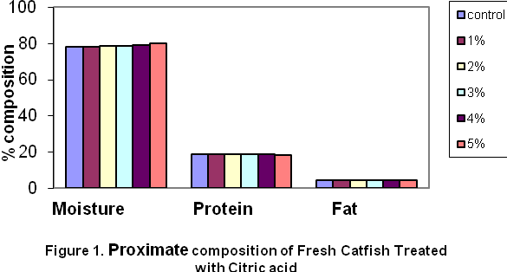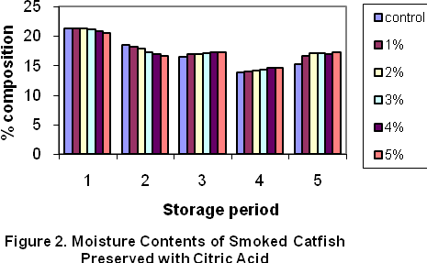
Note, in x-axis 1= Day 1, 2= 2^{n d} Wk, 3 = 4th Wk,
4= 6th Wk and 5= 8th Wk

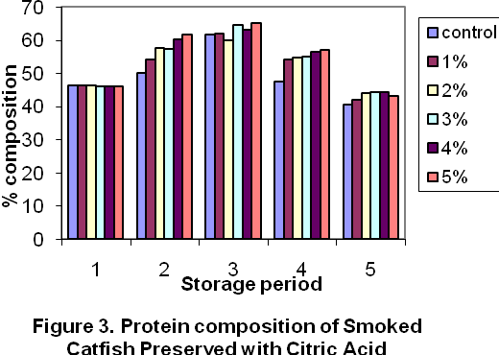 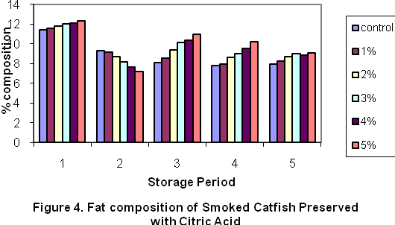 Note, in x-axis 1= Day 1, 2= 2^{n d} Wk, 3 = 4th Wk, Note, in x-axis 1= Day 1, 2= 2^{n d} Wk, 3 = 4th Wk,
4= 6th Wk and 5= 8th Wk 4= 6th Wk and 5= 8th Wk

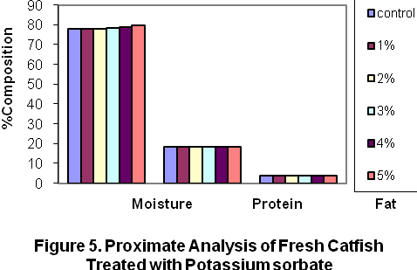

Note, in x-axis 1= Day 1, 2= 2^{n d} Wk, 3 = 4th Wk, 4= 6th Wk and 5= 8th Wk

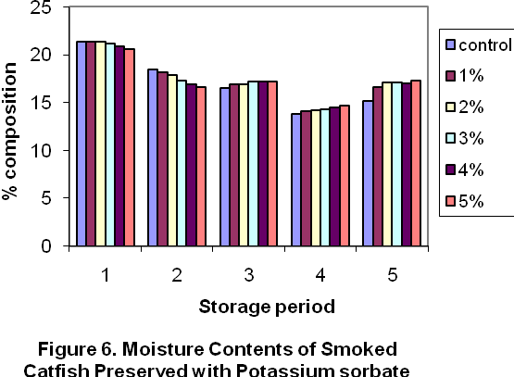

Note, in x-axis 1= Day 1, 2= 2^{n d} Wk, 3 = 4th Wk, 4= 6th Wk and 5= 8th Wk

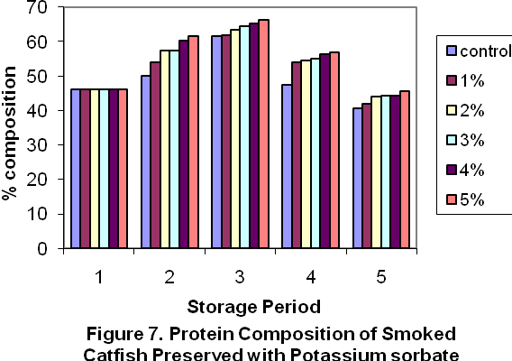

Note, in x-axis 1= Day 1, 2= 2^{n d} Wk, 3 = 4th Wk, 4= 6th Wk and 5= 8th Wk

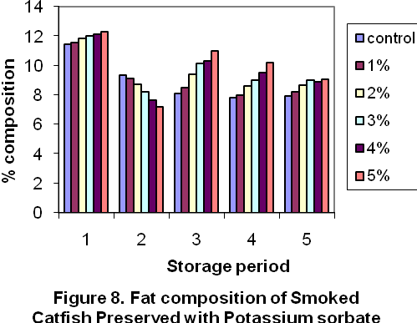

Note, in x-axis 1= Day 1, 2= 2^{n d} Wk, 3 = 4th Wk, 4= 6th Wk and 5= 8th Wk

Acknowledgement
The Authors are grateful to the Executive Director of NIFFR, New-Bussa, Nigeria for sponsoring this research work.

Correspondence to:
Omojowo Funso Samuel
National Institute for freshwater Fisheries Research (NIFFR). P.M.B. 6006, New-Bussa, Niger-State, Nigeria.
E-mail: jowosam@yahoo.com, G.S.M:08073536126

REFERENCES

[1] Afolabi OA, Arawomo OA. Oke, L.O.
Quality changes of Nigerian Traditionally
Processed freshwater fish species. I.
Nutritive and organoleptic changes. Journal
of Food Technology. 1984. 19, 333-340.

[2] AOAC. Official methods of analysis of the
AOAC (W. Hortwitz E.d.), 13th ed. AOAC,
Washington D.C., U.S.A 1980. 858pp.

[3] Asiedu MS, Julsham k, Lie O. Effect of local
processing methods on three fish species
from Ghana: Part I, Proximate composition,
fatty acids, minerals, trace elements, and
vitamins. Food Chem 1991. 40: 309-321.

[4] Austin B, Austin DA. General introduction.
In Methods for the Microbiological
Examination of fish and Shellfish, B. Austin
and D.A. Austin (Ed.) Ellis Horwood
Limited, England 1989, p19-24.

[5] Bennet RW. Bacteriological Analytical
Manual 6th edn., Association of Official
Analytical Chemists. Arlington, U.S.A 1984.

[6] Doe PE. Fish drying and smoking Production
and Quality. Technomic Publishing Co., Inc.
Lancaster, Pennsylvania 1998.

[7] Efivuvwevwere BJO, Ajiboye MO. Control
of Microbiological quality and shelf-life of
catfish (Clarias gariepinus) by chemical
preservative and smoking. Journal of Applied
Bacteriology 1996. 80: 465-470.

[8] FDA, Department of Health and Human
Services. FDA & EPA Safety levels in
regulations and Guidance. In Fish and
fisheries Products, Hazards & controls
guidance: Third Ed. Appendix 5 2001. p. 285.

[9] Harrigan WF, McCance MF. Laboratory
Methods in Food and Dairy Microbiology,
2nd Edn. London: Academic Press 1976.

[10] ICMSF (International Commission on
Microbiological Specifications for Foods
Micro organisms in Foods 2, Sampling for
Microbiological Analysis. Principles and
Specific Applications, 2nd edn. Oxford:
Blackwell Science 1986.

[11] Olatunde AA. Focusing on research
approaches to the study of fishery biology
in Nigeria inland waters. In proceedings of
the conference on two Decade of Research
on Kainji. NIFFR, New Bussa, 29th Nov-
1st Dec. 1989, 538-541.

[12] Omojowo FS, Ibitoye A. Comparisons of
the Microbial qualities of smoked Clarias
gariepinus using four different kilns. In
Fison proceeding, Port Harcourt 14th-18th
Nov. 2005.
[13] Pigott GM, Tuckker BW. Seafood Effects
of Technology on Nutrition, Marcel
Deckker Inc. N.Y.1990: 155-170.

[14] Ward AR. Fish smoking in the tropics. A
review. Trop. Sci. 1995:35, 103 – 112.

[15] SAS Institute, Inc. SAS User’s Guide:
SAS Institute Inc., Cary, NC 1992.

[16] Sofos JN. Sorbate Food Preservatives. Boca
Raton, FL: CRC Press 1989.

[17] Sofos JN. Sorbic acid. In Natural Food
Antimicrobial Systems, ed. A.S. Naidu
2000: 637-659. Boca Raton, FL: CRC
Press.

[18] Sneath PHA, Mair NS, Sharpe ME. Holt JG.
Bergey’s Manual of Systemic Bacteriology
1986. Vol. 2. Baltimore: Williams and
Wilkins.

[19] Speck ML. Compendium of Methods for
the Microbiological Examination s of
Foods 1984. 2nd edn. Washington, D.C:
American Public Health Association.

[20] Ufodike EBC, Obureke JU. Effects of
preservation techniques on quality of
Oreochromis niloticus muscle. J. Aqua. Sci.
1989. 4: 1-5.

[21] United States Food and Drug
Administration. Compliance policy guide,
No 7108. 24. Washington D.C 1978. Food
and Drug Administration.
[22] Virginia LTA. Hazard Analysis and Critical
Control Point (HACCP), Microbial safety
and Shelf life of Smoked Blue catfish
(Ictalurus furcatus) 2000. M.sc Thesis
submitted to the Graduate Faculty of the
Louisiana State University.

02/09/2009

