Establishment of the Unified Field Theory

Sun Chunwu
59 Xuhuzhen, Yangzhou, Jiangsu 225008, China
0514一82822538; yzscw@163.com; http://yzscw.blog.163.com

Abstract: There are many problems on natural science disturbing scientists. Einstein focused on finding fields of unified gravity, electromagnetic force, strong force and weak force, so he could not take the lead to create the Unified Field Theory to analyze which one is of bigger mass, and what had integrated all these forces to evolve new substances. As a result, the author tries to create the Unified Field Theory, its graphics and formulas in the purpose of correctly getting to know the causes in Nature and the ability of after-movement energy-change so as to benefit the mankind. [Nature and Science 2009;7(11):15-20]. (ISSN: 1545-0740).

Key words: Unified Field Theory; Oval charts and formulas; Application of the Unified Field Theory

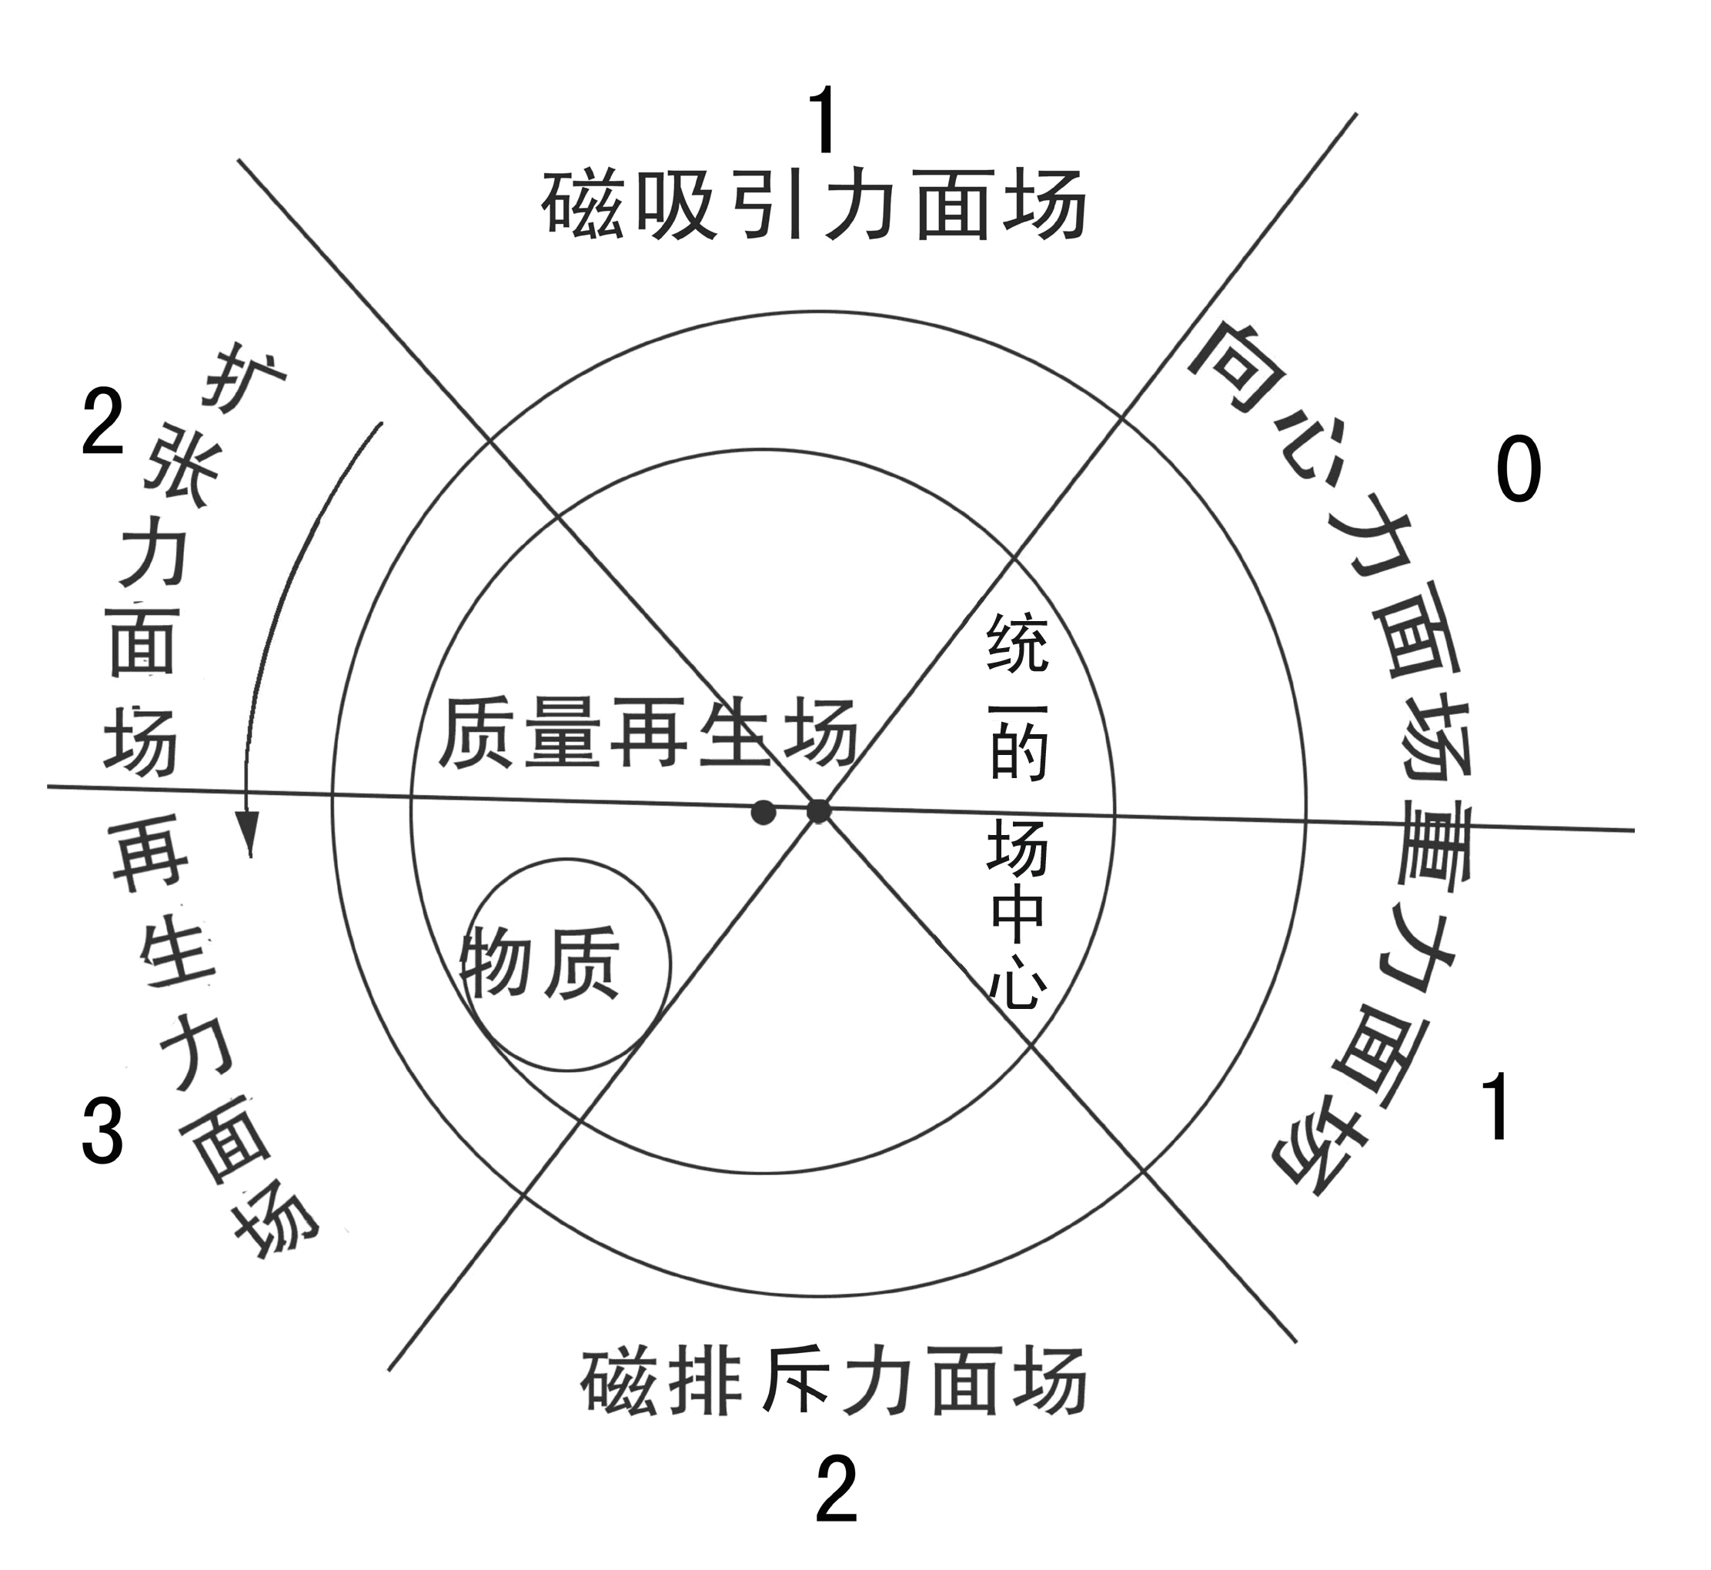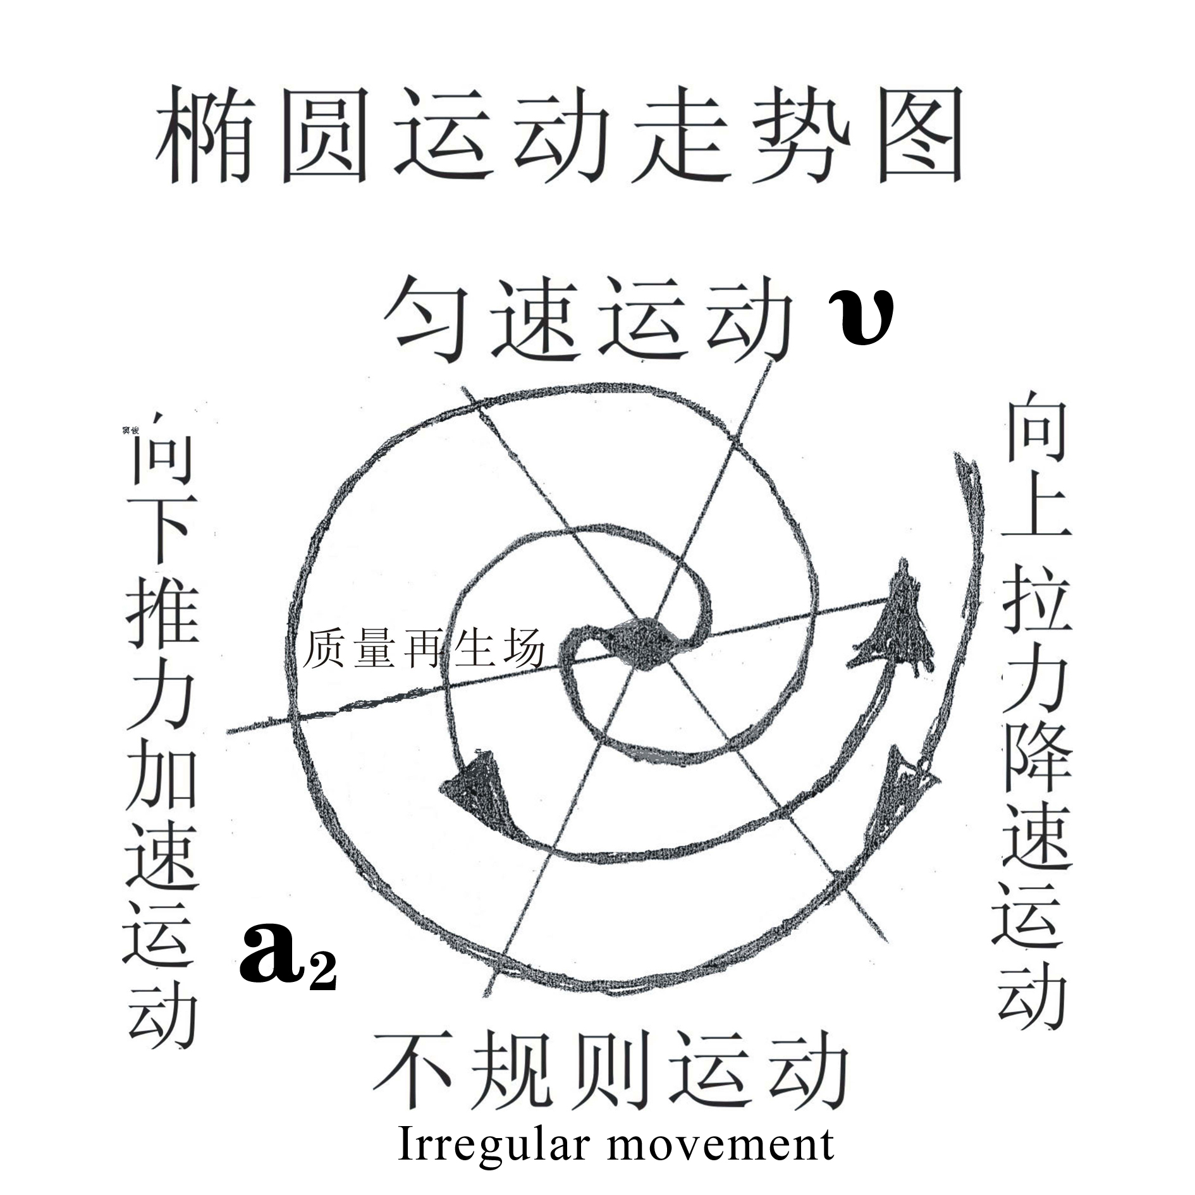

The Unified Field Theory integrates the formation and state of movement and development of things into an oval chart, sets data according to each position shown in the oval model, and then demonstrates by theory, teaching you how propose, solve, and discuss different kinds of problems. First of all, it informs you of what a unified field is. For example, masses of forces surfaces of different fields marked in this oval model generate different energies on the same field. The one of bigger mass is the unified filed. Therefore, when proposing, solving and discussing things like galaxies, planets, atoms, plant seeds, animal cells, a country or a person, etc., we can deem the living-body structure as the unity of the unified field, and then discuss how a mass moves on this living-body field to generate ethers such as gravity, magnetic force, strong force, and weak force, etc.
What is the function of the unified field? We regard core objects that take up and consume much energy such as the pole of rotation of the earth, the core of atoms, the central government of a country or a living person as the unified fields. Then we can make accurate mathematical explanation to elements at each position on the oval model, e.g. the mass, speed, of the planets, and its distance from the core of the galaxy, etc.
This filed is formed by concentric movement, with its mass depending on the energy of the centripetal force on the force surfaces of the fields around. Its function is to locate objects around and unify them when the limit of their movements is reached, and provide or inherit wisdom and energy for the objects around.
Therefore, time and space begin at this time. Gravity, magnetism, electricity, light, etc. are formed one after another after self-autorotation and being pushed. They disappear also with the disappearance of self-autorotation, and time and space ends as well.
What is the Unified Field Theory? For example, when discussing problems like why the planet moves faster on one side of the galaxy core, but slower on the other side, the methods used in the process of demonstrating the unified field are called the Unified Field Theory, which is composed of the Unified Field Theory, an oval chart and the formulas of problem-proposing and problem-solving. With it, problems involved in the unified field can be discussed.
The large circle in the oval chart stands for the size of an object in the unified field.
The hole in the small circle of the oval chart is called “Black Hole” at the core of the galaxy. It resembles the length of arms of a lever, or a woman’s womb, or copy tools of computers, weapons, etc., generating more energy after systematic accelerated movement. The mass of petrol is lost after being transformed, but the energy is conserved. As a result, the hole in the small circle and tools, etc. are called the mass-regeneration filed, which is used to generate more energy.
It has a uniform criterion of mass. The bigger the mass of the field, e.g. the fiercer the centrifugal force, or the larger the holes, r the heavier the tools and weapons people use, the more energy they generate.
On the contrary, every time when the mass of the field gets smaller, or when moving on the field of gravity or the field of centripetal force, the higher the object whirls, the slower it moves, and the less energy it generates.
The substances in the hole of the oval chart can also be regarded as the names of objects that generate energy. Every time it moves systematically, the bigger the mass, the more energy it generates; the smaller the mass, or the weaker the centrifugal force, the less energy it generates, or the less evolution of synthesis. Therefore, the movement is not only dependent on the surroundings, tools, and weapons, etc., but also restricted by its own mass. In addition, it cannot generate energy alone.
The six (relative) different fields of force surface in the oval chart represent the time of laws of motion of everything on the earth, including people, and they do ordered movement of a new round. The numbers stand for that during the process of development at each stage, the movement they do to generate energy is random. These six fields, just like the cores of the mass-regeneration field and the unified field, are divided into three kinds of masses--- big, medium, and small. The other chart is to illustrate the push and friction of centripetal and centrifugal forces in different spaces, i.e. the so-called yin yao and yang yao in the Eight Diagrams. When discussing about things, we have to be as accurate as what Zhouyi has predicted, combining all the data to work out the correct answer.
The top of the large circle in the oval chart stands for the starting point of the time of one object, or objects converged under this condition. It won’t change in energy. By a terminology in physics, we call it “the surface field of magnetic attraction”. We label the energy it generates from constant velocity motion as 1.
The protruding part of the top of the oval chart stands for the motion from the top to the bottom. We call it “the surface field of expansionary force”, and the energy it generates and converges is labeled as 2.
Under it, the acceleration inertia can generate more energy, e.g. to increase the ovality of the earth. We call it “the surface field of strong force”, or “the surface field of regenerative force”. The energy it generates is labeled as 3.
In short, movement in these two surface fields is in acclerrated motion because there is an inertia of push.
The very bottom of oval chart is the surface field of magnetic repulsive-force, standing for that the c entripetal force of a mass is stronger when it spins slowly and the centrifugal force is stronger when it spins quickly if a mass moves on this field and at this time. The energy generated has been decreased to 2. We call it “irregular motion”, which will result in fortuitous accidents.
The other side of the oval chart is a motion from the bottom to the top. The energy generated has decreased to 1. It does decelerated motion by inertia. We call it “the surface field of gravity”.
But on the top of such kind of field, since the objects have completely lost the ability to do work, and consumed energy by friction force and gravitation, so it does centripetal motion. Therefore, we call it “the surface field of centripetal force” or “the surface field of weak force”. The energy generated is 0.
In short, movement in these two surface fields is in deaccelerated motion because there is a centripetal force. And contraction as well as degeneration will happen.
Of course, the energy they have generated has done continuous accelerated centripetal movement, making the mass of the object in the center of the hole of the organizational structure of the joint force, generating more energy to do work after thrown by the centrifugal force after autorotation. If they move for a second time, the total mass of the system should be multiplied with the mass of the work done by throwing through acceleration inertia and the energy obtained from the distance away from the center, and then this new number should be multiplied with the energy of inertia one after another. After that, we can know energy evolved from different surface fields, giving rise to gradual acceleration of the speed of autorotation, such as expansion, photo-electro-magnetic or the element mass as shown in the positions on in different surface fields of the oval chart. The temperature changes periodically in energy, or does non-constant motion, etc
The object generating more energy doesn’t move in elliptic motion which consumes less energy but moves in circle which consumes more energy. For example, quark cannot generate more energy, so it moves towards the ellipse. Under the influence of the centripetal force, its energy generates in an accelerated way. When it comes to the center, it makes gas or objects in the hole, or blue light with high temperature and larger mass than it, generate new groups or new elements. Or, when it reaches the central point of the hole, it will lose the energy to spin by acceleration of the system, thus integrating electromagnetic force, strong force, gravity, etc. generated from autorotation by the friction and gravity of bigger mass.
The oval chart above is used to unveil the fact that things in the microcosm do elliptic motion. It is the centripetal movement that has caused the generation of centripetal force which enables the things entered the center to be thrown away by the centrifugal force by the autorotation of the system. All things in the Nature use these two kinds of simple and different pushing forces and friction forces to make objects on any field of the unified field generate energy have autorotation energy to evolve and develop and anytime anywhere, gradually generating gravity, electromagnetic force, strong force, weak force, etc. In this way, making use of each of their descriptions, and combining the data mentioned above, it is possible and reasonable to propose, settle, and discuss different problems arising from the things on the earth.
Apart from using the oval chart to unveil mysteries of the past, present and future of all things on the earth which generate energy in motion, proposing and settling problems by the structure of a unified oval ball, the Unified Field Theory also sets up one formula:
max

Kg≠m•a2•t

Min

This formula gives you an inspiration to propose and solve problems. This formula appears like a lever, enabling us to associate the mass of movement of all things which doesn’t equal the energy they can generate.
“≠”tells the person who proposes and settles problems about the problem of limit of energy generated in motion in the system of the mass. With this limit, we can get to know the death of things and the speed of irregular periodical movement. Three things are proposed: ①“m”stands for the mass at the early stage of convergence, or the history of past. “t”stands for the energy generated after the convergence, or the present mass. “kg” stands for different occasions, different conditions, different results, or its future mass. ② Regardless of past, present or future, galaxies or atoms, animals or plants, macro or micro, “≠” means the contradiction between fast and slow. The speed contributes to the development of this contradiction, and time is the one to reconcile the contradiction.
Therefore, they are in compliance with the mass, acceleration, time, and the environment in one structure so as to propose and solve the problems. ③ “≠”also stands for the existence of the speed on the two sides of the autorotation pole, and the photon, electron radiated after the movement. So we should use different forms to discuss and different formulas to calculate. “t” (time) stands for the energy that can be generated after movement due to the existence of the regenerative field, and with what kind of mass to converge around the autorotation pole, in the regenerative field and other fields.
You can get to know the mass after their movement based on these conditions. The energy generated will be either the strongest or the weakest decided by the following three elements: first, the acceleration speed of autorotation; second, the speed in different situations on the two sides of the autorotation pole; third, the speed before or after the mass limit being unified. The relationship among them is unified randomly. If anyone of them converges or evolves and generates different amounts of energy, there will be numerous changes in the fields, just like new things keep on emerging in the Nature. Then discussions have to be held again one by one, or different formulas are used to calculate.
Therefore, this formula, like Chinese ideographic writing, contains both philosophy and inspiration for readers to associate, correctly calculating them and making out the causes of what does more work one by one. These objects, exceeding the bearing capacity of the mass of the system, result in “strong force” such as “electromagnetic force”, nucleus (proton as well as neutron) and “weak force” when the atoms decay. Or, readers can propose a mathematical equation of this object to calculate physical quantities such as different forces, and intensity to solve the problems.
It is safe to say that with the Unified Field Theory and data from the oval chart showing you how to propose and solve problems, the researchers will get the insight to imitate out their own charts or fill the problems into the corresponding positions of the chart, then get to know what their nature is, or what kind of movement structure they belong to, e.g. whether they do rectilinear motion, or do elliptic motion on a tilt. In this way, researchers will get to know their movement from a comprehensive, systematic, related, and developmental perspective so as to discuss random problems emerged such as how planets move in the galaxy as a unified field. Also, they can use simple methods to quickly solve the problem on fastness and slowness. At the same time, the view of transforming mass into energy and the quantum theory proposed by Newton and Einstein, as well as the superstring theory, etc. are summed up and arranged scientifically, making it clear that the one with a bigger mass or a proper method is the unified theory.
In the future, once the Unified Field Theory and the oval chart are accepted, a more magnificent scientific mansion of physics as strong as the framework of reinforced concrete will be built to propose and solve problems, leading people to put mass into a system to generate more regenerative energy, and to create a new moralized era featured by “great scientific development” so as to benefit the mankind.
Next, let’s have a look at how the Unified Field Theory is used to propose and solve problems. I will just make a simple statement here, but you can infer the whole from a single instance. For more detailed information, please refer to passages of the series of the Unified Field Theory (45 all together), such as The Great Parturition of Mother Universe, and you can refer to the 162 problems solved by Wang Xiyu so as to further understand the scientific value of the Unified Field Theory.
Example 1： in the physical formula of the Unified Field Theory, we propose a limit of the energy that can be regenerated of the quality when in motion, and converge the biggest or smallest quality within the limit of “t” (time). The core of the unified field is like the central government, the quality-regenerative field is like the economic policy, and all the force fields are like different groups of people. When start moving at the same time, in what kind of state do they converge and move? Suppose each of them appears with the greatest quality in every field, and suppose the energy generated by the primitive quality is 1, that by the progressive quality is 2, by the advanced quality is 3, by the speculative quality is 2, by the backward quality is 1, and by the hard quality is 1, which constitute a system. When an advanced person who has operational management capability and enough money runs a factory or company, the business will develop very quickly at once, just like the objects that have accelerated and moved for a while in the quality-regenerative expansionary-force field and the regenerative field. If we use the figures, the energy they have generated is six (three times two) and nine (three times three), respectively. While those people who have no management capability or fund can only work for others. They are like the objects moving in the gravity field or the centripetal-force field, which get no help from any dark energy or dark matter. A year later, if we use the figures to express, apart from the daily-use articles, other profits they have gotten is three (three times one) and zero (three times zero).
From the Unified Field Theory, we can get to know that after years of energy accumulation, the quality of these people has evolved in this net-force structure by inertia, and the energy doesn’t conserve. And they will invest their money in the things they are interested in. Suppose the primitive group does the business of land disposal and land leasing, the progressive group invest their money on real estate development, and the speculative group does any business that can get profit, such as buying or selling the real estate, and the backward and hard group accumulate money to purchase the living houses for future development.
Due to the development of the market and the different development of various groups of people, the backward and hard group who accumulate money to buy their houses cannot catch up with the increase of commodity prices, and then there will be situation of oversupply and dissatisfaction to the society. Therefore, the central government should firstly decide whether it is a planned-economy society or a market-economy society, whether their motion speed, structure, policy or strategy are injurious to the common benefit, and whether they have exceeded the greatest or the least limit, and then the government can flexibly use different methods, such as policies and laws to regulate and unify the unreasonable forces inside its movement structure. For example, we need to take comprehensive measure in the complex market economy, for its perniciousness is the same as the stocks. On the one hand, it damages the enterprise’s profits; on the other hand, it does harm to the society. So the government should implement comprehensive treatment to those who illegally rent or sell land, who use the profit to run the real estate business, who irresponsibly apply loans from the bank, and also raise the salary of the low-income earners, provide subsidies for purchasing an apartment to the poor households, and take effective measures to the problems such as low-price public-land sales, and high-priced removal compensate, etc., so as to enable each component inside the matter to unify in the fierce movement or psychological world or legal system. It will be as regular as the six fields in the oval chart, being well-organized and harmonious. Things are run in this kind of condition, rather than the chaotic state of no certain proportion, no certain conflict, and no certain difference.
If the central government can't formulate a new policy in time, or cannot unify by force, then its ruling ability will be zero, and the social stability will be disturbed.
Example: Why are there two different spiral arms of different speeds around the galaxy? We should solve this problem--- fast and slow, in the oval chart. Firstly, you should find out the causes of the problem to be solved from intuition and sudden enlightenment. The mass of all the planets have given rise to the difference of the degree of inclination of the galaxy, changing the normal amount of energy generated after movement of the planets around the core of the galaxy. For example, some planets of small mass, or planets of big mass that have moved from the surface field of expansionary force or the surface field of regenerative force field to the surface field of gravity or the surface field of centripetal force, all do upwardly elliptical movement on the slant of the galaxy. Since there is centripetal force in both the two surface fields, the energy of autorotation regenerated by the star core inside the planet will decrease. Consequently, the autorotation of the planets doing upward movement around the core of the galaxy is unified by the gravity and friction force, and each of them decelerates in inertia and gradually bends to the core of the galaxy and forms the density wave, making use of the repulsive force to pull and move forward. On the other side, the planets are doing downward movement on the galaxy slant, being pushed by the acceleration inertia, enabling the working star core to regenerate much more energy in the acceleration inertia through the cavity whenever it is pushed one step forward by the centrifugal force. It will apply more force to the internal rock of the regenerative-force field of the earth mantle, and consequently increases the energy of the movement of the plate on the sphere surface. Meanwhile, some of the small granular matters inside the earth’s core will also be whirled and converged into numerous volcanic egg-shaped spheres of different sizes. Their masses of iron are constantly processed by the push and friction of centrifugal force and centripetal force, causing them to emit magnetism the same as the earth’s core. After pushing the mantle wall, it is pushed by the centrifugal force continuously. The earth’s core then keeps drifting and rising, no longer doing an elliptical movement consuming less energy as shown in the oval chart, while developing in to circular motion consuming more energy. Therefore, the intensity of autorotation is unified by the friction, gravitation and gravity with big mass in the core of the unified field, causing it to do upwardly accelerated movement of a shrinking ball, whirling from top down towards the south and north poles in the shape of the number “8” in cyclic motion, and converging with the plates in the mantle by the centripetal force from the earth’s crust and the centrifugal force from the earth’s core, and then, some of the mantle plates also emit magnetism. Since these movements are continuous, placing the top and bottom parts of the south and north poles spheres in a state of constant magnetism accumulation, so the magnetic fields of the South Pole and North Pole are formed. When it is during the day, there will be some space due to the conjunction of the mantle plates, but they cause many large holes in the magnetism layers (to know more, please refer to the internal structure of the perpetual motion machine). While the sun-facing plates around the earth’s core do downward acceleration motion in the day, they do inward bending deceleration motion in the night. The small plates on the two sides of the sphere move regularly and orderly in the south-pole field and the north-pole field from left to right, interrupting the line of magnetic induction from the whirling motion of the earth’s core to the elliptic motion of the mantel plates. Therefore, the mechanical energy changes into electric current, increasing the autorotation capability. Of course, the electrons inside the atom generate centripetal force, and the photons generate centrifugal force. When there is friction between two objects inside an atom, the one with weaker capability to bind the electron by the atom core will lose some electrons which will be transferred onto another object. Since it lacks electrons, it is positively charged. Conversely, the one which has gained extra electrons will be negatively charged. As a result, when the autorotation accelerates or regenerates different amounts of energy, there will be an uneven phenomenon that on one side of the galaxy, the objects move more quickly, and on the other side, the objects move more slowly.
In other words, spiral arms with different speeds on the two sides of the galaxy generate different amounts of energy because there is pulling force on the one side while pushing force on the other side. Besides, different masses of the planets on the two sides of the planet contribute to different amounts of energy. For example, on one side are the dark stars with a slower speed, which are at the early stage of evolvement, and on the other side are white dwarf stars with a quicker speed, which are at the late stage of evolvement. They converge, evolve, and generate; doing this again and again results in more energy generated, so the autorotation speed will certainly be quicker. In addition, different masses of the surface fields around the core of the galaxy have also exerted some impact, forcing the planets to move in their own surroundings and regenerate different amounts of energy, thus resulting in different speeds of movement. Apart from these, the inclination degrees of the planets also decide the limit of the amount of energy regenerated by the planets. There will also be problems like uneven periodical movement on the two sides of the galaxy core, and difference of the oval motion orbit and inclination. To solve problems in this system, we cannot explain them clearly with current physical theories or rules.

Acknowledgement:
I’d like to express my sincere thanks to Yang Lin, a postgraduate majoring in English at the School of Foreign Languages in Nanjing University. Without her help, I cannot submit the English version of my research paper. And I’d also like to show my gratitude to Mr. Chen Tianhua, who is a teacher in physics in Guangdong Province. He has provided me a lot with my essay.

A brief introduction to the author:
Sun Chunwu, male, born in July, 1948, with the research field being natural science, was a worker in Sanli Electrical Appliance Group.
Address: No. 59, Xihu Town, Yangzhou City, Jiangsu Province 225008, China
Tel: 0514-82822538
E-mail: yzscw@163.com;
Blog: http://yzscw.blog.163.com
Translator: Yang Lin

References:
- Assimov. Cosmos, Earth and Atomosphere (first livraison of Basic Knowledge of Natural Science). Tran. Wang Tao, Qian Dong, etc. The Press of Science, 1976.
- Chen Juquan, Chen Jianglan. Guidance and Training of Self-taught Examination on Philosophy. Press of the Huazhong University of Science and Technology.
- Ps. Books on Magic Skills written by Hong Kong people after the Spring Festival of 2007 has enlightened and encouraged me a lot

8/20/2009

