Study on accountable factors for physiological and biochemical variations in normal and variant Cinnamomum tamala (Nees and Eberm) seedlings

Neelam Rawat, Gunjan Sharma, P. Prasad and A. R. Nautiyal
High Altitude Plant Physiology Research Centre, Post Box No. – 14, HNB Garhwal University Srinagar Garhwal–246174 Uttarakhand, India
neelrawat08@gmail.com/neelrawat08@rediffmail.com

Abstract: The morphological variant seedlings premeditated were discrete from the normal plant seedlings in many characteristic features. Leaf pigments of both the plants did not differ much in leaf pigments (Chl a, Chl b and total chlorophyll content) wherein slight increase in carotenoide content was recorded in normal plant seedlings than the variant. Carbohydrates (soluble sugars and starch), soluble proteins, total free amino acid content was recorded maximum in variant seedlings compared to normal plant seedlings. Electrophoretic profile of polypeptides and isoenzymes executed greater band intensity of variant seedlings in comparison to normal plant. Chl a fluorescence measurements displayed slender increase in ABS/RC and DI/RC in the membrane model of the variant plant and in the leaf model, increase in ABS/CS_{O}, TR_{O}/CS_{O}, ET_{O}/CS_{O}, DI_{O}/CS_{O} and inactive reaction centers over normal was displayed by the variant plants. [Nature and Science 2009;7(11):58-64]. (ISSN: 1545-0740).

Keywords: Morphology, Pigmentation, SDS - PAGE, Isoenzymes, Fluorescence, Heat dissipation index.

Abbreviations: N (normal), V (variant). ABS/RC, DI/RC, ABS/CS_{O}, TR_{O}/CS_{O}, ET_{O}/CS_{O} and DI_{O}/CS_{O}

Introduction:
Survival of a species depends on its adaptability which in turn depends on a proper balance between flexible changes in the plants subjected to varying environmental stresses (Gairola, 1990). The adaptability in plants is measured in terms of the morphological, physiological and biochemical manifestations in a particular environment, these are closely interrelated (Bradshaw, 1965).
An individual genotype assumes particular characteristics in a given environment. However, in a diverse environment it may remain the same or may change. The stability, which is genetically determined, can vary from one genotype to another. It has been shown that the stability levels are specific for individual characteristics within a single genotype and are not common for all characters of a single genotype (Williams, 1960).
Plants being stationary can not escape through environmental stresses and thus are capable of structural and functional modifications. These modifications in a plant under a particular environment are under biochemical regulations which are ultimately controlled by the enzymes (Gairola, 1990). The environmental modifications of growth or phenotype are known to play an important role in the adaptation of plants to changing environment (Onipchenko, 2004).
Cinnamomum tamala (Nees and Eberm) commonly known as Tejpat or Indian cassia/Indian lignea (Lauraceae), 25 ft. height, 4.5 ft. girth, evergreen tree, distributed in Eastern Asia, Indo - Malayan and the Pacific Islands (Brandis, 1998) and is a moderate sized evergreen tree distributed in tropical and sub - tropical Himalaya between 3000 - 8000 ft amsl. Leaves contain essential oil (Eugenol and Isoeugenol) and bark contains 70 - 80 % cinnamic aldehyde (Anonymous, 1950). Ayurveda describes the use of leaves of Tejpatra in the treatment of ailments such as anorexia, bladder disorders, dryness of mouth, coryza, diarrhea, nausea and spermatohea (Kapoor, 2000). It is commonly used in food industry because if its special aroma (Chang and Cheng, 2002). The main constituents of cinnamon tamala are alpha pinene, camphene, myrecen, limonene, eugenol, p - cymene, methyl - eugenol, eugenol acetate and methyl ether of eugenol (Smith et al., 2002; Saino et al., 2003).
In the present work, an attempt has been made to compare normal Cinnamomum tamala seedlings with its morphological variant seedlings in terms of some physiological and biochemical parameters (Plate 1). The aspects studied included leaf pigments, carbohydrates, soluble proteins, total free amino acids, electrophoretic profiles of polypeptides, isoenzymes and chlorophyll a fluorescence measurements. The in attendance communication aims the liable factors responsible for variation in normal and variant cinnamon seedlings.

Methodology
Sample collection:
Two year old normal Cinnamomum tamala seedlings and its morphological variant seedlings growing in glass house conditions at High Altitude Plant Physiology Research Centre (HAPPRC) were used for the present study.

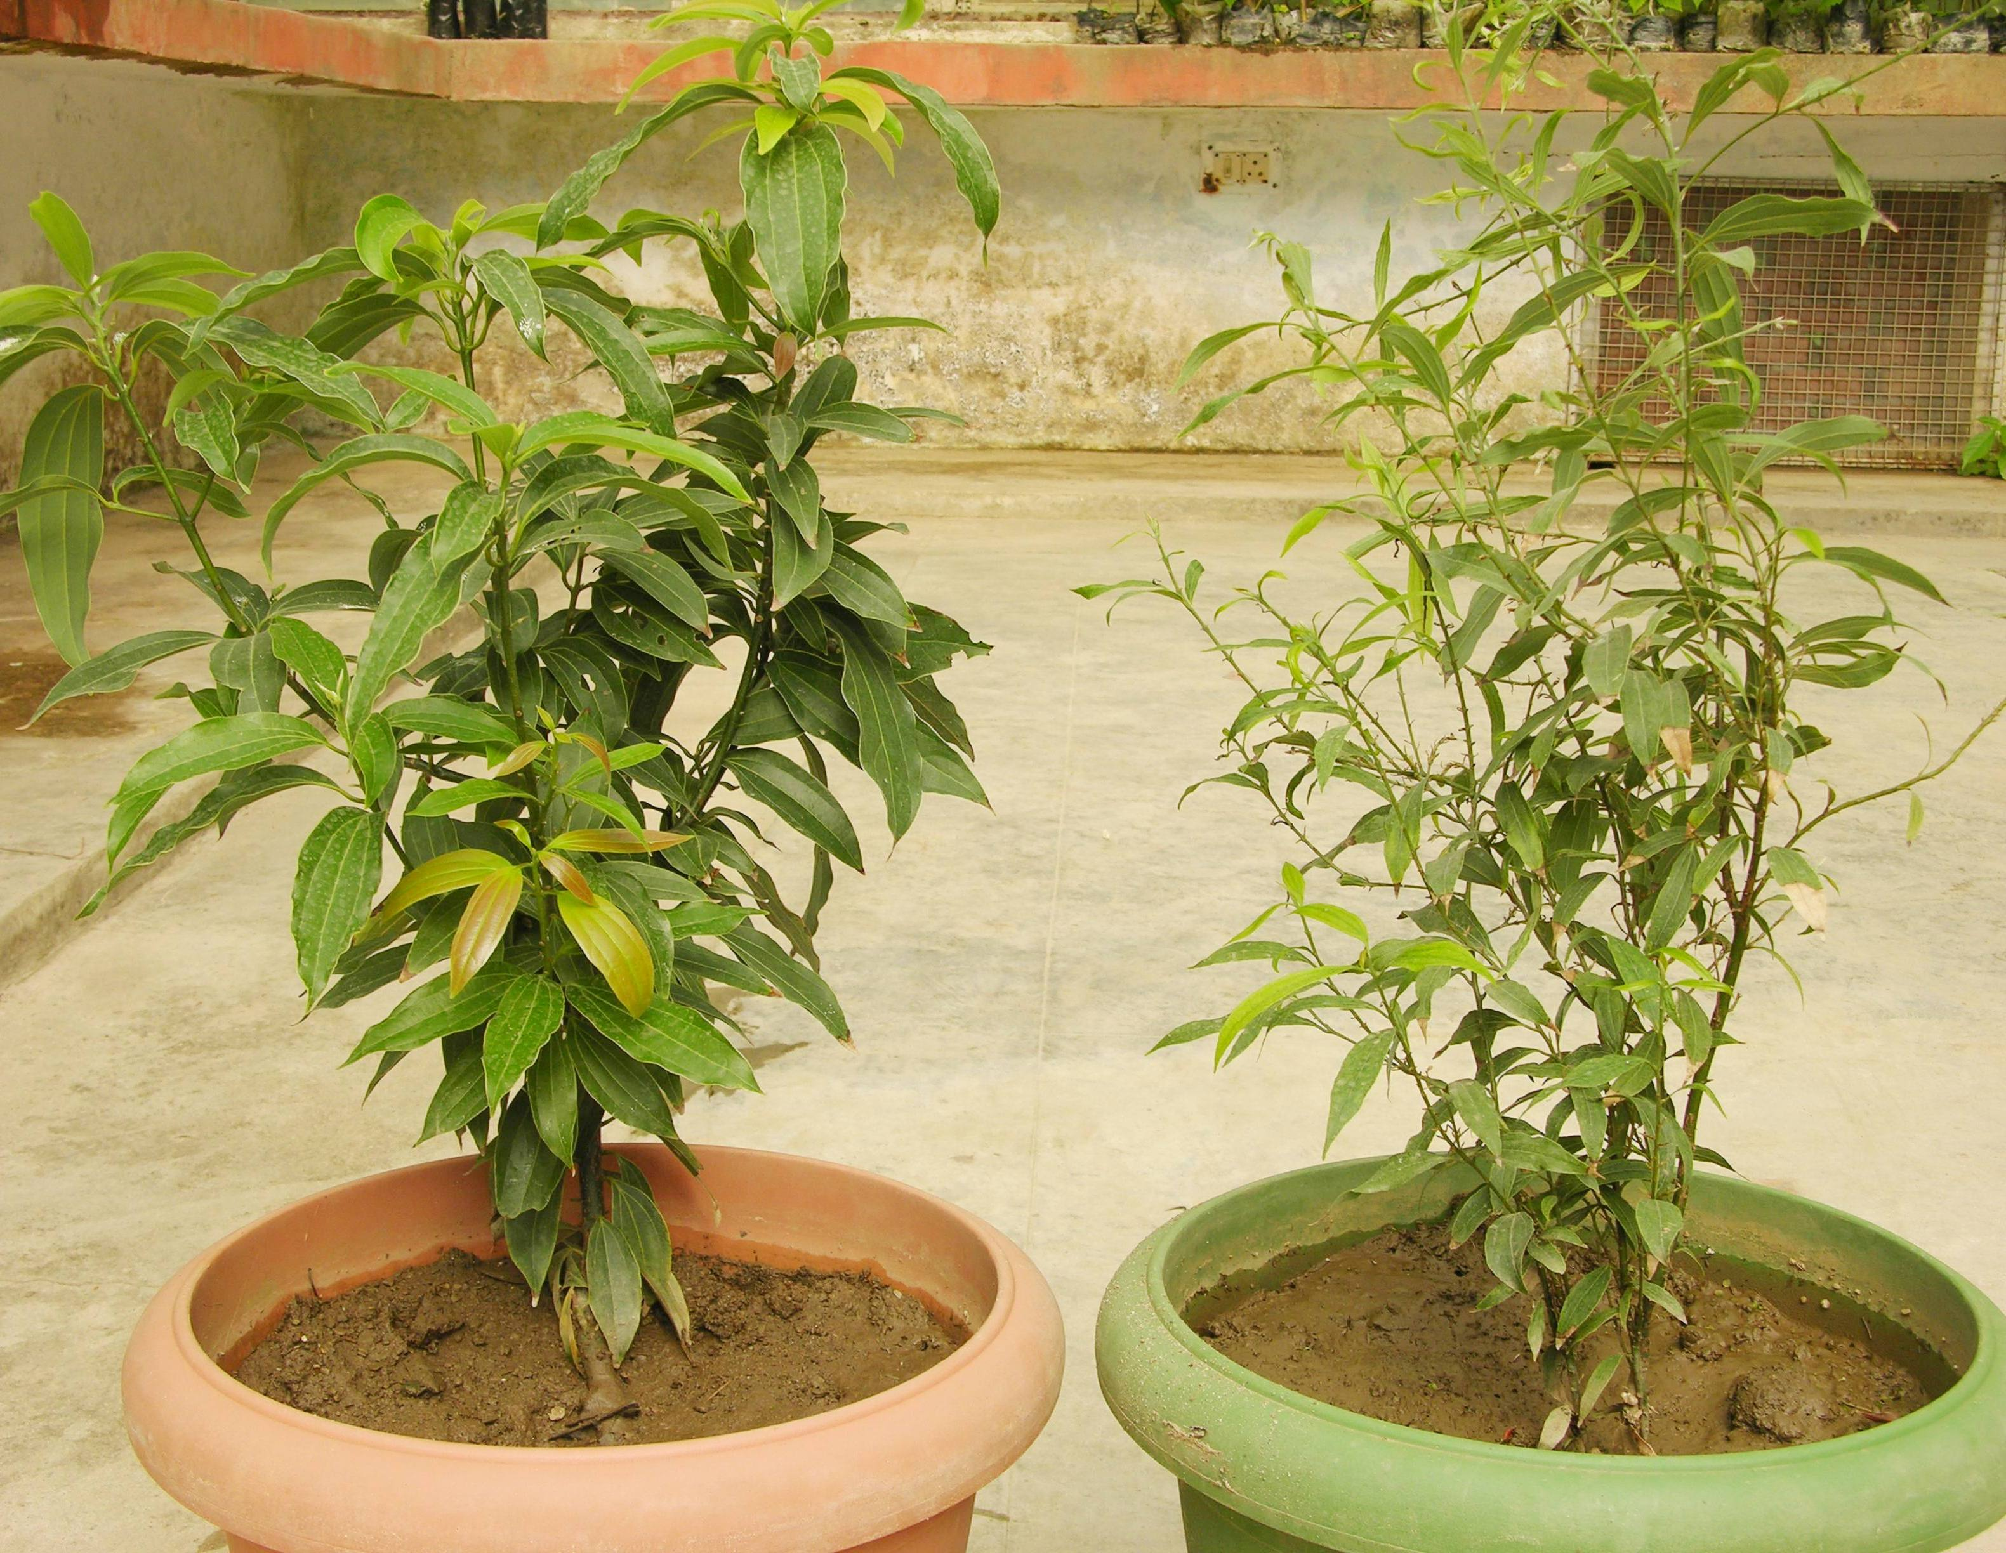
Normal
Variant
Plate 1. Normal and variant seedlings of Cinnamomum tamala

Morphological attributes:
Leaf length, leaf width, petiole length, right and left inter vein distance were recorded manually by using measuring scale, leaf thickness and petiole thickness were measured with the help of digital vernier caliper and leaf area was recorded by using digital leaf area meter.

Biochemical attributes:
Leaf pigments (chlorophyll and carotenoides) were estimated as per Holm, 1954. Soluble sugars were estimated as per Mc Cready et al. (1950). Total free amino acids were quantified by following the method of Moore and Stein (1954). Soluble protein estimation was carried out as per Bradford (1976). SDS - PAGE was worked out as per the method of Laemmeli (1970). Isoenzymes viz., peroxidase was separated on 7.5 % polyacrylamide gel as described by Davis (1964) and detected by Wetter (1982). Esterase was separated on 10 % Polyacrylamide gel as described by Bhadula and Sawhney (1987).

Physiological attributes:
Chlorophyll a fluorescence induction in both normal as well as variant seedlings was measured using a plant efficiency analyzer (PEA, Hansatech Ltd., U.K).

Results and Discussion
1. Variations in morphological attributes in normal and variant seedlings:
All the morphological attributes were recorded maximum for the normal plant seedlings compared to the variant seedlings (Table 1). The respective pattern could be ascribed to the quality and quantity of light intensity as has been earlier reported by Toole et al. (1956), Lokhart (1961), Goodchild et al. (1972) and Pandey and Sinha (1977). Soil physico-chemical environment is another determining factor as reported by many workers viz., Hillel (1972), Lal and Greenland (1979), Lal (1979a & b), Larson et al. (1989), Ghildiyal and Gupta (1991), Ouwerkerk (1991), Six et al. (2000), Saggar et al. (2001), Turrion et al. (2001), Jobbagy et al. (2001), Tessier et al. (2003), Ehrenfeld (2003), Westman et al. (2003), Haubensak and Parker (2004), Guo et al. (2004), Nziguheba et al. (2005).

Table 1. Variations in morphological attributes in normal and variant seedlings
Morphological attributes | Normal | Variant
Leaf area (cm²) | 525.19±99.17 | 177.09±81.39
Leaf length (cm) | 16.20±2.23 | 10.10±2.80
Leaf thickness (mm) | 0.40±0.02 | 0.30±0.06
Petiole length (cm) | 1.00±0.19 | 0.92±0.08
Petiole thickness (mm) | 1.95±0.15 | 1.27±0.42
Leaf width (cm) | 3.93±0.34 | 0.23±0.60
Right inter vein distance (cm) | 1.25±0.11 | 0.03±0.16
Left inter vein distance (cm) | 1.23±0.16 | 0.65±0.18

2. Variations in biochemical attributes in normal and variant seedlings
2.1. Leaf pigments:
The leaves of normal and variant plant seedlings did not differ much in Chl a, Chl b, total Chl and carotenoide content. The contents of Chl a, Chl b and total Chl were 0.4, 0.1 and 0.5 (mg/g fr. wt.) in normal leaves wherein variant contents were 0.4, 0.07 and 0.5, respectively. The normal and variant leaves did not differ much in their carotenoide contents which were recorded 0.33 and 0.30 (Figure1), respectively. Differences in the pigments between the two types were recorded. Such differences in the leaf pigmentation from one stage to another are known in the literature. A rapid increase in chlorophyll and carotenoide content during ontogeny of a leaf is a characteristic in an insertion gradient (Sestak, 1985). Ontogenetic changes in the contents of carotenoide have not been studied as often as those of chlorophylls (Sestak, 1978). Range of chlorophyll variation among the species is partly environmentally determined (Hornvedt, 1983).

2.2. Carbohydrate content:
Figure 2 executes that soluble sugar content was found maximum in variant plant seedlings (9.53 mg/g) in comparison to normal plant (7.8 mg/g). Morphological variability and biochemical differences in sugar level are important parameters which reflect variation due to environmental conditions rather than genetic variations. Like soluble sugars, starch content was found maximum in variant (32.03 mg/g) in comparison to normal plant seedlings (6.96 mg/g). Total free amino acids: The total free amino acid content was found maximum in variant leaves (3.63 mg/g) wherein 1.21 mg/g in normal seedling leaves (Figure 3). Soluble proteins: The soluble protein content in normal leaves were recorded 83.74 mg/g wherein variant leaves had 78.31 mg/g protein content (Figure 4). Miflin and Shewry (1981) reported that protein act as the reserve on nitrogen and sulphur during germination and the amount of protein content is of adaptive significance. Thus high protein content in the leaves of variant indicates the adaptive significance to sustain harsh climatic conditions.
Figure 1. Variations in leaf pigments in normal and variant seedlings
Figure 2. Variations in carbohydrate content in normal and variant seedlings
Figure 3. Variations in total free amino acid content in normal and variant seedlings
Figure 4. Variations in soluble protein content in normal and variant seedlings

2.3. Polypeptide profile:
In normal plant seedlings, appearance of polypeptide patterns was light in comparison to the variant seedlings. Normal as well as the variant had similar number of polypeptide bands i.e., five. Out of these bands the upper one is of high molecular weight and rests of the lower bands were of low molecular weight. The intensity of the first band in case of the variant was high in comparison to the normal plant (Plate 2). It is a well established fact that adaptation to any new environment can cause changes in the molecular configuration and in the activity of different enzymes (Straub, 1964). Considerable variations of polypeptide variation were also found in Polygonum species when acclimatized at three different altitudes (Prakash, 1999).
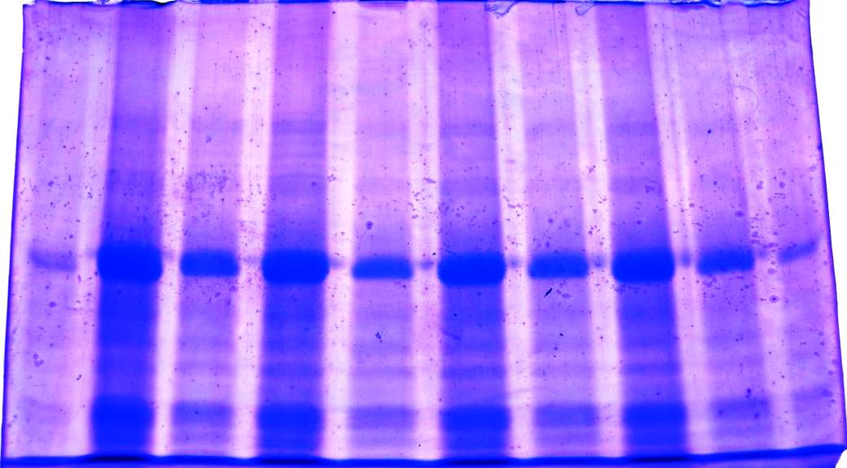
N
V
Plate 2. Polypeptide variation in normal and morphological variant seedling of C. tamala

2.4. Isoenzymes
2.4. a. Peroxidase:
Number of bands appeared in normal and variant was four, out of which three were of high molecular weight and the rest one is of low molecular weight (Plate 3). The placement of band appearance was similar in both the cases. However, the intensity of the third band from the migration point was high in case of the variant in comparison to the normal plant. Peroxidase is generally composed of a number of isoenzymes and is capable of catalyzing several types of metabolic activities and also involved in synthesis of ethylene. An increase in peroxidase activity probably represents an induced protective reaction delaying senescence (Birecka et al., 1977).
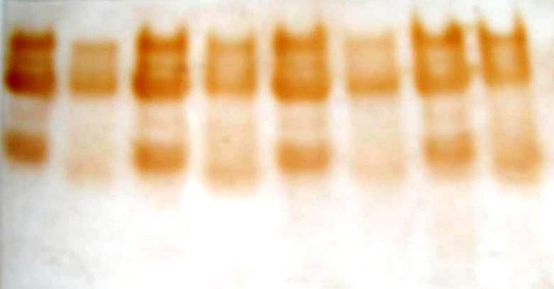
N
V
Plate 3. Peroxidase variation in normal and morphological variant seedlings of C. tamala
2.4. b. Esterase:
Number of bands appeared in normal as well as variant was three. The upper two were of high molecular weight and the lower one is of low molecular weight. The intensity of the first two bands in variant was high wherein low in the normal plant (Plate 4). Several isoenzymes including esterase have also been used in the analysis of genetic diversity of endangered species (Bousquenet et al., 1986; Godt and Hamrik, 1995). Isoenzymes variation has been used frequently to characterize germplasm collections (Brown, 1978; Goodman and Stuber, 1983; Souza and Sorrells, 1989).


N
V
Plate 4. Esterase variation in normal and morphological variant seedlings of C. tamala

3. Variations in physiological attributes in normal and variant seedlings:
Fluorescence measurements:
Minor variations between variant and normal seedlings were observed for different fluorescence characters. However, the main difference was observed for performance index which was more for variant seedlings in comparison to the normal seedlings. Pipeline models obtained for chlorophyll a transient of normal and variant seedlings of Cinnamomum tamala revealed normal variations between both the types. In the membrane model, a little bit increase in ABS/RC and DI/RC was observed in variant seedlings compared to normal seedlings. In leaf model, also variant plant recorded a little increase in ABS/CS_{O}, TR_{O}/CS_{O}, ET_{O}/CS_{O}, DI_{O}/CS_{O} and inactive reaction centers over normal plants (Plate 5). Chl fluorescence has been proven to be very useful, non - invasive tool for the study of the photosynthetic apparatus and more specifically the behavior of photosystem - II (Papageorgiou, 1975; Krause and Weis, 1991; Govindjee, 1995; Joshi and Mohanty, 1995; Schreiber et al., 1995; Lazar, 1999; Strasser et al., 1999, 2000).

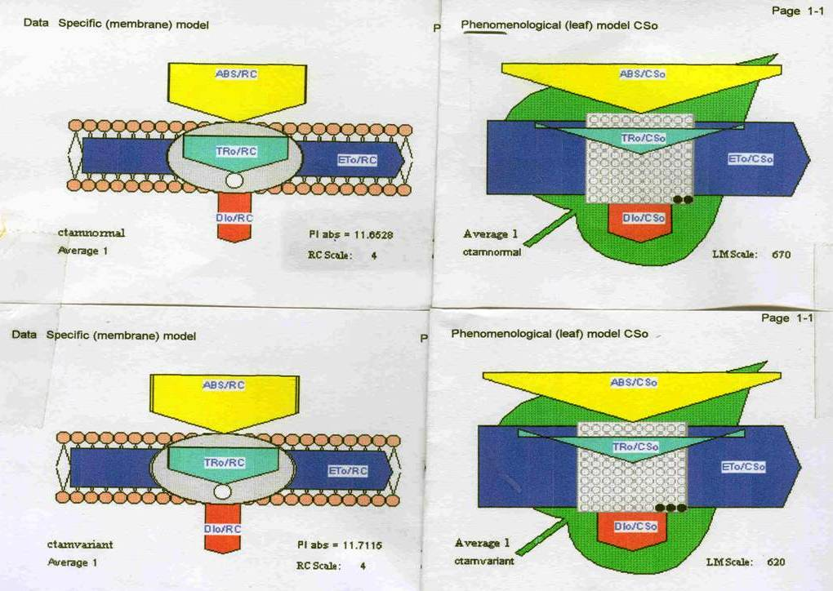

Plate 5. Pipeline models for specific fluxes (membrane model) and phenomenological fluxes (leaf model) for fluorescence characters of normal and morphological variant seedlings of C. tamala.

Acknowledgements: Authors are grateful to Prof. A. N. Purohit (Padamshree, FNA) for constructive criticism and timely encouragement. Thanks are also due to Dr. Vandana Gairola who had contributed in the manuscript through her thesis work. We also wish to acknowledge the help rendered by the technical staff of HAPPRC, HNB Garhwal University Srinagar, Uttarakhand, India.

Literature cited
- Gairola V (1990) Pigment and protein profile of Ougeinia leaves under sun and shade and heat shocks. PhD. Thesis. HNB Garhwal University, Srinagar Garhwal, Uttarakhand, India.
- Bradshaw AD (1965) Evolutionary significance of phenotypic plasticity in plants. Adv. Genetics. 115.
- Williams W (1960) Relative variability of inbred lines and F1 hybrids in Lycopersicon esculentum. Genetics. 45: 1457.
- Gairola V (1990) Pigment and protein profile of Ougeinia leaves under sun and shade and heat shocks. PhD. Thesis. HNB Garhwal University, Srinagar Garhwal, Uttarakhand, India.
- Onipchenko VG (2004) Alpine Ecosystems in the Northwest Caucasus. Kluwer Academic Publishers, Po. Box – 17, 3300 AA Dordrecht, The Netherlands.
- Brandis D (1998) Indian Trees: an account of trees, shrubs, woody climbers, bamboos and palms indigenous or commonly cultivated in the British Indian Empire. Bishen Singh Mahendra Pal Singh Dehra Dun India. 533.
- Anonymous (1950) Wealth of India, PID, CSIR, New Delhi.
- Kapoor LD (2000) CRC Handbook of Ayurvedic Medicinal Plants CRC Press, Inc. Boca Raton, Florida, 117.
- Chang Shang - Tzen, Cheng Sen - Sung (2002) J. Agric. and Food Chem. 50 (6):1389 - 1392.
- Smith RL, Adams TB, Doull J, Feron VJ, Goodman JI, Marnett LJ, Portoghese PS, Waddell WJ, Wagner BM, Rogers AE, Caldwell J, Sipes IG (2002) Food Chem. Toxicol. 40: 851–870.
- Saino F, Ghizzoni C, Gionfriddo F, Colombo E, Servillo L, Castaldo D (2003) Food Chem. 81: 469–475.
- Holm G (1954) Chlorophyll mutations in barley. Acta Agri. Scand. 4: 457pp.
- Mc Cready RM, Guggolz J, Silviera V and Owen HS (1950) Determination of starch and amylase in vegetables. Analy. Chem. 22: 1156-1158.
- Moore S and Stein WH (1954) A modified ninhydrin method for use in the chromatography of amino acids. J. Biol. Chem., 176: 367-388.
- Bradford MM (1976) A rapid and sensitive method for the quantification of microgram quantities of protein utilizing the principle of protein – dye binding. Analytical Biochem. 72: 248.
- Laemmeli UK (1970) Cleavage of structural proteins during the assembly of the head of bacteriophage T4. Nature. 227: 680.
- Davis BJ (1964) Disc electrophoresis. II. Method and application to human serum proteins. Ann. Newyork Acad.Sci.121: 404-427.
- Wetter LR (1982) Isoenzyme analysis of cultured plant cells, In: Plant Tissue Culture Methods. (eds. L. R. Welter and F. Constabel), IVth R. C. Canada, pp.105-111.
- Bhadula SK and Sawhney VK (1987) Esterase activity and isozymes during the ontogeny of stamens of male fertile Lycopersicon esculentum Mill., a male sterile stamenless –2 mutant and low temperature – reverted mutant. Plant Sci. 52: 187-194.
- Toole EH, Hendricks SB, Borthwick HA and Toole VK (1956) Physiology of seed germination. Annual Review. Plant Physiology.7: 299-324.
- Lokhart JA (1961) Photoinhibition of stem elongation by full solar radiation. Amer. J. Bot. 48 (5): 387.
- Goodchild DJ, Bjorkman, O and Pyliotis NA (1972) Chloroplast ultrastructure, leaf anatomy and content of chlorophyll and soluble proteins in rain forest species. Carn. Inst. Wash. Year Book. 71: 102.
- Pandey BN and Sinha RP (1977) Light as a factor in growth and morphogenesis. 1. Effect of artificial shading on Crotolaria juncea L. and C. sericea Retz. New Phytol. 79: 431.
- Hillel D 1972 Optimizing the soil physical environmental towards greater crop yields. Academic Press, New York and London. 240pp.
- Lal R and Greenland DJ 1979 Soil physical properties and crop production in Tropics. John Wiley and Sons, Chickaster. 551pp.
- Lal R 1979a Importance of tillage systems in soil and water management in the Tropics. In "Soil tillage and crop production" (ed. R. Lal). Proc. Series No. 2, IIIA Ibadan, Nigeria, 25-32pp.
- Lal R 1979b Soil tillage and crop production. Proc. Series No. 2, IIIA, Ibadan, Nigeria, 361pp.
- Larson WE, Blake GR, Allmaras RR, Voorhees WB and Gupta SC 1989 Mechanics and related processes in structured agricultural soils. NATO A51 series, Series E, Applied Sci. Vol 172. Kluwer Academic Pub, London.
- Ghildiyal BP and Gupta RP 1991 Soil structure – problems and management. Publication and information Div., ICAR, Pusa, New Delhi.
- Ouwerkerk CV Guest Editor. 1991 Special issue - Soil Compactness and Plant Productivity. Soil Tillage Res. 19: 95-362.
- Six J, Elliot ET and Paustin K 2000 Soil structure and soil organic matter. II. A normalized stability index and the effect of mineralogy. Soil Science and Society of American Journal 64: 1042-1049.
- Sagger S, Yeates GW and Shephard TG 2001 Cultivation effects on soil biological properties, microfauna and organic matter dynamics in Eutric Gleysol and Gleyic luvisol soils in New Zealand. Soil and Tillage Research 58: 55-68.
- Turrion MB, Gallardo JF, Haumaier L, Gonzalez MI and Zech W 2001 ³¹P-NMR characterization of Phosphorus fraction in natural and fertilized forest soils. Annals of Forest Science 58 (1): 89-98.
- Jobbagy EG and Jackson RB 2001 The distribution of soil nutrients with depth: Global patterns and the imprints of plants. Biogeochemistry 53: 51-77.
- Tessier JT and Dudley JR 2003 Vernal Nitrogen and Phosphorus retention by forest understory vegetation and soil microbes. Plant and Soil 256: 443-453.
- Ehrenfeld JG 2003 Effects of exotic plant invasion on soil nutrients cycling processes. Ecosystems 6: 503-523.
- Westman CJ and Laiho R 2003. Nutrient dynamics of drained peat land forests. Biogeochemistry 63: 269-298.
- Haubensak KA and Parker IM 2004 Soil changes accompanying invasion of the exotic shrub Cytisus scoparius in glacial outwash prairies of Western Washington (USA). Plant Ecology 175: 71-79.
- Guo D, Mou Pu, Jones RH and Mitchell RJ 2004 Spatio-temporal; patterns of soil available nutrients following experimental disturbances in a Pine forest. Oecologia 138: 613-621.
- Nziguheba G, Merck R and Palm CA 2005 Carbon and Nitrogen dynamics in a Phosphorus deficient soil amended with Organic residues and fertilizers in a Western Kenya. Biology and Fertility of Soils 41(4): 240-248.
- Sestak Z (1985) Chlorophylls and carotenoids during leaf ontogeny. In: Photosynthesis during leaf development (ed. Sestak Z.). W. Junk Publishers, 76.
- Sestak Z (1978) Photosynthetic characteristics during ontogenesis of leaves. 3. Carotenoids. Photosynthetica. 12: 89.
- Hornvedt R (1983) Medd. Nor. Inst., Skogforsk.
- Miflin BJ, and Shewry PR (1981) J. Exp. Bot. 32 (126)199-219.
- Straub R (1964) Untersuchungen über die Kationenumtausch-kapazitat der Wurzeln von Trockenrasen und Wiesenpflanzen. Thesis, Julius-Maximilians Universitä't, Würzburg
- Prakash V (1999) Ecophysiological and biochemical studies of some high altitude Polygonum species. D. Phil. Thesis. HNB Garhwal University, Srinagar, Uttarakhand, India.
- Birecka H, Chaskes MJ and Goldstein JJ (1977) Experimental Bot. 30: 565-573.
- Bousquenet J, Cheliak WM and Lalonde M (1986) Allozyme variability in natural population of green alder (Alnus crispa) in Quebec. Genome. 29: 345-352.
- Godt MJW and Hamrick JL (1995) Allozyme diversity in the endangered shrub Lindera mellisifolia (Lauraceae) and its widespread congener Lindra benzoin. Can.J. For. Res. 26: 2080-2087.
- Brown ADH (1978) Isozymes, plant population genetic structure and genetic conservation . Theor. Appl. Genet. 52: 145-157.
- Goodman MM and Stuber CW (1983) Races of Maize VI. Isozyme variation among races of Maize in Bolivia. Maydica. 28: 169-187.
- Souza E and Sorrells ME (1989) Inheritance and frequency of a null allele for diaphorase activity in North American Oat Cultivars. J. Herid. 80: 501- 503.
- Papageorgiou G (1975) Chlorophyll fluorescence. An intrinsic probe of photosynthesis. In: Govindjee JA, eds. Bioenergetics of photosynthesis. New York Academic Press. 320-366.
- Krause GH and Weis E (1991) Annual review of plant physiology and plant molecular biology. 42: 313-349.
- Govindjee (1995) Sixty - three years since Kautsky: Chlorophyll a Fluorescence. Australian Journal of Plant Physiology. 22: 131-160.
- Joshi MK and Mohanty P (1995) J. Sci. Industr. Res. 54: 155-174pp.
- Schreiber U, Hormann H, Neubauer C and Klughammer C (1995) Aust. J. Plant Physiology. 22: 209-220.
- Lazar D (1999) Chlorophyll a fluorescence induction. Biochim Biophys Acta. 1412: 1-28.
- Strasser RJ, Srivartava A, Tsimilli-Michael M (1999) Screening the vitality and photosynthetic activity if plants by fluorescence transient. In: Behl RK, Punia MS, Lather BPS eds. Crop improvement of seed security. Hisar, SSARM. 79-126.
- Strasser RJ, Srivartava A, Tsimilli-Michael M (2000) The fluorescence transient as a tool to characterize and to screen photosynthetic samples. In: Yunus M, Pathre U, Mohanty P. eds. Probing photosynthesis: Mechanism, Regulation and Adaaptation. Taylor and Francis, London, UK. 445-483.

9/20/2009

