A Preliminary Study on Genetic Variability in Hypoglycaemic Response to Vernonia amygdalina in Rats

Idowu Adewumi Taiwo*, Peter Godwin Chikwenye Odeigah

Genetics Research Laboratory, Department of Cell Biology and Genetics, University of Lagos, Akoka, Lagos 101017, Nigeria.
tai_dex@yahoo.com, Podeigah2003@yahoo.com

Abstract: The possibility that genetic factors play a role in sensitivity to the hypoglycaemic effect of Vernonia amygdalina (bitter leaf) was investigated through selective inbreeding in albino rats. Aqueous extract from the plant was administered orally using oro-gastric intubation and fasting plasma glucose concentration was monitored in the rats for 180 minutes. Percent Change of Glycaemia (PCG) was used as an index to measure the degree of glycaemia reduction following V. amygdalina administration. The initial PCG of the original unselected stock of animals (U) when treated with V. amygdalina was -4.5%, but after two generations of selective inbreeding (brother-sister mating) for sensitivity to the hypoglycaemic effect of the plant, the magnitude of PCG (-49.1%) was greater (P<0.05) in the sensitive F₂ offspring (i.e. S₂). Animals that were similarly inbred for resistance (R₂) had a PCG of -9.3% at F₂. a value which was significantly lower in magnitude than the PCG of S₂ animals (P<0.01). It was therefore suggested that since it was possible to develop two strains of rats that differ markedly in their sensitivity to the hypoglycaemic effect of V. amygdalina through selective inbreeding, the plasma glucose reducing action of V. amygdalina is probably mediated, at least partly, through genetic factors. The implication of the results of this study for the treatment of diabetes in conventional and herbal medicine is discussed.

[Nature and Science 2009;7(11):65-69]. (ISSN: 1545-0740)

Key words: Vernonia amygdalina,; hypoglycaemic; variation; selective inbreeding

1. Introduction

Variation in sensitivity to drugs had long been recognized as one of the several genetically controlled polymorphisms seen in human populations (Vesell, 1979). Human variations in response to drugs such as primaquine sensitivity, isoniazid inactivation, and response to hydrogen peroxide are well known because they have been studied in considerable detail in view of their relevance to clinical medicine and public health (Evans et al, 1960; Marks and Blanks, 1965; Odeigah and Okunowo, 1989). As opposed to the case with most conventional drugs that are usually recommended in clinical practice, variations in sensitivity to plant medicinal products, especially those that are commonly used in traditional medicine have received very little or no attention.
In many developing countries of the world, interest in native plant remedies has continued to increase as a result of the growing awareness of the importance of medicinal plants in health care delivery. This interest now extends to many urban and developed communities including parts of Europe and America. (Gill 1994; Lease and Williams, 1994). In Nigeria and many other poor African countries belief in traditional herbal medicine is strong. In our previous animal experimental studies, we have focused attention on the glycaemic activities of some common Nigerian dietary and medicinal plants with a view to ascertaining their importance in diabetic management (Odeigah et al, 1995; Odeigah et al, 1999; Taiwo et al, 2008). Data from these and other studies (Ogbuokiri and Ekpechi, 1989) suggested that Nigeria and many other African countries are endowed with dietary and medicinal herbs, which may play important roles in the treatment of diabetes and many other diseases. Recent studies in our laboratory have shown that Vernonia amygdalina Del. (Astereceae) may be of value in treating diabetes and even cardiovascular diseases such as hypertension (unpublished data).
In our previous experimements particularly in the present study, the control of environmental factors was rigid. In spite of this, it was repeatedly observed that in a given group of animals, considerable variations were always present in the degree of glycaemic response to V. amygdalina - the magnitude of glycaemic reduction was high in some animals but low in others. It was therefore thought that such variations in response might represent ordinary differences that occur by chance in a homogenous group or the consequences of some genetic factors. If the population were purely genetically homogenous and the observed variation was due to chance alone, it would not be possible to separate the group into different strains. By contrast, if sensitivity to hypoglycaemic effect of V. amygdalina is, at least, partly controlled by genetic factors, it should be possible to separate, through selective breeding, a given population of animals into two strains that differ significantly in their sensitivity to the hypoglycaemic effect of V. amygdalina.
The present paper is a report of a preliminary study which was carried out to test this possibility. It is hoped that the results of this investigation will stimulate further interest and discussions on pharmacogenetic aspects of herbal medicinal products in view of the growing interest in herbal medicine.

2. Materials and methods
2.1 Plant Materials and Extraction
Vernonia amygdalina were obtained from the wild near the University of Lagos main campus. The plant was authenticated at the Forestry Resarch Institute (FRIN), Ibadan, Oyo State, Nigeria. For the extraction, the plant materials were first washed free of sand, cut into pieces and air- dried before grinding into powder. Fifty grams of the powder was extracted with 500ml of distilled water using Soxhlet extraction. The extract was slowly evaporated in vacuo to obtain a total yield of 3.5g. weighed sample of the extract was then used to prepare test solutions.

2.2 Animals and their Treatment
An unselected group (U) of 24 Sprague-Dawley (SPD) rats (10 males: 14 females) constituted the parental generation (P) from which 2 strains were developed. The animals were obtained from the Laboratory Animal Center of the Nigerian Institute of Medial Research (NIMR), Lagos, Nigeria. The care of the animals, plant extraction, and the techniques of oral administration of materials and plasma glucose determination were the same as reported earlier (Odeigah et al, 1994). Briefly, the animals were fasted for 24 hours before each day of experiment. Fasting plasma glucose concentration (FPGC) was measured for 180 minutes at 30-minute intervals (0 minutes, 30 minutes.,…,180 minutes) after administration of plant extracts (250mg/kg body weight) by oro-gastric intubation. The control animals (10 rats - 5F:5M) were treated similarly except that distilled water (10.0ml/kg) was administered instead of V. amygdalina extract.

2.3 Selective Inbreeding
A modified selection method similar to that of Dahl et al., (1962) was used. From the original unselected stock (U), a mating group of male and females (1 male: 2 females) with the greatest percentage of glycaemia reduction after V. amygdalina treatment were regarded as sensitive (S), and were selected for inbreeding; those with the least values regarded as resistant (R) were similarly inbred. The presence of sperm cells observed microscopically on the vaginal smear of the females and the observation of mucus plugs on the floor of the cages were indicative of successful mating. Pregnant females were later separated and caged individually until the time of parturition and weaning of the F₁ offspring. The F₁ offspring from the sensitive line were designated as S₁ while their resistant counterparts were R₁. The procedure of selective inbreeding was repeated in each group to obtain F₂ offspring of sensitive (S₂) and resistant (R₂) animals respectively. Brother-sister mating was ensured, and crossbreeding between sensitive and resistant lines was not permitted except in F₂ generation when reciprocal crosses were carried out between S₂ and R₂ to obtain F₃ offspring. This was done in an attempt to see if sex difference plays a role in sensitivity to the hypoglycaemic effect of the plant extract.

2.4 Data Analysis
The percentage of glycaemia reduction was calculated at the 180th minute using the formula (Gidado et al, 2005):

% Change of Glycaemia = G_{X} – G_{O} x 100
G_{O}

where G_{O} and G_{X} are the values of 0-minute and 180-minute FPGC respectively. The results were analyzed using a statistical software package – SPSS Version 12. Data were expressed as mean + standard error of the mean (mean + SEM). Student’s t-test was employed for comparison between two sets of data. Differences between means were considered statistically significant when P<0.05.

3. Results
After treatment with V. amygdalina, the FPGC of the original unselected parents fell steadily during the 180-minute fasting plasma glucose determination from 6.2±2.1 to 5.3±2.4 mmol/l (P< 0. 05) at the 180th minute giving a percent change of glycaemia of –14.5%. This may be compared to the FPGC of the control animals that fluctuated between 5.4±2.2 and 6.7±2.3 mmol/l during the 180-minute FPGC monitoring period bringing about a percent change of glycaemia of 3.0%. Figure 1 shows the response curves of animals bred for sensitivity and resistance at succeeding generations. It can be seen that there was a development of increasing sensitivity to the hypoglycaemic effect of V. amygdalina due to selection in succeeding generations of sensitive animals as the curves obtained from S₁ and S₂ offspring fell below those of the other groups (U, R₁ and R₂). Moreover, V. amygdalina caused a greater percentage change of glycaemia reduction in S₁ (-35.7%) and S₂ (-49.1%) generations.
Unlike the pattern indicated above, the hypoglycaemic action of V. amygdalina was not pronounced in the animals bred for resistance to the hypoglycaemic effect of the plant. The magnitude of percent change of glycaemia reduced with succeeding generations. The response curves of the resistant animals are located above those of their sensitive counterparts; the gradient of slopes of their glycaemic curves is less when compared to that of the sensitive groups (Figure 1). Moreover, it was noted that the difference in response to V. amygdalina between S and R lines as measured by percentage change in glycaemia became more significant with succeeding generations of selective inbreeding.
Reciprocal crossbreeding between S₂ and R₂ were made to produce F₃ Comparison of percentage change in glycaemia between F₃ offspring from different reciprocal crosses of S₂ X R₂ did not indicate any significantly difference (P>0.05). Figure 2 made it clear that the plasma glucose curve of the F₃ offspring falls between those of the R₂ and S₂ animals (Figure 2).

4. Discussion
The results of the present study support earlier reports that V. amygdalina has hypoglycaemic effect and may therefore be of value in the treatment of diabetes (Ogbuokiri and Ekpechi, 1989; Gyang et al, 2004). In addition, it indicates the possibility of evolving two strains of rats that differ significantly in their response to the hypoglycaemic action of V. amygdalina. The fact that this could be achieved through selective inbreeding implies that genetic factors may play important role in sensitivity to the hypoglycaemic effect of V. amygdalina in rats. It will be of interest to know the nature of genetic factors involved. Further genetic and molecular studies are still going on in the laboratory for more insight into the issue raised above.

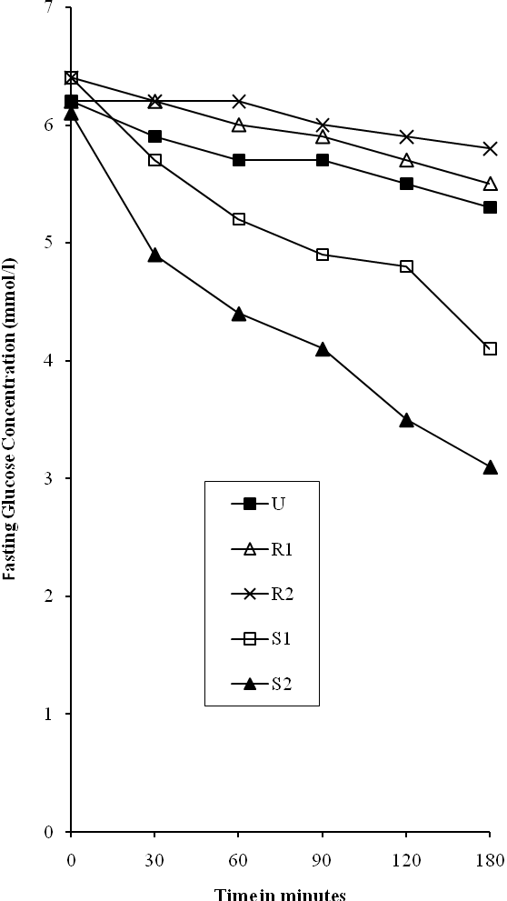

Figure 1. Fasting Glycaemic profiles in Rats in Rats Bred for Sensitivity and Resistance to the hypoglycaemic Action of V. amygdalin.
Note: U=unselected stock, R=resistant, S=sensitive, 1=1st generation, 2=2nd generation

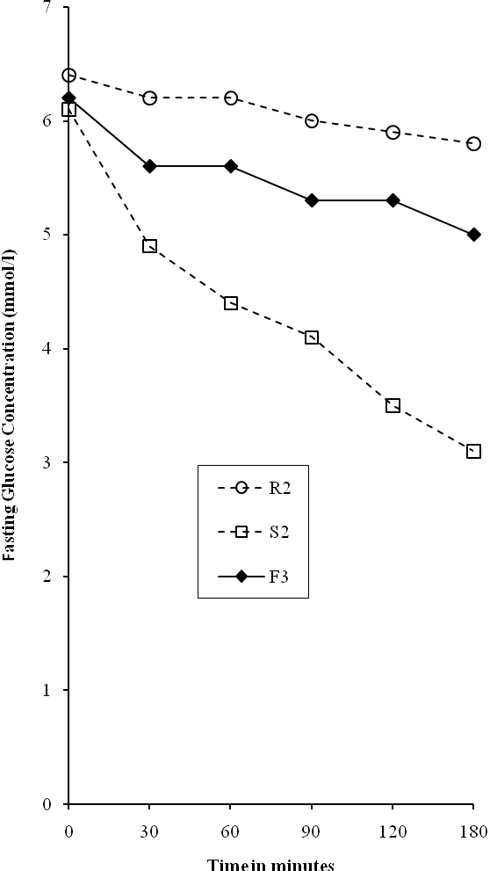

Figure 2. The Result of Cross Mating between Sensitive (S2) and Resistant (R2) to Give F3 Offspring. Note: S=sensitive, R=resistant, F=filial generation, 1,2,3=the level of generation.

In the original unselected parental generation of rats used in this investigation, it was always observed that the variation in sensitivity to V. amygdalina was continuous without sharp demarcation into sensitive and resistant animals. Variability in response to drugs may be continuous or discontinuous. If a test is carried out on a large number of subjects and their responses are plotted on a graph, the pattern of distribution may shed some light on the mode of inheritance involved. In the present study, the sample size of the unselected stock (n=24) is too small for any meaningful conclusion to be drawn on the mode of inheritance of glycaemic response to V. amygdalina. A much larger population of animals is needed to reveal more clearly the nature of the genetic factors involved. However, the present data, though limited, suggest that variation to glycaemic action of V. amygdalina is continuous and may therefore be under a polygenic control.
If the polygenic hypothesis is correct, the S₂ and the R₂ offspring obtained in the study were likely to be more homozygous at many loci than the original unselected stock in view of the well known effects of selective inbreeding on homozygosity. Moreover, the pattern of responses of the S₂ and the R₂ offspring were divergent when compared to their unselected parental stock. In future studies, It will be necessary to further purify these strains through selective inbreeding for more generations with a view to characterizing the genetic components more accurately. In such experiments, it is pertinent to note that albino rats, like other mammals, are outbreeders, and due consideration should be given to the occurrence of inbreeding depression and its associated deleterious consequences. This generally the case with natural outbreeders: Continuous inbreeding in such species increases homozygosity, and many other genes that are slightly or partially deleterious begin to show phenotypically thereby causing reduction in vigour and survival.
An important implication of the results of this study is that different workers studying the hypoglycaemic effect of V. amygdalina in animals might arrive at somewhat different conclusions. This will be so if chance selection of animals had led one to study genetically sensitive, and the other a resistant population. It seems reasonable to expect that similar genetic factors regarding sensitivity to the hypoglycaemic action of V. amygdalina also operate in man. However, human populations are usually genetically heterogeneous because of outbreeding that is ordinarily enforced in most human societies. It would therefore be illogical to expect a given group of humans to demonstrate uniform sensitivity or resistance to the hypoglycaemic effect of V. amygdalina as shown by these selectively inbred rats: Studies of isolated small human populations will, however, be somehow elucidating. Given the heterogeneous nature of human populations and the possible involvement of genetic factors in hypoglycaemic response to V. amygdalina as suggested by the results of this study, It is unlikely that diabetic patients on the same V. amygdalina treatment schedule would have similar degree of hypoglycaemic response to the plant. On the contrary, one would expect different treatment outcomes despite similar therapeutic regimes.
During our preliminary survey in a study recently concluded (results not yet published), it was discovered that some Nigerian herbalists, especially those in the southwestern part, sometimes secretly add oral hypoglycaemic drugs, particularly tolbutamide, to their concoctions for treating diabetes. The basis of this practice is not yet clear; however, it might be a strategy to increase the potency of antidiabetic herbal preparations as herbalists encounter isolated cases of poor response to herbal treatment in a manner similar to the case of the animals bred for resistance in this study. Previous reports from our laboratory indicating that hypoglycaemic action was enhanced when some plant extracts were administered into experimental animals simultaneously with tolbutamide as combined solutions are pertinent to this practice (Odeigah et al, 1999; Taiwo et al, 2008).
V. amygdalina is a pharmacodynamic plant with wide geographical distribution in Africa. It is commonly used for dietary and medicinal purposes in many parts of Africa especially in Nigeria. Previous reports have indicated that it may be of value in the treatment of diabetes (Ogbuokiri et al, 1989; Taiwo et al, 2008). The data obtained in this preliminary study further suggest that the plant may elicit varying hypoglycaemic responses in animals and, possibly, human subjects as a result of genetic factors. Further selective breeding and molecular studies are now being carried out in the laboratory to determine the heritability of this trait and possible association of various RFLPs and other molecular markers with the different inbred lines. The results of such molecular studies will help in the easy identification of patients for appropriate treatment programme.

Acknowledgement
We appreciate the the support and advice of the entire staff of the Department of Cell Biology and Genetics, University of Lagos. Mrs. B. T. Taiwo was very helpful in typing the manuscript.

*Correspondence to:
Idowu Adewumi Taiwo
Genetics Research Group, Department of Cell Biology and Genetics, university of Lagos, Akoka, Lagos 101017, Nigeria
Telephone:+234-01-5454891-3,+234-01-4972730-5; Ext. 2331
Cellular phone: +234-803-326-6013.
E-mails: tai_dex@yahoo.com, Podeigah2003@yahoo.com

References
[1] Vesell ES. Pharmacogenetics: multiple interactions between genes and environment as determinant of drug response. American Journal of Science 1979; 66:188-187.

[2] Evans DAP, Manley KA., Mckinsic VA. Genetic control of isoniazid metabolism in man. British Medical Journal 1960; 2: 485-491.

[3] Marks PA, Blanks J. Drug induced haemolytic anaemias associated with glucose-6-phosphate dehydrogenase deficiency: a genetically heterogeneous trait. Annals of NY Academy of Science 1965; 123: 198-206.

[4] Odeigah, PGC, Okunowo, MA. High Frequency of the Rapid Isoniazid Acetylator Phenotype in Lagos (Nigeria). Human Heredity1989; 39: 26-31.

30/09/2009
[5] Gill GV, Redmond S, Garrott F, Paisey R. Diabetes and alternative medicine: a case for concern. Diabetic Medicine 1994; 22: 210-213.

[6] Lease GP, Williams G. Complementary and Conventional medicine in clinical diabetes. International Diabetes Digest 1994; 6: 675-676.

[7] Odeigah PGC, Taiwo IA, Onokpite, GO. Comparative effects of the three common varieties of chilli pepper on oral glucose tolerance in normal and diabetic rats. International Diabetes Digest 1995; 6(4): 80-82.

[8] Odeigah, PGC, Taiwo, IA, Akomolafe, EO, Durojaiye DO. Hypoglycaemic actions of medicinal plants with tolbutamide in the albino rat. Diabetes International 1999; 9(3): 71-73.

[9] Taiwo IA, Odeigah PGC, Ogunkanmi LA. The glycaemic effects of Vernonia amygdalina and V. tenoreana with tolbutamide in rats and the implications for the treatment of diabetes mellitus. Journal of Scientific Research and Development 2008; 11: 122-130.
[10] Ogbuokiri JE, Ekpechi DLV. Anti-hyperglycaemic activity of Vernonia amygdalina on healthy adult volunteers. Clinical Pharmacy and Herbal Medicine 1989; 5(3): 18-21.

[11] Odeigah PGC, Taiwo, IA, Onokpite, GO. Effects of salt and chilli pepper on oral glucose tolerance in normal and alloxan diabetic rats. International Diabetes Digest 1994; 5: 70-73.

[12] Dahl LK., Heine M and Tassinari L. Effects of chronic excess salt ingestion: Evidence that Genetic factors play important role in susceptibility to experimental hypertension. Journal of Experimental Medicine 1962; 115: 1173-1190.

[13] Gidado A., Ameh DA and Atawodi SE. Effect of Nauclea latifolia leaves aqueous extracts on blood glucose levels of normal and alloxan induced diabetic rats. African. Journal of Biotechnology 2005; 4(1): 91-93.

[14] Gyang SS, Nyam DD, Sokomba EN. Hypoglycaemic activity of Vernonia amygdalina (chloroform extract) in normoglycaemic and alloxan-induced hyperglycaemic. Rats Journal of Pharmacy and Bioresources 2004;1(1):61-66.

10/9/2009

