Influence of Acute intake of Cooking Salt and Laboratory Salt on Glyceamic Response to Glucose Loading in Rats

Idowu Adewumi Taiwo*, Peter Godwin Chikwenye Odeigah, Liasu Adebayo Ogunkanmi, Reuben Omotoso.

Genetics Research Group, Department of Cell Biology and Genetics, University of Lagos, Akoka, Lagos 101017, Nigeria.
tai_dex@yahoo.com, Podeigah2003@yahoo.com

Abstract: An investigation on the effect of cooking salt and reagent grade laboratory salt on glyceamic response was carried out in albino rats. Oral glucose load of 3.0 g/kg body weight (b.wt) was given with or without addition of 0.9% cooking or laboratory salt. Both types of salt caused significantly higher (P<0.05) peak plasma glucose concentration (PPGC) at 60 minutes after loading (cooking salt: 10.4+2.4 mmol/l; laboratory salt: 10.0+1.2 mmol/l) than the control (PPGC of 7.6+0.3 mmol/l). Moreover, the PPGC of the salt treated groups was not brought down to the normal level at 120 minutes unlike in the control where the level fell to 6.8+0.3 mmol/l at 120 minutes. The glucose tolerance index (GTI), determined as area under the glucose tolerance curve, was higher (P<0.05) in the animals treated with laboratory salt (234.0+25.6mmol.min/l) and cooking salt (251.3+21.8 mmol.min/l) when compared to the control (51.0+15.9 mmol.min/l). It was therefore concluded that both types of salt increased glaceamic response to glucose challenge. The results imply a beneficial effect of salt restriction on glycaemic control. [Nature and Science 2009;7(11):70-73]. (ISSN: 1545-0740).

Key words: dietary salt; glycaemic response; oral glucose tolerance; diabetes

1. Introduction
There are considerable human and animal experimental studies implicating excessive dietary salt intake in cardiovascular diseases especially hypertension (Garrett et al, 2006). However, the long standing issue of the effect of salt on carbohydrate metabolism is still unresolved. Thorburn et al (1986) reported that adding salt to two common starchy foods resulted in an increase of the postprandial plasma glucose and insulin responses in human subjects. This agrees with the report of Odeigah et al (1994) that salt caused a higher peak plasma glucose level during oral glucose tolerance test (OGTT) in treated rats when compared with untreated rats. A mechanism that possibly involves influence of salt on digestive, absorptive or/and post-absorptive events was postulated. These authors and many others supported the call urging the diabetics and the general public to reduce their salt intake.
The observations that salt increases glycaemic response attracted considerable attention in the light of the observed association between hypertension and diabetes (Fuller, 1985). More recent reports by Yang et al (2008) and Ma et al (2009) had further highlighted some of the severe complications associated with both diseases. On the contrary, Gans et al (1987) and Foo et al (1998) found no association between salt loading and fasting plasma glucose or insulin levels. Despite the call by other workers urging diabetics and the general population to reduce their salt consumption, Gans et al (1987) and Foo et al (1998) did not support a beneficial role of salt restriction on glycaemic control in diabetes.
Previous studies have considered the effect of reagent grade laboratory salt on carbohydrate metabolism; however, possible glycaemic effects of common cooking salt, the form in which common salt is usually consumed in the general population, has received very little or no attention. Considering the aetiologic role of salt in hypertension, the observed association between hypertension and diabetes, the role of diet in hypertensive and diabetic management, and the fact that in the general population it is common cooking salt that is normally consumed and not the reagent grade laboratory salt, it will be interesting to see the glycaemic effects of this salt as compared to that of the reagent grade laboratory salt used in previous studies. The results of such study may shed more light on the implications of excessive dietary salt consumption in diabetes. We therefore carried out a short-term comparative study on the effects of these two types of salt on glyceamic response after acute glucose loading in rats.
If the observation that salt increases glycaemic response is correct, then both types of salt should reduce oral glucose tolerance in rats. Although sodium chloride NaCl) is the major constituents of both types of salt, It is expected that both salts should influence glycaemic response to different degrees because of their different composition regarding other components that are present apart from NaCl. The present study was therefore carried out to investigate these possibilities. Possible mechanisms of salt influenced glyceamic response and the implications of salt in diabetic management were discussed.

2. Materials and methods
Twenty adult male Sprague-Dawley (SPD) rats (180-200g) obtained from the Nigerian Institute of Medical Research (NIMR), Lagos, were randomly divided into three groups of 6 – 7 rats per cage for acclimatization in the Animal House of the University of Lagos. They were allowed free access to rat feed and tap water. All the animals were handled following the Guiding Principles in the Care and Use of Laboratory Animals endorsed by the American Physiological Society.
The animals were fasted for 18hours and were given 3.0g/kg body weight (b.wt.) of glucose load as 30% solution with or without 0.9% salt under light ether anaesthesia using oro-gastric intubation. Blood samples (125μl) were taken into heparnised capillary tubes from the tail just before the oral glucose loading (0 minutes) and at 30, 60, 90 and 120 minutes thereafter. Plasma was obtained by centrifugation (3,000 r.p.m.), and plasma glucose determinations were carried out by the glucose oxidase method (Trinder, 1969). The results were expressed as mean ± SEM, and the GTI or glucose tolerance index was taken as the incremental area under the glucose tolerance curve (Lebovitzand Feinglos, 1983). Statistical differences between means were determined by Students t-test and p values less than 0.05 were considered significant. Data analysis was done using a software package: Statistical Package for Social Scientist (SPSS) version 12.

3. Results
The results of the oral glucose tolerance test (OGTT) is presented in Figure 1. The starting fasting plasma glucose concentration (FPGC) of the animals range between 6.8+2.5-7.2+3.0. Thereafter, the plasma glucose concentration rose to different peak levels which were attained at the 60th minute of OGTT. When compared to the peak plasma glucose concentration (PPGC) of the control (7.6+0.3mmol/l), both types of salt caused higher (P<0.05) PPGC (cooking salt:10.4+2.4 mmoll/l; laboratory salt: 10.0mmol/L). Although cooking salt caused slightly higher PPGC than laboratory salt, the difference was not significant (P>0.05). The PPGC dropped to the normal level (6.8+0.3 mmol/l) in the control animal at 120 minutes but remained relatively high (P<0.5) in the salt-treated groups (cooking salt: 8.4+1.4 mmol/l; laboratory salt: 8.0+1.2 mmoll/l). Moreover, the glucose tolerance index (GTI) of the salt-treated groups (cooking salt = 251.3+21.8 mmol.min/l; laboratory salt=234.0+25.6 mmol.min/l) were significantly higher (P<0.05) than that of the control with a mean GTI of 51.0+15.9 mmol.min/l (Figure 2). Animals treated with cooking salt had higher but not significant GTI compared to those treated with laboratory salt; however the difference was not significant (P>0.05).
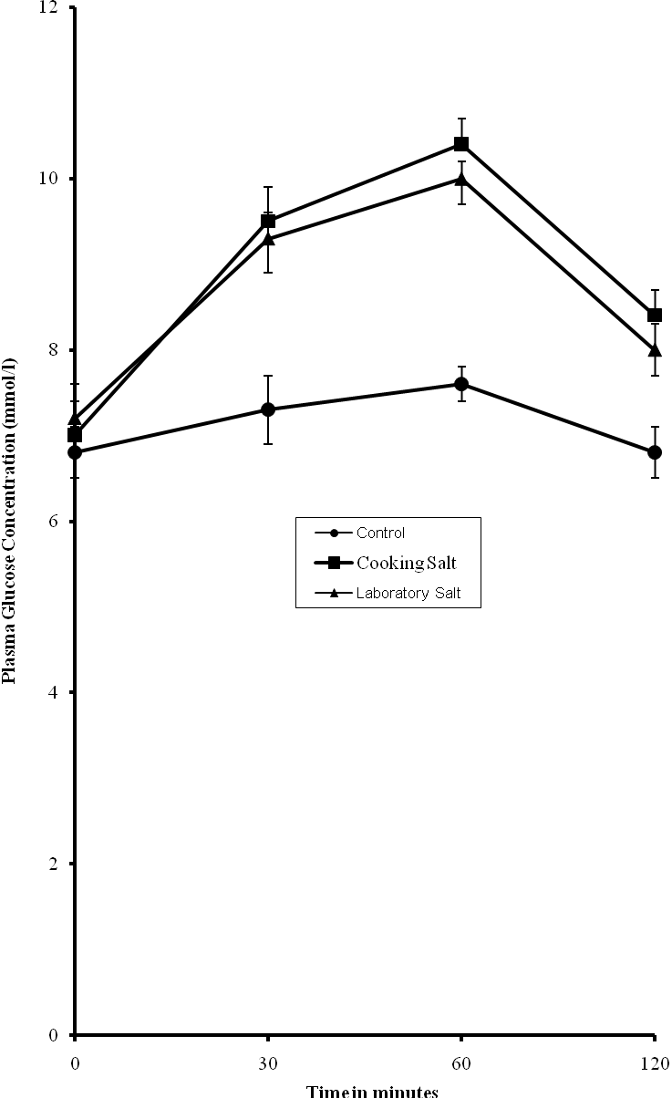
Figure 1. Comparative Influence of Cooking and Laboratory Salt on Glycaemic Response in Rats

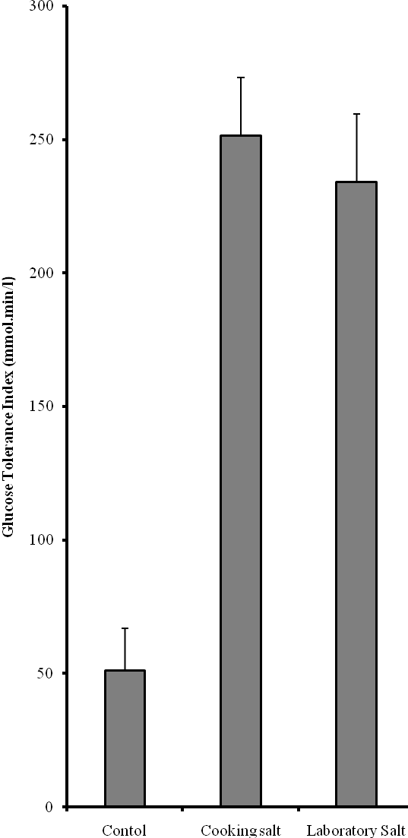
*

*

Figure 2. Higher Glucose Tolerance Index in Rats Treated with Cooking Salt and Laboratory Salt. Significant Difference from Control P<0.05) is Indicated by *

4.0 Discussion
Previous studies have shown variable effects of salt on glycaemic response. Our results agree with those of the Thorburn et al (1986) and a later study by Odeigah et al (1998) who reported that salt caused increased glycaemic response to carbohydrate feeding. These reports are discordant with those of Gans et al (1987) and Foo et al (1998) who observed that salt intake had no effect on glucose metabolism. These disparities suggest that other factors possibly genetic may play important role in glycaemic response to salt.
Findings from these studies have important health implications as regards the effect of dietary salt consumption in man. Considering the fact that human populations are genetically heterogenous as a result of outbreeding that is generally enforced in many societies, different individuals in a population are expected to show different sensitivities to glycaemic effect of salt. In view of this, different results would be obtained if by chance selection a researcher has as subjects, individuals that are sensitive while the other conducts his study in individuals that are resistant. The possibility of such sampling variation is particularly high in human experimental studies because the sample size is usually very small. The work of Gans et al (1987) is interesting in this respect; the results of their work did not support a beneficial effect of salt restriction in glycaemic control; however, they observed a trend toward increase in glycaemic level due to salt. According to these workers, this was not significant because the subjects showed “…considerable variability in glucose response”. In our own view, the presence of genetic factors, as the results of the present study suggests, may account for such variability in response.
Thus, the hyperglycaemic effect may be reduced or even eliminated especially if chance selection had caused the use of animals that were genetically resistant to the glycaemic effect of salt. Compared to the work of other investigators who used human subjects, the animals used in our study were likely more isogenic than human subjects in view of some degree of inbreeding that was allowed in the parent rat colony. This is not the case with humans because inbreeding is usually discouraged in most human populations. Therefore, the differences seen in response to the glycaemic effect of salt may be, at least partly, genetic. Efforts are presently being made in our laboratory to determine the heritability of this trait and its degree of response to selection with a view to creating two strains of rats namely those that are sensitive to the glycaemic effect of salt and those that are not sensitive through selective inbreeding. If sensitivity to the hypoglycaemic effect has a genetic component as suggested in this study, it should be possible to create two strains of animals that differ significantly in their response to the hypoglycaemic effect of salt through selective breeding.
In contrast to the views of some workers who do not support a beneficial effect of salt restriction in glycaemic control, the results of this study indicates that the recommendation urging the general population to restrict their salt intake should be upheld. This is particularly so for diabetics since success of diabetic management depends on good glycaemic control.

Correspondence to:
Idowu Adewumi Taiwo
Genetics Research Group, Department of Cell Biology and Genetics, university of Lagos, Akoka, Lagos 101017, Nigeria
Telephone:+234-01-5454891-3,+234-01-4972730-5; Ext. 2331
Cellular phone: +234-803-326-6013.
E-mails: tai_dex@yahoo.com, Podeigah2003@yahoo.com

References
[1] Garrett, MR, Joe B, Yerga-Woolwine D. Genetic linkage of urinary albumin excretion in Dahl salt-sensitive rats: influence of dietary salt and confirmation using congenic strains. Physiol Genomics 2006; 25: 39-49.

(2) [2] Thorburn AW, Brand JC, Truswell, AS. Salt and glycaemic response. British Medical Journal 1986; 299: 1697-1699.
(3)
(3) d [3] Odeigah, PGC, Taiwo IA, Onokpite GO. Effect of salt and chilli pepper on oral glucose tolerance in normal and alloxan-diabetic rats. International Diabetic Digest 1994;5: 70-73.
(4) (
(4) F [4] Fuller JH. Epidemiology of hypertension associated with diabetes mellitus. Hypertension 1985; 7 (Suppl. 2): 113-117.
(5) (
[5] Yang H, Wang Q, Zhu D. Influence of Euonymus alatus Sied extracts on MDCK proliferation and high concentration of glucose induced cell injury. Life Science Journal 2008; 5(4): 41-46

[6] Ma H, Yang Y, Cheng S. Transforming growth factor in diabetes and renal disease. Nature and Science 2009; 7(1): 91-95 l

(5) [7] Gans, ROB, Heine RJ, Donker, AJM, Van Der Veen EA Influence of salt on glycaemic response to carbohydrate loading. British Medical Journal 1987; 254: 1252-1253.
(6) F
[(6) [8] Foo M, Denver, AE, Coppack, SW, Yudkin JS. Effect of salt-loading on blood pressure, insulin sensitivity and limb blood flow in normal subjects. Clinical Science 1998; 95: 157-164.

[9] Trinder, P. Determination of glucose in blood using glucose oxidase with an alternative oxygen acceptor. Annals of Clinical Biochemistry 1969; 6: 24-27.

[10] Lebovitz, HE, Feinglos, MN. Mechanism of action of the second-generation sulfonylurea glipizide. In: The American Journal of Medicine (Proceeding of a Symposium). 1983: 46-54.

30/09/2009

