Antifungal Effects of Colloidally Stabilized Gold Nanoparticles: Screening by Microplate Assay

Kamel. A. M. Eid,¹ Heba. F. Salem,² Amina A. F. Zikry,¹ Ali .F. M. El-Sayed,³ Mohammed A. Sharaf^{1,4}

¹Department of Chemistry, Helwan University, Ain Helwan, Helwan 11795, EGYPT
²Department of Pharmaceutics, Faculty of Pharmacy, Beni Souef University, Beni Souef, EGYPT
³Applied Research Sector, Egy-Vac/ VACSERA, Giza, 22311, EGYPT
⁴Currently: Department of Chemistry, The American University in Cairo, New Cairo, Helwan 11835, EGYPT sharafma@aucegypt.edu

Abstract: Collidally stabilized gold nanoparticles NPs having sizes in the range of 3-20 nm have been prepared by citrate chemical reduction methods. The gold nanoparticles were characterized employing transmission electron microscopy TEM. The in vitro release kinetics and associated antifungal effects were investigated for Pencillium. Micro plate reader analyses were utilized for monitoring the antifungal effects. The results provided strong evidence that could warrant the consideration of gold nanoparticles as antifungal material. Such treatment could circumvent the side and passive immune effects of other antifungal material. Also, the nanoparticles thus prepared have the potential and ability of targeting specific sites.
[Kamel. A. M. Eid, Heba. F. Salem, Amina A. F. Zikry, Ali .F. M. El-Sayed, Mohammed A. Sharaf. Antifungal Effects of Colloidally Stabilized Gold Nanoparticles: Screening by Microplate Assay. Nature and Science 2011;9(2):29-33]. (ISSN: 1545-0740). http://www.sciencepub.net.

Key words: gold nanoparticles; colloidally stabilized; antifungal; microplate assay; release kinetics

1 .Introduction
When the size of a material is reduced to the nanometer length scale, its electronic and thus chemical properties manifest a pronounced change [1-3]. In nanometals, the properties of the surface become dominant and this lead to new characteristic properties [2]. In noble metals, the coherent collective oscillation of electrons in the conduction band induces large surface electric fields that greatly enhance the radiative properties of gold and silver nanoparticles during their interaction with resonant electromagnetic radiation [3]. The synthesis of noble metal nanoparticles has attracted an increasing attention due to their new and different characteristics as compared with those of the macroscopic condensed phase. As a result, nanoparticles are applied in a multitude of applications in various fields, such as: medicine, biotechnology, optics, microelectronics, catalysis, information storage, and energy conversions [1]. Gold nanoparticles have larger surface area and higher dispersion owing to their very small size (<20 nm). Moreover, colloidal gold solutions are the subject of an increased interest for investigation of their cytotoxicity properties for applications in pharmacology, medicine, food industry, and water purification, etc. Interaction of metal nanoparticles with microorganisms from fungi to viruses, e.g. HIV, is an expanding field of research [4]. In addition, Au⁺ ions from gold-based solutions have long term lasting biocidal effects and are known for their thermal stability and low volatility.
In this paper, we focus attention on the preparation and characterization of gold Nanoparticles ̣̣̣and the study of their antifungal effects on Pencillium fungal species depending on preparation gold Nanoparticles without capped polymer to benefit from a unique property of these nanoparticles. Micro plate based assays, is a rapid and sensitive method for detection, will be utilized for monitoring fungal growth and inhabitation.

2. Materials and methods
2.1. Materials
Tetra aureate chloride hydride HAuCl₄, tri-sodium citrate Na₃C₆H₅O₇, were provided by Sigma Aldrich, Germany. Hydrogen chloride HCL, Nitric acid HNO₃, and deionized water were provided by El Gomhoria Co., Egypt. All purchased Chemicals were used without additional purification.

2.2. Synthesis of Gold Nanoparticles.
The gold nanoparticles have been synthesized via Ferns method by the citrate reduction of HAuCl₄ [6]. A 100-mL 3-neck round bottom flask was cleaned in aqua regia (3 parts HCl, 1 part HNO₃) and rinsed with deionized water. An amount of 100 mL of 1 mM HAuCl₄ solution were heated to boiling and refluxed while being constantly stirred. Then, 10mL of a 38.8, 40 of trisodium citrate solution were added quickly. The color of solution had been noticed to change from yellow to black and finally to deep red. After the color change, the solution has been refluxed for an additional 15 minutes. The heat was then turned off and the solution had been stirred until it cooled to room temperature.

2.3. Characterization of Gold Nanoparticles
2.3.1. Transmission Electron microscopy
The size and morphology of the gold were studied using transmission electron microscopy TEM.A Jeol microscope, Japan, operating at an accelerating voltage of 80 kV. The gold samples were first diluted (1:10) in distilled water, and a 20 μL aliquot was applied onto a carbon coated grid. The solution was then left for 1 minute, and the excess was removed from the grid by blotting with a filter paper. The grids were placed in the grid box for tow hours to allow for drying before imaging.

2.3.2. Kinetics of the release study
Gold nanoparticles NPs were placed in a dialysis bag with a cut off of Mw=12 kDa. The bag was suspended in a phosphate buffer saline PBS solution (30 mL, pH 7.4). A continuous release of gold nanoparticles was measured over a period of 10 h. The release rate and order of kinetics were calculated to find the kinetic pattern, similar to the customary patterns observed for the release of many other drugs. The concentration of gold released was determined by atomic absorption spectrophotometry (Z-5000, Hitachi, Japan), Briefly the solution of gold nanoparticles was processed at 120 ºC in concentrated nitric acid in an oil bath for two hours [11-12]. The percentage of gold released was calculated using equation (1).

% cumulative gold released= [Wt / Wc] × 100 (1)

Where Wc is the total gold content in the dialysis bag and Wt is the gold content in the PBS medium at a time.

2.3.3. Micro-Plate Assay Anti-fungal effect.
Pencillium LB111 was purchased from the Department of Microbiology, Al-Azhar University, and Cairo, Egypt. The antibiogram method was used for fungal cell growth on mycotoxins (aflatoxin) [7]. Petri vessels with agarized Czapek Dox medium were inoculated by spreading fungi medium in a 96 well micro plates and were incubated for 24 hrs, at 37 ºC. The micro-plate cells were exposed to solutions of gold nanoparticles having different concentrations ranging from 10 µM up to 140 µM. Growth kinetics’ in the 96 well micro plate has been optically monitored using a micro plate reader [Tecn Infinity M200]. Again, the turbidity had been measured at wave lengths between 400-700 nm, in order to avoid any interference with the characteristic gold absorbance peak at 520 nm. The growth of fungi in the culture had been monitored by measuring the optical density OD at 700 nm. Samples were analyzed in replicates, at 37 ºC. The plate had been exposed to constant shaking between measurements, with the data being recorded every 30 minutes. Survival was calculated from the last point in the growth curve, relevant to a control value.

3. Results and Discussions
The size and morphology of the gold NPs were studied using transmission electron microscopy TEM. The particle size has been obtained using image analysis. The size has been reported as the mean diameter as shown in figure 1. It is clearly apparent that the gold nanoparticles have spherical form with a well-controlled particle size. Also and as would be expected, the particle size strongly depends preparation conditions. To get the distribution of particle size, the particle diameter of some particles which were selected at random from the different visions with each sample was measured. The distribution of particles size of gold became narrower and the average particle size became smaller. An average particle size about 10 nm can be observed with the samples us thprepared.
In Figure 2, the release kinetic for S1and S4 is represented. The two samples were having a particle size of 5 and 20 nm, respectively. The colloidal gold NPs has been placed in a dialysis bag and released into the release medium took place through dialysis membrane [13-15]. The measurements for each sample were conducted using atomic absorption due to the low concentration of gold released in the early stages of the experiments. The method was proven valid and very sensitive in the recognition of the low percentage of the gold released; more particularly in the early stages of the experiment. Continuous release of gold has been observed over the period of the study of 10 hours. The rate of dissolution and the concentration of gold was obeying the zero order kinetics with r²>0.96. The gold nanoparticles that had been released to the medium are expressed as the cumulative per cent of the drug released versus time. Our results are similar to the patterns observed with other drugs Margalit et al. have illustrated the mechanism of release of metal nanoparticles[13-15]. The dissolution profile showed that the rapid release of the gold nanoparticles sample 1 in comparison to the release of sample 4. About 90% of the gold nanoparticles S1 were released throughout the duration of the experiment i.e. after 8 hours. About 80% of the gold nanoparticles S2 were released throughout the duration of the experiment, i.e. after 10 h. This rapid gold release was correlated with the particle size and increasing surface area of the gold nanoparticles. Therefore, small nanoparticles underwent more rapid release kinetics than the bigger nanoparticles due to higher diffusability of the small particles. However, there was a difference in the final cumulative drug released throughout the study, the difference was insignificant at p<0.05. Therefore, both the sample 1 and sample 2 might be rapidly in release when incorporated in a dosage form and rapidly absorbed when applied in vivo. The above results suggest that the gold nanoparticles would be stable and rapidly released when applied at the infection sites.

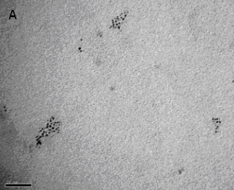

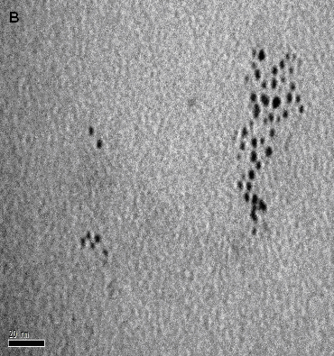

Figure 1. Image of spherical Gold nanoparticles using Transmission electron microscope (Jeol, Japan) operating at an accelerating voltage of 80 kV with scale bar 100nm (A) and with scale bar 20 nm (B).

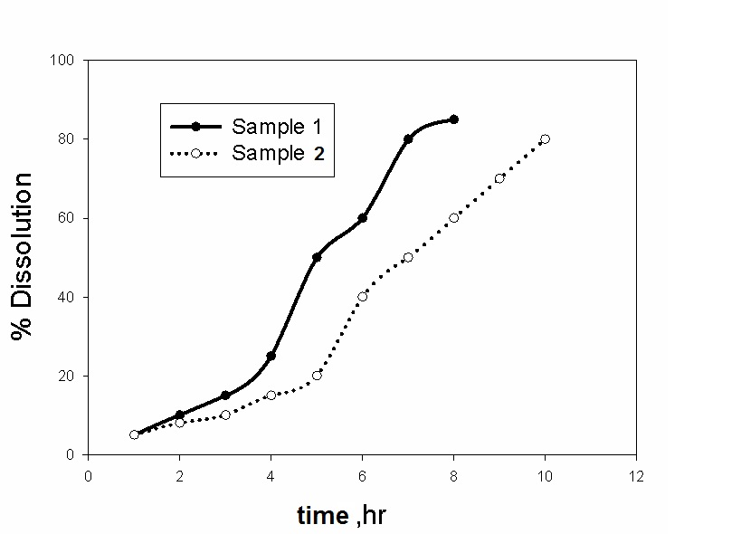

Figure 2. Cumulative amount of per cent gold released versus time using atomic absorption spectrophotometer20. The particle sizes were 5 and 20 nm, in the same order for Samples 1 and 2.

The colloidal gold nanoparticles were tested for their antifungal properties. The antifungal properties of gold nanoparticles against fungal species; namely: Pencillium are shown in Figure 3. The growth inhibitory concentration measurements were measured using fractional concentration ranging from10 to 130 µM. The antifungal activity of Gold ions could be described as following reasons: disruption of transmembrane energy metabolism and membrane electron transport chain by formation of insoluble compounds in the cell wall, the formation of insoluble compound may be due to the inactivation of cell wall sulphhydryl group, Gold ions can create mutation in fungal DNA by displacing the hydrogen bonds, gold ions can dissociate the enzyme complexes which are essential for respiratory chain and membrane permeability, disruption of membrane bounded enzymes and lipids could cause the cell lysis [4,5].
Pencillium growths were completely inhibited upon treatment with 130 µM of gold. Beyond any doubt; gold nanoparticles are lethal to fungi species owing to their smaller sizes. The lack of capping polymers on the surface of gold could contribute to the enhancement the NPs lethality. Intuitively this could owe to exposure to the unique properties of the unmodified surface of the nanometal particles [1-3]. It has been generally believed that the mechanism of the antibacterial effects of gold ions Au⁺ involves their absorption and accumulation by the bacterial cells that would lead to shrinkage of the cytoplasm membrane or its detachment from the cell wall [4]. Overall, effects of the gold nanoparticles on fungi are attributed to genome islands encoding a lot of toxins [8].
The complete inhibition of Pencillium growth that has been observed here is contrary to the finding of Zharov et al. [9]. They could not observe noticeable inhibition of bacterial growth upon treatment with surface modified gold NPs. It is our belief that the inhibition of the growth of microorganisms is not related to penetration of outer cell wall but is also dependent on the size of gold. Additional factors, albeit not completely understood, could come into play; e.g. the energetic of the gold NPs, the kinetics and mechanism of permeability. Nanosize. The interaction of the surface modified nanoparticles with the peptide glycol layer of the cells has a remarkable effect on the inhibition of growth of microorganisms [10]. The result thus obtained clearly indicates that the unmodified nanoparticles with their smaller size and unique surface properties are more potent [1-3]. In addition, the nature of the surface treatment plays a paramount role in the ability of the nanoparticles to inhibit the growth of microorganisms.

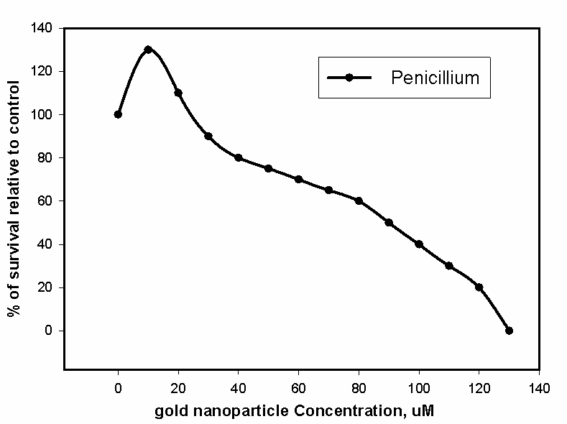
Figure 3. Survival Curve of fungal Strains Using Gold nanoparticles conc. and control, optical density using micro plate reader

4. Concluding Remarks
This work suggests that gold nanoparticles having sizes ranging from 5-20 nm.The results thus obtained lend strong evidence that could warrant the consideration of gold nanoparticles as antifungal agent that could circumvent the side and passive immune effects of other biocidal medications. The kinetic release data indicates that the release of the gold nanoparticles is inversely correlated with the size of the nanoparticles i.e. the release increased with smaller particles. The gold nanoparticle has the capacity to be used in the injection, spray, or lotion form on the infecting site. As such, a gold nanoparticle has a wide range of potential applications in medical applications, therapeutics, sterilization, general hygiene, etc. The unmodified nanoparticles with their smaller size and unique surface properties are more potent in the inhibition of growth of microorganisms. In addition, our results lend additional support to the fact that the nature of the surface treatment plays a paramount role in the ability of the nanoparticles to inhibit the growth of microorganisms.

Acknowledgments
The authors gratefully acknowledge Dr Mohammed Abdel-Gelil, AlArabia Medical Corp, Egypt who has made available his support for the PCS measurements.
MAS acknowledges the US Egypt Science and Technol. Joint Fund through grant (MA7-001-002), for partial support for this research.

Corresponding Author:
Mohammed A. SharafPresent Address: Department of Chemistry, The American University in Cairo, New Cairo, Helwan 11835, EGYPT
E-mail: sharafma@aucegypt.edu

References
1. Alivisatos AP, Semiconductor Clusters, Nanocrystals, and Quantum Dots. Science 1996, 271, 933-937.
2. Kreibig U, Vollmer M. Optical Properties of Metal Clusters. Springer: New York, 1995.

3. El-Sayed MA. Some Interesting Properties of Metals Confined in Time and Nanometer Space of Different Shapes. Acc. Chem. Res. 2001, 34, 257-264.

4. Elechiguerra JL, Burt J, Morones JR, Camacho-BragadoA, Gao X, Lara HH, Yacaman MJ . Interaction of Silver Nanoparticles with HIV-1. J. Nanobiotechnol. 2005, 3, 1–10.

5. Zheng X, Xie Y, Fan C, Chen Y, Ruan H, Ding C. Anti-bacterial and Cytotoxic Properties of Plasma Sprayed silver-containing HA Coatings Journal of Materials Science: Materials in Medicine 2008, 19, 3603-3609.

6. Frens, G. Controlled Nucleation for the Regulation of the Particle Size in Monodisperse Gold Suspensions Nature Phys. Sci. 1973, 241, 20-22.
8. Harshberger JW, Text Book of Mycology and Plant Pathology. Churchill Livinstone 1917.

9. Zharov VP, Mercer KE, Galitovskaya EN, Smeltzer M.S Photothermal Nanotherapeutics and Nanodiagnostics for Selective Killing of Bacteria Targeted with Gold Nanoparticles. Biophysical J. 2006, 90, 619-627.
10. Li XF, Feng XQ, Yang S, Wang TP, Su ZX, Effects of MolecularWeight and Concentration of Chitosan on Antifungal Activity Against Aspergillus Niger. Iranian Polym. 2008, 17, 843-852.
11. Missirlis D, Kawamura R, Nicola Tirelli N, Hubbell JA. Doxorubicin Encapsulation and Diffusional Release from Stable Polymeric Hydrogel Nanoparticles. European J. Pharm. Sci. 2006, 29, 120-129.
12. Demers LM, Mirkin CA, Mucic RC, Reynolds RA, III, Letsinger RL, Elghanian R, Viswanadham G. A Fluorescence-Based Method for Determining the Surface Coverage and Hybridization Efficiency of Thiol-Capped Oligonucleotides Bound to Gold Thin Films and Nanoparticles. Anal. Chem., 2000, 72, 5535–5541.
13. Margalit R, Okon, M, Yerushalmi Y, Avidor E. Bioadhesive Liposomes for Topical Drug Delivery: Molecular and Cellular Studies. J. Controlled Release 1992, 19, 275-287.
14. Yerushalmi N, Margalit R. Physicochemical Evaluation of a Stability-Driven Approach to Drug Entrapment in Regular and in Surface-Modified Liposomes. Biochem. Biophys. Acta , , 1994, 1189, 13-20.
15. Margalit R, Alon R, Linenberg M, Rubin I, Roseman TJ, Wood RW. Liposomal Drug Delivery: Thermodynamic and Chemical Kinetic Considerations J. Controlled Release 1991, 17, 285-296.
.

12/28/2010

