Effects of Aqueous Purslane (Portulaca Oleracea) Extract and Fish Oil on Gentamicin Nephrotoxicity in Albino Rats

Walaa.Hozayen, Mouhamed. Bastawy, Haidy.Elshafeey*

Chemistry Department, Faculty of Sciences, Beni-Suef University, Beni-Suef, Egypt
haidyalshafeey@yahoo.com*
Teaching assistance of Biochemistry, Faculty of Oral and Dental Medicine, Nahda University Beni-suef (NUB)

Abstract: Nephrotoxicity is of critical concern when selecting new drug candidates during the early stage of drug development. Because of its unique metabolism, the kidney is an important target of the toxicity of drugs, xenobiotics, and oxidative stress. Gentamicin (GM) is an antibiotic induced nephrotoxicity as it induces conspicuous and characteristic changes in lysosomes of proximal tubular cells consistent with the accumulation of polar lipids (myeloid bodies). These changes are preceded and accompanied by signs of tubular dysfunctions or alterations (release of brush border and lysosomal enzymes; decreased reabsorption of filtered proteins. The effect of gentamicin (80 mg/kg Bw/day) without or with oral administration of aqueous purslane (Portulaca oleracea) extract (400mg/kg BW/day) and fish oil (5mg/kg BW/day) co-treatments for 15 days was evaluated in adult male rats (80-120g). Plasma urea, uric acid and creatinine levels were assayed. Lipid peroxidation (indexed by MDA) and antioxidants enzymes like GSH, SOD and CAT were assessed. There was a decrease in plasma levels concentration of urea, uric acid and creatinine, In addition to decreasing in activities of GSH, SOD and CAT as well as an increasing in MDA concentration in the kidney as a result of gentamicin injection. Co-administration of aqueous purslane extract and fish oil was found to improve the adverse changes in the kidney functions with an increase in antioxidants activities and reduction of peroxidation.We propose that dietary fish oil or purslane extract supplementation may provide a cushion for a prolonged therapeutic option against GM nephropathy without harmful side effects.
[Walaa.Hozayen, Mouhamed. Bastawy, Haidy.Elshafeey. Effects of Aqueous Purslane (Portulaca Oleracea) Extract and Fish Oil on Gentamicin Nephrotoxicity in Albino Rats. Nature and Science 2011;9(2):47-62]. (ISSN: 1545-0740). http://www.sciencepub.net.

Key words: purslane,fish oil,nephrotoxicity and antioxidants

1. Introduction:
The kidney is a complex organ consisting of well-defined components that function in a highly coordinated fashion. A number of drugs, chemicals, heavy metals have been shown to alter its structure and function. Both acute and chronic intoxication have been demonstrated to cause nephropathies with various levels of severity ranging from tubular dysfunctions to acute renal failure ( Barbier.et al., 2005). Nephrotoxicity is of critical concern when selecting new drug candidates during the early stage of drug development Because of its unique metabolism, the kidney is an important target of the toxicity of drugs, xenobiotics, and oxidative stress (Uehara et al., 2007). The role played by antioxidants during drug-mediated toxicity was determined if they can reduce the oxidative stress induced by reactive intermediates produced by various chemicals and drugs (Sohn et al .2007 and Wu. et al. 2007).
Aminoglycosides are nephrotoxic because a small but sizable proportion of the administered dose is retained in the epithelial cells lining the S1 and S2 segments of the proximal tubules (Vandewalle et al., 1981) after glomerular filtration.Aminoglycosides accumulated by these cells are mainly localized with endosomal and lysosomal vacuoles but are also localized with the Golgi complex (Sandoval, et al., 1998). They elicit an array of morphological and functional alterations of increasing severity, aminoglycosides induce conspicuous and characteristic changes in lysosomes of proximal tubular cells consistent with the accumulation of polar lipids (myeloid bodies) (Begg, et al., 1995). These changes are preceded and accompanied by signs of tubular dysfunctions or alterations (release of brush border and lysosomal enzymes; decreased reabsorption of filtered proteins.
The P. oleracea was a rich source of omega-3- fatty acids, which was important in preventing heart attacks and strengthening the immune system (Simopoulos, 2004). Several biological properties have been attributed to P .oleracea:antiseptic, antispasmodic, diuretic, vermifuge (Xiang, et al., 2005), anti-scorbutic, antibacterial, wound-healing ( Lim and Quah, 2007), analgesic, anti-inflammatory activities and skeletal muscle relaxant, bronchodilator, anti-ascorbic, antipyretic, anti-asthma, and antitussive effect ( Islam, et al., 1998).

2. MATERIALS AND METHODS
1. Chemicals and drugs
Gentamicin and fish oil were purchased from Sigma Company (United Kingdom),Purslane was purchased from local market. Billirubin (total ,direct) kit, ALP kit, urea kit, uric acid kit and creatinine kit from Diamond Diagnostics (Egypt), total protein kit and albumin kit from Spinreact Company (Spain) , ALT and AST kit from Biomerieux chemical company and chemicals used in measurement of antioxidants from Sigma chemical company.

2. Plant extract
The aqueous extract of the purslane herb were boiled in the traditional way. Briefly, herbs were minced and seeped in boiling water in the proportion of 1:10 (w/v) for 3 h. This was repeated two additional times for 3 h of boiling. After boiling, the resulting crude extract was filtered and the filtered extract was evaporated to dryness under reduced pressure at 40 °C and a yield of 24–28% (w/w) was obtained. The dried powder was kept at 4 °C for future use (Hongxinga et al., 2007).

3. Experimental animals and design:
White male albino rats (Rattus norvegicus) weighing about 140-180g were used as experimental animals in the present investigation. They were obtained from the animal house of Research Institute of Opthalmology, El-Giza, Egypt. They were kept under observation for about 15 days before the onset of the experiment to exclude any intercurrent infection. The chosen animals were housed in plastic cages with good aerated covers at normal atmospheric temperature (25±5oC) as well as 12 hours daily normal light periods. Moreover, they were given access of water and supplied daily with standard diet of known composition and consisting of not less than 20% proteins, 5.5% fibers, 3.5% fats and 6.5% ash and were also supplied with vitamins and mineral mixtures.
The considered rats were divided into four groups containing six animals for each. These groups were:
Group 1: It was regarded as normal animals which were kept without treatments under the same laboratory conditions and was regarded as normal control group for other ones.
Group 2 (toxic group): The animals in this group were received intraperitoneal injection of single nephrotoxic dose of gentamicin for 15 days (80 mg/kg body weight) (Priyamvada et al., 2008). This group was considered as control for the remained groups.
Group 3 (Toxic treated with purslane aqueous extract): The rats in this group were administrated aqueous extract of purslane by gastric intubation after injection with gentamicinat at dose level of 400mg/kg b.wt for 15 days (Fayong Gong et al., 2009).
Group 4 (Toxic treated with fish oil): The rats in this group were administrated fish oil by gastric intubation after injection with gentamicinat at dose level of 5mg/kg b.wt for 15 days (Ali and Bashir, 1994).
All the treatments were performed orally and daily between 8.00 and 10.00 a.m.
By the end of the experimental periods, normal, control groups and treated rats were sacrificed under diethyl ether anesthesia. Blood samples were taken and centrifuged at 3000 r.p.m. for 30 minutes. The clear non- haemolysed supernatant sera were quickly removed, divided into three portions for each individual animal, and kept at -20 oC till used.

4. Phytochemical analysis of purslane
4.1. Samples preparation
For fatty acid analysis, crude oil was obtained from samples extracted with petroleum ether (b.p. 40–60 °C) in a Soxhlet apparatus; the remaining solvent was removed by vacuum distillation. For organic acids and phenolics determination and antioxidant capacity assay, an aqueous extract was prepared: three powdered sub samples (~ 5 g; 20 mesh) were extracted with 250 mL of boiling water for 45 min and filtered through Whatman no. 4 paper. The resulting extract was lyophilized in a freeze dried apparatus (Ly-8-FM-ULE, Snijders, Holland) and yields were calculated for Q. Sta Apolónia (leaves: 23.06 ± 1.16%; stems: 27.64 ± 1.56%), Q. Pinheiro Manso (leaves: 29.27 ± 0.65%; stems: 25.61 ± 0.14%), S. Bartolomeu (leaves: 21.21 ± 2.17%; stems: 22.03 ± 0.46%), and Samil (leaves: 25.88 ± 1.43%; stems: 25.31 ± 0.46%). The lyophilized extracts were kept in an exsicator, in the dark (Oliveira, et al, 2009). For the characterization and quantification of the phenolic compounds by HPLC/DAD, each lyophilized extract was redissolved in water. For organic acids determination they were redissolved in sulphuric acid 0.01 N prior to analysis by HPLC/UV.

4.2. Fatty acid composition
Fatty acids were determined by gas chromatography(DAN1 model) with flame ionization detection (GC-FID) capillary column based on the following trans-esterification procedure: fatty acids were methylated with 5 mL of methanol:sulphuric acid:toluene 2:1:1 (v/v), during at least 12 h, in a bath at 50 °C and 160 rpm; then 5 mL of deionized water was added, to obtain phase separation; the FAME were recovered with 5 mL of diethyl ether by shaking in a vortex, and the upper phase was passed through a micro-column of sodium sulphate anhydrous, in order to eliminate the water; the sample was recovered in a vial, and filtered through a 0.2 µm nylon filter (Milipore) before injection. The fatty acid profile was analyzed with a DAN1 model GC 1000 instrument equipped with a split/splitless injector, a flame ionization detector (FID) and a Macherey–Nagel column (30 m × 0.32 mm ID × 0.25 µm d_{f}). The oven temperature program was as follows: the initial temperature of the column was 50 °C, held for 2 min, then a 10 °C/min ramp to 240 °C and held for 11 min. The carrier gas (hydrogen) flow rate was 4.0 mL/min (0.61 bar), measured at 50 °C. Split injection (1:40) was carried out at 250 °C. For each analysis 1 µL of the sample was injected in GC. The results were recorded and processed using CSW 1.7 software (DataApex 1.7) and expressed in relative percentage of each fatty acid, calculated by internal normalization of the chromatographic peak area. Fatty acids were identified by comparing the relative retention times of FAMEs peaks from samples with standards (Oliveira et al., 2009).

4.3. Analysis of phenolic compounds by HPLC/DAD
Twenty microliters of lyophilized purslane leaves and stems extracts were analyzed using a HPLC unit (Gilson) and a Spherisorb ODS2 (25.0 × 0.46 cm; 5 μm, particle size) column. The purslane leaves and stems lyophilized extracts were analyzed using a mixture of formic acid 5% (A) and methanol (B), with a flow rate of 0.9 mL/min, as follows: 0 min—5% B, 3 min—15% B, 13 min—25% B, 25 min—30% B, 35 min—35% B, 39 min—45% B, 42 min—45% B, 44 min—50% B, 47 min—55% B, 50 min—70% B, 56 min—75% B, 60 min—100% B.Detection was achieved with a Gilson diode array detector. Spectral data from all peaks were accumulated in the range of 200–400 nm, and chromatograms were recorded at 330 nm. The data were processed on Unipoint system Software (Gilson Medical Electronics, Villiers le Bel, and France). Peak purity was checked by the software contrast facilities. Phenolic compounds quantification was achieved by the absorbance recorded in the chromatograms relative to external standards. The compounds were quantified as 5-caffeoylquinic acid (Oliveira et al., 2009).

5. Preparation of tissue homogenates
After the completion of the experiment, the kidneys were removed, decapsulated and kept in ice-cold buffered saline (154 mM NaCl, 5 mM Tris–HEPES, pH 7.5). The cortex was carefully separated from medulla as described earlier (Khundmiri etal., 2004). A 15% (w/v) homogenate was prepared in 0.1 M Tris–HCl buffer pH 7.5 using Potter-Elvehejem homogenizer (Remi motors, Mumbai, India); by passing 5 pulses. The homogenate was centrifuged at 3000g at 4 °C for 15 min to remove cell debris and the supernatant was saved in aliquots and stored at −20 °C for assaying the enzymes of carbohydrate metabolism, free-radical scavenging enzymes and for estimation of total-SH and lipid peroxidation.

6. Assay of kidney and liver function:
ALT (E.C. : 2.6.1.2.) Activity in serum was determined according to the method of Reitman and Frankel (1957) using reagent kits purchased from BioMerieux Chemical Company (France). AST (E.C.: 2.6.1.1.) activity in serum was determined according to the method of Reitman and Frankel (1957) using reagent kits purchased from Randox Company (United Kingdom). Bilirubin level in plasma was determined according to the method of Jendrassik et al., (1938) using the reagent kits purchased from Diamond Diagnostics (Egypt). Alkaline phosphatase activity in serum was determined according to the method of Rec. GSCC (DGKC) (1972) using the reagent kits purchased from Diamond Diagnostics (Egypt). Serum total proteins concentration was determined according to the method of Peters (1968) using reagent kits purchased from Spinreact Company (Spain). Serum albumin concentration was determined according to the method of Doumas et al. (1971) using reagent kits purchased from Spinreact Company (Spain). Urea concentration in serum was determined according to the method of Patton and Crouch (1977) using the reagent kits purchased from Diamond Diagnostics (Egypt). Uric acid concentration in serum was determined according to the method of Fossati et al., (1980) using reagent kits purchased from Diamond Diagnostics (Egypt). Creatinine level in serum was determined according to the method of Henry (1974) using the reagent kits purchased from Diamond Diagnostics (Egypt).

7. Assay of enzymatic and non-enzymatic antioxidant parameters
They were conducted chemically using chemicals purchase from Sigma chemical company and using Jenway spectrophotometer (Germany),Superoxide dismutase (SOD) was assayed by the method of Kar and Mishra (1976)., Catalase as described by Cohen et al., (1970) and glutathione peroxidase (GSH-Px) by the method of Van Dam et al. (1999). Lipid peroxidation (LPO) determined according to methods of Ohkawa et al., 1979 and vitamin C determined according to methods of Kyaw, 1978. Ascorbic acid concentration liver homogenate was determined at spectrophotometrically at 700 nm using acid phosphotungstate (Kyaw, 1978).

8. Statistical analysis
The Statistical Package for the Social Sciences (SPSS for WINDOWS, version 11.0; SPSS Inc, Chicago). Results were expressed as mean ± standard error (SE) and values of P>0.05 were considered non-significantly different, while those of P<0.05 and P<0.01 were considered significantly and highly significantly different, respectively (Levesque, R., 2007).

3-Results
The fatty acids profile is composed by twenty four fatty acids, with all samples presenting a similar constitution, although with some variations (Fig.1 ). Palmitic (C16) acid was the most abundant one in all samples, which contains 31.80% in sample. Oleic (C18:13n9c+t) acid was the second in order of importance, which contains 27.17% in sample followed by Butyl phenol, which containes 9.70% in sample. For the remaining fatty acids only stearic (C18) (2.02%), linoleic (C18:2n6c) acids (2.70%) and Linolenic (C18:3n3) acid (2.42) were present in considerable amounts. Three phenolic compounds were identified and quantified: Gallic Acid, Ferulic Acid and Caffeic Acid (Fig.1 and 2). The three phenol compounds have different concentration .gallic acid has the highest concentration (16685.09 ug/mlx7) then caffeic acid which has concentration (467.02 ug/mlx7), then ferulic acid which has concentration (167.91 ug/mlx7).
The gentamicin-induced rats exhibited a very highly significant decrease (P< 0.001) of body weight gain as compared to the normal ones (fig. 3). The injection with gentamicin gives -267.19% percentage changes in body weight gain. The oral treatment of gentamicin rats with extract of purslane after gentamicin administration exerted a very highly significant increase (P< 0.001) in body weight gain fish oil to gentamicin- intoxicated rats caused a very highly significant increase (P< 0.001) in body weight gain (fig. 3).
The gentamicin -induced rats exhibited a non-significant decrease of kidney weight gain as compared to the normal ones(fig.4).The oral treatment of gentamicin rats with extract of purslane and fish oil after gentamicin administration exerted a non-significant increase in kidney weight gain as compared to the gentamicin-control group (fig 4). The gentamicin-induced rats exhibited a very highly significant decrease (P< 0.001) of liver weight gain as compared to the normal ones (fig. 5). The oral treatment of rats with extract of purslane after gentamicin administration exerted a non-significant increase in liver weight gain as compared to the gentamicin-control group, while the administration of fish oil to gentamicin- intoxicated rats caused a very highly significant increase (P< 0.001) in liver weight gain (fig. 5).
The gentamicin intoxicated rats showed a highly significant increase (P < 0. 01) in serum level of urea, creatinine and uric acid as compared to normal control group (fig.6,7&8).The treatment with purslane extract of Portulaca oleracea to gentamicin intoxicated rats showed a significant decrease (P < 0.05) in urea and highly significant in creatinine and uric acid level (P < 0.01) as compared to gentamicin control group.The treatment with fish oil to gentamicin intoxicated rats showed a significant decrease in serum urea (P < 0.05) and highly significant in creatinine and uric acid level (P < 0.01) as compared to gentamicin control one.Treatment of gentamicin nephritic rats with fish oil and purslane give percentage changes in creatinine (-73.96%) and (-67.74%) respectively as compared with control ones.Treatment gentamicin nephritic rats with fish oil and purslane give percentage changes in urea (-51.50%) and (-52.95%) respectively as compared with control ones.Treatment gentamicin nephritic rats with fish oil and purslane give percentage changes in uric acid (-68.39%) and (-57.77%) respectively as compared with control ones (fig. 6,7&8).
The serum ALT , AST and ALP activities in gentamicin intoxicated rats showed a very highly significant increase (P < 0.001) as compared to the normal rats(fig. 9,10&11). The oral treatment with purslane extract exerted a very highly significant decrease (P< 0.001) in serum ALT, AST and ALP activities with apercentage change of -80.37%, -89.23% and -73.37% respectively as compared to gentamicin control group.While the oral treatment with fish oil exerted a highly significant decrease (P< 0.01) in serum ALT activity with apercentage change(-51.42%) as compared to the gentamicin control rats (fig.9). While, the oral treatment of gentamicin rats with fish oil exerted a significant decrease (P< 0.05) in serum AST activity as compared to the gentamicin control rats. Treatment with fish oil gives percentage changes in serum AST -46.22% as compared to the control ones (fig. 10). The treatment with fish oil to gentamicin intoxicated rats showed a very highly significant decrease (P < 0.001) in serum ALP activity as compared to gentamicin control ones.Treatment with fish oil give percentage changes in serum ALP -54.25% as compared to the control ones (fig. 11).
The nephritic rats induced by gentamicin exhibited a very highly significant decrease (P< 0.001) of serum total protein , albumin and globulin concentrations as compared to the normal rats(fig.12,13&14). The oral treatment of nephritic rats with purslane extract exerted a very highly significant (P< 0.001) in serum total protein and albumin concentration as compared to the nephritic control ones. While the treatment with fish oil showed a highly significant (P< 0.01) increase in gentamicin intoxicated rat as compared to gentamicin control group.While the treatment with fish oil to gentamicin intoxicated rats showed a very highly significant increase (P < 0.001) in serum albumin as compared to gentamicin control group (fig.13). On the other hand, The oral administration of purslane extract to nephritic rats showed a very highly significant increase (P< 0.001) in the serum albumin concentration as compared to the nephritic control rats(fig. 13). While the treatment with fish oil to gentamicin intoxicated rats showed a significant increase in serum albumin (P< 0.05) as compared to gentamicin control group.The gentamicin intoxicated rats showed a highly significant increase (P < 0.01) in plasma total bilirubin as compared to normal control group (fig. 15).The treatment with purslane extract showed a significant decrease (P < 0.05) in total bilirubin as compared to gentamicin control group.While the treatment with fish oil showed a highly significant decrease (P < 0.01) in total bilirubin as compared to gentamicin control group(fig. 15). The gentamicin intoxicated rats showed a significant increase (P < 0.05) in plasma direct bilirubin as compared to normal control group.The treatment with purslane extract showed a (P < 0.05) significant decrease in direct bilirubin as compared to gentamicin control group.While the treatment with fish oil showed (P< 0.01) highly significant decrease in direct bilirubin as compared to gentamicin control group.The gentamicin intoxicated rats showed a very highly significant increase (P< 0.001) in plasma indirect bilirubin as compared to normal control group(fig. 16). The treatment with purslane extract showed a (P < 0.01) a highly significant decrease in indirect bilirubin as compared to gentamicin control group.While the treatment with fish oil showed (P < 0.05) a significant decrease indirect bilirubin as compared to gentamicin control group (fig. 17).
The gentamicin intoxicated rats showed a very highly significant (P<0.001) increase in kidney MDA level as compared to normal control group.The treatment with purslane extract to gentamicin intoxicated rats showed a highly significant (P<0.01) decrease in kidney MDA level as compared to gentamicin control group (fig 18).The treatment with fish oil extract to gentamicin intoxicated rats showed a non- significant decrease in kidney MDA level as compared to gentamicin control group(fig. 18). The gentamicin intoxicated rats showed a very highly significant (P<0.001) decrease in kidney vitamin C content as compared to normal control group.The treatment with purslane extract to gentamicin intoxicated rats showed a very highly significant (P<0.001) increase in kidney vitamin C content as compared to gentamicin control group.The treatment with fish oil extract to gentamicin intoxicated rats showed a significant increase (P>0.05) in kidney vitamin C content as compared to gentamicin control group (fig. 19).
The gentamicin intoxicated rats showed a very highly significant (P<0.001) decrease in kidney catalase, SOD and reduced glutathione activities as compared to normal control group( fig.20, 21&22).The treatment with purslane extract showed a very highly significant (P<0.001) increase in kidney catalase activity as compared to gentamicin control one (fig. 20).The treatment with fish oil showed a very highly significant increase in kidney catalase activity (P<0.001) as compared to gentamicin control one. The treatment with purslane extract showed a very highly significant (P<0.001) increase in kidney SOD activity as compared to gentamicin control one (fig. 21).The treatment with fish oil showed a highly significant increase (P<0.01) in kidney SOD activity as compared to gentamicin control one.The oral treatment of gentamicin rats with extract of purslane to gentamicin intoxicated rats exerted a highly significant increase (P< 0.01) in kidney reduced glutathione activity as compared to the gentamicin -control group.The oral treatment of gentamicin rats with fish oil to gentamicin intoxicated rats exerted a significant increase (P< 0.05) in kidney reduced glutathione activity as compared to the gentamicin -control group (fig. 22).
The gentamicin intoxicated rats showed a significant (P<0.05) increase in hepatic MDA level as compared to normal control group (fig. 23).The treatment with purslane extract to gentamicin intoxicated rats showed a highly significant (P<0.01) decrease in hepatic MDA level as compared to gentamicin control group.The treatment with fish oil extract to gentamicin intoxicated rats showed a non significant decrease in hepatic MDA level as compared to gentamicin control group( fig. 23). On other hand, the gentamicin intoxicated rats showed a highly significant (P<0.01) decrease in ascorbic acid contents.The treatment with purslane extract to gentamicin intoxicated rats showed a very highly significant (P<0.001) increase in vitamin C content as compared to gentamicin control group (fig. 24).The treatment with fish oil extract to gentamicin intoxicated rats showed a significant (P<0.05) increase in vitamin C content as compared to gentamicin control group (fig. 24).
The gentamicin intoxicated rats showed a very highly significant (P<0.001) decrease in hepatic catalase activity as compared to normal control group (fig. 25).The treatment with purslane extract showed a very highly significant (P<0.001) increase in hepatic catalase activity as compared to gentamicin control one.The treatment with fish oil showed a highly significant increase in hepatic catalase activity (P<0.01) as compared to gentamicin control one.The gentamicin intoxicated rats showed a very highly significant (P<0.001) decrease in hepatic SOD activity as compared to normal control group (fig. 26).The treatment with purslane extract and fish oil showed a highly significant (P<0.01) increase in hepatic SOD activity as compared to gentamicin control ones. On other hand, the gentamicin -induced rats exhibited a highly significant decrease (P< 0.01) of hepatic reduced glutathione activity as compared to the normal control group.The oral treatment of gentamicin rats with extract of purslane and fish oil to gentamicin intoxicated rats exerted a highly significant increase (P< 0.01) in hepatic reduced glutathione activity as compared to the gentamicin (fig. 27).

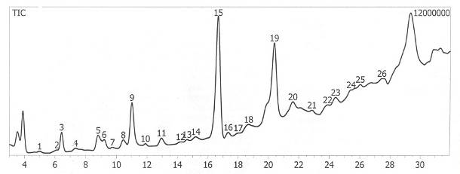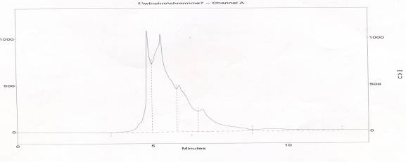
Fig (1) Phytochemical analysis of purslane by HPLC Fig(2)Phytochemical analysis of purslane by GC
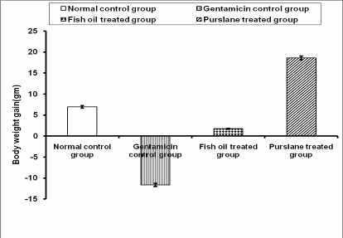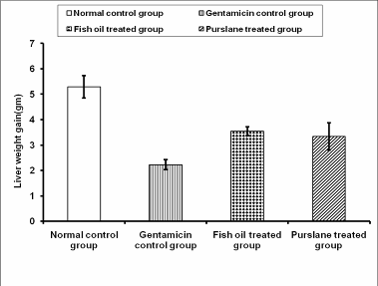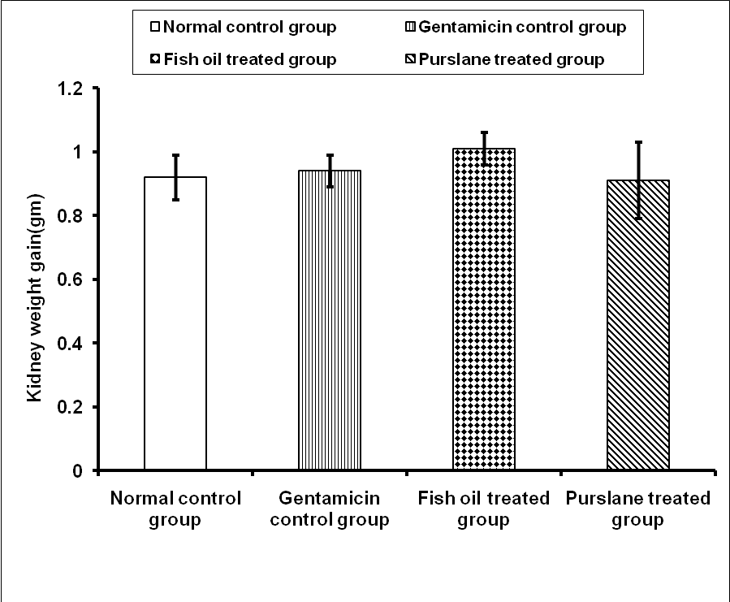
Fig(3) : Effect of purslane extract and fish oil on Fig (4): Effect of purslane extract and fish oil on Fig(5): Effect of purslane extract and fish oil on liver body weight gain on gentamicin nephritic rats. Kidney weight on gentamicin nephritic rats. weight gain on gentamicin nephritic rats
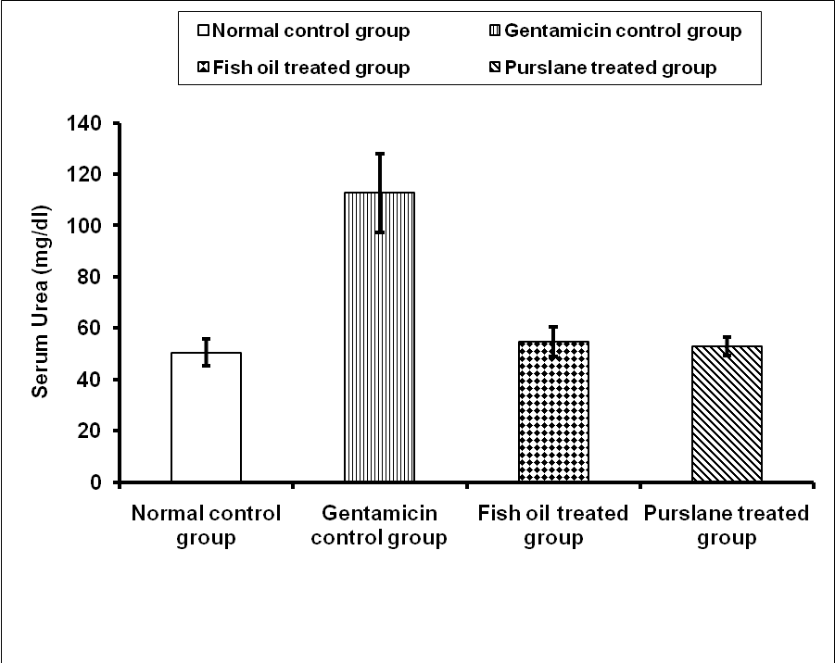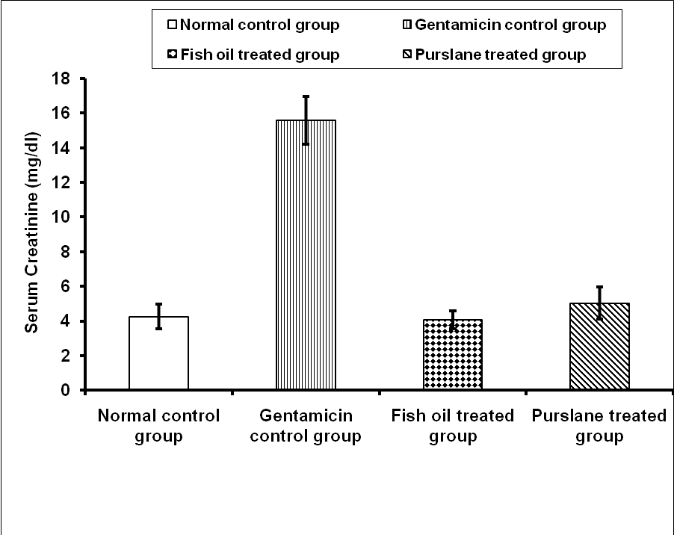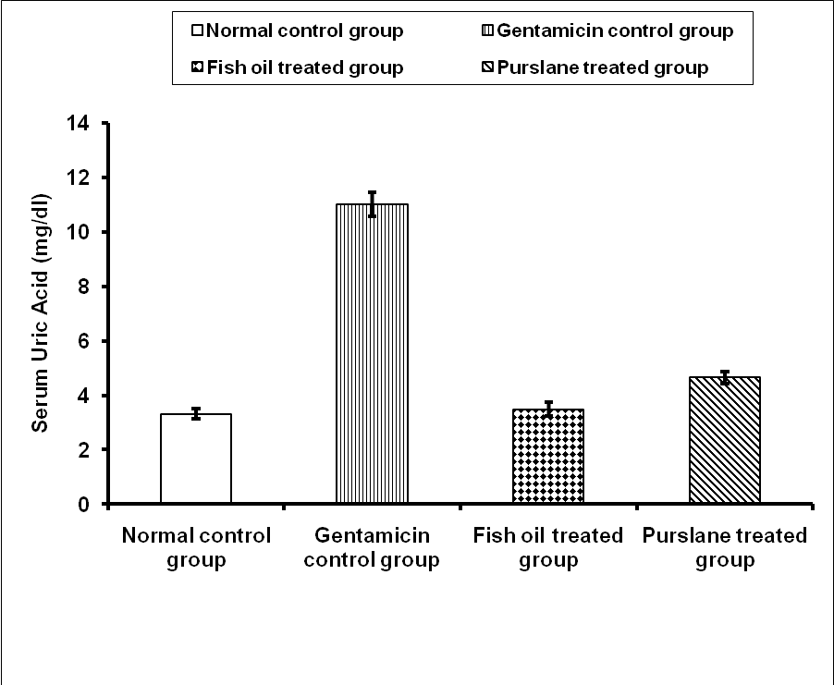
Fig (6): Effect of purslane extract and fish oil on Fig (7): Effect of purslane extract and fish oil on Fig (8): Effect of purslane extract and fish oil on
serum urea level on gentamicin nephritic rats serum creatinine level on gentamicin nephritic rats. serum uric acid level on gentamicin nephritic
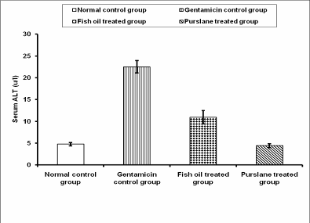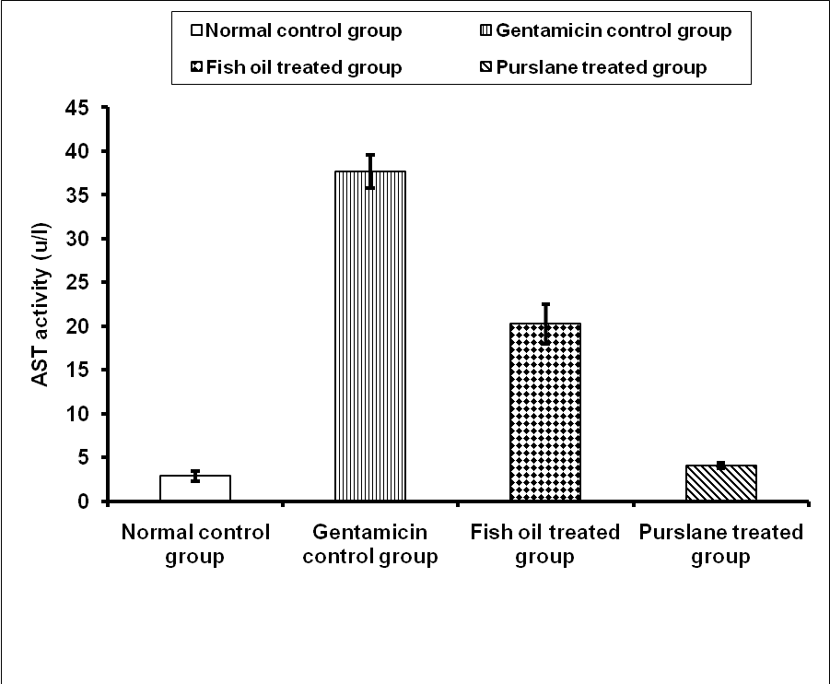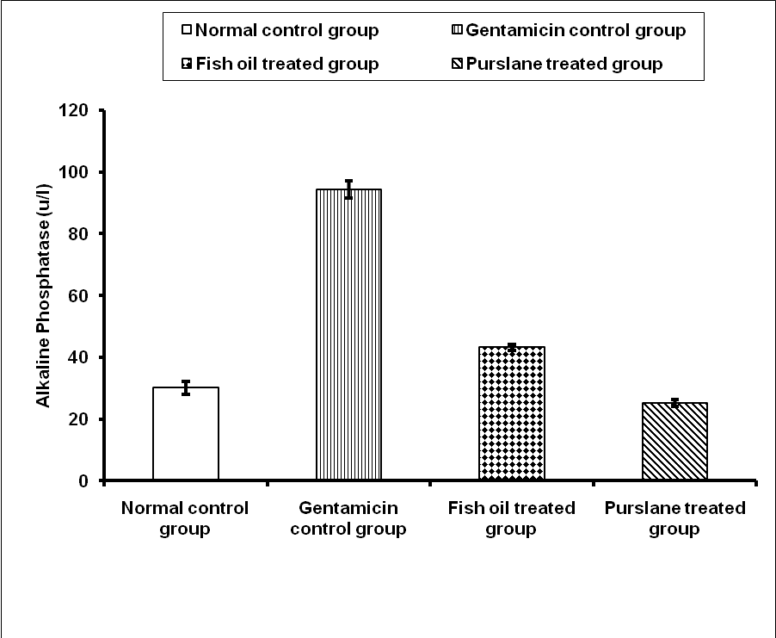
Fig (9): Effect of purslane extract and fish oil on Fig (10): Effect of purslane extract and fish oil on Fig (11): Effect of purslane extract and fish oil on
serum ALT level on gentamicin nephritic rats serum AST level on gentamicin nephritic rats. serum ALP level on gentamicin nephritic
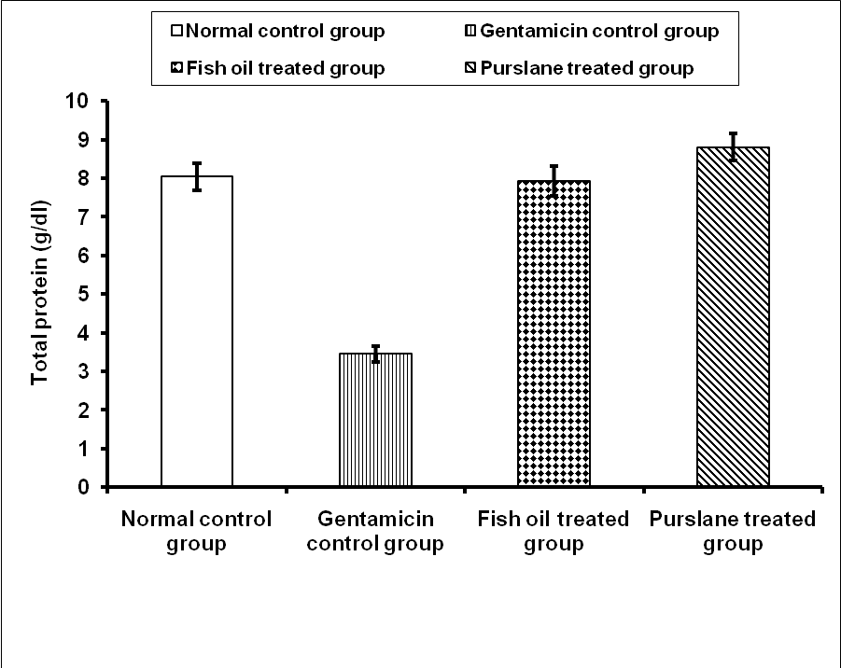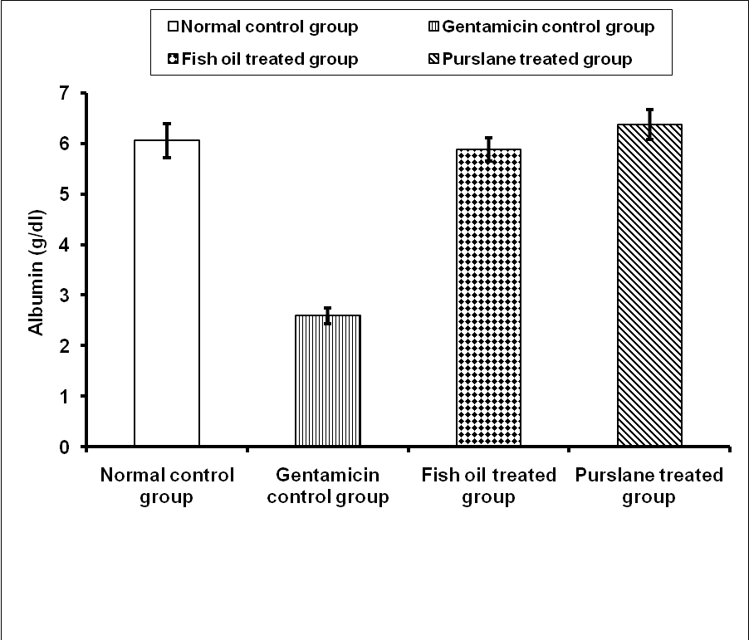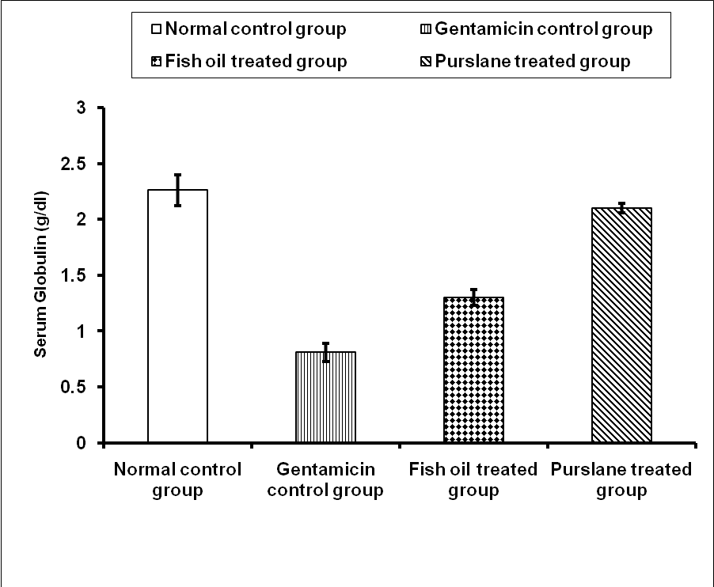
Fig (12): Effect of purslane extract and fish oil on Fig (13): Effect of purslane extract and fish oil on Fig (14): Effect of purslane extract and fish oil on
serum total protein level on gentamicin nephritic rats serum albumin level on gentamicin nephritic rats. serum globulin level on gentamicin nephritic
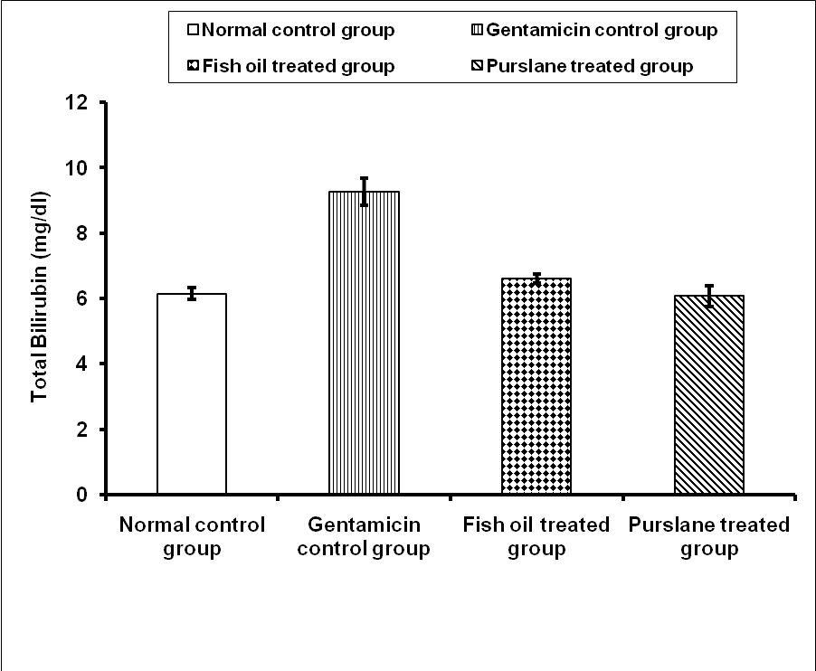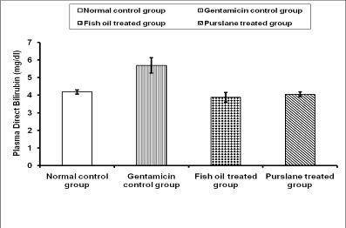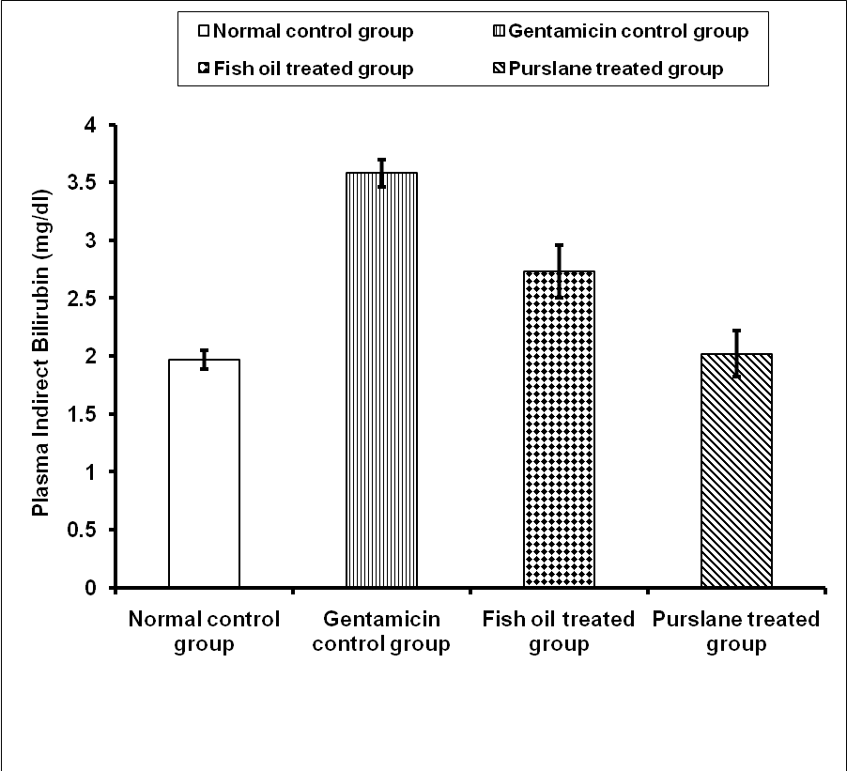
Fig (15): Effect of purslane extract and fish oil on Fig (16): Effect of purslane extract and fish oil on Fig (17): Effect of purslane extract and fish oil on serum serum total Billirubin level on gentamicin nephritic rats serum direct Billirubin level on gentamicin nephritic rats. total indirect Billirubin level on gentamicin nephritic
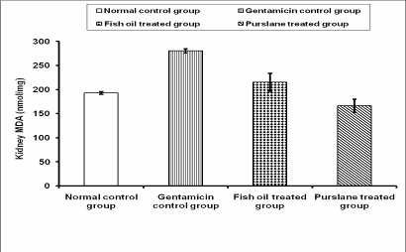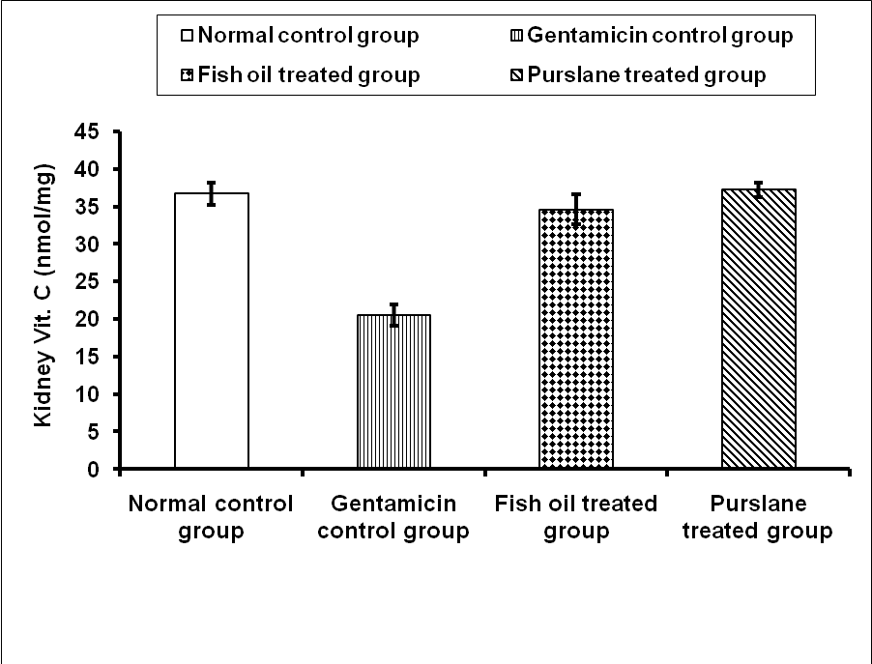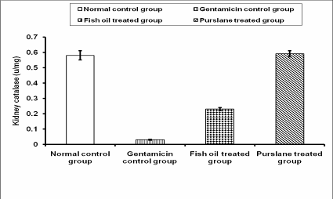
Fig (18): Effect of purslane extract and fish oil on Fig (19): Effect of purslane extract and fish oil on Fig (20): Effect of purslane extract and fish oil on
Kidney MDA level on gentamicin nephritic rats kidney Vit.C level on gentamicin nephritic rats. Kidney catalase level on gentamicin nephritic rats
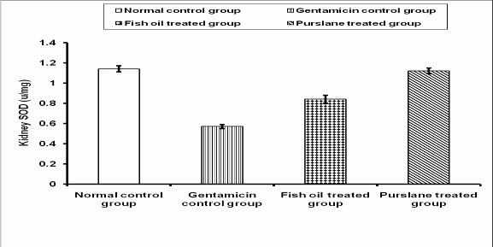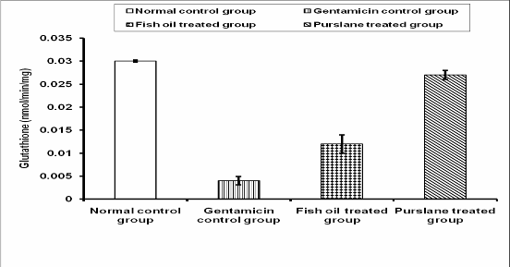
Fig (21): Effect of purslane extract and fish oil on Fig (22): Effect of purslane extract and fish oil on
Kidney SOD level on gentamicin nephritic rats kidney Glutathione level on gentamicin nephritic rats
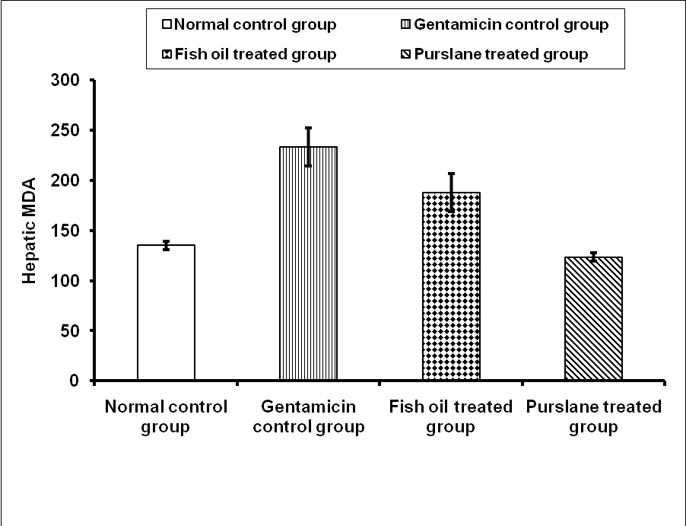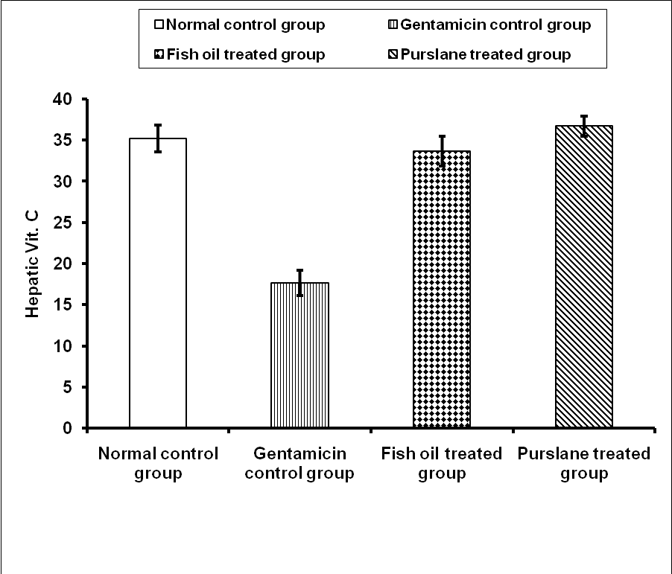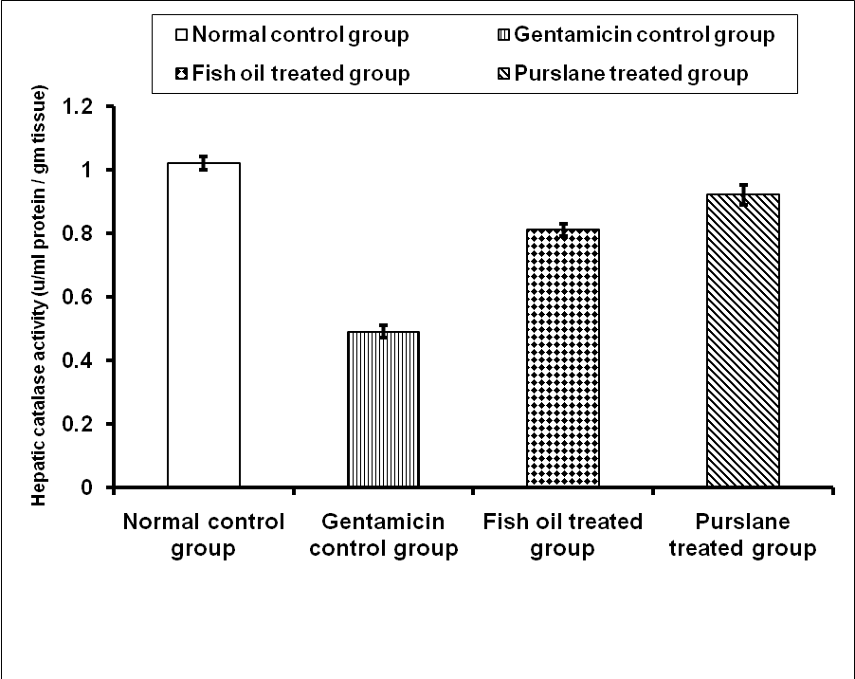
Fig (23): Effect of purslane extract and fish oil on Fig (24): Effect of purslane extract and fish oil on Fig (25): Effect of purslane extract and fish oil on
liver MDA level on gentamicin nephritic rats liver Vit.C level on gentamicin nephritic rats. liver catalase level on gentamicin nephritic rats
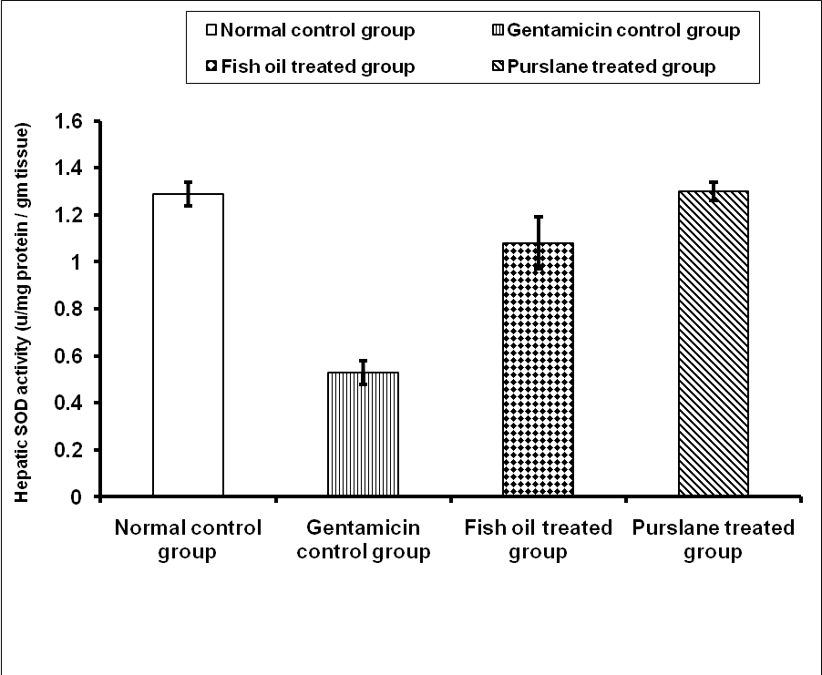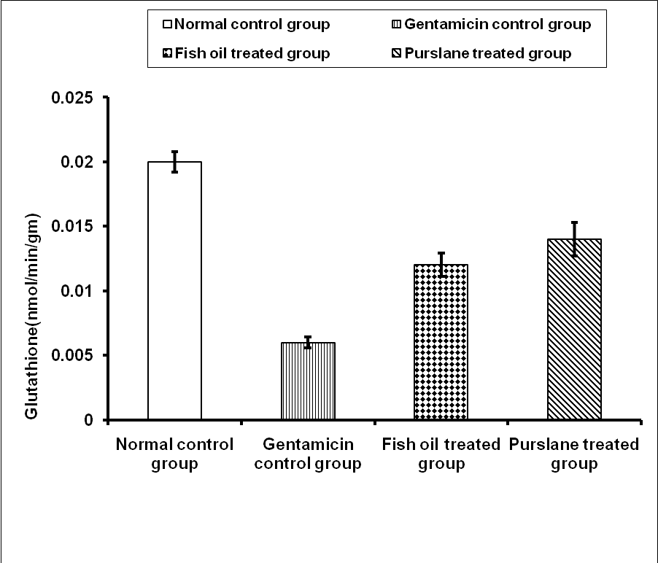
Fig (26): Effect of purslane extract and fish oil on Fig (27): Effect of purslane extract and fish oil on
liver SOD level on gentamicin nephritic rats liver Glutathione level on gentamicin nephritic rats

4. Discussion:
The kidney is a complex organ consisting of well-defined components that function in a highly coordinated fashion. A number of drugs, chemicals, heavy metals have been shown to alter its structure and function.In the present study gentamicin was selected as a nephrotoxicant to induce kidney damage. Fish oil (FO) enriched in ω-3 fatty acids has profound beneficial health effects against various pathologies including cardiovascular diseases, respiratory diseases, diabetes, depression, cancers, inflammatory and immune renal disorders. Reports showed that FO prevents gentamicin -induced nephrotoxicity (Vandewalle et al.,1981). Recent research demonstrated that purslane is a good source of compounds with a positive impact in human health. Those compounds include omega-3 fatty acids and β-carotene, vitamins and essential amino acids, α-tocopherols, ascorbic acid, and glutathione, as well as phenolics, and coumarins. Organic acids are also present and alkaloids have been reported to be important chemical constituents of this species (Simopoulos 2004). In our result Purslane presented high amounts of fatty acids as omega-3 and omega-6 PUFA, which are essential dietary fatty acids that cannot be synthesized by humans but have to be ingested. These acids play an important role in human growth, development and disease prevention.
Epidemiological and clinical studies suggest that omega-3 PUFA, found predominantly in marine organisms, may have beneficial effects in the prevention of several cardiovascular diseases (Davis et al, 2007), and in treatment of nephrotoxicity (Priyamvada et al., 2008) According to the above mentioned, purslane could be regarded as an alternative source of these nutrients for human consumption. In general terms, the obtained results were in agreement with those observed in previous works ( Odhav et al. 2007 and Oliveira et al., 2009). A few bibliographic data were available concerning to phenolic composition of P. oleracea. (Cai et al, 2004) referred that the most representative phenolic compounds of purslane were flavonols and flavones, but neither identification nor quantification was presented. (Xueqin et al., 2006) developed an analytical procedure for flavonoids identification in P. oleracea, but only apigenin was quantified in significant amount, higher in leaves than in stems, and kaempferol was also present just in one sample. Recently, (Spina et al., 2008) identified and quantified some benzoic acids and flavonoids in methanolic extracts of wild and cultivated purslane. In our results three phenolic compounds were identified and quantified (Gallic acid,Ferulic acid &Caffeic acid)which they are antioxidant agents that can be used in treatment or prevent several diseases The obtained results were in agreement with (Oliveira et al., 2009).
Body weight is frequently the most sensitive indicator of adverse effects of xenobiotics. So, it is considered as a determinant parameter of toxicity testing. Increased catabolism, seen in acute renal failure, results in acidosis which is accompanied by anorexia. Hence, oral food intake decreases and this causes body weight loss (Ali et al., 1992). In the present study, gentamicin was used to induce kidney failure in rats. A gradual decrease in food intake and growth rate was observed in gentamicin treated rats. A very highly significant decrease in body weight gain observed in gentamicin intoxicated control rat. These results were in agreement with (Erdem et al., 2000 and Bello &Chika, 2009). On the other hand, our study showed marked ameliorations on body weight gain for gentamicin intoxicated rats as compared to gentamicin control group. This effect could be associated to alterations in nutrient absorption and metabolic utilization after treatments. Our results in agreement with (Erdem et al., 2000) who showed that gentamicin caused a severe loss in body weight that was inhibited by taurine administration in gentamicin group. It was found that carbon tetra chloride (CCl₄) induced renal disorders in rat due to presence of abnormally high levels of BUN in serum, urobilinogen in urine and creatinine both in urine and serum are possible indicators of hepatic and/or kidney injuries induced through CCl₄ treatment (Muhammad et al., 2009 ). Gentamicin induced toxic effects in the kidney (Fouzia Rashid et al., 2005). The renal dysfunction due to gentamicin treatment was manifested by a very highly significant increase in serum urea, creatinine and uric acid levels as compared to the normal group of rat. This is in agreement with the results of Saleemi et al., 2009 and Polat, et al., 2006. It was reported that treatments with gentamicin produces nephrotoxicity (Atessahin et al., 2003 ) as a result of reduction in renal functions which was characterized by an increase in serum creatinine and serum urea level accompanied by impairment in glomerular functions. Serum creatinine level was more significant than the urea levels in the earlier phase of the renal damage. In the present study, it was shown that treatment with gentamicin alone to rats caused nephrotoxicity, which was correlated with increased creatinine, and urea levels in plasma (Karahan, et al., 2005). Our result showed that the treatment of gentamicin intoxicated rats with fish oil made decreasing in serum creatinine, serum uric acid and serum urea level due to its ability to treatment nephrotoxicity. This is in agreement with the results of Karahan, et al., 2005. Also, our result showed that the treatment of gentamicin intoxicated rats with purslane extract made decreasing in serum creatinine and serum urea level. This is in agreement with the results of Nitha et al. 2008. There are various drugs that may cause side effect such as Cisplatin (cis-diamminedichloroplatinum II, CP) that is a major antineoplastic drug for the treatment of various forms of cancers (Nakashima et al., 1990) and (Taguchi et al., 2005). However, CP and its analogs accumulate in the kidney causing nephrotoxicity (Khan₁, et al., 2009).Since the BBM contains a number of hydrolytic enzymes and transport systems, the effect of CP was determined on the activities of BBM enzymes and on Pi transport to assess damage caused by CP administration. CP significantly decreased the activities of Alkaline phosphatase( ALP), γ-glutamyl transferase (GGTase), and leucine aminopeptidase (LAP), BBM marker enzymes, in cortical homogenates and isolated BBM vesicles. A similar decrease was observed in medulla, suggesting an overall CP-induced damage to the kidney. The CP-induced decrease in BBM enzymes suggested a severe damage to the structural architecture of the BBM affecting its transport functions as these enzymes were shown to be directly or indirectly involved in the transport of various solutes (Khan₁ et al., 2009). The decrease in BBM enzyme activities was in fact due to the loss/release of enzymes and other proteinic components from damaged BBM into the lumen that later appear in the urine as demonstrated previously for CP and other toxicants (Anees et al., 2008 and Khan₂ et al., 2009). In contrast to CP, GT consumption, however, significantly increased the activities of BBM enzymes in the homogenate and BBM, indicated an overall improvement in renal BBM integrity as shown earlier (Khan et al., 2007 and Khan₂ et al., 2009). A variable increase in the activity of ALP/GGTase in the renal cortex and medulla can be considered due to their localization in the thickness of BBM (Yusufi et al., 1994) or due to differential access/accumulation of GT in these tissues.GT consumption in combination with CP treatment resulted in the reversal of CP-induced alterations in the activities of certain BBM enzymes in the renal tissues. The activities of ALP and GGTase in renal BBMV remained significantly higher in TCP compared to CP-treated renal BBM preparations, indicated a marked reversal of CP-induced effect by GT consumption on these enzymes. CP-induced decrease in LAP was also reduced by GT in renal BBM preparations (Khan₁, et al., 2009). The results convincingly demonstrate that GT consumption not only prevented the CP elicited decrease in the activities of certain enzymes, but they remained significantly higher in TCP compared to control and much higher than CP-treated rats as shown earlier (Khan₂, et al., 2009) . The activity of lysosomal enzyme, ACPase was significantly increased in the cortex and medulla by CP treatment. Alterations in ACPase activity demonstrate CP-induced loss of lysosomal function (Courjault-Gautier et al., 1995 and Kuhlmann et al., 1997).
Elevated activities of serum ALT, AST and ALP and levels of bilirubin (total & direct) after gentamicin intoxication in agreement with the result of El-Daley (1996). ALT is an enzyme used as an indicator of GM hepatic damage to rat hepatocytes (El-Tawil and Abdel-Rahman, 2001).AST presents two isozymes, one located in the cytoplasm and the other in the mitochondria.The presence of these enzymes outside the cell represents damage to the hepatic cell.Alkaline phosphatase is an ectoenzyme of the hepatocyte plasma membrane; an increase in serum alkaline phosphatase activity has been related to damage to the liver cell membrane (Kaplan, 1986).In view of the present results, it was found that gentamicin causes a highly significant elevation in serum activity of ALP. These results are in agreement with Fouzia Rashid et al., ( 2005) and Khan₁, et al., (2009).Serum bilirubin is one of the most sensitive tests employed the diagnosis of hepatic diseases. Bilirubin, is a chemical breakdown product of hemoglobin, is conjugated with glucuronic acid in hepatocytes to increase its water solubility. The increases of plasma total and direct bilirubin levels by gentamicin ensure that gentamicin is a toxic agent for liver which agree with (Abd Elzaher et al., 2007 and Abd Elzaher et al, 2008) .The above increases might be attributable to the excessive production of bilirubin as a result of excessive break down of red blood cells and the inability of animals to excrete bilirubin due to obstruction, either extra hepatic (from tumors or stones) and /or intrahepatic due to damaged liver cells (Abd Elzaher, 2008). Albumin and globulin are two key components of serum proteins. Because albumin is synthesized in the liver, it is one element that is used to monitor the liver function (Friedman et al., 1980). The present study results revealed that total serum proteins and albumin showed a marked significant decrease in gentamicin control rats as compared with the normal ones. These results are in accordance with the results of Kumar et al., (2004) and Natarajan et al., (2006) who showed a decrease of total protein content due to destruction of protein synthesizing subcellular structures.The decrease of total protein content in serum of gentamicin control rats was due to several reasons like increased free radical production by gentamicin. In the present study treatment with fish oil and purslane shows their ability to restore the normal functional status of the poisoned liver,that observed in gentamicin reduced animals and also to protect against subsequent gentamicin nephrotoxicity.The mechanism by which the fish oil induces its nephroprotective activity is not certain. However, it is possible that omega-3, a constituent of fish oil, is at least partly responsible for the protective activity against gentamicin nephrotoxicity (Priyamvada et al., 2008).An additional and important factor in the nephroprotective activity of any drug is the ability of its constituents to inhibit the aromatase activity of cytochrome P-450, thereby favoring liver regeneration. On that basis, it is suggested by Speck and Lauterburgh, (1990) which fish oil could be a factor contributing to its nephroprotective ability through inhibition of cytochrome P-450 aromatase. The serum activities of ALT; AST; ALP and γ-GT and plasma level of bilirubin in treated animals with fish oil after gentamicin intoxication in agreement with El-Daley (1996) `who showed the protective effect of fish oil on gentamicin–induced nephrotoxicity in rats.Also, our result showed that the treatment of gentamicin intoxicated rats with purslane extract decreased serum activities of ALT ; AST; ALP; and plasma level of bilirubin because it contain omega-3 ,omega-6 and phenolic compounda as antioxidants (Oliveira et al.,2009). In the present study the aqueous extract of purslane show improvement in biochemical parameters as a result of hepatotoxin challenge, indicating improvement of the functional status of the liver. Significant changes in classical enzymes such as ALT, AST and ALP, exclusively,as well as GGT suggest liver impairment ,since these are reliable indices of liver toxicity ,which are in agreement with (Omoniyi et al., 2006). An increase in ALP level may be attribute able to altered metabolism of the skeletal muscle (Olagunju et al., 2000). The protective effects due to treatment with purslane extract strongly indicated the possibility of the extract being able to prevent and/or mitigate any leakages of marker enzymes into circulation condition the hepatocytes to accelerate regeneration of parenchymal cells and preserves the Integrity of the plasma membranes and hence restores these enzymes levels (Al-Howiriny et al., 2004).
The aminoglycoside antibiotic gentamicin elicits renal tubular toxicity and cell death. Previous in vivo and in vitro studies suggested the mediation of reactive oxygen species in the tubular effects of gentamicin. In vivo animal models, reactive oxygen species have been identified as mediators of proximal tubular necrosis and acute renal failure caused by gentamicin (Walker, et al., 1999). Reactive oxygen species have been consistently demonstrated to be involved in the development of gentamicin-induced acute renal failure. It has been reported that gentamicin increases lipid hydroperoxide and suppresses superoxide dismutase, catalase and glutathione peroxidase activities (Martínez-Salgado et al., 2007).The present results have clearly demonstrated the ability of gentamicin to induce oxidative stress in rat liver and kidney, as evidenced by the very highly significant rise of lipid peroxidation product;and a very highly significant decline of endogenous antioxidants GSH, SOD and CAT. These findings are in agreement with other reports as Parlakpinar et al., (2005); Polat et al., (2006) and Yaman and Balikci, (2010).
On the other hand, the decrease in GSH level in liver might be attributed to the inhibition of its regeneration enzyme GSH-Rx (glutathaion reductase) by gentamicin treatment (Polat, et al., 2006).GSH is synthesized from oxidized glutathione (GSSG) and NADPH through the action of GSH-Rx (glutathaion reductase) (Akbay, et al., 1999). Also, a highly significant decrease in GSH activity was reported in this study, these observations are in agreement with those of Pedraza-Chaverri et al. (2000) and Farombi et al., (2006).
It was found that gentamicin administration to rats enhances the production of H₂O₂ in renal cortical mitochondria as a result of the increase in the production of superoxide anions. Superoxide anion and H₂O₂ may interact to form a reactive and unstable radical, namely a hydroxyl radical. This radical is formed by the reaction between H₂O₂ and Fe²⁺( Shah and Walker, 1992).
Fe²⁺ appeared to play an important role in the production of reactive oxygen radicals in gentamicin nephrotoxicity and when oxygen radicals begin to accumulate, renal cells exhibit a defensive mechanism by using various antioxidant enzymes; such as catalase, SOD and glutathione peroxidase activities( Obatomi and Plummer, 1993). Reduced activity of one or more antioxidant systems, due to the direct toxic effect of gentamicin or volume depletion due to gentamicin administration, leads to an increase in lipid peroxidation.The decreased amount of intracellular glutathione and the accumulation of H₂O₂ and hydroxyl radicals are the triggering factors in gentamicin nephrotoxicity.Also, a highly significant decrease SOD and catalase activity was reported in this study, these observations are in agreement with those of, Yaman and Balikci et al, (2010). It has been reported that GM suppresses antioxidant defense enzymes and increases lipid peroxidation in the kidney (Parlakpinar et al., 2005). The present results confirm earlier findings (Yazar et al., 2003) and show that GM administration to normal rats caused severe damage to renal tissues most likely by ROS mediated mechanism as evident by decreased activities of above antioxidant enzymes and total SH levels that led to increased lipid peroxidation (LPO). Also, a highly significant increase of lipid peroxidation activity was reported in this study, these observations are in agreement with those of (Anees.et al, 2008). In the present results, it was found that the hepatic vitamin C content showed a highly significant decrease in gentamicin untreated rats as compared to normal rats. Our results are in accordance with those of previous investigators (Kalayarasan et al, 2009).The observed decrease in the levels of ascorbic acid may be due to their increased utilization for scavenging gentamicin and/or oxygen derived radicals. Vitamin C plays an important role in the tissue defense system against the oxidative stress (Wefers and Sies, 1988). Decreased activities of vitamin C were found in the kidney of rats treated with gentamicin, indicating an increase in lipid peroxidation levels of these animals (Kalayarasan et al., 2009). A number of investigations have demonstrated that diet supplemented with fish oil (FO) enriched in ω-3 fatty acids has profound beneficial health effects against various pathologies (Simopoulos 1991) including cardiovascular diseases, respiratory diseases, diabetes, depression, cancers, inflammatory and immune renal disorders (Thakkar et al., 2000). Reports showed that FO prevents gentamicin and cyclosporine-A-induced nephrotoxicity (Thakkar et al., 2000 ). However, the biochemical mechanism or cellular response by which FO protects against UN nephrotoxicity has not been examined. The present work was undertaken to study detailed biochemical events/cellular response/mechanisms of gentamicin nephropathy and its protection by fish oil (FO) .We hypothesized that fish oil would prevent gentamicin -induced nephrotoxicity due to its intrinsic biochemical and antioxidant properties that would lead to improved metabolism and antioxidant defense mechanism in the kidney. The results of the present study demonstrate marked amelioration of gentamicin -induced nephrotoxicity parameters by dietary FO supplementation most likely by improving energy metabolism, BBM integrity and antioxidant defense (Priyamvadaet al., 2008).The protection against GM effect by FO can be attributed to its intrinsic biochemical and natural antioxidant properties. As can be seen from the results, feeding of FO alone caused significant increase of SOD, catalase and GSH-Px activities accompanied by lower LPO in renal tissues. Thus, it appears FO enriched in ω-3 fatty acids enhanced resistance to free radical attack generated by GM administration similarly as demonstrated in lupus nephritis and other pathologies (Chandrasekar et al., 1994). Dietary FO supplementation has also been shown to strengthen antioxidant defense mechanism in the plasma of normal rats (Erdogan et al. 2004).Recently, dietary FO has been shown to protect against ethanol-induced gastric mucosal injury (Leung,. 1992) in rats, a number of inflammatory diseases including lupus nephritis ( Chandrasekar et al., 1994), IgA nephropathy (Donadio, 2001) and murine AIDS ( Xi and Chen., 2000).Preliminary reports also showed partial protection by dietary FO/ω-3 fatty acids against cyclosporine/GM-induced nephrotoxicity (Thakkar et al., 2000 and Ali and Bashir., 1994); however, the mechanism involved was not studied in detail. Our results support that ω-3 fatty acids enriched FO may be effective dietary supplementation in the management of GM nephrotoxicity and other pathologies in which antioxidant defense mechanism are decelerated. The enzymes of oxidative carbohydrate metabolism and gluconeogenesis; Bruch bordered membrane (BBM), antioxidant defense mechanism and ³²Pi transport capacity appeared to be severely affected by GM treatment (Priyamvada. et al, 2008). The present results have clearly demonstrated the ability of fish oil to decrease oxidative stress in rat liver, as evidenced by the very highly significant decrease of lipid peroxidation product; and a very highly significant rise of endogenous antioxidants GSH, SOD and CAT These findings are in agreement with other reports ( Choi-Kwon et al., 2004 and Priyamvada et al., 2008).

5. Conclusion:
We conclude that while GM elicited deleterious nephrotoxic effects by causing severe damage to renal mitochondria, BBM and other organelles and by suppressing antioxidant defense mechanism, dietary supplementation with fish oil enriched in ω-3 fatty acids caused improvement in nutrition/energy metabolism, BBM integrity, ³²Pi transport capacity and antioxidant defenses and thus prevented GM-induced various deleterious effects. However, purslane enriched in ω-3, ω-6 fatty acids and phenolic compound caused highly improvement than fish oil in GM-induced nephrotoxicity parameters. Based on our present observations and already known health benefits, we propose that dietary fish oil or purslane extract supplementation may provide a cushion for a prolonged therapeutic option against GM nephropathy without harmful side effects.

Corresponding author:
Haidy.Elshafeey
Chemistry Department, Faculty of Sciences, Beni-Suef University, Beni-Suef, Egypt
haidyalshafeey@yahoo.com
Teaching assistance of Biochemistry, Faculty of Oral and Dental Medicin , Nahda University Beni-suef (NUB)
6. References:
- Abdel-Zaher A. O., Abdel- Rahman M. M., Hafez M. M. and Omran F. M. (2007): Role of nitric oxide and reduced glutathione in the protective effects of aminoguanidine, gadolinium chloride and oleanolic acid against acetaminophen-induced hepatic and renal damage. Toxicology, 234, (1-2), 124-134.
- Abdel-Zaher A. O., Abdel-Hady R. H., Mahmoud M. M. and Farrag M. M. Y., (2008): The potential protective role of alpha-lipoic acid against acetaminophen-induced hepatic and renal damage.Toxicology, 243,(3), 261-270.
- -Akbay A., Cinar K., Uzunalmogla O., Eranil S., Yurdaydin C., Bozkaya H. and Bozdayi M. (1999): Serum cytotoxin and oxidant stress markers in N-acetyl-cysteine treated thioacetamide hepatotoxicity of rat. Human Exp. Tox. 18, 669-676.
- Al-Howiriny, T., Al-Sohaibani, M. S., Al-Yahya, M. A. K. ElTahir and Rafatullah S., (2004): Hepatoprotectiveproperties of Commiphora opobalsamum (“Balessan”), atraditional medicinal plant of Saudi Arabia. Drug Exptl. Clin.Res. 30, 213-20.
- Ali BH, Bashir AA (1994): Effect of fish oil treatment on gentamicin nephrotoxicity in rats. Ann Nutr Metab. 38(6): 336-339.
- Ali BH, Abdel Gayoum AA, Bashir AA (1992). Gentamicin nephrotoxicity in rat: some biochemical correlates. Pharmacol Toxicol1992; 70: 419–423.
- Anees A. Banday, Neelam Farooq, Shubha Priyamvada, Ahad N.K. Yusufi and Farah Khan (2008), Time dependent effects of gentamicin on the enzymes of carbohydrate metabolism, brush border membrane and oxidative stress in rat kidney tissues Volume 82, Issues 9-10, 27 February 2008, Pages 450-459.
- Ateşşahin A. Karahan I. , S. Yilmaz, A.O. Çeribaşı and I. Pirincci, The effect of manganese chloride on gentamicin-induced nephrotoxicity in rats, Pharmacol Res 48 (2003), pp. 637–642.
- Barbier O., Jacquille G.t , Tauc M. , Cougnan M .and Poujeol P. , (2005). Effect of heavy metals on, and handling by kidney, Nephron Physiol. 99 (2005), pp. 105–110.
- Begg E.J. and Barclay M.L. (1995), Aminoglycisides—50 years on, Br.J. Clin. Pharmacol. 39 (1995), pp. 597–603.
- Bello . S O and Chika A (2009). Dose-Dependent Amelioration of Gentamicin-Induced Nephrotoxicity in Adult Swiss Albino Rats by Vitamin B-complex - A Preliminary Study.Tropical Journal of Pharmaceutical Research, April 2009; 8 (2): 111-116.
- Cai Y. Q. Luo, Sun M. and Corke H. (2004), Antioxidant activity and phenolic compounds of 112 traditional Chinese medicinal plants associated with cancer, Life Sciences 74 (2004), pp. 2157–2184.
- Chandrasekar B. and Fernandes G. (1994), Decreased pro-inflammatory cytokines and increased antioxidant enzyme gene expression by ω-3 lipids in murine lupus nephritis, Biochem. Biophys. Res. Commun. 200 (1994), pp. 893–898.
- Choi-Kwon. Smi , Kyung-Ae Park, Hee-Joo Lee, Myung-Sook Park, Joung-Hee Lee, Sang-Eun Jeon, Myoung-Ae Choe and Kyoung-Chan Park (2004) Temporal changes in cerebral antioxidant enzyme activities after ischemia and reperfusion in a rat focal brain ischemia model: effect of dietary fish oil Volume 152, Issue 1, 18 August 2004, Pages 11-18 .
- Cohen, G.; Dembiec, D. and Marcus,J. (1970):Measurments of catalase activity in tissue Analytical biochemistry,34:30-38.
- Courjault-Gautier F., Le Grimellec C., Giocondi M.C. and Toutain H.J. (1995), Modulation of sodium coupled uptake and membrane fluidity by cisplatin in renal proximal tubular cells in primary culture and BBM vesicles, Kidney Int 47 (1995), pp. 1048–1056.
- Davis L., Stonehouse W., Loots D.T., Mukuddem-Petersen J., van der Westhuizen F., Hanekom S.J. and Jerling J.C. ,(2007) The effects of high walnut and cashew nut diets on the antioxidant status of subjects with metabolic syndrome, Eur. J. Nutr. 46 (2007), pp. 155–164.
- Donadio J.V.,(2001).The emerging role of omega-3 polyunsaturated fatty acids in the management of patients with IgA nephropathy, J. Ren. Nutr. 11 (2001), pp. 122–128.
- EL DALY. EZZAT S. (1996), from department of biology,Faculty of Education,at Suez Suez canal university ,Egypt. Journal of academy of sciences 9:2, 37-48, (1996).
- El-Tawil O. S. and Abdel-Rahman M. S.(2001): The role of enzyme induction and inhibition on cypermethrin hepatotoxicity. Pharmacol Res.; 44(1):33-40.
- Erdem A. , Gundogan N.U., Usubutun A., Kilinc K., Erdem S.R., Kara A. and A. Bozkurt (2000), The protective effect of taurine against gentamicin-induced acute tubular necrosis in rats.Nephrology Dialysis and Transplantation 15 8 (2000),pp. 1175–1182.
- Erdogan H., E. Fadillioglu, S. Ozgocmen, S. Sogut, B. Ozyurt, O. Akyol and O. Ardicoglu, (2004).Effect of fish oil supplementation on plasma oxidant/antioxidant status in rats, Prostaglandin Leukot. Essent. Fatty Acids 71 (2004), pp. 149–152.
- Farombi E.O. and Ekor M. (2006) Curcumin attenuates gentamicin- induced renal oxidative damage in rats Drug Metabolism and Toxicology Research Laboratories, Department of Biochemistry, College of Medicine, University of Ibadan, Nigeria volume 44, Issue 9,(2006),pages 1443-1448.
- Fayong Gong , Fenglin Li , Lili Zhang , Jing Li , Zhong Zhang and Guangyao Wang (2009): Hypoglycemic Effects of Crude Polysaccharide from Purslane. Int. J. Mol. Sci., 10, 880-888.
- Fouzia Rashid, M. Kaleem, Sheema and B. Bano (2005). Comparative effect of olive oil and fish oil supplementation in combating gentamicin induced nephrotoxicity in rats. Indian Journal of Clinical Biochemistry. 2005, 20 (1): 109-114.
- Friedman R. B., Anderson R. E., Entine S. M. and Hirshberg S. B.(1980): Effects of diseases on clinical laboratory tests. Clinical Chemistry 26 (Suppl. 4), 1D– 476D.
- Hongxing Zhang, Yu Nancai, Huang Guofu, Shao Jianbo, Wu Yanxia, Huang Hanju, Liu Qian, Ma Wei, Yi Yandong and Huang Hao (2007) Neuroprotective effects of purslane herb aquenous extracts against d-galactoseinduced neurotoxicity volume 170,Issue 3 (2007) pages 145-152.
- Islam M.W., M.N.M. Zakaria, R. Radhakrishnan, M. Habibullah and K. Chan (1998), Evaluation of analgesic activities of the aerial parts of Portulaca v. sativa and its comparison with two related species, J. Pharm. Pharmacol. 50 (Suppl.) (1998), p. 226.
- Kalayarasan. Srinivasan, Ponnuraj Nagendra Prabhu, Narayanan Sriram, Ramar Manikandan, Munusamy Arumugam, Ganapasam Sudhandiran (2009) Diallyl sulfide enhances antioxidants and inhibits inflammation through the activation of Nrf2 against gentamicin-induced nephrotoxicity in Wistar rats Original Research ArticleEuropean Journal of Pharmacology, Volume 606, Issues 1-3, 15 March 2009, Pages 162-171.
- Kaplan M. M. (1986): Serum alkaline phosphatase—Another piece is added to the puzzle. Hepatology. 6: 226–228.
- Karahan I., Atessahin A., Yilmaz S. , Ceribasi A.O. and Sakin F., (2005) Protective effect of lycopene on gentamicin induced oxidative stress and nephrotoxicity in rats, Toxicology 215 (2005), pp. 198–204.
- Kar M. and Mishra D. (1976): Catalase, Peroxidase, and Polyphenoloxidase Activities during Rice Leaf Senescence. PlantPhysiol.; 57(2):315-319.
- Khan S.A., Priyamvada S., Arivarasu N.A., Khan S. and Yusufi A.N.K. (2007), Influence of green tea on enzymes of carbohydrate metabolism, antioxidant defense and plasma membrane in rat tissues, Nutrition 23 (2007), pp. 687–695.
- Khan₁ S.A., Priyamvada S., Farooq N., Khan S., Khan M.W. and Yusufi(2009), Protective effect of green tea extract on gentamicin-induced nephrotoxicity and oxidative damage in rat kidney, Pharm Res 59 (2009), pp. 254–262.
- Khan₂ Sara A., Shubha Priyamvada, Wasim Khan, Sheeba Khan, Neelam Farooq, Ahad N.K. Yusufi A.N.K. (2009),,Studies on the protective effect of green tea against cisplatin induced nephrotoxicity,Pharmacological Research, Volume 60, Issue 5, November 2009, Pages 382-391.
- Khundmiri .S. Asghar J,. Banday. A.A, Khan.F, Salim.S. Levi.M.Yusufi. A.N.K (2004), Effect of ischemia and reperfusion on enzymes of carbohydrate metabolism in rat kidney, Nephrol.17 (2004) 377-383.
- Kuhlmann M.K., Burkhardt G. and Kohler H. (1997), Insights into potential cellular mechanisms of cisplatin nephrotoxicity and their clinical application, Nephrol Dial Transplant 12 (1997), pp. 2478–2480.
- Kumar G., Banu S. G., Vanitha Pappa P., Sundararajan M. and Rajasekara Pandian M. (2004): Hepatoprotective activity of Trianthema portulacastrum L. against paracetamol and thioacetamide intoxication in albino rats. Journal of Ethnopharmacology 92: 37–40.
- Kyaw A. (1978): A simple colorimetric method for ascorbic acid determination in blood plasma. Clin. Chem. Acta, 86: 153-157.
- Leung F.W. (1992), Fish oil protects against ethanol-induced gastric mucosal injury in rats, Dig. Dis. Sci. 37 (1992), pp. 636–637. -Levesque, R (2007).SPSS Programming and Data\Management: A Guide for SPSS and SAS Users, Fourth Edition (2007), SPSS Inc., Chicago Ill. PDF ISBN 1568273908
- Lim Y.Y. and Quah E.P.L. (2007), Antioxidant properties of different cultivars of Portulaca oleracea, Food Chem. 103 (2007), pp. 734–740.
- Martínez-Salgado , López- Hernández F.J. and López-Novoa J.M., (2007).Glomerular nephrotoxicity of aminoglycosides, Toxicol. Appl. Pharmacol. 223 (2007), pp. 86–98.
- Muhammad Khan R., Wajiha Rizvi, Gul N. Khan, Rahmat A. Khan and Saima Shaheen (2009). Carbon tetrachloride-induced nephrotoxicity in rats: Protective role of Digera muricata,ªDepartment of Biochemistry, Faculty of Biological Sciences, Quaid-i-Azam University, Islamabad 4400, Pakistan. Volume 122, Issue 1, 25 February 2009, Pages 91-99.
- Nakashima T., Maehara Y., Kohnoe S., Hayashi I. and Katsuta Y.,(1990) Histologic differentiation and chemosensitivity of human head and neck squamous cell carcinomas, Head Neck 12 (1990), pp. 406–410.
- Natarajan SK, Basivireddy J, Ramachandran A, Thomas S, Ramamoorthy P, Pulimood AB, Jacob M, Balasubramanian KA. (2006): Renal damage in experimentally-induced cirrhosis in rats: Role of oxygen free radicals. Hepatology. 43(6):1248-56.
- Nitha.B. and Janardhanan K.K. (2008). Aqueous-ethanolicextract of morel mushroom mycelium Morchella esculenta, protects cisplatin and gentamicin induced nephrotoxicity in mice Original Research ArticleFood and ChemicalToxicology, Volume 46, Issue 9, September 2008, Pages 3193-3199.
- Obatomi DK, Plummer DT (1993). Influence of hydration states on the acute nephrotoxic effect of gentamicin in the rat. Toxicology1993; 80: 141–152.
- Odhav B., Beekrum S., Akula U.and Baijnath H. (2007), Preliminaryassessment of nutritional value of traditional leafy vegetables in KwaZulu-Natal, South Africa, J. Food Compos. Anal. 20 (2007), pp. 430–435.
- Ohkawa H., Ohishi N. and Yagi K. (1979): Assay for lipid peroxidation in animal tissues by thiobarituric acid reaction. Anal Biochem; 95:351–358.
- Olagunju JA, Oyadapo OO, Onasanya OO (2000). Effects ofisosaline extracts of Tetrapleura tetraptera and Olax subscorpioides on certain biochemical parameters of albinorats. Pharm Biol 2000; 38: 87–191.
- Oliveira. Ivo, Patrícia Valentão, Rosário Lopes, Paula B. Andrade, AlbinoBento and José Alberto Pereira (2009) Phytochemical characterization and radical scavenging activity of Portulaca oleraceae L. leavs and stems Microchemical Journal volume 92,Issue 2,July 2009,pages 129-134.
- Omoniyi KY, Mathew CI (2006). Protective effects of Zingiberofficinale (Zingiberacae) against carbon tetrachloride andacetaminophen-induced hepatotoxicity in rats. PhytotherapRes 2006;20:997–1002.
- Parlakpinar H, Tasdemir S, Polat A, Bay-Karabulut A, Vardi N, Ucar M, Acet A.(2005) Protective role of caffeic acid phenethyl ester (cape) on gentamicin-induced acute renal toxicity in rats.Toxicology. 2005 Feb 14; 207(2):169-177.
- Pedraza-Chaverri J., Maldonado P.D., Medina-Campos O.N., Olivares-Corichi I.V., Granados-Solvestre M.A., Hernandez-Pando R. and Ibarra-Rubio M.E. (2000), Garlic ameliorates gentamicin nephrotoxicity: relation to antioxidant enzymes, Free Radicals in Biology and Medicine 29 (2000), pp. 602–611.
- Polat. A, Parlakpinar H., Tasdemir S., Colak C., Vardi N. and Ucar M. (2006)., Protective role of aminoguanidineon gentamicin-induced acute renal failure in rats, Acta Histochem 108 (2006), pp. 365–371.
- Priyamvada. S, Priyadarshini M., Arivarasu N.A., Farooq N., Khan S. and Khan S.A. (2008). Studies on the protective effect of dietary fish oil on gentamicin-induced nephrotoxicity and oxidative damage in rat kidney, Prostaglandins Leukot Essent Fatty Acids 78 (2008), pp. 369–381.
- Saleemi. Muhammad Kashif, Muhammad Zargham Khan, Ijaz Javed, Ahrar Khan (2009).Pathological effects of gentamicin administered intramuscularly to day-old broiler chicks Original Research ArticleExperimental and Toxicologic Pathology, Volume 61, Issue 5, September 2009, Pages 425-432.
- Sandoval, R., Leiser J., and Molitoris B. A. (1998). Aminoglycoside antibiotics traffic to the Golgi complex in LLC-PK1 cells. J. Am.Soc. Nephrol. 9:167–174.
- Shah SV, Walker PD (1992). Reactive oxygen metabolites in toxic acute renal failure. Renal Failure1992; 14: 363–370.
- Simopoulos A.P., (1991) Omega-3 fatty acids in health and disease and in growth and development, Am. J. Clin. Nutr. 54 (1991), pp. 438–463.
- Simopoulos, A.P. (2004), Omega-3 fatty acids and antioxidants in edible wild plants, Biological Research 37 (2004), pp. 263–277
- Sohn.J.H, Han K.L., Choo J.H. and Hwang J.K. (2007), Macelignan protects HepG2 cells against tert- butylhydroperoxide-induced oxidative damage, Biofactors 29 (2007), pp. 1–10.
- Speck.R.F ., Lauterburg B.H., Sojcic S.(1990).Fish oil fluidizes microsomal membranes and induces glucuronidation but not CYT-P-450 reactions Journal of Hepatology, Volume 11, Supplement 2, 1990, Page S113.
- Spina M., Cuccioloni M., Sparapani L., Acciarri S., Eleuteri A.M., Fioretti E. and Angeletti M. (2008), Comparative evaluation of flavonoid content in assessing quality of wild and cultivated vegetables for human consumption, J. Sci. Food Agric. 88 (2008), pp. 294–304.
- Taguchi T., Nazneen A., Abid M.R. and Razzaque M.S. (2005),Cisplatin- associated nephrotoxicity and pathological events, Contrib Nephrol 148 (2005), pp. 107–121.
- Thakkar R.R., Wang O.L., Zerouga M., Stillwell W., Haq A.and Kissling R. (2000).,Docosahexaenoic acid reverses cyclosporin-A induced changes in membrane structure and function, Biochim. Biophys. Acta 1474 (2000), pp. 183–195.
- Uehara . T., Masuno T., Okada M., Inoue S., Torii M., Yamate J.and Maruyama T. (2007), Comparative analysis of gene expression between renal cortex and papilla in nedaplatin-induced nephrotoxicity in rats, Human & Experimental Toxicology 26 (2007), pp. 767–780.
- Van Dam P.S., Van Asbeck B.S., Bravenboer B., Van Oirschot J.F., Marx J.J. and Gispen W.H. (1999): Nerve conduction and antioxidant levels in experimentally diabetic rats: effects of streptozotocin dose and diabetes duration, Metabolism 48, pp. 442–447.
- Vandewalle, A., Farman N., Morin J. P., Fillastre J. P., Hatt P. Y., and Bonvalet J. P. (1981). Gentamicin incorporation along the nephron: autoradiographic study on isolated tubules. Kidney Int. 19:529–539.
- Walker. P.D, Barri Y.and Shah S.V. (1999), Oxidant mechanisms in gentamicin nephrotoxicity, Ren. Fail. 21 (1999), pp. 433–442.
- Wefers H. and Sies. H. (1988), The protection by ascorbate and glutathione against microsomal lipid peroxidation is dependent on vitamin E, Eur. J. Biochem. 174 (1988), pp. 353–357.
- Wu Y., Li L., Wen T. and Li Y.Q. (2007), Protective effects of echinacoside on carbon tetrachloride-induced hepatotoxicity in rats, Toxicology 232 (2007), pp. 50–56.
- Xiang L., Xing D., Wang W., Wang R., Ding Y.and Du L. (2005), Alkaloids from Portulaca oleracea L, Phytochem. 66 (2005), pp. 2595–2601.
- Xi .S. and Chen L.H. (2000), Effects of dietary fish oil on tissue glutathione and antioxidant defense enzymes in mice with murine AIDSutr. Res. 20 (2000), pp. 1287–1299.
- Xueqin Xu, Lishuang Yu and Guonan Chen, (2006) Determination of flavonoids in Portulaca oleracea L. by capillary electrophoresis with electrochemical detection Volume 41, Issue 2, 3 May 2006, Pages 493-499.
- Yaman I and Balikci E (2010). Protective effects of nigella sativa against gentamicin-induced nephrotoxicity in rats. Volume 62, Issue 2, March 2010, Pages 183-190.
- Yazar . E., Elmas M., Altunok V., Sivrikaya A. and Oztekin E. (2003), Effects of aminoglycoside antibiotic on renal antioxidants, malondialdehyde levels and some biochemical parameters, Canadian Journal of Veterinary Research 67 (2003), pp. 239–240.
- Yusufi A.N.K., Murayama N., Gapstur S.M., Szczepanska-Konkel M. and Dousa T.P. (1994), Differential properties of brush border membrane vesicles from early and late proximal tubules of rat kidney, Biochim Biophys Acta 1191 (1994), pp. 113–117.

12/25/2010

