Extraction Of Molybdenum (Vi) With 4-Adipoyl And 4-Sebacoyl Derivatives Of Bis (1-Phenyl-3-Methylpyrazolone-5) In Acid Media

Kalagbor, A. Ihesinachi ¹*, Uzoukwu, B. Augustus² and Chukwu, U. John²

1. Department of Science Laboratory Technology, Rivers State Polytechnic, Bori,
P.M.B. 20, Bori, Rivers State, Nigeria.
ksinachi@yahoo.com
2. Department of Pure and Industrial Chemistry, University of Port Harcourt,
P.M.B 5323, Choba,Port Harcourt, Rivers State, Nigeria
uzoukwupob331@yahoo.co.uk, lydiuche@yahoo.com

Abstract: Liquid – liquid extraction of Molybdenum (VI) ions from various aqueous medium have been carried out using chloroform solution of 4-adipoylbis (1-phenyl-3-methylpyrazolone-5), H₂Adp and 4-sebacoylbis (1-phenyl-3-methylpyrazolone-5), H₂SP in acid media (HCl, H₂SO₄ and HNO₃) in the presence and absence of butanol as a synergist. The degree of extraction of Mo (VI) using H₂Adp was found to be in the range of 82 – 95% for HCl concentrations of 10⁻³M to 10⁻¹M and 90 – 97% for HNO₃ (10⁻³M to 10⁻¹M) while H₂SO₄ concentrations gave 70% extraction. On the other hand, the degree of extraction of Mo(VI) using H₂SP was comparatively lower in all acid media. Under all acid conditions studied, H₂Adp was found to be a better extractant for Mo(VI) than H₂SP, while optimal extraction was better in HCl followed by HNO₃ and least in H₂SO₄ concentrations. However, introduction of butanol into the organic phase resulted in enhanced extraction of Mo(VI) to above 98% using both ligands in all three acid media for both H₂Adp and H₂SP. Statistical treatment using slope analysis show that the extracted specie is M_{O}O₂(SP)_{(o)} and M_{O}O₂(Adp)_{(o)}.
[Kalagbor, A. Ihesinachi , Uzoukwu, B. Augustus and Chukwu, U. John. Extraction Of Molybdenum (Vi) With 4-Adipoyl And 4-Sebacoyl Derivatives Of Bis (1-Phenyl-3-Methylpyrazolone-5) In Acid Media. Nature and Science 2011;9(3):37-]. (ISSN: 1545-0740). http://www.sciencepub.net.

Keywords: Liquid – liquid extraction, chloroform, Molybdenum (VI), acid media

1. Introduction
Extraction of metals using various ligands has been an on going study over the years. Hence the search for more ligands and better conditions for extraction of various metals cannot be over emphasized. In view of this, the ligands 4-adipoylbis (1-phenyl-3-methylpyrazolone-5), (H₂Adp) and 4-sebacoylbis (1-phenyl-3-methylpyrazolone-5), (H₂SP) which were first synthesized and characterized by Okafor and Uzoukwu (1991) having been found to exhibit the ability of effectively trapping toxic metals such as Fe, Cd, Cu, Ni, Mn, U, V and W from water, was considered for this study. Their extensive use in organic solutions as extractants (Bukowsky et al (1992), Uzoukwu and Okafor 1990, Uzoukwu et al 1996, 1998) has been demonstrated. They are β diketones, and like other 4-acylpyrazolones have equally proven to be efficient metal extractants forming stable complexes with some group I, II and many transition metals (Okafor, et al, 1993; Uzoukwu and Adiukwu, 1996; Chukwu and Uzoukwu, 2010). Introduction of various synergists have further improved the efficiency of these ligands in solvent extraction studies (Umetani et al 1990; Atanassova and Dukov, 2006; Bond et al, 1999). Therefore, this present work, aims at extraction of Molybdenum (VI) from concentrations of different acid media (HCl, HNO₃ and H₂SO₄) using 4-adipoylbis (1-phenyl-3-methylpyrazolone-5), H₂Adp and 4-sebacoylbis (1-phenyl-3-methylpyrazolone-5) H₂SP in chloroform. The distribution behavior of the metal ions in the organic phase containing these chelating agents in the presence and absence of butanol will also be studied.

2. Experimental
2.1 Materials
All reagents used were of analytical grade (Merck or BDH). They include HCl, HNO₃, H₂SO₄, Butanol, ammonium molybdate hydrate, Chloroform (CHCl₃). Deionized water was used throughout the experiment. Consort C531 pH/conductivity meter, BioBlock UV Spectrophotometer, Mechanical Shaker and extraction bottles were used.

2.2 Analytical Methods
Stock solutions of 0.01M of H₂Adp and H₂SP were prepared by dissolving the appropriate mass of the ligand (H₂Adp and H₂SP) each in Chloroform (CHCl₃). These solutions (H₂Adp and H₂SP) were stable for at least one month. Stock solution (100mgL⁻) of the metal ion Mo(VI) was equally prepared by dissolving appropriate mass of ammonium molybdate hydrate.
The aqueous phase was made up of 0.1ml aliquot of the metal ion stock solution followed by a solution of acid and deionized water to give 1ml such that the final dilution gave different concentrations of 0.001M to 5M for the acid. An equal volume (1ml) of 0.01M solution of H₂Adp / CHCl₃ and H₂SP / CHCl₃ was added respectively to make up the organic phase. This mixture was shaken mechanically for 30 minutes at room temperature. A shaking time of 30 minutes was found to be enough for equilibration. The phases were allowed to settle and then separated for analysis of the metal ion in the aqueous raffinate. Extraction in the presence of synergist was prepared using the same procedure. However, the organic phase was prepared using the extractants (H₂Adp and H₂SP) in a CHCl₃/BuOH mixture in the ratio 4:1.
The Mo(VI) ions in the aqueous raffinate were determined using established techniques (Jeffrey et al, 1987, Allen et al, 1974). A 0.5ml volume of the Mo(VI) extraction raffinate was introduced into 5ml sample bottle. Subsequently, 1ml of 60% HCl was added to acidify the solution, followed by 0.5ml of 20% NH₄SCN. A 0.2ml volume of freshly prepared 5% Ascorbic acid was added to form a cherry red complex. The solution mixture was made up to 5ml with deionized water. The absorbance of the cherry red complex was read at 470nm against a blank using a BioBlock UV Spectrophotometer. The amount of Mo(VI) in the aqueous solution after extraction was determined by comparing the absorbance of the solution with that of a standard calibration curve.
The concentration of metal ion extracted into the organic phase was determined by difference. Distribution ratio, D, was calculated as the ratio of metal ion concentration in organic phase (C_{o}) to that in the aqueous phase (C) thus,.

3. Results and discussion
3.1 Theoritical considerations
Earlier works of Uzoukwu et al (1998ª) have shown that these ligands are weak organic acids and therefore behaved as 4-acylbispyrazolone chelating acids in solution. Thus the extraction of the metals species (MoO₂²⁺) can be represented as follows.
MoO₂²⁺ + (b + c) H₂L_{(o)} (MoO₂)L_{b} (HL)_{C(o)} + (2b + c) H⁺ …… (1)
Where H₂L is the 4-acylbispyrazolone
[(MoO₂)L_{b}(HL)_{c}]_{(o)}[H⁺]^{(2b+c)}
K_{ex1} = [MoO₂²⁺] [H₂L]_{(o)}^{(b + c)} ………… (2)

Where K_{ex1} is the extraction constant. Hence the distribution ratio D is given by:

log D₁ = log K_{ex1} + (b + c) log [H₂L]_{o} – (2b + c) log [H⁺] …………… (3)

In the presence of a solvating agent such as butanol (BuOH), the distribution ration becomes:
log D₂ = logK_{ex2} + (b + c) log [H₂L]_{(o)} + d log [BuOH]_{(o)} – (2b + c) log[H⁺] .............(4)
where (MoO₂)L_{b}(HL)c_{(o)} and (MoO₂)L_{b}(HL)_{c}(BuOH)_{d(o)} represent the extractable metal complexes in the absence and presence of butanol respectively
Determination of the values of b, c, and d for interactions between the ligand and one mole of metal in the equations can be done through evaluation of the partial derivatives of the equations by the method of slope analysis as follows:
d [log D]
= (2 b + c) ……… (5)
d [log [H⁺] ]
= b + c ……… (6)

d [log D]
d [log [H₂L]_{o}
= d………… (7)
d [log D]
d [log [BuOH]_{(o)}]
= (a - 1) ……… (8)
d [log D]
d [log [H⁺] ]

If an acid is involved as a solvating agent in the extraction of the metal, the expected ion pair complex that would be extracted can be described by the following equation as proposed by Okafor and Uzoukwu (1990).

MoO₂²⁺ + (b+c)H₂L + xHA_{(o)} (H⁺)xMoO₂L_{b}(HL)_{c}.xA_{(o)}⁻ +(2b+c)H⁺ …….(9)

[(H⁺)_{x}MoO₂L_{b} (HL)_{c}.xA⁻]_{(o)} (H⁺)^{2b+c}
K_{ex3}= [MoO₂²⁺] [H₂L]_{(o)}^{b+c}[HA]^{x} ..… (10)

[(H⁺)xMoO₂L_{b}(Hl_{c).}xA–]_{(o)}
D₃ = [MO₂²⁺] ..…… (11)

log D₃ = log K_{ex3} + (a-1) log[M²⁺] + (b+c) log[H₂L]_{(o)} + e log [HA] + (2b+c) log H⁺ ……(12)

Determination of the value of e in the equations can be done through evaluation of the partial derivative of the equation by the method of slope analysis as follows:
d[log D₃] = e
d[log[HA]] …………… (13)

Evaluation of the quantities b, c, d and e will enable the stiochiometry of the extraction process for each of the extraction systems to be elucidated.

3.2 Extraction of Mo(VI) in the presence and absence of BuOH
Presented in Fig. 1 are plots of % extraction of Mo(VI) against acid concentrations of HCl, H₂SO₄ and HNO₃ for extraction using H₂Adp in the presence and absence of BuOH as a synergist. The result shows generally, that below 0.1M acid concentrations close to 98% extraction was achieved by the ligand, both in the presence and absence of BuOH as a solvating agent. However, in the extraction of the metal from H₂SO₄ acid concentrations, a maximum of 70% extraction was achieved at 0.001M H₂SO₄ acid concentration and this falls monotonously to less than 1% extraction at 0.5M H₂SO₄ acid concentration. This trend is similar to what was reported by Koladkar and Dhadke (2002) on the solvent extraction of Sc (III) from H₂SO₄ acid with PIA – 8 in toluene. The distribution ratio of Sc (III) decreased with increasing H₂SO₄ acid concentration while quantitative extraction was obtained at H₂SO₄ concentration range of 0.1 – 0.5M. 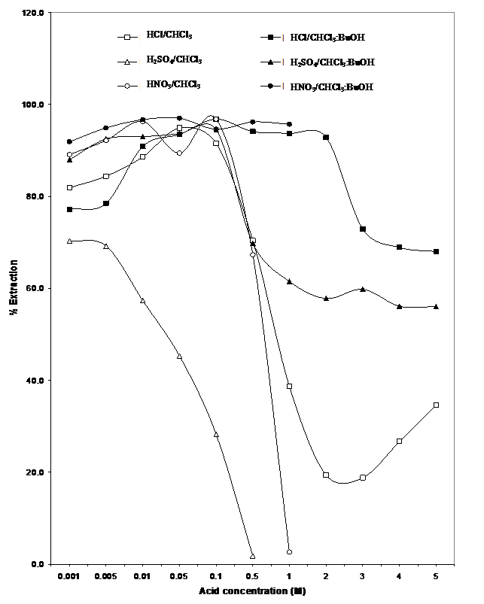 Figure 1: Variation of % Extraction of Mo(VI) with acid concentration for H₂Adp.

The synergist effect of BuOH was very obvious in the extraction of Mo(VI) from various H₂SO₄ concentrations as shown in Fig. 1, with almost 96% extraction of Mo(VI) at 0.01M H₂SO₄ acid concentration. This also fell monotonously but not drastically as was the case in the absence of BuOH in the organic phase. Hence 58 – 68% extraction was achieved even at high acid concentrations of 1M – 5M H₂SO₄.
Extraction from HCl and HNO₃ solutions also showed evidence of the synergistic effect of BuOH in the organic phase. Hence, between 96 – 98% was achieved for extractions using HCl when BuOH was introduced into the organic phase for all concentrations of HCl. However, in the absence of BuOH, this fell drastically to 0.5% at 1M HCl concentration.
For extractions using H₂SP in the presence and absence of BuOH as a synergist, plots of % extraction of Mo(VI) against acid concentrations of HCl, H₂SO₄ and HNO₃ is shown in Fig. 2.
Maximum % extraction was recorded at 80% and 50% for HCl and HNO₃ respectively between acid concentrations of 0.01M and 0.1M while at 0.001M H₂SO₄ concentration maximum % extraction of 38% was achieved, but fell monotonously to 5% at 0.5M acid concentration. Introduction of butanol into the extraction process enhanced the extraction of the metal ion in all the acid media with maximum % extraction of above 90% occurring between 0.5M and 0.05M acid concentrations for all three acids.
The results generally show that the synergist effect is more pronounced for extractions from H₂SO₄ solution more than from HCl and HNO₃ solution and so the trend can be summarized as follows:
H₂SO₄ > HCl ≈ HNO₃
Decrease in BuOH synergism for Mo(VI) extraction
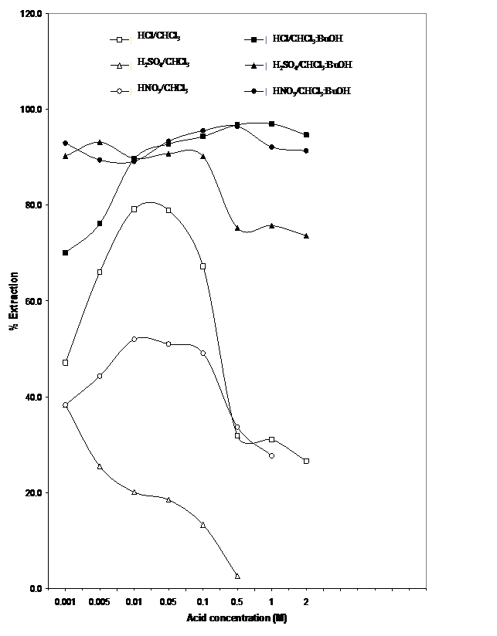Figure 2: Variation of % Extraction of Mo(VI) with acid concentration for H₂SP

From Figs. 1 and 2 above, the extraction of Mo(VI) from various acid concentrations for both ligands show that optimal % extraction is minimal at H₂SO₄ concentrations followed by HNO₃ and highest at HCl.
This has been attributed to low [H⁺] concentration from the relatively weaker acid, in which case the strong anionic conjugate base from the weak acids tend to be more reactive with the metal ions and masking them at these low acid concentrations.
These results therefore suggest that H₂Adp is a better extractant of the metal ion Mo(VI) than H₂SP. This is probably due to the differences in the chain length and orientation of the carbon atoms in these chelating agents.

3.3 Extraction Mechanism of Mo(VI)
Statistical treatment of data using slope analysis as applied to this work has earlier been discussed as reported by Uzoukwu 1998; Uzoukwu et al 1998^{b} and the mechanism of interaction presented in Figs 3 to 5. The mechanism of interaction between Mo(VI) and the ligands for H₂SO₄, HCl and HNO₃ solutions are presented as plots of log D versus log [Acid] in Fig 3. 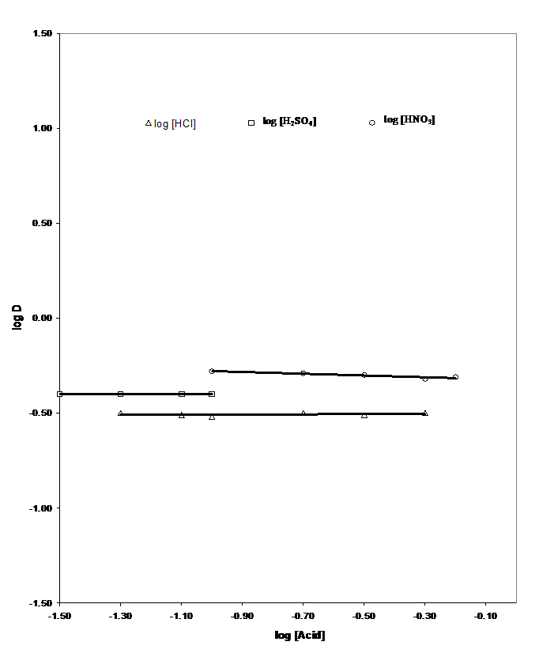
Figure 3: Plot of log D Vs log [Acid] for Mo(VI) with H₂Adp

The plots on Figs 3 show that the slopes are zero; hence applying equation (12), the value of “x” is equal to zero. Equation (8) presented a situation in which the extraction of the metal may take place through ion pair complex formation. However, from the result obtained from the slope analysis, it is therefore evidenced experimentally that the acids were not incorporated in the complex during the extraction process. Therefore no ion pair complex was extracted into the organic phase. This shows that the appropriate equation for the extraction of the non-ion pair complex is that of equation (1).
Figure 4 also shows that the slope obtained from plots of log D versus metal ion concentration is equal to zero as well. Hence, on applying statistical methods the extraction of the non-ion pair complex species implies that 1 mole of M_{O}O₂²⁺ is involved according to equation 8 where “a - 1=0”. This is an indication that 1 mole of the metal ion is involved in the extraction process since the log D plot is independent of changes in the metal ion concentration.
The interaction between the concentrations of the ligand is shown in figure 5 for the extraction of Mo(VI). A slope of one was recorded for all the three acids studied. Since there is no adduct complex formation as shown by the involvement of only 1 mole of Mo(VI) therefore “c” in equation (1) is then equal to zero. Hence from equation (6)
b + c = 1
b = 1 since c = o
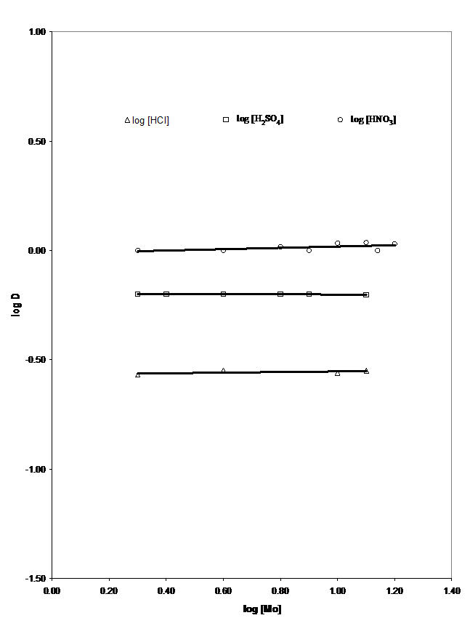
Figure 4: Plot of log D Vs log [Mo] with H₂Adp.

With b = 1 and c = o this is an indication that 1 mole of the ligand was involved in the extraction process. Since it is a quadridentate ligand this implies that 2 moles of protons were released in the process.
Therefore the extraction process can be presented as follows:
M_{O}O₂²⁺ + H₂Adp_{(o)} M_{O}O₂(Adp)_{(o)} + 2H⁺
…………… (14)

[M_{O}O₂ (Adp)_{(o)} ] [H⁺]
K_{ex} = [M_{O}O₂²⁺] [H₂Adp]_{(o)} ……… (15)

log D = log K_{ex} + log [ H₂Adp]_{(o)} – 2 log [H⁺] ……… (16)

Similarly, extraction of Mo(VI) using the ligand H₂SP followed the same trend (fig 6).
Therefore the extraction process can equally be presented as follows:

M_{O}O₂²⁺ + H₂SP_{(o)} M_{O}O₂(SP)_{(o)} + 2H⁺
....… (17)

[M_{O}O₂ (SP)_{(o)} ] [H⁺]
K_{ex} = [M_{O}O₂²⁺] [H₂SP]_{(o)} …… (18)

log D = log K_{ex} + log [ H₂SP ]_{(o)} – 2 log [H⁺] ………… (19)

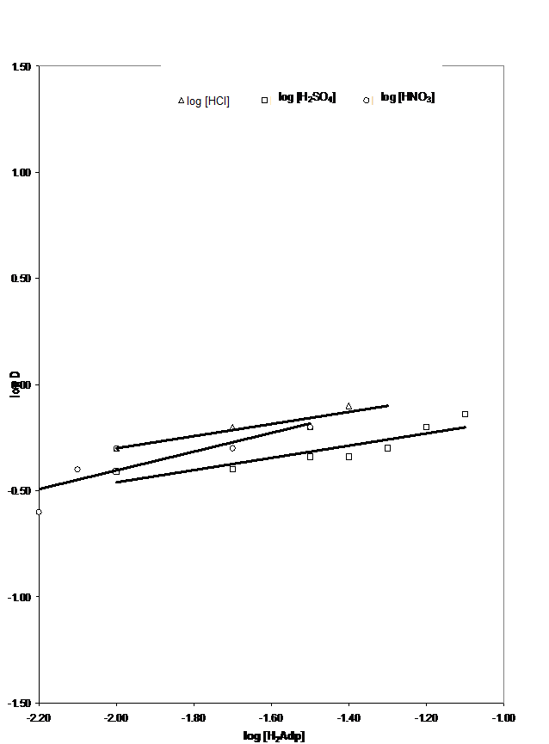

Figure 5: Plot of log D Vs log [H₂Adp] with Mo(VI)

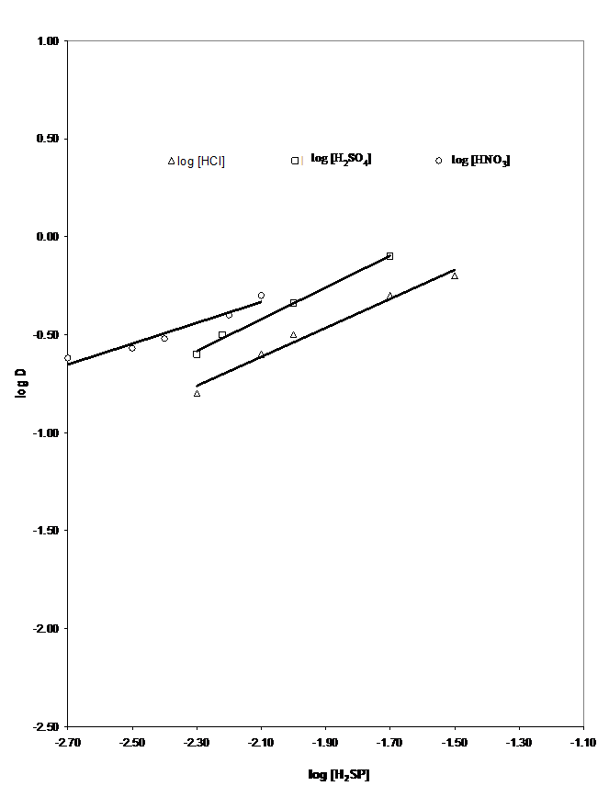
Figure 6: Plot of log D Vs log [H₂Adp] with Mo(VI)

4. Conclusion
Extraction of Mo(VI) ions using 0.01M of the ligand H₂Adp in chloroform from various acidic medium gave optimal % extraction above 90% within 0.01M and 0.5M acid concentrations for HCl and HNO₃ while extractions in H₂SO₄ solutions gave a slightly lower % extraction yield of 70% within the concentration range of 0.001 and 0.005. In the case of the ligand H₂SP, a much lower % extraction yield of 80% for HCl, 50% for HNO₃ and 39% for H₂SO₄ was obtained within the same acid concentrations.
Introduction of butanol as a synergist into the extraction system greatly enhanced the overall optimal % extraction to 98% and 95% for extractions using 0.01M H₂Adp and H₂SP in chloroform respectively, within the acid concentrations of 0.01M and 1.0M in all cases. In addition, increase in acid concentrations above 1.0M has a masking effect on the extraction of Mo(VI) ions likewise very dilute acid concentration below 0.01M. Hence extraction of Mo(VI) using 0.01M H₂Adp and H₂SP in chloroform is best favored within the acid concentration of 0.01M and 1.0M.
Using theoretical considerations and slope analysis, the extracted species were found to be M_{O}O₂(Adp)_{(o)} and M_{O}O₂(SP)_{(o)}.

Correspondence to:
Ihesinachi A. Kalagbor
Department of Science Laboratory Technology, Rivers State Polytechnic, Bori,
P.M.B. 20, Bori, Nigeria.
Telephone: +234 803 3098983
E-mail: ksinachi@yahoo.com

References
- Allen, S.E. Grinshaw H.M., Parkinson, J.A. and Quarmby C. (1974). Chemical Analysis of Ecological Materials. Blackwell Scientific Publication, Oxford, 179 – 314.
- Atanassova, M., Dukov, I. L. “Synergistic solvent extraction of trivalent lanthanoids with mixtures of 1-phenyl-3-methyl-4-benzoyl-5-pyrazolone and crown ethers”. Acta Chim. Slov. 2006; 53: 457–463.
- Bond, A. H., Chiarizia, R., Huber, V., Dietz, M. L., Herlinger, A. W., Hay, B. P. “Synergistic solvent extraction of alkaline earth cations by mixtures of di-n-octylphosphoric acid and stereoisomers of dicyclohexano-18-crown-6”. Anal. Chem. 1999; 71: 2757-2765.
- Bukowsky H., Uhlemann, E. Gloe, K. and Muhl P. (1992). Heterocyclic Tantomerism VII: X-Ray structures of Two Crystalline Tautomers of 4-Cinnamoyl-1,3-dimethylpyrazol-5-one. Anal. Chim. Acta 257, 105 – 268.
- Chukwu U. J., Uzoukwu, B. A. “Synergistic extraction of Zn²⁺ from aqueous buffer medium of chloride ions into 1- phenyl -3- methyl -4- Trichloro Acetyl Pyrazolone - 5 in Benzene and Hexane". Recent Patents on Materials Science. 2010; 3(2): 146-150.
- Jeffrey G. H., Bassett, J., Mendham, J. and Denny, R. C. eds. (1998). Vogels Textbook of Quantitative Chemical Analysis, 5th ed.
- Koladkar D. V. and Dhadke P. M. (2002). Solvent extraction of Sc(III) from Sulphuric acid solution by bis (2-ethylhexyl) phosphinic acid in toluene. J. Serb. Chem. Soc. 67 (40, 265 – 272).
- Okafor, E. C., Uzoukwu, B. A. “Extraction of Fe(III) and U(IV) with 1 ‐ phenyl ‐3‐ methyl ‐4‐ acyl‐ pyrazolones‐5 from aqueous solutions of different acids and complexing agents. Separation of Fe(III) from U(IV)”. Radiochimica Acta. 1990; 51: 167-172.
- Okafor, E. C. and Uzoukwu, B. A. (1991). Introducing a new bis (B-disketone): synthesis, UV-visible, IR, ¹H and ^{B}CNMR Spectral studies of 4sebacoyl-bis(1-phenyl-3-methylpyrazolone-5) and its U(VI), Fe(III) and Ca(II) complexes. Synth, React Inorg. Met. Org. Chem. 21 825
- Okafor, E. C., Adiukwu, P. U., Uzoukwu, B. A. “Synthesis and characterization of 4-iso-butyrl and 4-iso-valeroyl derivatives of 1-phenyl-3-methyl pyrazolone-5 and their U(VI), Th(IV), La(III), Fe(III), Pb(II) and Ca(II) complexes”. Synth. React. Inorg Met – Org Chem. 1993; 23(1): 97-111.
- Umetani, S., Kihara, S., Matsui, M. “Adduct formation properties of some polydentate phosphine oxides in the synergistic extraction of metals with 4-acyl-5 pyrazolone derivatives”. Solvent Extraction. 1990; 1992: 309-314.
- Uzoukwu, B. A. (1998a). A monograph presented at the conference on separatora “Kinetics of solvent extraction of metals from aqueous medium by 4-acylpyrazolones” held at Bydgoszcz, Poland organized by the Polish Chemical Society
- Uzoukwu, B. A., Adiukwu, P. U. “Spectroscopic studies of Th(IV), La(II) and Pb(II) complexes of 4-trifluoroacetyl and 4-trichloroacetyl derivatives of 3-methyl-1-phenylpyrazol-5-one”. J. Natn. Sci. coun. Sri Lanka. 1996; 24(3): 221-225.
- Uzoukwu, B. A., Adiukwu, P. U., Al-Juaid, S. S., Hitchcock, P. B., David Smith, J. “Pyrazolonato complexes of lead, crystal structures of bis (1-phenyl-3-methyl-4-acetylpyrazolonato) lead (II) and bis(1-phenyl-3-methyl-4-butanoyl pyrazolonato) lead (II)”. Inorganic Chimica Acta. 1996; 250: 173-176.
- Uzoukwu, B. A., Gloe K. and Duddeck, H. (1998). Metal (II) complexes of 4- acylbis (pyrazolone-5): synthesis and Spectroscopic. Synth. React Inorg. Met. Org. Chem. 28 (2), 207.
- Uzoukwu, B. A., Gloe K. and Duddeck, H. (1998^{b}). Extraction of Uranium(VI) and Vanaduim (V) with 4-adipoyl and 4-sebacoyl derivatives of bis(1-phenyl-3-methyl-pyrazolone-5) and effect of decanol on the distribution behaviour of these metal ions. Solv. Extr. and Ion exch. 16 (3), 751.
- Uzoukwu, B. A. and Okafor, E. C. (1990). Extraction of Fe(III) and U(IV) with 1-phenyl-3-methyl-4-acylpyrazolones-5 from aqueous solution of different acids and complexing agents. Radiochim Acta 51, 167.

03/01/11

