On the Chromosomes of two Cyprinid Fishes of the Subfamily Schizothoracinae from Kashmir.

^{*1}Farooq Ahmad Ganai, ¹Abdul Rahman Yousuf, ²Narinder Kumar Tripathi, ¹Ummer Rashid Zargar
¹ Limnology and Fisheries Laboratory, Centre of Research for Development, University of Kashmir, Hazratbal Srinagar-190 006 (India). Email: farooqmd84@gmail.com
²Animal Cytogenetics Laboratory, Deptt. Of Zoology, University of Jammu.
*Corresponding author: Farooq Ahmad Ganai. Email: farooqmd84@gmail.com.

Abstract: Karyotypic study of two Schizothorax species viz. Schizothorax plagiostomus and Schizothorax curvifrons belonging to family Cyprinidae, from River Jhelum Kashmir, was carried out. Conventional KCl-acetomethanol air-drying protocol was followed for the chromosomal preparation. The diploid chromosome number in S.plagiostomus was 96 with a chromosomal formula of 24m+18Sm+54t and fundamental number (NF) =138. Diploid chromosome number in S.curvifrons was 94 with Karyotypic formula 26m+20Sm+20St=28t and fundamental arm number (NF) =140. The evolutionary significance of polyploidy and the role of chromosomal rearrangements was discussed. Both these fishes are new to cytological literature.
[Farooq Ahmad Ganai, Abdul Rahman Yousuf, Narinder Kumar Tripathi, Ummer Rashid Zargar. On the Chromosomes of two Cyprinid Fishes of the Subfamily Schizothoracinae from Kashmir. Nature and Science 2011;9(3):53-61]. (ISSN: 1545-0740). http://www.sciencepub.net.

Key words: Schizothorax plagiostomus, Schizothorax curvifrons, River Jhelum, Karyotype.

Introduction
Cytogenetic studies in recent years gained a considerable importance concerning species characterization, evolution and systematic (Gold et al., 1990; Barat et al., 2002). The cytogenetical studies in fishes are limited to just about 10% of the total fishes known taxonomically all over the world (Barat et al., 1996). Fish chromosome data have great importance concerning evolution, systematics, aquaculture and mutagenesis (Al-Sabti, 1991). Chromosomal studies in fishes have not been as successful as those in other vertebrates because of relatively small size and large number of chromosomes found in many fish species and the limitations of the techniques employed (Klinkhardt, 1991). The air-drying technique, originally developed for mammalian organisms, is the most common procedure used for chromosome preparation in fish.
The increasing importance of chromosomal studies and the lack of data on fish karyotypes in Kashmir prompted us to examine the chromosomal content of Schizothorax plagiostomus and Schizothorax curvifrons. Both these fishes belong to subfamily Schizothoracinae, a widely distributed group in mountain streams, rivers and lakes around Himalayan Karakorum and Hindukush Ranges, The Tibet Plateau and Central Asia. These two fishes inhabit the River Jhelum, Lidder stream, Sindh Nallah of Kashmir Valley (Kullander et al., 1999).
In this study, cytogenetic analysis of S.plagiostomus and S.curvifrons from River Jhelum was carried out with air-drying technique to determine their basic karyological structure. Both these species are new to cytological literature.
Materials and Methods
Ten live specimens (five each for S.plagiostomus and S.curvifrons) were collected from River Jhelum, near Chattabal Downtown Srinagar. The initial identification was made on the basis of morphology (Kullander et al., 1999).
Chromosome and Karyotype analysis
All the samples were injected intraperitoneally with 0.05% Colchicine (Sigma, US) 1ml/100gm of body weight and kept alive for 2-3 hrs in fully aerated aquaria. Anterior kidney tissue was processed for chromosome preparation following conventional KCl-acetomethanol-air-drying protocols (Khuda-Bukhsh and Barat, 1987). The slides were stained with 2% Giemsa stain in phosphate buffer (PH 6.8). Leica DM LS2 trinoccular microscope fitted with a camera and 100x×10x oil immersion lens combination was used to scan the cells and take the photographs. Fifty to sixty well spread metaphase complements were obtained for each species. The chromosomes of 5 well spread metaphase complements for each species were individually measured from photomicrographs with precision dial callipers and their centromeric indices and arm ratios were determined in order to ascribe the morphology as suggested by Levan et al. (1964). Using chromosomal indicators (Table II and Table III) an ideogram (Figure 3 and Figure 4) was prepared for each species in MS Excel 2007 software.

Results
Schizothorax plagiostomus: Chromosome number counts from 60 cells from five individuals varied between 94-100 (Table I). The modal value of 2n=96 was seen in 60% of the cells examined. The diploid metaphase complements consisted of 96 chromosomes measuring between 2-8µm.Detailed karyotype analysis revealed that the 96 chromosomes comprised of 24 metacentric, 18 submetacentric and 54 telocentric chromosomes. The number of chromosome arms was determined as (NF) =138 and the chromosomal formula can be expressed as 29=24m+18Sm+54t (Figure 1).
Schizothorax curvifrons: The somatic metaphase complements contained 94 chromosomes in 40 out of 50 cells studied (Table I). Therefore, the diploid chromosome number in this species was ascertained to be 94 and the karyotype (Figure 2) consisted of 2n=26m+20Sm+20St+28t with the fundamental arm number (NF) of 140. The size of the chromosome varied between 10.4-1µm. Cells not showing modal counts were probably caused by loss during preparation or by chromosomes being obscured by surrounding cell nuclei. ‘
Discussion
Fishes are the most speciose vertebrate group, with an estimated 24618 recognised species; more than half the total number of living vertebrate species (Nelson, 1994) and exhibit a bewildering range of diversity in their ecology, morphology, life history, behaviour and physiology (Comber and Smith, 2004). Despite their diversity, they have remained cytologically neglected as standard karyotypes are reported for less than 10% of the total extant species of fish (Gold et al. 1990).
Both the species of Schizothorax analysed cytologically in the present study revealed a high number of chromosomes ranging from 94-96. . Species with high numbers are considered to have resulted through polyploidy from ancestral 2n= 48 or 50 (Rishi et al., 1998). Large-scale genomic expansions or whole-genome duplication events have been documented in early vertebrate evolution(Friedman and Hughes, 2001; Ohno.1970; Wang and Gu,2000), near the base of the phylogenetic tree of teleost fishes (Christoffels et al., 2004; Meyer and Schartl, 1999; Robinson-Rechavi et al., 2001;Wittbrodt et al., 1998), and near the basal roots of several major teleostean clades [such as salmonids (Allendorf and Thorgaard, 1984), catastomids (Ferris, 1984; Uyeno and Smith,1972), acipenserids (Vasil’ev,1999) and some cyprinids (Larhammer and Risinger,1994)]. Such genomic enlargements have been hypothesised as key factors that enable or even drive diversification in various vertebrate groups (Holland et al., 1994; Meyer and Malaga-trillo, 1999; Navarro and Barton, 2003a,b; Ohno,1970; Stephens,1951). Chromosome counts in nearly all cyprinid polyploids occur in multiples or combinations of the most common karyotype (48-50) and tetraploids (96, 98 or 100) and hexaploids (148-150) have arisen through hybridisation (Dowling and Secor, 1997). Our results suggest that these fishes are tetraploid. This is well illustrated by a number of species of fish belonging to diverse orders. Buth et al., (1991) noted 52 such taxa most of which belong to cyprinidae identified through karyological analysis (Dowling and Secor, 1997) and such forms are ancestral polyploids (Ohno et al., 1969). Polyploidy in fishes has been associated with traits including large body size, fast growth rate, long life and ecological adaptability (Uyeno and Smith, 1972; Schultz, 1980). Since Schizothorax fishes are hill stream fishes, it may be that polyploidy may have resulted on account of cold temperature of their habitat. The use of thermal shocks to eggs for induction of polyploidy (Chourrout, 1988) provides support to the above assertion. The role of polyploidy in evolution and survival of fish is very important because it prevents from natural selection pressure (Oellerman and Skelton, 1990).
Schizothorax plagiostomus revealed a diploid number of 29=96 (24m+18Sm+54t) and NF=138 while as S.curvifrons showed a diploid number of 29=94 (26m+20Sm+20St+28t) and NF=140. Decrease in the 2n and NF may be attributed to the Robertsonian arrangements and pericentric inversion (Choudhury et al., 1982).
The chromosomes of S.curvifrons were categorized into four groups (Fif.2) viz. Metacentric, submetacentric, subtelocentric and telocentric but none of the chromosomes could be recognised as subtelocentric in S.plagiostomus because cyprinid fishes are characterised by presence of relatively small chromosomes with their centromeric positions ranging gradually from median to nearly terminal, making it difficult to assign some chromosomes to particular chromosomal categories and thus making correct identification of individual chromosomes nearly impossible (Rab and Collares-Pereira, 1995). And the karyological study of teleost fish presents technical difficulties which are not encountered in the study of other vertebrates and these difficulties are due to small size and high number of chromosomes (Cucchi and Baruffaldi, 1990). Further, differential arm contraction can alter a chromosome classification in a karyotypic formula (Joswiak et al., 1980).
The overall dissimilarity in the 2n, Karyotypic configuration and NF points to the role of almost all types of chromosomal rearrangements in the karyological evolution of these two fishes. Both these fishes are new to the cytological literature.

Table I: Showing percentage frequency of the metaphases.

Species | No. Of chromosomes | No. Of cells | Frequency % of chromosomes | Modal diploid No.
Schizothorax plagiostomus | 94 | 5 | 8.33
Schizothorax plagiostomus | 96 | 36 | 60 | 96
Schizothorax plagiostomus | 98 | 12 | 20
Schizothorax plagiostomus | 100 | 7 | 11.66
Schizothorax curvifrons | 92 | 4 | 8
Schizothorax curvifrons | 94 | 40 | 80 | 94
Schizothorax curvifrons | 96 | 6 | 12

Table II: Chromosome morphometry of Schizothorax plagiostomus (m=metacentric; Sm= sub-metacentric; St= sub-telocentric; t=telocentric).

Pair No. | Length of short arm (µm) ‘S’ | Length of long arm (µm) ‘L’ | Total length(µm) ‘L+S’ | Arm ratio (L/S) | Centromeric index | Category
1 | 3 | 5 | 8 | 1.6 | 37.5 | m
2 | 4 | 4 | 8 | 1 | 50 | m
3 | 3 | 4 | 7 | 1.3 | 42.8 | m
4 | 3 | 3 | 6 | 1 | 50 | m
5 | 3 | 3 | 6 | 1 | 50 | m
6 | 3 | 3 | 6 | 1 | 50 | m
7 | 2 | 3 | 5 | 1.5 | 40 | m
8 | 2 | 3 | 5 | 1.5 | 40 | m
9 | 2 | 3 | 5 | 1.5 | 40 | m
10 | 2 | 3 | 5 | 1.5 | 40 | m
11 | 2.5 | 2.5 | 5 | 1 | 50 | m
12 | 2 | 2 | 4 | 1 | 50 | m
13 | 2 | 5 | 7 | 2.5 | 28.5 | Sm
14 | 2 | 5 | 7 | 2.5 | 28.5 | Sm
15 | 2 | 5 | 7 | 2.5 | 28.5 | Sm
16 | 2 | 4 | 6 | 2 | 33.3 | Sm
17 | 1 | 3 | 4 | 3 | 25 | Sm
18 | 1 | 2.5 | 3.5 | 2.5 | 28.5 | Sm
19 | 1 | 2.5 | 3.5 | 2.5 | 28.5 | Sm
20 | 1 | 2 | 3 | 2 | 33.3 | Sm
21 | 1 | 2 | 3 | 2 | 33.3 | Sm
22 | 0 | 4 | 4 | ∞ | 0 | t
23 | 0 | 4 | 4 | ∞ | 0 | t
24 | 0 | 4 | 4 | ∞ | 0 | t
25 | 0 | 4 | 4 | ∞ | 0 | t
26 | 0 | 4 | 4 | ∞ | 0 | t
27 | 0 | 4 | 4 | ∞ | 0 | t
28 | 0 | 4 | 4 | ∞ | 0 | t
29 | 0 | 4 | 4 | ∞ | 0 | t
30 | 0 | 3 | 3 | ∞ | 0 | t
31 | 0 | 3 | 3 | ∞ | 0 | t
32 | 0 | 3 | 3 | ∞ | 0 | t
33 | 0 | 3 | 3 | ∞ | 0 | t
34 | 0 | 3 | 3 | ∞ | 0 | t
35 | 0 | 3 | 3 | ∞ | 0 | t
36 | 0 | 3 | 3 | ∞ | 0 | t
37 | 0 | 3 | 3 | ∞ | 0 | t
38 | 0 | 3 | 3 | ∞ | 0 | t
39 | 0 | 3 | 3 | ∞ | 0 | t
40 | 0 | 3 | 3 | ∞ | 0 | t
41 | 0 | 3 | 3 | ∞ | 0 | t
42 | 0 | 3 | 3 | ∞ | 0 | t
43 | 0 | 2.5 | 2.5 | ∞ | 0 | t
44 | 0 | 2.5 | 2.5 | ∞ | 0 | t
45 | 0 | 2 | 2 | ∞ | 0 | t
46 | 0 | 2 | 2 | ∞ | 0 | t
47 | 0 | 2 | 2 | ∞ | 0 | t
48 | 0 | 2 | 2 | ∞ | 0 | t

Pair No.  Table III: Chromosome morphometry of Schizothorax curvifrons (m=metacentric; Sm= sub-metacentric; St= sub-telocentric; t=telocentric). | Length of short arm (µm) ‘S’ | Length of long arm (µm) ‘L’ | Total length(µm) L+S | Arm ratio (L/S) | Centromeric index | Category
1 | 5.2 | 5.2 | 10.4 | 1 | 50 | m
2 | 5 | 5 | 10 | 1 | 50 | m
3 | 5 | 5 | 10 | 1 | 50 | m
4 | 4 | 4.5 | 9.5 | 1.12 | 42.1 | m
5 | 4 | 4.5 | 9.5 | 1.12 | 42.1 | m
6 | 3 | 3.5 | 6.5 | 1.16 | 46.1 | m
7 | 3 | 3.5 | 6.5 | 1.16 | 46.1 | m
8 | 3 | 3 | 6 | 1 | 50 | m
9 | 2.5 | 2.5 | 5 | 1 | 50 | m
10 | 2.3 | 2.3 | 4.6 | 1 | 50 | m
11 | 2 | 2 | 4 | 1 | 50 | m
12 | 2 | 2 | 4 | 1 | 50 | m
13 | 2 | 2 | 4 | 1 | 50 | m
14 | 3 | 5.5 | 8.5 | 1.83 | 35.2 | Sm
15 | 2.9 | 5.4 | 8.3 | 1.86 | 34.9 | Sm
16 | 2.5 | 5.3 | 7.8 | 2.12 | 32.0 | Sm
17 | 2.2 | 5 | 7.7 | 2.27 | 28.5 | Sm
18 | 2 | 5 | 7 | 2.50 | 28.5 | Sm
19 | 1.8 | 4.1 | 5.9 | 2.27 | 30.5 | Sm
20 | 1.5 | 3.8 | 5.3 | 2.53 | 28.3 | Sm
21 | 1.2 | 3.3 | 4.5 | 2.75 | 26.6 | Sm
22 | 1.2 | 3.3 | 4.5 | 2.75 | 26.6 | Sm
23 | 1 | 2.8 | 3.8 | 2.80 | 26.3 | Sm
24 | 1.3 | 4.8 | 6.1 | 3.69 | 21.3 | St
25 | 1 | 4.5 | 5.5 | 4.5 | 18.1 | St
26 | 1 | 4.2 | 5.2 | 4.2 | 19.2 | St
27 | 1 | 4 | 5 | 4 | 20 | St
28 | 1 | 3.8 | 4.8 | 3.8 | 20.8 | St
29 | 1 | 3.8 | 4.8 | 3.8 | 20.8 | St
30 | 1 | 3.7 | 4.8 | 3.8 | 20.8 | St
31 | 1 | 3.6 | 4.6 | 3.6 | 21.7 | St
32 | 1 | 3.6 | 4.6 | 3.6 | 21.7 | St
33 | 1 | 3.6 | 4.6 | 3.6 | 21.7 | St
34 | 0 | 6 | 6 | ∞ | 0 | t
35 | 0 | 6 | 6 | ∞ | 0 | t
36 | 0 | 6 | 6 | ∞ | 0 | t
37 | 0 | 5 | 5 | ∞ | 0 | t
38 | 0 | 5 | 5 | ∞ | 0 | t
39 | 0 | 5 | 5 | ∞ | 0 | t
40 | 0 | 5 | 5 | ∞ | 0 | t
41 | 0 | 5 | 5 | ∞ | 0 | t
42 | 0 | 5 | 5 | ∞ | 0 | t
43 | 0 | 4 | 4 | ∞ | 0 | t
44 | 0 | 4 | 4 | ∞ | 0 | t
45 | 0 | 4 | 4 | ∞ | 0 | t
46 | 0 | 3 | 3 | ∞ | 0 | t
47 | 0 | 1 | 1 | ∞ | 0 | t

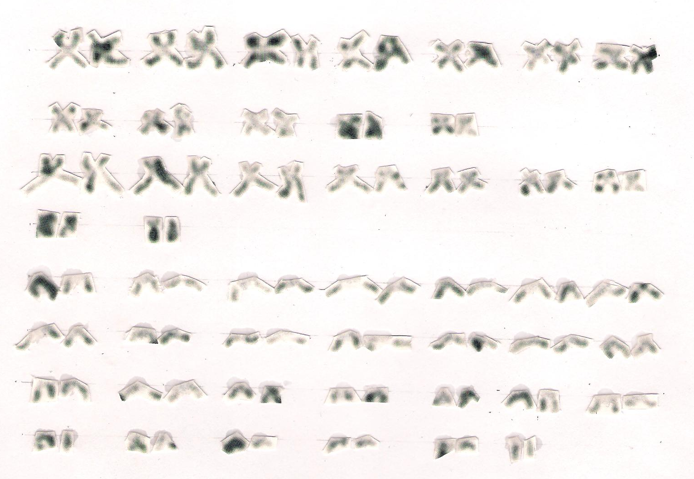
m

Sm

t

Figure 1: Karyotype of Schizothorax plagiostomus
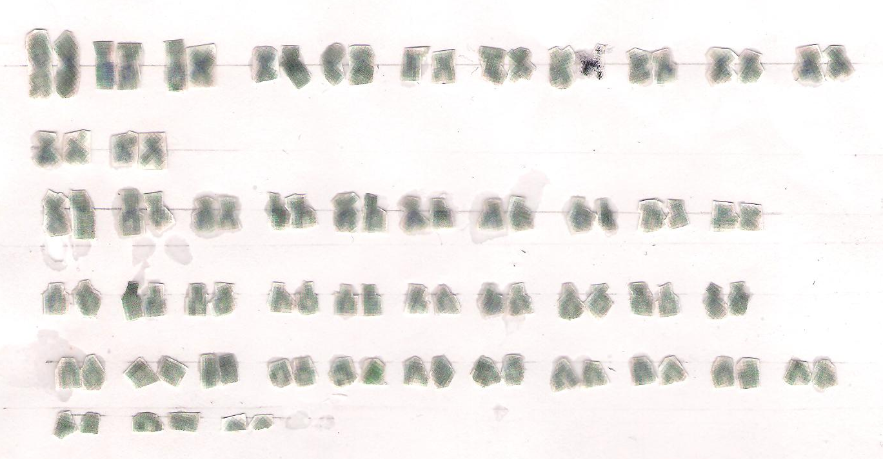
m

Sm

St
t

Figure 2: Karyotype of Schizothorax curvifrons

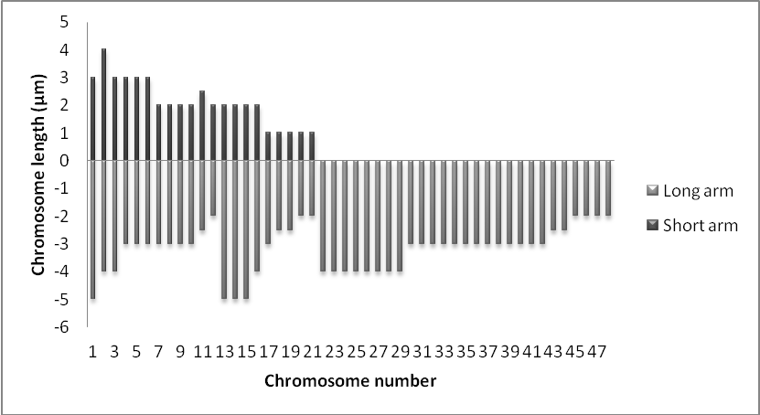
Figure 3: Haploid ideogram of Schizothorax plagiostomus.

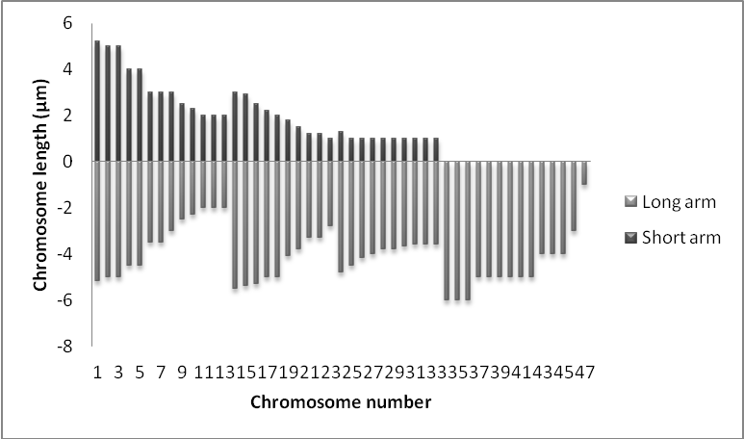
Figure 4: Haploid ideogram of Schizothorax curvifrons.

Date of submission: 11-02-2011.

Acknowledgement
The authors wish to thank the Director of the department for research facilities. We are also thankful to Dr. Farooz Ahmad Bhat, Assistant Professor division of Fisheries SKAUST-K for his help in the identification of the fish and CSIR, New Delhi for providing financial assistance in the form of JRF to Farooq Ahmad.

References
1. Allendorf F W and Thorgaard G H. Tetraploidy and the evolution of salmonid fishes. In: Evolutionary genetics of fishes (ed. B.J. Turner) 1984; pp. 1-53. N.Y.: Plenum Press.
2. Al-Sabti K. Handbook of Genotoxic effects and fish chromosomes. Ljubljana 1991; p.97.
3. Barat A, Sahoo P K, Ponniah A G. Karyotype and localization of NOR in threatened species Tenualosa ilisha (Ham) (Cluppidae: Pisces). La Kromosomo II.1996; 82:2828-2832.
4. Barat A, Sahoo PK, Ponniah AG. Karyotype and Nucleolar Organizer Regions (NORs) in a few hill stream fishes. In: Ayyappan S, Jena JK, Joseph MM (Eds). The Fifth Indian Fisheries Forum Proceedings, AFSIB, Mangalore and AoA, Bhubaneswar, 2002; pp.111-114.
5. Buth DG, Dowling TE and Gold JR. Molecular and cytological investigations. In: The biology of cyprinid fishes, Ed. I Winfield, J Nelson 1991; pp.83-126. London: Chapman and Hall.
6. Choudhury RC, Prasad R and Das CC. Karyological studies in five Tetradontiform fishes from the Indian Ocean. Copeia 1982; 3:728-732.
7. Chourrout D. Induction of gynogenesis, triploidy in fish, ISI Atlas of Science. Animal plant Sci.1988:65-70
8.Christoffels A, Koh EGL, Chia JM, Brenner S, Aparicio S and Venkatesh B. Fugu genome analysis provides evidence for whole-genome duplication early during the evolution of ray finned fishes. Mol. Biol. Evol.2004; 21:1146-1151.
9. Comber SCL and Smith C. Polyploidy in fishes: patterns and processes. Biological journal of the Linnaean Society 2004; 82:431-442.
10. Cucchi C and Baruffaldi A. A new method for karyological studies in teleost fishes. J.Fish. Biol.1990; 37:71-75.
11. Dowling TE and Secor CL. The role of hybridisation and introgression in the diversification of Animals. Annual Review of Ecology and Systematics 1997; 28:593-619.
12. Ferris SD. Tetraploidy and the evolution of catostomid fishes. In: Evolutionary genetics of fish (ed. B.J. Turner), 1984. N.Y: Plenum Press.
13. Friedman R and Hughes AL. Pattern and timing of gene duplication in animal genomes. Genome Res.2001; 11:1842-1847.
14. Gold JR, Li YC, Shipley and Powers PK. Improved methods for working with fish chromosomes with a review of metaphase chromosome banding. J. Fish. Biol.1990; 37:563-575.
15. Holland PW, Garcia-Fernandz J, Williams JW and Sidow A. Gene duplication and the origin of vertebrate development. Dev. Suppl.1994; 125-133.
16. Joswiak GR, Starnes WC and Moore WS. Karyotypes of three species of genus Phoxinus (Pices: Cyprinidae). Copeia 1980; 4:913-916.
17. Khuda-Bukhsh and Barat A. Chromosomes in fifteen species of teleosts (Pisces). Caryologia 1987; 40:131-144.
18. Klinkhardt MB. A brief comparison of methods for preparing fish chromosomes: an overview. Cytobios 1991; 67:193-208.
19. Kullander SO, Fang F, Delling B and Ahlander E. The fishes of Kashmir Valley. In: River Jhelum, Kashmir Valley, Impacts on the aquatic environment. Lenart Nyman (Ed.) 1999; pp.99-163.
20. Larhammer D and Risinger C. Molecular genetic aspects of tetraploidy in the common carp, Cyprinus carpio. Mol. Phylogenet. Evol.1994; 3:59-68.
21. Levan A, Fredga K and Sandberg AA. A nomenclature for centromeric position on chromosomes. Heriditas 1964; 52:201-220.
22. Meyer A and Malaga-Trillo E. Vertebrate genomics: more fishy tales about Hox genes. Curr. Biol.1999; 9:210-213.
23. Meyer A and Schartl M. Gene and genome duplications in vertebrates: the one-to-four (to-eight in fish) rule and the evolution of novel gene functions. Curr. Opin. Cell Biol.1999; 11; 699-704.
24. Navarro A and Barton NH. Accumulating post-zygotic isolation gene in parapatry: a new twist on chromosomal speciation. Evolution 2003a; 57:447-459.
25. Navarro A and Barton NH. Chromosomal speciation and molecular divergence-accelerated evolution in rearranged chromosomes. Science 2003b; 300:321-324.
26. Nelson JS. Fishes of the world. 3^{rd.} ed.1994. New York: John Wiley, Sons, Inc.
27. Oellerman LK and Skelton PH. Hexaploidy in yellow fish species (Barbus, Pisces, Cyprinidae) from Southern Africa. J.Fish Biol.1990; 37:105-115.
28. Ohno S, Muramoto JI, Klein J and Atkin NB. Chromosomes today. Vol.2. (eds. Darlington, C.D and Lewis, K.P.) 1969; pp.139-147. Oliver and Boyd, Edinburgh.
29. Ohno S. Evolution by gene duplication. Springer-Verlag 1970; Berlin and New York
30. Rab P and Collares-Pereira MJ. Chromosomes of European cyprinid fishes (Cyprinidae, Cypriniformes). A review. Fol. Zool.1995; 44:193-214.
31. Rishi KK, Shashikala and Rishi S. Karyotype study on six Indian hill-stream fishes. Chromosome Science 1998; 2:9-13.
32. Robinson-Rechavi M, Marchand O, Schriva H, Bardet PL, Zelus D, Hughes S and Laudet V. Euteleost fish genomes are characterized by expansions of gene families. Genome Res.2001; 11:781-788.
33. Schultz RJ. The role of polyploidy in the evolution of fishes. In: Lewis, EW.H, ed. Polyploidy: biological relevance. New York: Plenum Presss.1980; 313-339.
34. Stephens SG. Possible significance of duplications in evolution. Adv. Genet.1951; 4:247-265.
35. Uyeno T and Smith GR. Tetraploid origin of the karyotype of catostomid fishes. Science 1972; 175:644-646
36. Vasil’ev VP. Polyploidization by reticular speciation in acipenseriform evolution: a working hypothesis. J. Appl. Ichthyol.1999;15:29-31.
37. Wang Y and Gu X. Evolution of gene families generated in the early stages of vertebrates. J. Mol. Evol.2000; 51:88-96
38. Wittbrodt J, Meyer A and Schartl M. More genes in fish? Bioessays 1998; 20:511-512.

2/10/2011

