Spatial distribution and habitat preferences of selected large mammalian species in the Nech Sar National Park (NSNP), Ethiopia
Aramde Fetene¹, Girma Mengesha² and Tsegaye Bekele³
¹Debre Markos University, Department of Natural Resources Management, P.O Box 269 email: aramdefetene@yahoo.com
²Wondo Genet College of Forestry & Natural resource, Department of wildlife & Ecotourism Management, P.O.Box 128, Shshemene, Ethiopia
³Associate Professor, Hawasa University, Planning and Programming Office, P.O. Box 05, Hawassa, Ethiopia, e-mail:bekele57@yahoo.com (corresponding author)

ABSTRACT. A study on spatial distribution and habitat preferences of five large mammal species was conducted in the Nech Sar National Park (NSNP) for one year from January 2007-January 2008. The spatial distribution and habitat preference information is useful to propose appropriate patrol strategy for the management and conservation of the species with regard to attracting tourist and management of the park. The objective of this study was to determine the spatial distribution and habitat preference of five large mammals (Defassa waterbuck, Swayne’s Hartebeest, Greater Kudu, Lesser Kudu and Black and White Colobus). For the purpose of this study, the park was divided in to three management zones and nine patrolling teams composed of six individuals were involved in the data collection. Each individual was assigned to a certain management zone to monitor the status and distribution of large mammals and the impact of human activities on the Park on daily basis. The patrolling team was equipped with Garmin Etrix Venture GPS receiver and Communication Radio and point sampling technique was used to collect the necessary information. The data was summarized and all spatial data were recorded and analyzed using GIS Software (DNRgarmin and ArcGIS9.1). DNRgarmin was used to transfer data from GPS receiver to computer. ArcGIS9.1 was used to analyze the spatial distribution of the wild animals, habitat association and human activities. Comparison of the mean on the observation of different wild animals in the NSNP was carried out using SPSS17. The results of the study showed that there were a total of 3340 observations of the five large mammals on 29013 km track movements in the NSNP. Observation in this sense does not mean the number of individuals, but the frequency of wild animals seen during the inspection. In this regard, Greater Kudu has shown a significant wider distribution in the three zones of NSNP (P>0.05), with high ecological amplitude and high tolerance range to different habitat factors. The other four large mammals were concentrated in a particular association of different habitats. Herds of Swayne’s Hartebeest were restricted only to the Nech Sar Plain, Lesser Kudu, to west of the plain, on the mountain near to the hot spring, Defassa waterbuck on a hill of wooded grasslands near to Kulfo river and, the Black and white Colobus in the riverine forests of Kulfo and Sermele river valleys. Large numbers of peoples were observed in the Arba Minch forest and Lake Chamo collecting fuel wood and harvesting fish, respectively. The results of the study are important tools for the park managers, researchers and tourists, since it revealed clear species spatial distributions and habitat preferences.
[Aramde Fetene, Girma Mengesha and Tsegaye Bekele. Spatial distribution and habitat preferences of selected large mammalian species in the Nech Sar National Park (NSNP), Ethiopia. Nature and Science 2011;9(3):80-90]. (ISSN: 1545-0740). http://www.sciencepub.net.
Key words: habitat preferences, large mammals, monitoring, Nech Sar National Park, spatial distribution

INTRODUCTION
The distribution of an organism is primarily dependent upon the suitability of the environment for its survival, growth, and reproduction. Therefore, knowledge of ecology, physiology and systematic of the concerned organisms is essential. Plants and animals follow definite types of distribution such as continuous distribution, discontinuous or disjunctive distribution, and very restricted distribution in small areas (endemic) (Odum, 1971). Animals vary widely in their tolerance to environmental conditions. Some can survive in a variety of habitats, whereas others perish when removed from their natural surroundings. However, when this natural factor is disturbed by the intervention of mankind that pushes the animals to exist outside of their range of tolerance, this condition leads them to dwindle to the point of extinction. Researchers study animal distribution to understand the spread of animal-borne diseases, to acquire knowledge about the preservation of rare species that may have special needs, and to be informed about the changing geographical conditions, and our environmental history and its future. To understand these issues, a study needs to identify the specific climate, feed habits, and geographic features that different animals require, and what areas provide the best (Encarta, 2008; Mwangi and Western, 1997). Habitat for mammals and other organisms is disappearing quickly from the Earth’s surface due to human interferences (Patterson et al., 2003). This condition particularly affects the distribution patterns of large mammals as they wander in search of preferred habitats which are found in patchy habitats of protected area. As a result, some of the rare and endangered mammalian species have shifted their original range and occur in a few habitats in some countries. But there is a lack of information on where they frequently occur and on their migratory corridor within the habitat.
Therefore, understanding of habitat preference and spatial distribution of such large herbivores mammals is basic tool for the management of protected areas and it is also a prerequisite to determine the stocking density for introduction and re-introduction of animals to and from particular habitat (Dekker et al, 1996). For instance, mammals like Swayne’s Hartebeest (Alcellaphus buselaphus swaynei) which is a highly threatened subspecies is restricted to Ethiopia (Duckworth et al, 1992). Knowledge of habitat requirement and distribution along the environmental gradient is essential not only for the species survival but also for the sustainable management and conservation of protected areas. Based on this understanding, this study was conducted to identify the key priority habitats of five large mammals and their distribution in the Nech Sar National Park (NSNP) which may be used as an input for the planning and sustainable management of this unique conservation area.

MATERIALS AND METHODS
The Study Area
The study was carried out for one year from January 2007 to January 2008 in three management zones in the NSNP. The Park was established in 1974 in the scenic part of the Rift Valley floor between two lakes namely Abaya and Chamo. It is found at a distance of 500 km south of Addis Ababa and covers about an area of 514 km² of which 78 km² is covered with water bodies. NSNP is “a mosaic of forest, open woodland, grassland and fresh water habitat” (Duckworth et al, 1992). It is located between 5⁰51'- 6⁰05'N Latitude and 37⁰32'-37⁰48'E Longitude in the Southern Nations, Nationalities and Peoples Regional State (SNNPRS) at the center of Ethiopian Rift valley with an altitudinal range of 1,108-1,650 m.a.s.l (Bolton, 1970) (Figure 1).
The Park is bounded to the east by the Amaro Mountains, to the west the town of Arba Minch and to the north and south by lakes Abaya and Chamo, respectively. In the far eastern part of the park, hot springs bubble to the surface, while numerous natural springs known as Arba Minch (meaning ‘forty springs’) are found in the western most extreme of the Park (Tamrat, 2001). There are, two main river systems that flow through the park forming riverine forests and woodlands. Sermele River crosses north-south at the eastern part of the park along the grassy plains and Acacia woodlands and meets with Miyo River. The Kulfo River flows through the north of Arba Minch and then cuts across the neck of the narrow land and ends in a swamp on the shore of Lake Chamo (Tamrat, 2001).
The park contains more than 90 mammal species and it supports more than 350 species of birds and acts as the destination of many Palaearctic and intra-Africa migrants (Duckworth et al, 1992). It is classified as one of the sixty-nine Important Bird Areas in Ethiopia. Large mammals currently present in the study area are the common Zebra, Swayne’s Hartebeest, Grant’s gazelle, Greater kudu, Guenther’s dik dik, Anabus baboon, Black and white colobus, Hippopotamus, Spotted hyaena, Mountain reedbuck, Black-backed jackal, Side striped jackal, Golden jackal, Defassa waterbuck, Bushbuck, Klipspringer, Warthog and Bush pig. Leopard and lions are also occasionally seen. Lake Chamo supports a high density of very large crocodiles (many individuals in excess of 5m in length) with a particular concentration of them at the beach known as the ‘Crocodile Market’, the largest hippo population in Ethiopia, and abundant fish including Nile perch (Whitaker, 2007).
The Arba Minch ground water forests, Kulfo and Sermele riverine forests are found within the vicinity of NSNP (Duckworth et al., 1992). The ground water forests and the Sermele valley forests are located in the western and eastern part of the park, respectively, whereas, the Kulfo riverine forest is located in between the two forests but lose to the ground water forests.

METHODS
A three patrol zones were formed by dividing the park for ease of management. Boundaries of zones were made based on the understanding of the conservation requirements of NSNP’s Principal Ecosystem Components (FZS and IBC, 2006). The patrolling teams have worked in a shift round base and the patrol zones were the eastern circuits (Figure 2) which included the hot spring and Nech Sar plain and Sermele Valley riverine forest (zone 1), the western circuits included the Chamo Letto area, Arba Minch forest and Kulfo riverine forests (zone 2), and the central circuit included the Lake Chamo and the hilly areas of the park (zone 3).
Nine patrolling teams, each composed of six wildlife scouts were formed and the total number of scouts involved in this activity was 63 including one team leader assigned to each team. Nine Garmin Etrix Venture GPS receivers were handed over to each team leaders with proper setups (such as projection with WGS 84 UTM Zone 37N, recording unit to be in meter, time to count in 24 hours format, recording of track points automatically every 20 seconds) to mark way points and track for the proposed target sites of daily monitoring activities. Daily monitoring data sheets, binocular and radio for communication were also assigned to a team to collect all necessary information Training was given for the patrolling team on how to operate the GPS receiver and data recording in the field. Both direct and indirect wild animals counting systems were employed according to their appropriateness. This includes direct wild animal observation and recording indirectly based on their droppings, spoors, caracas, nesting sites and sounds.
To make a cross check on the impact of human activity in the Nech Sar national Park an independent controlling mechanism was devised other than the regular patrol strategy. On the selected five entrance gates to the park from the Arba Minch town, five additional technicians other than the regular wildlife scouts, were assigned to record information on the people entering and coming out from the park including the items which they collected from the park area and it was without the actual contact to illegal intruders. This extra observation was carried out for the sake of comparison with the regular patrol activity and to design best strategies for monitoring wildlife and human activity in the Nech Sar National Park. This cross checking study was made for three months (December, 2007, January, 2008 and February, 2008) at the last week of each month. The five entrance gates where cross check study made are locally known as ‘Green land’, ‘Moter Sefer’, ‘Dorze Sefer’, ‘Konter Sefer’ and ‘Kulfo Bridge’.

Data analysis
The records from regular patrol data of the GPS receiver was downloaded to the computer using DNRgarmin software and saved in Arcview shape file projected both in points and lines. For the geo-referenced points from the patrol data, the associated information recorded on the data sheet were: number of observations, way points (X&Y) coordinates, altitude, date, team number, type of observation, sighting distance, total animal number including the sex and age structure, human activity, habitat type and the wild animals activities during the recording time, data with respect to all human activities and wild animals’ movements were analyzed. Data base was also established for track movements and the associated information during the study period. For comparison and to check the effectiveness of regular patrol activity, the data collected from the independent monitoring activities, from each park entrance gate were also entered into a computer, separate database was established and analysed accordingly.
The spatial distribution and habitat association of the target large mammals were analyzed using ArcGIS 9.1 and mean comparison of the observed values were made using one-way analysis of variance (ANOVA) and Tukey’s test (95% confidence interval) was used to separate means of significantly different parameters with SPSS 17 software.

RESULTS
Spatial distribution of wild animals and human activity
The result of the study showed that 29013 km, track movements (Figure 3) and a record of 3340 of wildlife and 3078 human activities observations in the NSNP (Figure 4; a,b, c,d,e & f) . Observation in this sense does not mean the number of individuals, but the frequency of wild animals and human activities seen during the study period.
The different mammalian species had different tolerance rate to different habitat factors and ecological amplitude. In this regard, only Greater kudu showed wider distribution range in the NSNP and the others: Defassa waterbuck, Swayne’s Hartebeest, Lesser Kudu, and Black and White Colobus were restricted to particular habitat types (Figure 4).
Comparison with the regular patrol activity and crosschecking with independent monitoring activity, showed significant difference on the recording of information about human activity in the Nech Sar National Park. The results from independent monitoring activity carried out at the last weeks of the three months (December, 2007, January, 2008 and February, 2008), on the selected five entrance gates to the Park indicated that 3078 people have entered in to the forest and collected forest products for fuel wood, poles, split wood, grass, fruit, and charcoal. When comparing this result, with the data from regular patrol activities which were obtained at the same period by nine patrolling team, only 131 people were recorded for the last weeks of the three months (December, 2007, January, 2008 and February, 2008) which is by far less than the independent monitoring where 3078 people were recorded. This variation in the two monitoring activities showed a good indicator for the managers to change patrolling strategies to secure the park resources from an increased human population pressure. This result also indicated that regular patrol activity is important to collect up-to-date information about the wild life but less effective to monitor human activity as the illegal intruders enter to the park in opposite position and time to the wildlife scouts. Therefore, it is equally important to make in independent monitoring activity at a regular interval.
Habitat preference and frequency distribution
A total of 3340 observations were made for the five large mammals in NSNP during the study periods. The frequency of distribution of these wild animals varied depending on the type of animal considered and the highest frequency was recorded for the Black and White Colobus (27%) followed by Swayne’s Hartebeest 9.7% and the lowest record for Lesser Kudu 1.2% (Figure 5). The frequency for the Lesser Kudu is the lowest, because it is a habitat specific. Moreover, the animal is shy and could not be detected easily. As a result, the probability of being detected by the team members was low.
With respect to habitat selection, high frequency was observed for the natural forests 10.6% and lower for wetlands. This might be because the animals used the dense forest not only as source of food but also as cover from strong sun light and predation. The frequency of observation of animals in the wetlands is minimum (0.6%) because they were observed in this site only when they needed to drink water. However, each wild animal has its own habitat preference. Result from habitat-wildlife cross tabulation showed that Defasa waterbuck was frequently recorded in the open woodland (118), Greater Kudu in the open woodland (174), Black and White Colobus in the natural forest (966) and Riverine forest (680), Lesser kudu in the open woodland (56) and non in natural forest, riverine forest and wet lands, Swayne’s Hartebeest, in grass lands (559) (Table 1). The goodness-of-fit test showed significance differences in habitat selection of the five large mammals in the seven habitat types of NSNP (N = 3340, χ2 = 1595.03, df =6, P<0.01).
The result showed that there existed a significance difference between the different wild animals with respect to different habitats types both in terms of age and sex structure (p<0.05). Large number of animals was recorded in the natural forest which might be due to the availability of sufficient food and occurrence of minimum prey-predator interaction. A remarkable wild animal number was also recorded at riverine forest which might be due to the availability of water for the animals. Male adults were recorded most often in the natural forest and female adults in the grass lands which might be because female animals are responsible for raring their offspring and protect them from predator and hence will survive in open area to detect predator from distant. Sub adult, juvenile and calf, were also recoded repeatedly in the grass land that might be related to the aforementioned reasons, prey-predator interaction (Table 2).
When observations were compared along different months in different seasons of a year, the mammals showed variation in spatial distributions (Table 3). Accordingly, the highest observations were recorded during the wet season (April, May, June, July, August and September) for all the mammals. Highest observations for Defasa waterbuck June(54), Greater Kudu, May(100), Swayne’s Hartebeest, May (166), Black and White Colobus ,November (209) and for the Lesser kudu, July(16) was recorded (Table 3).
When observations in the different habitats was compared along the different months of the year (Table 4), the result showed significance difference in the occurrences of different mammals during the study period (p<0.05). The goodness-of-fit test also indicated significance differences in the observation of the five large mammals in the NSNP at different months and habitat types (N = 3340, χ2 = 2628.77, df =4, P<0.01).

Table1. Observation * Habitat types Cross tabulation in NSNP
Obrvations | Habitat types |  |  |  |  |  |  | Total
Obrvations | Open woodland | Grass land | Natural forest | Riverine forest | Wet land | Shrub land | Wooded grass- land | Total
Defasa waterbuck | 118 | 35 | 24 | 31 | 8 | 15 | 112 | 343
Greater Kudu | 174 | 140 | 8 | 5 | 21 | 11 | 122 | 481
Black and white Colobus | 36 | 4 | 966 | 680 | 9 | 76 | 23 | 1794
Lesser kudu | 56 | 1 | 0 | 0 | 0 | 1 | 21 | 79
Swayne's Hartebeest | 34 | 559 | 3 | 2 | 0 | 3 | 42 | 643
Total | 418 | 739 | 1001 | 718 | 38 | 106 | 320 | 3340

Table 2. (Mean ±SE) Wild animal observation along different habitat types of NSNP
Habitat Type | Observations
Habitat Type | Obs. of the five wild animal types | Total animal | Male  adult | Female adult | Sub adult | Juvenile | Calf | Unidentified
Bush land | 2.30±0.060ª | 3.67±0.176ª | 1.41±0.096ª | 2.86±0.190 | 1.36±0.135ª | 1.53±0.133ª | 1.64±0.388ª | 3.38±0.269ª
Grass land | 4.23±0.051^{d} | 5.43±0.253^{b} | 1.51±0.064ª | 3.30±0.186 | 2.49±0.187^{b} | 3.09±0.196^{c} | 2.69±0.328^{b} | 7.11±0.391^{b}
Natural forest | 2.95±0.011^{b} | 7.34±0.143^{c} | 2.28±0.082^{b} | 2.98±0.087 | 1.95±0.113^{b} | 2.18±0.088^{b} | 1.93±0.168ª | 6.68±0.117^{b}
Riverine forest | 2.91±0.016^{b} | 7.80±0.147^{c} | 2.26±0.101^{b} | 3.25±0.125 | 2.05±0.131^{b} | 2.21±0.082^{b} | 1.82±0.102ª | 6.98±0.157^{b}
Wet land | 2.03±0.110ª | 4.74±0.674ª | 1.50±0.251ª | 2.57±0.272 | 2.00±0.408^{b} | 1.25±0.250ª | 1.50±0.289ª | 6.54±1.643^{b}
wood land | 2.68±0.081^{b} | 5.66±0.348^{b} | 1.82±0.186ª | 2.95±0.284 | 1.43±0.163ª | 1.83±0.202ª | 1.67±0.289ª | 5.76±0.448^{b}
Wooded grass land | 2.27±0.076ª | 4.01±0.229ª | 1.59±0.093ª | 2.77±0.182 | 1.56±0.133ª | 1.83±0.196ª | 1.53±0.165ª | 4.13±0.424ª
Sig. | 000*** | .000*** | .000*** | .154^{ns} | .000*** | .000*** | .016* | .000***
Tukey HSD, abcd= means along the column followed by the same letter of superscript is not significantly different (p> 0.05), SE = standard error, *** = p<0.001, ** = p<0.01, * = p<0.05 and ns = non significant.

Table 3. Monthly observations of five large mammal species occurrences in the NSNP
Month | observation |  |  |  |  | Total
Month | Defassa waterbuck | Greater  Kudu | Black and White Colobus | Lesser  kudu | Swayne's Hartebeest | Total
January | 11 | 14 | 114 | 3 | 9 | 151
February | 21 | 15 | 121 | 4 | 15 | 176
March | 6 | 5 | 27 | 4 | 29 | 71
April | 41 | 37 | 111 | 15 | 87 | 291
May | 46 | 100 | 141 | 6 | 166 | 459
June | 54 | 92 | 193 | 11 | 117 | 467
July | 52 | 81 | 239 | 16 | 78 | 466
August | 31 | 27 | 188 | 4 | 31 | 281
September | 26 | 28 | 117 | 4 | 40 | 215
October | 13 | 29 | 171 | 2 | 12 | 227
November | 24 | 24 | 209 | 6 | 33 | 296
December | 18 | 29 | 163 | 4 | 26 | 240
Total | 343 | 481 | 1794 | 79 | 643 | 3340

Table 4. (Mean±SE) observations for five large mammals along different months of the year in NSNP
Month | Observations
Month | Types of animal Obs. | Total animal | Male adult | Female adult | Sub adult | Juvenile | Calf | Unidentified
Jan. | 2.90±0.065ª | 7.78±0.409^{b} | 1.87±0.240 | 3.38±0.389ª | 2.13±0.290 | 2.17±0.187 | 1.33±0.167ª | 8.11±0.446ª
Feb. | 2.87±0.072ª | 7.22±0.326^{b} | 1.73±0.173 | 3.32±0.525ª | 1.82±0.246 | 1.75±0.190 | 2.64±0.691^{b} | 7.98±0.369ª
Mar. | 3.63±0.156^{b} | 6.25±0.723^{b} | 2.21±0.323 | 3.95±0.778ª | 2.00±0.405 | 2.88±0.453 | 1.33±0.333ª | 5.65±0.667^{b}
Apr. | 3.32±0.095^{b} | 4.91±0.306ª | 1.68±0.089 | 3.36±0.218ª | 1.67±0.242 | 2.16±0.171 | 1.77±0.228ª | 4.71±0.330^{b}
May | 3.32±0.066^{b} | 5.24±0.237ª | 1.66±0.070 | 3.29±0.180ª | 1.97±0.174 | 2.13±0.166 | 2.10±0.237^{b} | 5.45±0.313^{b}
June | 3.03±0.067ª | 5.53±0.253ª | 1.81±0.089 | 3.23±0.187ª | 1.82±0.176 | 2.32±0.140 | 2.26±0.259^{b} | 6.42±0.330ª
July | 2.94±0.062ª | 5.56±0.247ª | 1.88±0.105 | 2.92±0.120^{b} | 1.86±0.142 | 2.32±0.155 | 1.96±0.217^{b} | 5.91±0.310^{b}
Aug. | 2.92±0.059ª | 6.36±0.260^{b} | 1.74±0.089 | 2.63±0.117^{b} | 1.85±0.156 | 2.12±0.162 | 1.53±0.165ª | 6.44±0.349ª
Sept. | 3.02±0.080ª | 6.51±0.325^{b} | 1.77±0.169 | 2.64±0.201^{b} | 1.96±0.227 | 2.02±0.161 | 2.50±0.567^{b} | 6.85±0.417ª
Oct. | 2.87±0.050ª | 6.84±0.291^{b} | 2.20±0.172 | 2.45±0.157^{b} | 1.95±0.235 | 2.19±0.177 | 1.76±0.185ª | 6.63±0.312ª
Nov. | 3.00±0.054ª | 7.09±0.413^{b} | 2.08±0.295 | 3.25±0.432ª | 2.43±0.309 | 2.07±0.181 | 2.36±0.341^{b} | 6.86±0.247ª
Dec. | 2.96±0.060ª | 6.06±0.258^{b} | 1.61±0.105 | 2.43±0.144^{b} | 1.75±0.229 | 1.94±0.130 | 1.30±0.153ª | 6.93±0.338ª
Sig. | .000*** | .000*** | .109 | .002** | .661 | .420 | .081* | .000***
Tukey HSD, ab= means down the column followed by the same letter of superscript do not differ significantly (p > 0.05), SE = standard error, *** = p<0.001, ** = p<0.01, * = p<0.05 and ns = non significant.
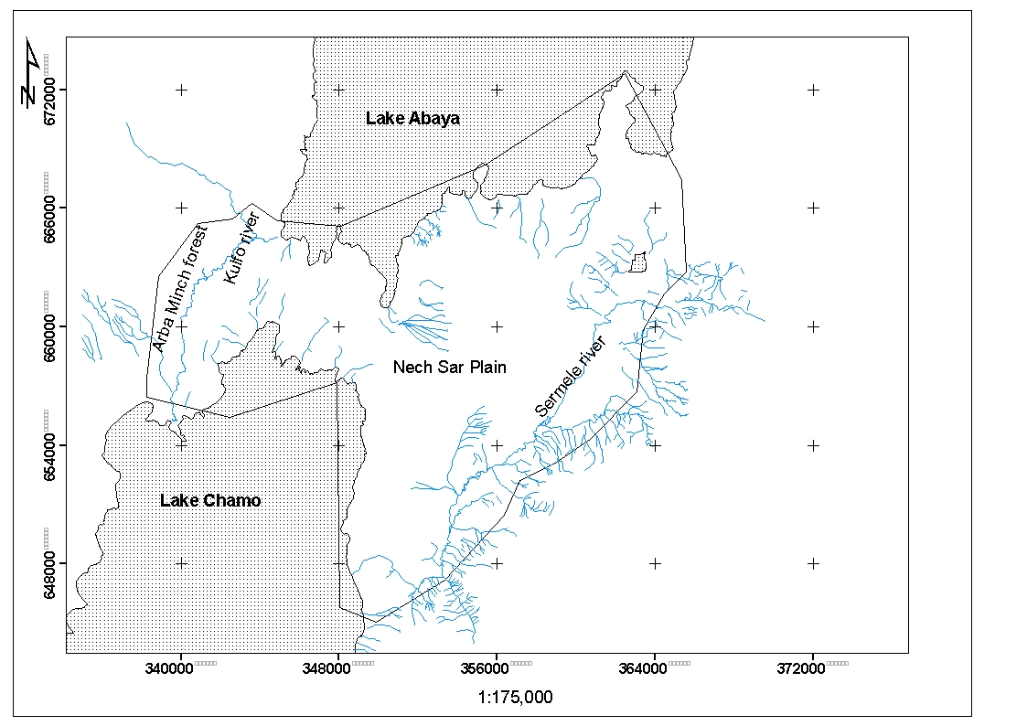

Figure 1. Map of the study area
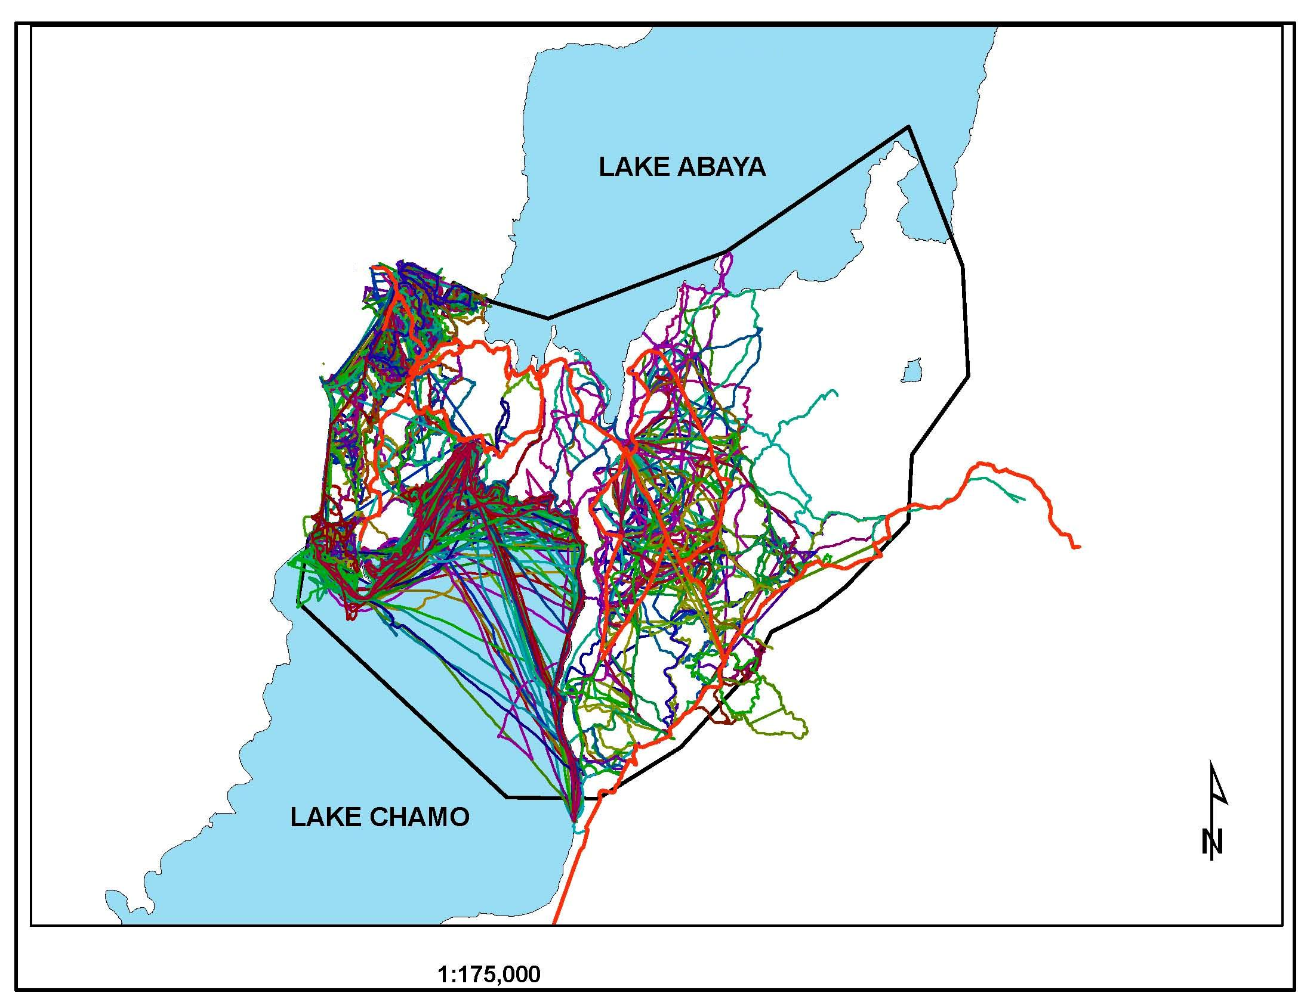
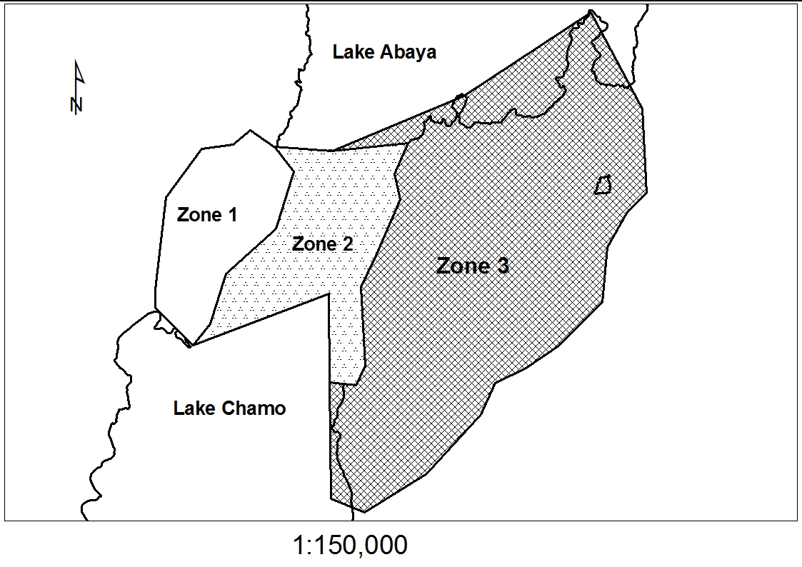

Figure 2. Map of the management zone Figure 3. Patrol track movements
in the study area during the study period
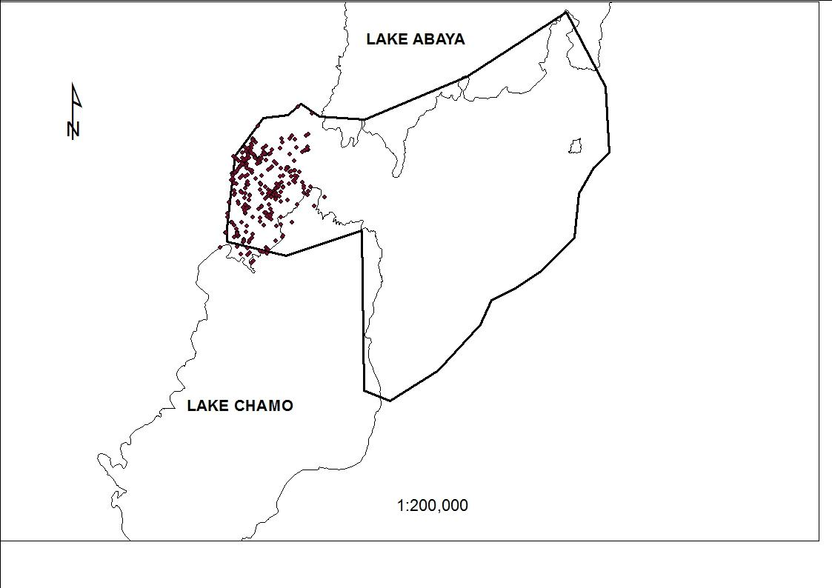
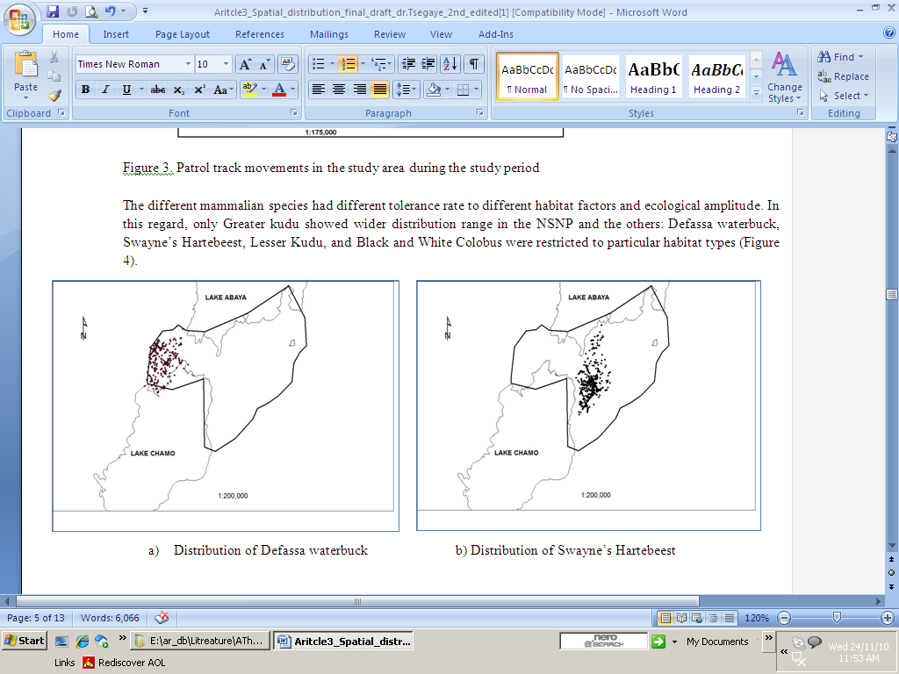
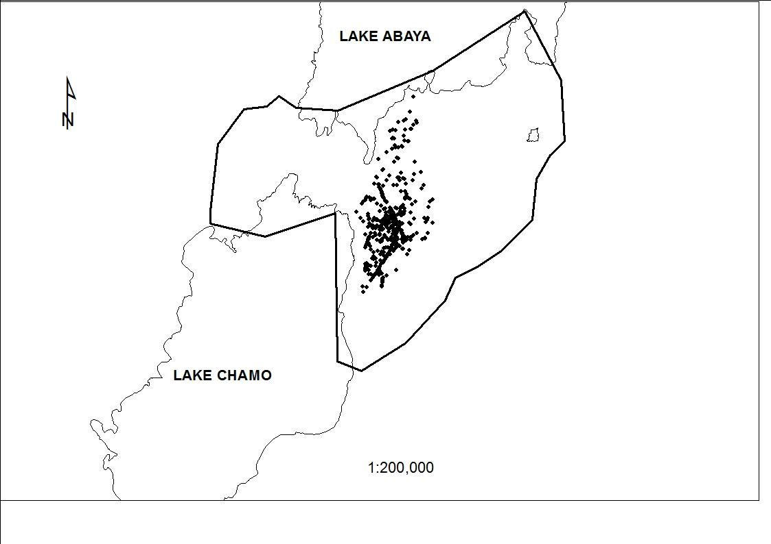

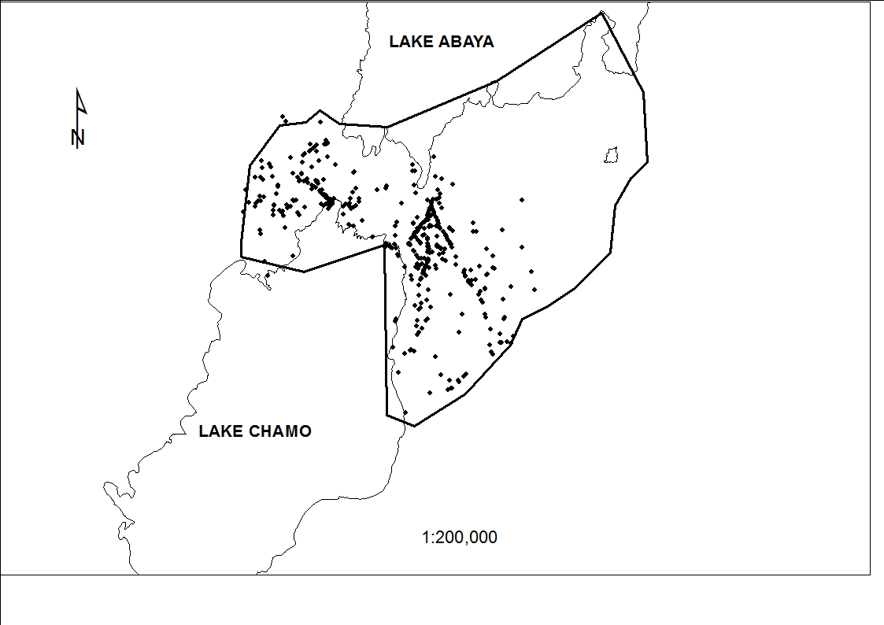
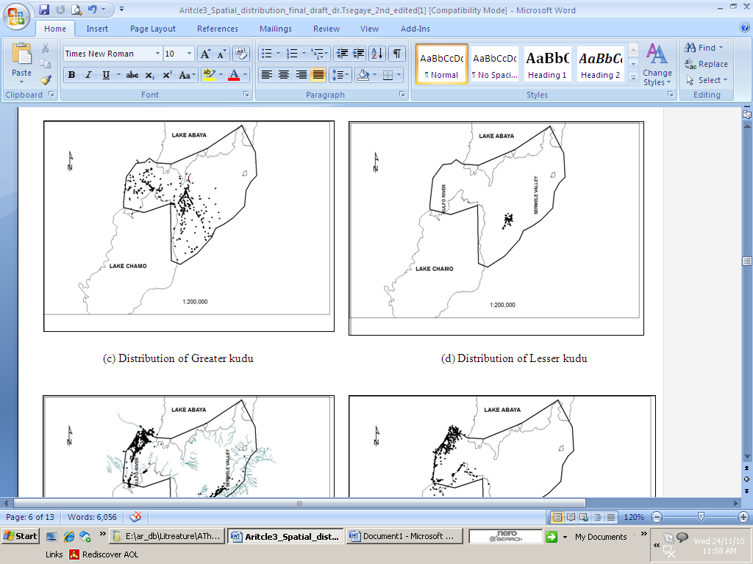
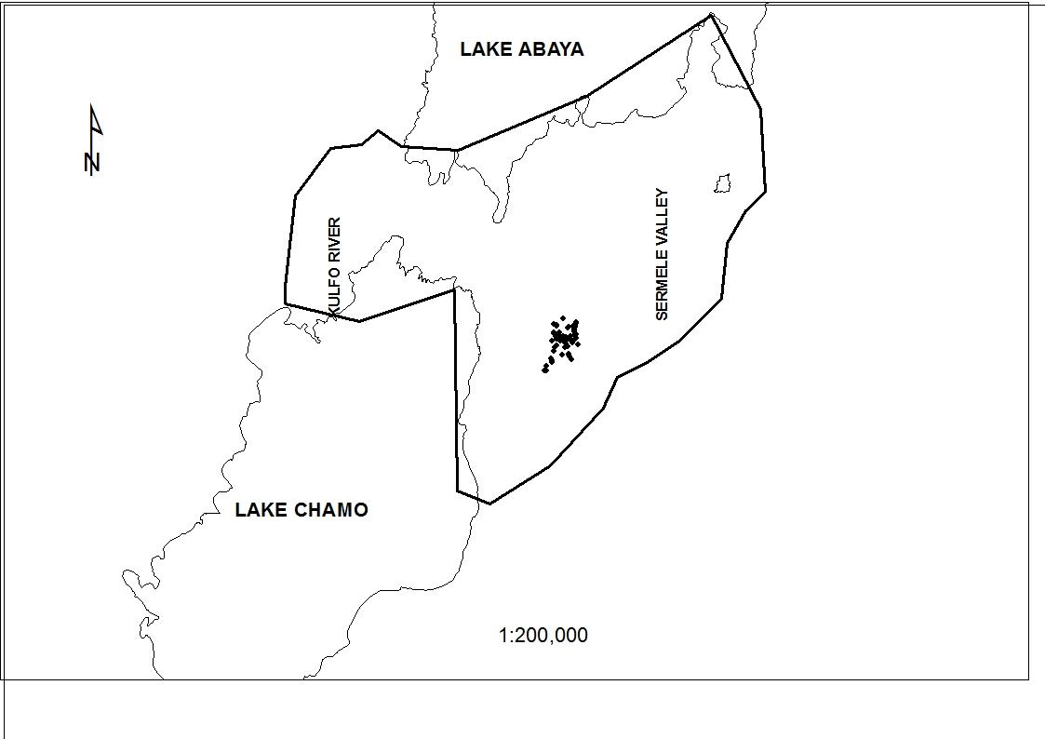

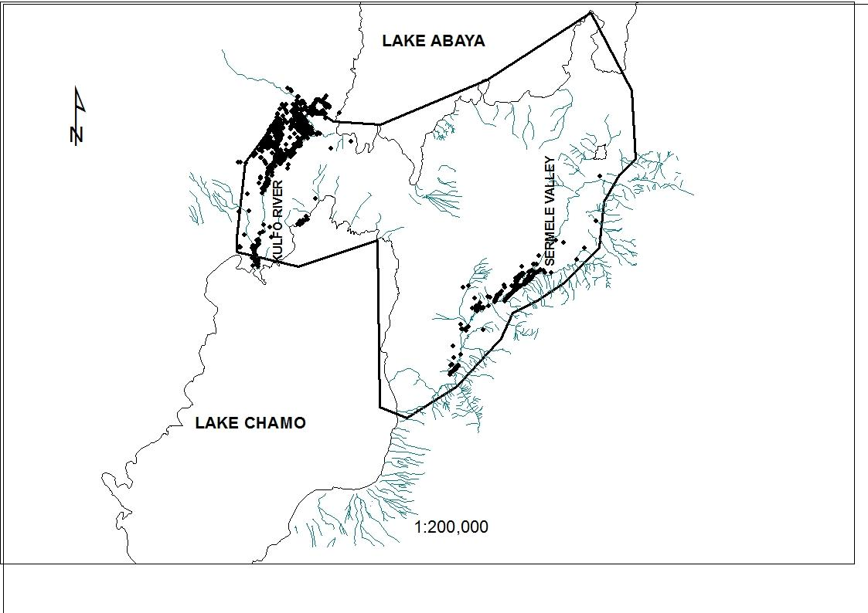
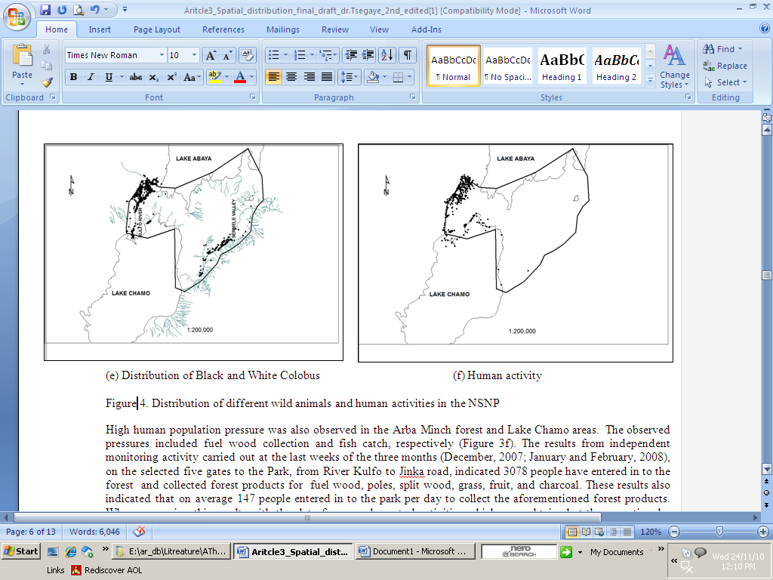
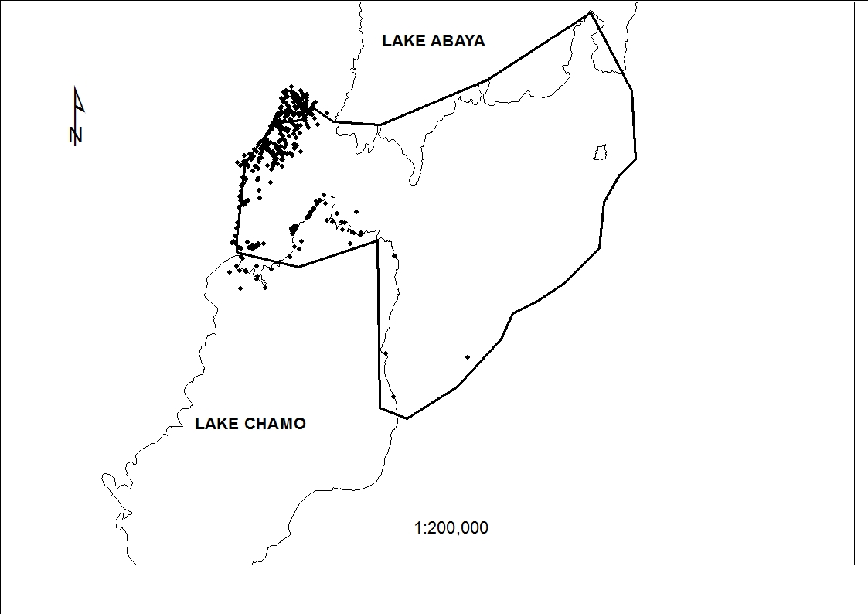

Figure 4. Distribution of different wild animals and human activities in the NSNP
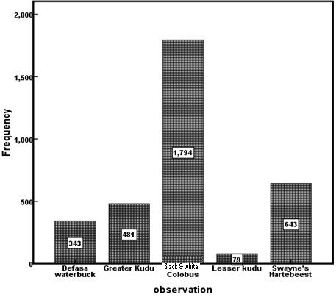

Discussion
A total of 481 observations for grater kudu were recorded during the study period. The greater kudu (Tragelaphus strepsiceros) most often occurred in open woodland (36.2%), grasslands (29.1%) and wooded grasslands (25.4%), less often in wetland (4.4%). The least often record for greater kudu was in closed forests (1.7%) and in riverine forests (1.03%). This result is similar to the most frequent use of woodland thickets and the least frequent use of closed forest by the mammal (Eden, 2006; Stuart and Stuart, 2000, Girma Mengesha and Afework Bekele, 2008). In contrast to the study by Skinner & Smithers (1990), the greater kudu was also observed to frequently use the open wooded grasslands of Nech Sar Plain. This might be due to the availability of more browse in the open woodland plains. In the terrestrial ecosystem of NSNP, greater kudu was observed to use a wide range of habitats. This could be related to the presence of preferred food plants in these habitats, its ability to eat a greater variety of woody plant species that provide browse and get cover and protection (Vaughan et al, 2000; Eden, 2006; Gray et al., 2007). During the study period, greater kudu was observed from single individual animal to a herd of 17 individuals foraging together indicating the kudu’s social behavior. The result was supported by other studies that revealed its gregariousness in the range 4-20 individuals, with females and their offspring forming cohesive social units and males associating in transient bachelor groups (Skinner & Smithers, 1990; Estes, 1997 cited in Eden, 2006).
Observation of greater kudu showed also habitat variation under different months and seasons. Out of the total observation for the 12 months for greater kudu which was 481, large observation was observed during May (100), June (92) and July (81). The reason could be the availability of enough food or grass at this time that kudus might get within their vicinity and can easily be observed by the monitoring team. It was often least observed during January (14), February (15) and March (5) due to the critical food shortage period of the dry season. As a result kudus wander to find food and distributed everywhere. Hence, significance difference was detected (P<0.05) in observing greater kudu along different months of the year within the study period.
A total of 79 observations were recorded for lesser kudu (Tragelaphus imberbis) during the study period which is the least observations made in relation to the frequency of the other four mammals (Greater kudu, Swayne’s Hartebeest, Black and white Colobus monkey and Defasa waterbuck). Lesser kudu frequently occurred in the open wood- land of a specific area (70.9%), less frequent in the wooded grasslands (26.6%) and the least observed in shrub lands and open grasslands (2.5%). This animal was hardly observed in dense forest, Riverine forests and water logged areas. This finding is not in agreement with Dorst and Dondelt (1990) that describes the frequent occurrences of the mammal in thickets and scrublands. The animals were also the least observed among the mammals. This could be related to its behavior i.e. the animals are too shy, alert and they are adapted to a particular area that protect them from predator. Because of this reason they are largely nocturnal, feeding during late evening and early morning and hiding by day in cover (Stuart and Stuart, 2000). They also showed a remarkable social group to a particular habitat type where adult males associate with females only when breeding. Lesser kudu can stay for long time without water which they use as protection mechanism to avoid detection by predators during search for water (Anonymous, 2009).They are also active in hearing and smelling as well as better runner and jumper than greater kudu which contributed to the least observation of the animals. There temporal distribution is almost similar along the months of the year in NSNP. Therefore, there was no significance difference in observing lesser kudu at different seasons and months of the year. The population status was limited to particular sites which might be due to their habitat specificity where locating mating partner is very low in comparison with other animals and resulted in low reproductive capacity per individual, lesser kudu produces only one calf per reproduction occasion (Anonymous, 2009).
A total of 343 observations were observed for Defasa waterbuck (Kobus ellipsiprymnus defassa) during the study period. The highest frequency distribution for Defasa waterbuck was recorded during June and July which was 54 and 52 observations, respectively (Table 3). These months are wet seasons where green brows are abundant in the study area for the animals to feed. Defassa waterbuck was frequently recorded in the open wood land (118 observations) which accounts about 34.4 % of the total observation in the study area for the study period (Table 1). Waterbucks are predominantly grazers (Taylor and Lyman, 1969), but they have been observed to include some browse in their diet, especially during the dry season when grasses become higher in structural components and lower in protein (Spinage, 1982). The Defasa waterbuck was restricted to a particular area and showed ecological separation from other species, this is in line with the findings of Mwangi and Western (1997) in Lake Nakuru National Park, Kenya. This could possibly be because they were competitively displaced by other species in feeding and habitat selection and they may have low ecological amplitude as well as low tolerance range.
A total of 1794 observations of the Black and White Colobus( Colobus Gureza) were made during the study period and it was predominantly observed in the Arba Minch forest, Kulfo and Sermele Riverine forests. This is in line with the study of American Zoo and Aquarium Association (2000) which indicated that the Black-and-White Colobus monkey is successful in a variety of habitats and most of the time they are forest dwellers including montane and gallery forests. The same source indicated that, although the Black and White Colobus come down to the ground, they are dependent on trees and are the most arboreal of all African monkeys. Their dominant food choices are strictly leaves from different trees of deciduous forest and spend most of their time in treetops, preferring to eat the tender young leaves found there. The Colobus monkey is at great risk in the NSNP from habitat destruction particularly at the Sermele Valley and also hunted for its beautiful fur, where its skin has been used to make dance costumes, hats and capes leading to its population reduction.
Swayne’s Hartebeest (SHB) (Alcellaphus buselaphus swaynei) is one of the endangered endemic wild animals of Ethiopia. At present Swayne's Hartebeest are found only in few localities in Ethiopia such as, Senkele SHB Sanctuary, NSNP and Mazie Wildlife Area. A total of 643 observations were made and all of them were recorded in the Nech Sar plain, none of them was recorded in the forests and wetlands. The total number of individuals in the NSNP during the study period was 35 and, they were frequently observed only in the plain. Studies have showed that, 90 individuals were transferred to Nech Sar National Park and 120 individuals were transferred to Awash National Park in 1974 to help ensure their survival (Lealem, 1974). According to Duckworth et al, (1992),only 40 individuals of the species were recorded in NSNP in 1992. 35 individuals in this study indicated that the population is declining to the point of extinction. Large number of SHB populations existed in the Senkele Hartebeest Sanctuary during 1976-1988, ranging from 448-2379 individuals (Nobuko, 2004). However, in 2008, the total number of Swayne’s Hartebeest counted was in 283 and 351 individuals during the wet and dry seasons respectively (Tewodros Kumssa and Afework Bekele, 2008). Swayne's Hartebeest lives in an open area, light bush, sometimes in tall Savannah woodland. They are social animals and are normally seen in herds of 4-15, up to 30 (EPA, 2004). SHBs is in danger of extinction at present than any other time in the past and is classified as "Critically endangered" (IUCN, 2002). Its range in all over four Ethiopia is threatened by habitat loss to agricultural expansion and livestock overgrazing (EPA, 2004). The same factors, particularly competition with domestic animals for food, space and degradation of their habitat by overgrazing has contributed to its decline in the NSNP. A total of 7587 heads of cattle and goats was recorded from the households in the nearby villages and illegal hunting by the nearby agro-pastoralists (Yisehak et al., 2006) that have destroyed the grassland habitats of SHB. Several studies proposed to create a buffer zone to integrate conservation and rural development; the idea, however, has not been followed by any action for the sustainable management of this endangered animal (Nobuko, 2004).
The five large mammalian species of the NSNP had different ranges of tolerances to different environmental variables. Hence some had wide range of tolerances and the other low range of tolerances. Thus management and conservation strategy for the mammals needs the consideration of their habitat selection. This study has shown that the Greater kudu had a wide range of tolerance as compared to Lesser kudu and Swayne’ Hartebeest that had a narrow range of tolerances. In addition to wide range of tolerance abilities, to a wider habitat conditions, the Grater kudu used verities of plant species as alternative food sources. On the other hand, lesser kudu, Defassa waterbuck and Swayne’ Hartebeest have high fidelity and low ecological amplitude. The distribution of the endemic Swayne’s hartebeest is particularly declining in the NSNP as a result of its narrow range of tolerances to environmental conditions and human activities. Therefore, proper management is urgently need in order to save this critically endangered species from local extinction
The Black and White Colobus Monkey selected riverine and large trees as best habitats. The study has indicated that the distraction of the large Acacia trees in the Sermele Valley for crop production is one of the reasons for the decline in the population number of Black and White Colobus. This could lead the animal to higher extinction risk in the area. Therefore, the riverine woodland habitat where the animals dwell should be managed properly to save the animals.
The habitats of NSNP where these mammals occurred are mosaic of grassland, open woodland, plain land, dense woodland and riverine woodlands. This indicates the importance of NSNP in harboring various species of mammals and provides opportunity to select preferred habitat types for the species. Currently, the situation of this national park is very much discouraging due to the competing claims over its natural resources. Thus, there is strong need for urgent actions that could rehabilitate the Park. The eastern part of the Nech Sar plain where the endangered Swayne’ Hartebeest and lesser kudu occur and the Sermele valley which is the best habitat of Gureza Colobus is commonly shared by the domestic animals and crop production. In the same manner, the independent monitoring data in the western part of the park revealed that the Arba Minch ground water forest is at a greater risk from increased wood collection for Arba Minch town. Therefore, to maintain the sustainable management of NSNP and the wild animals in it, the existing patrol strategy should be strengthened with full material, finance and training capacities.
AcknowledgmentS
This study was carried out with the financial assistance of African Parks Ethiopia PLC, Nech Sar National Park Project. Therefore, we are gratitude to African Parks for the financial and logistic assistances. We are also grateful all the wildlife scouts of NSNP for their strong commitment and participation in the field data collection.

References
- American Zoo and Aquarium Association (2000). Colobus Monkey Fact Sheet Sheet 5/1/94). Anonymous (2009). Lesser kudu special detail. Safari Club International.Place PP.
- Bolton, M. (1970). Rift Valley lakes Lakes Ecological Survey. Report 4: The Nech Sar plains. EWCO report ,Addis Ababa.
- Dekker, B., Van Rooyen, N., and Bothma, J. (1996). Habitat partitioning by Ungulates Ungulates on a Game Ranch in the Mopani Veld. S. Afr. J. Wildl. Res. 26: 117-122.
- Dorest, J. and Dandelot, P. (1990). A Field Guide to the large mammals of Africa. Harper Collins Publisher, London. 287pp.
- Duckworth, J. W., M. I. Evans, R. J. Safford, M. G. Telfer, R. J. Timmins & and Chemere Zewdie (1992). A Survey of Nechisar National Park, Ethiopia: Report of the Cambridge Ethiopia Ground- Water Forest Expedition 1990. International Council for Bird Preservation Study Report No. 50, U.K. PP.?
- Eden, D. G. (2006). Habitat Preference and Status of the Greater Kudu in Tembe Elephant Park, South Africa. University of Pretoria, Cape Twon?pp..
- EPA (2004). Environment for Development, Endangered species. Environmental Protection Authority, Addis Ababa, Ethiopia.
- FZS (2006). Bale Mountains National Park General Management Plan 2007 – 2017. Frankfurt Zoological Society, Ethiopia.
- Girma Mengesha and Afework Bekele (2008). Diversity, distribution and habitat association of large mammals of Altish, North Gonder, Ethiopia. Acta Zoologica Sincia 54: 20-29
- Gray, S. S., Simpson, T. R.,Baccus, J. T., Manning, R.W. and Schwertner, W.(2007). Seasonal Diet and Foraging Performance of Greater Kudu (Tragelaphus strepsicerus) in the Llano Uplift of Texas. Wildl.Biol. 13:75-8
- IUCN. (2000). IUCN Red Data List of Threatened Animals. International Union for Conservation of Nature and Natural Resources, Gland, Switzerland and Cambridge, UK.
- Lealem, B. (1974). Operation Swayne’s hartebeest. Orix, 12: 556-558
- Microsoft Encarta (2008). Encarta 1993-2007. Microsoft Corporation
- Mwangi, E. M. and Western, D. (1997). Habitat selection by large herbivores in Lake Nakuru National Park, Kenya. Biodiversity and Conservation 7(1): 1-8
- Nobuko, N. (2004). Resisting Imposed Wildlife Conservation: Arssi Oromo and The Senkelle Swayne’s Hartebeest Sanctuary, Ethiopia. African Study Monographs, 25(2): 61-77
- Odum, E.P. 1971. Fundamentals of Ecology. Saunders College Publishing, Philadelphia.
- Patterson, B. D., Ceballos, G., Sechrest, W., Tognelli, M. F., Brooks, T., Luna, L., Ortega, P., Salazar, I. and Young B. E. (2003). Digital Distribution Maps of the Mammals of the Western Hemisphere. Center for Applied boiscince, Conservation International 1:9pp.
- Skinner, J. D and Smithers, R. H. N. (1990). The Mammals of the Southern Africa Sub region. University of Pretoria, South Africa.
- Spinage, C. A. (1982) A Territorial Antelope: The Uganda Waterbuck. Academic Press, London.
- Stuart,C. and Sturat, T. (2000). Field Guide to the large Mammals of Africa. Struik Publisher, Cap Twon, 318pp.
- Tamrat Andargae (2001). Floristic Composition and Distribution of the Savannah Grass Land and Wood Land of Nech Sar National Park. MSc Thesis, Addis Ababa University.
- Taylor, C.R., Spinage, C.A. & Lyman, C.P. (1969) Water relations of the waterbuck, an East African antelope. Am. J. Physiol. 217: 630–634.
- Tewodros Kumssa and Afework Bekele (2008). Population status and structure of the endangered Swayne’s hartebeest, Alcelaphus buselaphus swaynei, in Senkele Swayne’s Hartebeest Sanctuary, Ethiopia. Acta Zoologica Sinica 54(4): 569–575
- Vaughan, T., Ryan, T. M. and Czaplewski, N. J. (2000). Mammalogy, 4th edition. Harcourt College Publisher, New York. 565pp
- Whitaker, R. (2007) Sustainable Use of the Lake Chamo Nile crocodile Population. African Parks (Ethiopia) Nechsar National Park Project. Project Document, Arba Minch, Ethiopia.
- Yisehak Doku, Afework Bekele, & Balakrishnan, M. (2006). Human impact on the plains zebra (Equus quagga) population in Nechisar Plains, Nechisar National Park, Ethiopia. International Journal of Ecology and Environmental Sciences 32: 137-142.

1/14/2011

