On the Biology of Apriona germari Hope (Coleoptera: Cerambycidae) Infesting Mulberry Plants in Jammu and Kashmir, India

Altaf Hussain¹, Abdul A. Buhroo²

¹ Post Graduate Department of Bioresources, University of Kashmir, Hazratbal, Srinagar-190006 India
² Post Graduate Department of Zoology, University of Kashmir, Hazratbal, Srinagar-190006 India
² Corresponding author: A. A. Buhroo, abuhroo@yahoo.com

Abstract - Investigations on the biology of mulberry longicorn beetle, Apriona germari Hope (Coleoptera: Cerambycidae: Lamiinae), revealed an annual life cycle of the lamiine species with a peak adult emergence in mid July and mid August in Jammu and Kashmir divisions respectively. Sex ratio fluctuated around 1:1 throughout the emergence period and the beetles required 11.0±0.73 days of maturation feeding period. Mature adults mated promiscuously during night with a peak period soon after the sun set, mated for an average of 46.6±4.69 seconds. Males approached females directly, recognized them by olfactory and visual cues. Oviposition started 2-3 days of first mating and eggs were preferably laid in the primary branches, 8-11 mm in diameter, of the host trees. Gravid females laid an average of 116.70±7.12 eggs in 42.60±2.25days of oviposition period. Eggs incubated in 22-24 days and the grubs developed through 9 larval instars in 40 weeks. Pre-pupae made pupal cells in the basal part of the host tree trunk, pupated there for 28.30±1.70 days and moulted into adults. The adults chewed circular emergence holes in the bark and did exit the pupal chambers from dusk to dawn.
[Altaf Hussain, Abdul A. Buhroo. On the Biology of Apriona germari Hope (Coleoptera: Cerambycidae) Infesting Mulberry Plants in Jammu and Kashmir, India. Nature and Science 2012;10(1):24-35]. (ISSN: 1545-0740). http://www.sciencepub.net.

Key words: biology; Apriona germari; mulberry plants

1. Introduction
The lamiine cerambycid, mulberry longicorn, Apriona germari Hope is commonly found in Burma, China, India, Japan, Korea, Pakistan and Vietnam infesting a large number of broad leave trees including mulberry plants in South Asian countries (Beeson, 1941; Duffy, 1968). Jammu and Kashmir is one of the traditional sericulture practicing states of India and a large section of people are directly or indirectly associated with the agro-industry (Khan et al. 2004). Apriona germari is a serious pest of mulberry plant, the sole food plant for the silkworm, Bombyx mori L. (Lepidoptera: Bombycidae) in the region (Hussain et al. 2009).
Borers are known as chronically damaging pests and their inaccessibility in woody hosts made it practically difficult to investigate their bionomics and control measures; for the same reasons there have been few published reports on the population dynamics of cerambycid species under field conditions (Donley, 1978; 1981; 1983; Nielson, 1981; Powell, 1982).
The infestation of the lamiine species to mulberry plants affects the economic product of the host plants both qualitatively and quantitatively, thus posing great threat to sericulture industry in the region and consequently the livelihood of agrocides and allied workers of the industry.
There are no detailed biological observations on various parameters of A. germari in Indian subcontinent and elsewhere except a preliminary investigation on its population dynamics by Hussain et al. (2007) in Jammu and Kashmir. Therefore the objective of the present study was to make a detailed account on the biology of the borer species in the mulberry farms of Jammu and Kashmir State.

2. Materials and Methods
The laboratory observations on the biology of Apriona germari were made in the Laboratory of Entomology, Postgraduate Department of Zoology, University of Kashmir, Srinagar, where as field observations were made in two mulberry farms, one at Miransahab, Jammu and another at Bimyar-Uri, Baramulla, maintained by Central Silk Board, Government of India and Jammu and Kashmir State Sericulture Development Department respectively.
Coupulatory and oviposition behaviors were studied in the laboratory. Newly emerged beetles were isolated from the culture maintained in the laboratory, sexed and assigned to the cylindrical rearing jars (30cm in depth and 10cm in diameter), containing feeding material (tender mulberry twigs) and primary mulberry branches (25cm long and 5-13mm in diameter) for oviposition. A total of 15 pairs of beetles (one pair per jar) were employed to study parameters viz. maturation feeding periods, coupulatory behavior and the reproductive potential of the lamiine species. The feeding material and oviposition branches were supplied alternatively till the death of the females. The oviposited branches removed from the jars were inspected for total oviposition and were kept in separate jars till hatching of grubs to study the incubation period and egg viability. Ethanol extract of female body was used to study the sexual behavior among males; visual cues in mate recognition were studied by polishing the eyes of males and allowed to locate/mate females.
Field observations were made to study the adult emergence period, larval period, total larval instars and pupation and regular survey trips were made from March 2005 to February 2008 for the purpose. Observations and subsequent collection of different developmental stages of the lamiine species were made keenly. Head capsule width of different larval instars was used to calculate total larval instars by Dyar’s ratio (Dyar, 1890).
The data recorded was tabulated and analyzed statistically. Arithmetic mean±SE (Standard error of mean), Chi square (𝝌²) test and Student’s t-test were utilized to analyze the data.

3. Results
3.1 Adult activity
Adults emerged from June through October in mulberry farms of Jammu and Kashmir State with peak emergences in mid July and mid August in Jammu and Kashmir provinces respectively (Figure 1). Adults emerged from pupal cells in the dusk to dawn through round/circular holes chewed in the bark by them. Emergence of the beetle fell in between 2nd and 3rd July and 6th August in Jammu and Kashmir divisions respectively, when 16% individuals became adults in each division. The peak and ending period in Jammu province were observed between 23rd and 24th July (50% adults emerged) and on 17th August (84% adults emerged) respectively. In Kashmir division peak and ending period fell in between 24th and 25th August (50% beetles emerged) and 16th September (84% adults emerged) respectively (Figure 2). Sex ratio fluctuated around 1:1 throughout the emergence period. There was no sexual dimorphism with respect to body size, however, length of antennae showed a well marked sexual dimorphisms, elongate in males (longer than the body) and short in females (shorter than the body), being significantly different (P>0.05). Adult longevity ranged between 26-89days. Females lived an average life of 51.20±3.5 days while as male longevity averaged 63.10±3.5 days; the difference in longevity of sexes is significant (P>0.05).
The newly emerged beetles required a feeding period of 11.0±0.73 days to attain sexual maturity. Mature adults mated promiscuously on the host trees during night with a peak period soon after sun set. The beetles (caged) copulated 2.80±0.416 times with different partners during first two hours after sun set, in the next two hours rate of copulation decreased and mating averaged 1.6±0.267 times. Mating period lasted for 46.6±4.69 seconds. Males approached females directly, recognized them by visual as well as olfactory cues. The indispensability of olfactory cues were confirmed by spraying the female body extract (ethanol extract) on mulberry twigs which were supplied to cages containing mature males. The males in the cages responded quickly and besides running swiftly and waving their antennae; started fighting among themselves, which is an indication of sexual arousal. Visual stimuli has synergistic effect to locate females as males with their eyes polished/covered with opaque fluid (nail polish) accessed females less frequently than expected by chance (Table 1). Females preferred larger males to mate and their preference decreased from larger to small size class (large > medium > small). Beetles were classified into small, medium and large classes according to body length from head to abdominal tip; small < 45 mm, medium 45-50 mm, and large ≥51mm (Table 2).

3.2 Egg laying
Oviposition started at 13.30 ± 0.76 days of emergence. Unmated females after maturation feeding period of 11.0±0.73 days chewed oviposition sites without laying eggs while mated ones scurried over host plants, chewed oviposition sites and started depositing eggs singly in them after 2-3 days of first mating. Females laid an average of 116.70±7.12 eggs during the oviposition period of 42.60±2.25 days (Table 3). Gravid females scurried over host plants, girdled the primary branches, 5-13 mm in diameter, severed bark and phloem completely and xylem partially; deposited eggs singly in the proximal part of the girdled branch just 2-3 cm below the girdle in the U shaped oviposition pits, gnawed with their mandibles (Figure 3). Females oviposited during night and placed their eggs in the oviposition pit, micropylar end facing downwards, with the wiping motion of their ovipositor. The oviposition pits were scared in the pith of primary branches (Figure 4).
The diameter of girdled branches just below the girdle ranged between 5-13mm. Among girdled cum oviposited branches, 17.12% of them were in group I (5-8mm in diameter), 62.16% in group II (diameter 8-11mm) and 20.72% in group III (diameter 11-13mm). Females prefer to oviposit in group II branches, ranging 8-11mm in diameter (Table 4).

3.3 Incubation period and hatching
The incubation period was observed to be 22-24 days. Mouth secretions of incubated grubs moistened the egg shell which helped in grub eclosion. The movements of the grubs resulted in the bursting of egg shell from the micropylar end and it crawled out leaving the egg shell in the oviposition pit. Newly hatched grubs without exposing themselves bore downwards, made their way into the main stem through the pith of primary branches (Figure 5). Moisture played an important role in the hatching of grubs, as eggs removed from the egg sites when placed in glass tubes shrinked and failed to hatch.

3.4 Feeding and tunneling of grubs
Grubs soon after hatching in the egg niches started their journey towards the main stem through the soft pith of primary branches of mulberry trees. The newly hatched grubs hollowed out the soft pith, ejected the excreta and chewed wood along with reddish brown sap through sub-tunnels/tunnels which arise from the central feeding tunnel and open to exterior through round circular holes. The grubs excavated a straight round central feeding tunnel through the pith of primary branches of host plant as it is comparatively soft tissue and it hatched in the same tissue. However, in the limbs of host trees, grubs chewed the feeding tunnel in the sapwood just beneath the cambium, more or less oval in shape. As the grubs grew in size and approached maturity, they made their way into the heartwood, excavated round oval feeding tunnels in the stem of host trees (Figure 6).
Feeding tunnels in the limbs and main stem are zigzag, communicated to the exterior by sub-tunnels for aeration and frass ejection (Figure 7). Cell sap also oozes out from the feeding tunnel through these sub-tunnels.
Though grubs expelled chewed wood fibers and excreta, but a small proportion of it were retained in the feeding tunnels. On dissecting the feeding tunnels, it has been observed that they (main feeding tunnels) have been blocked behind the origin of sub-tunnels from central feeding tunnel by retained chewed wood fibers. This block in the central tunnel more or less direct the cell sap to ooze out through the sub-tunnels, thus prevented the stagnation of cell sap in central tunnel in the vicinity of harboring grub.
The chewed wood fibers and excreta are different from each other and can be distinguished very easily. When shacked in small amount of water in a glass beaker, wood fibers floated, where as excreta sunk and discolored the water.

3.5 Larval instars and development
The determination of the number of larval instars of A. germari was made difficult by the almost continuous range of head capsule width measurements ranging between 1.30-9.50 mm. On the basis of the data recorded in the field, nine larval instars were identifiable. Expected head capsule width of each instar was also determined by Dyar’s ratio (Dyar 1890) which states that the growth ratio remains constant between the molts (Table 5).
Development from hatching to the prepupal larvae took 40 weeks. This period included the overwintering period (diapause) of about 3 months, which occurred in early December to March. Onset of larval diapause was marked by the stoppage of fresh frass extrusion through the openings of larval galleries. This developmental profile was studied in ambient conditions and recorded data of reared larvae from neonate to maturity is given in Table 6.
Head capsule width of the one week old larvae correspond to the head capsule width of 1st instar larva and that of 2nd week to 2nd instar; 4th, 8th and 12th week old larval head capsule widths correspond to 3rd, 4th and 5th instars respectively. Each instar was progressively longer than preceding instar. However, 8th and 9th instars were of same duration. Overwintering larvae (6th and 7th instars) experienced longer life of about 12-16 weeks in at least one stage.

3.6 Pupal period
Pupae developed in 28.30±1.70 days. The mature grubs transformed into pupae from late April through early August (Figure 8). Pupal development took place in the basal part of the tree in an elliptical pupal cell. The mature larvae (prepupae) widened the central feeding tunnel, prepared an elliptical chamber (pupal cell) in the wood at a distance of about 10-15mm from the surface, measuring about 56-67 mm in length and 25-30 mm in breadth and blocked the larval gallery opening into the elliptical pupal cell with fibrous frass. By this time only coarse wood fibers were extruded out through the sub-tunnels which marked the onset of pupation.
On dissecting the pupal cell, naked pupae measuring 47.50±2.28mm in length were observed lying parallel to tree axis with the head facing upward. The newly transformed adults remained in their pupal chambers for about 4 days to harden their cuticle. In the mean time they chewed round/circular exit holes in the wood and phloem and emerged through these holes (Figure 9).

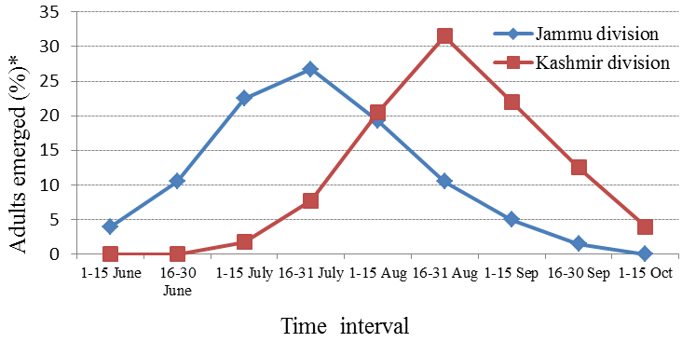
Figure 1. Population dynamics of A. germari (adults) in mulberry farms of Jammu and Kashmir

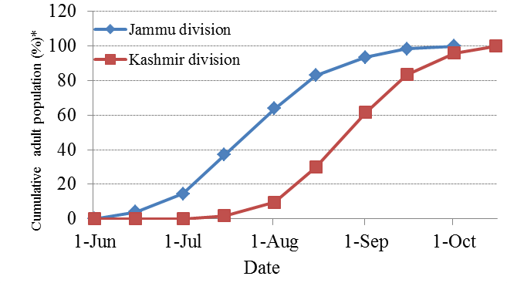

Figure 2. Cumulative population of A. germari (adult) in mulberry farms of Jammu and Kashmir
* mean of 2005, 2006 & 2007 observations

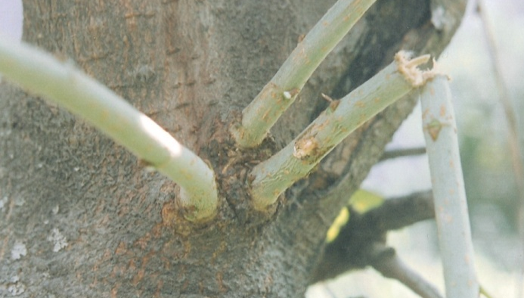

Figure 3. Girdled primary branch showing the oviposited site of A. germari and the apical part hanging with its base

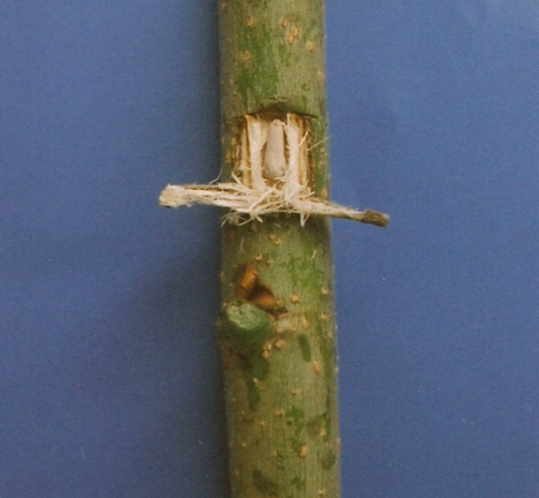
Figure 4. Egg of A. germari in the egg niche with its micropylar end facing downwards

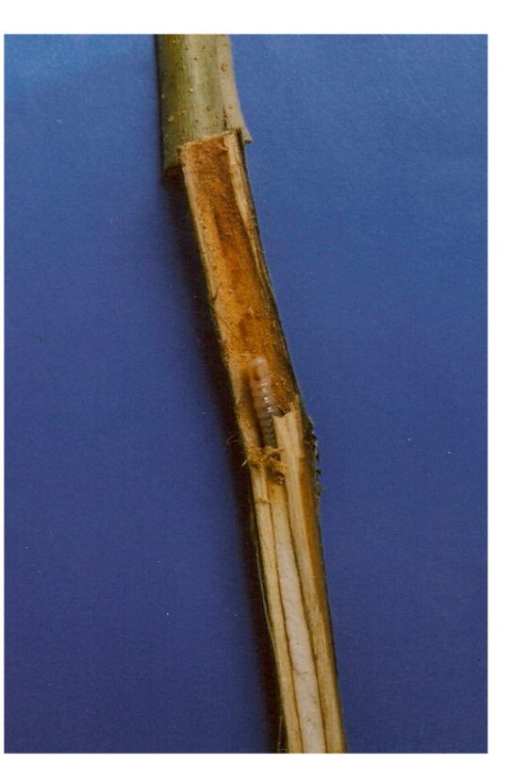
Figure 5. Newly hatched grub boring downwards through soft pith of mulberry twig

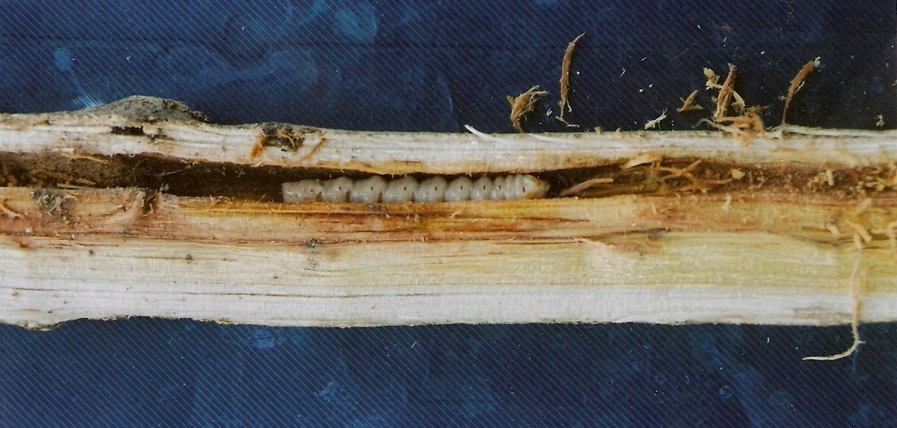
Figure 6. Mature 9th instar larva in the main feeding tunnel

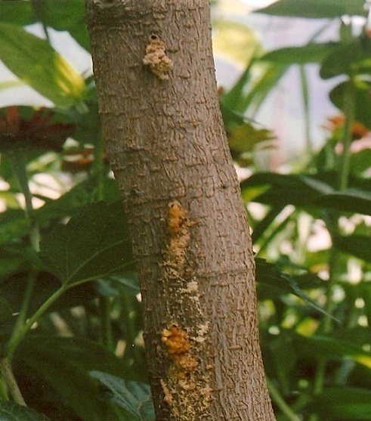
Figure 7. Sub-tunnels arising from the main feeding tunnel of A. germari extruding frass

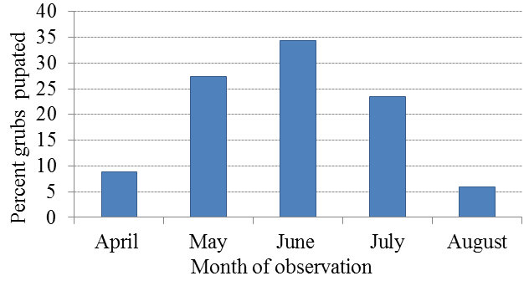
Figure 8. Pupal stage of A. germari

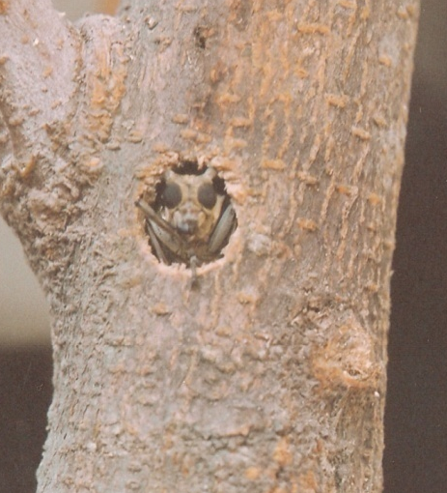
Figure 9. The A. germari emerging from the pupal cell through circular emergence hole

Table 1. Frequency of males of A. germari locating their mate by visual cues
Males with eyes | Males accessed females (%) | Males failed to access females (%)
Polished  Unpolished | 19.05  54.55 | 80.95  45.45

Table 2. Relationship between male body size and female mate refusal in A. germari
Male size | Body size (♂) mm | No. of tested pairs | ♀s refused mating (%) | ♀s accepted mating (%)
Small  Medium  Large | < 45  45-50  ≥51 | 13  13  14 | 76.92  30.76  21.42 | 23.07  69.23  78.57

Table 3. Weekly and life time fecundity of A. germari
Ovipo-siting  Female | Weekly oviposition
Ovipo-siting  Female | I | II | III | IV | V | VI | VII | VIII | IX | Life time fecundity | Oviposition period
No.1 | 22 | 24 | 21 | 19 | 25 | 20 | 5 | - | * | 136 | 44
No. 2 | 19 | 25 | 22 | 28 | 18 | 24 | 16 | 2 | * | 154 | 50
No.3 | 16 | 19 | 21 | 22 | 15* | - | - | - | - | 93 | 33
No.4 | 20 | 24 | 19 | 17 | 23 | 25 | 19 | 19 | * | 148 | 54
No.5 | 18 | 22 | 19 | 14 | 16 | 14 | - | * | - | 103 | 40
No.6 | 17 | 17 | 13 | 21 | 15 | 9 | * | - | - | 92 | 39
No.7 | 13 | 19 | 22 | 23 | 16 | 5 | - | * | - | 98 | 37
No.8 | 24 | 27 | 25 | 21 | 18* | - | - | - | - | 115 | 35
No.9 | 15 | 21 | 17 | 13 | 22 | 16 | 3 | * | - | 107 | 43
No.10 | 18 | 15 | 26 | 21 | 19 | 22 | 14 | 5 | * | 121 | 51
Mean | - | - | - | - | - | - | - | - | - | 116.70 | 42.60
*Females died

Table 4. Oviposition preference of A. germari on mulberry branches of different diameter
Group | Branch diameter (mm) | Girdled cum oviposited branches | % Girdled cum oviposited branches
I  II  III | 5-8  8-11  11-13 | 19  69  23 | 17.12  62.16  20.72

Table 5. Comparison of observed (mean) and expected values of head capsule widths (mm) of the larvae of A.germari
Mean observed head capsule width of Ist instar larva (N=10) = 1.39mm.
Mean observed head capsule width of 2nd instar larva (N=10) =1.75mm.
Head capsule width of 2nd instar larva
Growth ratio (Dyar’s ratio) =  = 1.75/1.39 = 1.26.
Head capsule width of 1st instar larva
Mean observed head capsule width of 9th instar (mature larvae) (N=10) = 9.11mm
Larval instar | Head capsule width (mm) |  |  | Difference (mm)
Larval instar | Observed (Mean ±SE) | Range | Expectedª | Difference (mm)
I  II  III  IV  V  VI  VII  VIII  IX | 1.39±0.0421  1.75±0.0138  2.27±0.0215  2.69±0.0256  3.40±0.0661  4.52±0.0581  5.50±0.0680  7.01±0.0060  9.11±0.7570 | 1.30-1.50  1.60-1.90  2.00-2.40  2.50-3.00  3.10-3.80  4.00-5.10  5.30-6.40  6.50-7.90  8.20-9.50 | 1.39  1.75  2.21  2.78  3.50  4.41  5.56  7.01  8.83 | 0.00  0.00  0.06  -0.09  -0.10  0.11  -0.06  0.00  0.28
ª Expected head capsule width established by Dyar’s ratio (1.26). Multiplying Dyar’s ratio with the observed head capsule width of 1st instar larva gives the expected head capsule width of 2nd instar which when multiplied again with Dyar’s ratio gives expected head capsule width of 3rd instar and so on.

Table 6. Developmental period of the larvae of A. germari
Age (weeks) | Head capsule width (mm) | Corresponding larval instar | t-value
1  2  4  8  12  16  20  24  28  32  36  40 | 1.35±0.027  1.89±0.028  2.29±0.110  2.70±0.024  3.32±0.022  4.40±0.030  4.47±0.049  4.57±0.033  5.83±0.050  5.95±0.013  7.90±0.025  9.15±0.030 | I  II  III  IV  V  VI  VI  VI  VII  VII  VIII  IX | 1.36  1.85  0.17  0.28  1.16  1.83  0.66  0.75  1.16  0.92  1.38  0.49

4. Discussion
The current study provided a detailed account of the biology of A. germari in mulberry farms of Jammu and Kashmir State. Although mulberry plants are prone to the attack of a large number of insect pests, but the lamiine species under discussion is a major one causing damage to the host plants (mulberry plants) both qualitatively and quantitatively (Hussain and Chisti, 2010).
The apparent difference in the emergence time of the lamiine species in the two regions is due to the different topography and climatic conditions of the two regions. Moreover similar observations regarding the emergence of Cerambycid beetles in different geographical regions are on record. Jolles (1932) reported that Cerambyx dux Fald. (Coleoptera: Cerambycidae), emerged between 15th May and 15th June in Palestine, but Saliba (1977) reported the emergence of the same beetle in late July in Malta. Another longicorn beetle, Batocera rufomaculata De Geer emerged in July in Lyallpur (Husain and Khan, 1940), but in Dehra Dun, the beetle emerged in March (Mathur, 1957). The development of insects in any stage of life can be subdivided into starting period, peak period and ending period when 16%, 50% and 84% of the population reaches this stage respectively (Xiao, 1992). Accordingly the starting period and peak period of adult emergence of mulberry longicorn beetle in Jammu province fell in between 2nd and 3rd July and 23rd and 24th July respectively and the ending period was observed on 17th August. It took about a month to reach the starting period from its first appearance, 21 days from starting to peak period, 23-24 days from peak period to the ending and about one and a half month from ending period to its disappearance. In Kashmir division, starting period was observed on 6th August and peak and ending period fell in between 24th and 25th August and 16th September respectively and they took about a month from their first appearance in field to starting period, 19-20 days from starting period to peak period and 22-23 days from its peak to ending period. The beetles disappeared after about one month of ending period. The starting period, peak period and ending period of emergence and disappearance pattern in two regions is synchronized and the same pattern of adult emergence has been observed by Gao et al. (1997) in another longicorn beetle, Anoplophora glabripennis Motschulsky.
Adult feeding is essential for maturation of gonads and improves copulation in Anoplophora glabripennis Motschulsky (Dejia and Yining, 1997). Observations on the prematuration feeding period by cerambycid beetle is well documented (Linsley, 1959). Hanks (1999) reported that lamiine species feed for an average of 6.7±1.2 days to attain sexual maturity. The foregoing discussion reveals that adult feeding is necessary for the maturation of A. germari, a lamiine species under study.
Although mulberry longicorn beetles mate promiscuously, but the male rivalry contests were commonly observed in the laboratory and even the ethanol extract of female body aroused the male behavior and they started biting each other. The rivalry contests among longicorn beetles are so intense that the males may lose their body organs like antenna and legs (Beeson, 1941; Yokoi, 1989; Reagel et al. 2002).
Female body odor of A. germari only elicited mating behavior in males and visual stimuli is synergistic rather necessary to locate their mate. Fukaya et al. (2004) demonstrated the same behavior in anther longicorn beetle, Anoplophora malasiaca Thomson. Thus pheromones sexually arouse males of the longicorn beetles and visual stimuli are necessary for their mate location.
Body size often directly influences the reproductive success of animals (Alcock, 1995). Among insects large males usually edge out small rivals in aggressive contests over females (Thornhill and Alcock, 1983). Lawrence (1986) found that large males dominate in Tatraopes tetraopthalmus (Coleoptera: Cerambycidae) population. In the present study A. germari females in laboratory often refused smaller males indicating their preference for larger ones and the observation is at par with Hanks et al. (1996), who reported the same behavior in Phoracantha semipunctata F. (Coleoptera: Cerambycidae).
Females of the mulberry longicorn beetle started depositing eggs in egg niches after 2-3 days of first mating. Though females chewed the egg niches after maturation feeding period of 11.0±0.73 days, but did not lay eggs, indicating indispensability of mating for egg laying. Pre-oviposition period of most of the Cerambycid beetles is 9.0±1.0 days (Linsley, 1961) and it varies significantly among species especially in Lamiines (Hanks, 1999).
Lamiine species are unique among Cerambycids in gnawing an egg niche in bark or stem and sealing them with a material from the ovipositor (Duffy, 1953; Linsley, 1961). Females of the Cerambycid beetle under study laid an average of 2.73 eggs per day and a total of 116.7 eggs in their life. Fecundity rate of some Cerambycid beetles is on record; daily and life time oviposition of red oak borer, Enaphalodes rufulus Haldeman is 6.3 eggs and 119 eggs respectively (Donley, 1978); daily and life time fecundity for Monochamus carolinensis (Coleoptera: Cerambycidae) were reported to average 2.6-5.7 eggs and 116.5-200 eggs per female respectively (Walsh and Linit, 1985).
Eggs hatched within 22-24 days, though the present observation is in contradiction with Hanks (1999), who reported that Lamiine species hatch in 10.9±1.3 days, but Eritian (2003) reported an incubation period of 24 days in the same Lamiine species, A. germari, which strongly support the current finding. The grubs emerged from the eggs through an orifice made by contraction-stretching movements of the larvae, left the egg shell in the oviposition pit and made their way towards the main stem. The present observation is at par with that of Beeson (1941), who reported that the grubs of Cerambycid beetles emerge through the micropylar end and leave the egg shell in the oviposition pit.
Grubs of Lamiinae feeding in the wood always make straight tunnels, while those feeding on the bark make zigzag tunnels, (Beeson, 1941; Linsley, 1959; 1961), thus confirming the current observation strongly. Reflecting relative nutritional quality of woody tissues, the grubs of the lamiine species under study fed on the soft pith of primary branches, which has relatively high nitrogen content than heartwood (Savely, 1939; Hanks, 1999). The grubs ejected frass through sub-tunnels arising from the main feeding tunnel which is a common observation among Lamiine species (Beeson, 1941; Craighead, 1950; Nielsen, 1981).
Head capsule width measurements revealed 9 larval instars in the development of A. germari. Though the continuous range of head capsule width measurements made it difficult to establish the number of larval instars of mulberry longicorn beetle, but the data lead the authors to ascertain them. Expected head capsule width of larval instars, calculated by Dyar’s ratio (Dyar, 1890), more or less coincide the observed head capsule width of respective instars, which confirmed the study. Linsley (1961) reported that larval instars of Cerambycid beetles feeding on wood of living/healthy trees varied between 7 and 10; however, Tara (1983) established 9 larval instars in another longicorn beetle, Batocera rufomaculata DeGeer by Dyar’s ratio. Goodwin and Pettit (1994) reported 9 larval instars in Acalolepta vastator Newman, a longicorn beetle infesting grapevines in New South Wales while Logarzo et al. (2002) reported 7 larval instars in Apagomerella versicolor (Coleoptera: Cerambycidae). The foregoing discussion reveals that the most of Lamiine species pass through 7-10 larval instars which confirm the present observation pertaining to the number of larval instars of A. germari.
The larvae of mulberry longicorn beetle took about 40 weeks to develop from first through mature larvae (last larval instar). This period included the overwintering period of 3-4 months. The developmental period of each larval instar was progressively longer than the preceding instar and the same observation has been recorded by Goodwin and Pettit (1994) in another longicorn beetle, Acalolepta vastator Newman. The larvae of most of the Lamiine species feeding on the living hosts develop in 7-12 months; however, in very few species larval periods never exceed 14 months (Beeson, 1941; Keen, 1952; Paulino-Neto et al. 2006). Husain and Khan (1940) reported a larval period of 3-6 months and 6 months in Batocera rufomaculata DeGeer respectively, however, Palaniswamy et al. (1979) observed that B. rufomaculata completed its life cycle in 3 months on artificial diet in laboratory. The larval period, including diapause of Apagomerella versicolor (Coleoptera: Cerambycidae), lasted 9-12 months (Logarzo et al. 2002).The foregoing discussion on the larval period of longicorn beetles revealed that in most of the Cerambycid species, it is of about 10 months duration and the Lamiine species under study enjoyed about the same larval period.
Pupal period of most of the Lamiine species varies between 3-5 weeks (Linsley, 1959; 1961; Hanks et al. 1990). The current observation is that the pupa of mulberry longicorn beetle pupated in an elliptical cell excavated by the mature larva in the stem. Before transforming into pupa, the larva blocked the gallery from both the ends with coarse wood fibers and enjoyed the pupal period of 28.30±1.7 days in the closed cell. The present results more or less agree with Ertian (2003), who reported a 24 days of pupal period of the longicorn beetle under report. Variation in the developmental period of insects is a common observation and it largely depends on the environmental factors (Linsley, 1959; 1961).

References
- Alcock, J. Body size and its effect on male-male competition in Hylaeus alcyoneus (Hymenoptera: Colletidae). Journal of insect Behavior 1995; 8: 149-159.
- Beeson, C.F.C. The Ecology and Control of the Forest Insects of India and the Neighbouring Countries, Bishen Singh Mahendra Pal Singh, first reprint 1993, Dehradun. 1941: pp. 1007.
- Craighead, F.C. Insect enemies of eastern forests. Misc. Publ. 1950; No. 657. USA, WA- Washington, DC: USDA.
- Dejia, L. and Yining, L. Relationship between sexual development and the days after emergence, supplementary feeding and copulation of Anoplophora glabripennis Motschulsky. J. Northw. For. Coll. 1997;12: 19-23.
- Dejia, L. and Yining, L. Relationship between sexual development and the days after emergence, supplementary feeding and copulation of Anoplophora glabripennis Motschulsky. J. Northw. For. Coll. 1997;12: 19-23.
- Donley, D.E. Oviposition by the red oak borer, Enaphalodes rufulus (Coleoptera: Cerambycidae). Annals of the Entomological Society of America 1978;71(4): 496-498.
- Donley, D.E. Control of the red oak borer by removal of infested trees. Journal of Forestry 1981;79(11): 731-733.
- Donley, D.E. Cultural control of the red oak borer (Coleoptera: Cerambycidae) in forest management units. Journal of Economic Entomology 1983;76(4): 927-929.
- Duffy, E.A.J. A Monograph of the Immature Stages of British and Imported Timber Beetles (Cerambycidae). London: Brit. Mus. (Nat. Hist.). 1953: 350pp.
- Duffy, E.A.J. A Monograph of the Immature Stages of Oriental Timber Beetles (Cerambycidae). London: Brit. Mus. (Nat. Hist.). 1968: 434pp.
- Dyar, H.G. The number of moults of Lepidopterous larvae. Psyche 1890;5: 420-422.
- Ertian, H. Protection of Mulberry plants, Oxford & IBH Publishing Co. Pvt. Ltd. New Delhi. 2003: 610p.
- Fukaya, M., Akino, T., Yasuda, T., Yasui, H. and Wakamura, S. Visual and olfactory cues for mate orientation behaviour in male white-spotted longicorn beetle, Anoplophora malasiaca. Entomologia Experimentalis et applicata 2004:111: 111-115.
- Gao, R., Li, G., Wang, K. and Sun, J. The occurrence and population dynamics of adult Anoplophora glabripennis (Coleoptera: Cerambycidae). Forest Research 1997;10(6): 619-623.
- Goodwin, S. and Pettit, M.A. Acalolepta vastator (Newman) (Coleoptera: Cerambycidae) infesting grapevines in the Hunter Valley, New South Wales 2. Biology and ecology. Journal of the Australian Entomological Society 1994;33: 391-397.
- Hanks, L.M. Influence of the larval host plant on reproductive strategies of Cerambycid beetles. Annual Review of Entomology 1999;44: 483-505.
- Hanks, L.M., Millar, J.G. and Paine, T.D. Biology and ecology of eucalyptus longhorn beetle, Phoracantha semipunctata F. in southern California. In: Adams D, Rios J, editors. Proceedings of the 39th meeting of the California Forest Pest Council. Sacramento (CA), 1990:12-16.
- Hanks, L.M., Millar, J.G. and Paine, T.D. Body size influences mating success of the eucalyptus longhorned borer (Coleoptera: Cerambycidae). Journal of Insect Behavior 1996;9(3): 369-382.
- Husain, M.A. and Khan, M.A.W. Bionomics and control of the fig tree borer, Batocera rufomaculata De Geer (Coleoptera: Cerambycidae). The Indian journal of agricultural Science, 1940;10(6): 945-959.
- Hussain, A. and Chisti, M.Z. Studies on the Nature and Extent of Damage to Mulberry Plants by Apriona germari Hope (Coleoptera: Cerambycidae). Journal of Research and Development 2010;10: 143-150.
- Hussain, A., Chishti, M.Z., Buhroo, A.A. and Khan, M.A. Adult Population of Apriona germari Hope (Coleoptera: Cerambycidae) in Mulberry Farms of Jammu and Kashmir State (India). Pak. Entomol. 2007;29(1): 15-17.
- Hussain, A., Khan, M.A., Chishti, M.Z. and Buhroo, A.A. Cerambycid Borers of Mulberry (Morus spp.) in Jammu and Kashmir, India. Indian Journal of Applied & Pure Biology 2009;24(1): 101-103.
- Jolles, P. A study of the life history and control of Cerambyx dux Fald., a pest of certain stone fruit trees in Palestine. Bulletin of Entomological Research 1932;23: 251-256.
- Keen, F.P. Insect enemies of western forests. Misc. Publ. 1952; No. 273. USA, WA- Washington, DC: USDA.
- Khan, M.A., Dhar, A., Zeya S.B. and Trag, A.R. Pests and Diseases of Mulberry and their Management. Bishen Singh Mahinder Pal Singh, Dehra Dun, India 2004; 68 p.
- Lawrence, W.S. Male choice and competition in Tetraopes tetraophthalmus: effects of local sex ratio. Behav. Ecol. Sciobiol. 1986;18: 289-296.
- Linsley, E.G. Ecology of Cerambycidae. Annuual Review of Entomology 1959;4: 99-138.
- Linsley, E.G. The Cerambycidae of North America, Part I. Introduction. University of California publications in Entomology 1961;18: 1-97.
- Logarzo, G., Gandolfo, D. and Cordo, H. Biology of Apagomerella versicolor (Boheman) (Coleoptera: Cerambycidae) in Argentina, a candidate for biological control of cocklebur (Xanthium spp.). Biological control 2002;25: 22-29.
- Mathur, R.N. Ailanthus excels Roxb., a new host of Batocera rufomaculata De Geer (Coleoptera: Cerambycidae). Indian Forester 1957;83(9): 563-564.
- Nielsen, D.G. Studying biology and control of borers attacking woody plants. Bulletin of the Entomological Society of America 1981;27: 251-259.
- Palaniswamy, M.S., Babu, P.C.S. and Subramaniam, T.R. Studies on the biology of mango stem borer, Batocera rufomaculata De Geer (Coleoptera: Cerambycidae). South Indian Horticulture 1979;27(3&4): 100-106.
- Paulino-Neto, H.F., Vasconcellos-Neto, J. and Carmello-Guerreiro, S.M. The biology of Oncideres humeralis Thorms (Coleoptera: Cerambycidae: Lamiinae) and new Cerambycidae-Melastomastaceae host plant associations. Studies on Neotropical Fauna and Environment 2006;41(3): 227-233.
- Powell, W. Age specific life-table data for the eucalyptus boring beetle, Phoracantha semipunctata F. (Coleoptera: Cerambycidae), in Malavi. Bull. Ent. Res. 1982;72: 645-653.
- Reagel, P.F., Matthew, D.G. and Hanks, L.M. Aggregation and mate location in the red milkweed beetle (Coleoptera: Cerambycidae). Journal of Insect Behavior, 2002; 15(6): 811-830.
- Saliba, L.J. Observations on the biology of Cerambyx dux Fald. in the Maltese Islands. Bulletin of Entomological Research 1977;67:107-117.
- Savely, H.E. Jr. Ecological relations of certain animals in dead pine and oak logs. Ecol. Mono. 1939;9: 321-385.
- Tara, J.S. Investigations on the insect pests of mulberry (Morus spp.) in Jammu region of Jammu and Kashmir state. Ph.D. Thesis, 1983: University of Jammu.
- Thornhill, R. and Alcock, J. The Evolution of Insect Mating Systems. Harvard University Press, Cambridge. 1983: 547pp.
- Walsh, K.D. and Linit, M.J. Oviposition biology of the pine sawyer, Monochamus carolinensis (Coleoptera: Cerambycidae). Annals of the Entomological Society of America 1985;78: 81-85.
- Xiao, G. Forest Insects of China, 2nd edition. Forestory Publishing House of China, Beijing, China. 1992: pp. 70-71.
- Yokoi, N. Observation on the mating behavior of the yellow-spotted longicorn beetle, Psacothea hilaris (Pascoe) (Coleoptera: Cerambycidae). Japanese Journal of Applied Entomology and Zoology 1989;33: 175-179.

11/11/2011

