Studies on Biologically Significant Mercury(II) , Nickel(II) and Lead(II) – Isoleucine Binary Complexes in Solution

Brij Bhushan Tewari

Department of Chemistry, Faculty of Natural Sciences, University of Guyana, P. O. Box: 101110, Georgetown, Guyana, Tel: 592-222-4926, Fax: 592-222-3596,
Email: brijtew@yahoo.com

Abstract: The stability constants of Hg²⁺, Ni²⁺ and Pb²⁺ complexes with isoleucine were determined by paper ionophoretic technique. Present method is based upon the migration of a spot of metal ions on a paper strip at different pHs of background electrolyte. A graph of pH against mobility gives information about the binary complexes and permit to calculate their stability constants. The first and second stability constants of [Hg(II) – isoleucine], [Ni(II) – isoleucine] and [Pb(II) – isoleucine] complexes were found to be (8.80 ± 0.02, 7.52 ± 0.05), (7.27 ± 0.01, 5.86 ± 0.03 and (7.17 ± 0.05, 3.32 ± 0.09) for Hg(II), Ni(II) and Pb(II) complexes, respectively at 0.01 M ionic strength and a temperature of 35° C.
[Brij Bhushan Tewari. Studies on Biologically Significant Mercury(II) , Nickel(II) and Lead(II) – Isoleucine Binary Complexes in Solution. Nature and Science 2012;10(1):45-52]. (ISSN: 1545-0740). http://www.sciencepub.net.

Key words: paper electrophoretic technique; overall mobility; mercury(II) complexes; nickel(II) complexes; lead(II) complexes; isoleucine ; stability constant.

1. Introduction
For the general case of complex ML_{n}, the stepwise formation or stability constants (K_{n}) are:
[ML]
M + L  ML K₁ =
[ML][L]

[ML₂]
ML + L  ML₂ K₂ =
[ML][L]

[ML₃]
ML₂ + L  ML₃ K₃ =
[ML₂][L]

--- ---
[ML_{n}]
ML_{n-1} + L  ML_{n} K₁=
[ML_{n-1}][L]
where M and L are metal cation and ligand anion respectively. For the calculation of total concentration of final complex product (ML_{n}) the overall formation constant is used
[ML_{n}]
β_{n} =
[M][L]^{n}

The overall formation constant is the product of stepwise formation constants
β_{n} = K₁ . K₂ . K₃ ……….K_{n}

The inverse of formation constant, the dissociation constant K_{d} is also some time useful.
[M][L]
ML  M + L K_{d} =
[ML]

K_{d} has the same form as K_{a} for acids, which facilities comparisons between metal complexes and Brφnsted acids.
A significant development on the determination of stability constants of complexes was made by Jokl (Jokl, 1964) [1]. Metal complexes play an important role in various biological systems, hence the formation, stability and reactivity of these complexes have been an active field of research (Sherman, 1987) [2]. Banerjea (Banerjea, 1995) [3] has classified nickel as beneficial and mercury as well as lead as toxic metals, respectively. The average nickel content of healthy human body weight (70 kg) is 0.01 g/man. The amount of elements nickel, lead and mercury in human diet (mg/day) are (0.30-0.50), (0.06-0.50) and (0.004 – 0.020), respectively. Deficiency of nickel in body effect the function of liver. Mercury is extremely harmful, even in concentration of 0.03 ppm in drinking water is not permissible. Mercury enters natural waters through industrial discharge (such as of Chlor – alkali industry) whereby bacterial action it is converted into very soluble and water soluble methylmercury ion, Hg (CH₃)⁺, which is taken by the fish and through food chain enters higher animal and man. Lead destroys sulphur containing proteins and enzymes, causes damage to DNA, RNA, brain and central nervous system functions. Lead also inhibits several steps in the formation of hemoglobin. Mercury(II), Nickel(II) and Lead(II) have significant biomedical applications but are toxic at higher concentration ( Sutton, 2007; Das, 2007; Kaneko, 2007 ; Sumi, 2008; Karthikeyan, 2008; Lee, 2009; Shokrollahi, 2009; Khan, 2010; Chang, 2010; Saeed, 2010; Na’aliya, 2010; Chandra, 2009; Patil, 2009; Chattopadhyay, 2010; Bulut, 2009; Prakash, 2011; Adeyemi, 2009; Wen-Xing, 2010; Sheta, 2009; Herranz, 2010; Ou-Yang, 2010; Imanpoor, 2010; Vanysek, 2008; Hassan, 2008) [4-27].
Isoleucine is an essential amino acid, which means that humans cannot synthesize it, so it must be part of our diet. It is generally coded amino acid, its codons are AUU, AUC and AUA. Isoleucine promotes muscle recovery, needed for the formation of hemoglobin regulation of blood sugar level and blood clot formation. Deficiency of Isoleucine is only found in people deficient in dietary protein but symptoms may include headaches, dizziness, fatigue, depression, confusion as well as irritability, symptoms of deficiency may mimic the symptoms of hypoglycemia. Isoleucine has several significant applications in biological systems (Papp, 2010; Li, 2009; Mitrophanov, 2008; Irvine, 2008; Sato, 2011; Kashiwada, 2007; Kawabe, 2006; Takors, 2007; Dimitrov, 2007) [28-36]. The usual drawbacks of paper electrophoretic technique like variation in temperature during electrophoresis, capillary flow on paper, electro-osmosis and adsorption affecting the mobility of charged moieties, are quite well known ( Shaw, 1969)[37].
Publications ( Tewari, 2001, 1995, 1996, 2005, 2009, 2010)[38-43] from our laboratory described new method for the study of metal complexes. A search of literature indicated very few report on Ni(II) – isoleucine complexes and no report on Hg(II) – isoleucine and Pb(II) – isoleucine complexes. In view of this attempt were made to establish the optimum conditions for metal(II) – isoleucine complex formation. In addition, present paper describes a paper electrophoretic method for the determination of stability constants of these complexes.

2. Experimental Section
2.1 Instruments
Systronics (Naroda, India) paper electrophoresis equipment horizontalcum-vertical type, model 604 has been used. The apparatus consisted of a PVC moulded double tank vessel. In our laboratory significant change in the instrument has been made. Two hollow rectangular plates covered with thin polythene sheets have been used through which thermostated water is run for controlling the temperature. The tanks were closed with a transparent PVC moulded lid. The whole assembly is tight, which prevent moisture changes, which may upset the equilibria in a paper strip. This assembly design thus keeps to a minimum the disturbing effects of evaporation from the unwanted liquid flow in the paper. Each electrolyte tank contains a separate electrode chamber. The auxiliary unit is specially designed to operate either voltage mode or on current mode.
An Elico (Hyderabad, India) model L₁₋₁₀ having glass and calomel electrodes assembly and working on 220 V 50 Hz established a.c mains, was used for pH measurements. Electrophoresis cell showing sandwiched paper strips and water supply is shown in Figure 1.

2.2 Chemicals
Mercury(II), nickel(II) and lead(II) perchlorate solutions were prepared by preliminary precipitation of metal carbonates from a 0.1 M solution of sodium carbonate (AnalaR grade, BDH, Poole, UK). The precipitates were thoroughly washed with boiling water and treated with calculated amounts of 1 % perchloric acid. The resulting mixture was heated to boiling on a water bath and then filtered. The metal content of the filtrates were determined and final concentration was kept at 0.005 M ( Kolthoff, 1957; Vogel, 1978) [44, 45]. The position of the Ni²⁺ spots on the paper at the end of the experiment was detected using ammonical dimethylglyoxime (DMG), that of Pb²⁺ detected by 0.1% solution 1 – (2 – pyridylazo) – 2 – naphthol (PAN) (Merck, Darmstadt, Germany) in ethanol, that of Hg²⁺ detected using hydrogen sulphide in water. The 0.005 M glucose (BDH, AnalaR) solution was prepared in water and used as an indicator for the correction due to electro-osmosis. A saturated aqueous solution (0.9 mL) of silver nitrate was diluted with acetone to 20 mL. Glucose was detected by spraying with this silver nitrate solution and then with 2% ethanolic solution of sodium hydroxide, when a black spot was formed. Paper strips showing position of metal ions spot after electrophoresis is shown in Figure 2.

2.3 Background electrolyte
Stock solution of 5.0 M perchloric acid was prepared from its 70% solution (SDS, AnalaR grade). 2.0 M sodium hydroxide and 0.5 M isoleucine (BDH, Poole, UK) solutions were prepared. The background electrolyte used in the study of binary complexes were 0.1 M perchloric acid and 0.1 M isoleucine. The system was maintained at various pH by the addition of sodium hydroxide.
2.4 Procedure

Whatman No. 1 filter paper for chromatography was used for the purpose of electrophoresis. For recording observation of particular metal ion, two paper strips were spotted with the metal ion solution along with additional two spotted with glucose using 1.0 μL pipette and then mounted on the insulated plate. Each of the two electrolyte vessels was filled with 150 mL of BGE solutions containing 0.1 M perchloric acid and 0.01 M isoleucine. The paper become moistened with the background electrolyte solutions due to diffusion. The second insulated plate was placed on paper strips and then thermostated water (35° C) was circulated into the plates to keep the temperature constant. The lid was then placed on the instrument to make it air tight. It was left for 10 minutes to insure wetting the strips. Subsequently a direct 240 V potential was applied between electrodes. Electrophoresis was carried out for 60 minutes after which the strips were removed from the tank and dried. The metal ion and glucose spots were detected by specific reagents. The leading and tailing edges were measured from marked center point and the mean taken. The distance moved by glucose was subtracted (in case of migration toward anode) to obtain correct path length. Migration towards anode and cathode were designated by negative and positive signs, respectively.

Electrophoretic observation of metal ions were recorded at various pH values of the background electrolyte, the ionic strength being maintained at 0.1 M. The observed mobility of migrant was calculated by using the formula.

d
U =
x . t

After applying the correction factor the observed mobility is given as:

d ± d_{G}
U =
x . t

where U = mobility of metal ion / complex ions; d = mean of duplicate distance travelled by metal ion / complex ion; d_{G} = mean of duplicate distance travelled by glucose spot; x = field strength (7.5 V/cm); t = time for electrophoresis.

The dissociation constants of pure isoleucine were determined by the same paper electrophoresis technique. The two paper strips were spotted with pure isoleucine along with two glucose using 0.1 M perchloric acid only in a background electrolyte. The electrophoresis was carried for 60 minutes as for metal ions. The electrophoretic speed was calculated and the speed of the metal ion / isoleucine spots are reported with pH values. The individual speeds of the duplicate spots were found to be fairly equal.

3. Results
As is evident from Figure 3, the plot of overall electrophoretic mobility of the metal ion spot against the pH gives a curve with two plateaus in each case. The first plateau corresponds to a region in which the metal ions are uncomplexed. It is obvious that protonated ionic species of isoleucine, which exists at low pH range are non-complexing [CH₃ - CH₂ – CH (CH₃) – CH (NH₃⁺) - COOH]. Figure 3 secret that mercury(II), nickel(II) and lead(II) ions form their first complex movements toward negative electrode. Hence, one isoleucine anionic species [CH₃ - CH₂ – CH (CH₃) – CH (NH₂) - COO⁻] must have combined with mercury(II), nickel(II) and lead(II) to give 1:1, [Hg{CH₃ CH₂ – CH (CH₃) CH (NH₂) COO}]⁺, [Ni {CH₃ CH₂ – CH (CH₃) – CH (NH₂) COO}]⁺ and [Pb {CH₃ CH₂ – CH (CH₃) - CH (NH₂) COO]⁺ complex cations, respectively.

The third plateau in each case is in zero region showing neutral nature of metal – ligand complex. Hence, two anionic species of isoleucine [CH₃ CH₂ – CH (CH₃) - CH (NH₂) COO⁻] must have combined with metal ions to give 1:2, [Hg{CH₃ CH₂ CH (CH₃) CH (NH₂) COO}₂], [Ni {CH₃ CH₂ CH (CH₃) CH (NH₂) COO}₂] and [Pb {CH₃ CH₂ CH (CH₃) CH (NH₂) COO}₂] neutral complexes, respectively.
The chemical literature also assigns a prominent chelating property to the zwitterions ( Blackburn, 1973) [46]. A further increase of pH has no effect on the mobility of metal ions, which indicates no further interaction between the metal ions and ligands. It is significant that these studies gives clear evidence of the complexation of the anionic species of isoleucine with metal ions forming two varieties of binary complexes of 1:1 and 1:2 in composition. In general the complexation of metal ions with isoleucine anion may be represented as:

K₁
M²⁺ + L⁻  ML⁺ (1)

K₂
ML⁺ + L⁻  ML₂ (2)

where M²⁺ represents the Hg²⁺, Ni²⁺ and Pb²⁺ metal ions, [L⁻] is the isoleucine anion; K₁ and K₂ are the first and second stability constants, respectively.
The metal spot on the paper is thus a combination of the uncomplexed metal ions; 1:1 complex, and 1:2 complex. The spot is moving under the influence of the electric field, and the overall mobility is given by the equation of Jokl (Jokl, 1964) [47]

Σu_{xp} · β_{xp} [HpL]^{x}
U = (3)
Σ β_{xp} [HpL]^{x}

where [HpL]^{x} is the concentration of general complex species; β_{xp} is the overall mobility constant of the complex; u_{xp} is the speed of the general complex [M(HpL)^{x}] present in the combination. On taking into consideration different equilibria, the above equation is transformed into the following form:

u₀ + u₁ K₁ [L⁻] + u₂ K₁ K₂ [L⁻]²
U = (4)
1 + K₁ [L⁻] + K₁ K₂ [L⁻]²

where u₀, u₁ and u₂ are the mobilities of uncomplexed metal ions, 1:1 and 1:2 metal complexes, respectively. The dissociation constants of pure isoleucine (k₁ = 10^{2.25}, k₂ = 10^{9.62}) was determined by some paper electrophoretic technique. The mode of dissociation of pure isoleucine is shown in Figure 4. Using the dissociation constants of isoleucine, the concentration of the pure isoleucine anion [L⁻] is determined for the pH values) of interest from which K₁ can be calculated. The concentration of complexing isoleucine anion [L⁻] is calculated with the help of the equation.
[L_{T}]
[L⁻] = (5)
1 + [H] / k₂ + [H]² / k₁ • k₂

where [L_{T}] is the total concentration of the isoleucine ligand, (0.01 M); k₁ and k₂ are the first and second dissociation constants of pure isoleucine, respectively.
For calculating first stability constant, K₁ the region between first and second plateau is pertinent. The overall mobility will be equal to the arithmetic mean of the mobility of uncomplexed metal ion, u₀ and that of the first complex u₁, at a pH value where K₁ = 1/[CH₃ CH₂ CH (CH₃) CH(NH₂) COO⁻].

The second stability constant K₂, of the 1:2 complex can be calculated by taking into consideration, the region between second and third plateau of the mobility curve. The (se) calculated values K₁ and K₂ are given in Table 1.

4. Discussion
The precision of the method is limited to that of paper electrophoresis, and uncertainty in the result is ± 5%. Hence, it cannot replace the most reliable methods, even though it is new approach deserving further development. The stability constants of metal complexes can be very easily calculated by this technique, therefore the present method is advantageous over other methods (viz., polarography, potentiometry, solubility, etc. reported in chemical literature. The molecular structure of isoleucine is as follows:
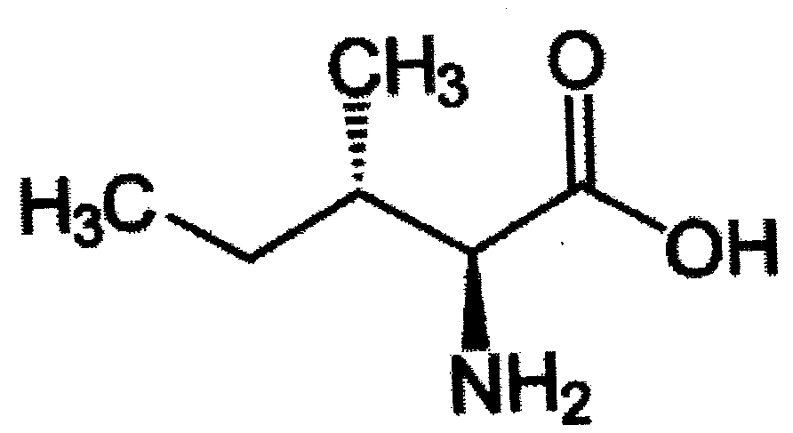

It is observed from Table 1 that value of first and second stability constants of ML⁺ and ML₂ complexes follow the order:
mercury(II) > nickel(II) > lead(II).

The proposed structure for the ML₂ complexes may be given as:

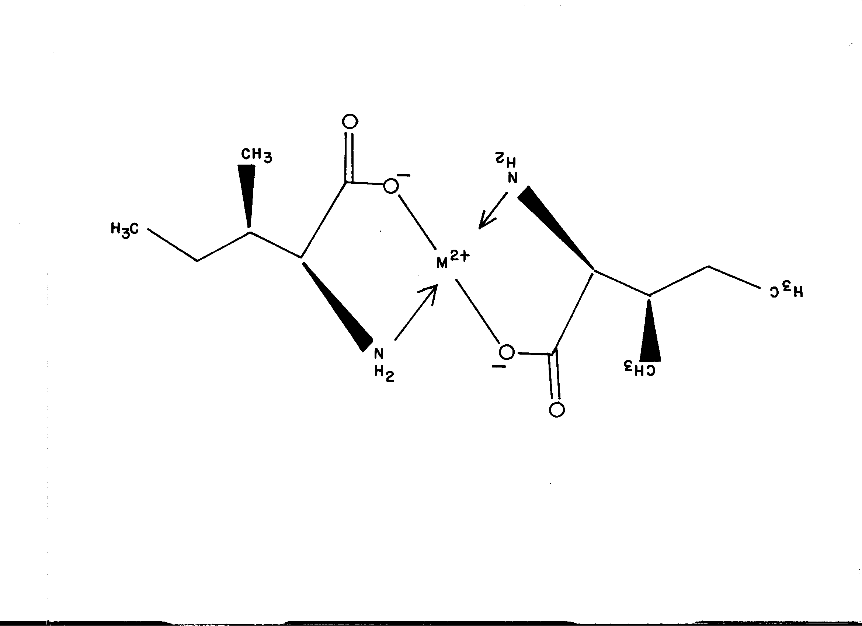

The values of second stability constant are found to be lower in comparison to first stability constant in each system, this may be due to the decrease in coordinating tendency of ligand with the higher state of aggregation. It is also clear from Table 1 that mercury(II) -isoleucine and lead(II) – isoleucine complexes are found to have highest and lowest stability constant values, respectively. Therefore it is inferred that Hg²⁺ cations has greater affinity with oxygen donor ligand, while Pb²⁺ cation has lesser affinity with oxygen donor ligands.

Table 1: Stability constants of binary complexes of mercury(II), nickel(II) and lead(II) with α-aminobutenoic acid.
Metal ions | Complexes | Stability constants | Logarithm stability constant values*
Mercury(II) | ML⁺  ML₂ | K₁  K₂ | 8.80 ± 0.02  7.52 ± 0.03
Nickel(II) | ML⁺  ML₂ | K₁  K₂ | 7.27 ± 0.01  {5.40 (Martell, 1974) [48] }  5.86 ± 0.03  {4.30 ( Martell, 1974) [48] }
Lead(II) | ML⁺  ML₂ | K₁  K₂ | 7.17 ± 0.05  3.32 ± 0.09

Ionic strength = 0.1 M; temperature = 35 ° C; M = metal cations (Hg²⁺, Ni²⁺, Pb²⁺); L = ligand (isoleucine) ; isoleucine anion = [CH₃ CH₂ CH (CH₃) CH (NH₂) COO⁻].
*Literature values are given in parenthesis.

5. Conclusions
The following conclusions can be drawn from the present study:
Mercury (II), nickel (II) and lead (II) are important for biological systems but as such they are toxic at higher concentration. The isoleucine may be used to reduce the level of these ions in biological systems. Mercury (II) – isoleucine and lead (II) – isoleucine complexes are found to have highest and lowest stability constant, respectively. ML₂ complexes are found to have low stability constant value and less stable in comparison to ML complexes in each system. Biologically important mercury (II) – isoleucine, nickel(II) – isoleucine and lead(II) – isoleucine can be prepared on large scale at particular pH of the background electrolyte. The simple modified electrophoretic technique has thus proved to be helpful in deciding whether a complex system is formed or not and if it is formed its stability constants can also be determined.

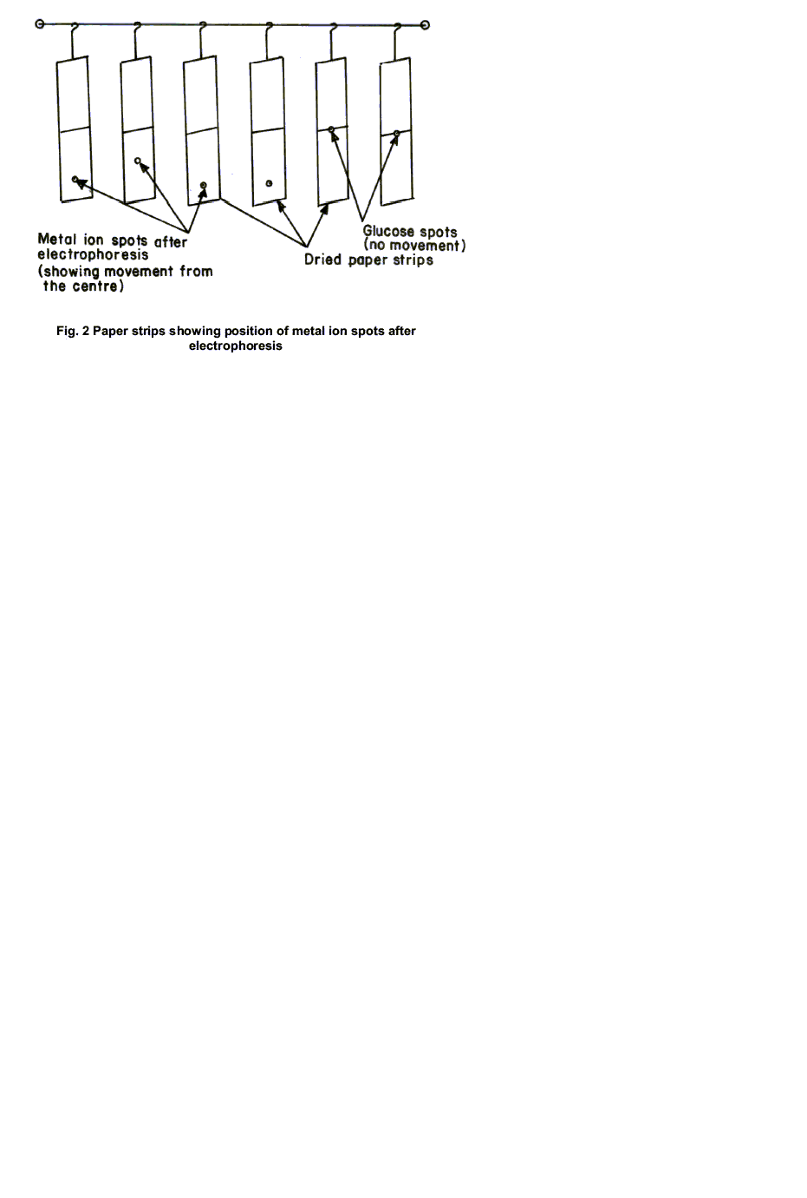

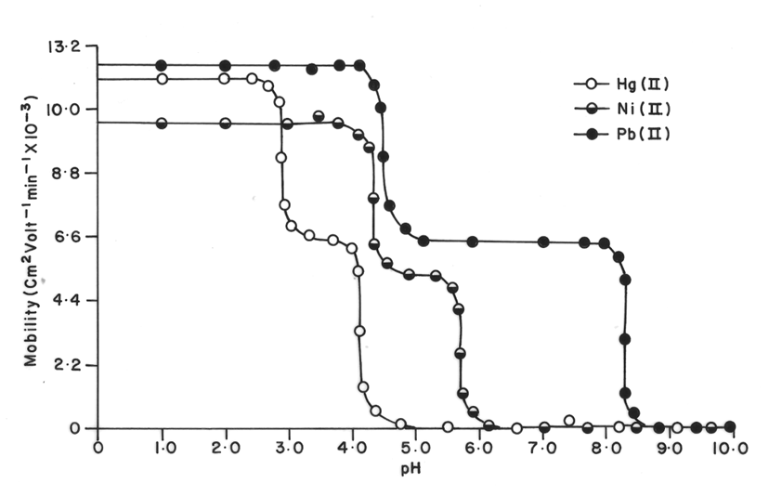

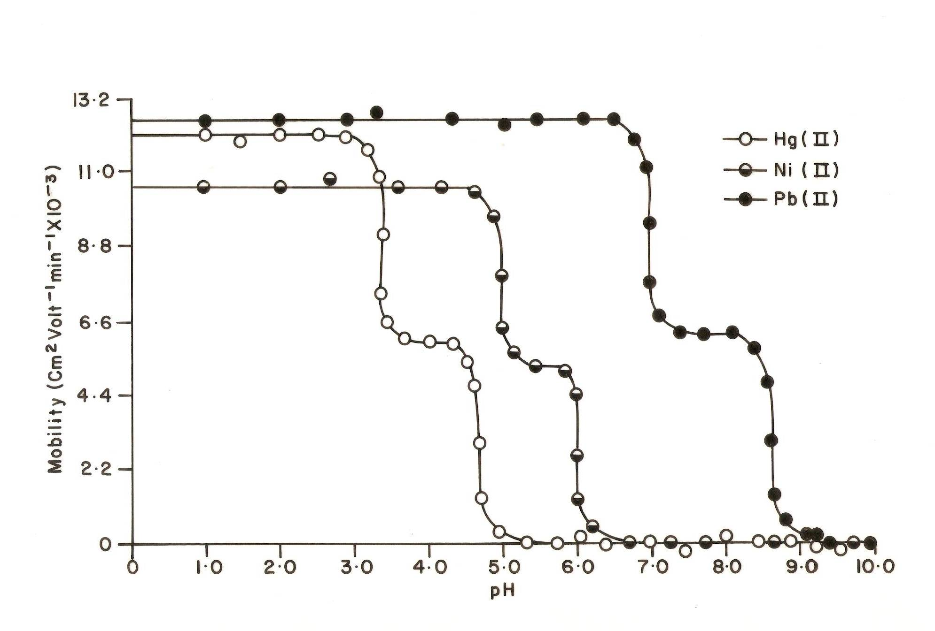
Figure 3.Mobility curve for the metal(II) isoleucine systems.
 = Hg(II) - isoleucine, = Ni(II) - isoleucine
 = Pb(II) – isoleucine. Background electrolyte = 0.1 M perchloric
acid and 0.01 M isoleucine. pHs were maintained by addition of sodium hydroxide. The paper strips were spotted with 0.1 μL of sample solutions and glucose (for making osmotic corrections).

[CH₃ CH₂ CH (CH₃) CH (NH₃⁺) COOH]
k₁  -H⁺
[CH₃ CH₂ CH (CH₃) CH (NH₃⁺) COO⁻]
k₂  -H⁺
[CH₃ CH₂ CH (CH₃) CH (NH₂) COO⁻]
Figure 4. Mode of dissociation of pure isoleucine. Ionic strength = 0.01 M. temperature = 35°C.

References
- Jokl V. Studies on complexation in solution with paper electrophoresis(II). Electrophoretic mobility and stability of mononuclear complexes. J. Chromatogr., 1964 :14: 71-8.
- Sherman SE. , Lippard SJ. Structural aspects of platinum anticancer drug interactions with DNA. Chem. Rev., 1987:87:1153-81.
- Banerjea D. Some aspects on the role of metal ions in biological systems. Everyman’s Sci., 1995: 29, 176- 84.
- Sutton DJ. ,Tchounwou PB. Mercury induces the externalization of phosphatidyl – serine in human renal proximal tubule (HK – 2) cells. Int. J. Environ. Res. Public Health , 2007: 4(2): 138-44.
- Das SK., Das AR., Guha AK. A study on the adsorption mechanism of mercury on Aspergillus Versicolor biomass. Environ. Sci. Technol., 2007: 41: 8281-87.
- Kaneko JJ., Ralston NVC. Selenium and mercury in pelagic fish in the central north pacific near Hawaii. Biol. Trace Elem. Res., 2007:119: 242-54.
- Sumi D. Biological effects of and responses to exposure of electrophilic environmental chemicals. J. Health Sci., 2008: 54(3): 267-72.
- Karthikeyan J. , Parameshwara P. , Shetty A. N. Indirect complexometric determination of mercury(II) using 3 – acetyl – 2 – thiohydrantoin as a selective mashing agent. Indian J. Chem. Technol., 2008: 15: 493-96.
- Lee MH. , Lee SW. , Kim SH. , Kang C., Kim JS. Nanomolar Hg(II) detection using nile blue chemodosimeter in biological meter. Org. Lett. , 2009: 11(10), 2101-04.
- Shokrollahi A. , Ghaedi M. , Shamsipur M. Highly Selective transport of mercury(II) ion through a bulk liquid membrane. Quim. Nova., 2009: 32 (1), 153-57 .
- Khan MR. , Khan MM. Effect of varying concentration of nickel and cobalt on the plant growth and yield of chickpea. Aust. J. Basic Appl. Sci., 2010: 4 (6): 1036 – 46.
- Chang EL. , Simmers C., Knight DA. Cobalt complexes as antiviral and antibacterial agents. Pharmaceuticals, 2010: 3: 1711 – 28.
- Saeed S. Rashid N. Ali M. Hussain R. Synthesis, Characterization and Antibacterial activity of nickel(II) and copper(II) complexes of N – (alkyl (aryl) carbamothioyl) – nitrobenzamide. Eur. J. Chem., 2010: 1(3): 200 – 205.
- Na’aliya J. The Stability constants of nickel(II) complexes of amino acids with polar uncharged R-groups, Bayero J. Pure Appl. Sci. , 2010 : 3(1): 241-44.
- Chandra S., Tyagi M. , Sharma K. Mo(II), Co(II), Ni(II) and Cu(II) complexes of tetraaza macro-cyclic ligands: synthesis, characterization and biological screening. J. Iran Chem. Soc., 2009: 6(2): 310-16.
- Patil SS. , Thakur GA. , Patil VR. Synthesis, spectral and biological studies on some mixed ligand Ni(II) complexes. Acta Poloniae Pharmaceutica – Drug Res., 2009: 66(3): 271-77.
- Chattopadhyay T. , Mukherjee M. , Mondal A. , Maiti P., Das D. A unique nickel system having versatile catalytic activity of biological significance. Inorg. Chem., 2010:49(7): 3121- 29.
- Bulut I. , Ucar I. , Kazak C. Spectroscopic and Structural study of Ni(II) dipicolinate complexes with 2 – amino – 4 – methylpyrimidine. Turk J. Chem., 2009: 33: 347-54.
- Prakash A., Gangwar MP. , Singh KK. Synthesis, spectroscopy and biological studies of nickel(II) complexes with tetradentate Schiff bases having N₂O₂ donor group. J. Dev. Biol. Tissue Eng., 2011: 3(2), 13-19.
- Adeyemi AO. Biological immobilization of lead from lead sulphide by Aspergillus Niger and Serpula Himantioides. Int. J. Environ. Res., 2009: 3(4): 477-82.
- Wen-Xing D. Role of autophagy in liver physiology and pathophysiology. World J. Biol. Chem., 2010:1(1): 3-12.
- Sheta VS., Benson DE. Protein design provides lead (II) ion biosensors for imaging molecular fluxes around red blood cells. Biochemistry, 2009: 48(2): 462-70.
- Herranz H. Cohen SM. Micrornas and gene regulatory networks: Managing the impact of noise in biological systems. Genes Dev., 2010:24:1339- 44.
- Ou-Yang HD., Wei, MT. Complex fluids: Probing mechanical properties of biological systems with optical tweezers. Annu. Rev. Phys. Chem., 2010: 61:421- 40.
- Imanpoor MR., Bagheri T. The Correlation between blood biochemical factors with some biological characteristics of gonad fertilization success, hatching rate and larbal size in Caspian Kutum, Rutilus frisii kutum. World J. Zoology, 2010: 5(4):278 – 81.
- Vanysek P., Ramirez LB. Interface between two immiscible liquid electrolytes: A review. J. Chil. Chem. Soc., 2008: 53(2): 1455-63.
- Hassan RYA., Habib IHI., Hassan HNA. Voltammetric determination of lead(II) in medical lotion and biological samples using chitosan – carbon paste electrode. Int. J. Electrochem. Sci., 2008: 3: 935-45.
- Papp P. ,Shchukin P., Matejcik S. Specific formation of negative ions from leucine and isoleucine molecules. J. Chem. Phys., 2010: 132:14301-10.
- Li Z L., Wang Y H., Chu J., Zhang YP. , Zhang SL. Effect of branched – chain amino acids, valine, isoleucine and leucine on the biosynthesis of bitespiramycin 4”-0’ – acylspiramycins. Braz. J. Microbiol., 2009: 40: 734-46.
- Mitrophanov AY. , Groisman EA. Positive feedback in cellular control systems. BioEssays , 2008: 30(6), 542-555.
- Irvine NM., Yerkes CN., Graupner PR., Roberts RE. , Hahn DR., Pearce C., Gerwick BC. Synthesis and characterization of synthetic analogs of cinnacidin, A novel phytotoxin from Nectria. Sp. Pest Manag. Sci., 2008: 64(9): 891-899.
- Sato C., Aikawa K. , Sugiyama S. , Nabeta K., Masuta C., Matsuura H. Distal transport of exogenously applied jasmonoyl, isoleucine with wounding stress. Plant Cell Physiol., 2011: 53(2): 509-17.
- Kashiwada A., Sakakibara A., Nakamura Y., Matsuda K. Monodispersed dimerization of isoluecine Zipper – coiled Coil Trimer. Bull. Chem. Soc. Jpn., 2007: 80(7):1296-301.
- Kawabe M., Sano M. , Hagiwara A. ,Tamano S., Suzuki S. , Shisai T. Lack of carcinogenicity of L- isoleucine in F344 / DuCrjrats. Food Chem. Toxicol., 2006:44(2): 278-85.
- Takors R., Bathe B., Rieping M. , Hans S. , Kelle R. , Huthmacher K. Systems biology for industrial strains and fermentation processes – examples: amino acids. J. Biotechnol., 2007: 129:181-90.
- Dimitrov T. , Mihaylova G. , Boycheva S. , Naydenova N. , Tsankova M. Changes in the amino acid composition of buffalo milk after chemical activation of its lactoperoxydase system. Ital. J. Anim. Sci., 2007: 6(2): 1050-52.
- Shaw DJ. Electrophoresis, Academic Press, London, 1969, pp. 99-103.
- Tewari, BB. Electrophoretic Technique in the study of metal ligand interaction. Reviews Anal. Chem., 2001: 20(4): 303-11.
- Tewari BB. Ionophoretic technique for the determination of stability constants of metal – nitrilotriacetate – methionine mixed complexes. J. Chromatogr. A, 1995:718:454-58.
- Tewari, BB. Paper electrophoresis in the study of mixed ligand complexes in solution. The system Fe(III) and Cr(III) –
methylcysteine – penicillamine. Biomed. Chromatogr., 1996:10: 221-24.
- Tewari, BB. Studies on lead(II) and uranyl(II) mixed complexes with methionine and cysteine and the formation constants of these complexes. Russ. J. Inorg. Chem., 2005: 50(1):35-39.
- Tewari, BB. Complex formation of some divalent metal ions with oxygen donor ligands. Rev. Boli. Quim., 2009: 26(1): 30-36.
- Tewari BB. Studies on complexation in solution with a paper electrophoretic technique [The system copper (II) / cobalt (II) – methionine – penicillamine]. J. Chem. Eng. Data, 2010: 55(5): 1779-83.
- Kolthoff IM. , Belcher R. Volumetric Analysis, Interscience Publisher Inc., New York, Vol. 3, 1957.
- Vogel, AI. Text Book of Quantitative Inorganic Analysis, Including Elementary Instrumental Analysis. 4th Edition, Longman’s, London, 1978.
- Blackburn JR. , Jones MM. Stereoselective in the metal complex catalyzed hydrolysis of amino acid ester (III). J. Inorg. Nucl. Chem., 1973: 35: 1605-20.
- Jokl V. Studies on complexation in solution with paper electrophoresis, J. Chromatogr., 1964: 6: 432-39.
- Martell AE. , Smith RM. Critical Stability Constants, Amino Acids, Plenum Press, New York, Vol. 1, 1974,p.12.

11/20/2011

