Population of House Sparrow, Passer domesticus (Linnaeus, 1758) in Different Habitats of District Kurukshetra, Haryana (India)

Girish Chopra¹, Ajay Kumar² and Parmesh Kumar³

^{1, 2} Department of Zoology, Kurukshetra University, Kurukshetra -136119, Haryana, India
³ University College, Kurukshetra University, Kurukshetra -136119, Haryana, India
email: ²ajayindorakuk@yahoo.com,

Abstract: The house sparrow, Passer domesticus (Linnaeus, 1758) is closely associated with human habitations and cultivation from historic times. However, this bird species once seen widely everywhere has now shown marked decline in its population in many parts of the world including India. The present study was carried out to assess the population status of house sparrow in different habitats of district Kurukshetra, Haryana (India). For this purpose monthly periodic visits from January, 2010 to December, 2010 were made in the four selected habitats namely, rural open areas/rural residential premises, ware houses/godowns/rice shellers, agricultural area and fallow lands. Line transects and scan sampling methods were used for counting the numbers of house sparrows. The maximum population of house sparrow was recorded in rural open areas/rural residential premises followed by ware houses/godowns/rice shellers and agricultural area. However, not even a single individual of house sparrow was spotted in selected fallow lands in all the four tehsils of district Kurukshetra during the study period. The average population density in rural open area/rural residential premises, ware houses/godowns /rice shellers, agricultural area and fallow lands was estimated to be 6.47±1.11, 0.91±0.23, 0.55±0.22 and 0.00±0.00 individuals/Km², respectively. There was a significant difference in abundance of birds during different months in the selected habitats. Specific reasons for monthly variation in the sparrow populations in general and the absence of birds in the fallow lands could not be ascertained.
[Girish Chopra, Ajay Kumar and Parmesh Kumar. Population of House Sparrow, Passer domesticus (Linnaeus, 1758) in Different Habitats of District Kurukshetra, Haryana (India). Nature and Science 2012;10(1):113-122]. (ISSN: 1545-0740). http://www.sciencepub.net

Keywords: House sparrow, Selected habitats, Population density, Haryana

1. Introduction

Birds are among the best monitors of environmental changes and have been used to evaluate the environment throughout the history as bio-monitors. The changes in their population, community structure, behavior patterns and reproductive ability have most often been used to assess ecological status of any given ecosystem (Bilgrami, 1995). An unnatural change in the population of a bird species will provide an early warning towards an ecological imbalance in the given environment. Thus, maintaining the populations of bird species provides an economically viable option for ecosystem management. The house sparrow (Passer domesticus) is one such species, which is closely associated with human habitations and cultivation from historic times (Ali, 1996; Chamberlain, 2007) and thus serves as an indicator of ecological health of the given area.
House Sparrow is sexual dimorphic, male is characterized by grey-crown, cheeks and under parts; black on throat, head, upper breast and between the bill and eyes. Female do not posses black on head or throat, nor a grey crown under parts. The young ones are characterized as deeper brown in color and the beak is dull yellow. It is omnivorous and feeds on grains, fruit buds, flower nectar, weed seeds, insects and kitchen scrap, though chicks are fed with aphids, weevils, grasshoppers, and caterpillars (Crick et al., 2002). Aphids are essential for nestling survival of the House Sparrow. The nest is built in holes of structures, under the tiles or around roof area of houses. House sparrows are monogamous and long-term pair bond is maintained throughout and between breeding seasons. The species breed in small colonies or in loose groups.
The house sparrow is one of the most wide spread and abundant birds in the world (Summer-Smith, 1988; Anderson, 2006). However, a marked decline of sparrow population has been reported from different countries over the globe particularly in urban habitats including Berlin (Dröscher, 1992), Brussels (Balmori and Hallberg, 2007), Central Europe (Bauer et al., 2005), Spain and Dublin (Prowse, 2002) and Western Europe (Summers-Smith, 1999; Crick et al., 2002). The House Sparrow is already red listed in the Netherlands, where it has a decline over 50% of its total population in the last 25 years of the 20th century. In UK, a massive decrease in the House Sparrow population (Crick et al., 2002; Hole et al., 2002; Raven et al., 2003; Anonymous, 2004) has led to almost complete extinction in some urban centres like London, where there was a 71% decline from 1994 to 2002 (Raven et al., 2003). In 2002, the House Sparrow was added to the Red List of U.K. endangered species (Summers-Smith, 2003). As far as India is concerned, the survey reports on the occurrences of house sparrow at different places have shown a considerable decline in its population along urban gradient (Daniels, 2005; Rajashekar and Venkatesha, 2008; Khera et al., 2010; Bhattacharya et al., 2010; Ghosh et al., 2010). The primary causes of this decline have not yet been ascertained. But a number of hypotheses have been put forward as possible causes of the decline of house sparrows in urban-suburban habitats. These include predation, competition, lack of nest sites, disease, food availability and pollution (Summers-Smith, 1999). As far as Haryana state is concerned, this species was very common but its population had shown a considerable decline. However, till date no authentic data is available on the population status of this bird. Therefore, present study was designed to assess population of house sparrow in different habitats of district Kurukshetra, Haryana (India).

2. Materials and Methods
During present study, information on the population of house sparrow, Passer domesticus (Linnaeus, 1758) was collected in district Kurukshetra, Haryana (India). District Kurukshetra also called as Rice bowl of India. It is situated at 29⁰52´ N to 30⁰12´ N latitude and 76⁰26´ E to 77⁰04´ E longitude in the state of Haryana (fig. 1). It is surrounded by the districts of Yamuna nagar in East, Karnal in South, Kaithal in South-West and amalgamates in district Ambala in West and North. It has four tehsils namely, Pehowa, Thanesar, Shahabad and Ladwa with 419 villages. The total area of district Kurukshetra under cultivation is 1,680,000 ha.
Monthly periodic visits were made in each selected study site from January, 2010 to December, 2010. In tehsil Pehowa, five rural open areas/rural residential premises namely, Gauchard (PVI), Dhanipura (PV2), Bhatta majra (PV3), Nipura (PV4) and Khadaspur (PV5); five godowns/ware houses/rice shellers namely, HAFED1 (PG1), HAFED2 (PG2), Satara rice seed store godowns (PG3), Seth tara chand seed store (PG4) and Govt. ware house, Pehowa (PG5) were selected (fig. 2). Similarly, in the tehsil Thanesar five rural open area /rural residential premises namely, Rampura dera (TV1), Fatuhpur (TV2), Raidaspur (TV3), Khaspur (TV4) and Amin (TV5); five godowns/ware houses/rice shellers namely, Anaz mandi (TG1), FCI godowns (TG2), Krishna seed store (TG3), HAFED (TG4) and Haryana ware house corporation (TG5) were selected (fig. 3). Five rural open area/rural residential premises namely, Damawali (SG1), Rawa (SG2), Damli (SG3), Salimpur (SG4), Padlu (SG5) and five godowns/ware houses/rice shellers namely, HAFED1 (SG1), State ware house corporation (SG2), Anaz mandi (SG3), HAFED 2 (SG4) and Markendeshwar rice store (SG5) were selected in the tehsil Shahabad (fig. 4). Also, in the tehsil Ladwa five rural open area/rural residential premises namely, Bapdi (LV1), Bapda (LV2), Badonda (LV3), Badondi (LV4), Bhukha majra (LV5) and five godowns/ware houses/rice shellers namely, Anaz mandi (LG1), State ware house corporation (LG2), Mohan rice store (LG3), Aggarwal rice store (LG4) and FCI godowns (LG5) were selected (fig. 5). Agricultural lands and fallow lands were also selected for the same (fig. 2, 3, 4,5).
Line transects (Watson, 1965) and Scan sampling (Altman, 1974) methods were used for counting the numbers of house sparrows. Counting of the birds was made in the day phase i.e., morning phase 5.00 A.M.–11.00 A.M. and evening phase 3.00 P.M.-7.00 P.M., when they were the most active and conspicuous. The collected data was later statistically analysed to estimate the population on monthly basis.

3. Results and Discussion
Monthly periodic visits from January, 2010 to December, 2010 were made in four selected habitats namely, rural open area/rural residential premises, ware houses/godowns/rice shellers, agricultural areas and fallow land in all the four tehsils of district Kurukshetra, Haryana to assess population status of house sparrow, Passer domesticus (Linnaeus, 1758). The results on sparrow population in different habitats are presented in Table1. The average population density of house sparrow in selected rural open area/rural residential premises, ware houses/godowns /rice shellers and agricultural area of all over district Kurukshetra was estimated to be 6.47±1.11, 0.91±0.23, 0.55±0.22, respectively. However, not even a single individual of house sparrow was spotted in selected fallow lands in all the four tehsils of district Kurukshetra during the study period. Average population density of house sparrow was observed minimum 5.80±0.70 individuals/Km² in selected rural open area/rural residential premises of tehsil Thanesar to maximum 7.24±2.61 individuals /Km² in selected rural open area/rural residential premises of tehsil Pehowa. Also in selected ware houses/godowns/riceshellers, it varied from minimum 0.47±0.14 house sparrow/Km² of tehsil Thanesar to maximum 1.41±0.35 house sparrow/Km² of tehsil Pehowa. Similarly in selected agricultural fields, average population density of house sparrow was observed minimum 0.41±0.27 sparrows/Km² in tehsil Shahabad to maximum 0.74±0.20 sparrows/Km² in tehsil Ladwa. Not even a single individual of House Sparrow was spotted in selected fallow lands in all the four tehsils of district Kurukshetra during the study period.

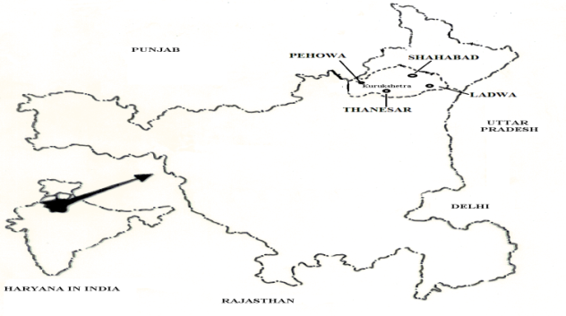

Fig.1 Map of district Kurukshetra (Haryana).
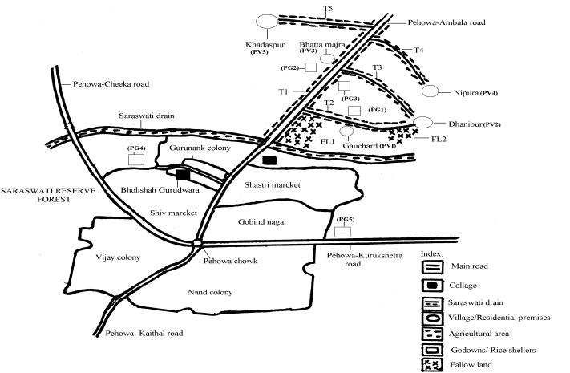
Fig. 2 Selected habitats in tehsil Pehowa of district Kurukshetra.
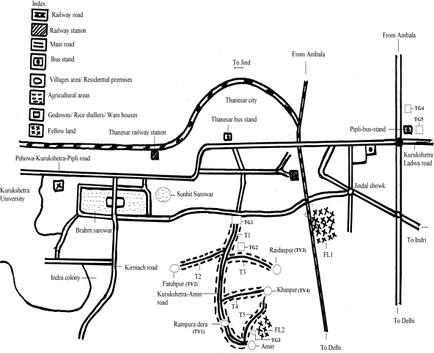

Fig. 3 Selected habitats in tehsil Thanesar of district Kurukshetra.
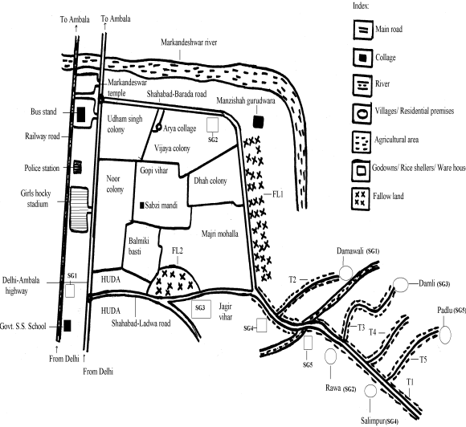
Fig. 4 Selected habitats in tehsil Shahabad of district Kurukshetra.

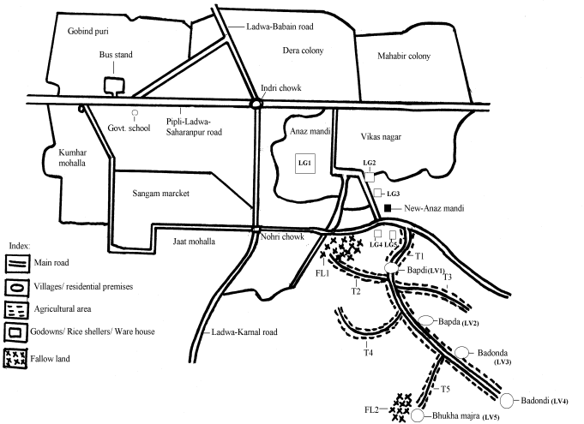
Fig. 5 Selected habitats in tehsil Ladwa of district Kurukshetra.

Occurrence of house sparrow near human habitations such as suburban areas, gardens, parks, agricultural areas, stables, feedlots, villages and godowns is well documented over the globe (Summers-Smith, 1988; Louther and Cink, 1992; Monika, 2005; Sharma, 2009). However, its abundance varies in different habitats. Moreover, dwindling of sparrow populations along urban gradient is getting more into focus in different parts of the world including India (Dröscher, 1992; Summers-Smith, 1999; Balmori and Hallberg, 2007; Rajashekar and Venkatesha, 2008; Khera et al., 2010; Bhattacharya et al., 2010; Ghosh et al., 2010). Monika (2005) recorded maximum numbers of house sparrows in rural areas as compared to agricultural areas and further observed that house sparrow do not inhabit in dense forest area. Similarly Bohler and Claus (2007) also observed maximum population density of house sparrow in rural areas (50individual/10 hactares) as compared to parks and garden (48 individuals/10 hactares) and industries area (45 individuals/10 hactares). In the present study also, population density of house sparrow was observed maximum in the rural open area/ residential premises followed by ware houses/godowns/rice shellers and agricultural area. The availability of plenty of food such as grains, vegetables, insects, especially caterpillars in the vegetables and the suitable nesting sites could be important factors for the high density of sparrows in rural open area/ residential premises. In rural areas sparrows were dependent on the leftover grains thrown to them after people cleaned their grains. This habit of still throwing leftover cleaned grains to the sparrows still continues in the rural sides. The study sites in rural areas consisted of cultivated fields where rice, wheat, sunflower and vegetables were grown. Moreover, in these areas weeds, shrubs and bushes of various plant species were also common. Sparrows were always in the habit of building nests in tiled houses under the rafters, niches in the gables, and in some houses intentional holes were made near the roofing to accommodate sparrow nests. They were found to build nests in hanging lampshades, wall clocks, behind photo frames hung on walls. In present study, the optimum habitats for House Sparrows were holes of buildings, under tiles or eaves and green areas to provide insect food for the young. Habitat quality is known to have a major influence on the sparrow populations, with availability of food sources. Simwat (1977) reported that 84% of the total food of the sparrow nestling comprised insects, with caterpillars contributing about 38%.Thus availability of a variety of food sources for both adults and nestlings and essential nesting sites around the food sources primarily play an important role in the abundance of house sparrow populations.
However, not even a single individual of House Sparrow was spotted in selected fallow lands in all the four tehsils of district Kurukshetra during the study period. Earlier workers have also reported non occurrence of hose sparrow in dense forest and tundra (Summers-Smith, 1988; Monika, 2005; Thompson, 2009; Mclissa, 2010).
There was significant difference in abundance of birds during different months of the study in the selected habitats. Monthly variations in population density of house sparrow recorded in all the four tehsils in different habitats (table 2). The population density of house sparrow varied from a minimum of 8.07 sparrows/Km² (October, 2010) to maximum of 16.96 sparrows/Km² (September, 2010) in rural residential premises/rural open area and from minimum of 1.72 house sparrows/Km² (December, 2010) to maximum of 18.96 house sparrows/Km² (May, 2010) in ware house/rice shellers / godowns . In agricultural area maximum of 3.06 house sparrows/Km² were recorded during May and August, 2010 while no bird was spotted during months of February, July and December 2010 in this habitat (fig. 6,7,8,9). As far as fallow lands habitat is concerned, not even a single individual of House Sparrow was spotted in all the four tehsils of district Kurukshetra during the entire study period (fig 6, 7, 8 and 9). Similarly, earlier workers have also recorded seasonal variations in the populations of house sparrow in different habitats (Esterbrook, 1999; Bohner et al, 2003; Monika, 2005; Rajashekar and Venkatesha, 2008). Esterbrook (1999) recorded the house sparrow number more or less continuous decline in winter during the period (1975-1999). The sparrow population had decline in garden during winters (Robinson et al, 2005). Monika (2005) also observed that various seasonal factor such as humidity, rain fall, temperature etc. effect the population density of house sparrow. In the present study population density of house sparrow was observed declining in winter season in rural open area/rural residential premises and agricultural area (crop lands), during summer and monsoon seasons in ware houses/godowns/rice shellers. However, during present study specific reasons for monthly variation in the sparrow populations in general and the absence of birds in the fallow lands could not be ascertained.
The possible causes of dwindling population density of house sparrow in selected habitats namely, rural open area/rural residential premises, warehouses/godowns/rice shellers, agricultural areas and fallow lands in district Kurukshetra could be loss of nesting sites due to urbanization, criss-cross cable wires in and around hose sparrow rich density areas, use of insecticides, reducing habitats and mobile tower radiations. Altizer et al, (2004), Hole (2001), Hole et al, (2002), Pinowski et al, (1995), Smith (1998), Wotton et al, (2002), Rajashekher and Ventkatenta (2008) also reported similar results.Further, in present study area the inter specific competition with Common Babbler (Turdoides caudata) in house sparrow rich density areas may be cause for decline the population of house sparrow as both birds have similar habits and habitat.

Table: 1 Average population density of house sparrow in selected habitats in four tehsils of district Kurukshetra.
Name of Selected Habitat | Average population density in Tehsils
Name of Selected Habitat | Pehowa | Thanesar | Shahabad | Ladwa | Overall Kurukshetra
RRP/ROA | 7.24±2.61 | 5.80±0.70 | 6.28±0.74 | 7.10±0.83 | 6.47±1.11
WH/RS/G | 1.41±0.35 | 0.47±0.14 | 1.16±0.27 | 0.63±0.16 | 0.91±0.23
AF | 0.66±0.26 | 0.42±0.16 | 0.41±0.27 | 0.74±0.20 | 0.55±0.22
FL | 0.00±0.00 | 0.00±0.00 | 0.00±0.00 | 0.00±0.00 | 0.00±0.00
RRP-rural residential premises, ROA- Rural open area, WH-ware house, RS-rice shellers, G-godowns, AF- agricultural areas, FL- fellow land.
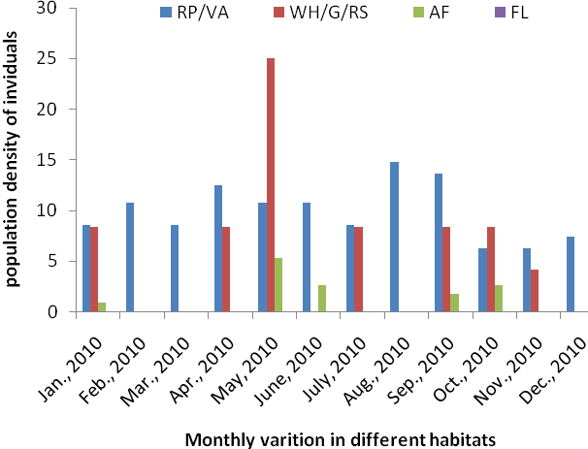
Fig. 6 Monthly variation of population density of house sparrow in selected habitat of tehsil Pehowa

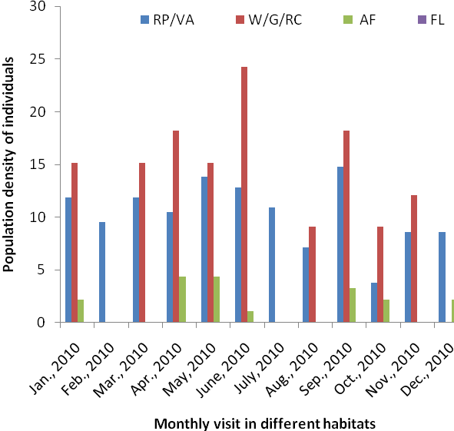
Fig. 7 Monthly variation of population density of house sparrow in selected habitat of tehsil Thanesar.
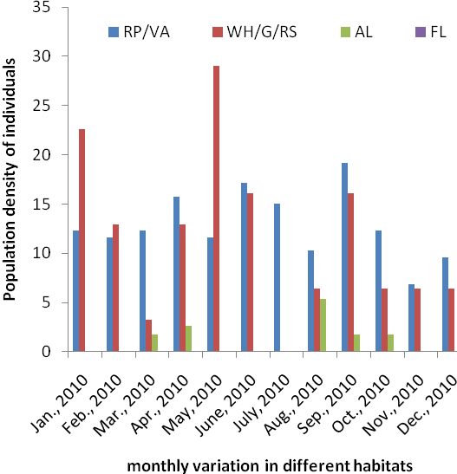
Fig. 8 Monthly variation of population density of house sparrow in selected habitat of tehsil Shahabad.
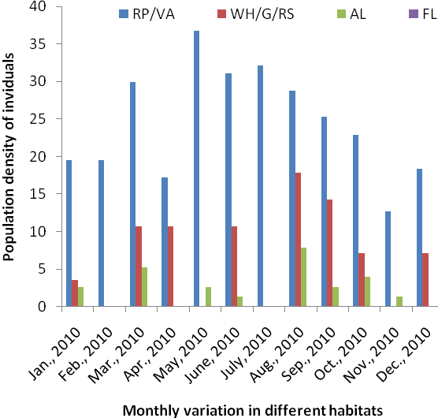
RRP-rural residential premises, ROA- Rural open area, WH-ware house, RS-rice shellers, G-godowns, AF- agricultural fields, FL- fallow land.
Fig. 9 Monthly variation of population density of house sparrow in selected habitat of tehsil Ladwa.

Table: 2 Monthly variation of average population density of house sparrow in selected habitat of district Kurukshetra, Haryana during January 2010 to December 2010
Month | Average population density in different selected habitats  (sparrows/km² )
Month | RRP/ROA | WH/RS/G | AA/CL | FL
January | 10.82 | 13.79 | 1.27 | 0.00
Febraury | 11.47 | 3.44 | 0.00 | 0.00
March | 13.57 | 8.62 | 1.53 | 0.00
April | 13.24 | 10.34 | 1.78 | 0.00
May | 14.05 | 18.96 | 3.06 | 0.00
June | 15.83 | 12.06 | 1.27 | 0.00
July | 14.21 | 10.34 | 0.00 | 0.00
August | 13.08 | 9.48 | 3.06 | 0.00
September | 16.96 | 12.93 | 2.80 | 0.00
October | 10.82 | 8.62 | 2.80 | 0.00
November | 8.07 | 6.89 | 0.25 | 0.00
December | 9.85 | 1.72 | 0.00 | 0.00
RRP-rural residential premises, ROA- Rural open area, WH-ware house, RS-rice shellers, G-godowns, AF- agricultural fields, FL- fallow lands.

Correspondence to:
Prof. Girish Chopra
Department of Zoology, Kurukshetra University,
Kurukshetra-136119, (Haryana) India
Cellular phone: +91-9896235132
E-mail: girishchopra2@gmail.com

References
(1) Ali S and Ripley SD. Hand book of birds of India and Pakistan. Oxford University Press Bombay 1987: 126.
(2) Altizers P, Bibby J, Clobert M and Phillips K. A field guide of the birds of China. Oxford University, Oxford 2004:126.
(3) Altman J. Observation study of behavior: sampling methods. Behaviour 1974;49:227-265.
(4) Anderson R. Biology of the ubiquitous House sparrow: From genus to population. Oxford University Press 2006;11(2):12-16.
(5) Anonymous P. The International Symposium of the Working Group on Granivorous Birds - Granivorous Birds as Agricultural Pests and Epidemiological Vectors. Does pollution of urban environment influence clutch size in the Tree Sparrow (Passer montanus)? In Nestling mortality of granivorous birds due to microorganisms and toxic substances: Synthesis, (Eds. Pinowski, J., Kavanagh, B. and Pinowska, B.). domesticus indicus in and around Bangalore”, Current Science 2005; 94(4): 446-449.
(6) Arya V. Population status of house sparrow, Passer domesticus in Ajmer (Rajasthan). Ph.D. thesis, Maharishi Dayand University, Ajmer (Rajasthan, India) 2005:142-145.
(7) Balmori H and Hallberg V. Wall clining: Energy saving by the house sparrow, Passer domesticus Ibis 2007; 126(1):72-74.
(8) Bhattacharya R, Roy R, Ghosh S and Dey A. Observations on house House Sparrow (Passer domesticus) in Delhi, India”’ Urban Ecosystem 2010;13(1):111-116.
(9) Bohler V and Cluse GS. Buy bird, hello virus, the Teligraph, Calcutta, India. Retroviral November 3 (2007), from http:www.teligraphIndia.com/1081103/jsp/atleisure/story-10055641.jsp.
(10) Bohner J, Schluz W and Witt K. Abundant and bettered density of house sparrow (Passer domesticus) in Berlin. Berl. Orinthol. Berlin2003;32:42-61.
(11) Chamberlain DE, Toms, MP, ClearyMcHarg R, Banks A N. House Sparrow (Passer domesticus) habitat use in urbanized landscapes”, Journal of sparrow at Bandel, Hoogly, Proceedings of National Seminar on Biodiversity 2007;13(1):154-156.
(12) Crick RD, Noble DG, Robinson J, Brown AF, Hughes J, Procter D, Gibbons D and Galbraith CA. The population status of birds in the United Kingdom, Channel Islands and Isle of Man: An analysis of conservation concern. British Birds 2002;95:410-448.
(13) Denis J. Distribution, abidance and dynamic of house sparrow (Passer domesticus) in Berlin Intern. Stud. Sparrow. 2005;32:15-23.
(14) Droscher V. Diets of House Sparrows in Urban and Rural Habitats. Wilson Bulletin 1992; 98:137-144.
Easterbrook F. House sparrow taking insects from car radiators. Notorins 1999;33(3):190-191.
(15) Ghosh S, KiHyun Kim and Bhattacharya R. A survey on house sparrow Environmental Science, Kalyani University 2010:147 – 152.
(16) Hole JM. Parrot of the world. Blandford, London 2001:7-17.
(17) Hole Y, Clayton DH, Joxis P and Cotgreave P. Relationship of bill morphology to grooming behavior of birds. Animal behavior 2002;47:195-201.
(18) Khera N, Das A, Srivastava S and Jain S. Habitat wise distribution of the house sparrow, Passer domesticus 2010;5(3):16-19.
(19) Lowther P and Cink C. The house sparrow 1992:81-89.
(20) McLissa C. Are the Parision Sparrow Disappearing (Club Nature et Environment d’lle de France) 2010:1-4.
(21) Monika G. Preliminary survey of house sparrow ( Passer domesticus) in three areas of Haridwar, Uttrakhand. M.Sc. thesis, Gurukul Kangri University, Haridwar, India 2005:1-27.
(22) Rajashekher S and Ventkanteha MG. Occurrence of home sparrow, Passer domesticus indicus and around Banglore. Current science 2008; 94(4):446-449.
(23) Raven P, Crick H, Marchant J, Noble DG, Bailli SR, Balmer DE, Beaven LP and Coombes R. Breeding birds in the wider countryside: Their conservation status 2003 Report no. 353(BTO).
(24) Rhamoni, R. (2008): Fight to extinction. Spectrum, The Tribune. Retrived June 8, 2008, from http://www.tribuneindia.com/2008/20080608/spectrum/main1.htm.
(25) Robinson T, White GC and Burnham KP. Program mark: Survival estimation from populations of marked animals. Bird Study 2005;46:120-139.
(26)Sharma K. Where are all the sparrow gone? Retrined June, 2009, from http://indiwo.in.com/india/feather/harmony-in-life-life/where-are-all-the-sparrow-gone/40681/0.
(27) Summer-smith J. The Adaptive House Saprrow Notorins 1999;21(1):88.
(28) Summersmith Y. The house sparrow. Colhis, London, UK 1988:1-18.
(29) Summers-Smith J. The Sparrows. illustrated by Robert Gillmor. Calton, Staffs, England: T. & A. D. Poyser 1988:1-11.
(30) Thompson L. The use of artificial nest sites erected for Starlings in Canterbury, New Zealand. New Zealand Journal of Zoology 2009;1(1):349-354.
(31) Watson M. Food of Nestling House Sparrows (Passer domesticus) and Tree sparrows (Passer montanus) in Agrocenoses. Polish Ecological Studies 1965;1:227-242.

11/12/2011

