Aspects of reproductive biology of big eye grunt Brachydeuterus auritus (Valenciennes, 1832)

Fatimat Adenike Adebiyi*

Department of Marine Sciences, Faculty of Science, University of Lagos, Akoka, Yaba, Lagos, Nigeria
adebiyi_fatima@yahoo.com

Abstract: Aspects of reproductive biology of big eye grunt Brachydeuterus auritus off Lagos coast, Nigeria were investigated and focussed on sex ratio, gonadosomatic index, stages of gonadal development and fecundity. A total of 450 fish with body length of 11.7 – 19.3 cm (total length) and body weight of 12.4 – 110.5g were used for this study. The sex ratio of B. auritus was 1: 1.11 (male to female). The females were more than the males. However, there was no significant difference (p > 0.05) in sex ratio from the expected 1:1 distribution. Gonadosomatic index ranged from 0.18 – 12.73%. The mean gonadosomatic index was 3.96 ± 0.19. High gonadosomatic indices were observed in July, August and September which indicated the spawning period and falls within the wet season. Quiescent, maturing and mature ovarian and testicular stages of gonadal development were observed in all samples of B. auritus collected for this study. Fecundity ranged from 12,503 – 74, 045 eggs with a mean of 32, 344 ± 1,889 eggs. This suggested that B. auritus is a low fecund fish. Fecundity –length and fecundity-weight relationships showed positive correlations. The Fecundity-length and fecundity–weight relationships were determined by regression analysis with the regression equation Log F = 1.8985 + 2.2706 Log L (r = 0.5083) for fecundity–length relationship and Log F = 4.0292 + 0.2657 Log W (r = 0.3090) for fecundity-weight relationship. Fecundity was more related to length than to weight. This information is relevant for fisheries recruitment and population dynamics as well as breeding programmes in aquaculture of B. auritus.
[Fatimat Adenike Adebiyi. Aspects of reproductive biology of big eye grunt Brachydeuterus auritus Valenciennes, 1832) . Nature and Science 2012;10(2):19-24]. (ISSN: 1545-0740). http://www.sciencepub.net. 3

Key words: Brachydeuterus auritus, fecundity-length relationship, fecundity-weight relationship, gonadal development, Lagos coast, reproductive biology, sex ratio.

1. Introduction
Sex ratio, gonadosomatic index, stages of gonadal development and fecundity are some important aspects of fish reproductive biology, which give information necessary for successful fisheries management and recruitment in natural water bodies and aquaculture of fish species.
Sex ratio provides information on the representation of male and female fish by stating the proportion of male fish to female fish in a population and indicates the dominating sex of fish in a population which constitutes basic information in assessing reproductive potentials and estimating stock size in fish population (Vicentini and Araujo, 2003). In order to determine female spawning biomass, estimates of reproductive potential can be added to sex ratio information to give a better understanding and assessment of stock status relative to a biological indicator, which has been observed for some fish stocks (Morgan, 2008).
Gonadosomatic index is an index of the size of gonad relative to size of the fish (Dadzie and Wangila, 1980) and is an indicator of gonadal development in fish. Gonadosomatic index determines the percentage of body weight of fish used for egg production.
Fecundity is one of the important aspects of reproductive biology of fish species which provides information on the number of eggs in the ovary prior to the next spawning season (Bagenal, 1978). Fecundity studies are useful for systematics in racial studies that has connection with total population estimation and is also relevant in studies of population dynamics and productivity.
The Lagos coast contains many economically important fish species for fishery. B. auritus is one of the fish species known as grunts and is one of the demersal resources of the Lagos coast. B. auritus forms part of the trawl fishery catch in the Lagos coast and belongs to family Haemulidae and inhabits soft muddy sandy bottoms at depth between 15-50 m (Mensah and Quaatey, 2002)
Information on reproductive biology of some economically important fish species in the Lagos coast have been reported by some authors (Marcus and Kusemiju, 1984; Anyanwu, 1990). There are few references to the study of the biology of grunts off the Lagos coast, Nigeria. It is pertinent to note that there is paucity of information on the reproductive biology of B. auritus off Lagos coast. The reproductive biology of B. auritus has not been widely reported. Hence, the need to carry out this study which aimed at some aspects of reproductive biology of B. auritus with particular interest in sex ratio, gonadosomatic index, stages of gonadal development and fecundity. The information obtained from this study will enhance our knowledge of reproductive biology of B. auritus and contribute to estimation of reproductive metrics which is vital for aquaculture and fisheries management.

2. Materials and methods
2.1. Study area
The Lagos coast was the study area for this research. The Nigerian coastline is between longitude 02° 53¹ to 08° 14¹E and latitude 06° 21¹ to 03° 55¹N, covering a distance of 85 km and lies in between the Gulf of Guinea. Lagos coast is a narrow coastal shelf and lies between 14, 816 km and 27,780 km with a total area of 41,000 km². It is a marine environment and salinity is a major limiting factor to the growth of some organisms in the Lagos coast (FAO, 1969; Nwankwo and Onyema, 2003).

2.2. Collection of specimens and sampling
Specimens of B. auritus were purchased from fish mongers at the landing centre of trawlers fishing off the Lagos coast, at the jetty in Ijora Olopa, Lagos, Nigeria. The specimens were collected from January to September 2005. The fish was identified by using the FAO fish identification manual (FAO, 1981). Fifty samples were randomly selected each month, making a total of 450 samples collected during the study period. The samples were transported to the research laboratory and preserved in a deep freezer at -20 °C until examination and analysis.

2.3. Morphometric measurements
The specimens were brought out of the deep freezer and allowed to thaw and the body length and weight were measured. Total and standard lengths were measured using a one-meter measuring board graduated in cm. The fish was wiped with a dry napkin before weighing and body weight and ovary weight were measured using a weighing balance (Sartorius model).

2.4. Sex ratio
Each specimen was dissected and the gonads were removed after dissection. The sex of each specimen was identified by examination of the gonads. The proportion of the two sexes relative to one another was used to calculate the sex ratio.

2.5. Gonadosomatic index
The gonadosomatic index was calculated according to Strum (1978) as follows:

GSI = weight of gonad × 100
weight of fish

2.6. Stages of gonadal development
Gonadal stages were examined macroscopically and classified according to Nikolsky (1963) as follows:
Stage I-Immature
Stage II-Quiescent
Stage III-Maturing
Stage IV-Mature
Stage V- Running
Stage VI-Spent
The number of males and females in the different stages of gonadal development were counted and recorded.

2. 7. Fecundity estimation
Fecundity which is the number of ripe eggs in the female prior to the next spawning season was estimated according to Bagenal (1978). Only ovarian developmental stages III and IV were used for fecundity estimation. Fecundity was estimated through subsampling by gravimetric method. The gonad weight of the fish was measured before preservation in Gilson fluid. Preserved gonads, were later washed with water before counting.
The eggs were placed in a Petri dish and a subsample of 1g of eggs was measured. Then the number of eggs in the subsample was counted. Five subsamples were taken and the mean value of eggs was used to calculate the total number of eggs in the gonads. Thirty mature ovaries were used for fecundity study of B. auritus.
Regression analysis was carried out relating fecundity to size of fish. The relationship between fecundity and size of fish was determined by using the formula
F = aX^{b}
Where F = Fecundity, X = Standard length of fish (cm) or weight of fish (g), a= Regression constant and b= Regression coefficient.
The relationship was transformed into a straight line using logarithm, as
Log Y = a + b Log X.

2.8. Statistical analyses
Data were analysed using statistical analysis software (SAS 9.2) and Microsoft Excel 2003 software. Data were expressed as mean ± standard error of mean. The sex ratio was tested for the expected 1:1 ratio by using chi-square analysis. Fecundity-length and fecundity-weight relationships were analysed by using regression analysis. The relationship of fecundity with body length and body weight of fish was also analysed by using Pearson’s correlation analysis. Level of significance was selected as p < 0.05.

3. Results
3.1. Sex ratio
A total of 213 males and 237 females were observed out of 450 samples examined. The sex ratio was 1: 1.11 (male to female). The difference in sex ratio was not significant (p > 0.05).

3.2. Gonadosomatic index
The gonadosomatic index of B. auritus ranged from 0.18% (in a fish of standard length 13.1 cm and body weight 55.4 g) to 12.3% (in a fish of standard length 11.5 cm and body weight 27.5 g). The mean gonadosomatic index was 3.96 ± 0.19. High gonadosomatic indices were observed in July, August and September.

3.3. Stages of gonadal development
In this study, only three stages of gonadal development were observed in male and female B. auritus. These were stage II- quiescent, stage III- maturing and stage IV- mature. Table 1 shows the macroscopic features of the stages of ovarian and testicular development of B. auritus.

Table 1. Stages of gonadal developments of Brachydeuterus auritus
Stages of  gonadal development | Macroscopic features
 | Ovary | Testis
I  II  III  IV  V  VI | Not encountered  Ovary was tiny, translucent and creamy white in colour. Oocytes were not visible.  Ovary was large, opaque and light yellow in colour. Blood vessels were seen on the surface  Ovary was enlarged, yellowish in colour and the eggs were clearly visible.  Not encountered  Not encountered | Not encountered  Testis was tiny, threadlike and translucent.  Testis was large, opaque and creamy white in colour.  Testis was enlarged and whitish in colour. Milt could be released if the testis was under pressure.  Not encountered  Not encountered

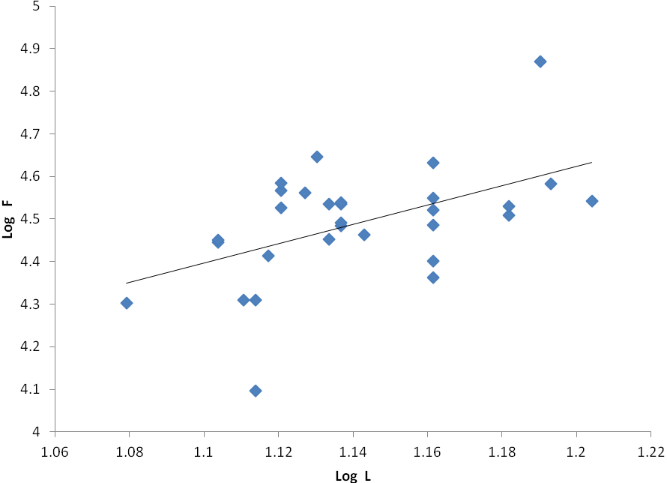
Log F = 1.8985 + 2.2706 Log L
(r² = 0.2583).
Figure 1. Fecundity-length relationship of Brachydeuterus auritus off Lagos coast

3.4. Fecundity
The number of eggs in each mature ovary ranged from 12,503 eggs (in a fish of standard length 13.0 cm and body weight 4.1 g) to 74,045 eggs (in a fish of standard length 15.5 cm and body weight 110.5 g). A mean fecundity of 32,344 ± 1,889 eggs per female was obtained. Fecundity was positively correlated with length and body weight. The correlation coefficient r was 0.5083 and 0.3090 for fecundity-length and fecundity-weight relationship, respectively. The fecundity – length relationship is illustrated in Figure 1. The regression equation was
Log F = 1.8985 + 2.2706 Log L (r = 0.5083).

The fecundity - weight relationship is illustrated in Figure 2. The regression equation was Log F = 4.0292 + 0.2657 Log W (r = 0.3090).

4. Discussion
The sex ratio of B. auritus in the Lagos coast suggested that there were more males than females. There was a deviation from the 1:1 sex ratio distribution. However, the difference in sex ratio was not significantly different (p > 0.05) from the expected 1:1 distribution. Kusemiju et al. (1979) reported the opposite in sex ratio for B. auritus which indicated that the males outnumbered the females. This was contrary to the results of sex ratio obtained for B. auritus in this study. The difference in sex ratio of B. auritus tested by Kusemiju et al. (1979) was not significantly different (p > 0.05). Similarly, the difference in sex ratio of B. auritus reported in this study was not significantly different from the normal distribution of sex ratio. In cape coast, Ghana B. auritus had more females than males (Asabere-Ameyaw, 2001). The sex ratio of B. auritus obtained in this study was similar to that of B. auritus off the cape coast in Ghana. The sex ratio of trout sweetlips grunt Plectorhynchus pictus was 1: 1.09 (male to female) (Al-Ogaily and Hussain, 1990). This indicated more females than males. A similar sex ratio was obtained for B. auritus in this study.
Gonadosomatic index was high in July – September, the highest gonadosomatic index was in July (7.29 ± 0.05) and this suggested that this could be the spawning period of B. auritus. July – September fall in the wet season. During the wet season, rainfall is high, water levels in the Lagos coast increase and food availability is also high, thus providing favourable conditions for spawning to occur. High gonadosomatic indices were recorded for trout sweetlips grunt Plectorhychus pictus during the months of March, April, May and December, which suggested that these months are the spawning period of this fish (Al-Ogaily and Hussain, 1990). This was not in line with the results obtained for B. auritus in this study. High gonadosomatic indices were recorded in July - September.
Immature stage of gonadal development i.e. stage I was not present in the ovarian and testicular samples examined in this study. This indicated that the samples collected for this study were quiescent, maturing and matured fish.

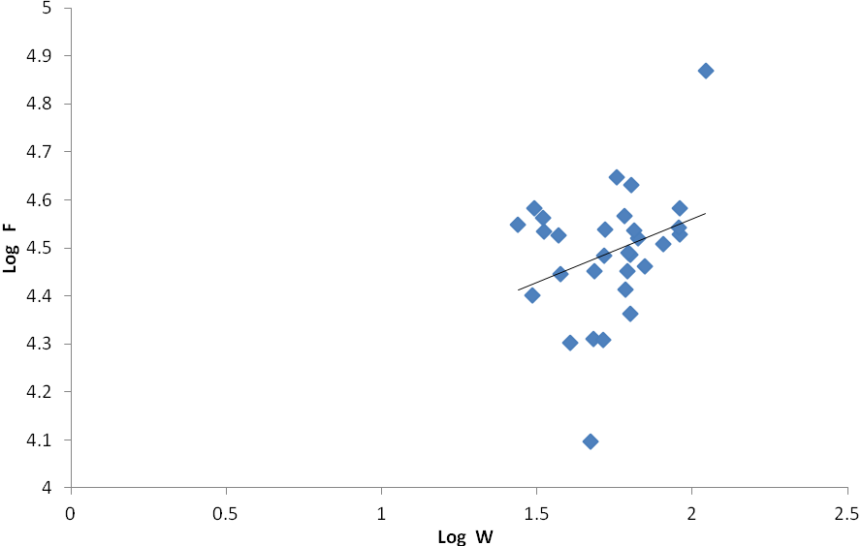
Log F = 4.0292 + 0.2657 Log W (r²= 0.0955)

Figure 2. Fecundity-weight relationship of Brachydeuterus auritus off Lagos coast

Also, it can be deduced that B. auritus with body length 11.7 – 19.3 cm (total length) and body weight of 12.4 – 110.5 g are not yet matured, maturing and matured fish. Stage V- running and stage VI- spent were not encountered in both male and female gonads of B. auritus examined in this study. This suggested that samples of B. auritus examined in this study were yet to spawn.
Information collected from fecundity studies of B. auritus implied that it is a low fecund fish with few thousands of eggs per female, unlike high fecund fish species that have millions of eggs per female. Also, the relation of fecundity to length and weight of fish showed that there was a positive correlation between fecundity and length and fecundity and body weight of B. auritus. It was noted that fecundity was more related to length than to body weight of B. auritus. This was revealed by the results of regression and correlation analysis on fecundity-length and fecundity-weight relationships. Estimation of potential fecundity of B. auritus could be obtained from the regression equation of fecundity-length and fecundity-weight relationships. It is better to use fecundity-length relationship than fecundity-weight relationship for estimation of fecundity potential because it is easier for fish weight to increase or decrease depending on fish physiological and nutritional state, leading to fluctuations in weight. Whereas, fish length is stable and does not fluctuate. Also, the result of the fecundity size relation showed that fecundity was more related to length than to weight.
The silver grunt Pomadasys argenteus had an estimated potential fecundity of 625,848 – 2,424, 846 eggs (Abu-Hakima, 1984). In comparison with the estimated fecundity of B. auritus, it had a higher fecundity than B. auritus. This comparison is influenced by fish size; Pomadasys argenteus examined by Abu-Hakima (1984) had standard length range of 23.0-59.5 cm, whereas in samples of B. auritus examined for fecundity estimation in this study the standard length was 13.0 – 15.5 cm. It is obvious that larger fish tend to have larger ovaries and therefore higher fecundity compared to smaller fish. Fecundity of trout sweetlip grunt Plectorhychus pictus for 31.5 - 41.5 cm fish of 3-6 years old fish was 495,450 - 855,067 eggs (Al-Ogaily and Hussain, 1990). The size of B. auritus used for estimation of fecundity in this study was smaller (13.0 - 15.5 cm standard length); hence, comparison of the fecundity estimates of Plectorhynchus pictus with B. auritus is influenced by size. The relation of fecundity to size of trout sweetlip grunt Plectorhychus pictus showed positive correlation. Fecundity and length and fecundity and weight were well related as revealed by the regression equation Log F = 0.256 + 2.166 Log L (r = 0.983) and Log F = 3.149 + 0.986 Log W (r = 0.989) for fecundity-length and fecundity-weight relationships of Plectorhynchus pictus, respectively (Al-Ogaily and Hussain, 1990). In this study fecundity was more related to length than to body weight of B. auritus.

5. Conclusion
The results of this study signified that the deviation in sex ratio from the 1: 1 distribution which was in favour of females was not significantly different form the expected 1:1 distribution. High gonadosomatic indices in some months indicated that B. auritus will likely spawn in the wet season and estimates of fecundity potential of B. auritus could be obtained from the fecundity size relationship using fish length, given that fecundity was more related to length than to body weight of fish. This information will contribute to knowledge of reproductive biology of B. auritus and is relevant for its successful aquaculture and fisheries management.

Acknowledgements
Thanks to the Department of Marine Sciences, University of Lagos for the provision of laboratory facilities used in this study and to Dr. Ugwumba, A. A. A. for academic assistance during the study.

Correspondence to:
Fatimat Adenike Adebiyi
Department of Aquaculture, Faculty of Agriculture, Universiti Putra Malaysia. 43400 UPM Serdang, Selangor, Malaysia.
Telephone: +60133325064
Fax: +60389474949
E-mail: adebiyi_fatima@yahoo.com

References
[1] Vicentini RN, Araujo FG. Sex ratio and size structure of Micropogonias furnieri (Desmarest, 1823) (Perciformes, Sciaenidae) in Sepetiba bay, Rio de Janeiro, Brazil. Brazillian Journal of Biology. 2003; 3: 559-566.
[2] Morgan MJ. Integrating reproductive biology into scientific advice for fisheries
management. Journal of Northwest Atlantic Fishery Science. 2008; 41: 37-51.
[3] Dadzie S, Wangila BCC. Reproductive biology, length-weight relationship and relative condition of pond raised Tilapia
zilli (Gervais). Journal of Fish Biology. 1980; 17: 243-253.
[4] Bagenal TB. Methods of assessment of fish production in freshwater. Oxford: Blackwell scientific publication. 1978.
[5] Mensah MA, Quaatey SNK. An overview of the fishery resources and fishery research in the Gulf of Guinea. In: Mc Glade JM, Cury P, Koranteng KA, Hardman-Mountford NJ. eds. The Gulf of Guinea large marine ecosystems. 2002: 227-240.
[6] Marcus O, Kusemiju K. Some aspects of the reproductive biology of the clupeid
Ilisha Africana (Bloch) off Lagos coast, Nigeria. Journal of Fish Biology.
1984; 25: 679-689.
[7] Anyanwu AO. Some aspects of the reproductive biology of the croakers, Pseudotolithus senegalensis (C & V) and P. typus (Bleeker) off the coast of Lagos, Nigeria. Journal of Aquatic Sciences. 1990; 5: 59-64.
[8] FAO. Fisheries survey in the Western and Mid-Western Regions, Nigeria. Rome: FAO. (FAO/SF: 74 NIR 6). 1969.
[9] Nwankwo DI, Onyema IC. A checklist of planktonic algae off Lagos coast. Journal of Scientific Research and Development. 2003; 9: 75-82.
[10] FAO. Species identification sheets for fishing purpose, Eastern central Atlantic.
Field guide to the commercial marine
resources of the Gulf of Guinea. 1981; 3: 99-
102.
[11] Strum LMG. Aspects of the biology of Scombemorus maculatus (Mitchill) in Trinidad. Journal of Fish Biology. 1978;13: 155-172.
[12] Nikolsky GV. The ecology of fishes. London and New York; Academy press. 1963.
[13] Kusemiju K, Olaniyan CIO, Garba EO. Food habits and sex ratio of the big eye Brachydeuterus auritus (Valenciennes, 1831) off Lagos coast, Nigeria (Pisces, Pomadasyidae). Bulletin de l’Institut Francais d’Afrique Noire. 1979; 41A: 863-874.
[14] Asabere-Ameyaw A. Observations on the reproductive biology and recruitment of the big eye grunt Brachydeuterus auritus (Pisces: Haemulidae), in Ghana. Journal of the Ghana Science Association. 2001; 3: 14-21.
[15] Al-Ogaily SM, Hussain A. Biology of gruntb Plectorhynchus pictus (Thunberg, 1972 Haemuliudae, Teleostei, Percoidei) from the red sea (Jizan area). Fisheries Research. 1990; 9: 119-130.
[16] Abu-Hakima R. Comparison of aspects of the reproductive biology of Pomadasys, Otolithes and Pampus
spp. in Kuwaiti water. Fisheries Research. 1984; 2: 177-200.

12/30/2011

