Source Rocks Thermal Evaluation and Burial History Reconstruction in the Caswell Sub-basin, Northwest Shelf, Australia

Lisssn N. H. ^{1*} and Sheng He ²

^{1*}: Department of Oil and Gas Exploration, Faculty of Earth Resources China University of Geosciences (Wuhan), Hubei 430074, People’s Republic of China.
²: Key Laboratory of Tectonics and Petroleum Resources, China University of Geosciences MOE, Wuhan 430074, China
lissannh14@yahoo.com

Abstract: The Caswell Sub-basin is the northernmost depocentre of the Browse Basin which is a hydrocarbon-bearing, offshore passive margin basin formed by Gondwana breakup on the southern Timor Sea region of the Australia's Northwest Shelf. A study utilizing integrated source rock geochemical assessment, and basin-modeling techniques using BasinMod® computer programme was performed in the sub-basin. The modeling was conducted using rift-heatflow approach, constrained and calibrated through maturity indicators, thermal data and kinetic parameters combined with geological and geophysical data. The study had the objective of evaluating the source rocks’ hydrocarbon generative potential, determining their maturity status and reconstructing the paleo-thermal regime of the Caswell Sub-basin. The geochemical source rocks assessment study suggests widespread mature, fair to good quality source rocks at multiple stratigraphic levels in the Jurassic - Early Cretaceous section and most of the oil-prone source sources are associated with the transgressive marine shale sequences of the Vulcan and Echuca Shoals formations, and the more gas-prone source associated with the fluvio-deltaic shales of the Plover Formation. The geohistory models show an Early-Late Triassic subsidence with comparatively constant and slow rates, Late-Triassic to middle-Jurassic rifting with a steady sedimentation and Late-Jurassic to Cenozoic subsidence with the highest rates and maximum mean sediment accumulation which is reached at the present. Horizon maturity modeling indicates that post-Turonian source units are presently immature through the entire sub-basin. Most source units first reached oil window in the mid-late Cretaceous (91-125 Ma), below 1500 m depth and temperature of 82-100 °C. In the central Caswell Sub-basin, top gas window was first reached by the Jurassic source rocks in early Eocene, corresponding to 3600-4000 m depth and temperature of 138-142 °C and for the rest of the sub-basin in the late Miocene time when buried to 2600-4300 m and temperature increased over 145 °C.
[Lisssn N. H. and Sheng He. Source Rocks Thermal Evaluation and Burial History Reconstruction in the Caswell Sub-basin, Northwest Shelf, Australia. Nature and Science 2012;10(2):124-141]. (ISSN: 1545-0740). http://www.sciencepub.net. 19

Keywords: Caswell Sub-basin; Source Rocks Thermal Evaluation; Burial History; offshore Sub-basins Australia; Maturity modeling

1. Introduction
The Caswell Sub-basin, which constitutes the study area for this study is the northernmost depocentre of the Browse Basin which in turn comprises one of a series of petroleum-bearing extensional basins in the Northwest Shelf region of Australia that cumulatively form the so-called Westralian Superbasin (Bradshaw, 1993). The sub-basin is bounded to the south and southeast by the Leveque and Yampi shelves, to the west and southwest by the Barcoo and the Seringapatam Sub-basins and flanked to north and northeast by the Ashmore Platform and the Vulcan Sub-basin (Willis, 1988; Hoffman and Hill, 2004). The sub-basin comprises the central Caswell depocenter, the Buffon-Brecknock Trend and Prudhoe Terrace (Fig. 1.1).
The sub-basin is confirmed to be a hydrocarbon province that hosts significant, but as yet undeveloped gas, condensate and sub-economic oil reserves. Although extensive exploration studies and research activities have been executed in the sub-basin since gas discovery times in 1971 (Scott Reef-1 well), but most of them have been directed to resolve the structural and stratigraphic complexities, to recognize hydrocarbon traps, trap integrity, fault seal and reservoir and predict source characterization (Blevin et al., 1998a). Thus, many aspects concerning relative significance and influence of the geological events on source rock maturity, hydrocarbon generation and expulsion are far from being conclusively covered. Moreover, there still many uncertainties remained in regard to aspects of assessing source rock characteristics, regional distribution of the potential oil or gas-prone source rocks, accurate burial and thermal maturation histories and detection of kitchen areas (Kennard et al., 2004). This raises the need for documented systematic geochemical and modelling studies; in order to address the deficiencies and complement previous work on source rocks’ geochemical assessment and to develop sub-basin-wide thermal and burial history models to understand the fundamental aspects of the petroleum potential of the sub-basin.
In addition to the above mentioned major objectives, a number of specific objectives are meant to achieve from the study: 1) to review the temporal and special distribution of potential source rocks within the sub-basin and where appropriate, to redefine this distribution. 2) to refine and expand the characterization of potential source rocks sub-basin-wide (by presenting a regional interpretation and quantitative assessment of their organic matter richness, quality and maturity). 3) To derive calibrated burial, thermal and potential source rock maturity history models of representative wells in order to predict time and depth at which the onset of petroleum generation and expulsion occurred within each well. The overall aim of these models is to increase the general understanding of thermal history and hydrocarbon potential of the Caswell Sub-basin.

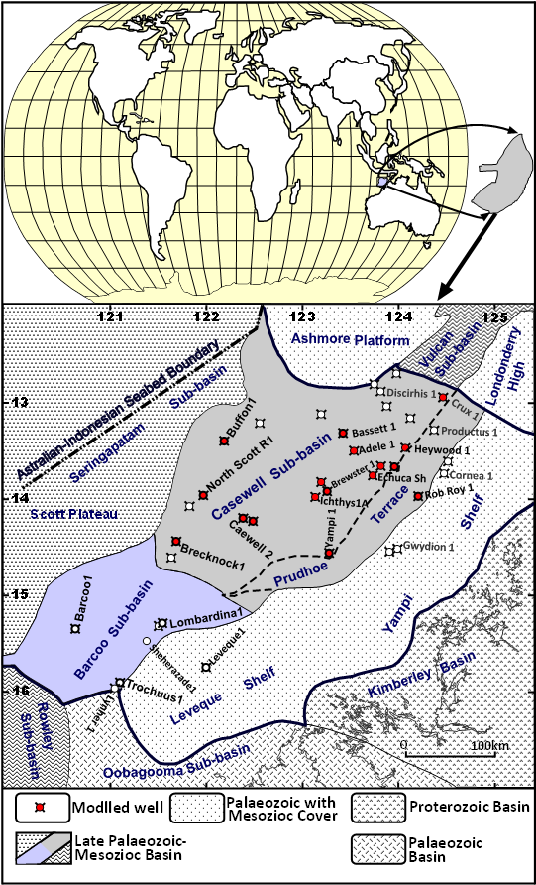
Figure 1.1: Location Map of the Caswell Sub-basin showing the modeled wells

2. Local Structural and Tectonic Setting
The tectonic evolution and structural setting presented in this study is based upon a comprehensive review of the structural and tectonic analysis derived from interpretation of seismic, stratigraphic and biostratigraphic data combined with the works of AGSO, (1994); Etheridge and O’Brien, (1994); Blevin et al., (1998b) and Struckmeyer et al., (1998).
The sub-basin as apart of the Browse Basin has undergone a complex, multi-stage structural history with six tectonically controlled major phases (Fig. 3.1, Blevin et al. 1997&1998b; Struckmeyer et al, 1998) as reviewed below:
1- During the earliest tectonic phase (Late Carboniferous to Early Permian), a NW to N-oriented full-lithosphere extension and upper-crustal faulting occurred, resulting in the initiation of a series of intracratonic half-grabens, driven by rifting and subsequent separation of the Sibumasu continental fragment from the Australian plate. This event was ended with compartmentalization of the basin into distinct sub-basins (Struckmeyer et al, 1998).
2- In the Permo-Triassic sag phase which accompanied the Beddout movement, further thermal subsidence took place producing more half grabens and developing transgressive to shallow marine conditions (Blevin et al, 1998a).
3- An inversion-driven event in the Late-Triassic to Early-Jurassic time occurred contemporaneous with the onset of rifting between Australia and Argoland resulting in formation of synrift depocentres (AGSO, 1994 and Struckmeyer et al. 1998). The event caused significant uplift, erosion, reactivation and partial inversion of the Paleozoic half-grabens, and initiation of large scale anticlines/synclinal features that marked by a regional rift angular unconformity at the base of the Plover Formation (Etheridge and O'Brien, 1994).
4- A second extensional phase occurred during the Early-Middle Jurassic resulting in collapse of pre-existing anticlines, rejuvenation of older faults and development of newer ones (Struckmeyer et al, 1998). This event and the associated sea-floor spreading caused continental block separation of the Argo Abyssal Plain from NW Australia, resulting in pronounced uplift of major platforms, subaerial erosion, peneplanation and subsidence of the deopcenters and the outboard areas. Consequent major regional Callovian break-up unconformity formed (AGSO, 1994).
5- The Late-Jurassic to mid-Oligocene time constituted a second thermal subsidence phase that characterized by prolonged period of rapid-to-waning subsidence (reflects thermal cooling), minor reactivation, higher sea levels and greater accommodation space.
6- A relatively minor compression subsidence related to the convergence of the Australia-India and Eurasia Plates occurred during the Late Tertiary which was most pronounced along the basin margin and progressively decreases inboard. The compression caused significant fault reactivation, structural inversion and folding. Some of these inversions can also probably be directly attributed to the rapid loading by the Late Tertiary carbonate wedge (AGSO, 1994).
The shelf-ward boundary of the Caswell Sub-basin is defined by a ‘hinge’ where the dip of the basement changes from relatively flat lying to gently basinward dipping, The sub-basin is bounded to the west by a major north to north-northeast trending structural zone, the Buffon-Scott Reef-Brecknock Anticlinal Trend (Fig. 2.1; Hocking et al, 1994; Struckmeyer et al, 1998).

Figure 2.1: Browse Basin Map Showing Generalized Structural Elements and Trends (Modified after Allen et al. 1978)

3. Stratigraphy
The sedimentary history and stratigraphy described in this work are disclosed from a comprehensive review of all available unpublished open-file reports and well log data integrated with the works of Elliott, (1990), Boreham et al. (1997) and Blevin et al. (1997).
The sub-basin is estimated to contain over 15 km thick clastic and carbonate sediments forming a total of 22 unconformity or disconformity-bounded sequences, with stratigraphic succession extending from the uppermost Carboniferous to the Recent (Allen et al., 1978; Ellliot, 1990; Blevin et al., 1997 and Struckmeyer et al., 1998). The succession comprises two contrasting major series separated by a Callovian unconformity “Ca”. The older series (the Pre-breakup Sequence) deposited in an intra-cratonic basin between episodes of block faulting resulting from crustal tension. The younger series (the Post-breakup Sequence) is laid down subsequent to breakup under marginal marine to marine conditions on a continental margin.
Since there is no previously established formal lithostratigraphic nomenclature for the sub-basin, formation equivalent names from the Vulcan Sub-basin are adopted in this work following Blevin et al., (1998) and Struckmeyer et al., (1998). The stratigraphy and the depositional environment are described below and summarized in the chronostratigraphic column Figure 3.1:

3.1 The Pre-rift Sequences (Intracratonic Sag Phase): Sedimentation began as early as the Early Palaeozoic time when the Browse Basin started as intra-cratonic high blocks-bounded basin, since then, sedimentation history reflected the progressive break-up of the Eastern Gondwanaland through the mechanism of rifting and sea floor spreading. Little is known concerning the Cambro-Ordovician sedimentation owing to sparse data, deep burial in the central basin and absence from the basin margins.
A Late Carboniferous section consisting of fluvio-deltaic and shallow marine sediments was mapped preserved under Early Permian unconformity (Kp) beneath the central Caswell Sub-basin (Allen et al., 1978 and Bradshaw 1993).
Early Permian (Wadeye Group) rocks have been intersected above the Base-Permian (Kp) unconformity along the southeastern margin, comprising predominantly glacial and glacio-marine limestones and shales with minor siltstones, sandstones and volcaniclastics. The section is conformably overlain by a Middle-Late Permian sequence (Hyland Bay Formation) that consist of shallow marine to deltaic sandstones and shales with minor carbonates (Bradshaw, 1993 and Boreham et al., 1997).
Although, seismic data indicate existence of a thick Triassic sequence in the area between the Prudhoe Terrace and the Scott Plateau, but the Triassic sections (Osperey, Polard, Challis, and Nome formations) have only been intersected unconformably (Top Permian Pz) overlying the Mt Goodwin Formation a long the basin margins. The series is generally consist of shallow marine to a shoreline carbonates and shales, grading upwards to fluvio-deltaic interbedded siltstones, sandstones and shales containing thin coaly beds (Struckmeyer et al., 1998).

3.2 The Syn-Rift Sequences (breakup Phase): In the syn-rift (breakup) phase, thick Early–Middle Jurassic sediments (Plover Formation) were unconformably (Top Triassic, Tr) deposited throughout the sub-basin as a rift-fill sequence, and is typically preserved beneath another prominent Callovian angular (Ca) unconformity. Thick fluvio-deltaic and coastal-plain sandstone and shale bodies with minor marine influenced associated with occasional siltstone, coals and carbonates are characteristic of this rift-sequence. Minor extrusives (basalts) and igneous intrusives (gabbros and tholeiites) are encountered in some parts of the sub-basin (Buffon-1 and North Scott Reef-1) suggesting magmatic activity continued even after breakup (Blevin et al, 1998a and Struckmeyer et al., 1998).

3.3 The Post-rift Sequences (Drift Phase): Continental breakup during the Middle Jurassic was followed by a period of subsidence and marine transgression referred to as the Post-breakup tectonism, during which the post-rift sequences (drift phase sediments) were deposited (Allen et al., 1978). The sequences commenced by deposition of the Late Jurassic-Middle Cretaceous section (Flamingo and Lower Bathurst Island Groups); where a major marine transgression caused progressive basin flooding resulted in deposition of the Flamingo Group sediments. An unconformity of Valanginian age (Va) truncates the group, separating its lower part (Vulcan Formation) from an upper unit (Sandpiper Sandstone and Swan Formations).
The Late Jurassic Vulcan Formation is sub-divided by a top Jurassic unconformity (Ju) into upper and lower units. The lower part consists of stacked sequences of prograding, sand, shale, and siltstone and the upper one comprises predominantly interbedded marine sandstones and shales.
An Early Cretaceous section was deposited above the Flamingo Group in an obvious Base-Baremian (Kbar) disconformity forming the Echuca Shoals and Jamieson formations which were in turn separated by an Aptian (Ap) unconformity. While the former forms a sequence of thick radiolarian glauconite and calcareous claystone and sandstone, the later comprises marine to fluvial claystones and sandstone with thin interbedded shales and minor carbonates (Blevin et al, 1998b).
Fully open marine conditions prevailed the Late Cretaceous time causing the contemporaneous lithofacies to be dominant by hemi-pelagic carbonates and when tectonically enhanced sea level fall occurred, a major Turonian erosional channelled surface (Tu) was developed separating the upper Bathurst Island Group (Woolaston, Gibson, Fenelon and Puffin formations) from the lower counterpart (Blevin et al, 1998a). The group composed of calcareous marine shelf facies comprising marls, calcarenties and calcilutites and the fan system comprising fine clastic sediments and even a series of lenticular sandstone bodies (Puffin Formation).
The Woodbine Group sediments (Johnson, Grebe, Hibernia, Prion, Cartier, Oliver and Barracouta formations) were unconformably (Base Tertiary unconformity T) deposited on the older rocks comprising predominantly of carbonates sequences (Shuster et al, 1998). Thick prograding carbonate wedges were deposited during Early Paleocene in the outer edge of sub-basin (the Scott Reef area) succeeded by the shales and sandstones of the Johnson Formation and Grebe Member. The Hiberina and Prion Formations were deposited during the Paleocene to Eocene as s shallow marine shelf sediments and interrupted during the Oligocene when the shelf was exposed after a global sea level fall and consequently an angular unconformity (Top Oligocene OL) developed. Deposition resumed in the Neogene and continued during the Pleistocene with sub-basin-wide marl and Calcilutite of the Oliver and Barracouta formations being deposited.

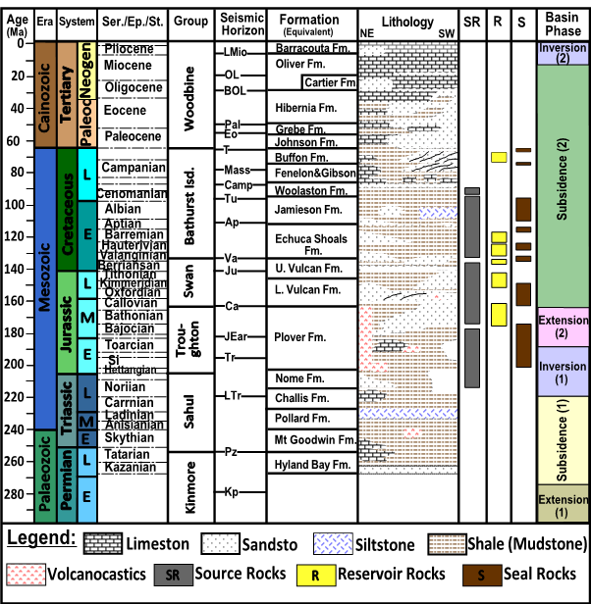
Figure 3.1: Stratigraphy of the Caswell Sub-basin showing Sequence Framework used for Geohistory Modelling (modified After Struckmeyer et al. 1998 and Blevin et al., 1998a)

4. Methods and Data Sources
5.1 Data sources: The data need to make available for this study are those pertaining to source rock characterization and burial and thermal maturity history reconstruction. These data include; interpreted seismic data, geological and stratigraphic data, comprehensive geochemical data (total organic carbon, Rock-Eval pyrolysis, and vitrinite reflectance), well log data and temperature data.
The study relies on re-evaluated existing data accumulated from the intensive geological research and petroleum exploration activities in the sub-basin during the last four decades and have been released to the public domain by various industrial companies, private authors and governmental departments. They are available in different forms; unpublished well data, open-file basic well completion and research reports and some published literatures.
The sub-basin’s geological and stratigraphic control information (formation boundaries and thicknesses) for the present study was based on the structural and sequence stratigraphic analysis established for the Browse Basin by Blevin et al., (1997 and 1998a), and Struckmeyer et al. (1998) integrated with interpretation of the high resolution seismic surveys of Geoscience Australia (AGSO, 2001). The ages of the sequences are based on the Geoscience Australia Timescale, their consistent, updated biostratigraphic database (STRATDAT) and Browse Basin Biozonation and Stratigraphy Chart (Blevin et al., 1997; and 2001).
Basic well completion reports, seismic/ velocity data, well log data, temperature data, geochemical data are available from open-files database at both the Department of Minerals and Energy of Western Australia (DMEWA 2010) and the Australian Geological Survey organization (AGSO). Some of these data can also be obtained via the Geoscience Australia Petroleum Well Database interface: (www.ga.gov.au/oracle/apcrc) or hard copy reports presented by some petroleum companies including; Woodside petroleum Ltd, Japex AC Ltd, Geotechnical Services, Amoco Aust Explor, Bridge Oil Ltd, Mobil Explor, BHP petroleum, the Shell Company of Australia Ltd and the Robertson Research (Channon and Powell, 1976, Inpex, 2004, Andrzej et al., 2006).

5.2 Methods: In order to derive among other results the petroleum potential history, understand and assess the geological and thermal evolution of the Caswell Sub-basin, The above mentioned data from the different sources were compiled to carryout a systematic research through identification of potential source rocks and assessment of their geochemical characteristics (Copard et al., 2002, Dahl et al., 2004) and mapping of the effective source units, combined with reconstruction of integrated geohistory and thermal maturity history models.
Selected formations source character have been assessed on a well- by well basis using geochemical parameters relating to thermal gradient and maturity {expanded logs and corresponding depth plots of total carbon (TOC), Tmax, Ro and S2 in addition to kerogen type and Thermal Alteration Index (TAI), rock –Eval pyrolysis and kerogen Elemental Analysis}. The assessment utilized a geochemical datasets of over 1900 open-file and AGSO RockEval pyrolysis, TOC, and petrographic analysis (vitrinite reflectance).
1D modeling for burial history and thermal maturity was performed on selected representative wells from which measured thermal and maturity data were collected. The wells were selected on conditions that they: (I) are distributed through reasonable geographic location considering the possibility to cover different stratigraphic settings within the basin; (II) represent different geologic settings and drilled to depths that penetrated reasonable sections of interest; (III) have measured maturity data and downhole temperature data to aid in calibrating thermal and maturation models; (IV) show good tectonic history (uplift and unconformities).
Initially, a conceptual model based on the geological evolution and interpreted geophysical data was built to provide the temporal framework required for the essential input parameters (Poelchau et al. 1997). The information from the conceptual models and the measured control data were combined in a numerical form and transformed into a BasinMode® simulator, PC-windows-based software package version 7.61, developed by Platte River Associates Inc., (Platte River Associates Inc., 1989 and 2005) to generate the required models.
BasinMod® software is designed to model the basin geo-history or burial history by analyzing the cumulative subsidence of selected stratigraphic horizons encountered in a well (Tissot and Welte, 1984; Falvey and Deighton, 1982). Input data for the model commonly include; thickness of units in boreholes, average lithologies, formation and events ages, paleopathometry and other rock parameters.
Since compaction has the most significant impact on thermal history which, in turn, affects the timing of source rock maturity, petroleum generation and expulsion, the basin geo-history or burial history modeling approach in BasinMod® system is based on accurate decompaction and subsequent backstripping. The modeling work was based exclusively on the mechanical compaction method that basis on the fact that the thicknesses of sediments are reduced by a predictable amount according to lithology and depth of burial. The compaction and exponential factors express how much a specific lithology will be reduced in thickness and this was calculated following the “Reciprocal Compaction Relationship” of Falvey and Middleton, (1981) that assumes porosity changes proportionally to the change in sediment load:
(1/Φ) = (1/Φ₀) + KZ
Where: Φ ≡ Porosity; Φ₀ ≡ Initial porosity; K ≡ Compaction and z ≡ depth.
Backstripping and tectonic subsidence estimation for the geohistory reconstruction in BasinMod® system is based on the passive margin formation and subsidence mechanisms equation of Steckler and Watts, (1978):
Where: Dt≡ the amount of tectonic subsidence.\ S≡ the total stratigrapgic thickness of the sediment column corrected for compaction (m).\ ρs≡ the average density of the sediment stratigrapgic column (g/cm3).\ Wd≡ the palaeo-water depth (m).\ ΔSL≡ the relative increment for eustatic sealevel variation (m).\ ρm≡ the density of asthenosphere (g/cm3).\ ρw≡ the density of water (g/cm3).\ Φi≡ the porosity of stratigrapgic unit i.\ ρsgi≡ the grain density of stratigrapgic unit i (g/cm3).\ Si≡ the thickness of stratigrapgic unit i after compaction correction.
Thermal history is vital to both maturity modelling and kinetic modelling, where changes in maturation and kinetics occur exponentially with respect to temperature and linearly with respect to time. Among the range of options BasinMod provides for reconstruction of the thermal history, a non-steady state, variable rift heat flow over time that is a simplification of the Jarvis and McKenzie finite rifting model (1980) was adopted for the modeling as a fundamental constrain for the relationship between thermal history and tectonic evolution. The reason behind this selection is that the Browse Basin experienced several deformation phases including lithospheric thinning, hence, heat flow is expected to vary over the geological history of the basin; mostly showing increase at the times of rifting and decrease in the post-rift phases and taking into account the previously tested heat-flow scenarios (Kennard et al., 2004).
The non-steady state, rift heat flow incorporates a higher heat flow episode during the rift phase and an exponential reduction during the post-rift phase (McKenzie, 1978) which is formulate in BasinMod using the thermal decay equation:
$F\left(t\right)=\frac{{\text{kT}}_{1}}{z}\left\{1+π\sum_{n=1}^{∞}{{\text{nb}}_{n}{\left(−1\right)}^{n+1}×\text{exp}\left[−n^{2}π^{2}\left(t−Δt\right)k/{a^{2}}\right]}\right\}$
Where: F(t) ≡ Heat Flux at surface at time t; t ≡ time of rifting; k ≡ thermal conductivity kT1/z ≡ heat flow prior to rifting, based on present day heat flow b_{n} ≡ coefficient (Eigenvalue) a = thickness of lithosphere, default is 125 km.
For the calculation of rifting heat flow in BasinMod estimation of crustal stretching factor (β) is required, which is defined as:
β = ρ_{o} /ρ
Where: ρo ≡ initial lithospheric thickness; ρ ≡ lithoshperic thickness immediately after stretching.
Present-day heat flow data available from a map of surface heat flow published by Kennard et al., (2008), who used sea bottom temperatures, bottom hole temperatures and modeled sediment thermal conductivities (derived from CSIRO, 2001) to calculated present-day heat flow will be incorporated into all numerical 1D models.
Maturity history will be simulated based on the burial history reconstructed in the geohistory model. The methodology involves derivation of the heat flow history using the present-day observed temperatures with paleo-temperature indicator data (such as vitrinite reflectance Ro and Rock Eval Tmax) and adjusting them against the computed maturity and thermal curves until best-fit models reached which considered representing the thermal history experienced by the sediments in the past (Lerche et al., 1984).
For the maturity calculation, the LLNL Easy %Ro method (introduced by Sweeney and Burnham (1990) was applied. The method is based upon calculation of the vitrinite reflectance from correlations of (%Ro) with the chemical composition of a kerogen (carbon content and H/C and O/C ratios). As oxygen and hydrogen are eliminated from the kerogen during thermal maturation, the aromatic rings become larger and more concentrated until graphite results.
The initial correlation of the H/C and O/C ratios to %Ro is given as:
Ro (%) = 15.64 exp {- 3.6(H/C)}
Ro (%) (%) =12 exp {- 3.3(H/C)} - (O/C).
The correlation between %Ro and carbon content used is:
Ro (%) = exp (-1.25 + 0.045Δ + 3 Δ ⁵ +1.6 ´10⁶ Δ ¹⁵) where: Δ ≡wt% C-65.
A chemical kinetic equation is needed to calculate the extent of the above reactions. Maturation reactions are assumed to be a function of time, temperature, and pressure (always neglected), thus assuming time-temperature dependence relation can be adequately described by the Arrhenius equation:
dW_{i/}dt=–W_{i} A exp(–E_{i}/RT)
Where: Wi ≡ the i-th reaction in the concentration of reactants; Ei ≡ the i-th activation energy; A≡ frequency factor (Arrhenius constant), R ≡ the gas constant; T ≡ absolute temperature; t ≡ time. Solution of equation (Eq. 8) to get:
W_{i}/W_{oi} = exp [-$\int_{0}^{t}{A\text{exp}(−{E_{i}}/{\text{RT}})\text{dt}}$]
Where: Woi for the i-th reaction in the material of the original concentration. The vitrinite conversion rate or the total intensity of reaction can be expressed as:
TR =$\sum_{i}{f_{i}−}\sum_{i}{f_{i}}({W_{i}}/{W_{\text{oi}}})=\sum_{i}{f_{i}}(1−{W_{i}}/{W_{\text{oi}}})$
Where TR represents the transformation ratio of vitrinite; participated in the i-th reaction of the material in the vitrinite proportion, known as the stoichiometric coefficients.
The transformation ratio (TR) is then used to calculate Ro (%) using the following equation:
Ro (%) = exp (- 1.6 + 3.145 × TR)
The LLNL method for the maturity calculation was selected because it is believed to be most appropriate overall choice as; (i) the LLNL Easy %Ro model is calibrated with VITRIMAT, a more complete chemical model, and gives similar results; (ii) the Arrhenius-reaction approach, with a distribution of activation energies, allows more accurate modelling over a wider range of Ro (%) o values (0.3 - 4.5) as well as with variable heating conditions.

5. Source Rocks Evaluation
This section is focused on identifying potential source rocks and determining their geochemical characteristics. Open-file well log data, core/cutting sample description, organic richness and Rock-Eval pyrolysis yields, in addition to source models and comprehensive geochemical assessment undertaken by Willis (1988), Boreham et al (1997), Blevin et al (1998 a&b) indicate the existence of source intervals at multiple stratigraphic levels over much of the sub-basin. These potential source rocks include shales, mudstones, some local thin coal beds and very rare siltstone sequences spanning the Permian to Late Cretaceous section (Boreham et al., (1997) and AGSO, 1997), however, the Cretaceous and Jurassic sequences specifically the Plover, Vulcan, Echuca Shoals and Jamieson Formations are likely the best interval for development of effective petroleum source rocks in the basin.
The source rock assessment is conducted using combined geochemical datasets of over 944 total organic carbon (TOC), 240 vitrinite reflectance measurements (Ro) and 936 Rock-Eva1 values from selected cutting (CUTT) and side-wall-cores (SWCs) samples. The samples selected mainly from open-file AGSO RockEval pyrolysis and a few published geochemical studies based upon the followings:
a) Depending upon the organic richness interest, the majority of samples chosen come from the Lower Cretaceous Jamieson and Echuca Shoals formations, the Upper Jurassic Vulcan Formation and the Lower-Middle Jurassic Plover Formation (Fig. 3.1).
b) In order to avoid using samples affected by migrated oil and/or contaminants, those with anomalously high production indices PI (>0.7) and low Tmax values (<390°C), were excluded from the source rock evaluation.
c) To minimize the mineral matrix effect, samples corrected for mineral matrix effect were selected (Blevin et al., 1998b) and samples with small S₂ peaks (< 0.2 mg HC/g rock) were considered unreliable.
d) The assessment utilized classification based on the standard cut-off values typically required for NW Shelf sediments according to Radlinski et al. (2004) as listed in table 1:

Table 1: General Source Rock Evaluation Parameters (After Radlinski et al. 2004).
(A) Organic Matter Quantity (Richness)
Quantity |  | TOC Wt % |  | S₂ (mg hc / g rock) | S₁ + S₂
Poor |  | 0 - 0.5 |  | 0 - 2.5 | 0 - 3
Fair |  | 0.5 - 1 |  | 2.5 - 5 | 3 - 6
Good |  | 1 - 2 |  | 5 - 10 | 6 - 12
Very Good |  | 2 - 4 |  | 10 - 20 | 12 - 16
Excellent |  | > 4 |  | > 20 | > 16
(B) Source Rock Quality
Quality |  | Atomic H/C |  | HI (mg hc/g TOC) | S₂/S₃
Gas-prone |  | 0.8 |  | < 100 | < 3.0
Gas/Oil-prone |  | 0.8 -1.0 |  | 100 - 200 | 0.3 - 5.0
Oil/gas-prone |  | 1.0 – 1.2 |  | 200 - 300 | 5.0 -10.0
Oil-prone |  | > 1.2 |  | > 300 | > 10.0
(C) Kerogen Type
Type |  | Atomic H/C |  | HI (mg hc/g TOC) | Main Product at Peak Maturity
Type I |  | > 1.5 |  | > 600 | Oil
Type II |  | 1.2 – 1.5 |  | 300 - 600 | Oil
Type II/III |  | 1.0 – 1.2 |  | 200- 300 | Oil & Gas
Type III |  | 0.7- 1.0 |  | 50 - 200 | Gas
Type IV |  | < 0.7 |  | < 50 | None
(D) Source Rock Maturity
Maturity | %Ro |  | Tmax (Type II) |  | Tmax (Type III) | PI
Immature | < 0.5 |  | < 430 |  | < 435 | ≤ 0.1
Early Mature | 0.5 - 0.7 |  | 430 - 435 |  | 435 - 440 | 0.1 – 0.25
Peak Mature | 0.8 - 1.0 |  | 435 - 460 |  | 440 - 460 | 0.25 – 0.3
Late Mature | 1.0 - 1.3 |  | 460 - 470 |  | 460 - 470 | 0.3 - 0.4
Post Mature | >1.3 |  | > 470 |  | > 470 | > 0.4

5.1 Source Rocks Richness and Generative Potential
The total organic carbon content (TOC) of sediments generally refers to the organic matter abundance in the rocks and when combined with kerogen type and maturity can give a full depiction of the petroleum generating potential. Therefore, measurements of TOC and thermal cracking of the organic matter by pyrolysis (S₁ and S₂ mg/g) are essential in assessing source rock richness and generative potential (Peters, 1986).
The available Rock-Eval/TOC data suggest that Jamieson Formation sediments has extremely lean to fair organic richness and low potential yields (table 2 and Fig. 5.1 & 5.2) in the central Caswell Sub-basin (TOC= < 0.3% - 2.0% with average values of 0.9% and S₁+S₂= 0.12 - <5 mg HC/g rock). In Prudhoe Terrace, source rocks generally have poor to fair organic richness and moderate generation potential (0.51% - 1.87% with average values of 1.0% TOC and 0.29 - 8.25 average 6.69 S₁+S₂). Thus the overall source richness and generation potential are rated as poor (mean TOC contents= 1.0% and mean S₁+S₂=3.025 mg HC/g rock).
According to the pyrolysis data the Echuca Shoals Formation characterized by a significant difference in TOC content and S₁+S₂ values between the deeper areas and the shallower shelf areas. The succession reveals highest TOC and S₁+S₂ values (up to 7.9% and 6.9 HC/g rock respectively) in central sub-basin, lower values (~1.59% and 5.24 HC/g rock respectively) in Prudhoe Terrace ((table 2). Thus the formation is rated as moderate to good in organic richness (mean 1.8% TOC) with poor to fair potential for petroleum generation (average values of <3 mg HC/g rock S₁+S₂). A few facies of good potential are also evident particularly within both the Caswell and Barcoo sub-basins where values up to 6.9 HC/g rock S₁+S₂ are not uncommon.
A plot of available geochemical data (Fig. 5.1 and 5.2) shows that Vulcan Formation generally characterized by good associated with some very good and fair richness (0.58% to >4% TOC) containing fair to good potential for generation with S₁+S₂ values of 1.22 to 10.67 mg HC/g rock (> 3 average).
As seen from the data points in figure 5.1 and the S₁+S₂ and TOC values ((table 2), the Plover Formation display considerable variation in organic richness (good to very good, 1.5 - 4.94 TOC %) and source-rock potential (poor to very good, 0.02 - 16.8 HC/g rock S₁+S₂). Some local samples within Prudhoe Terrance exhibit even very good to excellent petroleum-generation potential as they possess average TOC of 4.93 to 12.38 % and average S₁+S₂ values of 17.78 to 38.43 mg HC/g rock. The TOC contents of samples from where the formation is present at the deepest part of the study area, range between 2.13 and 4.94%, which reflect mainly good to excellent sources, except for the Buffon-Brecknock Trend, which have TOC values generally < 1%.
In summary, the assessment refers to a considerable variation in source potential even within the same interval, likely reflecting facies variation or depositional conditions as well as present-day maturity level. The present day source richness of the sub-basin is rated generally as moderate to good with fair to moderate potential for petroleum generation, although some thin high quality source beds are present within the Lower to Middle Jurassic rocks.

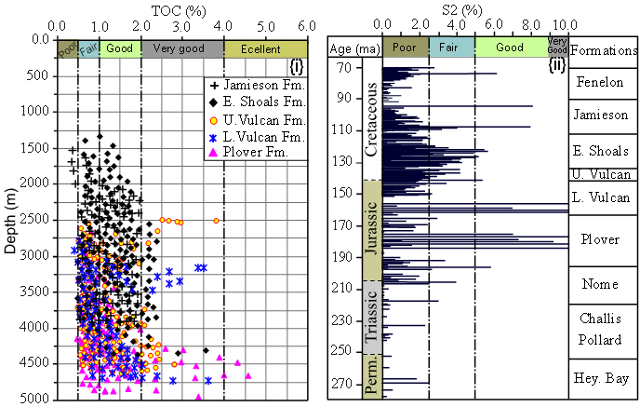
Figure 5.1: Plots of Depth (i) and Age (ii) Versus TOC and S₂ Values for Richness of Source Rock samples from Caswell Sub-basin

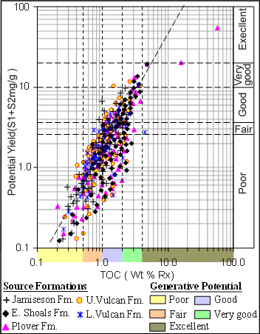
Figure 5.2: Plot of Potential Yield (S₁+S₂) Versus TOC (iii) for Generation Potential of Source Rock samples from Caswell Sub-basin (Boundaries after Ghoria 1998)

Table 2: TOC and Rock-Eval Pyrolysis Range for the different source formations
Sub-basin/ Tectonic unit | TOC (%) | S₁+ S₂ (mg/g) | HI (mg/g)
Jamieson Formation | 0.3 - 2.06  0.9 (416) | 0.12 - 5.21  2.4 (221) | 122.5 - 259  127.67 (121)
Central Caswell Sub-basin | 0.3 - 2.06  0.9 (416) | 0.12 - 5.21  2.4 (221) | 122.5 - 259  127.67 (121)
Prudhoe Terrace | 0.51 - 1.87  1.0 (19) | 0.29 – 8.25  6.69 (9) | 122 –269.41  162.3 (19)
Echuca Shoals Formation | 1.2 - 7.9  1.6 (388) | 0.9 - 6.9  2.91 (216) | 43.2 - 453.7  232.3 (217)
Central Caswell Sub-basin | 1.2 - 7.9  1.6 (388) | 0.9 - 6.9  2.91 (216) | 43.2 - 453.7  232.3 (217)
Prudhoe Terrace | 0.8 - 1.59  1.08 (12) | 0.86 - 5.24  2.52 (8) | 80.7 - 246.1  147.6 (8)
Upper Vulcan Formation | 0.58 - 4.85  1.12 (229) | 1.13 - 6.81  3.3 (144) | 54.2 - 680.11  269.0 (125)
Central Caswell Sub-basin | 0.58 - 4.85  1.12 (229) | 1.13 - 6.81  3.3 (144) | 54.2 - 680.11  269.0 (125)
Prudhoe Terrace | 0.62 - 2.1  1.05 (6) | 1.06 - 7.89  3.4 (6) | 50.5 – 286.5  148.9 (6)
Lower Vulcan Formation | 0.6 - 4.45  1.15 (114) | 1.22 – 10.67  3.16 (75) | 32.3 - 399.6  163.4 (70)
Central Caswell Sub-basin | 0.6 - 4.45  1.15 (114) | 1.22 – 10.67  3.16 (75) | 32.3 - 399.6  163.4 (70)
Prudhoe Terrace | 1.0 - 3.5  1.2 (8) | No data | 33 – 269  104.4 (17)
Plover Formation | 2.13 - 4.94  2.3 (129) | 0.02 - 16.8  2.9 (92) | 23.6 - 320  82.8 (83)
Central Caswell Sub-basin | 2.13 - 4.94  2.3 (129) | 0.02 - 16.8  2.9 (92) | 23.6 - 320  82.8 (83)
Prudhoe Terrace | 1.5 - 40.34  12.8 (17) | 0.4 - 12.8  3.43 (14) | 32.37 - 252.7  143.2 (14)
Minimum value -Maximum value
Average (number of samples)
5.2 Source Rocks Quality
Source rock quality depends on both the type and the amount of organic matter present in the sediments. Organic matter type constitutes an important factor in evaluating source rock potential since it controls both the nature of the hydrocarbon products (oil versus gas) and the yield (Tissot and Welte, 1984).
The Jamieson source rock samples posses hydrogen index (HI) values between >130 and 269.41 mg HC/g TOC with 140.1 in average ((table 2) and contain Type III to Type II/III kerogen indicating that they range from being gas-prone to having some liquids potential. Some source rocks from this formation in the Caswell Sub-basin contain intertinitic Type IV kerogen (Fig. 5.3). These pyrolysis results indicate that the Jamieson Formation is not expected to generate liquid hydrocarbons.
The Echuca Shoals Formation has similar organic matter type to the aforementioned formation, but with better liquids potential as HI values ranging from >50 to 453.7 mg HC/g TOC (average HI = 210) indicating that most samples have kerogen Type III and II and sometimes a mixture of Type II/III (table 2). There are many intervals in the sub-basins where source rocks have liquids potential (HI > 200 mg/g TOC, relatively high Type II₂ kerogen). Therefore, based on the pyrolysis results, some liquid hydrocarbons expected to be generated within the Echuca Shoals Formation.
The Late Jurassic Vulcan Formation has similar kerogen characteristics to the Cretaceous section, but generally contains number of intervals in which oil-gas prone, mixed Type II/III slightly exceeds gas- prone Type III kerogen (HI= 50.5- 680 averaging to 229.7 mg HC/g TOC, table 2). On the modified van Krevelen diagram (HI vs. Tmax diagram Fig. 5.3) the samples of the sub-basin distribute along the pathways of Type II₂ and Type III kerogen with a few samples straddling the Type II₁ kerogen field. The Lower Vulcan Formation yields HI values of 32.2 - 399.6 with a mean value of 146.4 (mg HC/ g TOC), which is typical for gas-oil prone Type III to II/III kerogens and a small amount of intertinitic Type IV. In terms of tectonic units, the pyrolysis-derived HI plotted versus Tmax diagram (Fig. 5.3) characterizes the source rock organic matter as mainly of Type II₂ associated with Type III in central sub-basin, Type III to Type II₂ with traces of Type IV in Prudhoe.
Hydrocarbons generated from the Plover Formation are likely to be dominated by gas rather than oil as most samples contain preponderate Type III gas- prone organic matter with HI values of 23.6 - 272 with a mean value of 122 mg HC/ g TOC. Lesser amounts of Type II₂-bearing source rocks are present, hence oil might be expected. The graphical presentation in the Van Krevlen diagram (Fig. 5.3) suggests that source rocks of this formation within the Prudhoe Terrane still yields Type III kerogen as the main organic matter with small amounts of Type II₂. Type III kerogen dominates source rock’s organic matter in the central sub-basin areas.
From the mentioned a count, it appears that, although the organic matter is in general composed of Type III and Type II₂ kerogen, it seems likely to get better upward from Plover Formation that contain mainly Type III to Vulcan and the Echuca Shoals formations which contain gradually increasing Type II₂ with small number of samples with Type II₁. a fact pointing to predominance of gas-prone source rocks with wet gas/condensate and dry gas produced, dependant on maturity. The Vulcan and Echuca Shoals formations are due to their deposition in a marine setting and lower maturity are considered to be more oil-prone than the source rocks of the Plover Formation.

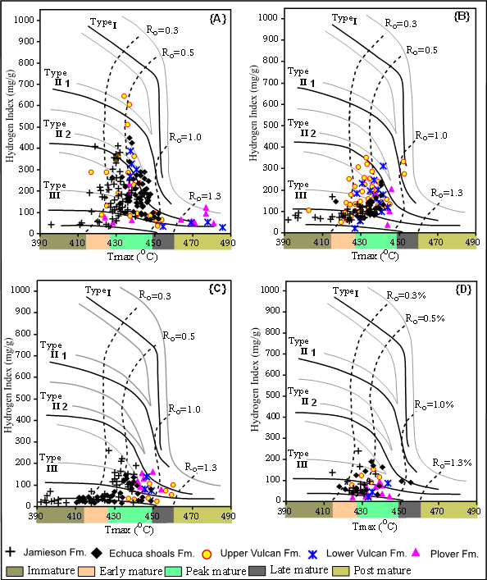
Figure 5.3: Cross-plots of Tmax versus Hydrogen Index (HI) defining kerogen types for source rocks samples from; Caswell Sub-basin {A} Brewster-Ichthys Field {B} N & NE Caswell Sub-basin {C} Central Caswell Sub-basin {D} Brecknock -Buffon Trend.

5.3 Source Rocks Maturity
Throughout this study, thermal maturity is defined in terms of a combination of the most commonly measured and widely quoted thermal maturity indicators, such as vitrinite reflectance (Ro), Tmax and production index (PI) in addition to the thermal modeling.
Vitrinite reflectance values and pyrolysis data in table 3 {Ro= 0.29 - 1.03 % (average 0.61), Tmax= 390 - 546°C (average 436) and PI= 0.02 - 0.34 (average 0.2} coupled with HI vs. Tmax diagrams (Fig. 5.3) indicate that the Jamieson Formation is mainly immature to marginally mature but never entered the gas generating maturity. The present day maturity depth gradient (Fig. 5.4) indicates that oil window threshold was reached at depth of ~ 1500m and the mid oil maturity at depths of ~2700m. The section is mature for oil generation only in the inboard portion of the sub-basin {Ro= 0.5-1.0 % (average 0.65), and PI= 0.2 - 0.34 (average 0.22); Fig. 5.4}. It is marginally mature along the Prudhoe Terrace (average Ro= 0.41%, and PI= 0.16) and in the outboard portion of the sub-basin (average Ro= <0.5%, and PI= <0.25).
Based on Ro and pyrolysis data, the Echuca Shoals Formation is set in a better maturity state than the overlying Jamieson Formation, though generally it is rated as of low maturity stage with mean 0.65%, Ro, 434°C Tmax and 0.34 PI (table 3). The values of Ro= 0.33-0.61 % (average 0.51), Tmax= 411 - 442°C and PI= 0.06 - 0.24 (average 0.14); indicate that the formation is early mature along the Prudhoe Terrace, but slightly increases basin-wards to mid mature in the central Caswell Sub-basin with only few samples at late mature stage. These maturity states are confirmed by the HI vs. Tmax diagram (Fig. 5.3) on which most samples scattered through these fields. Echuca Shoals Formation have first reached the onset of maturity when buried under depth of not less than 1650m, the peak oil maturity window corresponding to depths of 2550 – 2700 m and the wet gas window to depth of below 3450 m (Fig. 5.4).
The maturity plots (Fig. 5.3 and 5.4) and the mean values of Ro= 0.85 %, Tmax= 438°C and PI= 0.25 show that both the upper and lower Vulcan formations within the basin have overall rate that still in early to medium maturity state. Form the perspective of the different tectonic units, the maturity indicator data (table 3) and sample trends in HI against Tmax diagram (Fig. 5.3) reveal the formations to be in early mature state in the Prudhoe Terrace and. In the central sub-basin, maturity state of the formations range between mid-mature to late mature, though some samples occupy the post mature dry gas field. Form the cross plot of Ro% versus depth (Fig. 5.4), the Late Jurassic section reached marginal maturity at depths range of 1300 - 1900 m, peak oil maturity window at 2000-2500 m, wet gas zone when buried to about 2700 - 3600 m and dry gas stage at 3700 - 4200m.
According to the variation of Ro (0.35 - 2.1 %), Tmax (391 - 494ºC) and PI (0.1-0.9) parameters thzat have a mean values of 0.69%, 439ºC and 0.24 respectively (table 3), the Plover Formation has different maturity levels ranging from mature to post-mature with overall mean of mature to late mature levels. From the Ro Vs depth cross plot (Fig. 5.4), it appears that the formation first reached early, peak, late and post mature levels corresponding to depth below 1400m, 2100m, 2800m and 3500m respectively. The HI against Tmax diagram (Fig. 5.3) and the Ro & pyrolysis dada reveal that the formation in the sub-basin has overall maturity of peak mature stage (mean values of Ro 1.09 %, Tmax 438ºC and PI 0.3), though, possibly late to over -mature in the deeper parts (values up to Ro= 2.1 %, Tmax= 494ºC) and PI= 0.7). In Prudhoe Terrace, the mean values of Ro= 0.56 – 0.7 %, Tmax= 434 - 437ºC and PI= 0.21 – 0.31 suggest that most sediments are at least early mature to mature source rocks.
Taking the sub-basin’s tectonic units, source rocks reached to the highest maturity level in the central Caswell Sub-basin, medium level in western parts and lower levels of basically early-mature to immature in Prudhoe Terrace.

Table 3: Measured Maturity Parameters for Source Rocks of Caswell Sub-basin
Sub-basin/ Tectonic Unit | Ro (%) | Tmax (° C) | PI
Jamieson Formation
Central Caswell Sub-basin | 0.34 - 1.03  0.65 (120) | 390 - 546  442 (216) | 0.02 - 0.34  0.22 (155)
Prudhoe Terrace | 0.29 - 0.56  0.41 (11) | 413 – 440  435 (9) | 0.03 - 0.21  0.16 (9)
Echuca Shoals Formation
Central Caswell Sub-basin | 0.39 - 1.19  0.56 (71) | 411 - 539  434.3 (206) | 0.03 - 0.41  0.36 (183)
Prudhoe Terrace | 0.33 - 0.61  0.51 (5) | 411 - 442  439 (8) | 0.06 - 0.24  0.14 (8)
Upper Vulcan Formation
Central Caswell Sub-basin | 0.57 - 1.65  0.74 (55) | 400 - 496  435 (106) | 0.06 - 0.61  0.28 (124)
Prudhoe Terrace | 0.63 - 0.69  0.66 (3) | 413 - 431  434 (6) | 0.14 - 0.38  0.23 (6)
Lower Vulcan Formation
Central Caswell Sub-basin | 0.51 - 1.99  0.97 (98) | 409 – 489  434 (64) | 0.08 - 0.82  0.31 (63)
Prudhoe Terrace | No data | 419 – 441  432 (17) | No data
Plover Formation
Central Caswell Sub-basin | 0.6 - 2. 1  1.09 (50) | 434 - 494  438 (75) | 0.15 - 0.9  0.3 (91)
Prudhoe Terrace | 0.35 - 1.0  0.56 (7) | 391 - 442  434 (14) | 0.1 - 0.36  0.31 (14)
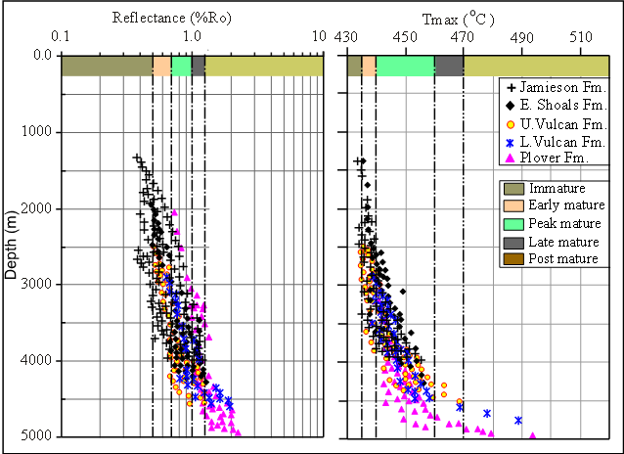
Figure 5.4: Maturity Depth Gradient based on Plot of Vitrinite Reflectance (R_{o}) and Tmax versus Depth for the Source Rocks of Caswell Sub-basin

6. Geohistory Modelling
Geohistory modeling evaluates the cumulative subsidence/deposition history of a stratigraphic sequence encountered in a well by plotting the depths of the rock unit interfaces against their respective geological ages (Tissot and Welte, 1984; Falvey and Deighton, 1982). Figures 6.1– 6.4 (B&D) illustrate the modeled geohistory and isotherms (10 ºC spacing) curves for 7 selected wells which were chosen to represent the 17 modeled wells.

6.1 The Central Caswell Sub-basin: The wells Caswell-2 and Ichthys-1A were drilled in the major depocentre of central Caswell Sub-basin that hosts more than 15 km thick sediments (Ellliot, 1990). The tow wells have virtually similar burial histories until about the end of Jamieson deposition in mid Cretaceous, at that time the sedimentation/subsidence rates began to decrease in Caswell-2 and about half the thickness of Jamieson sediments was deposited as compared to Ichthys-1A (Figs. 6.1 B&D).
Caswell-2 recorded a Jurassic succession down to the upper part of Plover Formation that deposited through constant slow sedimentation/subsidence rates. In Late Jurassic and Mid Cretaceous times, the area subsided rapidly accumulating about 2200 m of sediment. From the Mid Cretaceous subsidence continued until maximum burial of more than 4800 m gained at the present time. The burial history of the Ichthys-1A illustrates more or less continuously sedimentation/subsidence from the latest Middle Triassic to the Tertiary when interrupted by the Late Miocene compression uplift.

6.2 The Buffon–Brecknock Trend: The burial history of Buffon-1 well is dissimilar to any of the other burial histories in that it received the least volume of sediments during the Late Cretaceous and Late Paleocene times, as the formations here only from about 1500 m thicker sedimentary section (Fig. 6.2 B). From 200 Ma to about 165 Ma, the intersected section shows subsidence/sedimentation rates that appear to have been fairly constant and relatively slow. After a brief period of uplift and erosion during the mid Jurassic Callovian unconformity (Ca), sedimentation regained again with faster rate and rapid subsidence between 150 Ma and about 125 Ma. The rate of subsidence and deposition increased substantially but with slower rate from the Middle Jurassic to the present interrupted only with the Late Cretaceous–Early Paleogene uplift.

6.3 The Prudhoe Terrace: Figure 6.3D presents the burial history curves from 4176 m depth Yampi-1 well that included in this study as a guide geological history to the Prudhoe Terrace which lies to the east. The well has experienced enhanced subsidence in Late Permian and Early Jurassic times and continued during the Late Jurassic but most likely ended with uplift and erosion in the Early Cretaceous before resuming in the late Cretaceous to Tertiary times. In the Oligocene, minor uplift and erosion are encountered, after which accelerated subsidence of the outer shelf occurred leading to the deposition of a thick prograding carbonate wedge. The Rob Roy-1 well was drilled on the western flank of the Rob Roy Graben to 2286 m and penetrated a sedimentary section ranging in age from Recent to Permian before intersecting Pre-Cambrian basement. The well constitutes one of the few wells within the basin that intersect Permian sediments. The burial history for this well closely resembles that at Yampi-1 except that the rate of sediment accumulation was not as rapid during deposition of the Upper Bathurst Island and Woodbine Group sediments. The burial history of this well is mostly characterized by three distinct Features: (1) a very rapid subsidence from the Late Permian to Top Triassic deposited more than 900 m of sediments but interrupted by uplift and erosion that removed the 200 m thick Nome formation (2) constantly increasing and relatively slow subsidence/sedimentation rates appear to have been leading subsidence between mid Jurassic and Late Paleocene interrupted only by insignificant erosional events (3) a short phase of uplift in the Middle Jurassic and Late Paleocene (Fig. 6.3B).
Prudhoe-1 well drilled on a fault-related structure near the center of the Prudhoe Terrace. Burial history of the well (Fig. 6.4D) indicates that the well intersected a thin section of the Upper Permian Heyland Bay Formation in relatively shallow depth (~3322 m) because about 300 m from the Triassic section (Pollard and Nome Formations) has been removed by the Early Triassic uplift and erosion (Tr). Burial history of the well is characterized by overall relatively slow subsidence until the recent time only faced by Early Cretaceous and Early Paleocene compression uplifts. The Heywood-1 well represents the eastern part of the study area close to the Heywood Graben. The well which penetrates 4572 m of sediments, represents an almost complete sequence of syn and post-rift sediments (Lower Jurassic to Recent). The burial history of the well (Fig. 6.4D) indicates a very rapid overall subsidence and sedimentation especially in the Cretaceous and Tertiary times to the extent that a greater thickness of Bathurst island Group and Woodbine Group sediments were deposited here than at any of the other burial history locations.

7. Thermal Maturity History Modelling
Thermal maturity is a measure of the degree of metamorphism of kerogen as a function of time and temperature in a sedimentary formation. It gives a rough estimate of the maximum temperature a formation has reached. Basin modeling was used as the most efficient available approaches for the reconstruction of thermal and maturity history. The derived thermal models are applied to sub-basin-wide, multi-well (17 wells) locations, and the results are illustrated by best visual-fit models on maturity/ thermal calibration diagrams. 7 of these models are presented in figures 6.1- 6.4 A&C. The generated models for the five potential source sequences are discussed in the following:

7.1 The Jamieson Formation: As shown by the best-fit models in the figures. 6.1- 6.4 A&C, the upper part of the formation barely have entered the maturity level within the Prudhoe Terrace and in remainder of the sub-basin is presently only marginally mature. The basal section of the formation is mid mature in central Caswell Sub-basin especially in the Ichthys-Brewster Field (Ichthys-1A well), early mature along the Brecknock–Buffon Trend and Prudhoe Terrace (Buffoon-1, Rob Roy-1, Caswell-2, Tinichthys-1, Heywood-1 and Prudhoe-1,) and immature in all other parts (Yampi-1).
The modeling results (Figs. 6.1- 6.4) show that the Jamieson Formation have never reached the wet gas window through out the sub-basin, and only entered the peak oil window in some localized areas within the northern part of central Caswell Sub-basin, (Ichthys 1A) and the Brecknock-Buffon Trend (Buffon-1). In these localized areas (Titanichthys-1), the formation first reached the oil maturity onset state in the Late Cretaceous (88–93 Ma) at depth of about 1530 m and at temperature ranging between 81°C and 83°C. In the southwestern part of Central Caswell Sub-basin (Caswell-2) and along the Brecknock- Buffon Trend (Buffon-1) the Jamieson Formation commenced entering the oil window zone during the Tertiary in depth range of 1700 -2000 m and temperature range of 82–100°C. In the later area the formation entered the peak oil window at depths of 2900-3000 m in the Miocene/Pliocene time (6-4 Ma) at high temperatures of 115°C–122°C. In the wells along the Prudhoe Terrace (Prudhoe-1 and Heywood-1), the Jamieson Formation first entered the early oil maturity zone in the Late Cretaceous/Paleocene time (77–54 Ma) when buried to depths of 1650 to 1720 m at 81°C–87°C.

7.2 The Echuca Shoals Formation: The Lowe Cretaceous Echuca Shoals Formation, in contrast to the overlying Jamieson Formation, is sufficiently mature for hydrocarbon generation over a wider area. The maturity level indicated by the modeling in most wells located on the eastern margin (Heywood-1, Prudhoe-1, and Yampi-1) is the early maturity level. Maturity steadily increases to the northwest from early oil maturity zones basinwards from Prudhoe Terrace to oil and wet gas maturity zones in the central part of the sub-basin.
From the simulation results (Figs. 6.1- 6.4), it can be seen that the formation have never reached the wet gas window allover the basin except for Buffon-1 well in which it first entered the zone in Pliocene time corresponding to the depth of about 3540 m and temperature of about 147 °C.
In the Brewster- Ichthys Field (e.g. Titanichthys-1 and Ichthys-1A), the formation first entered the oil maturity window in the mid Cretaceous (108–115 Ma) corresponding to temperature range of 85-88°C and depths of 1200- 1500 m and peaked in the Late Cretaceous (75–92 Ma) when the unit buried to 1800–2700 m under temperature of 112-118°C. The formation in the modeled wells of the central Caswell Sub-basin, e .g. Caswell-2 commenced entering the oil maturity zone in the Late Cretaceous (~98–76 Ma) time at 1700 m and 86°C. In the modeled well along the Brecknock- Buffon Trend, (Buffon-1), early oil maturity reached in the Late Cretaceous (93 Ma), 1100 m depth and 85 °C temperature and in the mid Miocene (15–13 Ma), with temperature rose to about 115 °C, the unit first passed to the peak oil window at 2730 m depth.
The Echuca Shoals Formation within the Prudhoe Terrace wells (Heywood-1 and Prudhoe-1,) entered the oil window during the Late Cretaceous (96-81 Ma) in depth range of (1400–1700 m) and temperatures of (83- 90°C) and peaked during the Lat Eocene (40-35 Ma) at depths of 2800–2900 m and raised temperature of (103–108 °C).

7.3 The Vulcan Formation: The Late Jurassic Vulcan Formation is generally characterized by a wide variation in thickness and wide ranges of organic richness; hence, separate models for the upper and lower parts have been generated for this sequence:
The Upper Vulcan Formation: The maturity modeling shows that the Upper Vulcan Formation, where-ever intersected throughout the sub-basin have attained early mature to late-maturity states. On the Brecknock–Buffon Trend and Heywood Graben (Heywood-1 and Buffon-1) the formation straddles the early mature to mature oil zone and in the Prudhoe Terrace (Rob Roy-1, Prudhoe-1 and Yampi-1), the sequence is early mature. Within the central Caswell Sub-basin, maturity ranges from the fully oil maturity zone (Caswell-2 and Tinichthys-1) to late mature oil / fully mature gas and condensates zone (Brewster-1A, Ichthys-1A).
The Lower Vulcan Formation: The Lower Vulcan Formation is currently in the early mature state on the Prudhoe Terrace (Rob Roy-1), and the mid-mature on the Brecknock–Buffon Trend and Heywood Graben (Heywood-1, Prudhoe-1, Buffon-1 and Yampi-1). In the Caswell Sub-basin, current maturity level ranges from the oil maturity zone (Caswell-2, Tinichthys-1) and the wet gas window (Adele-1, Ichthys-1A).to dry gas maturity in the central and outer parts of the sub-basin (Brewster-1A).
In central part of the modeled Caswell Sub-basin (e.g. Caswell-2 and Titanichthys-1), the sequence reached early oil window during mid Cretaceous time 126–116 Ma upon attaining different levels of burial depth 1300 m to 1700 m and temperatures of 83°C to 89°C. Peak oil generation reached at the mid-Late Cretaceous when depth of burial exceeded 2000 m and temperature reached to more than 113°C. Towards the Cretaceous/Tertiary boundary, the formation turned to generate wet gas under increased temperatures of 138 °C to 142°C and burial depth 2700 m –3600 m.
In the modeled well of the Brecknock- Buffon Trend (Buffon-1) the formation required a temperature of (~90 °C) and shallower depth of (~1000 m) for commencing oil maturation during the mid Cretaceous time (~125 Ma), it passed to the zone of wet gas in the late Miocene time upon reaching temperature of 147 °C and depth of 3600 m. In the Prudhoe Terrace wells (Prudhoe-1 and Heywood-1), the sequence entered marginal maturity zone in different time periods throughout the mid Cretaceous (118–120 Ma), in depth range of 1400 m to 1900 m and temperature range of 82°C to 92°C. Peak maturity commenced in Late Cretaceous (72–97 Ma) while the unit buried to depth of 1800–2500 m and subjected to temperatures in the range 109°C to 110°C.
In contrast to the overlying younger formations, the Vulcan Formation reached the dry gas window in some parts of the basin especially in the Brewster- Ichthys Field (Ichthys-1A well) when buried deep to over 3700 m under high temperature of about 152 to 154 °C in the mid Eocene time (48-47 Ma).

7.4 The Plover Formation: The Early–Middle Jurassic Plover Formation have been preserved to varying depths beneath the breakup unconformity after significant subsidence, uplift and erosion, consequently it reached different maturity levels in varying times and temperatures. The formation wherever intersected within the basin passed the early oil zone and in many parts it reached even to the dry gas window.
In Yampi-1 the formation was first within the onset of oil maturity in mid Cretaceous time (~125 Ma) at depth of 1610 m corresponding temperature of 88°C, and peaked during the Late Cretaceous time (~97 Ma) at depth of 2420 m and temperature of 108°C.
Onset of oil maturity within the central Caswell Sub-basin wells (Titanichthys-1 and Caswell-2) first commenced in the Early Cretaceous time (~130 -125 Ma) in depth range of 1300 m to 1800 m and temperatures range of 89°C to 91°C. Not until the Early Cretaceous time (118–112 Ma) when the formation first entered the peaked oil window in depth range of 2000 m to 2500 m and temperature in range of 112°C-118°C. With depth range of 2600 m to 4300 m and temperature in range of 135°C-145°C, the formation commenced entering the wet gas window in Miocene.
In the Brecknock- Buffon Trend, modelling results indicated that both the Plover Formation and the overlying Vulcan Formation entered the oil/gas window under relatively the same time and temperature and comparable depths. The results for the wells in the vicinity or along the Prudhoe Terrace (Prudhoe-1), show that the formation entered marginal maturity zone in the mid Cretaceous (123–100 Ma) at depths ranging between 1500 m to 2000 m and temperature ranging between 85°C to 94°C. It was almost Late Cretaceous time (99–72 Ma) when temperature increased to about 112 °C, burial depth reached 2100 -2300 m and the formation was first in the peak oil maturity zone in these well locations. In Heywood-1 well, the formation was first in the marginal oil mature zone during the Early Cretaceous (~132 Ma) in 1780 m depth and 87 °C temperature, and peaked about 105 Ma, 2500 m depth and 111°C temperature. Upon attaining 4000 m under temperature of about 134.8°C, the formation in this well entered the wet gas zone during the Eocene (~51 Ma).

8. Conclusions
The following key points summarized as conclusions drawn from the study:
(1) The modeling results are in agreement with the exploration history and the geochemical source rocks assessment study that suggest widespread mature, fair to good quality source rocks at multiple stratigraphic levels in the Jurassic - Early Cretaceous section, a fact which implies that the rift-heatflow modeling presented in this study simulates satisfactorily the geological history of the basin. Most of the oil-prone sources are associated with the transgressive marine shale sequences of the Vulcan and Echuca Shoals formations, and the more gas-prone source associated with the fluvio-deltaic shales of the Plover Formation.
(2) The modeled post-Permian burial-history (the depths penetrated by the wells) for the sub-basin’s principle tectonic areas reveals some common features including: (i) maximum burial depth reached at the present day. (ii) generally, three tectonic episodes are clearly depicted; an Early to Late Triassic subsidence with comparatively constant and slow rates, Late Triassic to middle Jurassic rifting with a steady sedimentation and Late Jurassic to Cenozoic subsidence with the highest subsidence rates and maximum mean sediment accumulation. (ii) Cenozoic sediments make up about half of the present-day total thickness of sedimentary cover. (ii) Significant erosion of the sedimentary section occurred in the basin margins during Late Triassic, Callovian and Early Miocene times.
(3) Modeled horizon maturity indicates that the scattered post-Turonian source units have never reached maturity except for localized areas in the Brecknock–Buffon Trend. Early maturity is first reached in late Cretaceous (91-125 Ma) time under temperature of 82-100 °C when the Jamieson and Echuca Shoals formations are buried below a regional cutoff of approximately 1500 m in the central Caswell Sub-basin, Brecknock–Buffon Trend, Ichthys-Brewster Field and some parts of the Prudhoe Terrace. Source maturity peaked within the Jamieson and Echuca Shoals formations (in central Caswell Sub-basin and the Brecknock–Buffon Trend) when buried to depth of 2700-3000 m in Lat Eocene to Lat Miocene time (40-6 Ma) at temperature range 108-122°C and within the older (Vulcan and Plover) formations when attained burial depth of more than 2000 and subjected to temperature of 111-119°C mostly in the Late Cretaceous time (75-99 Ma). The Vulcan and Plover formations wherever intersected are in the early to peak maturity levels and even reach the late-and post-mature levels in the central Caswell Sub-basin and Ichthys-Brewster Field. Top gas window was first reached by the Jurassic source rocks in early Eocene time, corresponding to 3600-4000 m depth and under temperature of 138-142 °C for the central Caswell Sub-basin and for the rest of the basin in the late Miocene time, when temperature increased over 145 °C and buried to 2600-4300 m.

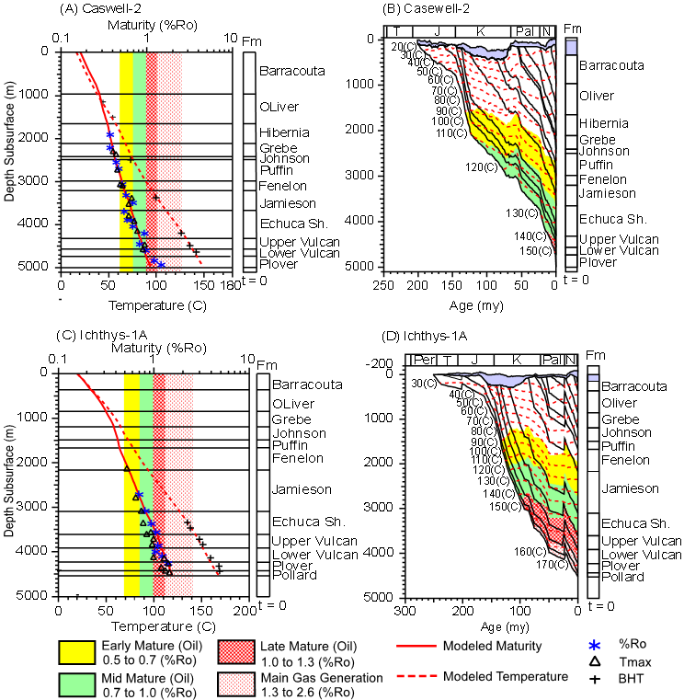
Figure 6.1: Thermal Maturity (calculated versus measured) and Geohistory Models of tow key wells; {(A & B) Caswell-2; (C & D) Ichthys-1A} in the Central Caswell Sub-basin
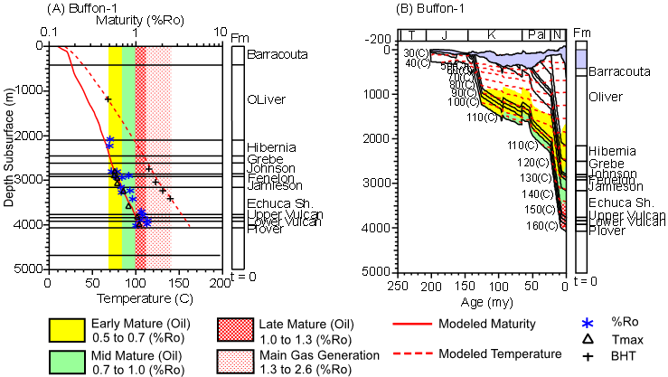
Figure 6.2: Thermal Maturity (calculated versus measured) and Geohistory Models of a key well of; (Buffon-1) in the Buffon–Brecknock Trend

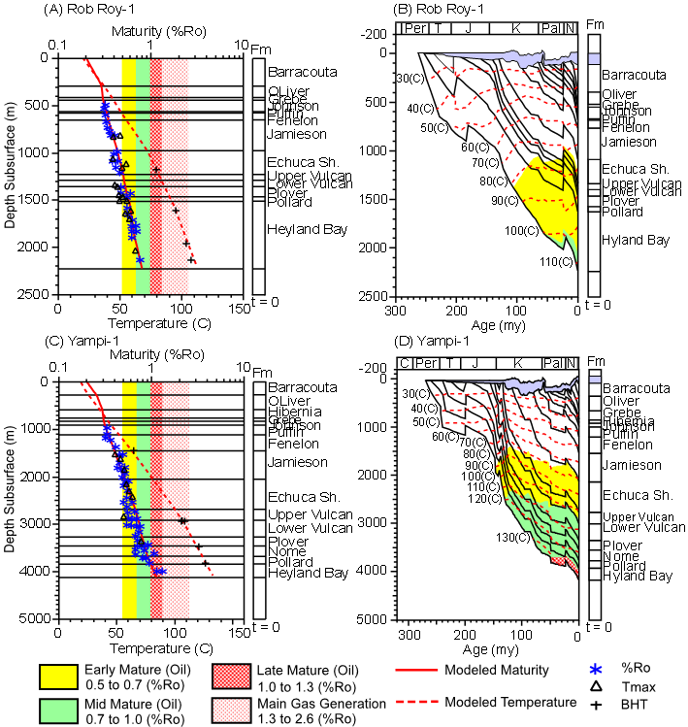
Figure 6.3: Thermal Maturity (calculated versus measured) and Geohistory Models of tow key wells; {(A & B) Rob Roy-1; (C & D) Yampi-1} in the Prudhoe Terrace
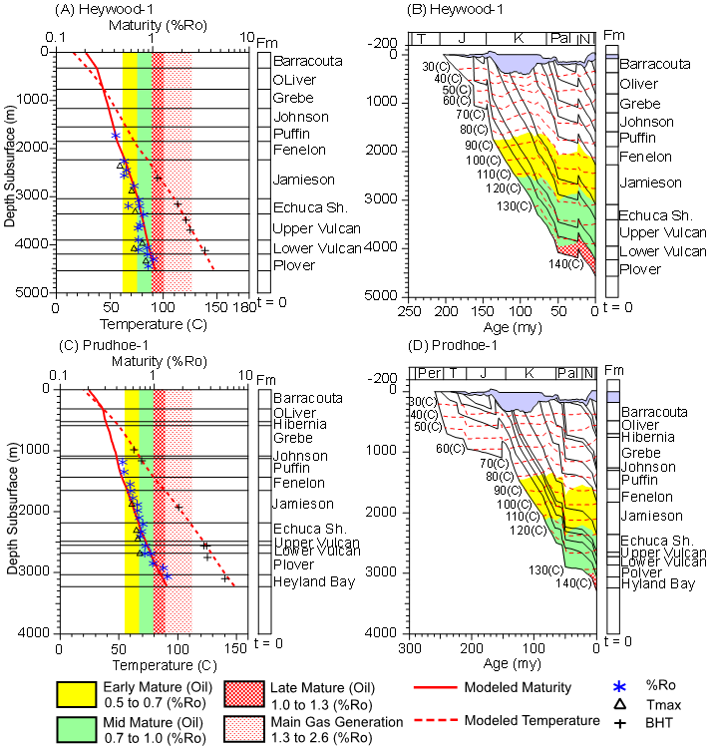
Figure 6.4: Thermal Maturity (calculated versus measured) and Geohistory Models for tow key wells; {(A & B) Heywood-1; (C & D) Prudhoe-1} in the Prudhoe Terrace

Acknowledgements
The study mostly relies on re-evaluated existing data that have been released to the public domain by various industrial companies and governmental departments. Thus the authors would like to express their deep appreciation to Department of Minerals and Energy of Western Australia (DMEWA), the Geosciences Australia (formerly AGSO), BHP Billiton Petroleum, Robertson Research Petroleum Services Ltd., Inpex Browse, Nippon Petroleum and Woodside Offshore Petroleum Pty Ltd. The authors also extend their thanks to Platte River Associates Inc. for the academic loan of BasinMod software package and the Department of Petroleum Engineering, China University of Geosciences (Wuhan), for their significant contribution by availing their resources during the conduction of the research.

Correspondence to:
Lissan N.H.
Department of Oil and Gas Exploration, Faculty of Earth Resources China University of Geosciences (Wuhan), Hubei 430074, People’s Republic of China.
Telephone: +86 18986127225
Cellular phone: 01186-130-3103-8107;
Emails: lissannh14@yahoo.com

References
AGSO North West Shelf Study Group, 1994: Deep reflections on the North West Shelf Australia: Changing our perceptions of basin formation. The Sedimentary Basins of Western, Australia: Proceedings of Petroleum Exploration Society of Australia Symposium, Perth, (1994): 63-76.
AGSO, Geoscience Australia, 2001: Line drawings of AGSO– Geoscience Australia’s regional seismic profiles, offshore northern and northwestern Australia. Geoscience Australia, Record 2001/36, CD-ROM.
Allen, G. S., Pearce., L.G.G, & Gardner, W.E., 1978: A regional interpretation of the Browse Basin. The APEA Journal, 18(1): 23-33.
Andrzej P.R., Dianne S. Edwards, Alan L. Hinde, avenpo t and Joh M. Kennard, 2006: Geoscience Australia’s laboratory data in Hydrocarbon Generation and Expulsion from Early Cretaceous Source Rocks in the Browse Basin, North West Shelf, Australia: a Small Angle Neutron Scattering and Pyrolysis Study, Geoscience Austral a Record 2007/04, 250 p. ISBN 1921 362733.
Blevin, J. E., Boreham, C.J., Summons, R.E., Struckmeyer, H.I.M. and Loutit, T.S., 1998a: An effective Lower Cretaceous petroleum system on the North West Shelf: Evidence from the Browse Basin. IN: Purcell, P.G. and Purcell, R.R. (Editors), The Sedimentary Basins of Western Australia 2: Proceedings of the Petroleum Exploration Society of Australia Symposium, Perth, (1998): 397-420.
Blevin, J. E., Struckmeyer, H.I.M., Boreham, C.J., Cathro, D.L., Sayers, J. and Totterdell, J.M., 1997: Browse Basin high resolution study, interpretation report, North West Shelf, Australia. AGSO Record 1997/38, unpublished.
Blevin, J. E., Struckmeyer, H.I.M., Cathro, D.L., Totterdell, J.M., Boreham, C.J., Romine, K.K., Loutit, T.S. and Sayers, J., 1998b: Tectonostratigraphic framework and petroleum systems of the Browse Basin, North West Shelf. IN: Purcell, P.G. and Purcell, R.R. (Editors), The sedimentary basins of Western Australia 2: Proceedings of the Petroleum Exploration Society of Australia Symposium, Perth, (1998): 369-395.
Blevin, J. E., Struckmeyer, H.I.M., Cathro, D.L., Nicolls, R.S., Laurie, J.R., Kennard, J.M., Ryan, D. and Miyazaki, S., 2001: Browse Basin Biozonation and Stratigraphy, Chart 7 (2001). Australian Geological Survey Organization.
Boreham, C.J., Roksandic, Z., Hope, J.M., Summons, R.E., Murray, A.P., Blevin, J.E. and Struckmeyer, H.I.M., 1997: Browse Basin organic geochemistry study, North West Shelf, Australia. Volume 1, interpretation report. AGSO Record 1997/57.
Bradshaw, M., 1993. Australian petroleum systems: PESA Journal, : 43-53.
Channon, R.D. and D. E. Powell, 1976: Formation Temperature Data as an Aid to the Evaluation of hydrocarbon prospects on the Australian NW Shelf, BOCAl PTY LTD.
Copard, Y., Disnar, J.R., Becq-Giraudon, J. F., 2002: Erroneous maturity assessment given by Tmax and HI Rock-Eval parameters on highly mature weathered coals // Int. J. Coal Geol. 2002. Vol. 49. P. 57–65.
CSIRO, 2001: Sea-floor temperature data extracted from the CARS2000 Climatology database, CSIRO Marine Division, (unpublished).
Dahl, B., Bojesen-Koefoed, J., Holm, A., Justwan, H., Rasmussen, E., Thomsen, E. 2004: A new approach to interpreting Rock-Eval S2 and TOC data for kerogen quality assessment // Org. Geochem. 2004. Vol. 35. P. 1461–1477.
DMEWA, (Department of Mines and Petroleum, Western Australia) 2010: Browse Basin, Petroleum Prospectivity, Web page http://www.dmp.wa.gov.au/1878.aspx#2028 (last accessed 8 October 2010).
Elliot, R.M.L., 1990: Browse Basin. In: Geology and Mineral Resources of Western Australia: Geological Survey of Western Australia, Memoir 3, 535-547.
Etheridge, M.A. and O’brien, G.W., 1994: Structural and tectonic evolution of the Western Australian margin basin system. Petroleum Exploration Society of Australia Journal, 22: 45-64.
Falvey, D. A., and Middleton, M. F., 1981: Passive continental margins: evidence for a prebreakup deep crustal metamorphic subsidence mechanism: Oceanologica Acta SP, 103–114.
Falvey, D.A. and Deighton, I., 1982: Recent advances in burial and thermal geohistory analysis. APEA Journal, 22(1):65-81.
Ghoria, K.A.R., 1998: Petroleum source-rock potential and thermal maturity of the Officer Basin, Western Australia. Geological survey of Western Australia, pp: 52.
Hoffman, N., and Hill, K.C., 2004: Structural-stratigraphic evolution and hydrocarbon prospectivity of the deep-water Browse Basin, North West Shelf, Australia. In: Ellis, G.K., Baillie, P.W. and Munson, T.J. (eds), Timor Sea Petroleum Geoscience. Proceedings of the Timor Sea Symposium, Darwin, 19–20 June 2003. Northern Territory Geological Survey, Special Publication 1, 393-409.
Hocking, R.M., Mory, A.J. and Williams, I.R., 1994: An atlas of Neoproterozoic and Phanerozoic basins of Western Australia. In: Purcell, P.G. and Purcell, R.R. (eds), The Sedimentary Basins of Western Australia: Proceedings of the Petroleum Exploration Society of Australia Symposium, Perth, 1994, 21–43.
Inpex Browse Ltd 2004: Petroleum Geochemistry Screening analysis of the Browse Basin wells, Open-file Report No. Geochem-04031, Prepared by PT. Corelab Indonesia.
Jarvis, G.T. and Mckenzie D.P. 1980: Sedimentary Basin Formation with Finite Extension Rates. Earth and Planetary Science Letters, 48: 42-52.
Lerche, I., Yarzab, R. F., Kendall, C. G. St., 1984: Determination of paleoheat flux from vitrinite reflectance data. Bulletin ofmthe American Association of Petroleum Geologists 68, 1704- 1717.
Kennard, J. M., Deighton, I., Ryan, D., Edwards, D. S. and Boreham, C. J., 2004: Subsidence and Thermal history modelling: New insights into hydrocarbon expulsion from multiple petroleum systems in the Browse Basin. In: G.K. Ellis, P.W. Baillie and T.J. Munson, Editors, Timor Sea Petroleum Geoscience, Proceedings of the Timor Sea Symposium, Special Publication (2004): 1–25.
McKenzie, D., 1978: Some remarks on the development of sedimentary basins, Earth and Planet Sci. lett., v. 40, 25-32.
Peters K.E., Moldown, J.M., Schoell M. and Hempkins W.B., 1986: Petroleum Isotopic and Biomarker Composition Related to source rock Organic matter and depositional Environment. Org. Gechem., vol. 10, p. 17-27.
Platt River Associates Inc. 1989: BasinMod Manual, A Modular Basin Modeling System, Platt River Associates, Denver, CO, 200 pp.
Platte River Associates Inc., 2005: BasinMod_1D Manual for Accompany the March 2005 Release. Platte River Associates Inc, 2790 Valmont Road, Boulder CO 80304, USA, 546 pp.
Poelchau HS, Baker DR, Hantschel T, Horsfield B, Wygrala B 1997: Basin simulation and the design of the conceptual basin model. In: Welte DH, Horsfield B, Baker DR (eds) Petroleum and basin evolution. Springer Verlag, Berlin, p 535.
Radlinski, A.P., Kennard J.M., Edwards D.S., Hinde A.L. and Davenport, R. 2004: Hydrocarbon generation and expulsion from Early Cretaceous source rocks in the Browse Basin, North West Shelf, Australia: a small angle neutron scattering study. APPEA Journal 2004, 151-180.
Shuster, M.W., Eaton, S., Wakefield, L.L. and Kloosterman, H.J., 1998: Neogene tectonics, greater Timor Sea, offshore Australia: implications for trap risk. The APPEA Journal, 38 (1): 351-379.
Steckler, M.S., and Watts, A.B., 1978: Subsidence of the Atlantic type continental margin off New York: Earth and Planetary Science Letters, v. 41, p. 1–13.
Struckmeyer, H.I.M., Blevin, J.E., Sayers, J., Totterdell, J.M., Baxter, K. and Cathro, D.L., 1998: Structural evolution of the Browse Basin, North West Shelf: New concepts from deep-seismic data. IN: Proceedings of the Petroleum Exploration Society of Australia Western Australian Basin Symposium II, Perth: 345-367.
Sweeney, J.J., and Burnham, A.K., 1990: Evaluation of a simple model of vitrinite reflectance based on chemical kinetics: Association of Petroleum Geologists Bulletin, v. 74: 1559-1570.
Tissot B.P. and Welte D.H., 1984: Petroleum Formation and occurrence, 2nd edition, Springer, Berlin.
Willis, I., 1988: Results of exploration, Browse Basin, North West Shelf, Western Australia, in Purcell, P. G., and Purcell, R. R., eds., 1988, The North West Shelf, Australia: Proceedings of Petroleum Exploration Society Australia Symposium, Perth, 1988: 260-271.

1/29/2012

