Reflection Seismic studies on the Razzak oil field, Western Desert, Egypt

Fathy Shaaban^{1&3}, Fouad Shaaban² and Sameh Ibrahim ²

^{1.} National Research Institute of Astronomy and Geophysics, Helwan, Egypt
^{2.} Faculty of Science, Mansoura University, Mansoura, Egypt
^{3.} Department of physics, faculty of science King Khaled University, K.S.A
Shaaban_F@hotmail.com

Abstract: Twenty Reflection seismic sections have been used to shed light on the subsurface structural setting and the hydrocarbons entrapment styles in the Razzak field of the Egyptian Western Desert. This is achieved through integrated geological and geophysical studies utilizing a number of maps and cross sections. The interpretation has been traced four reflectors, the Massajid Formation, Alamein Dolomite Member, Abu Roash "G" Member, and the Apollonia Formation.The NW-SE and NE-SW trending seismic sections revealed a number of Late Cretaceous wrench and shear faults forming horsts allover the mapped field. These faults led to a very thin Lower Cretaceous section occupies the horst block area compared to very thick section on the downthrown side of the two main faults. For some instances dry hole conditions occur due to missing of an adequate structural closure on the horst block area.The TWT maps on the top of the traced reflectors reveal different structural closures with lateral strike-slip fault displacement. These maps revealed that the field almost tectonically ceased since the Late Cretaceous time with minor NE faulting accompanied with tilting tectonisms.
[Fathy Shaaban, Fouad Shaaban and Sameh Ibrahim. Reflection Seismic studies on the Razzak oil field, Western Desert, Egypt. Nature and Science 2012;10(3):7-15]. (ISSN: 1545-0740). http://www.sciencepub.net. 2

Keyword: Reflection Seismic studies; Razzak oil field; Western Desert; Egypt.

- INTRODUCTION:
The study area lies in the northern part of the Egyptian Western Desert (Fig. 1), NE of the Qattara depression, almost 55 Km south of the Mediterranean coast and 250 Km NW of Cairo. It is bounded by the Alamein and Yidma oil fields in the East, and by the Aghar oil field in the West.
Fig.(1): Index map showing the geographical location of the Razzak oil field, North Western Desert, Egypt.

The Western Desert comprises the area West of the Nile river and Delta and covers about two-thirds of the area of Egypt. Up to the present, all commercial and noncommercial hydrocarbon accumulations have been found in the northern part of the Western Desert, north of latitude 29° 00'. Surface and subsurface data indicate that the sedimentary succession ranges from Cambrian to Recent with the oldest sediments resting on Precambrian basement, unconformities at various stratigraphic levels. A number of these unconformities are known within the Paleozoic and at its end; they are consequences of Early Paleozoic (Caledonian) and Late Paleozoic (Hercynian) tectonic events which caused the north-south folding and block faulting system. These events were followed by Late Jurassic (Nevadian) and then Cretaceous-Tertiary (Laramide) tectonic events which had a marked effect on the Mesozoic-Early Tertiary succession in north Egypt. These events were responsible for the unconformities known at different stratigraphic levels within the Jurassic, Cretaceous and Early Tertiary sections. The Laramide event, on the other hand, brought about the marked unconformable relations of the Cretaceous-Tertiary contacts which are associated with the NE-SW trends of the Syrian Arc fold system. The Razzak, Alamein and Yidma fields lie along one of these arcs. The major part of the north Western Desert is covered by the Miocene sediments which dip gently to the north. Well data, along with geophysical data, indicate the presence of a number of sedimentary basins of varying dimensions within the Paleozoic, Jurassic, Lower Cretaceous and Early Tertiary (El Ayouty, 1990).

- Exploration history of the Razzak Field;
The exploration history of the Razzak field is dated back to the year 1963 when Pihilips Petroleum Company acquired most of the Western Desert leases (EGPC, 1986 and 1992, El-Shaarawy and Zaafan, 1993 and Hegazy, 1993). In 1972, the first exploratory well NWD349-1 was drilled by AMOCO to test the Alamein dolomite high structure (El Bishlawy, 1972). The well was drilled to a total depth of 11,098 ft. into the Jurassic, Khatatba Formation. This well encountered more than seven oil-bearing zones ranging in age from the Early to Late Cretaceous. The development plan has been established for delineating and developing the Razzak field. This was carried out by the drilling of the Razzak-2 and the Razzak-3 wells.
In December, 1972, the Razzak-10 well was drilled to test a separate structure to the northeast, all Formations were wet. In April, 1973, the Razzak-13 was drilled. This well penetrated down to the Jurassic Bahrein Formation. It tested four Barrels of oil from the Massajid carbonate section. Gases and oil were recovered from the Khatatba sand section. Development plan continued until 1974, when the Razzak-14 well. In March, 1978, the Razzak-15 well tested another structure to the northeast. The well tested wet Alamein dolomite and was put on production as a Bahariya producer in May, 1978. The Razzak-23 and NWD 350-1 dry holes were the last wells drilled in the Razzak field in 1981. Seven years later, after acquiring new seismic vintage over the Razzak field area in 1987, the NWD349-2 well tested the upthrown side of a major NE-SW oriented fault which bounds the Razzak field from the north (El Shaarawy et al., 1989 a and b). The well was a dry hole with heavy oil shows within the Bahariya sands. Stratigraphically, the sedimentary sections of the Western Desert ranges from Lower Paleozoic to Recent (Fig. 2).
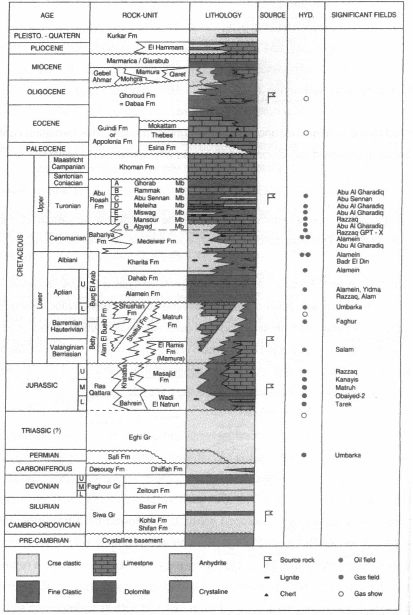
Fig.(2): Generalized lithostratigraphic column of the Western Desert and its hydrocarbon significance (Schlumberger, 1995).

The paleozoic depocenters seem to trend generally NNW-SSE, being controlled by the major faults developed in Late Precambrian time. In the northwestern corner of the Western Desert, a Paleozoic section of some 3000 m thickness has been delineated. In Late Carboniferous, regional up warping related to Hercynian orogeny affected the whole Western Desert and led to terrestrial conditions which prevailed during the Permo-Triassic time. They are represented by the widespread, unconformable Eghi Formation. This Formation consists of light-colored sandstone with some coaly seams. Some intercalations of dolomite and shales are present.
Throughout Mesozoic time, a cotinental depositional environmental prevailed over the whole of the Western Desert. There, the Nubian strata, whose age ranges from Jurassic to Late Cretaceous, unconformably overlie Precambrian basement and/or Paleozoic classic series. Their aggregate thickness is around 1500m, these strata may be subdivided into three sedimentary cycles, each consisting of a basal, well developed sandy unit, followed by a transgressive shaly, marginal marine-type sequence. The three transgressive phases occurred in Late Jurassic, Middle and Latest Cretaceous respectively.
The transitional period between Late Cretaceous and Early Tertiary corresponds to the Alpine orogenic phase during which the ENE-WSW Syrian arc system of deformation was most active. At the end of Cretaceous time, sedimentation was continuous in the structurally low and subsiding areas, but depositional gaps and erosional truncations were common on the pre-existing highs, which were reactivated, especially during the Paleocene. The extension of the Esna Formation, mainly Paleocene in age, it consists of light, chalky, occasionally reefal limestone, alternating with a variable content of fossiliferous shales.
The sedimentary cover of the Western desert is part of the foreland deposits which fringe the northern continental margin of the Afro-Arabian shield from the southernmost area of the Western Desert. The exposed Pre-Paleozoic basement shows a regional northward slope, with corresponding increasing thickening of the unconformable sedimentary cover, made up of Paleozoic,Mesozoic and Tertiary to Recent rock units.
The investigation of more than 300 wells covering the northern part of the Western Desert carried out by the (El Shaarawy and Haggag, 1990), revealed that this part of the Western Desert could be classified into five main sedimentary basins (Fig. 3). These basins are the Gindi, Natrun, Abu Gharadig, Paleozoic and the Northern basins. The Gindi basin to the east is mainly an Eocene basin. The Natrun basin to the northeast is mainly a Jurassic basin. The Abu Gharadig basin to the south is mainly a Late Cretaceous basin.
It is worth mentioning the study field lies within the Northen sedimentary Basin, which is mainly of Early Cretaceous and Jurassic age.
Tectonically, the Western Desert, is subdivided ,from south to north, into four units. These are the Craton and Stable Shelf, the Unstable Shelf, the Hinge Zone and the Miogeosyncline (Fig. 3).
The Miogeosyncline is presently submerged and partially buried under thick Plio-Pleistocene deposits in relation to the Nile Delta. During Paleozoic time, at least two phases of major deformation produced a N to NW trending system of block faulting and gentle folding with marked unconformities within the Paleozoic section. Although these movements were rejuvenated, a new trend of structures was superimposed and became predominant in the modeling of the basement and distribution of the sediments. With a general easterly trend (ENE to ESE), this new grain resulted from the Alpine orogenic phases which follow one another throughout the Mesozoic time and had their climax during Lower Tertiary.
Fig.(3): Sketch of the structural aspects of the country of Egypt (Schlumberger, 1984).

Concurrently, from Late Jurassic onwards, differential depocenters developed with corresponding strong changes in thickness and facies, especially during the Upper Cretaceous. Structures result primary from vertical movement of basement blocks, and consist of draped over and/or faulted anticlinal features. Compressional anticlines are subordinate and probably derive from drag folding, related to lateral movement along basement faults (Schlumberger, 1984).

- MATERIALS AND METHODS:
The present study is mainly based on Twenty Reflection seismic lines traversed the Razzak field in different directions (Fig. 4). These data are supplied by the authority of the Egyptian General Petroleum Corporation (EGPC).
The location and attitude of the interface that gave rise to each reflection event are calculated from the arrival times. Seismic velocity enters into the calculation of the location and attitude of the interfaces. The results are combined into cross-sections and contour maps that represent the structure of the geological interfaces responsible for the events. Patterns in the seismic data are sometimes interpreted in terms of stratigraphic features or as indicators of hydrocarbons. Further information is gained about the penetrated Formations by measuring their geophysical properties with the aid of wireline logs.
Fig.(4): Locations of the available seismic lines and wells at the Razzak oil field, Western Desert.

- RESULTS AND DISCUSSIONS:
The available seismic sections are used for evaluating the structural setting of the Razzak field. This is through two groups, the first trends NW-SE and the second trends NE-SW and represented by the following sections. The Interpretation are based on detecting four reflectors, the Massajid Formation, Alamein Dolomite member, Abu Roash "G" Member, and the Apollonia Formation, which are delineated in the A-A' cross section (Fig. 5).
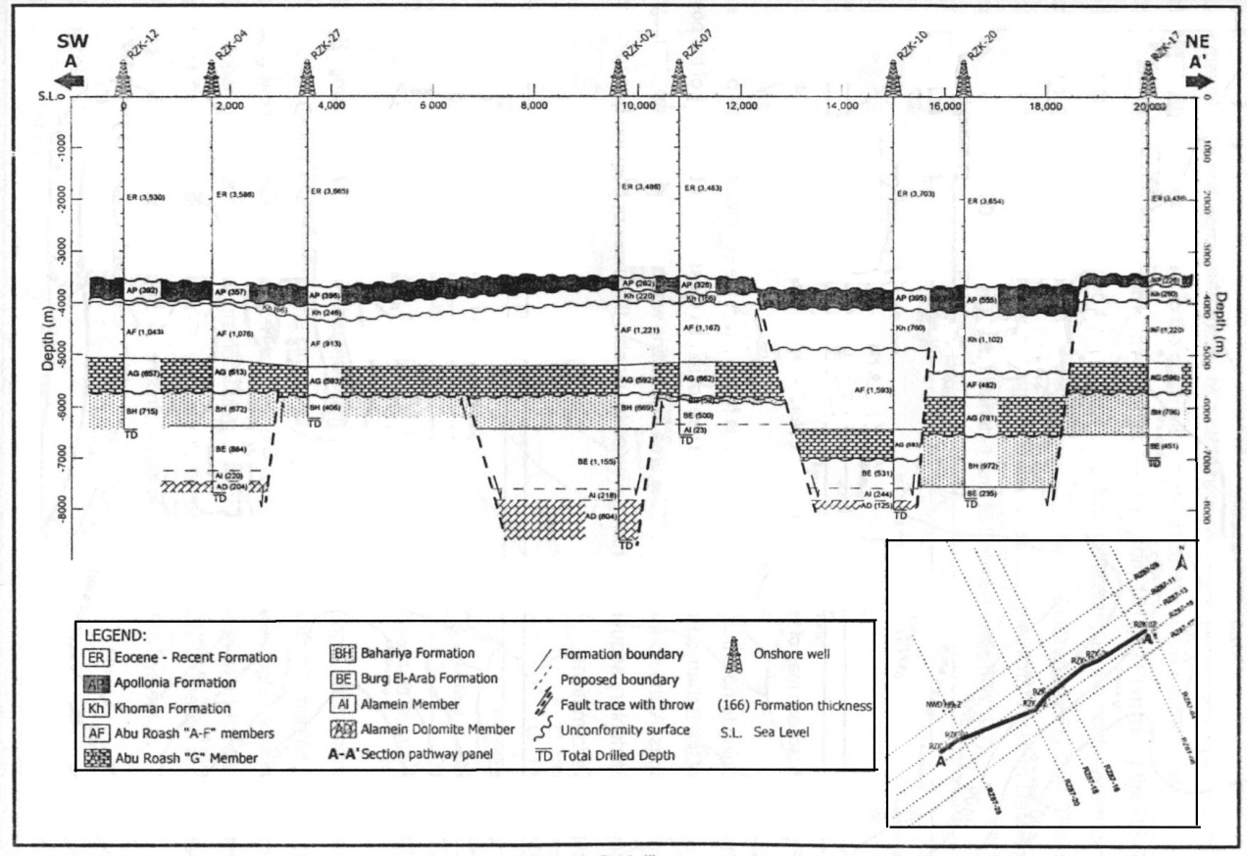
Fig.(5): Structural cross section along the profile A-A', the Razzak oil field, illustrates the downhole information of the individual wells represented by the all encountered sedimentary intervals. The section pathway panel of the cross section displayed in the inserted map. The horizontal axis at the top corresponds to the relative horizontal inter-well spacing. The vertical axis is a true vertical depth relative to the means sea level.

The NW-SE seismic section group:

The RZ87-04 Seismic section (Fig. 6) has two main faults (No.'s 15 and16) ranched geometry forming a horst block. The fault (No. 10) also runs parallel to the main fault (No. 16). A wedge of the lower Cretaceous section is elaborated toward the SE on this line. This seismic line verifies the NE extension of the horst block all over the mapped field.

Fig.(6): RZ87-04 Seismic Line.

The RZ87-06 Seismic section (Fig. 7) shows the effect of the Late Cretaceous wrench faulting, where both NE-SW main fault (No. 15) and the NW minor fault trend are present and interact with each other. This seismic line indicates that the fault (No. 6) displays different magnitudes of throw for the Cretaceous Alamein dolomite member and Massajid Formation as a result of the shear effect.

Fig.(7): RZ87-06 Seismic Line.

The RZ87-16 Seismic section (Fig. 8) shows the shear fault (No. 4) cuts the main fault (No.16). The effects of the Late Cretaceous wrench faulting appears to be in two sites, the first where the NE-SW main fault (No. 15) and the NW minor fault trend are present and interact with each other. The second, where both the fault (No. 8) and the NE minor faults are present and interact with each other. Also the fault (No. 6) is a wrench fault. On the downthrown side of the fault (No.15) a very thick wedge of the Lower Cretaceous section is present, compared to thin section on the downthrown side of the fault (No. 16).
Fig.(8): RZ87-16 Seismic Line.

The RZ87-18 seismic line (Fig.9) shows that the northern dip of the downthrown side of the two main faults (No.15) and (No.16). A very thin Lower Cretaceous section occupies the horst block area compared to very thick section on the downthrown side of the two main faults (No.15) and (No. 16). The effects of the wrench faulting are obvious on the faults (No's. 4, 6, 7 and 8).
Fig.(9): RZ87-18 Seismic Line.

The RZ87-20 seismic line (Fig. 10) shows shear faults (No's.4 and 5) where obvious and the structural closures of the Cretaceous levels are clear. These closures are situated on the downthrown side of the main fault (No. 15). This seismic line shows the northerly dipping of the downthrown side of the main fault (No. 16).
The RZ87-28 seismic line (Fig. 11), where the NWD349-2 and RZK-04 wells are located. The four seismic reflectors are picked on the seismic line by tying with the NWD349-2 well. The wrenching and shearing criteria of the two main faults (No's.15 and 16) are clear and the shear fault (No.2) cuts the main fault (No. 16). The effects of the wrench faulting are obvious on the faults (No's. 1 and 3). The NWD349-2 well is a dry hole because of the missing of an adequate structural closure on the horst block area.

Fig.(10): RZ87-20 Seismic Line.

Fig.(11): RZ87-28 Seismic Line.

The NE-SW seismic section group:
The RZ87-09 seismic line (Fig. 12) shows the faults (No.1) and (No.14) as good examples for a wrench faulting. The main fault (No.16) is cut by the shear faults (No.4 and 6). The main fault (No.16) separates the thick and thin Lower Cretaceous sections on its downthrown and up thrown sides, respectively. The RZ87-11 seismic line (Fig. 13) shows different sets of shear faults which oriented NW-SE trend exhibits a very complex structural pattern. The main fault (No.15) is cut by the shear faults (No's.13 and 14). Also the fault (No.4) cuts the shear fault (No.6). The main fault (No.16) is cut by shear faults (No's. 9 and10). The fault (No.6) displays different magnitudes of throw for the Cretaceous; Alamein Dolomite Member and the Massajid Formation as a result of the shear effect.

The R287-13 seismic line (Fig. 14) shows that the main fault (No.15) is cut by the shear faults (No's. 1 and 5). A wedge of the Lower Cretaceous section is still occupying the downthrown side of the main fault (No.15). The effects of wrench faulting are obvious on the faults (No's. 4, 6 and13).

Fig.(12): RZ87-09Seismic Line.

Fig.(13): RZ87-11 Seismic Line.

Fig.(14): RZ87-13 Seismic Line.

The RZ87-15 seismic line (Fig. 15) shows that the main fault (No.15) is cut by the shear faults (No.1), (No's. 6 and 11). These faults terminate in the Khoman or the younger Formations that clearly date the time of the Late Cretaceous tectonics that affected the area. The effects of the wrench faulting are obvious on a lot of faults in this seismic line.

The RZ87-17 seismic line (Fig.16) reveals the effects of the wrench faulting by the faults (No's.4, 6 and 11). These wrench faults cut the main fault (No.15). The regional NE direction of thickening of the Lower Cretaceous section on the downthrown side of the main fault (No.15) is still obvious. The shear fault (No.1) is obvious in this seismic tine with other minor faults.

Fig.(15): RZ87-15 Seismic Line.

However, four two-way time (TWT) seismic contour maps have been constructed on tops of the Massajid Formation, Alamein Dolomite Member, Abu Roash "G" Member, and the Apollonia Formation. This is to illustrate areally the structural elements affected the Razzak field.

Fig.(16): RZ87-17 Seismic Line.

The TWT map on the top of the Massajid Formation (Fig.17). This is to illustrate areally shows an erratic time distribution pattern allover the Razzak field with a general increasing direction northward recording the maximum TWT value of 2760 m. sec at the V.P. 340 on the R287-06 seismic line, while decreases gradually to the SE and SW of the field recording the minimum value of 1900 m. sec at the V.P. 140 on the RZ87-09 seismic line.
The major two faults (No's. 15 and 16) that are delineated on the seismic sections (see Figs. 6-16) striking the field in a NE-SW direction. The downthrown of the fault (No. 15) is due to the south with a magnitude up to 500 m. sec, while it is to the north for the fault (No. 16) with a throw magnitude of 200 m. sec, forming a horst-like structure. The northeast increase of the TWT values indicates a general plunge of the horst block, with a general tilt NE ward.
The NW-SE faults No. 's 1. 2, 4, and 6 in the interpreted seismic sections (see Figs. 6-16) crossing diagonally the horst block and offsetting the main NE-SW oriented faults No's 15 and 16 as well as the horst block in a right-lateral strike-slip displacement component. The intersections of the NW-SE and the NE-SW trending faults gave rise to different structural closures. The RZK-13 and RZK-1 wells are located on three different fault blocks that formed as a result of branching of the fault No. 15, with possible Jurassic lead areas as three-way closures. The area to the NW of the field shows a good structural Jurassic closure that can be acted as a good lead in case of sealing from the south by the fault No.16. The horst block bounded by the two main faults No's 15 and 16 is another possible Jurassic lead. The horst block at the NE of the mapped field that is possibly sealed by the shear fault No.6 from the SW direction is also a possible Jurassic lead.
The TWT map on the top of the Alamein Dolomite Member (Fig. 18) shows also an erratic distribution pattern allover the Razzak field with a general increasing direction NE ward recording the maximum TWT recorded value of 2300 m. sec at the V.P. 180 on the RZ87-16 seismic line, while decreases generally to the NW and SW directions recording the minimum TWT value of 1710 m. sec at the V.P. 200 on the RZ87-11 seismic line.
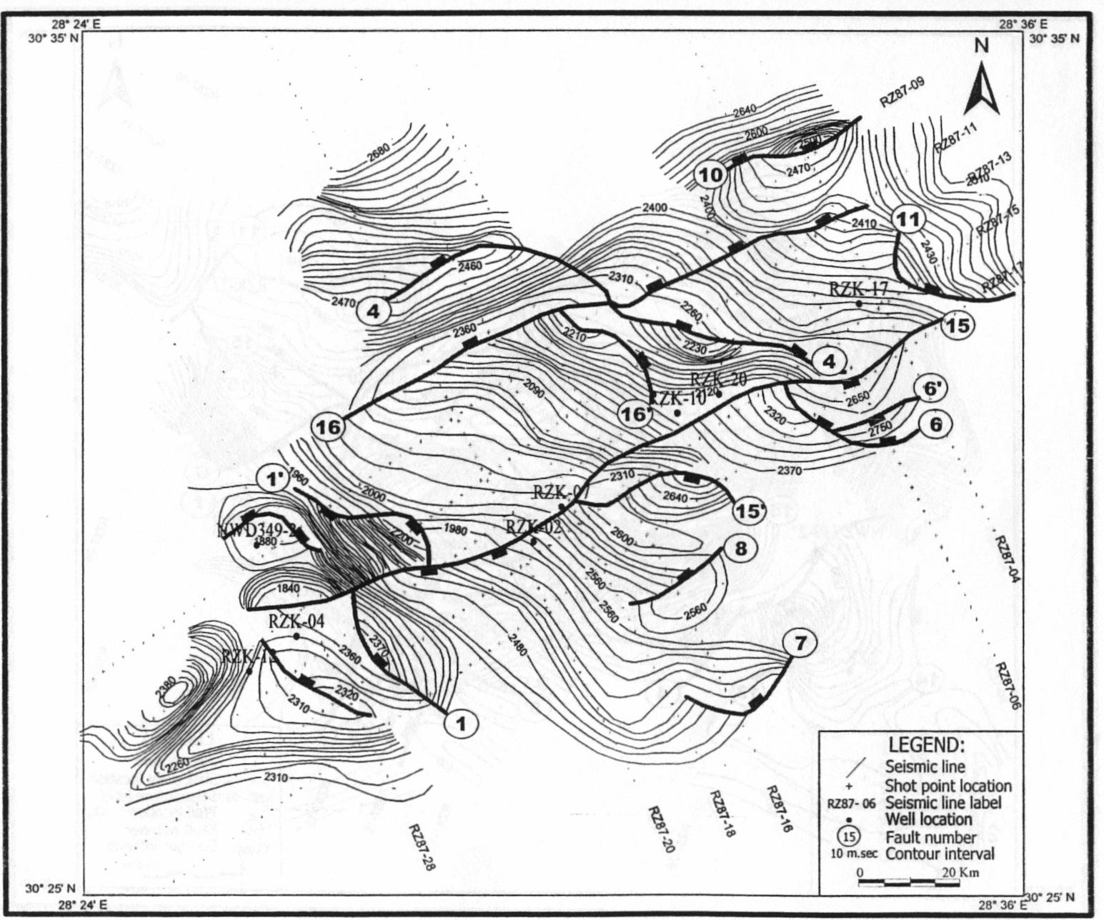
Fig.(17): Two way time (m.sec) structural contour map on top Massajid Formation.

The two major faults (No's 15 and 16), (see Figs. 6-16) striking the field in a NE-SW direction, with a southward downthrown of 200 m. sec of the fault No. 15 and a northward 80 m. sec downthrown for fault No. 16. These faults form a horst like structure, with a general plunge NE ward. The two faults numbered No.'s 4 and 6 in the interpreted seismic sections are cutting diagonally the horst block and offsetting the main NE-SW oriented faults No.'s 15 and 16 in a right-lateral strike-slip component of displacement.

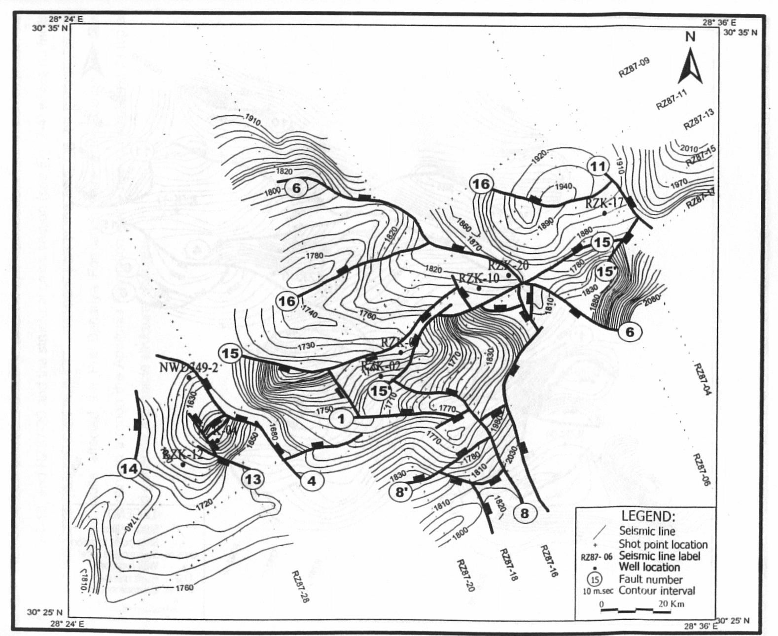
Fig.(18): Two way time (m.sec) structural contour map on top Alamein Dolomite Member.

The intersections of the NW-SE and the NE-SW trending faults gave rise to different structural closures, of them three different enechelon closures are situated along and on the downthrown side of the fault No. 15. The closure to the east of the field is formed by the faults No.'s 6 and 11, the central closure is formed by the faults No.'s 4 and 1, while the western one is bounded by the faults No.'s 1 and 4.

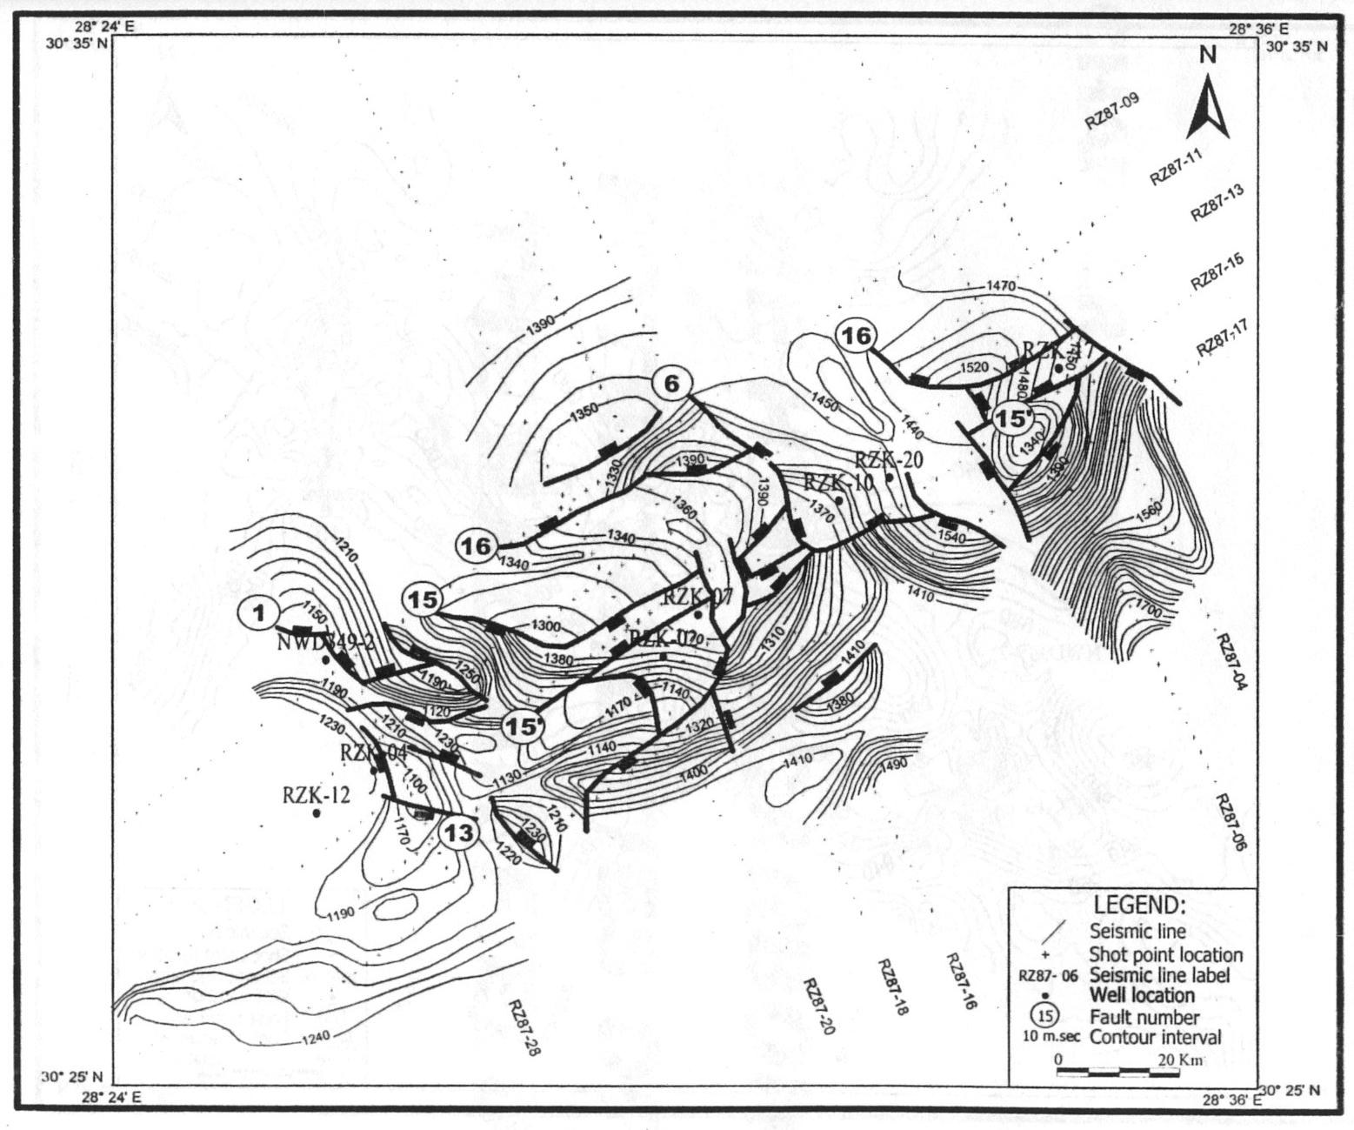
Fig.(19): Two way time (m.sec) structural contour map on top Abu Roash "G" Member.

Structurally the western closure is shallower than the eastern one, which reflects the regional NE tilts of the studied field. Possible lead on the Alamein Dolomite map is also possible to the northeastern horst block of the field, which is thought to be sealed from the west by the fault No.11. Another one to the northwestern side of the field but needs to be sealed from the south by the fault No. 16.
The TWT map on the top of the Abu Roash "G" Member (Fig. 19) shows an irregular time distribution pattern allover the Razzak field with a general increasing direction NE toward recording the maximum value of 1730 m. sec at the V.P. 272 on the RZ87-06 seismic line, while decreases gradually toward the north and southwestern parts of the mapped area recording the minimum TWT value of 1120 m. sec at the V. P. 340 on the RZ87-11 seismic line.

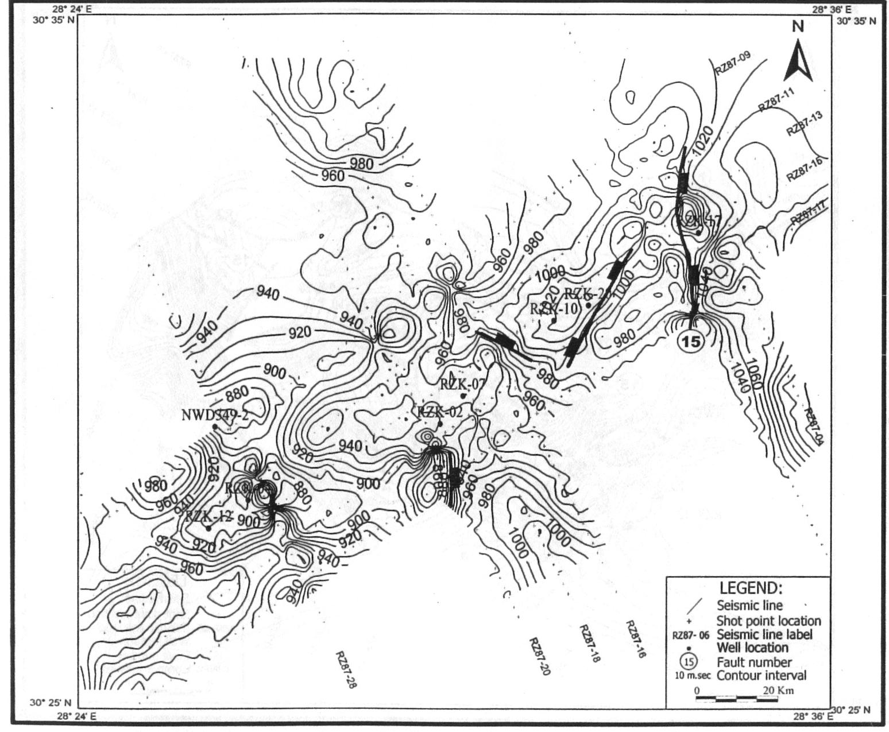
Fig.(20): Two way time (m.sec) structural contour map on top Apollonia Formation.

The lateral extension of the two major faults No.'s 15 and 16, that are delineated on the seismic sections (see Figs. 6-16) can be noticed clearly in this map, as they are crossing the field in a NE-SW direction, with a downthrown of the fault No.15 to the south with magnitude up to 80 m. sec, while that of the fault No. 16 is of 40 m. sec to the north. These two faults form a horst-like structure, with a general plunge northeast ward. The horst block exhibits a very narrow areal extension due to the migration effect through depth of the two main faults No's 15 and 16.
Most of the NW-SE strike-slip faults do not reach the top of the Massajid Formation and the Alamein Dolomite Member, (Figs. 16 and 17). The three enechelon structural closures that have been demonstrated on the top of the Alamein Dolomite are also seen on TWT map of the Abu Roash "G" Member (Fig. 17). These closures are dissected by the NW-SE trending shear faults, which play a role in the hydrocarbon distribution. The intersections of the NW-SE and the NE-SW faults gave rise to possible sites for other possible structural closures.
The TWT map on the top of the Apollonia Formation (Fig. 20) shows the general increasing direction E and NE wards recording the maximum TWT value of 1120 m. sec at the V.P. 101 on the RZ87-04 seismic fine, while decreases gradually to the S and SW wards recording the minimum TWT value of 840 m. sec at V.P. 470 on the RZ87-17 seismic line.
Based on this TWT map the top surface of the Apollonia Formation appears to be nearly free from the faulting effects that affected the underlying Abu Roash "G" Member, Alamein Dolomite Member, and Massajid Formation.
This map revealed that the mapped field almost tectonically ceased since the Late Cretaceous time with minor NE faulting accompanied with tilting tectonisms. This indicated from the seismic sections No's RZ87-16, RZ87-18, and RZ87-20 and the structural cross section (see Fig. 5) where no faults affected the Post Bahariya Formation at the southwestern part of the field. On the contrary, at the northeastern part the faults affected the Pre Bahariya Formation were active during the Late Cretaceous time and continued through the Apollonia Formation giving rise to sculpturing its top at this sector of the field and generate a possible structural closures.

- CONCLUSIONS:
The Razzak field structure is one of the most complex structures in the Western Desert of Egypt. The field lies within the Northern sedimentary Basin, which is mainly of Early Cretaceous and Jurassic age. Its exploration history is dated back to the year 1963. Oil and gas produced from the Khatatba and Bahariya sands and Alamein dolomite. New seismic vintage over the Razzak field area in 1987 lead to new discoveries.
Twenty Reflection seismic sections have been used to shed light on the subsurface structural setting and the hydrocarbons entrapment styles in the Razzak field in the Egyptian Western Desert. This is achieved through integrated geological and geophysical studies utilizing a number of maps and cross sections. The interpretation has been traced four reflectors, the Massajid Formation, Alamein Dolomite member, Abu Roash "G" Member, and the Apollonia Formation.
The NW-SE and NE-SW trending seismic sections revealed a number of Late Cretaceous wrench and shear faults forming horsts allover the mapped field. These faults led to a very thin Lower Cretaceous section occupies the horst block area compared to very thick section on the downthrown side of the two main faults. For some instances dry hole conditions occur due to missing of an adequate structural closure on the horst block area. The NE-SW trending ''three-way'' closures which from the Razzak oil field structures are sealed to the north by a NE-SW oriented major fault.
The TWT maps on the top of the traced reflectors reveal different structural closures with lateral strike-slip fault displacement. These maps revealed that the field almost tectonically ceased since the Late Cretaceous time with minor NE faulting accompanied with tilting tectonisms.

Corresponding Author:
Dr. Fathy Shaaban
Department of Geomagnetism and electricity
NRIAG, Helwan 11722, Egypt.
E-mail: shaaban_F@hotmail.com

REFERENCES:
- Aadland, A. J. (1990). ''Western Desert of Egypt Regional Geology'', Personal Communications
- Abdel Hady,Y. E. (1975). ''Petrographic characteristics of oil bearing Rocks in Alamein oil field, Significance in source Reservoir relation in North Western Desert of Egypt '',Am. ASS. Pet. Geol. Bull., Vol-59, No. 3, 510- 523 P.
- Beleity, A. M. (1973). ''Razzak Member as a good marker in Bahariya Formation '', GUPCO's Internal Report, Unpublished, 1-10P.
- EGPC (Egyptian General Petroleum Corporation) (1986). '' History of oil Exploration, Egypt '', 8 the EGPC conference, Cairo, Nov., 1- 34P.
- EGPC (Egyptian General Petroleum Corporation) (1992). Western Desert, oil and Gas fields, A comprehensive overview '', 11th EGPC conference, Cairo, No. 1-4310.
- EL Ayouty, M. K.(1990).''Petroleum Geology of Western Desert'' Consultant, Cairo, Egypt, 586-594P.
- EL Bishlawy, S. (1972). ''NWD349 -1 Well Recommendation'', Gupco's Internal Report, Un-published, 1-10 P.
- EL Shaarawy, O., A. (1994). ''Zonation of the Bahariya Formation and Alamein Dolomite Reservoirs in the Razzak oil field, North Western Desert of Egypt '', Second International Conference on The Geology of the Arab World, Cairo University, Cairo, Jan - 22-26,1-16P.
- EL Shaarawy, O. A., Abdel Aal, A. , Papazis, P., and Helmy, H. (1988). ''Razzak - 24 and 25 Water Injection Wells For the West Razzak field'', GUPCO' s Internal Report, Unpublished,1-6 P
- EL Shaarawy, O. A., Abdel Aal, A., and papazis, P. (1989 a). ''NWD349-2 (st -2) Post Appraisal'', Gupco's Internal Report, Unpublished, 1-16 P.
- EL Shaarawy, O. A., Abdel Aal, A., Papazis, P., and Helmy, H. (1989b). '' NWD 349 - 2 (IF 36 -4) Well Recommendation'', Gupco's Internal Report, Unpublished, 1-22P.
- EL Shaarawy, O. A., Abdel Aal, A.,and Papazis, P. (1992a). ''Tectonic setting of the Razzak oil field, North Western Desesrt of Egypt '', 11th EGPC Conference, Cairo, 1-20P.
- El Shaarawy, O. A. and Haggag, M, (1990). ''Isosalinity study of the North Western Desert of Egypt '', 10 th EGPC Conference, Cairo, Nov., 1- 22 p.
- EL Shaarawy, O. A. and Zaafan, S. (1993). ''Wire-line test recommendation on Abu Gharadig Field'', Gupco's Internal Report, Unpublished, 1-12p.
- Fawzy, A. and Dahi, M. (1992). '' Regional Geological Evaluation of The Western Desert, Egypt'', Geology of the Arab World conference, Cairo University, Cairo, Jan. 111 - 149P.
- Hagras,M., EL Awdan, A. and Gawdat, M. (1992). ''Hydrocarbon Potential of the Alam EL Bueib siliciclastics Revived The Industry '', 11th EGPC Conference, Cairo, Abstract.
- Hassan, N. and Tammamm,T. (1992).''Gindi Basin, Focus on Hydrocarbon Capabilities'', 11th EGPC conference, Cairo, 1-26P.
- Hegazy, A. K. (1993). ''Introduction to Jurassic Discoveries in north Western Desert '', First Seminar on study of the Jurassic system in Egypt, Academy of scientific Research and Technology, June, Abstract.
- Kamhawy, M., EL Askary, T.,and Said, M. (1992). '' A study on Variation in API Gravity of West Razzak oils'', 11 th EGPC Conference, Cairo, 1-16P.
- Matwalli, M. H, philip, G., and Wali, A. (1982). '' Primary Dolomites as oil reservoirs, Their occurrences and Significance in the North Western Desert, Arab Republic of Egypt'', Acta Geological Academic sceintiarum Hungaricae, Vol. 25, (3-4),297-329P.
- Mosca, F. and Aboul Gadayel (1992). '' Geochemical Modeling within the Kanayis Area, Western Desert, Egypt, 11th EGPC Conference, Cairo, 1-13P.
- Oison, P.K. (1986).''Western Desert oil -oil and oil-Rack Correlation Study'', AMOCO'S Report, Unpublished, 1-200P.
- Parker, J. R. (1982). '' Hydrocarbon Habitat of Western Desert'', 6th EGPC Conference, Cairo, 1-8P.
- Robertson Research International (1982).' 'Petroleum potential Evaluation of the Western Desert, the Arab Republic of Egypt '', 8 volumes.
- Schlumberger (1984). ''Well Evaluation Conference, Egypt'', Geology of Egypt, 1-64.
- Schlumberger (1995). ''Well Evaluation Conference, Egypt'', Geology of Egypt, 58-66.
- Shahin, A. N. (1988). ''Undiscovered Hydrocarbon Reserves and Their preservation Time limits in West Qarun Area, Abu Gharadig Basin, Western Desert, Egypt,''9th EGPC conference Cairo, 1-25P.
- Shahin, A-N- and Dahi, M. (1992). ''Paleozoic Rocks Distribution and Hydrocarbon Potential in the Western Desert, Egypt,''11th EGPC Conference, Cairo,1-23P.
- Zein EL DIN, M. Y., Mtbouly, S., Moussa, S., and Abdel Khalik, M. (1990). '' Geochemistry and oil Correlation in The Western Desert, Egypt, 10th EGPC conference, Cairo, 1-21P.

1/12/2012

