The Potential Effect of Flaxseed on Female Postmenopausal Rats

*Hala F. Osman, Samia K. Yousef Ayad and Amal Abdel-Aziz El-Mahdy

Radioisotopes Department, Nuclear Research Center, Atomic Energy Authority, Egypt
*hala1fawzy@gmail.com

Abstract: Phytoestrogens are plant compounds with estrogen-like biological activity. Phytoestrogen intake plays a role in preventing the development of some chronic diseases attributed to ovarian hormone deficiency. Flaxseed is a dietary source of phytoestrogen which contain lignans. The current work is conducted to study the effects of supplementation of flaxseed mixed with basal daily diet (B.D.) on protection of cardiovascular system and alleviation of osteoporosis in female postmenopausal rats. Fifty female postmenopausal rats were classified to 5 groups (n=10); one group served as control without addition of flaxseed, three groups were assigned to consume 3 different doses of flaxseed mixed with B.D.( 10,15& 20g/kg.b.wt.) and last group was orally received ovestin beside B.D. for 3months. Serum lipid profile, alkaline phosphatase (Alp), Ca⁺⁺ and phosphorous (P) were assessment. Estradiol level and bone mineral density (BMD) were measured. The obtained results showed significant decrease in total cholesterol, triglycerides and LDL-cholesterol with an elevation in HDL-cholesterol particularly at 10 and 15 g flaxseed/kg.b.wt. Elevation effect was seen in total cholesterol, triglycerides and HDL-cholesterol with reduction in LDL-cholesterol when ovestin was administrated to postmenopausal female rats. An improvement in bone-turnover as a result of mixed flaxseed to B.D. indicated by elevation in Alp and reduction in urinary excretion of ca and p particularly when 10g flaxseed added to normal diet. Very slightly beneficial effect found in BMD of femur different parts when flaxseed was mixed with B.D. Conclusion; 10-15g flaxseed/kg b.wt may be an effective alternative therapy to alleviate postmenopausal symptoms and may protect cardiovascular system by altering lipid profile favorably, also may improve bone-turnover with reduction in bone-fracture risk. Supplementation of flaxseed for more than three months may improve BMD.
[Hala F. Osman, Samia K. Yousef Ayad and Amal Abdel-Aziz El-Mahdy. The Potential Effect of Flaxseed on Female Postmenopausal Rats. Nature and Science 2011;9(4):1-8]. (ISSN: 1545-0740). http://www.sciencepub.net.

Key words: Osteoporosis, Hormonal replacement therapy, cardiovascular diseases, Phytoestrogen, Flaxseed, Lignans.

1. Introduction:
Ovaries gradually produce estrogen in the period up to menopause, then its blood level decline as a result (Lerner, 2006). The declining levels of estrogen can cause distressing symptoms with increased incidence of osteoporosis, cardiovascular disease (Coelingh etal., 2008).
Administration of estrogen to replace its falling level can alleviate the distressing symptoms and this called hormonal replacement therapy (HRT). Several studies have shown that estrogen replacement therapy (ERT) maintains skeletal mass and protect cardiovascular system in postmenopausal women (Delmas, 2002). Although hormonal replacement therapy is an effective treatment in alleviating distressing symptoms but women are unwilling to initiate this treatment due to long term ERT has been associated with increased risk factor of breast and uterine cancer and contraindication (Radhakrishnan etal., 2009).
Estriol is one of the estrogen that has lower risk than other estrogen of causing cancer (Jirapino etal., 2003). Ovestin tablets contain the active gradient estriol which is naturally occurring form of estrogen (Rochon etal., 2007). Because a high risk of cancer as a result of (ERT), many studied have been performed recently to investigate that natural phytoestrogens act as safe treatment (Luine etal., 2006).
Phytoestrogen are non-steroidal plant compounds found in many fruits, vegetables, grains and seeds (Arjmandi, 2001). Lignans are structurally related to estrogen. The strong resemblance between lignan and estrogen inable lignan to compete with estrogen against estrogen receptors site, so dietary lignans may block the estrogen receptors sites, displacing harmful excessive estrogen as harmless flushes from the body as waste (Stephen, 2006). Lignans have estrogenic and estrogenic activity. If there is little estrogen in the body as postmenopausal women, lignans may act like weak estrogen but when natural estrogen is abundant, lignans may reduce estrogen's effects by displacing it from the body (Carreau etal., 2008).
Flaxseed is a rich source of mammalian phytoestrogen lignans. Mammalian lignans (enterolectone and enterodiol) are formed by the action of colon normal flora (Stephen etal., 2003).
Lignans may also possess antioxidant activity as scavenging free radical oxygen that are formed as a result of aging and improve antioxidant status (Stephene, 2006). High intake of Lignan may not be safe for women with a history of estrogen-sensitive cancer (Arjmandi, 2001). Osteoporosis is a reduction in bone mass as a result of lowering level estrogen during menopausal period (Coelingh etal., 2008). Some studies reported that lignans may alleviate age-related bone loss and decrease bone fracture (Tsuang etal., 2008) and may reduces cardiovascular disease (Cassidy and Hooper, 2006).

2. Materials and Methods:
Female menopausal albino rats (250-300 g) at the average age ranging from 16-19 months were purchased from National Research Center, Dokki, Giza, Egypt. Rats were allowed to climate for one week prior to the initiation of experiment. Rats were maintained at balanced diet (B.D.) and tap water that allowed ad libitum.

Chemical and Natural treatment
Ovestin was obtained from Sedico Pharmaceutical Co. 6 October City-Egypt dissolved in water and adjusted for daily gavages injection of 12µg/kg.b.wt for three months.
Flaxseed was supplies from Agriculture Research Center, Giza, Egypt. It was prepared at 3 different doses 10,15&20 g/kg b.wt for 3 months. Fifty female menopausal rats were divided into five groups (n=10) according to their dietary supplementation.
Group I: Received balanced diet only served as control.
Group II: Received 10 g /kg.b.wt flaxseed mixed with balanced diet.
Group III: Received 15 g /kg.b.wt flaxseed mixed with balanced diet.
Group IV: Received 20 g /kg.b.wt flaxseed mixed with balanced diet.
Group V: Received 12 µg/Kg.b.wt Ovestin by gavages beside balanced diet.
Animals were sacrificed and blood samples were collected by cardiac puncture, blood centrifuged and obtained serum was kept frozen till analysis:

Biochemical and hormonal analysis:
Serum total cholesterol, high density lipoproteins (HDL) and low density lipoproteins (LDL) were determined according to (stein, 1987) and Triglyceride was evaluated according to (Young, 1990), serum alkaline phosphatase by (Moss, 1982), inorganic phosphorous according to (Tietz, 1990), serum calcium by (Kozera, 1984), all these parameters were estimated by enzymatic colorimetric method and measured by spectrophotometer. The estradiol hormone was determined by radioimmunoassay according to (Bergquist et al.., 1983).
Bone mineral density (BMD) was determined by DEXA-Norland XR-46 version 3.9.6 in National Research Center.

Statistical analysis:
The data was subjected to one-way ANOVA and the differences between means at 0.05 probability level were determined by Duncan's new multiple range test (Dytham, 1999).

3. Results:
As shown in table (1); Supplementation of whole flaxseed with daily diet at concentration 10 and 15 g/kg body weight (Gr II and III) for 3months significantly decreased (P<0.05) the levels of S. cholesterol, triglycerides and low density lipoprotein-cholesterol (LDL-cholesterol), where as high density lipoprotein (HDL-cholesterol) significantly increased (P<0.05) when compared with postmenopausal rats not treated with flaxseed (GrI). In addition; supplementation with 20 g/kg. b.wt flaxseed for 3 months (GrIV) showed slightly significant decrease (P<0.05) in S. cholesterol but still around the level of control postmenopausal rats where as S. triglycerides level were significantly elevated (P<0.05) with elevation of HDL and reduction in LDL were observed when compared with post menopausal female rats (GrI). Orally administration with 12µg/kg ovestin for 3 months (GrV) significantly elevated (P<0.05) cholesterol and triglycerides but in contrary elevated HDL with reduction in LDL where observed when compared with untreated postmenopausal rats.
As shown in table (2); Postmenopausal rats without treatment with flaxseed revealed a significantly decrease (P<0.05) in S. alkaline phosphatase activity (ALp), Ca⁺⁺ and inorganic phosphorous but treatment with whole flaxseed at different concentration for 3 months reduced bone loss and this indicated by significantly increase (P<0.05) in S. ALp activity and Ca⁺⁺ particularly treatment with 10g/kg.b.wt flaxseed where as treatment with 15 and 20 g/kg significantly (P<0.05) increases S. ALp without elevation in S. Ca⁺⁺ . No significant change observed in the level of S. Ca⁺⁺ when postmenopausal rats supplied with 15 and 20 g/kgb.wt flaxseed compared with control. Orally treated with ovestin significantly (P<0.05) decreased ALp activity with non significant alteration in Ca⁺⁺ and phosphorous (indicated no improvement in bone loss).

Table (1): Effect of flaxseed and ovestin on Cholesterol, Triglycerides, HDL and LDL levels in postmenopausal female rats.
LDL  (mg/dl) | HDL  (mg/dl) | Triglycerides  (mg/dl) | Cholesterol  (mg/dl) | Parameters  Groups
41.6±1.3ª | 21.2±1.0^{c} | 76±2.1^{b} | 78±1.6^{b} | Control (GrI)
19.9±0.9^{c} | 23.7±0.8^{c} | 56.7±2.0^{d} | 55±1.4e | Flaxseed 10g/kg (GrII)
22.7±1.3^{cb} | 29.4±1.3^{b} | 66±2.0^{c} | 64±1.9^{d} | Flaxseed 15g/kg (GrIII)
24.1±1.3^{b} | 28.6±1.2^{b} | 93±2.6ª | 72±1.3^{c} | Flaxseed 20g/kg (GrIV)
24.5±1.1^{b} | 51.3±1.5ª | 99.6±3.2ª | 94±1.7ª | Ovestin 12µg/kg (GrV)
Data are means of 10 replicates± standard error. Means in the same raw have the same litter are not significantly different at 0.05.

Table (2): Effect of flaxseed and ovestin on Alkaline Phosphatase, Calcium ions and Inorganic Phosphorus levels in postmenopausal female rats.
Inorganic phosphorus mg/dl | Calcium ions mg/dl | Alkaline phosphatase U/L | Parameters  Groups
8.4±0.5^{ab} | 12.7±0.5^{bc} | 290±20.6^{c} | Control (GrI)
8.3±0.2^{ab} | 17.5±0.9ª | 677±30ª | Flaxseed 10g/kg (GrII)
9.2±0.5ª | 12.3±0.6^{bc} | 317±18.4^{c} | Flaxseed 15g/kg (GrIII)
7.5±0.3^{b} | 11.8±0.5^{c} | 466±25^{b} | Flaxseed 20g/kg (GrIV)
8.5±0.5^{ab} | 13.9±0.3^{b} | 203±11^{d} | Ovestin 12µg/kg (GrV)
Data are means of 10 replicates± standard error. Means in the same raw have the same litter are not significantly different at 0.05.

Fig (1) showed daily treatment with whole flaxseed at different concentration for 3month was significantly elevated (P<0.05) estrogen level particularly at 10&15g/kg.b.wt whereas orally treatment with ovestin as a hormonal replacement therapy resulted in a high significant (P<0.05) elevation of estradiol level when compared with postmenopausal rats.
‘
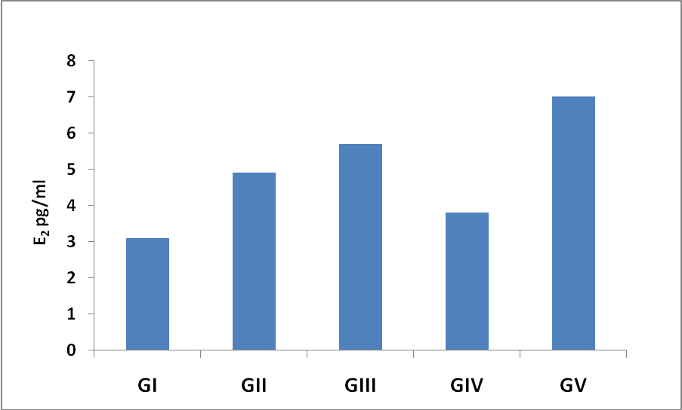
Fig (1): Effect of flaxseed and ovestin on serum Estradiol levels in postmenopausal female rats.

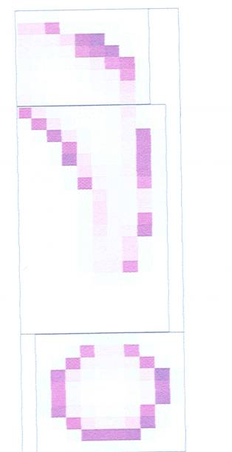
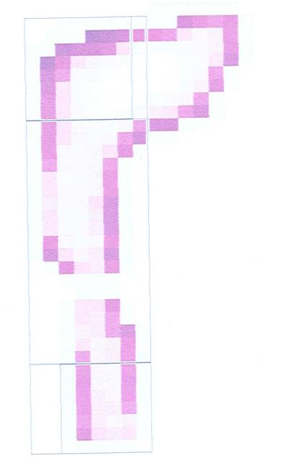

(GrI) (GrI)



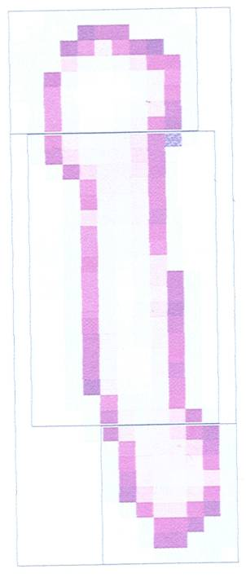
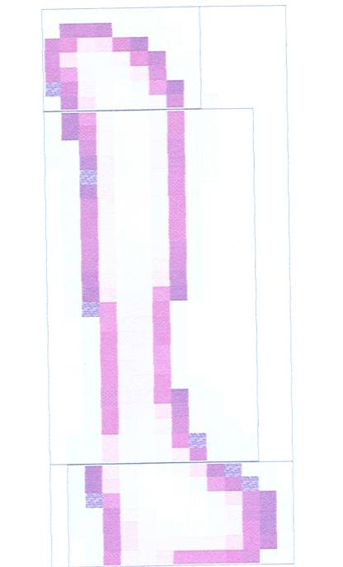

(GrII) (GrIII)

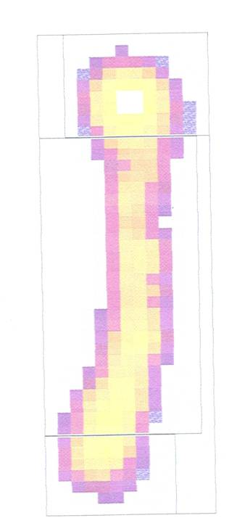
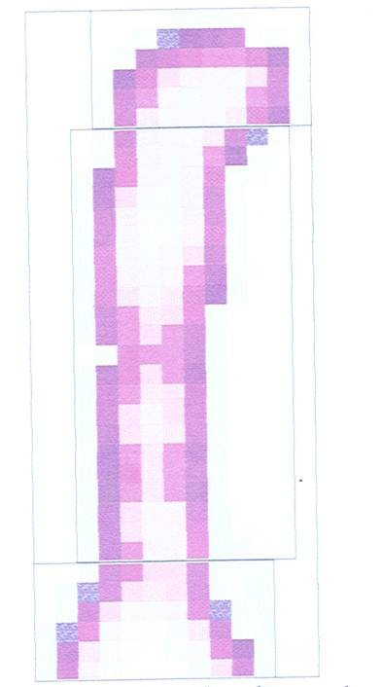

(GrIV) (GrV)

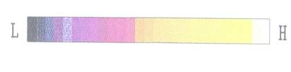

Fig (2): Effect of flaxseed and ovestin on BMD (g/cm³) of femur different parts in different groups postmenopausal female rats.

Table (3): Effect of flaxseed and ovestin on BMD (g/cm³) of femur different parts in postmenopausal female rats.
Middle | Distant | Proximal | Total | Parameters  Groups
0.109±0.002^{ab} | 0.109±0.002ª | 0.113±0.002ª | 0.112±0.002ª | Control (GrI)
0.100±0.001^{bc} | 0.088±0.001^{c} | 0.102±0.001ª | 0.100±0.002^{b} | Flaxseed 10g/kg (GrII)
0.103±0.001^{ab} | 0.110±0.002ª | 0.099±0.002ª | 0.101±0.003^{b} | Flaxseed 15g/kg (GrIII)
0.093±0.003^{c} | 0.099±0.004^{b} | 0.083±0.101ª | 0.094±0.001^{c} | Flaxseed 20g/kg (GrIV)
0.111±0.006ª | 0.116±0.005ª | 0.111±0.002ª | 0.109±0.001ª | Ovestin 12µg/kg (GrV)
Data are means of 10 replicates± standard error. Means in the same raw have the same litter are not significantly different at 0.05.

As shown in table (3); dietary with whole flaxseed with daily diet for 3 months at different concentration (10,15, and 20 g/kg.b.wt) showed slightly significant change (p<0.05) but without observed alteration in BMD g/cm³ when compared with base line (GrI). Orally gavage with ovestin not improve BMD of femur in different parts of postmenopausal female rats when compared with untreated control group.

4. Discussion:
Flaxseed is a very rich source of lignan that had potential effect in reduction of total cholesterol and LDL-cholesterol without inducing hypertriglyceridemia, so, lignan were found to have advantage in cardiovascular health (Radhakrishnan etal., 2009). The effect of dietary flaxseed as phytoestrogen on protection of cardiovascular system and biochemical markers of bone remodeling in postmenopausal were evaluated. In the present study there was reduction in total and LDL-cholesterol after supplementation of flaxseed to the basal diet of postmenopausal rats for 3months and these may be contributed to improve cardiovascular system. Flaxseed had hypocholesterolemic effect that could be reduced total cholesterol and low density lipoprotein (LDL-cholesterol). Bloedon and Szapary, (2004) and Owen etal., (2004) demonstrated that cholesterol lowering effect of diet high in phytoestrogen as flaxseed may be due to their ability to increase LDL-receptor activity. The hypocholesteromic effect of flaxseed can be attributed to its α-Linolenic acid and fiber component (Edralin etal., 2002). Dekleyn etal., (2002) reported that dietary intake of phytoestrogen were associated with b.d. improve in metabolic cardiovascular risk profile in postmenopausal women. These results were coinciding with the data of the present study.
Also the present work revealed that, the addition of flaxseed had potential effect on lipid profile by reduction in total cholesterol, triglycerides and LDL-cholesterol beside elevation of HDL-cholesterol. The level of total cholesterol was significantly reduced as a result of addition of flaxseed to the basal diet of postmenopausal rats. These results were in agreement with Pellizzon etal., (2007) who found that supplementation of phytoestrogen to the normal diet reduced plasma cholesterol level and this may attributed to increase in bile acids formation. Because flaxseed had very high content of α-linolenic acid (Omega-3fatty acids) and fiber component as mentioned before.
Data obtained from the current study were in contrary to the results of Lee and Prasad, (2003) who stated that lipid profile still elevated even after treatment, so flaxseed does not produce any alteration in serum lipid profile. The ineffectiveness of flaxseed was associated with its ineffectiveness in altering the levels of oxidation stress. Edraline etal., (2002) observed that consumption of 40gm flaxseed for 3months resulted in significant decrease in both total and LDL-cholesterol but HDL were lowered with reduction in APoA-1 and Apo-B which were in contrary to the result of the present study. Elevation of HDL-cholesterol in the present study may be attributed to that flaxseed activate apolipoprotein incorporate in HDL biosynthesis.
Orally administration of ovestin to the postmenopausal rats in this work showed significant elevation in total cholesterol, triglycerides and HDL-cholesterol where a reduction in LDL-cholesterol was observed. These results were disagreed with Arjmandi, (2001) who reported the hormonal replacement therapy (HRT) is the most effective treatment in reduction of cardiovascular disease. The result of treatment with HRT in the present work may be attributed to that ovestin not contain α-linolenic acid and fiber which had potential effect in protection of cardiovascular system.
The current study showed that, the addition of flaxseed to daily diet of postmenopausal rats significantly elevated both Ca⁺⁺ and P and this may be due to reduction in their urinary excretion and increase their absorption. These findings providence evidence that dietary supplementation with flaxseed can prevent bone loss in postmenopausal rats so phytoestrogen intake play a role in preventing some chronic disease as age-related bone loss (Branca, 2003, Dodin etal., 2005 and Tsuang etal., 2008). Declining of estrogen level as a result of postmenopausal period resulted in a greater bone turnover which were manifested by increase in alkaline phosphatase activity (ALp) and reduction in both Ca⁺⁺ and phosphorous (P) levels as a marker for bone resorption (Lofman etal., 2005 and Maclaughlin etal., 2006).The results of those studies that mentioned before were similar to the results of the present study of postmenopausal rats. The protective effect of estrogen on bone tissue of premenopausal women is believed to be due primarily to their antiresorptive action (Arjmandi, 2001 and Riggs etal., 2002). Hadjidakis and androulokis, (2006) reported that ovarian hormone deficiency as a result of post menopausal or overiectomized female rats reduce Ca⁺⁺ and P absorption and increase urinary excretion which were coincide with the results of the present work.
Boulbaroud and Arfaoui (2008) demonstrated that significant elevation in (Alp) activity with elevation in urinary Ca and P excretions were observed in postmenopausal rats. Also studied the supplementation of flaxseed did not improve Ca⁺⁺ and P levels while a decreased urinary excretion of Ca⁺⁺ and p were noted which were disagreed with the present work.
In the present investigation estradiol hormone level was increased when rats supplemented with flaxseed. This result in agreement with Brook etal., (2004) who reported that supplementation with flaxseed improve the decline level of estrogen in postmenopausal women to great extent.
Furthermore data obtained illustrated that a very slightly alteration in BMD femurs were observed after addition of flaxseed to basal diet of postmenopausal rats. These results of BMD femurs different parts in postmenopausal rats supplemented with flaxseed were in agreement with Dodin etal., (2005) and Boulbaroud and Arfaoui (2008) who proved that administration of flaxseed at different concentration did not appear to have a beneficial effect on BMD. On the other hand Arjmandi, (2001) reported that addition of phytoestrogen to postmenopausal women may enhance the effectiveness of Ca⁺⁺ leading to increase bone mineral density (BMD). Also data revealed no improvement in BMD were observed when postmenopausal rats orally gavage with ovestin as a hormonal replacement. These results disagreement with Coelingh etal., (2008) who found that the oral bioavailability of sterol in ovariectomized rats increased bone mineral density and increased bone strength.
The free radicals generated in bone environment enhance osteoclast formation and bone resorption but supplementation with flaxseed reduce the rapid rate of bone loss by enhancing antioxidant status which may agreed with the manifestation of the present work. Also, addition of phytoestrogen to the daily diet of postmenopausal rats decreased the rate of bone resorption may be due to α-linolenic acid inhibiting the biosynthesis of prostaglandin and decreasing oxygen-free radicals (reduction in bone resorption) (Lofman etal., 2005).

5. Conclusion:
10-15g/kg.b.wt of flaxseed supplemented to postmenopausal rats were equivalent to 30-40g/kg.b.wt to human daily diet as phytoestrogen for 90 days which may be effective to have potential role in improvement of lipid profile with decrease risk of cardiovascular diseases and reduction of bone turnover. Daily supplementation with flaxseed for more than 3 months may improve BMD.

Corresponding author:
Hala F. Osman
Radioisotopes Department, Nuclear Research Center, Atomic Energy Authority, Egypt
hala1fawzy@gmail.com

6. References:
- Arjmandi H. Bahram, (2001): The role of phytoestrogens in the prevention and treatment of osteoporosis in ovarian hormone deficiency. J. of Amer., College of nutrition. 20:398-402.
- Bergquist C., Nillius S. J. and Wide L., (1983): Human gonadotrophin therapy: 1, Serum estradiol and progesterone patterns during conceptual cycles. Fertil.Steril.,39:761-5.
- Bloedon L.T. and Szapary P.O., (2004): Flaxseed and cardiovascular risk. Nutr.Res.,62:18-27.
- Boulbaroud S. and Arfaoui A., (2008): Does flaxseed uptake reverse induced-bone loss in ovariectomized rats? Int. J. osteoporosis metabolic disorders, 1:24-30.
- Branca F., (2003): Dietary phytoestrogens and bone health. Proc. Nutr. Soc., 62:877-887.
- Brook S., Ward J.D., Lewis W.E., Hilditen J.E. and Wong J., (2004): Supplement with flaxseed alters estrogen metabolism in post menopausal woman to a great extents. Am.J.Clin.Nutr.,79:318-25.
- Carreau C., Flouriot G., Bennetau-pelissero C. and Potier M., (2008):Enterodiol and enterolactone, two major diet-derived polyphenol metabolites have different impact on ER alpha transcriptional activation in human breast cancer cells. J. Steroid. Biochem. Mol. Biol., 110:176-85.
- Cassidy A. and Hooper L., (2006): Phytoestrogens and cardiovascular disease. J.Br. Menopause.Soc.,12:49-56.
- Coelingh Bennink H.J., Heegaard A.M., Visser M., Holinka C.F. and Christiansen C., (2008): Oral bioavailability and bone-sparing effects of estrol in an osteoporosis model Climacteric, 11 Supple., 1:2-14.
- Dekleyn M.J., Van dir SYT, Wilson P.W., Grobee D.E. and Jacques P.F., (2002): Dietary intake of phytoestrogens is associated with a favorable metabolic cardiovascular risk profit in postmenopausal U.S women. J. Nutr.132:276-82.
- Delmas, P.D., (2002): Treatment of postmenopausal osteoporosis. Lancet, 359: 2018-26.
- Dodin S., lemay A., Jacques H., Lacgarc F. J.C. and Macsse B., (2005): The effects of flaxseed dietary supplement on liquid profile, bone mineral density and symptoms in menopausal women: A randomized, Double-blind, wheat germ plocebo-controlled ,Clinical trial. J. Clin. Endocrinol. Metab., 90:1390-97.
- Dytham C., (1999): Choosing and using statistic: A biologist's guide , Black well Science LTd., London UK.
- Edralin A. Lucas, Robert D. Wild, Lisa J. Hammond, Donia A. khalil, Shanil juma, Bruce P. Daggy, Barbara J. Stoecker and Bahram H. Arjmandi, (2002): Flaxseed improve lipid profile without altering biomarkers of bone metabolism in postmenopausal women. J. of Clinical Endocrinology, Metabolism. 87, 1527-32.
- Hadjidakis D.J. and Androulakis I.I., (2006): Bone remodeling. Ann. N. Y. Acad. Sci.,1092:385-96.
- Jirapino M., Theppisai U., Manonai J., Sucharwatnachai C. and Joregnsen L.N., (2003): Effect of combined oral estrogen/phytoestrogen (kliogest) on bone mineral density, plasma lipids and post menopausal symptoms in HRT-naïve Thai women. Acta Obtet., Gynecol., Scan., Sept., 82(9): 857-66.
- Kozera R.J.,(1984): Parathyroid gland. In:Kaplan,L.A&Pesce, A.J.,eds. Clinical Chemistry, Theory, analysis, and correlation. St. Louis: Mosby Company; 806-815.
- Lee, P., and Prasad K., (2003): Effects of flaxseed oil on serum lipids and atherosclerosis in hypercholesterolermic rabbits. J. cardiovoscular pharmacol. Ther., 8(3) :227-35.
- Lerner U. H. (2006): Bone remodeling in post-menopausal osteoporosis. J. Dent. Res., 85(7) : 584-595.
- Lofman O. , Magnusson P., Toss G. and Larson L., (2005): Common biochemical markers of bone turnover predict future bone loss: A5-year follow-up study. Clini.Chimic.Acta , 356 : 67-75.
- Luine, v., Attalla S., Mohan G., Costa A. and Frankfurt M., (2006): Dietary phytoestrogens enhance spatial memory and spine density in the hippocampus and prefrontal cortex of ovariectomized rats. Brain Res., 1126:183-87.
- Maclaughlin E.J., Sleeper R.B., McNetty D. and Rachl C.L., (2006): Management of age-related osteoporosis and prevention of associated fractures. Ther-chin Risk Manage., 2:281-95.
- Moss D.W., (1982): Alkaline phosphatase isoenzymes. Clin. Chem. 28:2007-2016.
- Owen A.J., Roach P.D. and Abbey M., (2004): Regulation of low-density lipoprotein activity by estrogens and phytoestrogens in a Hep. G2- Cell model. Ann.Nutr.Metab. , 48(4):269-75.
- Pellizzon M.A., Billhe J.T., Boedon L.T., Szapary P.O. and Rader D.J., (2007): Flaxseed reduces plasma cholesterol level in hyper-cholesterolemic mouse models. J.Am.call.Nutr.26(1):66-75.
- Radhakrishnan G., Rashm A.N., and Vaid N.B., (2009): Isoflavon rich soy protein supplementation for postmenopausal therapy. Int. J. of Gynecol and Obstet. (11): 1528-39.
- Riggs B. L., Khosla S. and Melton L. J., (2002): Sex steroids and the construction and conversion of the adult skeleton. Endocr. Rev., 23:279-302.
- Rochon D., Vortherms T., Seid lova, Wuttke D. and Wuttke w., (2007): Effect of dietary equal on body weight gain, intra-abdominal fat accumulation, plasma lipid and glucose tolerance in ovesiectomized Sprague-dawley rats. Menopause, 14 (5):925-32.
- Stein E.A., (1987): Lipids, lipoprotein and apolipoproteins. In: Titez N.W., ed., Fundamentals of clinical Chemistry. 3rd.ed Philadelphia: W.B. Saunders 448-481.
- Stephen M.C., Philip D.C., Lisa P.J., Biem H.J., Khozon T., Senanyake V., Vatanparast H., Jonthan P.L., whiting S.J. and Pahwa penam, (2003): Arandomized controlled trial of the effects of flaxseed lignan complex on metabolic syndrome composite score and bone mineral is older adults. Appl.Physiol.Nutr.Metab.34(2):89-98.
- Stephen Daniells, (2006): The growing science of lignan’s health benefits. Breaking news on supplements and nutrition, Europe.
- Tietez N. W.,ed, (1990): Clinical guide to laboratory tests 2nd Philadelphia, Pa: W.B. W.B. Saunders Company: 444-447.
- Tsuang, Y.H., Chen L.T., Chiang C.J., Wut L.C. and Chiang Y.F., (2008): Isoflavones prevent bone loss following ovariectomized in young adult rats. J. Orthop. surg., 2:3-12.
- Young D. S., (1990): Effects of drugs on clinical laboratory tests. Tired ed., 1990:3:6-12.

2/1/2011

