Effect of Cadmium Pollution on Neuromorphology and Function of brain in Mice Offspring

^{*1}Hussein A. Kaoud and ²Mohey M. Mekawy

¹Department of Veterinary Hygiene and Environmental Pollution, Faculty of Veterinary Medicine, Cairo University, Egypt
² Department of Toxicology and Forensic Medicine, Faculty of Veterinary Medicine, Cairo University, Egypt.
*ka-oud@link.net

Abstract: Cadmium chloride (CdCl₂) was given to Swiss-Webster pregnant female mice at the concentrations of (50mg/L) and (100mg/L) (w/v) respectively, in their drinking water. Treatment started few days before pregnancy and it continued until delivery and weaning the offspring. After the weaning period (22 days), all male offspring were isolated and subjected to “Standard Opponent” test at the age of 25 days. The results of this test showed a significant and dose-dependent increase in the non-social behavior, such results showed a significant decline in the social behavior including naso-genital and naso-nasal contact, number of fights, rear, wall rear and displacement activities of the Cd exposed groups. Brain impairments due to the neurotoxic effect of Cd treated groups were indicated by histopathological investigation and neurochemichal analysis. The present prenatal Cd effects in the male offspring are possibly via in utero exposure and/or via mother’s milk.
[Hussein A. Kaoud and Mohey M. Mekawy. Effect of Cadmium Pollution on Neuromorphology and Function of brain in Mice Offspring. Nature and Science 2011;9(4):28-35]. (ISSN: 1545-0740). http://www.sciencepub.net.

Key Words: Cadmium; Prenatal exposure; Brain impairment; Mice offspring; Behaviour.

1. Introduction:

Prenatal exposure to neurotoxicants may affect brain development and function. Neurotoxic agents present in the environment and especially in the food chain may reach the brain of the fetus or the newborn during critical periods of brain development. These agents may affect cerebral function and development resulting in long-lasting or permanent deficits in cerebral function that can be reflected at different ages (youngness, adulthood or elderly) as alterations in motor function or coordination and/or altered intellectual function with alterations in learning ability and/or memory. These neurological alterations would be consequence of alterations in the function of one or more [1].
Heavy metals discharged as waste products from different industries are considered a major source of environmental pollution. Cadmium (Cd) which is one of these pollutants has taken considerable attention for its great different toxic effects on living individuals. Cadmium toxicity is increasing in incidence today for several reasons. One of the primary reasons is zinc deficiency in many commonly eaten foods. Zinc, which is protective against cadmium, is becoming increasingly deficient in the soil and consequently in food. Food processing and eating of refined food further reduces zinc intake.
Exposure to cadmium is also increasing due to its use as in iron coating, steel and copper. It is also used in copper alloys, stabilizers in rubber and plastics, cigarette papers, fungicides and in many other products. Often these industries cause water, air and food pollution with this metal [2]. Cadmium used in industry finds its way into many water supplies. In addition, soft water is more dangerous since the calcium in hard water has a protective effect. Old galvanized pipes and new plastic (PVC) pipes are sources of cadmium in our drinking water.
Cadmium is unique among other metals because of its toxicity at a very low dosage and long biologic half life and its low rate of excretion from the body [3]. It is listed by the U.S. Environmental Protection Agency as one of 126 priority pollutants.
Neurotoxicity appears in a variety of neurochemical and behavioral changes [4, 5]. This neurotoxicity was still not regarded to certain specific reason; Cd may exhibit several effects on neural level concerning neurochemical mediators [4, 6] Assembly of cell membrane proteins and phospholipids may also be affected under Cd toxicity [7, 8].
The aim of our present study was to asses the impact of cadmium -exposure present in the environment on some brain functions in mice off spring with special reference to neurobehavioral effects.

2. Materials and Methods
Experimental animals
Adult male and female Swiss-Webster mice were used (n=50, BW 25±5 g), the animals housed in opaque plastic cages (three females with one male in each cage) in the Animal House Unit in Faculty of Veterinary Medicine, Cairo University. Animals were kept under reversed lighting conditions with white light on from 22.30 to 10.30 hours local time. The ambient temperature was regulated between 18 and 22 C. On pregnancy (appearance of vaginal plug was considered as day one of pregnancy), the males were removed from the cages and the females were exposed to experimental treatments. Treatment started few days before pregnancy and it continued until delivery. Food (Standard Diet) and water were available adlibitum.

Cadmium administration
Cadmium chloride (analytical grade, Riedel de Haen, Germany) was dissolved in deionized distilled water in the concentrations of (50 mg/L) and (100 mg/L) (w/v). These cadmium concentrations formed the sole drinking fluid source for the experimental group of dams during the prenatal period of the experiment. The drinking fluid containing cadmium concentrations were changed with fresh preparations every five days. The control groups were received deionized distilled water only. All pregnant mice were housed individually. Treatment of mothers was started few days before pregnancy and it continued until delivery pregnancy. After weaning at the age of 22 days, 25 male offspring from each treatment category and control group were subjected to the tests at the age of 25 days .Puberty is around day 25-30 in mice, estrogen has been shown to affect non-reproductive behaviors in humans and rodents, including anxiety, fear, and activity levels [9],therefore “Standard opponent” tests were carried out on male offspring.

“Standard Opponent” Test
“Standard opponent” tests under dim red lighting (ca. 8 lux) as described by [10] . The docile and age-matched male “standard opponents” were rendered anosmic by applying 25µl of 4% zinc sulphate solution to the nasal tract under ether anesthesia for three days prior to encounters [11]. The anosmic ‘standard opponent’ intruders were introduced in the home cages of ‘test animals’ and the “standard opponent” test of each ‘test animal’ was observed visually for 500 seconds. The opponents were used only once and the selected “elements” of behavior were studied [12].

Biochemical Analysis
All the mice were weighed and sacrificed by cervical decapitation. Brains were cut into two sagittal pieces with surgical scalpel, and tissues of at least five animals were pooled to prepare enough samples for biochemical estimation. Samples were then diluted tenfold and the homogenate was spun at 10,000 rpm for 15 min and the supernatant was used for enzymatic assay. Biochemical estimation by standard methods was conducted for AchE and BchE [13], MDA [14] and ascorbic acid [15] in brain tissues of control and Cd-treated animals.

Cadmium Determination
Each sample was represented by one gram of tissues dissected from the brain of at least five animals were pooled to prepare enough samples for determination of Cd in brain tissues. The samples then placed in a clean screw-capped tube and digested according to the method described by [16]. The obtained solutions were then analyzed by using Air/ Acetylene Flame Atomic Absorption Spectrophotometer (UNICAM 696 AA Spectrometer) for determination of cadmium levels in examined samples.

Histopathological examination
Histopathological examination in brain of control and Cd-treated animals. Tissue specimens from brain of all experimental mice were collected and fixed in neutral buffered formalin, processed by conventional method, embedded in paraffin, sectioned at 4-5 µm and stained by Haematoxylin and Eosin [17].

Statistical Analysis
Data of “Standard opponent” tests were compared within the experimental groups by ANOVA test and Mann- Whitney U test [18].

3. Results
“Standard Opponent” Test
Results of the various treatments are shown in Tables 1 and 2. The behavioral data (mean ± SE) in the “Standard Opponent” test of male offspring are given in (Tables 1 and 2). Almost all of the elements of behavior were affected by prenatal CdCl₂- exposure and these effects were statistically significant in a dose-dependent manner. The non-social and social behavior of the exposed offspring were significantly and dose-dependently affected showing an increase in the former and a decrease in the later, respectively. The elements of social behavior including attack, numbers of fights, naso-nasal and naso-genital contacts, wall rears and rears were decreased significantly in a dose-dependent manner. The latencies to threat and attack were also increased significantly and dose-dependently. Overall, the results indicate that the social behavior is significantly decreased due to the prenatal CdCl₂-exposure in a dose- dependent manner. Conversely, the nonsocial behavior and its elements like wall rears and rears, in young male adult offspring were increased significantly and dose- dependently.

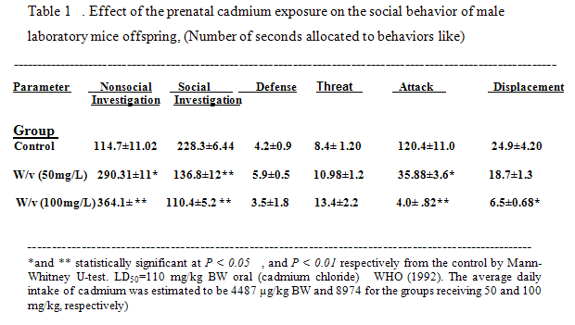

- WHO (1992) and Agency for Toxic Substances and Disease Registry (1999)

Acetylcholinestrase and Butyrylcholinesterase
Activities of AchE and BchE (Acetylcholinestrase and Butyrylcholinesterase) showed a concentration-dependent decrease in all the tissues studied (Tables 3.).
Excessive intake of Cd from CdCl₂ in drinking water significantly reduces AchE and BchE activity in the brain tissues. This decrease could be due to loss of neuron cell bodies in the brain, loss of synaptic structures, or inhibition of enzyme activity. These effects could be corroborated with cognitive dysfunctions observed in experimental animals.
MDA
Significant decrease in free radical scavenging enzymes and a concomitant increase in lipid peroxidation (MDA) in brain tissues studied suggests an increase in oxidative stress after excessive Cd intake. Such increase in free radicals in neuronal cell bodies could be correlated with loss of neurons in brain and synaptic structures in neuromuscular junctions.
The impairments due to the neurotoxic effect of Cd in brain of mice treated with high dose (100 mg /L) were indicated by histopathological investigation. The impairments included congestion of blood vessels, necrosis of neurons (Fig.A), neuronphagia (Fig.B) and focal gliosis (Fig.C) as well as haemorrhage in Virchow space. Moreover, in hippocampus the pyramidal cells appeared atrophied and necrosed (Fig. D).

Ascorbic acid
A parallel increase in ascorbic acid content (Table 3.), an important antioxidant in brain after Cd intake, is difficult to explain. An increase in ascorbic acid content suggests its role in amelioration of stress.

Concentrations of cadmium in the brain tissues
The concentrations of cadmium in the brain tissues after 52 days of treatment were 10 µg/g and 65 µg/g of (50mg/L) and (100mg/L) (w/v) respectively, in their drinking water (< 0.05 vs. control). While, the mean concentration of Cd in the brain tissues of control group was 2 µg/g.

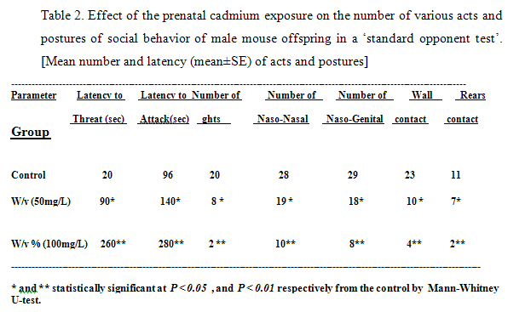

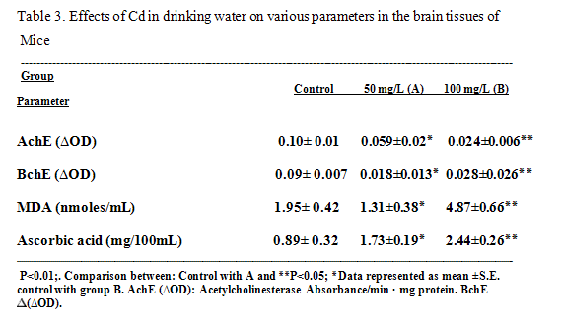

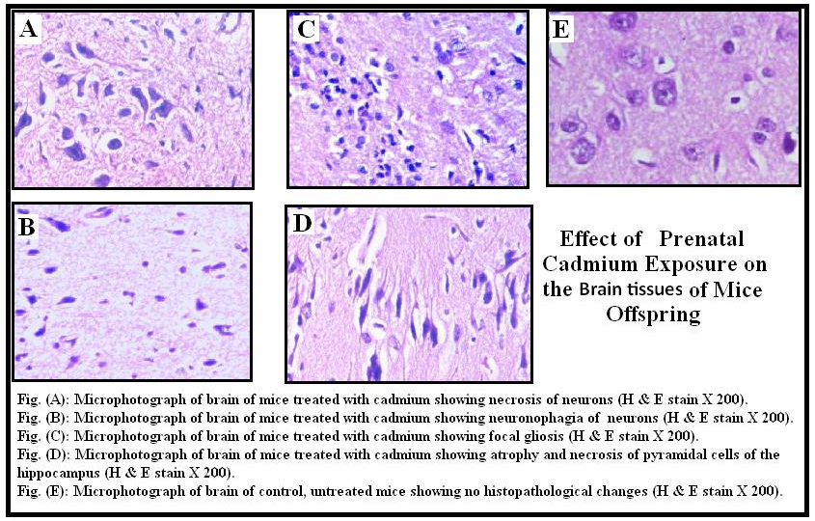

Fig. (A): Microphotograph of brain of mice treated with cadmium showing necrosis of neurons (H & E stain X 200).
Fig. (B): Microphotograph of brain of mice treated with cadmium showing neuronophagia of pyknotic neurons (H & E stain X 200).
Fig. (C): Microphotograph of brain of mice treated with cadmium showing focal gliosis (H & E stain X 200).
Fig. (D): Microphotograph of brain of mice treated with cadmium showing atrophy and necrosis of pyramidal cells of the hippocampus (H & E stain X 200).
Fig. (E): Microphotograph of brain of control, untreated mice showing no histopathological changes (H & E stain X 200

4. Discussion:
The present results clearly suggest that after the weaning period, various behavioural indices in young male offspring were affected in the “Standard Opponent” test. Thus, these results clearly emphasize that pre and postnatal cadmium exposure is extremely dangerous. A strong correlation exists between maternal and umbilical cord blood cadmium levels indicating prenatal transfer of cadmium from mother to developing fetus in utero [19]. Cadmium can enter into the brain parenchyma and neurons during the critical point of development [20] causing neurological alterations [21, 22]. [23] described the toxic result of cadmium exposure in the form of morphological development, sensory motor reflexes, biochemical and behavioral outcomes in rodents. It is now well documented that significant quantities of compounds that are given to mothers during late pregnancies and during postnatal period, may be transmitted to the offspring in utero and /or via mother’s milk during lactation [24-28,19]. It is known that a major portion of brain cells (70%) of the closely related rats are formed after birth [29]. Furthermore, it has been established that the hippocampus in the brain may be most vulnerable to the neurotoxicity of neurotoxic materials in the very rapid growth period. The hippocampus and the cerebral cortex are the key structures of memory formation [30-33], because the hippocampus is especially indispensable in the integration of spatial information.
There were significant differences in hippocampus and the Opponent” test, in mice which received high dose of Cd (100 mg / L) and untreated group (control). The Opponent” test has been associated with hippocampal activity and cholinergic activity neurotransmission (learning ability and motor activities) Many investigators have reported that hippocampus is one of the most vulnerable regions in the AD brain [34] and hippocampal lesions in general produce changes in rat's activity levels [35] and impairment in spatial memory [36]. So, we could be stated that, hippocambus is the main target of CNS due to Cd exposure. The impairments due to the neurotoxic effect of Cd in brain of mice treated with high dose (100 mg /L) were indicated by histopathological investigation (Fig. A-E) showed congestion of blood vessels, necrosis of neurons), neuronphagia, focal gliosis as well as the pyramidal cells appeared atrophied and necrosed especially in hippocampus (Fig.D).
Histological changes were observed in rat organs exposed to 8 mixtures of metals [37]. Cadmium causes hemorrhages in the autonomic ganglia with cell necroses and damage to nerve cells and nerve fibers. [4] observed changes of drinking behavior in rats exposed to acute Cd intoxication. There were significant decreases (P< 0.05) in the activity of acetylcholinestrase. (AchE) enzyme in the brain of Cd administered groups (Table 3). [6] observed enzymatic changes in rats exposed to lead intoxication.
Acetylcholinestrase (AchE) is an enzyme that responsible for hydrolyzing and so deactivating acetylcholine in the body. It is a good indicator of sublethal toxicity by heavy metals [38]. Brain contains 2 forms of AchE, membrane bound forms constitute 90% of the enzyme and soluble form represents the rest 10% [39, 40]. Level of the soluble form considered a simple and sufficient indicator of relative change of AchE in the brain [41, 42] which measures the turnover of Ach activity [43]. Alterations in this enzyme level are indicative to impairment of cholinergic function [44]. Our results revealed significant inhibitory effect on AchE activity in brain tissue of mice offspring which is in accordance with previous investigations of [45- 47] in rats.
Cadmium inhibits release of acetylcholine, probably by interfering with calcium metabolism [37]. Cadmium can enter into the brain parenchyma and neurons [20] causing neurological alterations in human [21] and animal models [22].
This study suggested that, exposure to cadmium present in the environment and especially in the food chain may reach the brain of the fetus or the newborn during critical periods of brain development and could be produced cumulative developmental abnormalities in the brain prenatally, which is expressed in the young adult male offspring in disturbed form of long lasting social behavioral outcomes and learning ability. It seems that the impairments of behaviors in relation to learning and memory are due to the disturbance of the hippocampal circuit and its vast connections through cortical and subcortical pathway.
Acknowledgements
This research was sponsored by Department of Animal Hygiene and Environmental Pollution (Faculty of Veterinary Medicine, Cairo University). We thank Dr. Mervat M.Kamel (Prof.of Animal Behavior Faculty of Veterinary Medicine, Cairo University) for technique assistance.

Corresponding author
Hussein A. Kaoud
Department of Veterinary Hygiene and Environmental Pollution, Faculty of Veterinary Medicine, Cairo University, Egypt
*ka-oud@link.net

5. References:
[1] Piedrafita B, Monfort P, Cauli O, Llansola M, Rodrigo R, Montoliu C, El Mlili N, Felipo V Mechanisms of developmental neurotoxicity: Molecular and behavioral correlates. Abstracts / Toxicology Letters 2006; 164S, S1–S324.
[2] Newsome W H , Davies D ,Doucet J PCB and organochlorine pesticides in Canadian human milk. Chemosphere 1995; 30, 2143- 2153.
[3] Jones M M ,Cherian C Cadmium, a unique metal. Toxicology J; 1990: 62,1.
[4] De Castro E , E Silva, H Ferreira, M Cunha, C Bulcao, C Sarmento,et al.,. Effect of central acute administration of cadmium on drinking behavior. Pharmacol. Biochem. Behav 1996; 53, 687–693.
[5] Desi I, Nagymajtenyi L, Schuiz H Behavioural and neurotoxicological changes caused by cadmium treatment of rats during development. J. Appi Toxicol 1998; 18 (1), 63-70.
[6] Antonio M T, Leret M L Study of the neurochemical alterations produced in discrete brain areas by perinatal low-level lead exposure. Life sciences. 2000; 67(6):635-42.
[7] Herak-Kramberger C M ,Sabolic I The integrity of renal cortical brush-border and basolateral membrane vesicles is damaged in vitro by nephrotoxic heavy metals. Toxicology 2001; 156, 139–147.
[8] M T, Laura Corredor L , Leret M L Study of the activity of several brain enzymes like markers of the neurotoxicity induced by perinatal exposure to lead and/or cadmium. Toxicology Letters 2003; 143, (3), 331-340.
[9] Morgan M A, Pfaff D W Effects of Estrogen on Activity and Fear-Related Behaviors in Mice. Hormones and Behavior 2001; (40), 4, 472-482.
[10] Brain P F, McAllister K H, Walmsley S V Drug effects on social behaviour: methods in ethopharmacology. In: Boulton, A.A., Baker, G.B. &Greenshaw, A.J. (Eds.) Neuromethods 1989; Vol. 13 (pp. 687-739). Humana press, Clifton NJ.
[11] Brain P F, Benton D, Childs G, Parmigiani S The effect of the type of opponent in tests of murine aggression. Behav Proc 1981; 6,319 -328.
[12] Brain P F , Ajarem J S ,Petkov V V The utility of ethological assessments of murine agonistic interactions in behavioural teratology: the foetal alcohol syndrome 1987. In: Oliver, B., Mos, J. &Brain, P.F. (Eds.) Ethopharmacology of agonistic behaviour in animals and humans (pp. 110 -121). Martinus Nijhoff Publishers, Dordrecht.
[13] Ellman G L , Courney U D , Andres Junior V , Featherstone R M A new and rapid colorimetric determination of AchE activity. Biochem Pharmacol 1961; 7, 88-95.
[14] Netelson, S., 1971. Techniques of clinical chemistry, (3rd ed). Springfield, IL: Charles C Thomas.
[15] Buege J A , Aust S D The thiobarbituric acid assay. Methods of enzymol 1978; 52,306-7.
[16] Finerty M W, Madden J D,Feagly S E , Grodner R M Effect of environs and seasonality on metal residues in tissues of wild and pond raised Cray fish in Southern Louisiana. Arch Environ. Contam Toxicol 1990; 19:49.
[17] Bancroft J D,Stevens A ,Turner D R Theory and Practice of Histological Techniques 1996; (4th ed). New York, Churchill, Livingstone.
[18] Sokal R R ,Rohlfe F J Biometry: The principles and practice of statistics in biological research 1981; W.H. Freeman, San Francisco.
[19] Ajarem J S, Qasim M A, Ahmad M Effect of postnatal lead exposure on the development and behaviour of mice offspring. Saudi J Biol Sci 2003; 10, 1-14.
[20] Nishimura Y,Yamaguchi J. Y ,Kanada A,Horimoto K ,Kanemaru K,Satoh M Increase in intracellular Cd(2+) concentration of rat cerebellar granule neurons incubated with cadmium chloride,cadmium cytotoxicity under external Ca (2+) – free condition.Toxicol In Vitro 2006; 20 (2) : 211- 6.

[21] Rose C S , Heywood P G ,Costanzo R M Olfactory impairment after chronic occupational cadmium exposure J Occup Med 1992; 34 (6), 600 -5.
[22] Lukawski K, Nieradko B, Sieklucka- Dziuba M Effects of cadmium on memory processes in mice exposed to transient cerebral oligemia. Neurotoxicol Teratol 2005; 27 (4), 575-84.
[23] Barannski B Effect of exposure of pregnant rats to cadmium on prenatal and postnatal development of the young.Neurosci.Res 2007; 58 (2) 149 – 55.
[24] Draski L J , Burright R G ,Donovick P J The influence of prenatal and/or postnatal exposure to lead on behavior of preweanling mice. Physiol Behav 1989; 45, 711-715.
[25] Ajarem J S , Ahmad M Behavioral and biochemical consequences of perinatal exposure of mice to instant coffee: a correlative evaluation. Pharmacol. Biochem Behav 1991; 40, 847-852.
[26] Ajarem, J S, Ahmad, M Prenatal nicotine exposure modifies behaviour of mice through early development. Pharmacol. Biochem. Behav. 1998 a; 59,313-318.
[27] Ajarem, J S, Ahmad, M Effects of prenatal exposure of mice to non-alcoholic malt beverage “beer” on the offspring. Saudi J Bio Sci 1998 b; 5, 78-92 .
[28] Ajarem, J S , Brain, P F , Prenatal caffeine exposure modifies behavioral responses in mice. Behav Pharmacol 1993; 4,541-544.
[29] Patel, A J Under nutrition and brain development Trends Nat Sci 1983; 6, 151-154.
[30] Izquierdo, I , da Cunha, C , Rosat, R , Ferreira, M B C , Jerusalinsky, D ,Medina, J H Neurotransmitter receptors involved in memory processing by amygdola, medial septum and hippocampus of rats.Behvioral and Neurobiology 1992; 58,16-25.
[31] Thiel, W in: "Computational Thermochemistry" (Eds. K K Irikura and D J Frurip), ACS Symposium Series 677, American Chemical Society, Washington, DC, 1998; pp. 142-161.
[32] Shirai, N , Suzuki, H Effect of dietary docasahexaenoic acid and catechins on maze behavior in mice. Ann Nutr Metab 2004; 48, 51-8
[33] Leussis, M P , Bolivar, V J Habituation in rodents: a review of behaviour, neurobiology and genetics Neurosci Biobeh Rev 2006;30, 1045 – 1064.
[34] Liu, R, Liu, I Y , Bi, X , Thompson, R F , Doctrow, S R , Malfroy, B , Baudry, M Reversal of age-related learning deficits and brain oxidative stress in mice with superoxide dismutase/catalase mimetics. Proc Nati.Acad Sci USA 2003 ; l00, 8526-8531.
[35] Holland, P C , Lamouneux, J A , Han, J S ,Gallagher, M Hippocampal lesions Interfere with Pavlovian negative occasion setting. Hippocampus 1999 ;9,143 – 157.
[36] Deacan, R M J , Craucher, A ,Rawlins, JNP Hippocampal cytotoxic lesions effects on species –typical behaviours in mice.Beh.Brain Res 2002; 32, 203-213.
[37] Jadhav, SH, Sarkar, SN, Patil, RD ,Tripathi, HC Effect of subchronic exposure via drinking water to a mixture of eight water – contaminating Metals: A Biochemical and histopathological study in male rats. Arch Environ. Contam Toxicol 2007; 53, 667-677.
[38] Forget, J, Pavillon, JF, Beliaeff, B, Bocquene, G Joint action of pollutant combinations (Pesticides and metals) on survival (LC₅₀ values) and acetyl- cholinesterase activity of Trigriopus Brevicornis (Copepoda Harpacticoida). Environ Toxicol Chem 1999; 18,912-918.
[39] Atack, JR, Perry, EK, Bonham, JR, Candy, JM, et al. Molecular forms of acetylcholinestrase and butyrylcholinesterase in the aged human central nervous system, Journal of Neurochemistry 1986; 47,263-277.
[40] Mortensen, S R, Brimijoin, S, Hooper, M J, Padilla, S Comparison of the in vitro sensitivity of rat acetylcholinesterase to chlorpyrifosoxon: What do tissue LC50 values represent? Toxicol Appl Pharmacol 1998; 148, 46–49.
[41] Muller, F, Dumez, Y ,Massoulie, J Molecular forms and solubility of acetylcholinesterase during the embryonic development of rat and human brain Brain Res 1985 ; 331, 295-302.
[42] Zakut, H, Matzkel, A, Schejter, E, Avni, A ,Soreq, H Polymorphism of acetylcholinesterase in discrete regions of the developing human fetal brain. Journal of Neurochemistry 1985; 45,382-389.
[43] Sastry, BVR, Janson, VE, Jaiswal, N ,Tayeb, OS Changes in enzymes of cholinergic system and acetylcholine release in the cerebra of aging male Fischer rats. Pharmacology 1983;26,61-72.
[44] Slechta, DA, Pokora, MJ Lead induced changes in muscarinic cholinergic sensitivity, Neurotoxicology 1995; 16, 337-348.
[45] Eck, PC, Wilson, B Cadmium toxicity. Copyright © 1989 - The Eck Institute of Applied Nutrition and Bioenergetics, Ltd.
[46] Gupta, A, Gupta A, Murthy, RC, Chandra, SV Neurochemical changes in developing rat brain after pre-and postnatal cadmium exposure. Bull. Environ Contam Toxicol 1993; 51, 12-17.
[47] Antonio, MT, Corredor, L, Leret, ML Study of the activity of several brain enzymes like markers of the neurotoxicity induced by perinatal exposure to lead and/or cadmium Toxicol Lett 2003; 143,331-340.

2/1/2011

