The Petrography and Major Element Geochemistry of the Granite Gneiss of Arigidi area, S/W, Nigeria.

Ademeso Odunyemi ^{1*}, Adeyeye Olufemi ^{1,}

- Department of Geology, Adekunle Ajasin University, Akungba-Akoko, Nigeria
tonyademeso@gmail.com

Abstract: The granite gneiss of Arigidi area, falls within the migmatite-gneiss-quartzite complex of the Nigerian basement and occurs in association with grey gneiss, granite, charnockitic rocks and pelitic gneiss lithologies. The outcrops of the rock were studied in the field, eight samples were analysed for petrographic and geochemical characteristics. In thin section, quartz, plagioclase, biotite and opaque minerals which are ubiquitous ranged from 16.3-42.2, 18.4-42.4, 11.3-28.6 and 6-10.7vol%, respectively while orthoclase, microcline, pyroxene and hornblende ranged from 0-11.1, 0-19.3, 0-12.4 and 0-16.3vol%, respectively showing that most of the samples are tonalitic in composition. Geochemically, the SiO₂ content of the granite gneiss ranged from 63.42-74.30, Al₂O₃ ranged from 11.83-15.46 while Fe₂O₃ ranged from 1.33-3.22wt%. FeO ranged from 2.13-5.83, Na₂O from 0.40-3.91, K₂O from 0.05-3.42, CaO from 0.82-5.78 and MgO from 0.42-5.47wt%. MnO ranged from 0.03-2.11 while TiO₂ ranged from 0.01-1.46wt%. Discrimination diagrams revealed a preference for igneous fields by the granite gneiss. It is therefore deduced that this tonalitic granite gneiss has an igneous origin.
[Ademeso Odunyemi, Adeyeye Olufemi. The Petrography and Major Element Geochemistry of the Granite Gneiss of Arigidi area, S/W, Nigeria. Nature and Science 2011;9(5):7-12]. (ISSN: 1545-0740). http://www.sciencepub.net.

Key words: Arigidi, granite gneiss, discrimination, tonalite, igneous origin

1. Introduction
Arigidi area, falls within the migmatite-gneiss-quartzite complex of the Precambrian Basement complex of Nigeria as classified by Adekoya et al. (2003) and used severally (Rahaman, 2006; Dada 2006). It lies between 5º45’E to 5º49’E and 7º33’N to 7º37’N of Ikole NE sheet. Major lithologies in the area include granite gneiss, grey gneiss, biotite granite, charnockitic rocks and pelitic gneiss (Fig. 1). Metamorphism in the area is believed to have attained granulite facies grade (Rahaman and Ocan, 1988). Structurally, the occurrence of sigmoidal strike-slip shear zones (Fig 2) and centimetric strike-slip faults make the occurrence of at least three phases of deformation (D3) probable in the area (Ferre et al., 1996). Ejimofor et al., (1996) worked on the petrography and major element geochemistry of the basement rocks of northern Obudu area, eastern Nigeria. It was shown mineralogically that, the preference of igneous fields by the granite gneisses suggest their affinity for igneous progenitors. Elueze et al., (2004) determined the petrochemistry and petrogenesis of granite gneiss from Abeokuta area, southwestern Nigeria and concluded that the abundance and variation of major and minor trace elements suggest that the protoliths of the gneisses are mainly of igneous affinity, though with probable crustal contamination.

2. Materials and methods
The area was mapped on a scale of 1:30,000. The nature of outcrop, geographical location, colour, texture, mineralogy and structures were noted on the field. Fresh samples were collected and subjected to petrographical studies using petrological microscope. Photomicrographs were captured with digital camera. AAS was used to determine Si, Al, Fe, Ca, Mg, Mn and Ti while AES was used to determine Na and K. The content of minerals was plotted on the QAP diagram for the purpose of classification while the geochemical results were plotted on the discriminatory diagrams of Middleton (1960) and Tarney (1977) to infer the petrogenesis.

3. Results
3.1 Field description
The rock occurs as low-lying outcrops, small hills and inselbergs. It is associated with augen gneiss, quartzo-feldsparthic gneiss and granite. It is fine to medium grained, weakly to strongly foliated rock and strikes predominantly in a NNW-SSE direction with a steep dip (averagely 58º) in both directions. The foliation is defined by biotite streaks which have narrow thicknesses that range between 1 and 2mm. The leucocratic quartz and K-feldspar – rich streaks have a wider thickness that range between 0.2 and 2.5cm.

7º37’N
7º33’
5º45’E
5º49’E
Figure 1. The Geological Map of Arigidi Area (Modified after Arigidi Independent Mapping Group, 2009)

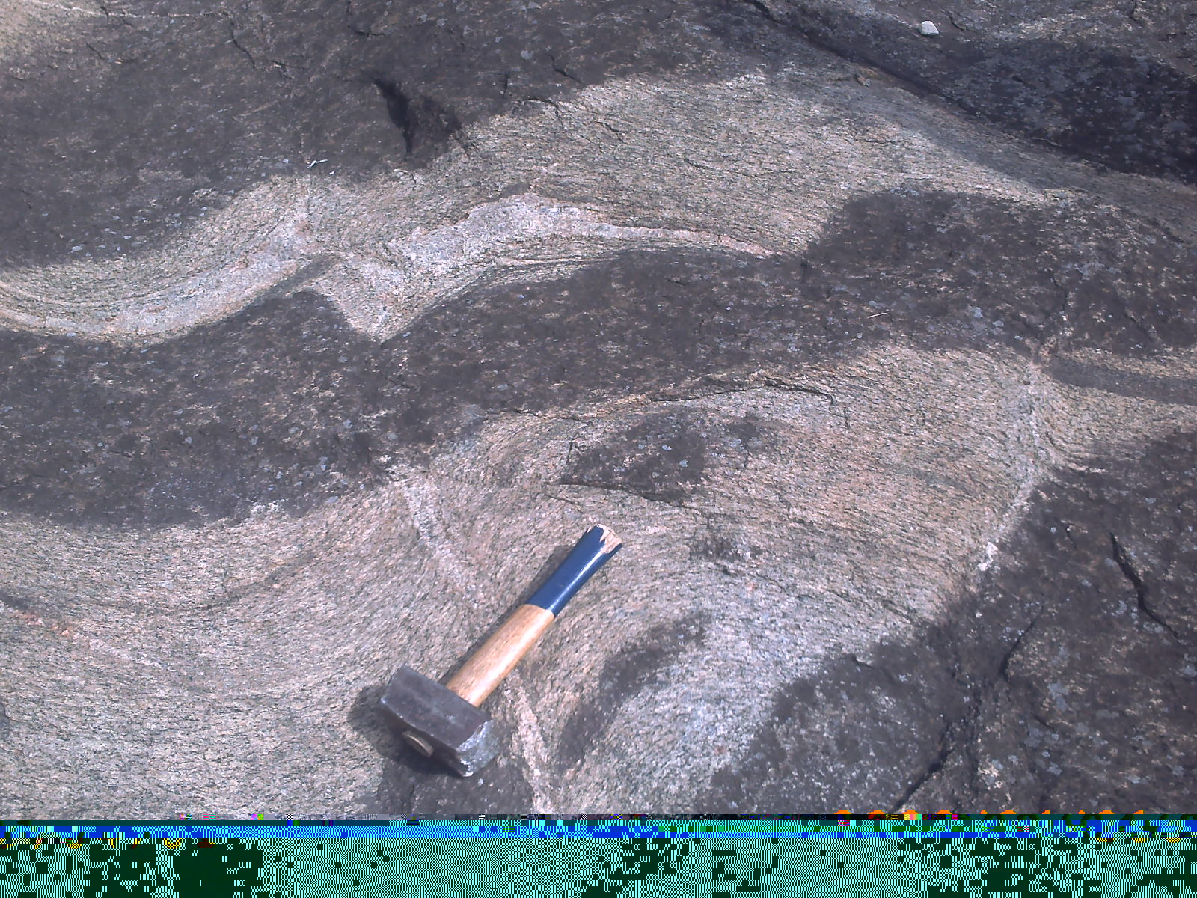
Figure 2. Strike-Slip Sigmoidal Fault

3.2 Petrography
In thin section, the rock contains quartz which is colourless under plane polarized light and occurs as euhedral prisimatic crystals, and plagioclase with its distinguishing polysynthethic twinning according to albite law. Others minerals in the thin section are microcline typified by cross-hatched twinnings; biotite which is brownish in thin section, exhibits pleochroism and occurs as plates and laths which show preferential allignment with the foliation plane; orthoclase is colourless though it may be cloudy in contrast to quartz with twinning according to Carlsbad law as its distinguishing characteristic; pyroxene; and hornblende (Fig. 3) (Table 1). On the QAP diagram, five of the eight samples analyzed plotted as tonalites representing over 60% of the granite gneiss of Arigidi while the remaining plotted as granodiorite and granite (Fig. 4).

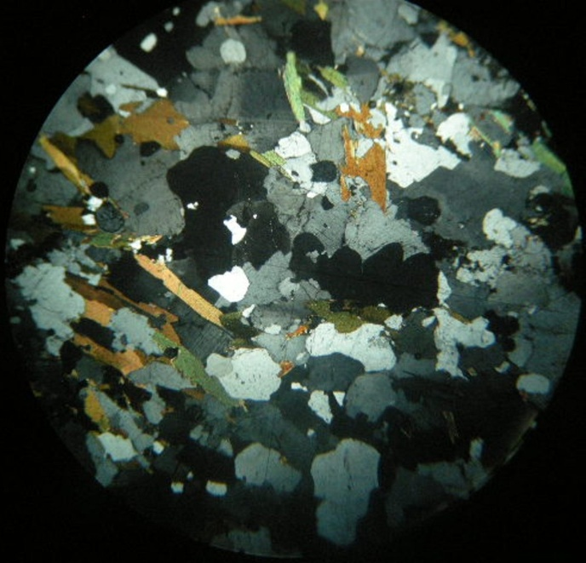
2ummm
B

B

Qz

Qz

P

P

Figure 3. Photomocrograph of granite gneiss under cross nicols showing guartz (Qz), plagioclase (P), and biotite (B).

Figure 4. QAP Diagram for Arigidi Granite Gneiss (after Streckeisen, 1976).
1=Not Igneous; 2=Alkali Granite; 3=Granite; 4=Granodiorite; 5=Tonalite; 6=Alkali Quartz Syenite; 7=Quartz Syenite; 8=Quartz Monzonite; 9=Quartz Monzodiorite; 10=Quartz diorite; 11=Alkali Syenite; 12=Syenite; 13=Monzonite; 14=Monzodiorite; 15=Diorite.

3.3 Geochemistry
3.3.1 Major element data
The SiO₂ content of the granite gneiss ranges from 63.42-74.30% which corresponds to an intermediate to acid composition. Al₂O₃ ranges from 11.83-15.46% while Fe₂O₃ ranges from 1.33-3.22% and FeO varies from 2.13-5.83%. The Na₂O content ranges from 0.40-3.91%, K₂O from 0.05-3.42%, CaO from 0.82-5.78% and MgO from 0.42-5.47%. MnO ranges from 0.03-2.11% while TiO₂ ranges from 0.01-1.46% (Table 2). Geochemically, the Arigidi granite gneiss is similar to that of Southern India except for its higher FeO, Na₂O and K₂O contents and lower MnO and TiO₂ (Table 3). All other species are about the same.

4. Discussion
4.1 Petrogenesis
The geochemical data are plotted on discriminatory diagrams to establish the geochemical evolution of the rock. On the plot of K₂O versus Na₂O (after Middleton, 1960), six of the eight samples plotted outside the field of eugeosynclinal sandstones (Fig. 5) while on the TiO₂ versus SiO₂ discrimination diagram (Tarney, 1977), two of the eight samples plotted outside, one on the boundary line and the remaining five plotted in the igneous field (Fig. 6). A consensus is yet to be reached on the evolution of the Nigerian granite gneisses. Grant (1970), used ⁸⁷Sr/⁸⁶Sr studies to arrive at an igneous origin for the Ibadan granite gneiss. Burke et al. (1972), on the other hand, argued that the parent banded gneiss from which the granite gneiss was derived could have evolved by isochemical metamorphism of a shale-greywacke sequence. Rahaman and Ocan (1978), believed that the most of the granite gneisses in the Nigerian basement complex are intrusive. In the case of Onyeogocha (1984), partial melting of crustal rocks was used to explain the granite gneisses of north-central Nigeria. Rahaman (1988) stated that geochemical data available were insufficient to unequivocally distinguish between sedimentary and igneous origin for the granite gneisses.
In the face of the various schools of thought outlined above, the granite gneiss of Arigidi shows a preference for an igneous protolith as shown by the discrimination diagrams. This is further reinforced by the petrographic studies of the samples of the granite gneiss which revealed the absence of minerals, which are typical of paragneisses, like sillamanite, kyanite, staurolite or cordierite. The indication of this is that the rock is not likely to be of sedimentary origin.
In addition, Rahaman and Ocan (1988), also proposed an igneous origin for the gneisses that are associated with the pellitic gneisses of Ikare area, southwestern Nigeria of which the Arigidi granite gneiss is a part.
Finally, the tonalitic composition of the granite gneiss of Arigidi buttresses the Tonalite-Trondhjemite-Granodiorite (TTG) composition reported for the gneisses of western Nigeria (Pidgeon et al. 1976; Bruguier et al. 1994).

TABLE 1: MODAL COMPOSITION OF GRANITE GNEISSES (Vol %)
 | AL1 | AL2 | AL3 | AL4 | AL5 | AL6 | AL7 | AL8 | Range
Quartz | 33.2 | 42.2 | 16.3 | 18.2 | 25.2 | 38.1 | 37.3 | 27.2 | 16.3-42.2
Orthoclase | - | - | 11.1 | - | - | - | - | - | 0-11.1
Microcline | 19.3 | - | - | 8.3 | - | - | - | - | 0-19.3
Plagioclase | 28.2 | 34.2 | 18.4 | 32.3 | 42.4 | 32.6 | 30.4 | 40.2 | 18.4-42.4
Biotite | 13.2 | 14.3 | 28.6 | 18.4 | 22.6 | 21.5 | 23.3 | 11.3 | 11.3-28.6
Opaque Minerals | 6.0 | 9.2 | 9.3 | 10.7 | 9.3 | 8.2 | 8.5 | 6.3 | 6.0-10.7
Pyroxene | - | - | - | 12.4 | - | - | - | 14.4 | 0-12.4
Hornblende | - | - | - | 16.2 | - | - | - | - | 0-16.3
Total | 99.9 | 99.9 | 100.0 | 100.3 | 99.5 | 100.4 | 99.5 | 99.4 | 99.4-100.4

TABLE 2: MAIN ELEMENT GEOCHEMISTRY OF GRANITE GNEISSES (Wt %)
 | AL1 | AL2 | AL3 | AL4 | AL5 | AL6 | AL7 | AL8 | Range |  |  | Mean
SiO₂ | 74.30 | 70.94 | 73.22 | 63.42 | 70.36 | 73.45 | 73.26 | 68.37 | 63.42-74.30 |  |  | 70.92
Al₂O₃ | 13.03 | 11.83 | 12.62 | 13.35 | 15.46 | 12.37 | 12.70 | 13.32 | 11.83-15.46 |  |  | 13.09
Fe₂O₃ | 1.33 | 1.42 | 2.11 | 2.72 | 2.29 | 2.52 | 3.22 | 2.74 | 1.33-3.22 |  | 2.32
FeO | 2.42 | 4.14 | 3.22 | 4.10 | 3.20 | 3.84 | 3.36 | 5.83 | 2.13-5.83 |  | 3.76
Na₂O | 2.98 | 3.91 | 3.43 | 0.10 | 1.00 | 0.84 | 0.40 | 0.80 | 0.40-3.91 |  | 1.81
K₂O | 2.32 | 3.42 | 3.22 | 1.02 | 0.05 | 0.60 | 0.51 | 0.42 | 0.05-3.42 |  | 1.45
CaO | 1.20 | 1.42 | 0.82 | 4.60 | 5.82 | 3.06 | 2.88 | 5.78 | 0.82-5.78 |  | 3.20
MgO | 0.42 | 1.21 | 0.80 | 5.47 | 1.40 | 2.11 | 1.58 | 2.21 | 0.42-5.47 |  | 1.11
MnO | 0.10 | 0.04 | 0.04 | 2.11 | 0.04 | 0.03 | 0.11 | 0.08 | 0.03-2.11 |  | 0.32
TiO₂ | 0.50 | 0.30 | 0.40 | 1.46 | 0.20 | 0.40 | 0.01 | 0.32 | 0.01-1.46 |  | 0.45
Total | 98.62 | 98.6 | 99.88 | 99.26 | 99.82 | 99.42 | 98.03 | 99.87

TABLE 3: COMPARISON OF ELEMENT OF GRANITE GNEISSES (Wt %)
 | 1(8) | 2(3) | 3(4) | 4 | 5
SiO₂ | 70.92 | 65.48 | 63.46 | 70.36 | 64.60
Al₂O₃ | 13.09 | 17.94 | 19.87 | 14.42 | 17.00
Fe₂O₃ | 6.08 | 1.97 | 1.50 | 0.66 | 3.60
FeO | 6.08 | 2.93 | 1.44 | 1.95 | -
Na₂O | 1.81 | 4.07 | 3.48 | 3.35 | 4.17
K₂O | 1.45 | 1.07 | 5.37 | 5.38 | 3.48
CaO | 3.20 | 3.01 | 5.05 | 2.03 | 3.43
MgO | 1.11 | - | - | 0.90 | 1.58
MnO | 0.32 | 0.03 | 0.03 | - | -
TiO₂ | 0.45 | 1.75 | 0.64 | 0.32 | 0.54
NOTE: (n) Refers to average number of samples

- Arigidi granite gneiss
- Orthogneiss Vandeikya (Ejimofor et al., 1996)
- Orthogneiss Ushongo (Ejimofor et al., 1996)
- Granite gneiss, Jos Plateau, Nigeria (Wright, 1971)
- Granite gneiss, S. India (Condie et al., 1982)

K₂O (wt %)
Na₂O (wt %)
Fig. 5: K₂O versus Na₂O Discrimination Diagram (after Middleton, 1960)

TiO₂ (wt %)
SiO₂ (wt %)
Fig. 6: TiO₂ versus SiO₂ Discrimination Diagram (after Tarney, 1977)

5. Conclusions
From the forgoing, it is therefore thought that the granite gneiss of Arigidi is an orthogneiss of tonalite composition.

6. Recommendations/Suggestion
However, it is candidly recommended that Isotope and rare earth element (REE) studies be carried out on the study area to conclusively determine the petrogenesis of the granite gneiss seeing that major element geochemistry alone cannot be used to decipher conclusively, the petrogenesis of a metamorphosed rock.

Correspondence to:
Ademeso, O. A.
Department of Geology,
Adekunle Ajasin University
Akungba-Akoko
Ondo State. Nigeria.
Telephone: +2348034738470
+2348125226711
Emails: tonyademeso@gmail.com

References
[1] Adekoya, J.A, Kehinde-Phillips, O.O. and Odukoya, A.M. (2003): Geological Distribution of Mineral Resources in Southwest Nigeria. In: Prospects for Investment in Mineral Resources of Southwestern Nigeria, Elueze, A. A. (Ed), Elsevier, USA., ISBN: 978-36831-0-1. pp 1-13.
[2] Adeyeri, O., Adeyeye, O.A., Adu, R., Aduloju, O., Ajiborode, T.L., Akinboro, A., Akinlofa, O. (2009): Geology of Arigidi. An Unpubl Independent Mapping Report by Arigidi Group (2008/2009 session), Dept. of Geol., Adekunle Ajasin Univ., Akungba, Nigeria.
[3] Bruguier, O, Dada, S.S. and Lancelot, J.R. (1994): Early Archaean Component
( > 3.5 Ga) within a 3.05 Ga Orthogneiss from Northern Nigeria: U-Pb Zircon Evidence. In: Earth Planetary Science Letters, 125. pp89-103.
[4] Burke, K.C., Freeth, S.J. and Grant, N.K. (1970): Granite Gneisses in the Ibadan Area, Nigeria. In: T. F. J. Dessauvagie and A. J. Whiteman (Eds). African Geology. Geology Dept. Univ. Ibadan, Nigeria.
[5] Dada, S.S. (2006): Proterozoic Evolution of Nigeria. In: The Basement Complex of Nigeria and its Mineral Resource (Oshin ,O. Ed.). Akin Jinad and Co. Ibadan, Nigeria, pp24 – 44.
[6] Ejimofor, O.C., Umeji, A.C. and Turaki, U.M. (1996): Petrography and Major Element Geochemistry of the Basement Rocks of Northern Obudu Area, Eastern Nigeria. In: Jour. Of Min. and Geol. Vol 32. Nig. Min. and Geos. Soc. Publ. pp1 – 8.
[7] Elueze, A. A., Bolarinwa, A.T. (2004): Petrochemistry and Petrogenesis of Granite Gneisses in Abeokuta Area, Southwestern Nigeria. In: Jour. of Mining and Geo. Vol 40(1). Nig. Min. and Geos. Soc Publ. pp –8.
[8] Ferre, E, Deleris, J, Bouchez, J.L, Lar, A.U., and Peucat, J.J (1996): The Pan-African Reactivation of Eburnean and Archaen Provinces in Nigeria: Structural and Isotopic Data. In: Journal of the Geological Society, London, Vol. 153, 1996. pp. 719-728.
[9] Garrels, R.M. and Mackenzie, F.T. (1971): Evolution of Sedimentary Rocks. Publ. by W. W. Norton and Co. Int. New York, p394.
[10] Grant, N.K. (1970): The Geochronology of Precambrian Basement Rocks from Ibadan Southwestern Nigeria. Jour. of Africa Earth Sci, Vol 2 (1), pp41 – 51.
[11] Middleton, E.V. (1960): Chemical Composition of Sandstone. Bull Geol. Soc of America. Vol 71, pp1011 – 1026.
[12] Onyeogocha, A.C. (1984): Petrology and Geologic History of Northwestern Akwanga area in Northern Nigeria. J. Afric. Earth Sci. V. 2(1), pp 41-51.
[13] Pidgeon, R.T, Van Breemen, O and Oyawoye, M.O. (1976): Pan-African and Earlier Events in the Basement Complex of Nigeria. 25th International
Geological Congress. Sydney. Australia. 3. 667.
[14] Rahaman, M.A. (1988): Recent Advances in the Study of the Basement Complex of Nigeria. In: Precambrain Geol. Of Nigeria (ed. By Nigeria, Geol. Survey). Pp11 – 43.
[15Rahaman, M.A. (2006): Nigeria’s Solid Mineral Endowment and Sustainable Development. In: The Basement Complex of Nigeria and its Mineral Resource (Oshin,O. Ed.). Akin Jinad and Co. Ibadan, Nigeria. Pp139 – 168.
[16] Rahaman, M.A. and Ocan, O. (1978): On the Relationship in the Precambrian Migmatite Gneiss of Nigeria. Jour of Mining Geo, vol 15 (1), pp 23 – 32.
[17] Rahaman, M.A. and Ocan, O. (1988): The Nature of Granulite Facies Metamorphism in Ikare Area, Southwestern Nigeria. In: Precamb. Geol. of Nigeria. GSN pub, pp 157 – 163.
[18] Streckeisen, A.L. (1976): To each Plutonic Rock its Proper Name. Earth-Science Reviews 12.
[19] Tarney, J. (1977): Petrology, Mineralogy and Geochemistry of the Fallad Plateau basement rocks. Site 330, Deep Sea Drilling Project, Initial Report, 36, pp893 – 921.

3/1/2011

