Pollutant Dynamics And Distribution In Sediments North Of Lagos Lagoon Ecosystem.

Adeleye A. O.¹, R. O. D., Shelle¹, A. E., Akinnigbagbe¹

¹Nigerian Institute for Oceanography and Marine Research [NIOMR]
3, Wilmot Point Road, Victoria Island, P.M.B. 12729, Lagos, Nigeria.
E-mail: adedayoseun@gmail.com; Tel: +234 8030623808

ABSTRACT: Thermal pollution was investigated in the sediment North of Lagos lagoon. The result revealed the heavy metal distribution in sediment to be Fe>>>Zn>Pb>Cu. The concentration level of Cd is generally below <0.002 mg/Kg in all the stations studied. The concentration levels of heavy metal gave evidence of pollution in sediment. The results obtained confirmed that over heated water and effluent discharge was the source of pollution in this part of the lagoon. The distribution of heavy metals in sediment and safety status is discussed.
[Adeleye A. O., R. O. D., Shelle, A. E., Akinnigbagbe. Pollutant Dynamics And Distribution In Sediments North Of Lagos Lagoon Ecosystem. Nature and Science 2011;9(5):13-16]. (ISSN: 1545-0740). http://www.sciencepub.net.

Keywords: Thermal pollution, Heavy metals, sediment, ecosystem, Nigeria.

1. INTRODUCTION
Human activities have always impacted on coastal areas; it is only within the last two centuries that the effects of industrialization, intensive Agriculture, tourism and coastal engineering (dredging) have seriously begin to threaten marine life (Kakulu, S.E. and Osibanjo, O. 1988). Most of these impacts have led to environmental pollution i.e. introduction of substances or energy by man into the environment, which may put living resources and human health at risk. Many substances pollute the marine environment, but non biodegradable compounds (such as Heavy Metals) are the most dangerous due to their inmate ability to constantly remain with the ecosystem.
Heavy metals are referred to as any metallic chemicals elements that has a relatively high density and toxic, highly or poisonous at low concentrations. Heavy metals such as Cu, Zn and Pb are normal constituents of marine and estuarine environments. Additional quantities are introduced from industrial or thermal waste or sewage. They entered the biogeochemical cycle and as a result of being potentially toxic, interfere with the ecology of a particular environment. Heavy metals can be accommodated in three basic reservoirs; water, biota and sediments. Several studies have reported the accumulation of these metals in the tissue of aquatic biota from contaminated areas (Nwani et al 2010, Edem et al 2009 and Unyimadu et al 2008).
The establishment of a thermal plant in Ikorodu North axis of Lagos lagoon has resulted in increase volume of waste generated by industries and other commercial activities in the area. These wastes and effluents generated are directly or indirectly discharged into the lagoon. Toxic pollutants like Cu, Cd, As, and Cl present in heated effluent make water unsuitable for any purpose. The decrease in density, viscosity and solubility of gases increases the settling speed of suspended particles which seriously affect the food supplies of aquatic organism. (Bhatia S. C. 2009). Sediment retains most of the waste and effluent discharge into lagoon. Heavy metals presences in sediments are important indicators of pollution status of an aquatic environment.
Therefore, this study was carried out to assess the distribution of the selected heavy metals in the sediments along Egbin thermal plant situated at Ikorodu Lagos.

2. Materials And Methods
SAMPLING AREA: Lagos is a densely populated metropolitan city in Nigeria with more than 12 million people. The Lagos lagoon is the largest among other lagoon systems of the Gulf of guinea. The lagoon receives a number of important large rivers namely Yewa, Ogun, Oshun and Ona. It empties into the Atlantic Ocean at Lagos harbor. The brackish water lagoon surrounding the Lagos Island generally located between longitude 3⁰ 10’ and 3⁰ 4’ SE and latitude 6⁰ 5’ and 6⁰ 36’ N. The estimated area of the main body of the lagoon is 150.56Km² (Ajao et. al 1996). The area north of the lagoon is not well provided with road network so many communities within; traditionally rely on water as means of transportation.
The lagoon is highly polluted by urban and industrial wastes which posed a threat to the large population depending on it for potable and recreational water, as well as source of cheap and affordable protein. Six sampling stations along North of Lagos lagoon starting from Egbin thermal plant outlet toward the West were chosen for the entire study. The stations were mapped out from the point of heated water effluent from the thermal plant toward the West. The sampling was carried out between February and April 2010.

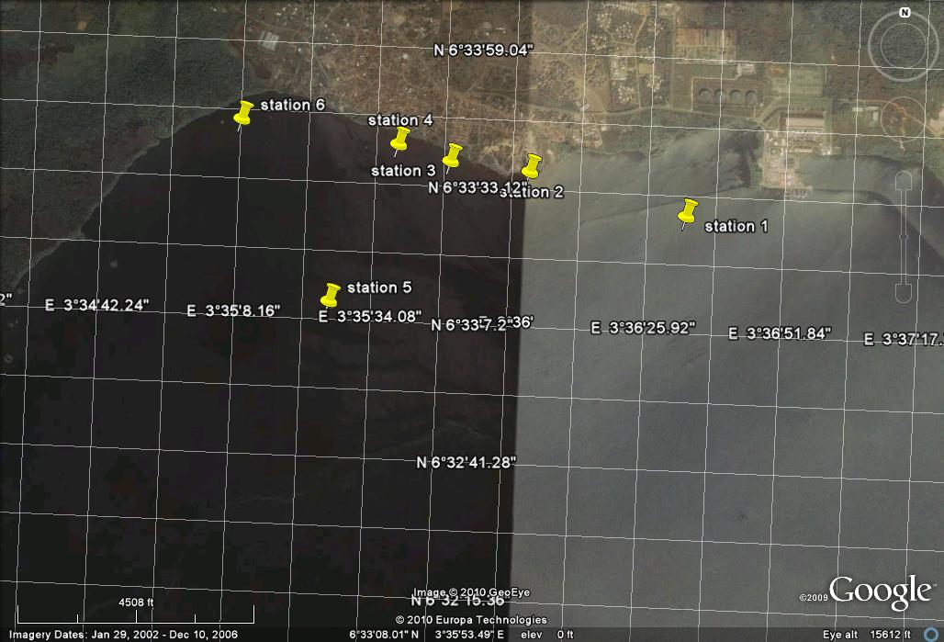
Figure 1: Satellite imagery of the study sites
Source: Google earth imageries

SAMPLE COLLECTION AND ANLYSIS:

Table 1: Positions for stations
Stations | Coordinates
Station 1 | 06º 33’26”.7N,  03º 36’ 32.6” E
Station 2 | 06º 33’33”.9N,  03º 36’ 02.6” E
Station 3 | 06º 33’35”.3N,  03º 35’ 47.5” E
Station 4 | 06º 33’38”.1N,  03º 35’ 37.5” E
Station 5 | 06º 33’38”.0N,  03º 35’ 25.4” E
Station 6 | 06º 33’41”.7N,  03º 35’ 07.6” E

Sediments were collected with the aid of Van Veen grab at each station and stored immediately in polythene bag. Sediments collected were stored at 4º C in an ice-box and transported to the laboratory.
The entire samples were separately air dried in a laboratory. When dried, it was homogenized and sieved to remove big particulates. Homogenated sediment samples were then digested as follows: 5g of the powdered sediment samples were weighed into a 100 ml beaker. 15ml of freshly prepared mixture of HNO₃ / H₂O₂ ratio 1:1 were added to each sample and covered with a wash glass. It was allowed to stand for 30 minutes during which initial reaction subsided. . Digestion was carried out on hot plate whose temperature was allowed to rise gradually until it reached a maximum temperature of 160ºC in a fume cupboard. Heating was continued for about 2 hours, reducing the volume in the beaker to about 2 - 5ml. The beaker and its contents were allowed to cool and the content was transferred with whatman filtration into a 50ml volumetric flask and made up to mark with distilled water (FAO/SIDA, 2003). The digested samples were then analyzed for Pb, Fe, Zn, Cu and Cd using a Flame Atomic Absorption Spectrophotometer model Varian SpectAA 400 plus AAS with aqueous calibration standard prepared from the stock standard solutions of the respective elements.

3. Reagents
All chemicals and reagents used were of analytical grade and of highest purity possible.

Chart 2: Distribution and concentration of Heavy Metals in sediments North of Lagos Lagoon

Chart 3: Distribution and concentration of Iron in sediments North of Lagos Lagoon

4. Result and Discussion
The heavy metal concentration in the sediments along Egbin thermal plant situated at Ikorudu, Lagos Nigeria is presented in chart 2 and 3. The concentration of the heavy metals studied was generally higher than standard set for marine environment except for Cadmium. The concentration of Fe was highest in all the stations investigated ranging from the minimum of 31.672 mg/Kg at station 4 and maximum of 106.972 mg/Kg at station 1. This is expected as previous results have shown that Fe level concentration is higher in Nigeria soil (Aderinola et al 2009). The result showed that Station 1 has the highest concentration of Fe 106.973mg/Kg and Cu 0.260mg/Kg may be as a result of receiving large volume of heated water which increase settling rate of suspended particles. It was revealed that some toxic pollutant likes Cu, Cd, As and Cl are present in heated effluents which makes water unsuitable for use. (Bhatia S. C., 2009). It was discovered that station 4 recorded the lowest concentration of Pb, Fe, Zn, Cu, 0.140 mg/Kg, 31.672 mg/kg, 0.668 mg/kg and 0.140 mg/kg respectively. This may be due to the fact that the station is farther away from the Egbin thermal plant and other industries situated around Ikorudu axis. Cadmium was below the detection limit in any of the stations.
The result revealed the heavy metal distribution in sediment to be Fe>>>Zn>Pb>Cu. This observed trend clearly reveals sediment absorbs and accumulates toxic pollutants waste discharged into it. It has been shown that sediment permit the detection of heavy metals that may be either absent or in low concentration in the water column. The value obtained for Zn, Pb and Cu in this report is in line with the report of Aderionla (2009) who obtained 0.730±0.337 mg/kg, 0.450±0.598 mg/kg and 0.600±0.272 mg/kg respectively from Lagos lagoon Nigeria. This report is in contrary with what Nubi et al (2009) who reported Zn, Pb, Cu concentration of 77.13 mg/Kg, 19.14 mg/Kg, 11.62 mg/Kg at dumping site, Ibadan and also Unyimadu et al (2004) reported Zn, Pb concentration of 50.23±13.93, 78.76±23.23 in sediment from Lagos lagoon, Nigeria which are higher. The result showed that concentration of all the heavy metals studied were highest in station 1, followed by station 3, station 2, station 5, station 6 and station 4.

5. Conclusion
The result of this study reveals the adverse health implication the people in the study area could be exposed to, who are generally depending on this water bodies for recreational purpose, potable water and sources of cheap avoidable protein fish. Periodic monitoring of these metals in both sediment and aquatic organism to ensure safety is advocated.

Acknowledgements:
The researchers are grateful to the Director of Physical/Chemical Oceanography NIOMR Nigeria, Dr. E. A. Ajao for his invaluable contributions and support to carry out this research.

Corresponding Author:
Adeleye, Adedayo Oluwaseun
Physical/Chemical Oceanography Department,
Nigerian institute for oceanography and marine research, Victoria Island, Lagos. Nigeria.
E-mail: adedayoseun@gmail.com

References
- Aderinola O. J., E.O. Clarke, O. M. Olarinmoye, V. Kusemiju and M.A. Anatekhai (2009). Heavy metals in surface water, sediments, fish and Periwinkles of Lagos lagoon. American-Eurasian J. Agric. & Environ. Sci., 5 (5): 609-617
- Ajao, E. A., Okoye,B.C.O. and Adekanmbi,E.O. (1996). Environmental Pollution in the Nigerian Coastal Waters. A case study of the Lagos Lagoon. Water Quality Monitoring and Environmental Status in Nigeria. FEPA Monograph 6:101 – 112.
- Bhatia S. C. (2009).Environmental pollution and control in chemical process industries.
- Edem C. A., Osabor V., Iniama G., Etiuma R. and Eke J. (2009). Distribution of Heavy metals in bones, gills, livers and muscles of (Tilapia) Oreochromis niloticus from Henshaw Town Beach Market in Calabar, Nigeria. Pakistan Journal of Nutrition 8 (8): 1209-1211.
- FAO/SIDA (1983). Manual of Methods in Aquatic Environmental Research, part 9. Analyses of metals and organochlorines in fish. FAO fisheries Technical Paper, 212. Federal Environmental Protection Agency 1991. Guidelines and Standards for Environmental Pollution Control in Nigeria:1-238.
- Kakulu, S.E. and Osibanjo, O. (1988). Trace heavy metal pollution studies in sediments of the Niger delta area of Nigeria. Journal of Chemical Society of Nigeria. 13: 9-15.
- Nubi, O. A. Osibanjo, O. and Nubi, A. T (2008). Impact assessment of dumpsite leachate on the qualities of surface water and sediment of river Eku, Ona-Ara Local Government, Oyo State, Nigeria. Science World Journal Vol 3 (No3)
- Nwani C. D., D. A. Nwachi, O. I. Okogwu, E. F. Ude and G. E. Odoh (2010) Heavy metals in fish species from lotic freshwater ecosystem at Afikpo, Nigeria. Journal of Environmental Biology, 31(5) 595-601
- Unyimadu, J. P., Asuquo ,F. E. and Udoghu, U. (2004). Trace metal pollution studies in fin fish and sediment from Lagos lagoon. Trop. Environ. Res. 5 (1&2), 338-345.

3/9/2011

