Cultural control of elm bark beetle, Scolytus kashmirensis Schedl (Coleoptera: Scolytidae) infesting elm trees (Ulmus spp.) in Kashmir

^{*1} Parveez A Bhat, ²Farooq Ahmad Ganai, ¹Muni Parveen, ¹A.A. Buhroo

¹Department of Zoology, University of Kashmir, Hazratbal Srinagar-190 006, India.
²Centre of Research for Development, University of Kashmir.
*Email: bhatparveez@gmail.com.

Abstract- Cultural control was carried out against the Scolytus kashmirensis, the shot-hole borer and the fungal vector ( Ophiostoma ulmi) of Dutch elm disease of elm trees (Ulmus spp.) in Kashmir. Seasonal pruning, sanitation and removal of brood trees was done to assess the effectiveness of the cultural control in relation to the borer, Scolytus kashmirensis. Seasonal pruning reduced infestation of S. kashmirensis significantly; spring and autumn pruning reduced it by 2.33% and 63.67% respectively. Sanitation reduced the borer infestation rate by 61.02% and 63.49% in two treated elm plots. Removal of brood trees reduced the infestation rate by 42.41%. Ulmus villosa though prone to their attack showed slight resistance as compared to the U. Wallichiana. Experiments assessing the significance of these processes are presented in this paper.
[Parveez A Bhat, Farooq Ahmad Ganai, Muni Parveen, A.A. Buhroo. Cultural control of elm bark beetle, Scolytus kashmirensis Schedl (Coleoptera: Scolytidae) infesting elm trees (Ulmus spp.) in Kashmir. Nature and Science 2011;9(5):28-33]. (ISSN: 1545-0740). http://www.sciencepub.net.

Keywords: Scolytus kashmirensis; Ophiostoma ulmi; Ulmus spp; Pruning; Sanitation; Brood trees.

Introduction:
Bark beetles (Coleoptera :Scolytidae) are of great economic importance to forestry and horticulture in the temperate climatic zones including the Valley of Kashmir. Elm trees in poor physiological conditions are often attacked by species of the genus Scolytus (Coleoptera: Scolytidae) which, although they are secondary pests, are a major cause of trees decay. Dutch Elm Disease (DED) (Gibbs and Brasier, 1973), caused by the fungus Ophiostoma ulmi (Schwarz) Nannfeltd [=Ceratocystis ulmi (Buisman) C. Moreau], is one of the most destructive plant diseases to affect elm trees (Brasier, 1991).
Ulmus wallichiana is the host of elm bark beetle, Scolytus kashmirensis Schedl (Schedl, 1957). S. kashmirensis is the common shot-hole borer on elm trees in Kashmir Valley. It acts as a vector of O. himal ulmi, the Dutch elm disease pathogen only in the Himalayas (Brasier and Mehrotra, 1995).
Although the disease may be transmitted in several ways (Schwarz, 1922., Smucker, 1935), insects are the best fungal vectors (Marchel, 1927; Jacot, 1934; 1936; Collins et al., 1936). In particular, the elm bark beetles belonging to the genus Scolytus Geoffroy (Coleoptera: Scolytidae) have been demonstrated to be the most efficient vector of the fungal spores (Gibbs, 1974; Sengonca and Leisse, 1984; Webber and Brasier, 1984; Neumann and Minko, 1985; Webber, 1990; Basset et al., 1992; Favaro and Battisti, 1993; Battisti et al., 1994a; Faccoli and Battisti, 1997). In spring, young beetle adults emerging from dead elms fly towards the top of healthy elms for maturation feeding on the crotches young twigs (Gibbs, 1974; Webber and Brassier, 1984). The feeding activity carried by the infected beetles may cause the contamination of the host tissues and the consequent development and diffusion of the fungus within the xylem and vessels. Later beetles move to the trunk of elms attacked on twig crotches the previous year. Here the inner bark provides ideal breeding material on which larvae can develop (Parker et al., 1941). The bark also becomes contaminated with the spores of O. ulmi carried by infected beetles when breeding galleries are excavated. The maternal galleries are an ideal micro-environment both for the growth and sporulation of the fungus (Webber and Brassier, 1984). Losses caused by the beetles are not confined to feeding activities alone but also intensifies by disseminating disease pathogens. Their population increases rapidly when there is abundance of decadent tree, wind fall and weakened tree due to water, diseases, nutrients or salt stresses (Wood, 1982).The distribution of bark beetles is largely determined by the distribution and abundance of their host tree species and climate (Lekander et al., 1977). The older, taller elms are preferred for feeding by the bark beetles and therefore much more likely to become diseased compared with younger trees (Sengonca and Leisse, 1984).
The trees infested by the bark beetles may be recognized at a distance by fading foliage of the tree, initially a light green then changing to a light straw colour in a few weeks, and eventually to yellowish-brown. Close inspection may show a fine reddish-brown boring dust in bark cervices and at the base of the tree (Webber, 1990).
The objective of the present study was to assess the effectiveness of the cultural control in relation to the elm borer, Scolytus kashmirensis.

Materials and Methods:
The cultural investigation was carried out from the study areas at Anantnag, Shopian, Baramullah and Ganderbal during the 2009-10.Cultural control was executed by the following methods:

Pruning:
Spring and Autumn pruning were made to investigate its impact on the infestation rate of the shot-hole borer among elm plants.

Sanitation:
It involved the prompt removal and disposal of dead and dying elms to reduce bark beetle breeding sites. The barked elm wood, leaves, twigs were completely disposed off along with their harboring beetles at two sites/locations during the present study in Autumn, 2009. The infestation rate was compared with the control site in the following season.

Removal of brood trees:
It involved the removal of brood trees (unrecoverable-infested trees) followed by their destruction along with harboring grubs. A small proportion of infested trees were sacrificed during the present study in spring and autumn of 2009. Brood trees were removed in two elm nurseries at two sites/locations and the infestation rate was compared with the control plot/site in the next season.

Data analysis:
The observations made during the current study were tabulated and graphically presented. The data was statistically analyzed by different methods. Arithmetic mean± SE (Standard error of mean) and Chi square (X²) test were used to analyze the data. The means were compared by Student’s t-test and the values were considered significant at P ≤ 0.05.

Results:
Cultural control encompasses all those practices that aim at reducing the pest infestation through the manipulation of regular farm practices. Cultural management practices, viz., seasonal pruning, sanitation, and removal of brood trees were evaluated against S. kashmirensis.

Seasonal pruning:
Autumn pruning reduced the borer infestation rate significantly (P<0.05) while as spring pruning gave insignificant results (P>0.05) (Table 1). Spring pruning reduced the infestation rate of elm shot-hole borer in the next generation by 2.33% as compared to the control plots, whereas autumn pruning reduced it by 63.67% (Figure 1).

Table 1: Effect of Seasonal pruning on infestation rate of S. kashmirensis.
Pruning season | No. of sampled trees | % infestation in following spring | % reduction over control | t- value
Spring | 50 | 19.43±1.00 | 2.33 | 0.40
Autumn | 50 | 6.73±0.67 | 63.67 | 15.00
Control | 50 | 19.66±0.76 | 0.00 | 0.00

Pruning is a usual farm practice which involves the removal of infested primary branches. The beetle under study deposited its eggs in the primary branches and the newly hatched grubs made their way into the main stem of the infested trees through the soft pith of these branches. Pruning prevented the newly hatched grubs to colonize in the main stem of elm trees as their earlier instars harbouring the primary branches were destroyed along with the pruned branches.

Sanitation:
Sanitation in two elm plots/nurseries reduced the borer infestation rate by 61.02% in I plot and 63.49% in II plot as compared to control plot/ nursery. (Table 2). Reduction in the borer infestation rate over control was ascribed to the sanitation of elm plots/nurseries (Figure 2).

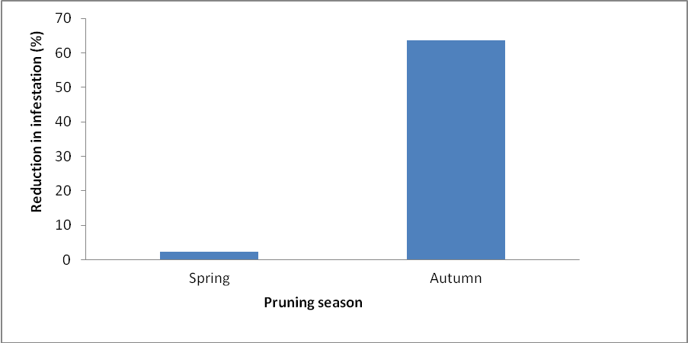
Figure 1: Effect of seasonal pruning on infestation rate of S. kashmirensis.

Table 2: Effect of sanitation on elm plots/nurseries.
Treatment in elm plots | No. of trees ascribed to sanitation | Infestation rate (%) in following spring | % reduction over control | t-value
I | 100 | 8.77±0.68 | 61.02 | 15.33
II | 100 | 7.55±0.57 | 63.49 | 16.00
Control | 100 | 10.43±0.58 | 0.00 | 0.00

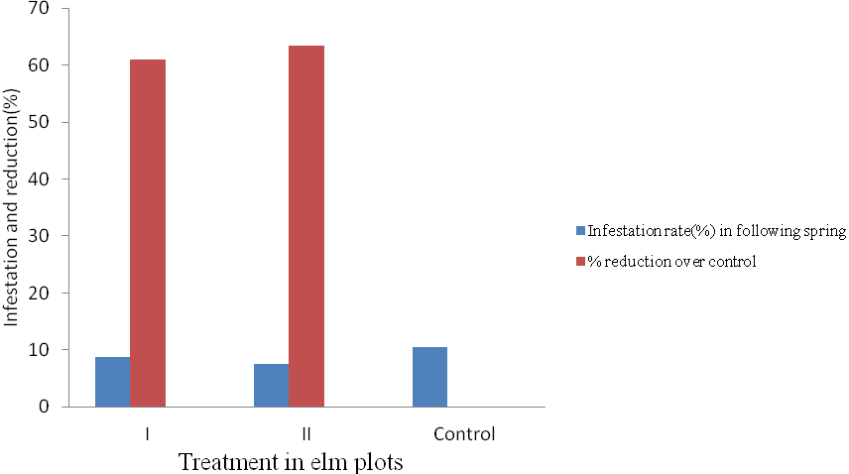
Figure 2: Control of S. kashmirensis by sanitation.

Removal of brood trees:
The infestation rate of the borer was reduced in the elm nurseries/ plots significantly (P<0.05) (Table 3) by the removal of brood/ infested trees. During the study period, in the treatment plots the borer infestation rate was reduced by 42.41% while as in control plot infestation rate increased by 5.45%, however, the latter is statistically insignificant (P>0.05).
First treatment involved the removal of 10.33% infested trees and reduced the infestation rate by 17.30%, while as in second treatment 11.55% infested trees were sacrificed which resulted in the reduction of borer attack by 27.31%. A total of 21.88% infested trees were removed and the harboring grubs were killed which in turn resulted in the failure of shot-hole borer populations to regain pretreatment densities which resulted in curtailed mating and subsequent egg laying and finally reduced infestation rate (Figure 3).

Table 3: Efficacy of brood tree removal against S. kashmirensis.
Treatment | Pre-treatment infestation (%;mean±SE) | Post-treatment infestation (%;mean±SE) | Reduction over previous generation (%) | t-value
I | 20.65±0.62 | 17.35±0.30 | 17.30 | 5.16
II | 17.37±0.30 | 13.29±0.60 | 27.31 | 7.43
Control | 19.44±0.40 | 20.50±1.20 | -5.45 | 0.83

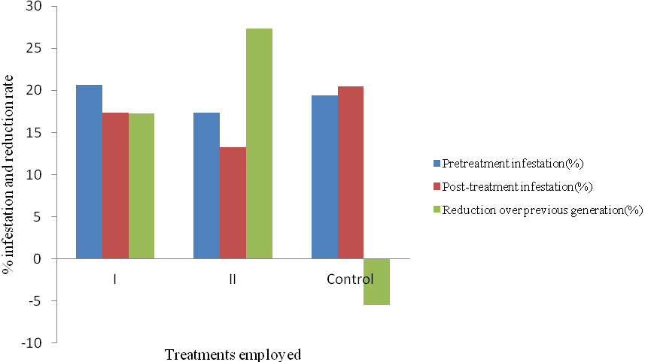
Figure 3: Effect of brood tree removal against S. kashmirensis.

Discussion:
Bark beetles are distributed worldwide occupying a wide range of niches on woody and herbaceous plants. The species of genus Scolytus (Coleoptera: Scolytidae) attack elm trees (Ulmus sp.) in poor physiological condition and are a major cause of tree’s decay. Most species of the family are polyphagous causing wide spread mortality among host tree species (Craighead,1950).
Pruning of trees is a cultural operation, an economical tool employed in integrated pest management of perennial plants. The pruning cut for the removal of the branch should be made approximately 10′ behind the point at which healthy wood is first observed (Lanier, 1988). Wounding trees by pruning will attract the bark beetle vectors of Dutch elm disease (Byers et al., 1980).
The findings of the current study is at par with that of the Lanier (1988) who suggested that ideally, routine pruning should be done in the dormant season or should be restricted to the periods of beetle inactivity, and of Sanborn (1996) who recommended that elm trees should not be pruned from March to September. Spring and Autumn pruning reduced infestation rate of the elm borer by 2.33% and 63.67% respectively.Autumn pruning prevented the elm trees from the borer infestation by destroying the harboring grounds of overwintering larvae along with the pruned branches, thus restricting the infestation in the next season. Spring pruning could not prevent the elm plants from the borer infestation as the twigs sprouted from the spring pruned plants are the preferred oviposition sites for elm shot-hole borer.
Pruning in the management of S. kashmirensis, the shot-hole borer under study is appealing for several reasons viz., reduced the borer infestation rate significantly; no environmental hazard encountered; does not interfered in the economics of silviecosystem.
Sanitation is the most important element of management program for existing elms because it removes the elm bark beetles breeding habitat from the system. It consists of the immediate removal of any dead or wounded branches, and the debarking of branches stored for use as lumber and fuel. The present study is at par with the Schreiber and Peacock (1974); van Sickle and Sterner (1976) who suggested that the most effective control measures against the elm bark beetles to date have been based on sanitation programs consisting of prompt removal of recently dead or dying trees, as well as the speedy destruction of all elm material infested by beetles. Lanier (1988) suggested that no borer infestation and thereof Dutch elm disease management program will be successful without good sanitation. Sanitation prevented elm trees from borer infestation as it destroyed the overwintering harboring grounds of the borer. It reduced the borer infestation rate by 61.02% in I elm plot and 63.49% in II elm plot as compared to control plot. Lanier (1988) suggested that sanitation including pruning combined with fungicides gives better disease management than sanitation, pruning or fungicides alone when dealing with a residual infection. Sanitation should be viewed as a community-wide management tactic.
Removal of brood trees as a control measure reported here is based on locating and subsequent removal of heavily infested trees (brood trees) that are unrecoverable which is an attempt to work out the control strategy against the shot-hole borer under study. Brood trees after removal were dissected and the harboring grubs were exposed and killed which in turn resulted in the failure of elm borer to regain pretreatment densities, thus infestation rate automatically reduced. Removal of heavily infested trees reduced elm borer, S.kashmirensis attack by 42.41% in two treatments.
Elm trees (Ulmus sp.) stressed by unfavorable environmental conditions, disease, defoilation, age, or poor tree care are most susceptible to bark beetle attack (Hagen, 1995). Heavy infestation of Lamiine species cause widespread mortality among host tree species (Yang et al, 1995; Ertain, 2003). Donley (1981) showed that the control of red oak borer, Enaphalodes rufulus by removal of infested trees reduced 50% and 90% borer population after treatments in first and second generations respectively.
The present investigation revealed that the shot-hole borer (Scolytus kashmirensis) infested elm trees (Ulmus wallichiana and U. villosa) in Kashmir. The aforementioned borer exploited one or the other tissues of elm plants. The borer, S. kashmirensis mine the inner bark (the phloem-cambial region) on twigs, branches or trunks of elm trees and resulted in the stunted growth of infested host tree. The S. kashmirensis is of great economic importance as it attacks the living/healthy but weakened elms, lead them to ultimate death and also feed on the dead and dying plant tissues, so plays a significant role in the host plant physiology and/or economy.
Management practices by cultural operations reduced the infestation rate significantly. Seasonal pruning reduced infestation of S. kashmirensis significantly; Spring and Autumn pruning reduced it by 2.33% and 63.67% respectively. Sanitation reduced the borer infestation rate by 61.02% and 63.49% in two treated elm plots. Removal of the brood trees reduced S. kashmirensis infestation rate by 42.41%. None of the two species of the genus Ulmus (U. wallichiana and U. villosa) offered complete resistance to the attack of the borer under study, however, U. villosa though prone to their attack showed slight resistance as compared to the U. wallichiana screened in the region which are more or less equally susceptible to the borer.

REFERENCES:
- Basset, Y., Favaro, A., Springate, N.D. and Battista, A. 1. Observations on the relative effectiveness of Scolytus multistriatus (Marsham) and Scolytus pygmaeus (Fabricius) (Coleoptera: Scolytidae) as vectors of the Dutch elm disease. Mitteilungen-der-Schweizerischen-Entomologischn Gesellschaft. 1992;65 (1-2): 61-67
- Brasier, C.M. Ophiostoma nova-ulmi sp. nov., causative agent of current Dutch elm disease pandemics. Mycopathologia, 1991;115: 151-161.
- Brasier, C.M. and Mehrotra, M.D. Ophiostoma himal-ulmi sp.nov., a new species of Dutch elm disease fungus epidemic to the Himalayas. Mycological Research, 1995;99: 205-215.
- Byers, J.A., Svirhra, P., Koehler, C.S. Attraction of elm bark beetles to cut limbs on the elm. Journal of Arboric, 1980;6: 245-246.
- Collins, C.W., Buchanan, W.D., Witten, R.R., Hoffman, C.H. Bark beetles and other possible insect vectors of Dutch elm disease. J. Econ. Ent. 1936;34: 369-372.
- Craighead, F.C. 1950. Insect enemies of Eastern forests. Misc. Publ. No. 657. USA, WA- Washington, DC; USDA.
- Donley, D.E. Control of the red oak borer by removal of infested trees. Journal of Forestry,1981; 79 (11): 731-733.
- Donley, D.E. Cultural control of the red oak borer (Coleoptera:Cerambycidae) in forest management units. Journal of Economic Entomology, 1983;76 (4); 927-929.
- Ertain, H. 2003. Protection of Mulberry plants, 610p. Oxford & IBH Publishing Co. Pvt. Ltd. New Delhi.
- Favaro, A. and Battisti, A. Observations on the elm bark beetle Scolytus pygmaeus Fabricius (Coleoptera: Scolytidae) as a possible vector of the fungus Ophiostoma ulmi (Schwarz) Nannfeldt. Redia. 1997;76: 2, 459-466
- Faccoli, M., Battisti, A. Observations on the transmission of Ophiostoma ulmi by the Smaller elm bark beetles (Scolytus spp.). In: Gregoire, J.C., Liebhold, A.M., Stephen, F.M., Day, K.R., Salmon, S.M. (eds.): Integrating Cultural Tactics Into The Management of Bark Beetles and Reforestation Pest. USDA Forest Service Tech. Rep. NE-236, Vallombrosa (FI), Italy, 1997;172-176.
- Gibbs, J.N. Correlation between cultural characteristics and pathogenicity in C. ulmi from Britain, Europe and America. Nature,1974; 241: 381-383.
- Gibbs, J.N., and Brasier, C.M. Biology of DED. Forestry Commission Forest Report. 1973;94: 1-9.
- Hagen, W.B. 1995. Managing bark beetles in urban and rural trees. Tree Notes, California, Department of Forestry and Fire Protection Publ., No. 19.
- Jacot, A.P. Acarina as possible vector of the Dutch elm disease. J. Econ. Ent. 1934;27: 858-859.
- Jacot, A.P. Three possible mite vector of the Dutch elm disease. Ent. Soc. Of America.1936; 29: 627-635.
- Lanier, G.N. Therapy for Dutch elm disease. Journal of Arboric. 1988;13 (7): 188.
- Lanier, G.N. Trap trees for control of Dutch elm disese. Journal of Arboric,1989; 15 (5): 105-111.
- Lekander, B. The distribution of bark beetles in the Nordic countries. Acta Entomol. Fenn. 1977;32: 1-37.
- Neumann, F.G. and Minko, G. Studies on the introduced smaller European elm bark beetle, Scolytus multistriatus, a potential vector of Dutch elm disease in Victoria. Aus. For. 1985;48: 116-126.
- Parker, K.G., Readio, P.A., Tyler, L.J. and Collins, D.L. Transmission of Dutch elm disease pathogen by Scolytus multistriatus and the development of the infection. Phytopathology, 1941;31: 657-663.
- Sanborn, S. R. 1996. Controlling bark beetles in wood residue and firewood. Sacramento: California Department of Forestry and Fire Protection, Tree Notes 3.
- Schedl, K.E. Indian bark and timber beetles I. Indian Forest Records Entomology, 1957;9:165-169.
- Schreiber, L. R., Peacock, J. W. Dutch elm disease and its control. USDA, Agric. Inf. Bull., 1974;14 pp.
- Schwarz, M.B. The twig vascular disease of the elm. Medelingenuithet Phytopathologisch laboratorium Willie Commelin Scholten.1922; 5: 1-73.
- Segonca, C., Leisse, N. Significance of bark beetles (Coleoptera: Scolytidae) in the spread of Dutch elm disease in the area Euskirchen West Germany. Zeitschrift Angewandte Entomologie. 1984;98: 413-423.
- Smucker, S.J. Air currents as possible carriers of Ceratostomella ulmi. Phytopathology,1935; 25: 442-443.
- van Sickle, G. and Sterner, T. E. Sanitation: a practical protection against Dutch elm disease in Freddericton, New Brunswick. Plant Dis. Report. 1976;60: 336-338.
- Webber, J.F. and Brasier, C.M. The transmission of Dutch elm disease: a study of the process involved. In: Anderson, J., Rayner, A.D.M., Walton, D., (eds.): Invertebrate- Microbial Interactions, Cambridge University Press, Cambridge1984; 271-307.
- Wood, S.L. 1982. The bark beetles and ambrosia beetles of North and Central America (Coleoptera: Scolytidae), a taxonomic monograph. Brigham Young University, Provo, UT.
- Yang, X., Zhou, J., Wang, F. and Cui, M. A study on the feeding habits of the larvae of two species of longicorn (Anoplophora spp.) to different tree species. J. North West For. Coll. 1995;10: 1-6.

3/16/2011

