The Value of Esterman Binocular Visual Field Testing in Issuing A Driver’s License for Glaucoma Patients

Iman A. Fahmy, Fady E. Mitwally, and *Marwa A. Fouly

Glaucoma Department, Research Institute of Ophthalmology (RIO)-airo- Egypt
*marwa_elfouly@yahoo.com

Abstract: Purpose: To identify the relation between monocular visual field in glaucoma patients and binocular visual field (VF) (Esterman VF) and its effect on driving performance in different stages of glaucoma and to investigate whether Esterman disability score (EDS) is suitable for the assessment of mobility difficulty. Objective: Whether the visual efficiency scale in drivers’ licensing currently adopted to determine the legal grade of visual disability associated with visual field loss is appropriate or not for the evaluation of disability regarding driving. Patients and Methods: Twenty eight patients recruited from the glaucoma clinic of the Research Institute of Ophthalmology (RIO) with different grades of glaucomatous VF affection were included in the study: mild VF affection: MD >6.00 dB, moderate VF affection: MD 6-12 dB, severe VF affection: <12 dB. Normally sighted control subjects were recruited from the outpatient clinic of the RIO. The glaucoma patients included in the study were follow-up patients of the glaucoma clinic. Detailed ophthalmological examination was performed including corrected and uncorrected visual acuity (VA) measurement using the Landolt VA chart, assessment of the angle of the anterior chamber using the Goldman contact lens for grading, examination of the optic nerve head using the 90 D indirect Volk lens, monocular visual field test using the Automated Humphery VF Analyzer 24-2 strategy and the binocular Esterman VF of the same patient on the same day. The correlation between the EDS and the monocular VF 24-2of each eye and the degree of subjective mobility difficulty was analyzed by statistical formulae. Conclusion: In addition to the currently adopted visual efficiency scale, EDS could be employed for the assessment of mobility difficulty in patients with visual field loss, also to establish new judgment criteria for issuing driver’s license.
[Iman A. Fahmy, Fady E. Mitwally, and *Marwa A. Fouly. The Value of Esterman Binocular Visual Field Testing in Issuing A Driver’s License for Glaucoma Patients]. Nature and Science 2011;9(5):109-118]. (ISSN: 1545-0740). http://www.sciencepub.net.
Keywords: Esterman Binocular Visual Field; Driver’s License; Glaucoma Patient

1. Introduction:

Automobile drivers’ licensing is sometimes based partially upon visual field assessment. In most jurisdictions such assessment is the exception rather than the rule, and there are currently no internationally accepted standards. Some authors have suggested that the overall binocular VF is most important in driving and that losses in one eye may well be compensated for if the other eye’s overlapping field is still functional, (Johnson and Kelter, 1983).
Usually the least level of visual acuity required for driving is equivalent to 6/12 in each eye according to the Egyptian driving law.
A good field of vision is also required to ascertain whether it meets the requirements for driving. The Driver and Vehicle Licensing Agency (DVLA) state that an adequate field of vision is required by law and a considerable deterioration in the binocular field of vision is a hazardous defect, (Johnson & Keltner, 1983). Drivers with restricted fields may be prone to a higher incidence of side collisions.
The minimum field of vision for safe driving is defined as ‘a field of at least 120 degrees on the horizontal, measured using a target equivalent to the white Goldmann III- 4e settings. In addition, there should be no significant defect in the binocular field which encroaches within 20 degrees of fixation above or below the horizontal meridian. Homonymous or bitemporal defects which come close to fixation, whether hemianopic or quadrantanopic, are not accepted as safe for driving.
The Esterman binocular VF test has been used to assess VF disability in motor vehicles license applicants and patients with severe VF loss due to glaucoma. The Esterman scoring system has been adopted by the American Medical Association 1994 as a standard for rating visual disability, (Mills and Drance, 1986).

2. Subjects and Methods
Twenty eight glaucoma patients were included. The male to female ratio was 14 males (50%) and 14 females as shown in table (1). Mean age of subjects was 54.3 ± 16.2 years ranging from 17 to 83 years as shown in table (2).
Patients were categorized according to the results of automated perimetry using Humphrey 24-2 full-threshold VF testing protocol. The VF test mean deviations (MD) provide an overall measure of VF loss in each eye. Patients were divided into:
Mild VF affection: MD >6.00 dB Fig. 5-6,
Moderate VF affection: MD 6-12 dB Fig. 3-4 and
Severe VF affection: <12 dB. Fig. 1-2
Table (3) shows that 7.1% of the patients had mild VF affection, 53.6% had moderate VF affection and 39.3% of the patients had severe VF affection.
Exclusion criteria were: (1) physical or cognitive impairment; (2) an eye disease or condition that may affect vision, including cataracts of greater than mild severity; and (3) failing visual acuity screening tests or a visual field screening test (Humphrey Esterman binocular visual field), (4) complicated and refractory glaucoma.
The Esterman binocular VF test, on the Humphery automated perimeter was performed. It is based on the principal that some regions of the VF are functionally more important than others. The binocular versions of the test presents suprathreshold stimuli equivalent to a III-4e (10dB) target on the Goldmann perimeter at 120 loci throughout the VF, including 150⁰ in the horizontal meridian (75⁰ in each direction) and 100⁰ in the vertical meridian (40⁰ superiorly and 60⁰inferiorly). More stimuli are presented centrally, inferiorly, and along the horizontal meridian than at other locations as these areas of the VF are thought to be the most important functionally. Points that are missed are retested once before a miss is recorded. The percentage of points seen by the patient comprises the Esterman efficacy score.
The VF requirement typically consists of the ability to see for at least 120⁰ to 140⁰ in the horizontal meridian with both eyes together. The Esterman test can be used to document the extent of the binocular horizontal field for drivers’ license requirements. In addition, the Esterman test has been used to assess functional disability in patients with glaucoma, (Mills and Drance, 1986).
The technician moves the chin rest to the far right position, the patient places his/her chin in the chin cup on the left. There is no need to use the trial lens holder or an eye patch; the patient may wear spectacles for the test. The patient moves his/her head to center eye monitor between patient’s eyes.

3. Results:
A sample of 28 cases who met eligibility criteria were included. The male to female ratio was 50% as shown in Table (1).

Table (1) Distribution of gender of studied cases (N=28)
 | No. | %
Males | 14 | 50.0
Females | 14 | 50.0

The mean age of subjects was 54.3 ±SD 16.2 ranging from 17 to 83 years and the median was 59 years as shown in Table (2).

Table (2) Descriptive statistics of the age of the studied cases (N=28)
 | Mean (SD) | Range
Age | 54.3 16.2 | 17-83 years
Median | 59 years

The MD was used to characterize patients’ visual fields into three categories (McKean-Cowdin et al., 2007):
- Mild VF damage: unilateral damage MD ≤ (-)6 dB
- Moderate VF damage : MD from (-)6 dB – (-)12 dB
- Sever VF damage: MD ≥ (-)12 dB

Table (3) Distribution of severity of visual field affection among studied patients (N=28)
 | No. | %
Mild | 2 | 7.1
Moderate | 15 | 53.6
Severe | 11 | 39.3

This table shows that 7.1% of the patients had mild, 53.6% had moderate and 39.3% of the patients had severe VF affection.
This classification system was based on perimetric test results using Humphrey 24–2 threshold strategy monocular VF test for both eyes

Table (4) Comparison between gender and the mean Esterman Score: (N=28)
 | Mean | SD | P
Males N=14 | 73.7 | 30.7 | 0.2
Females N=14 | 84.3 | 17.3
P>0.05 not significant

There is no statistically significant difference between males and females as regards the mean Esterman score.
There is a higher mean Esterman score among females compared to males but the difference is not statistically significant.

Table (5) Comparison between age of the patients and the mean Esterman Score: (N=28)
Age | Mean | SD | T | P
<=59 years  young N=14 | 79.5 | 25.8 | 0.1 | 0.9
>59 years old N=14 | 78.5 | 25.36
P>0.05 not significant

There is no statistically significant difference between old and young cases as regards the mean Esterman score.

Table (6) Comparison between severity of visual field affection and the mean Esterman score: (N=28)
 | Mean | SD | P
Mild | 94.5 | 2.1
Moderate | 90.5 | 10.4 | 0.000**
Severe | 60.5 | 30.4
** P<0.01: highly significant

LSD (least significance difference) shows a significant difference between severe versus mild and moderate VF affection, while no significant difference was found between mild and moderate cases.
There is a lower mean Esterman score among cases with severe vision affection compared to moderate and mild cases and the difference is highly significant statistically.

Table (7) Percentiles of Esterman score among studied patients: (N=28)
 | Value
5th | 17.9
10th | 29.8
15th | 42.9
25th | 66.7
50th | 88.5
75th | 95.7
90th | 99.0
95th | 99.5

A percentile (or centile) is the value of a variable below which a certain percent of observations fall. So the 25th percentile is the value (or score) below which 25 percent of the observations may be found.
The 25th percentile is also known as the first quartile (Q₁), the 50th percentile as the median or second quartile (Q₂); the 75th percentile as third quartile (Q₃).
This table shows the median value for Esterman score among all studied patients is (88.5). This table also shows the cut value of Esterman score below which for example we can not issue a driving license is 66.7 (25th percentile of the cases) with good monocular reliability indices (RI).

Table (8) Comparison between severity of visual field affection and the mean right median deviation, left median deviation, right pattern SD, left pattern SD (N=28)
 | Mean | SD | F | P
Right median deviation  Mild  Moderate  Severe | -0.36  -4.57  -22.5 | 1.4  2.9  8.7 | 31.8 | 0.000**
Left median deviation  Mild  Moderate  Severe | 0.32  -5.7  -24.3 | 0.4  6.3  6.8 | 30.6 | 0.000**
Right pattern SD  Mild  Moderate  Severe | 1.1  3.5  7.6 | 0.1  1.8  2.4 | 15.4 | 0.000**
Left pattern SD  Mild  Moderate  Severe | 1.1  4.2  7.2 | 0.1  3.0  3.0 | 4.9 | 0.01*
** P<0.01: highly significant
LSD (least significance difference) test showed significant difference between severe versus mild and moderate monocular visual field affection.

There is no significant difference between the mean of the studied parameters of mild cases versus moderate cases.

Table (9) Correlation coefficient between right and left median deviation and Esterman binocular vision score (N=28)
 | Right median deviation | Esterman score
Left median deviation | r=0.811  P=0.000** | R=0.733  P=0.000**
Right median deviation |  | R=0.733  P=0.000**
** P<0.01: highly significant

There is a highly significant positive correlation between left median deviation and right median deviation among studied patients. There is a highly significant positive correlation between left median deviation and Esterman score. There is a highly significant positive correlation between right median deviation and Esterman score.

Table (10) Correlation coefficient between right and left pattern SD and Esterman binocular vision score (N=28)
 | Right PSD | Esterman score
Left PSD | r=0.666  P=0.000** | r=-0.158  P=0.4
Right PSD |  | r=-0.228  P=0.2
** P<0.01: highly significant

There is a highly significant positive correlation between left PSD and right PSD. There is no significant correlation between left PSD and Esterman score. There is no significant correlation between right PSD and Esterman score.

Table (11) Distribution of low Esterman score among studied cases (cases below cut off value 66.7 is considered as bad Esterman and not pass vision test) (N=28)
 | Number | Percent
Pass | 21 | 75.0
Not pass  Below cut off value | 7 | 25.0

This table shows that 7 patients (25%) of the studied patients had a low Esterman score below the cut off value meaning that they are not allowed to be issued a drivers license.

Table (12) Distribution of low Esterman score according to severity of visual field affection among studied patients: (N=28)
 | Pass  > cut off value  No. % | Not pass  < cut off value  No. % | X2 | P
Mild N=2 | 2 100.0 | 0 0
Moderate N=15 | 14 93.3 | 1 6.7 | 8.4 | 0.01*
Severe N=11 | 5 45.5 | 6 54.5
* P<0.05 significant

One patient from the moderately affected Esterman score patients cannot drive (6.7%), compared to 6 patients from the severely affected (54.5%).

Table (13) Percentiles of Esterman score among cases with severe visual field affection:
Severe cases of visual field affection
N=11 | Value
5th | 17.0
10th | 17.4
15th | 18.6
25th | 31.0
50th | 65.0
75th | 87.0
90th | 97.0
95th | 99.0

The cut off value for driving in severely affected patients according to the Esterman score was at the 50th (65 value) below which patients should not be allowed to drive

A case of bilateral advanced glaucoma

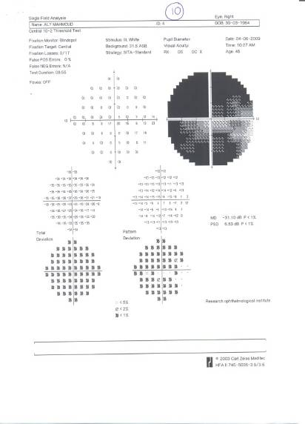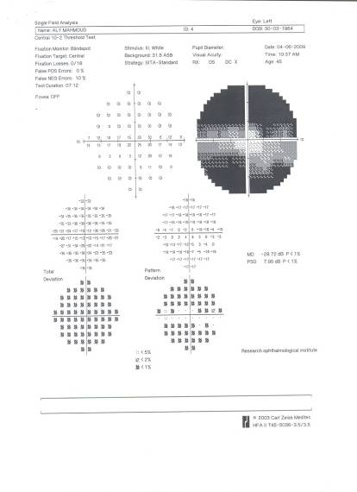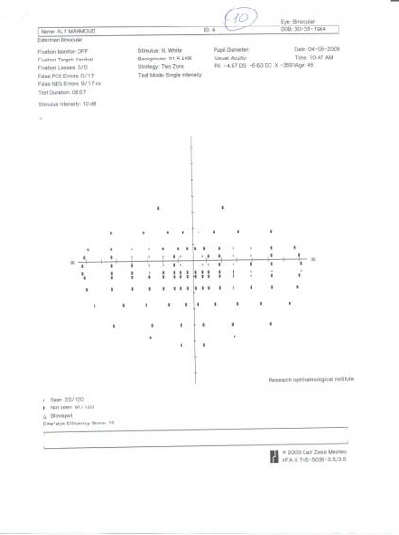
Fig.1 MD of right eye (-) 31.1 MD of left eye (-) 28.72 Esterman score = 23/120

A case of bilateral advanced glaucoma with a good Esterman score

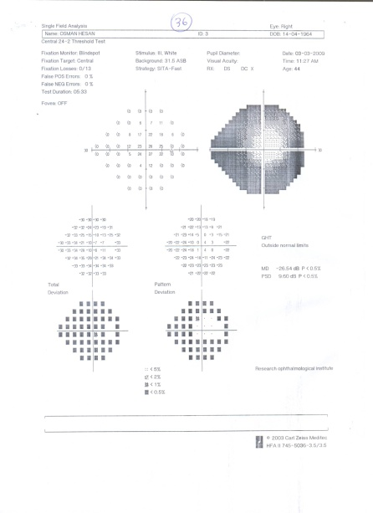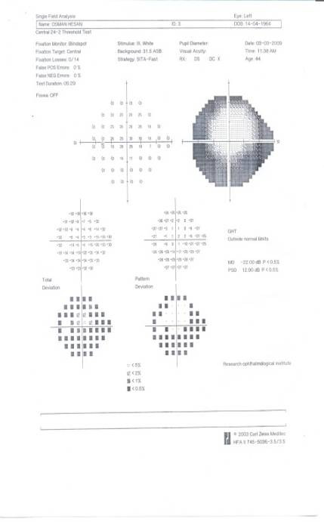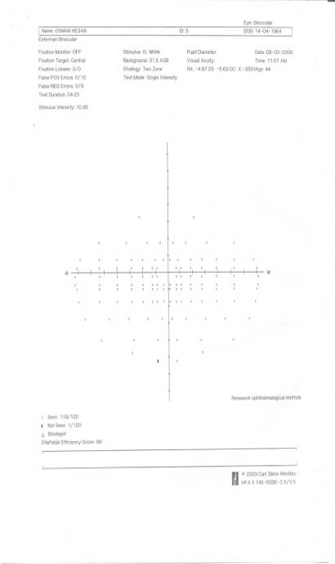 Fig.2 MD of right eye (-) 20.54 MD of left eye (-) 22 Esterman score =119/120

A case of bilateral moderate glaucoma

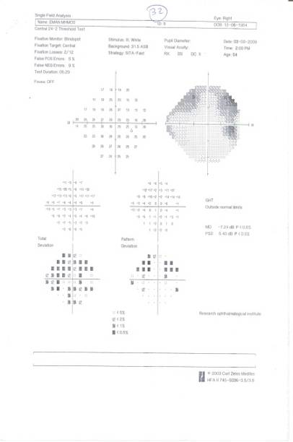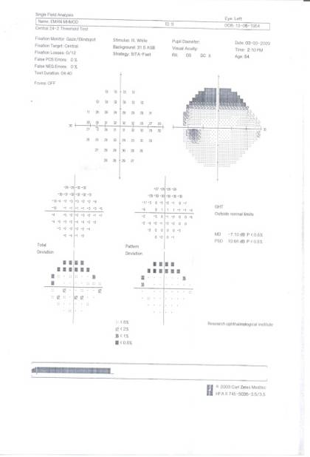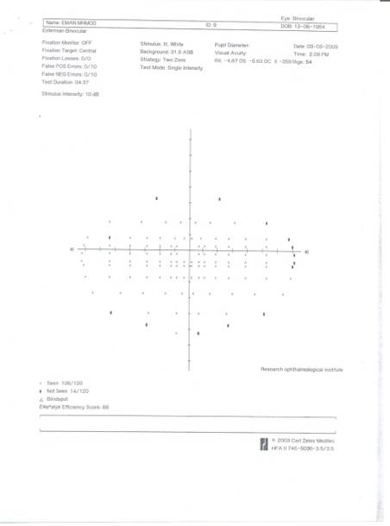
Fig.3 MD of right eye (-) 7.42 MD of left eye (-) 7.10 Esterman score = 106/120

A case of bilateral moderate glaucoma

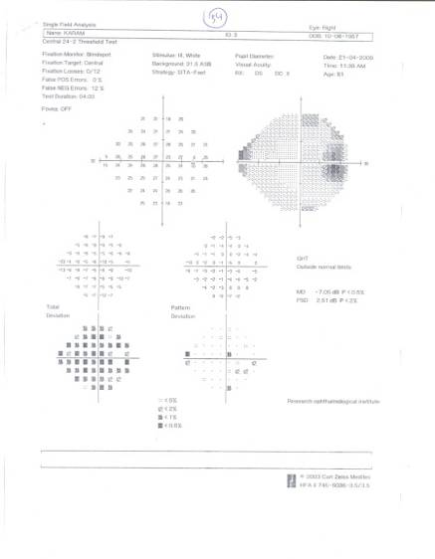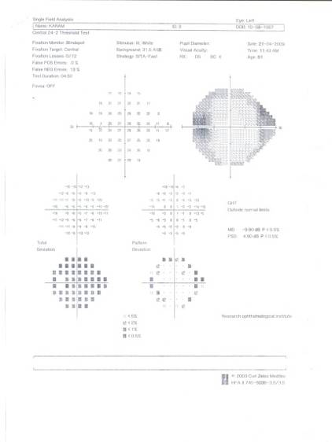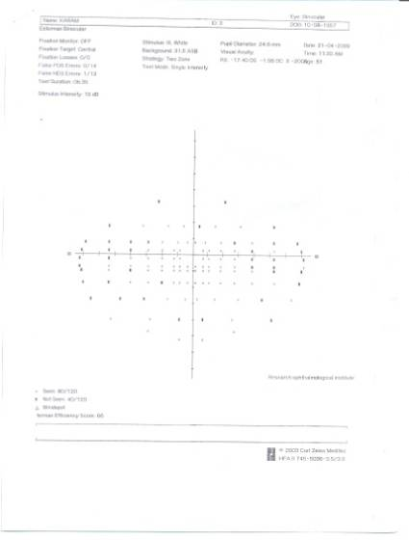
Fig.4 MD of right eye (-) 7.05 MD of left eye (-) 9.90 Esterman score = 80/120

A case of bilateral early glaucoma

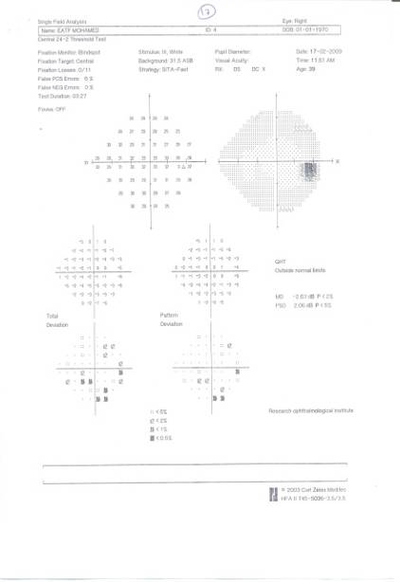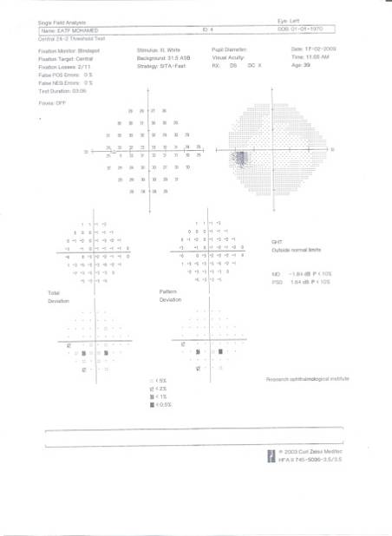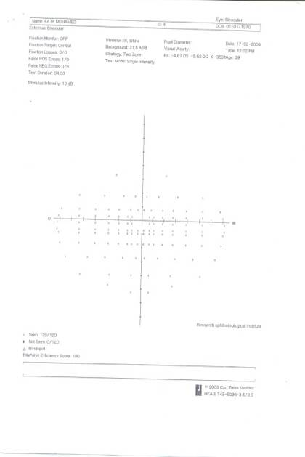
Fig.5 MD of right eye (-) 2.63 MD of left eye (-) 1.84 Esterman score = 120/120

A case of bilateral early glaucoma

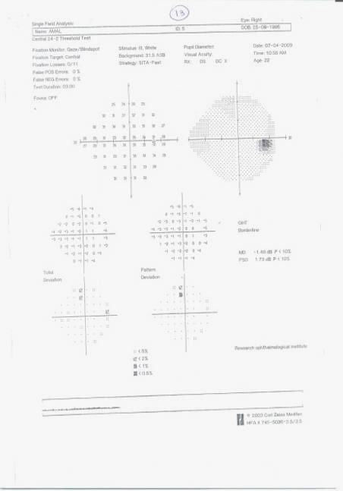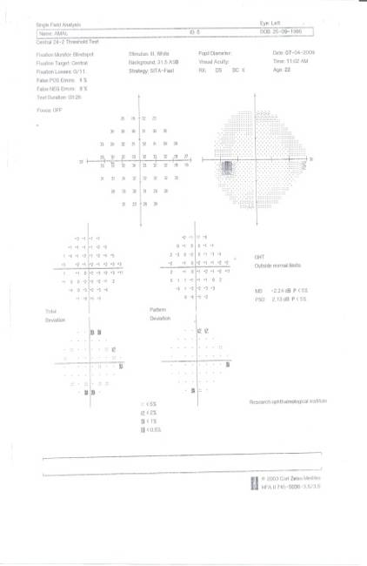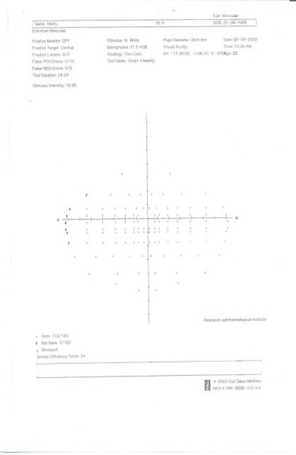
Fig.6 MD of right eye (-) 1.48 MD of left eye (-) 2.24 Esterman score = 113/120

A case with right eye moderate glaucoma affection and left eye severe glaucoma affection

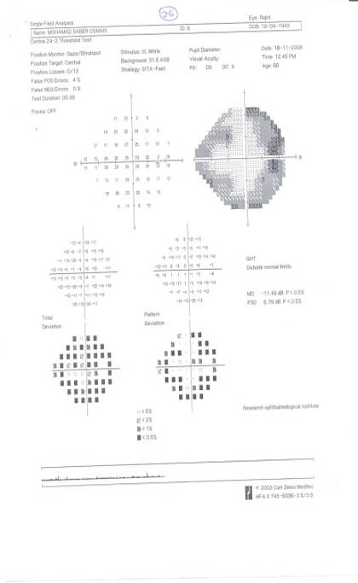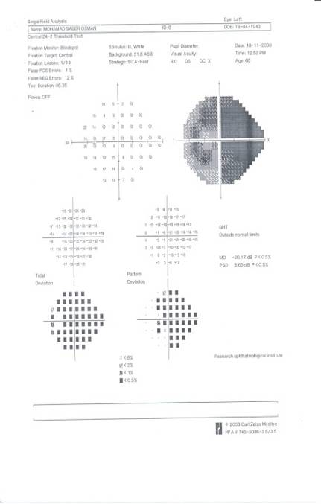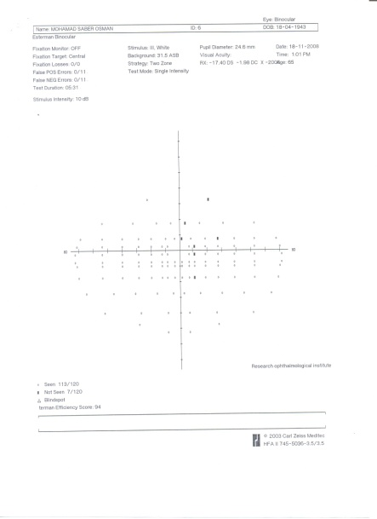
Fig.7 MD of right eye (-) 11.49 MD of left eye (-) 26.17 Esterman score = 113/120

A case with right eye moderate glaucoma affection and left eye mild glaucoma affection

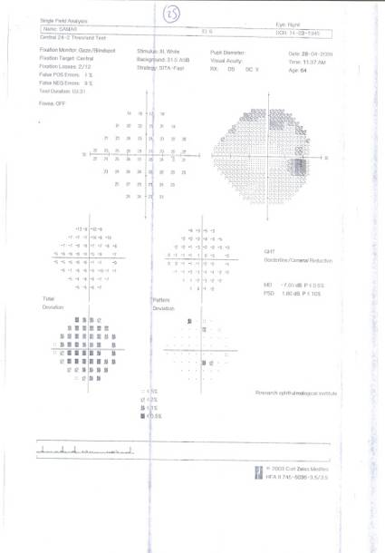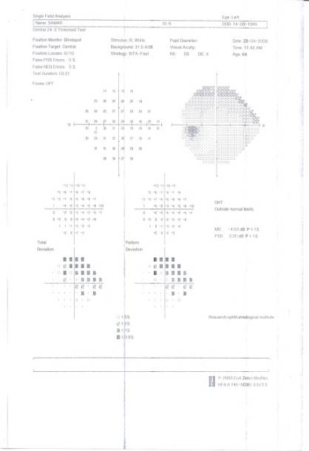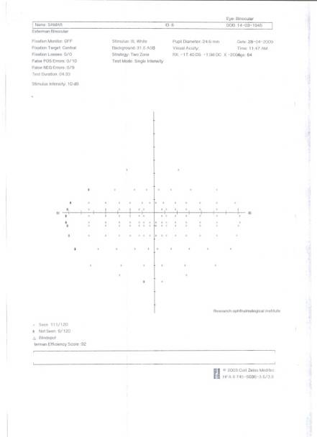
Fig.8 MD of the right eye (-) 7.05 MD of the left eye (-) 4.03 Esterman score = 111/120

4. Discussion:
In the present study we investigated whether the Esterman disabilities score (EDS) is suitable for the assessment of mobility difficulty in patients with visual field loss. Driving endpoints, such as driving cessation or limitation, should be considered as secondary outcomes in evaluating glaucoma treatments.
Glaucoma affects approximately 2% of adults over the age of 40, (Friedman et al, 2004), and disease prevalence increases dramatically with age, (Quigley and Broman, 2006). Aging of the population worldwide will lead to substantially more individuals with glaucoma in coming years, which may result in dramatically more individuals with glaucoma-related visual disability.
In addition, measurement of disability from glaucoma can define guidelines to increase patient safety while driving, (Rowe, 2006).
Patients with glaucoma rate driving as very important in preserving independence. The two most important concerns identified by glaucoma patients were the risk for VF loss leading to an inability to drive and the fear of long-term blindness, (Bhargava et al, 2006). Ang and Eke, (2007), found that though most glaucoma patients in their study retained useful vision, almost half (47%) eventually lost vision, resulting in driving ineligibility.
In our study the mean Esterman score was higher among females compared to males but the difference was statistically insignificant as shown in table (4). This coincides with, (Edwards et al, 2008) who concluded that gender, although previously found to be predictive of driving cessation, was not a significant risk considering baseline driving. Several cross-sectional studies have indicated that women are more likely than men to cease driving, (Vance et al, 2006). Overall, prior research and these results indicate that although older women from contemporary cohorts drive less at baseline, they may not be more likely to cease driving across time. However, they advised to be cautious about over interpreting the conflicting cross-sectional and longitudinal research, as both designs contain specific methodological biases that may make direct evaluation of cross-sectional as compared with longitudinal predictors difficult, (Anstey, 2002; Hofer, Sliwinski, & Flaherty, 2002).
No statistical difference was found between age of patients and the mean Esterman score as shown in table (5). Our results coincide with the work of (Janz et al, 2009), who found no significant association between driving status and age.
When comparing the severity of VF affection and the mean Esterman score we found a significant difference between severe and moderate VF affection, while no significant difference was found between mild and moderate cases, table (6). There is a lower mean Esterman score among cases with severe visual affection compared to moderate and mild cases and the difference is highly statistically significant, table (6).
McGwin et al, (2005), found that older adults with severe field loss in their worse functioning eye are at risk of involvement in collisions rather than are those with glaucoma who have no field loss.
Nelson-Quigg et al, (2000), noted that in many instances, the appearance of the binocular visual field of patients with glaucoma was better than expected on the basis of observation of the monocular visual fields alone which coincide with our study. This is in part because glaucomatous visual field loss only occasionally overlaps for corresponding locations in the two eyes, the degree of overlap is often partial, and the degree of sensitivity loss is often asymmetric between the two eyes. A method of generating an accurate representation of the binocular visual field from monocular visual field data may be useful for clinicians in assessing whether patients are likely to encounter difficulties with driving, mobility skills, and other everyday tasks.
Percentiles of Esterman score among our studied patients are shown in table (7). A percentile is a value that represents a percentage position in a list (range) of data. This table also shows that the driving endpoint value of Esterman score was 66.7, below which for example, we can not issue a driving license (25th percentile of all cases) with good monocular reliability indices (RI).
Our study is different from and additive to others in that, we could determine the percentile for mild, moderate and severe glaucoma below which patients are advised not to drive being 25th percentile for mild and moderate glaucoma patients and 65th for advanced glaucoma VF changes, tables (8 -10) reveal that in glaucoma with the binocular VF affection, patients can drive if below 25th percentile, table (11) shows the distribution of low Esterman score among studied cases (the value 66.7 is considered as bad Esterman below which glaucoma patients cannot be allowed to pass the vision test), 7 patients (25%) of the studied groups had that score.
Table (12) shows the distribution of low Esterman score according to severity of visual field affection among studied patients, one patient from the moderately affected Esterman score cannot drive (6.7%), compared to 6 patients from the severely affected (54.5%).
The increased accident incidence in the advanced glaucoma group indicates that glaucoma patients were not able to compensate for their visual field loss during driving. These findings are consistent with a study of the peripheral visual fields by Johnson and Keltner (1983) conducted over 10,000 driver’s license applicants in California, who found that individuals with binocular peripheral field loss had twice the accident rates as compared to a control group with normal visual fields. Our results showed, that for safe driving in severely affected patients with advanced VF losses OU according to the Esterman score, was at the 50th percentile (65 value), below which patients should not be allowed to drive, table (13). Therefore, binocular VF is very important for the decision of driving, since the monocular VF even if advanced in both eyes may be misleading, Fig. 7-8.

5. Conclusion
Patients with glaucoma have greater difficulty in performing safe driving tasks with progressive VFs, particularly when bilateral damage is present. Using the binocular VF examination has proven importance in assessing the driving ability of glaucoma patients before issuing a driver`s license, even if the monocular VF of each eye is severely affected, which will definitely improve their quality of life. We advise adding the binocular VF test among the numerous driving licenses tests conducted at traffic offices. It will be important to conduct further studies, that directly assess the on field driving and mobility of glaucoma patients.

Corresponding author
Marwa A. Fouly
Glaucoma Department, Research Institute of Ophthalmology (RIO)-airo- Egypt
marwa_elfouly@yahoo.com

6. References:
- Anderson, D.R., and Patella V.M., 1991. Automated static perimetry; 2nd Ed. St. Louis: Mosby.
- Ang GS, Eke T., 2007. Lifetime visual prognosis for patients with primary open-angle glaucoma. Eye; 21(5):604-608.
- Anstey K., 2002. The interpretation of shared age-related variance among factors in cross-sectional cognitive aging studies. Gerontology; 48:2–4.
- Bhargava J.S., Patel B., Foss A.J., King A.J., 2006. View of glaucoma patients on aspects of their treatment: an assessment of patient prefrance by conjoint analysis. Invest. Ophthalomol Vis Sci.; 47(7):2885-2888.
- Friedman D.S., Wolfs R.C., O'Colmain B.J., et al., 2004.Prevalence of open-angle glaucoma among adults in the United States. Arch Ophthalmol; 122:532–538.
- Hofer, S. M., Sliwinski, M., & Flaherty, B. P., 2002. Understanding ageing: Further commentary on the limitations of cross-sectional designs for ageing research. Gerontology; 48: 22–29.
- Jans N.K., Musch D.C., Gillespie B.W., Wern P.A. and Niziol L.M., 2009. Evaluating clinical change and visual function concerns in drivers and nondrivers with glaucoma. Invest. Ophthalomol Vis Sci.;50(4):1718-1725.
- Jerri D. Edwards, Lesley A. Ross, Michelle L. Ackerman, Brent J. Small, Karlene K. Ball, Stacy Bradley, and Joan E. Dodson, 2008. Longitudinal Predictors of Driving Cessation among Older Adults from the ACTIVE Clinical Trial. Journal of Gerontology: PSYCHOLOGICAL SCIENCES; Vol. 63B, No.( 1):6–P12.
- Johnson, C.A., and J.L. Kelter, 1983. Incidence of visual field loss in 20,000 eyes and its relationship to driving performance. Arch. Opthalmol; 101: 371-75
- McGwin G. Jr., Xie A., Mays A., et al., 2005. Visual field defects and the risk of motor vehicle collisions among patients with glaucoma. Invest.Ophthalmol.Vis.Sci.; 46:4437–4441.
- McKean-Cowdin R., Varma R., Wu J., Hays R.D., Azen S.P.; Los Angeles Latino Eye Study Group, 2007. Severity of visual field loss and health-related quality of life. Am J Ophthalmol; 143(6):1013-23.
- Mills R.P. and Drance S.M., 1986. Esterman disability rating in severe glaucoma. Ophthalmology; 93:371-378.
- Mo Knight, A.J.D. Shinar, and B. Hilburn, 1991. The visual and driving performance of monocular and binocular heavy-duty truck drivers. Accid Anal Prev.; 23:225-37.
- Nelson-Quigg J. M., Cello K., Johnson C.A., 2000. Predicting Binocular Visual Field Sensitivity from Monocular Visual Field Results. Invest. Ophthalomol Vis Sci.; 41(8):2212-2221.
- Pradeep Ramulu, 2009. Glaucoma and Disability: Which tasks are affected, and at what stage of disease?: Curr Opin Ophthalmol. March; 20(2): 92–98.
- Quigley H.A., Broman A.T., 2006.The number of people with glaucoma worldwide in 2010 and 2020. Br J Ophthalmol.; 90:262–267.
- Rowe F.J., 2006. Visual fields via the visual pathway: Blackwell Publishing Ltd
- Wood, H.M., and Troutbeck, 1994. Effect of visual impairment on driving. Hum Factors; 36:476-87.

3/29/2011

