Light Hydrocarbons in Niger Delta Oils: Geochemical Significance of Ring Preference.

Mark O. Onyema and Leo C. Osuji.

Department of Pure and Industrial Chemistry, University of Port Harcourt,
P.M.B 5323, Choba,Port Harcourt, Rivers State, Nigeria

onyemark@yahoo.com

Abstract: The light hydrocarbon ring preference (RP) in crude oils from the Niger Delta has been investigated. The crude oil samples were analyzed using gas chromatographic fingerprints of ring preference light hydrocarbons. The ratios of P₂³, P₃³ (3RP) and N₂⁵ (5RP) ranged from 9.73 to 13.27%, 4.04 to 7.90% and 8.75 to 14.71% with no compositional variation of ring preference for correlation and/or differentiation. The ratio of 6RP, N₁ ranged from 38.47 to 55.17% and revealed Niger Delta crude oils as exhibiting high 6RP. The ratio of parent P₁ separates the oils into two homologous sets. k₂ supports the grouping by P₁, compares well with RP ratio and classified EN-A4, EN-A9 (Eastern) and CE-B3, CE-C7 (Central) as marine source crude oils and WT-D5 (Western) as terrigenous source oil. Plots of ring preference further showed that Western Niger Delta oil remained distinct from the Central and Eastern oils. Gross differences observed on star plots of key ring preference parameters established that the Central and Eastern crude oils remained constrained and distinct from the Western. The ring preference appears to be reliable but must be interpreted within a complete understanding of the petroleum system under study
[Mark O. Onyema and Leo C. Osuji. Light Hydrocarbons in Niger Delta Oils: Geochemical Significance of Ring Preference. Nature and Science 2011;9(5):205-210]. (ISSN: 1545-0740). http://www.sciencepub.net.

Key words: Ring Preference, Light Hydrocarbons, Niger Delta, Geochemical, Star Plot.

1. Introduction
The petroleum fraction between C₁ – C₉ hydrocarbons are referred to as light hydrocarbons (LHs), and constitute about 50% of the carbon in petroleum (Mango, 1997). They are formed between 75-140ºC through catalysis of n-alkane parent into daughter iso- and cycloalkanes. This involves three-, five- and six-carbon ring closure and cleavage of C-C bond in the lipophilic domains of kerogen (Mango, 1992). The six carbon ring compounds N₁⁶ originate via a six carbon ring cyclisation of the n-heptane parent, P₁. Second parent, P₂³ forms N₂⁵, by a five carbon ring closure and P₃³ via a three carbon ring closure as seen in fig. 1 (Mango, 1990).

where
P₁ = n-hexane
P₂³=2-methylhexane+ 3-methylhexane
P₃³=3-ethylpentane + 2,2-, 2,3-, 2,4-, 3,3-dimethylpentane+2,2,3-trimethylbutane
N₁⁵= ethylcyclopentane + 1,2-(cis+trans) dimethylcyclopentane
N₁⁶ = methylcyclohexane + toluene
N₂⁵=1,1-dimethylcyclopentane+1,3-(cis+trans) dimethylcyclopentane
Figure 1: A schematic representation of the Formation of Light Hydrocarbons by Steady State Catalysis (Mango, 1990, 1994).

The LHs are commonly used in evaluating crude oils however, the most relevant geochemical criteria are those which reflect the genetic relationship between organic matter as well as provide information about migration of fluids (Osuji and Antia, 2005). Oils displaying a uniform overall geochemical composition show large compositional variations in LHs reflecting variations in three ring preference (3RP: P₂³and P₃³), five ring preference (5RP: N₂⁵) and six ring preference (6RP: N₁⁶) (Mango, 1994).
Mango (1994) divided C₇ LH ratios into two categories: invariance ratio of isoheptanes and dimethylcyclopentanes, k₂ and ring preference. The invariance ratio [k₂ = P₃³/ (P₂³+ N₂⁵)] remains constant over the course of petroleum generation with homologous oil suites, but distinctly different from another suite of homologous oils (Ten Haven, 1996; Mango, 1990). However, it is the ring preference that gives the C₇ LHs high resolution in distinguishing genetically distinct oils (Mango, 1997). Star plots and ratios of ring preference LHs have proven effective in oil-oil and oil-source correlation (Halpern, 1995). Zhang et al. (2005) used differences observed in k₂ to characterize oils from the Tarim basin, north west China into marine and terrigenous.
Applying biological markers, Eneogwe and Ekundayo (2003) sorted crude oils from Western Niger Delta into three families. Manilla and Onyema (2008) used low molecular weight geochemical markers to characterize Niger Delta oils while Ekweozor and Udo (1988) delineated Niger Delta oils with respect to their source on the basis of their oleanane content. Eneogwe (2003) in analysing Western Niger Delta oils based on variations in their LHs, observed methylcyclohexane and toluene as the most important discriminating variables.
The purpose of this study is to examine the potential of the ring preference of light hydrocarbons as biomarkers for crude oil correlation and speciation in Niger Delta crude oils.

2. Province Geology
The Niger Delta is situated on the West African continental margin at the Gulf of Guinea and is one of the world’s largest tertiary delta systems (Doust, 1990). It formed during the continental breakup in the cretaceous era, with the delta developing from Paleocene. The Niger Delta basin covers an area of 75,000km² and consists of regressive clastic sequences (Sonibare et al., 2008). The lithostratigraphic sequence of the Niger Delta are distinguished on the basis of sand-shale ratios and is divided into three units namely Akata, Agbada and Benin formations (Short and Stauble, 1967). The Akata formation (Paleocene to Recent), at the base of the delta, consists of thick shale deposited under marine conditions. This formation transitions from the continental margin into the deep water portion of the basin. Deposition of the overlying Agbada formation (Eocene into the Recent) to the north consists of interbedded shale and sandstones about 4000km thick in the central part and thinning seawards towards the delta margins. The Agbada formation is overlain by the Benin formation (latest Eocene to Recent) is composed of coastal plain sands that are up to 2000km thick (Sonibare et al., 2008, Tuttle et al., 1999). The Niger Delta is an extremely prolific hydrocarbon province. The source rocks for crude oil in the Niger Delta are the marine shale facies of the upper Akata formation and the shale interbedded with paralic sandstone of the lower Agbada formation (Tuttle et al., 1999).

3. Materials and Methods
3.1 Samples
Five crude oil samples were collected from the Niger Delta region, Nigeria, and used for this study. The crude oil samples (one litre each) were obtained from producing well heads by field technicians, with the assistance of the Department of Petroleum Resources (DPR). Two crude oil samples each were collected from Akwa Ibom and Rivers States and the fifth from Delta State and were labeled as EN-A4, EN-A9 (Eastern) , CE-B3, CE-C7 (Central) and WT-D5 (Western) respectively.

3.2 Gas chromatographic analysis
The light hydrocarbons were analyzed using the Hewlett Packard (HP) 6890 gas chromatography (GC) fitted to a fused silica capillary column (30m x 0.25μm) and equipped with a flame ionization detector (FID). Whole oil gas chromatography oven temperature was programmed with a 15min hold at 35ºC and ramped at 2ºC from 35ºC to 70ºC, 3ºC/min from 70 to 120º. The final temperature was held for 20mins. Separated components were detected by FID Light hydrocarbon peak identification was based on data presented by Mango (1990 and 1994) and area integration of each peak was processed by the HP chemstation software.

3.3 Microscale correlation
Microscale correlation technique using gas chromatographic analysis of LHs will be used for the purpose of correlation and/or differentiation between the Niger Delta oils under investigation by comparing ratios of compounds. The microscale correlation technique will be pictorially represented in a star diagram for easy comparison of the fluids.

4. Results and discussion
All the sample crude oils from the Niger Delta show characteristic light hydrocarbons which constitute the bulk of carbon in petroleum. GC fingerprints of all the Niger Delta oil samples are presented in Fig. 2.

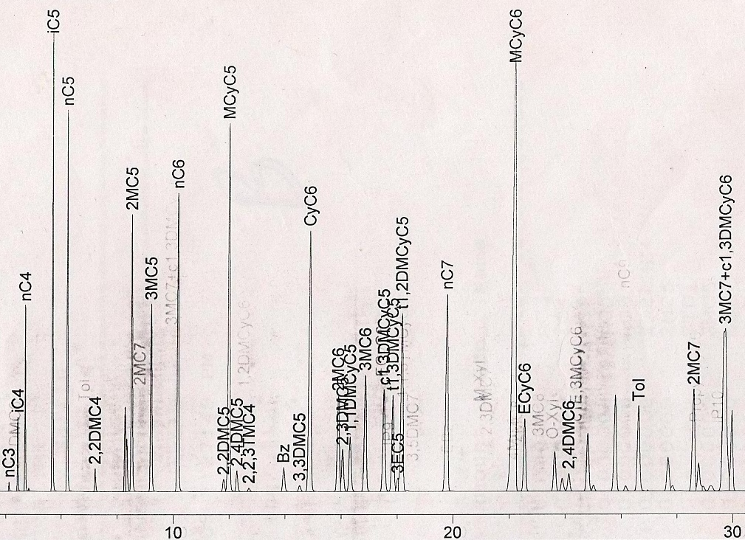 GC Fingerprint of Oil Sample CE-B3 (Central)

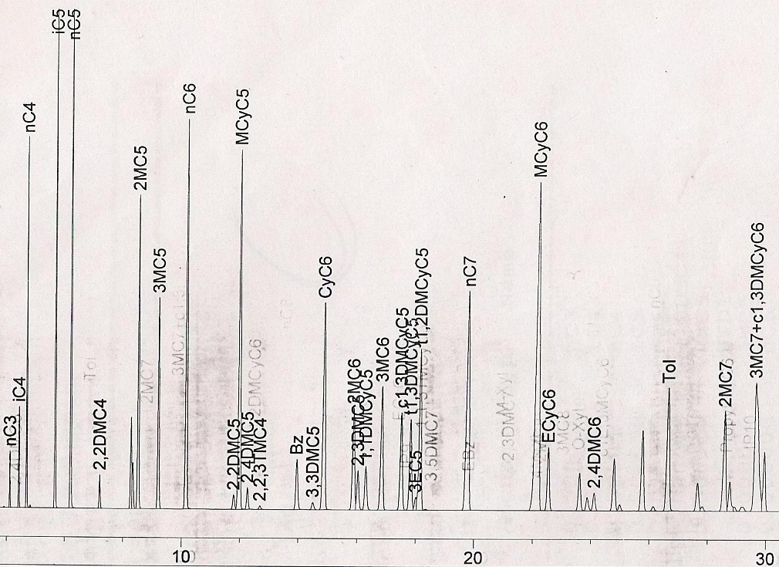 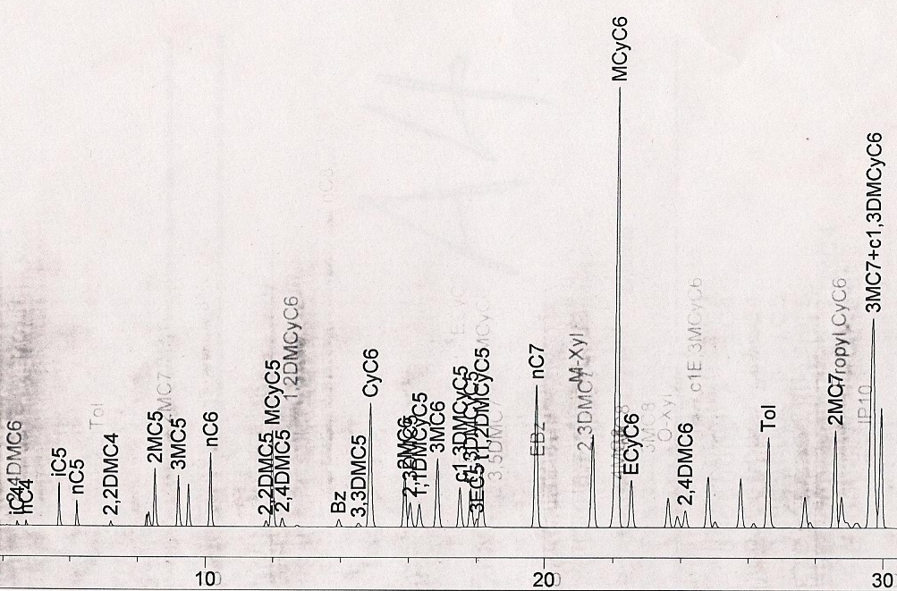 GC Fingerprint of Oil Sample CE-C7 (Central) GC Fingerprint of Oil Sample EN-A4 (Eastern)
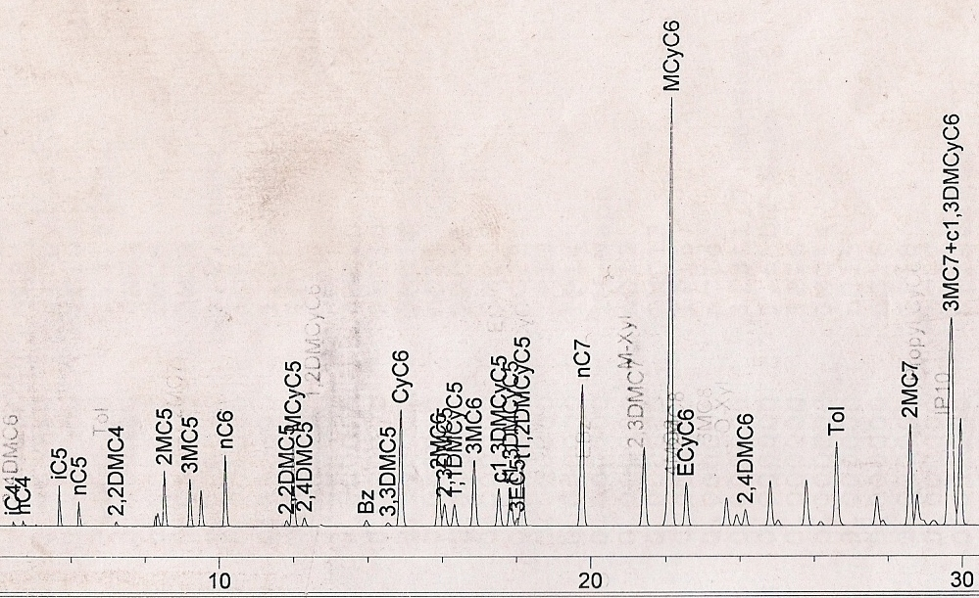 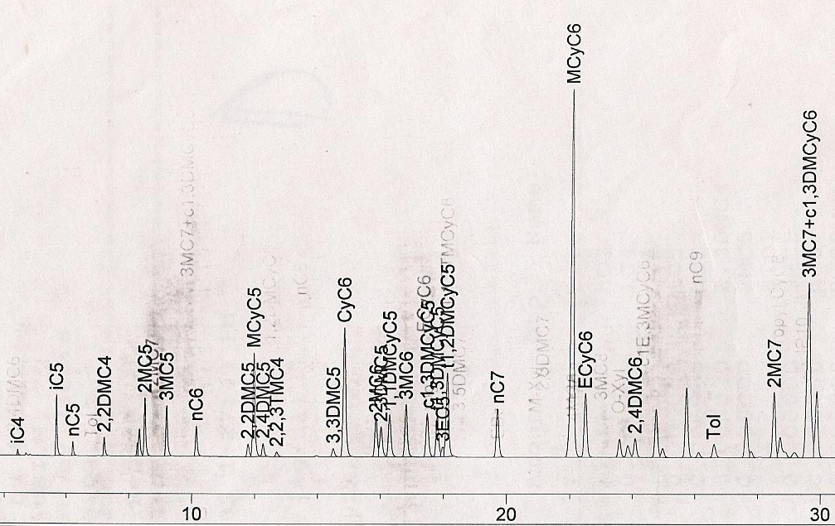 GC Fingerprint of Oil Sample EN-A9 (Eastern) GC Fingerprint of Oil Sample WT-D5 (Western)
Figure 2: Gas Chromatographic Fingerprints of the studied Niger Delta Oil Samples showing characteristic Light Hydrocarbons.

4.1 Ring preference ratios
The results for the light hydrocarbon ring preference ratios of the parent (P₁), three ring preference (3RP: P₂³ and P₃³), five ring preference (5RP: N₂⁵) and six ring preference (6RP: N₁⁶) of the five crude oil samples are presented in Table 1. Of these, notably, P₁ discriminated between the samples. The data showed that the oil, WT-D5, from the western Niger Delta had low P₁ ratio of 5.29% and separated clearly from oils
EN-A4 (12.99%), EN-A9 (13.39%) (Eastern) and CE-B3 (11.85%), CE-C7 (15.70%) (Central).
The ratios of P₂³, P₃³ and N₂⁵ ranged from 9.73 to 13.27%, 4.04 to 7.90% and 8.57 to 14.71% with no compositional variation of ring preference for correlation and/or differentiation. The ratio of N₁⁶ was observed to be high ranging from 38.47 to 55.17%. This result revealed that all the Niger Delta exhibited 6RP.
Light hydrocarbon parameter based on Mango’s invariance ratio, k₂ involving isoheptanes and dimethylcyclopentanes, supports the grouping by P₁. k₂ is a reliable indicator of source organic matter. Zhang et
al (2005) reported that marine oils are characterized by low k₂ values (average 0.23) and terrigenous oils by high k₂ values (average 0.35).

Table 2: Summary of Compositional Ring Preference Characteristics of Crude Oils from the Niger Delta.
 | Eastern Niger Delta  (Akwa Ibom State) |  | Central Niger Delta  (Rivers State) |  | Western Niger Delta  (Delta State)
Parameter | EN-A4 | EN-A9 | CE-B3 | CE-C7 | WT-D5
Total C₇ | 2374.89 | 2981.80 | 10087.06 | 13661.91 | 1194.35
P₁ | 308.52  (13.00%) | 399.18  (13.39%) | 1195.51  (11.85%) | 2144.66  (15.70%) | 63.22  (5.29%)
P₂³ | 256.52  (10.80%) | 323.89  (10.86%) | 1209.04  (11.99%) | 1812.59  (13.27%) | 116.26  (9.73%)
P₃³ | 103.83  (4.37%) | 124.98  (4.19%) | 496.03  (4.92%) | 689.52  (5.05%) | 94.39  (7.90%)
N₂⁵ | 221.13  (9.31%) | 271.89  (9.12%) | 1484.21  (14.71%) | 1899.12  (13.90%) | 167.93  (14.06%)
N₁⁶ | 1239.06  (52.17%) | 1561.44  (52.37%) | 4256.61  (42.20%) | 5255.32  (38.47%) | 549.60  (46.02%)
MCyC6 | 1025.63  (43.19%) | 1309.08  (43.90%) | 3706.01  (36.74%) | 4075.86  (29.83%) | 529.06  (44.30%)
Tol | 213.43  (8.99%) | 252.36  (8.46%) | 550.60  (5.46%) | 1179.46  (8.63%) | 20.55  (1.72%)
k₂ | 0.22 | 0.21 | 0.18 | 0.19 | 0.33
MCyC6 = Methylcyclohexane Tol = Toluene

This data classifies WT-D5 crude oil (0.33) as terrigenous organic input to source and CE-B3 (0.18), CE-C7 (0.19), EN-A4 (0.22) and EN-A9 (0.21) as marine organic input to source.
A plot of isoheptanes and dimethylcyclopentanes is presented in fig. 3. The ring preference plot further supports k₂ in that CE-B3, CE-C7, EN-A4 and EN-A9 crude oils remained constrained and distinct from WT-D5 crude oil.

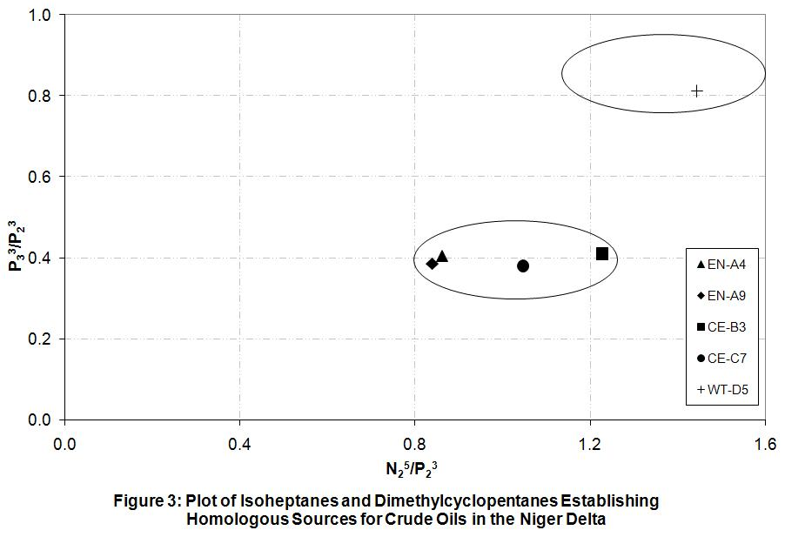

4.2 Invariance of Ring Preference
An invariance plot of ring preference, fig. 4, establishes definitely that the Central (CE-B3, CE-C7) and Eastern (EN-A4, EN-A9) crude oils are similar and different from the Western (WT-D5 (Western) oils. This again remains consistent with two homologous sources (marine and terrigenous) for oils in the Niger Delta.

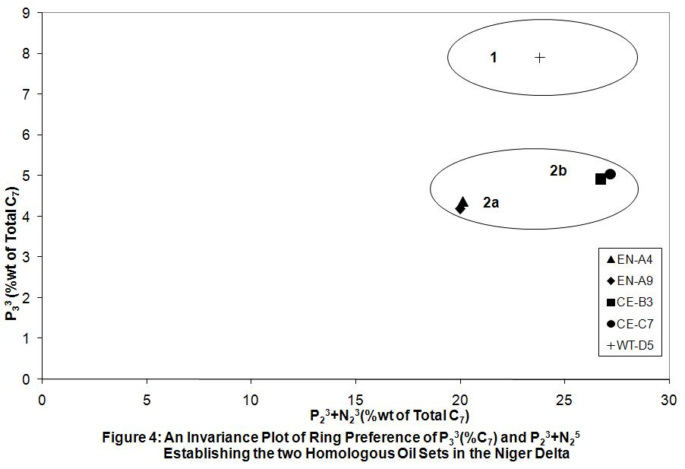

This model not only discriminated between the two main genetic oils of the Niger Delta, but also classified the marine source oils into two sub-types. This may be indicative of two sub-petroleum system or that the Central crude oils have migrated distances from the east to their present accumulations.

4.3 Microscale correlation of ring preference
Comparisons of ratios of ring preference LH compounds are put in pictorial form of a star diagram to make correlation and/or differentiation of the Niger Delta oils easier. Star diagram have been used to represent chemical compositions of oils and water samples from reservoirs, as well as correlation and/or differentiation (Halpern, 1995; Ali et al., 2002). A star diagram, with five axes, of key ring preference parameters is presented in fig. 5 and will be referred to hereafter as ring preference star diagram (RPSD). Figure 5 depicts RPSD for all the studied oils.
The RPSD showed that the Eastern (EN-A4, EN-A9) and Central (CE-B3, CE-C7 (Central) crude oils followed patterns that were similar suggesting a close grouping among the oils and is reflective of oil generation from the same source rock (marine). Gross differences were observed in the RPSD of the Western oil (WT-D5) which followed patterns different from those of the eastern and southern oils. This differentiation in patterns followed by the oils is in line with differences in source rocks between the oils (Ali et al., 2002) further confirming different sources for the western Niger Delta oils.
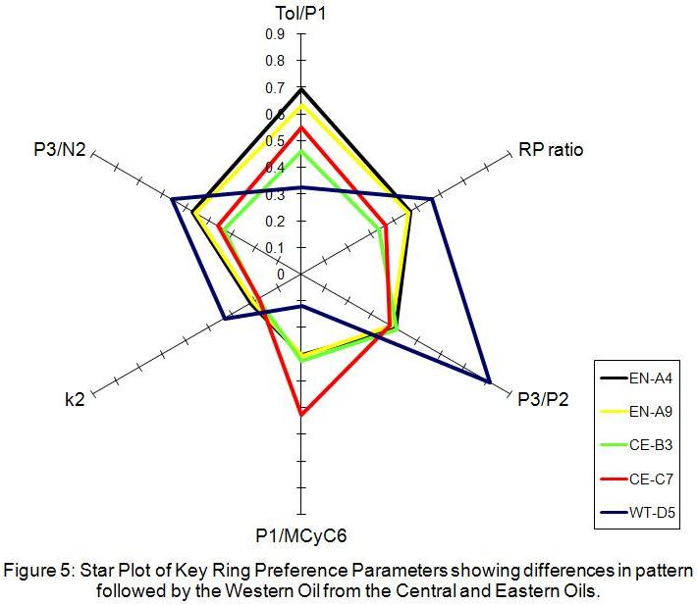

5. Conclusions
Analyses of light hydrocarbon ring preference have revealed the Niger Delta oils as exhibiting high 6RP. Parameter P1 and invariance ratio of RP, k₂, grouped the Niger Delta oils into two: marine and terrigenuous sources. This was further confirmed by ring preference plots and star diagram which delineated the two genetic sources of oils in the Niger Delta. Thus the light hydrocarbon ring preference provides a technique for interpreting the Niger Delta oils.

Acknowledgements:
We are grateful for the facilities and support provided by Exxon Mobil Co., Dr. C. I. Eneogwe Martin Iyasele.

Correspondence to:
Mark O. Onyema
Department of Pure and Industrial Chemistry, University of Port Harcourt,
P.M.B 5323 Choba,
Rivers State, Nigeria
Telephone: +234 803 041 5230
Email: onyemark@yahoo.com

References
- Ali, F.M., Al-Khadrawi, R.M, Perzanowski, H., Halpern, H.J. 2002. Central Saudi Arabia Crude Oil: A Geochemical Investigation. Petroleum Science and Technology 20, 633-654.
- Doust, H. 1990. Petroleum Geology of the Niger Delta. Geochemical Society, London, Special Publications 50, 365
- Ekweozor, C.M., Udo, T.O. 1988. The Oleananes: Origin, Maturation and Limits of Occurrence in Southern Nigeria’s Sedimentary Basins. Organic Geochemistry 13, 131-140

- Eneogwe, C. I. 2003. The Distribution of Light Hydrocarbons in Western Niger Delta Oils. Journal of Petroleum Geology 26, 479-488
- Eneogwe C.I., Ekundayo O. 2003. Geochemical Correlation of Crude Oils in the NW Niger Delta, Nigeria. Journal of Petroleum Geology 26, 95-103
- Halpern, H. I. 1995. Development and Applications of Light-Hydrocarbon-Based Star Diagrams. American Association of Petroleum Geologists Bulletin 76, 801-815
- Mango, F. D. 1990. The Origin of Light Hydrocarbons in Petroleum: A Kinetic Test of the Steady-State Catalytic Hypothesis. Geochimica et Cosmochimica Acta 54, 1315-1323.
- Mango, F. D. 1992. Transition Metal Catalysis in the Generation of Petroleum and Natural Gas. Geochimica et Cosmochimica Acta 56, 553-555.
- Mango, F. D. 1994. The Origin of Light Hydrocarbons in Petroleum: Ring Preference in the Closure of Carbocyclic Rings. Geochimica et Cosmochimica Acta 58, 895-901.
- Mango, F. D. 1997. The Light Hydrocarbons in Petroleum: A Critical Review. Organic Geochemistry 26, 417-440
- Manilla P. N. and Onyema, O. M. 2008. Correlation of Some Crude Oils Using Low Molecular Weight Geochemical Markers: A Case Study of the Niger Delta. Journal of Chemical Society of Nigeria 33, 225-234
- Osuji, L.C. and Anita B.S. 2005. Geochemical Implications of some Chemical Fossil as Indicators of Petroleum Source Rocks. Journal of Applied Science and Environmental Management 9: 45-49
- Short, K. C. and Stauble, A. J. 1967. Outline of Geology of Niger Delta. American Association of Petroleum Geologists Bulletin. 51, 761-779.
- Sonibare, O., Alimi, H., Jarvie, D. and Ehinola, O.A. 2008. Origin and Occurrence of Crude Oil in the Niger Delta, Nigeria. Journal of Petroleum Science and Engineering 61, 99-107
- Ten Haven, H.L. 1996. Applications and Limitations of Mango’s Light Hydrocarbon Parameters in Petroleum Correlation Studies. Organic Geochemistry 24, 957-976
- Tuttle, W.L.M, Brownfield, E.M. and Charpentier, R.R. 1999. The Niger Delta Petroleum System. Chapter A: Tertiary Niger Delta (Akata-Agbada) Petroleum System, Niger Delta Province, Nigeria, Cameroon and Equatorial Guinea, Africa. U.S. Geolgical Survey, Open File Report 99-50-H
- Zhang, C., Li, S., Zhao, H. and Zhang, J. 2005. Applications of Mango’s Light Hydrocarbon Parameters to Petroleum from Tarim Basin, NW China. Applied Geochemistry 20, 545-551

4/25/2011

