DNA fingerprinting of Rape seed (Brassica rapa L.) varieties of Bangladesh using SSR markers

M.R. Molla^{1*}, M.N. Islam², M.M. Rohman³, I. Ahmed¹ and L. Rahman⁴

¹Molecular Biology Laboratory, Plant Genetic Resources Centre, Bangladesh Agricultural Research Institute, Joydebpur, Gazipur, Bangladesh
²Department of Biotechnology, Sher-e-Bangla Agricultural University, Dhaka
³Molecular Breeding Laboratory, Plant Breeding Division, Bangladesh Agricultural Research Institute, Joydebpur, Gazipur, Bangladesh
⁴Department of Genetics and Plant Breeding, Bangladesh Agricultural University, Mymenisingh
rezwanbt@gmail.com, motiar_1@yahoo.com

Abstract: The identification and differentiation of the varieties through DNA fingerprinting using microsatellites (SSRs) are quite effective, when the variety specific primers are used. This is gaining importance particularly when the distinguishing a variety from others using morphological traits are becoming difficult due to use of limited elite varieties for new varieties. A set of microsatellite loci (B.n.12A, B.n.38A and B.n.59A1) has been investigate to distinguish the uniqueness of nine released rape seed (Brassica rapa L.) varieties in Bangladesh for the purpose of obtaining distinctness of the plant variety at molecular level. In the present study a total of nine rape seed (Brassica rapa L.) varieties have been used to characterize those groups. Upon PCR amplification, the alleles were separated on polyacrylamide gel using a sequencing gel electrophoresis system and visualized by silver-staining method. The loci were polymorphic in all the varieties. Differences were observed in heterozygosities in the studied varieties. The mean observed heterozygosity (Ho) and expected heterozygosity (He) were 0.124 and 0.507, respectively. Varied ranges of alleles occurred might be due to mutation of di-nucleotide repeat units which could also be indicative of varietal differences. Polymorphism Information Content (PIC) values in the present study were high which ranged from 0.481 to 0.667. UPGMA dendrogram based on Nei’s (1972) genetic distance indicated differentiation of nine varieties of rape seed into two main clusters: Tori-7, BARI sharisha-9 and BARI sharisha-12 grouped in cluster 2 while others in cluster 1. In cluster 1 Agrani and Sampad grouped together in sub-cluster I and with minimal genetic distance (0.000). Safal also showed nil genetic distance with SS-75 and BARI sarisha-6. The varieties Sampad and Tori-7 showed the highest genetic distance value (3.860). Nine rape seed varieties in this study showed unique and differential DNA banding patterns across at least one and/or combination of three primers. The data obtained can be provided some levels of identity and protection against remaining and other practices are beyond ethics and rules.
[Molla MR, Islam MN, Rohman MM, Ahmed I, Rahman L. DNA fingerprinting of Rape seed (Brassica rapa L.) varieties of Bangladesh using SSR markers. Nature and Science 2011;9(5):222-228]. (ISSN: 1545-0740). http://www.sciencepub.net.

Keywords: SSR, Genetic diversity, Polymorphism Information Content (PIC), Rape seed

1. Introduction
In Bangladesh a good number of Brassica varieties have been released and registered for cultivation. The crop genus Brassica comprises of six economically important species with great genetic and morphological diversity. The origin, evolution, taxonomy, and genomic relationships of the crop Brassicas have been reviewed extensively. These are usually cultivated for their edible oils, the content of which varies between 33 and 37% of the grains. These seed oil however contains high erucic acids and high glucossinolates. In Bangladesh these varieties, particularly the one of Brassica rapa L. (Tori-7) is a very short duration crop (75-80 days). This variety is cultivated in marginal lands mostly as monocrop.
There are extensive Brassica breeding programmes from which large number of variants is being selected every year in Bangladesh. These along with the varieties already developed and registered for cultivation are very good sources of variable genes. It is not possible to differentiate all these materials only through morphological traits so attempts have been taken to use microsatellites for analysis of variation within and between populations. It is possible through this technique to calculate the genetic distances between individuals in order to infer levels of relatedness or even to determine parentage, which often represent an important basis for subsequent evolutionary or ecological analysis of phenotypical traits (Rahman et al., 2006, Lynch, 1990 and Bowcock et al., 1994).This assumption is further clear from the study of Song et al. (1999) where according to them many commercial soybean varieties arise from limited elite entries and are often indistinguishable based on these traits. They further opined that a system based on DNA markers could provide unique DNA profiles or fingerprints for cultivars. This is more important in countries where the PVP has provisions for exemption for research purposes as in case of US PVP of 1994 which enables plant breeders to obtain Intellectual Property Rights for 20 years at the same time kept provisions for research sharing. Similar conditions exist in similar acts of many other countries. This requires the variety distinctness to be more unique and at the DNA level as in cases of forensic identification of distinctness by SSR.
In soybean, maize and potato there has been considerable works on the DNA profiling using either RAPD or SSR technique. The most important issue here is to distinguish the varieties not only at the morphological trait level but also at the DNA level. With increasing number cultivars in Bangladesh and the presently amended acts of Plant Variety and Farmers Right Protection Act (PVFRPA) where breeder’s right has been given, the necessity of DNA level distinction has become necessary. With the increase number of varieties being in the farmers’ field, there has been an interest to differentiate these varieties at molecular level so that the variety identification can lead to use of both morphological and molecular characters. The Ministry of Agriculture, Government of Bangladesh decided to characterize these varieties at their molecular level. The present study was an attempt to distinguish the uniqueness of the variety and establish genetic diversity of the nine of rape seed varieties in Bangladesh using a moderate number of primer pairs.

2. Materials and Methods

2.1 Collection of samples and isolation of genomic DNA:
Seeds of nine rape seed (Brassica. rapa L.) varieties were collected from Oilseed Research Center of Bangladesh Agricultural Research Institute [Sonali sarisha (SS-75), Kalayania (TS-72), Tori- 7, BARI sarisha-6, BARI sarisha-9 and BARI sarisha-12) and Department of Genetics and Plant Breeding, Bangladesh Agricultural University, Mymensingh (Sampad, Agrani and Safal)]. Seeds were germinated and grown at aseptic condition. Fresh leaf samples of 12-days-old seedling were used as the source of genomic DNA. Leaf tissues were cut into small pieces, homogenized and digested with extraction buffer (50 mM Tris-HCl, 25 mM EDTA, 300 mM NaCl and 1% SDS, pH 8.0). After incubation for 20 minutes at 65 ºC with intermittent swirling, the mixture was emulsified with an equal volume of phenol: chloroform: isoamyl alcohol (25:24:1 v/v/v). DNA was precipitated using two volume of absolute alcohol in presence of 0.3M sodium acetate and pelleted by centrifugation. The pellets were then washed with 70% ethanol, air dried and re-suspended in an appropriate volume of TE buffer (10 mM Tris-HCl, 1 mM EDTA, pH=8.0). DNA quality was checked by electrophoresis in a minigel and quantification was accomplished using a spectrophotometer (Spectronic® Genesis™, Spectronic Instruments Inc., USA).

2.2 Microsatellite markers and PCR amplification:
A set of five microsatellite loci ( B.n.12A, B.n.35D, B.n.38A, B.n.59A1 and B.n.68/1) have been selected from the literature cited by Szewc-McFadden et al. (1996) to estimate the potential of these marker for variety identification. Finally three primers, B.n.12A, B.n.38A and B.n.59A1 were selected based on their performance for SSR data analysis (Table 01). Polymerase Chain Reactions were done in a volume of 10 μl containing 10X PCR Buffer, 0.25 mM each of the dNTPs, 2.5 µM of each primer, 1 unit ampli Taq DNA polymerase, 50 ng template DNA and a suitable amount of sterilize deionized water. Amplification were carried out in a oil free thermal cycler (Thermal cycler gradient, Eppendorf) with the following program: Initial denaturation at 94 ºC for 3 min followed by 35 cycles at 95 ºC for 30 sec, 58 ºC for 45 sec, and 72 ºC for 1 min and a final cycle at 72 ºC for 7 min. PCR products were checked in 2% agarose gel.

2.3 Determination of Microsatellite allele lengths:
PCR products were electrophoresed on a 6% denaturing polyacrylamide gel containing 19:1 Acrylamide: Bis acrylamide and 8M urea. Electrophoresis was done using the Sequi Gen GT sequencing gel eletrophoresis system (BIO-RAD Laboratories, Hercules, CA). A pre-run of the gel for 30 minutes at 120W was followed by a final run at 60W and 50 ºC upon loading of denatured PCR products for a specified period depending on the size of amplified DNA fragment (usually 1 hour for 100 bp). After completion of electrophoresis, the DNA fragments were visualized following the Promega (Madison, WI) Silver-staining protocol. The size (in nucleotides) of the most intensely amplified band for each microsatellite marker was determined based on its migration relative to molecular weight (mw) size markers (100bp DNA ladder, Genei, India).

2.4 Analysis of microsatellite data:
The bands representing particular alleles at the microsatellite loci were scored manually and designated the bands as A, B, C etc. from the top to the bottom of the gel. The genotypes of different strains were scored as AA, BB, CC etc. for homozygous or as AB, AC, BC etc. for heterozygous. A single genotypic data matrix was constructed for all loci. The software DNA FRAG version 3.03 (Nash, 1991) was used to estimate marker length and allelic length.

Table 1. Details of the microsatellite markers used in this study
Sl. No. | Locus | Forward Primer | Reverse Primer | Ann.T.
1 | B.n.12A* | gcc-gtt-cta-ggg-ttt-gtg-gga | gag-gaa-gtg-aga-gcg-gga-aat-ca | 58 ºC
2 | B.n.19A | cac-agc-tca-cac-caa-aca-aac-cta | ccc-cgg-gtt-cga-aat-cg | 58 ºC
3 | B.n.38A* | caa-ggc-caa-aag-tgt-cca-t | acg-ctg-tct-tca-ggt-ccc-act | 58 ºC
4 | B.n.59A-1* | tgg-ctc-gaa-tca-acg-gac | ttg-cac-caa-caa-gtc-act-aaa-gtt | 58 ºC
5 | B.n.68A-1 | tcg-cat-gct-cct-cta-gac-tcg | ttt-agc-acg-gga-atg-tca-gg | 58 ºC

Ref: Szewc-McFadden et al. (1996)

3. Results and Discussion
SSR profiles of nine rape seed (Brassica rapa) varieties tested with three primers are presented in Figure 1 in which three consecutive lanes presented each of the varieties and each lane with single individual. Allelic variation and diversity index (PIC) are shown in Table 2. All three microsatellite markers were found to be polymorphic, revealing a total of nine alleles with an average number of three alleles per locus in the nine rape seed (Brassica rapa) varieties examined (Table 2). At the B.n.12A locus, a total of three different alleles were identified among the nine rape seed genotypes ranging in size from 271 bp to 321 bp. Likewise, 3 alleles (size ranging from 149 bp-153 bp and 431 bp-450 bp) were detected at the locus B.n.38A and B.n.59A1 respectively (Table 2). Varied ranges of alleles occurred might be due to mutation of di-nucleotide repeat units which could also be indicative of varietal differences (Molla et al., 2007). The SSR are usually used widely for the analysis of the variations within and between populations. The distance calculations are based usually on the proportion of shared alleles (Lynch, 1990 and Bowcock et al., 1994) This method followed implicitly the infinite allele model, thus assuming independence of alleles and ignoring mutational processes, which can result in a biased distances especially when alleles are highly polymorphic. The identified SSR primers sometimes may not only indicate the locus of a single genome when the genomic constitution of the variety or the species is of long association and might have the possibility of sharing the gene(s) of one genome with that of the other accrued in the same genome through mutation of any dimension. This is more common when the tetraploidy happens in a population where the number of locus of the same gene(s) became double the number in diploid, and may also became three instead of four because of the nature of gene balance and gene recombination in the tetraploidy, which is part of the mutation by number of genome.
Brassica campestris or B. rapa is a diploid with AA genome of 2n=2x= 20, while B. napus (2n=2x=38) or rapeseed is an amphidiploid with B. rapa as one of its putative parents. The other parent is B. oleracea having CC genome of 2n=2x=18. These informations on the basic diploid also indicate that the 20 chromosome of B. rapa or 18 chromosome of B. oleracea have also absorbed the chromosome of two types of presently unknown sources. In case of the B. rapa, the selection for seed in the Mediterranean, Near east and India resulted into oleifera, dichotoma and trilocularis which have further given rise to chinensis, pekinensis and nippossinica having same number of chromosome with same AA designation, because they do easily get crossed with fertile fruits and seeds. This indicates the flexibility in its genomic constitution with absorbed micro-mutants.

Table 2: Size and frequency of alleles and diversity index at three microsatellite loci in nine rapeseed (Brassica rapa L.) varieties
Locus | Allele Size (bp) | Allele frequency | Diversity Index  (PIC=1-∑Xi²)
B.n.12A | 321 | 0.6852 | 0.481
B.n.12A | 312 | 0.1667 | 0.481
B.n.12A | 271 | 0.1481 | 0.481
B.n.38A | 153 | 0.1111 | 0.667
B.n.38A | 151 | 0.7778 | 0.667
B.n.38A | 149 | 0.1111 | 0.667
B.n.59A1 | 450 | 0.2222 | 0.667
B.n.59A1 | 443 | 0.4444 | 0.667
B.n.59A1 | 431 | 0.3333 | 0.667

The PIC value which is the reflection of allele diversity was also estimated. The average PIC value was 0.605 and it ranged from 0.481 (B.n.12A) to 0.667 (B.n.38A and B.n.59A1). Lower PIC values were observed might be due to use of limited number of inbred rape seed varieties showing less number of alleles in our study. Gene diversity (heterozygosity) is presented in Table 3. The mean observed heterozygosity (Ho) and expected heterozygosity (He) were 0.124 and 0.507, respectively which might be due to small number of alleles (3) per locus.

Table 3. Summary of heterozygosity statistics for all loci

Locus | Obs_Hom | Obs_Het | Exp_Hom* | Exp_Het* | Nei** | Ave_Het
B.n.12A | 0.630 | 0.370 | 0.510 | 0.499 | 0.4808 | 0.272
B.n.38A | 1.000 | 0.000 | 0.623 | 0.377 | 0.3704 | 0.000
B.n.59A1 | 1.000 | 0.000 | 0.346 | 0.654 | 0.6420 | 0.000
Mean | 0.877 | 0.124 | 0.493 | 0.507 | 0.4977 | 0.091
St. Dev | 0.214 | 0.214 | 0.139 | 0.139 | 0.1366 | 0.157
* Expected homozygosity and heterozygosity were computed using
** Nei's (1973) expected heterozygosity

SSR genotypic data from a number of loci have the potential to provide unique allelic profiles or DNA fingerprints for precisely establishing genotypic identity. Comparisons between SSR band positions against each marker in this study are shown in Table 4. The band patterns corresponding to individual variety may help to recognize the variety in question. When one primer would not distinguish individual variety from others, another primer should be considered and sometimes combination of more than one primer should be taken into account. Thus additional primer or set of primers might be needed to test to identify all expected varieties.
Among nine alleles detected, three were specific to two rape seed varieties. One specific allele was detected in the variety Sampad (B.n.38A/149) and BARI sarisha-9 (B.n.38A/153) (Table 2). The three microsatellite primer pairs were able to identify and discriminate six rape seed varieties.

Table 4: Analysis of three microsatellite loci for nine rape seed varieties

Sl. no. | Cultivars | Band positions due to primers (bp)
Sl. no. | Cultivars | B.n.12A |  |  |  | B.n.38A |  |  |  | B.n.59A1
1 | Agrani | 321 |  |  | AA |  | 151 |  | BB | 450 |  |  | AA
2 | Kalayania (TS-72) | 321 | 312 |  | AB |  | 151 |  | BB | 450 |  |  | AA
3 | Sampod |  | 312 | 271 | BD |  |  | 149 | CC |  | 443 |  | BB
4 | Safal | 321 |  |  | AA |  | 151 |  | BB |  | 443 |  | BB
5 | Sonali sarisha (SS-75) | 321 |  |  | AA |  | 151 |  | BB |  | 443 |  | BB
6 | Tori-7 | 321 |  | 271 | AD |  | 151 |  | BB |  | 443 |  | BB
7 | BARI sarisha-6 | 321 |  |  | AA |  | 151 |  | BB |  | 443 |  | BB
8 | BARI sarisha-9 | 321 | 312 | 271 | ABD | 153 |  |  | AA |  |  | 431 | CC
9 | BARI sarisha-12 | 321 | 312 | 271 | ABD |  | 151 |  | BB |  |  | 431 | CC

The variety Agrani and Kalayania (TS-72) could be easily identified by the primer B.n.12A and B.n.59A1, in which Agrani showed diploid condition at locus B.n.12A (Table 4). In combination of two alleles B.n.12A 321+271 and B.n.59A1443 also identified Tori-7. Besides, BARI sarisha-12 only differed by the combination of B.n.12A and B.n.59A1 exhibiting 151 and 431 bp (Table 4). Our results represent one of the first attempts to find out a small set of microsatellite makers to discriminate rape seed varieties of Bangladesh providing meaningful data that can be enlarged by additional rape seed varieties and new microsatellite markers. Microsatellites are considered appropriate for variety identification because of their ability to detect large numbers of discrete alleles repeatedly, accurately and efficiently (Smith et. al. 1996). In a study, a minimum number of three microsatellite markers was sufficient for rapid and unambiguous discrimination of olive varieties (Dunja et. al., 2002).
UPGMA dendogram based on Nei’s (1972) genetic distance indicated segregation of nine varieties of rapeseed into two main clusters: Tori-7, BARI sharisha-9 and BARI sharisha-12 grouped in cluster 2 while others in cluster 1 (Fig. 1). In cluster 1 Agrani and Sampad grouped together in sub-cluster I with minimal genetic distance (0.000). The highest genetic distance value (3.860) was observed between Sampad and Tori-7 (Table 5). This distance is possible because the variety Sampad is of yellow sarson ecotype having self-compatibility as the nature of pollinating behaviour. The material was first introduced in Bangladesh from Czechoslovakia and subsequently with adequate selection pressure the variety was released by Bangladesh Agricultural University, Mymensingh. It is also interesting to note that the Agrani and Sampad falls in the same group also because, possibly the latter one is selection from the former.
The results of the present study could be applied as a preliminary instruction to maintain the appropriate identity of rape seed varieties and in broad sense, to protect the plant varieties of Bangladesh. The SSR profiles could distinguish some of the rape seed varieties. The unidentified varieties should be characterized at more loci and a set of least number of informative loci to be identified for variety identification. The data obtained can be used for varietal survey and the construction of a database of all rape seed varieties grown in Bangladesh, providing also additional genetic information of the agronomic and quality characteristics of rape seed varieties.

4. Acknowledgement
This research presented here was supported by the institution, Seed Industry Development under the Ministry of Agriculture, Government of the Peoples Republic of Bangladesh with the financial assistance of Danish International Development Agency (DANIDA). The technical support provided by Prof. Dr. Md. Samsul Alam of the Department of Fisheries Biology and Genetics at Bangladesh Agricultural University, Mymensingh, is acknowledged with appreciation.

Correspondence to:
M.R. Molla
Scientific Officer
Plant Genetic Resources Centre
Bangladesh Agricultural Research Institute
Joydebpur, Gazipur-1701, Bangladesh
E-mail: rezwanbt@gmail.com
Cellular phone: +8801712570443

Emails: rezwanbt@gmail.com
motiar_1@yahoo.com

Table 5. Summary of Nei’s (1972) genetic distance values between nine rapeseed (Brassica rapa L.) varieties for all loci

Varieties | Agrani | Kalayania  (TS-72) | Sampad | Safal | Sonali sarisha (SS-75) | Tori-7 | BARI sarisha-6 | BARI sarisha-9 | BARI sarisha-12
Agrani | ****
Kalayania  (TS-72) | 0.090 | ****
Sampod | 0.000 | 2.025 | ****
Safal | 0.4055 | 0.602 | 1.018 | ****
Sonali sarisha (SS-75) | 0.405 | 0.602 | 1.018 | 0.000 | ****
Tori-7 | 0.443 | 0.610 | 3.860 | 0.449 | 0.443 | ****
BARI sarisha-6 | 0.405 | 0.602 | 1.018 | 0.0000 | 0.000 | 0.443 | ****
BARI sarisha-9 | 1.677 | 1.992 | 2.4086 | 1.677 | 1.677 | 0.549 | 1.677 | ****
BARI sarisha-12 | 0.697 | 0.670 | 2.185 | 0.697 | 0.697 | 0.077 | 0.697 | 0.562 | ****

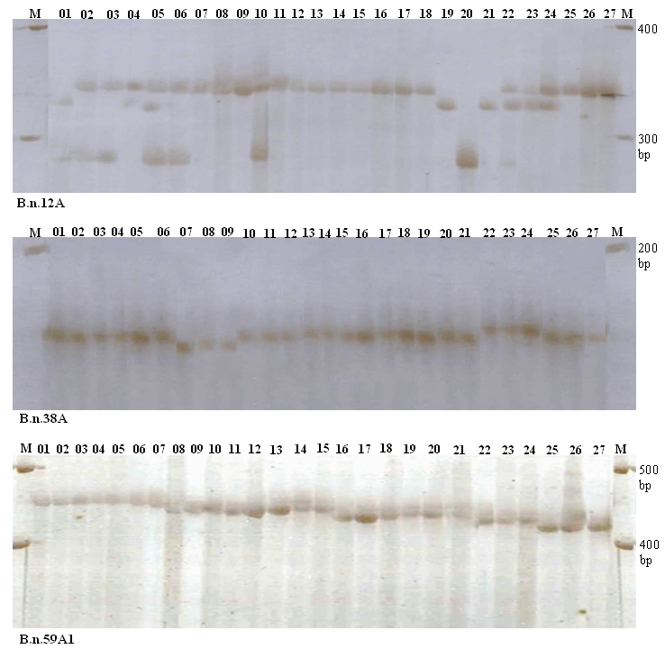
Figure 1. Microsatellite profiles of nine rape seed (Brassica rapa L.) varieties across three loci, B.n.12A, B.n.38A and B.n.59A1. Lanes, 1-3 = Agrani; 4-6 = Kalayania (TS-72); 7-9 = Sampad; 10-12 = Safal; 13-15 = Sonali sarisha; 16-18 = Tori 7; 19-21 = BARI sharisha-6; 22-24 = BARI sharisha-9; 25-27 = BARI sharisha-12. M: Molecular wt. Marker (100 bp DNA ladder)

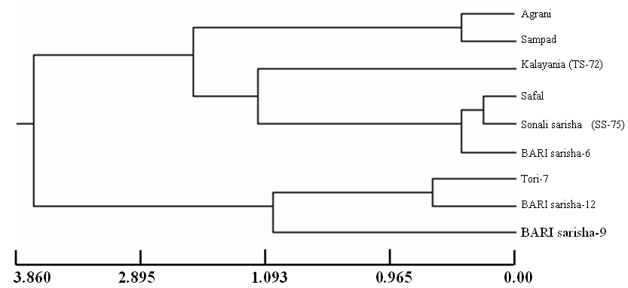

Figure 2. UPGMA dendrogram based on Nei’s (1972) genetic distance, summarizing the data on differentiation between five Rapeseed varieties according to microsatellite analysis.

References
[1]. Bowcock, A.M, A. Ruizlinares and J. Tomfohrde, 1994. High-resolution of human evolutionary tress with polymorphic microsatellites. Nature, 368: 455-457.
[2]. Dunja, B, J. Jakse and B. Javornik, 2002. DNA fingerprinting of olive varieties by microsatellite markers. Food Technol. Biotechnol., 40: 185-190.
[3]. Lynch, M., 1990. The similarity index and DNA fingerprinting. Mol. Biol. Evol,, 7: 478-484.
[4]. Molla, M. R., M. N. Islam L. Rahman, 2007. DNA fingerprinting of Maize (Zea mays Linn.) cultivars of Bangladesh using SSr markers. Bangladesh. J. Crop. Sci., 18(1):63-72.
[5]. Nash J.H.E., 1991. DNAfrag, Version 3.03. Institute for Biological Sciences, National Research Council of Canada, Ottawa, Ontario, Canada.
[6]. Nei, M., 1972. Genetic distance between populations. American Naturalist, 106: 283-292.
[7]. Nei, M., 1973. Analysis of gene diversity in subdivided populations. Proc. Natl. Acad. Sci. USA, 70: 3321–3323.
[8]. Rahman, L., M.R. Molla, S. Sultana, M. N. Islam, N.U. Ahmed, M. S. Rahman, M.A.N. Nazim-ud-doula, M.S. Alam and M.S.Alam, 2006. Plant Varieties of Bangladesh: Morphological and Molecular Characterization. Seed Industry Development, Ministry of Agriculture, Government of the Peoples’ Republic of Bangladesh, 486.
[9]. Smith, S. and T. Helentjaris, 1996. DNA fingerprinting and plant variety protection. In : Paterson AH (ed) Genome Mapping in Plants (Landes Cpmpany), 95-110.
[10]. Szewc-McFadden, A.K., S. Kresovich, S.M. Bliek, S.E Mitchell and J.R. McFerson. 1996. Identification of polymorphic, conserved Simple Sequence repeats (SSRs) in cultivated Brassica species. Theor. Appl. Genet., 93: 534-538.

4/07/2011

