Geomorphic Evidence of Active Tectonics in the Dhundsir Gad Watershed of Alaknada Basin, Uttarakhand, India

Hari Ballabh¹, Devi Datt Chauniyal¹ & Mahendra Singh Lodhi^{2, *}

1. Department of Geography, H.N.B. Garhwal University, Srinagar, Uttarakhand 246174, India
2. GB Pant Institute of Himalayan Environment & Development, North East Unit, Itanagar, Arunachal Pradesh 791113, India
ballabh2228@gmail.com, chauniyal_devidatt@yahoo.co.in, mahen29.mail@gmail.com

Abstract: The study of geomorphological features of a watershed can help in understanding the behavior of active tectonic movements. In view of the geological and geomorphic importance the Himalayan region, the importance of study the geomorphic features such as river meander, confluence angle, channel direction etc., works as a driving force for investigating the temporal changes in these features. Dhundsir Gad, a tributary of Alaknanda river in Lesser Himalaya is a small geomorphic unit, which is important for the activity along the North Almora Thrust (NAT) which cross the Dhundsir Gad and separate it into two tectonic units. As a result drainage anomalies are developed along the course of river. In the present study geomorphic analyses of drainage basins were carried out using topographical maps, aerial photographs and satellite imageries. The strong control by the thrust, faults and lineaments on the drainage network is well signature in the form of drainage pattern and seasonal rivulets.
[Hari Ballabh, Devi Datt Chauniyal & Mahendra Singh Lodhi. Geomorphic Evidence of Active Tectonics in the Dhundsir Gad Watershed of Alaknada Basin, Uttarakhand, India. Nature and Science 2011;9(6):1-6]. (ISSN: 1545-0740). http://www.sciencepub.net.

Key words: geomorphology; drainage anomalies; active tectonics; lesser Himalaya; Alaknanda river

1. Introduction
The landforms like mountains, plains, valleys, river etc. are analogous in their formation with reference to the tectonic changes in earth subsurface. The changes in their feature and shape can also be interlinked to the tectonics to a great extent. Tectonic deformation causes change in channel slope, which in turn is responsible for variations in channel morphology, fluvial processes, and hydrological characteristics of a river system (Jain and Sinha, 2005). A good amount of important literature on earlier studies of active tectonic in Himalayan region and their linkages to geomorphology has been cited in Jain and Sinha (2005), and Singh and Awasthi (2010). The work done so for in this particular dimension and region further explicates the importance and scope for supplementary studies in lesser Himalayas so that the available knowledge can be strengthen. Certainly the Himalaya is the greatest mountain range in the world and in recent years a lot of attention by the researchers and environmentalist has been paid to study the geological and hydrological aspects in different parts of the region. The tectonic characteristics of lesser Himalaya have been studied by many researchers so far. However, the recent tectonic activity within the Lesser Himalaya is common and is evident in the form of changing river courses (fossil valleys), entrenched meanders, river gorges, raised aggradational and degradational terraces (Sati et. al., 2007).

2. Study Area
The representative watershed is the right bank tributary of the Alaknanda river which is located in the Tehri Garhwal (Kirtinagar Tehsil) of Uttrakhand (Figure 1). Geographically the watershed is bounded by 78o 44’ to 78o 49’ E. long and 30º13’ to 30º 23’ N lat covering 50.5 km² area. The Dhundsir Gad rises from the Maniknath hill range in the north at the height of 2360 m. and joins with Alaknanda at the height of 520 m near Dhundprayag. Tola Gad, Negail Gad and Udiyar Gad are the main tributaries of the Dhundsir Gad. The climate of the study area is sub-tropical and average annual rainfall varies from 100 – 150 cm.

3. Methodology
Stimulated by the already completed research work in Himalayan region and to add a new testimony in the research domain for this particular part of Indian Himalaya, the present study was planned and executed following a relatively simpler methodology. The present study attempts to present the observed geomorphologic responses as tectonic changes in a small watershed of Lesser Himalaya. To study the geomorphic responses in the highly stressed zone of the Lesser Himalaya, a small watershed known as Dhundsir Gad was selected. The geomorphic and hydrographic features of Dhundsir Gad have been analyzed with the help of Survey of India (SoI) topographic maps, field data and Google imagery. The geomorphometric parameters were extracted on 1:25,000 scale and rectified further with ground-truth field data. This paper also illustrates the spatial mapping of active faults delimitated on geomorphological features such as drainage pattern, change in river course, fault etc.

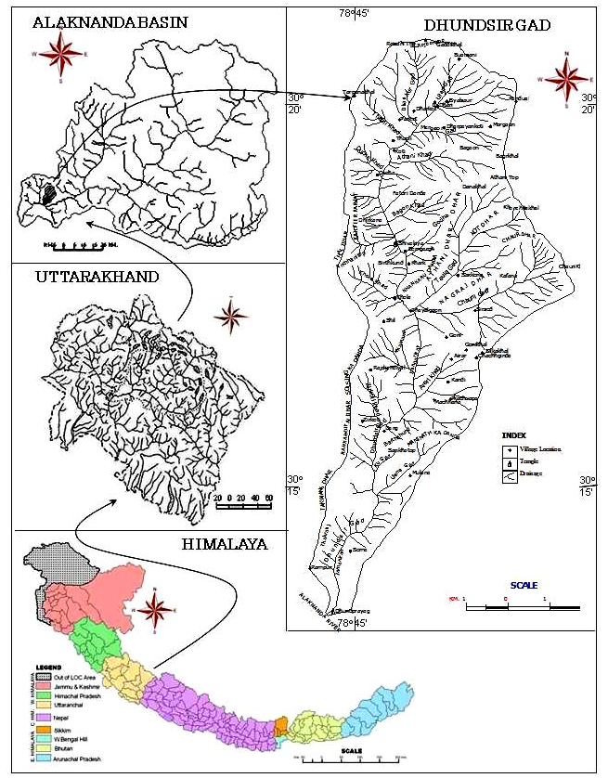
Figure 1: Location of the study area.

4. Results

Dhundsir Gad watershed is situated across the North Almora Thrust (NAT) in the Tehri Garhwal near Srinagar. North Almora Thrust (NAT) through NW to SE direction with very steep dipping rocks which separates the two tectonic units. Garhwal group of rocks consists of Sandra, Deoban (upper, middle and lower) and Damta formations. The Garhwal group consists of ferruginous quartzite, phyllite, slate and dolomite limestone rocks. This sequence is characterized by extensive occurrence of meta-basic rocks. Arrenceous, carbonaceous and micaceous three types of phyllitic rocks are well exposed in the study area. Large number of folds, fractures, faults, lineaments and joints control the drainage landform pattern of the watershed. The major stream follows the synclinal axis of folds. The thrusts and faults have changed the course of the river at numerous places, and the river become sinuous in nature. The Dhundsir Gad generally follows the N-S trend of lineament. The fourth order tributaries of Dhundsir Gad follow the NE-SW trend of lineaments, while the NW-SE trend of lineaments are follows by third order streams.
Geomorphologic parameters of a watershed are the faithful indicators of hydrological characteristics. Dhundsir Gad is a 5th order stream which flows through a very steep gradient. Longitudinal profile of the stream shows the concave curve near to the base level. This indicates that the Dhundsir Gad passing through a major fracture which is commonly found along and across the major tectonic unit. This linear feature is reactivated and displaced by later phase of successive tectonic phases, so that the stream flows along a tear fault from Pailgaon to Jhirkoti (Figure 2). The major geomorphologic feature of the watershed is deep vertical gorges and “V” shaped valley throughout the channel course. Old landslide, scree cones and colluvial fan are prominent features on the dip and scarp slopes. Before joining the master stream at Dhundprayag it forms a river meander. In the upper part (from Shivalaya to Zirkoti) the river flows in almost state course and the shape of the profile is smooth. The basic reason of such smooth profile curve is the river flows throughout quartzite resistant terrain. In the middle part, the river is passing through a very narrow gorge and there are number of knick points, falls and rapids which shows the episodic upliftment of the Himalaya. The lower valley bottom walls are narrow and steeper.
Dhundsir Gad watershed is characteristically a branching river system responding to ongoing tectonic deformation in the basin. The relatively flat mountain terrain is deformed by several active deformation processes, which divide the area in different tectonic blocks. Each tectonic block is characterized by association of fluvial anomalies viz. compressed meanders, knick point in longitudinal profiles, channel incision, anomalous sinuosity variations, sudden change in river flow direction, river flow against the local gradient and distribution of over bank flooding, and waterlogged area.
Geomorphic features in a watershed provide a support in recognizing the tectonic movements. The approach using Google Earth web images and topographic maps coupled with field observations have provided information on the nature of movement of local faults. Dhundsir Gad river response to active tectonics depends upon the nature and amount of vertical movement in the basin and the trend of the fault with respect to river flow. In Dhundsir Gad, most of the subsurface faults are cutting across the river channel. The differential movements along these faults have produced tilting that triggered channel avulsion and shifted river flow from NW to SE.
Based on the study the following anomalies can be recognized in the study area:

4.1. Compressed meander
One of the compressed meander can be recognized at village Koti, where there is a 1 km band of river. The main stream is flowing in a state of direction from NE to SW but the stream suddenly bands towards west and then turn to southeast direction (Figure 2 & Figure 3). It is the result of an active tectonic and folding of rocks. It seems like a folded nose through which the stream flows in a semi circle rout.

4.2. Change in confluence angle
Generally, it is seen that the master stream bands to join in main stream either at an acute angle or at right angle, but in the study area there are places where the main stream is banding to meet their tributaries. At the place of Dharpayankoti the tributary streams flows in a state direction while the main stream join in tributary stream from right angle. Similar type of drainage anomalies is also recognized between Dhundsir Gad and its tributaries channels. Out of these some other examples of confluence angle are also recognized in 3rd order and 2nd order streams of many locations.

4.3. Change in channel course
The main examples of such anomalies are near Dharkot in the upper valley, the second order tributary of Taula Gad (Khal Dhar) near the village Sirsed (Figure 2) and second order tributary of Nagelagair Gad near the village of Kafana, this also shows the evidence of active tectonics in the Himalaya region. Last two examples are the result of stream capturing during alternate deformation stages of the region.

4.4. Channel course direction
Generally, the tributary streams join in the main stream either from right angle of in the acute angle. But one of the typical examples of course direction is seen near Khark village. One of the third order stream and its tributary locally known as Khad joins the master stream (Dhundsir Gad) from opposite directions at abuts angle (150º) which shows that the stream flows in a major linear feature either fracture or fault. Similar type of examples is also noted at Rankandiyal village.

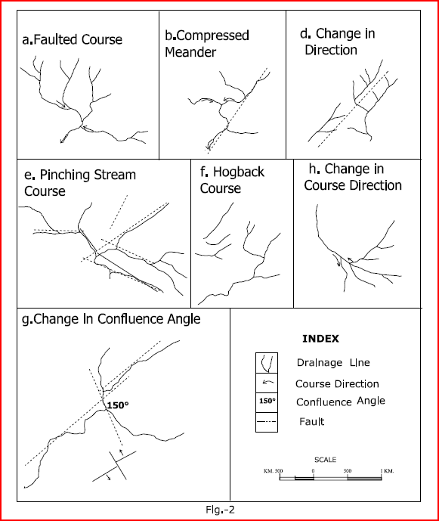
Figure 2: Drainage Anomalies of Dhundsir Gad.

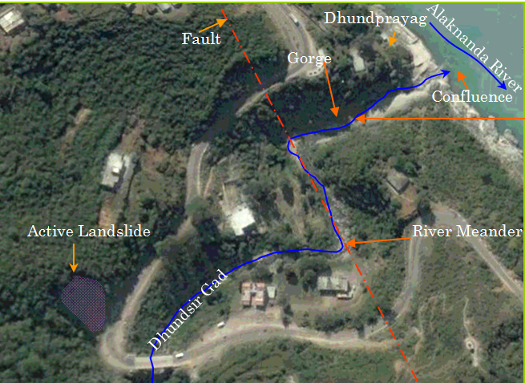
Figure 3: River meander of Dhundsir Gad at Dhundprayag (Image Source: googleearth.com)

4.5. Change in length, order and area
The main stream have longer course, large areal expansion and rises from highest elevation, but this criteria cannot applied in case of Dhundsir Gad and Dhankur Gad. The Dhundsir Gad rises at the higher of 2360 m while the Dhankur Gad rises at the elevation of 2300 m. Secondly, before making their confluence at Dhari the order of the Dhundsir Gad is lower (3rd) while the Dhankur Gad order is higher (4th). If we see the areal expansion of both these streams than we found that the area of tributary stream is higher than the main stream. Another example of change of order is also found between Dhundsir Gad and Chauri Gad. Here the tributary stream of Chauri Gad is of higher order (5th) while the master stream of the area is of immediate lower order (4th). It is also a typical drainage anomaly in the study area.

5. Conclusions
The drainage anomalies in the present drainage basin may be result of continued tectonics disturbances in the Himalaya. The following conclusions can be drawn from above discussion:
- The fluvial terrain in the study area have responded and adjusted to slow and subtle active tectonic movements. These adjustments can be recognized using geomorphic data.
- All subsurface faults in the basin are presently active and have produced distinctive response manifested as fluvial anomalies.
- Typical responses to uplift included development of compressed meanders, convexity in longitudinal profile, pinching of stream, anti flow direction, stream piracy, and frequent channel avulsions. The stream is showing sudden change in flow direction because of the change in local relief and increased over bank flooding. This study suggests significant differences in tectonic setting and activation of sub-surface faults within Dhundsir Gad.

Correspondence to:
Mahendra Singh Lodhi
G.B. Pant Institute of Himalayan Environment & Development
North East Unit, Vivek Vihar
Itanagar – 791113
Telephone/FAX: +91-360-2211773
Email: mahen29.mail@gmail.com

Information of Authors:
1. Dr. Hari Ballabh
Department of Geography, H.N.B. Garhwal University, Srinagar 246174, Uttarakhand, India

E-mail addresses: ballabh2228@gmail.com

Contact Numbers: +919412924847 (Mob.)

2. Dr. Devi Datt Chauniyal
Professor, Department of Geography,
H.N.B. Garhwal University, Srinagar 246174, Uttarakhand, India

E-mail addresses: chauniyal_devidatt@yahoo.co.in
Contact Numbers: +91-1346-211530

3. Mahendra Singh Lodhi*
G.B. Pant Institute of Himalayan Environment and Development,
NE Unit, Vivek Vihar, Itanagar, Arunchal Pradesh, India
Email: mahen29.mail@gmail.com
Telephone/FAX: +91-360-2211773

References
- Sati SP, Sundriyal YP, Rawat GS. Geomorphic indicators of neotectonic activity around Srinagar (Alaknanda Basin), Uttarakhand. Current Science 2007; 2 (6): 824-829.
- Jain V, Sinha R. Response of Active Tectonics on the Alluvial Baghmati River, Himalayan Foreland Basin, Eastern India. Geomorphology 2005; 70: 339-356.
- Singh T, Awasthi AK. Stream Profiles as Indicator of Active Tectonic Deformation Along the Inter-Foreland Thrust, Nahan Salient, NW India. Current Science 2010; 98 (01): 95-98.

3/24/2011

