The Study of Gastric Motility and Helicobacter Pylori Infection in Hypothyroidism

Fadila Gad Allah ,Salwa Seddik, Inas Elkhder ,Iman Kamel

Departments of Endocrinology and Gastro-enterology, Ain Shams University,Cairo, Egypt.
salwaseddeek@hotmail.com

Abstract:The patients suffering from hypothyroidism are at increased risk of developing disturbances in the digestive system. The gastric motility dysfunction may be present early in hypothyroidism. The Helicobacter pylori infection, which is prevalent in developing countries, is possibly related to hypothyroidism.To study the disturbance in gastric myoelectrical activity as well as the infection with Helicobacter pylori in hypothyroidism.40 hypothyroid female subjects aged 20-40 years of age were chosen the study, with duration of hypothyroidism less than 5 years and a mean body mass index 25.4%. None of the patients had a history of surgery or radioiodine therapy. 40 normal females were chosen as matched controls. Electrogastrography ( EGG) was done for each case using mixed fluid and a carbohydrate solid meal. The Helicobacter pylori antibody Ig G was measured in each case by ELISA. Electrogastrography in hypothyroid patients showed a decrease in the percentage of normal dominant frequency( DF) in the fasting and post prandial periods. The power ratio( PR) was low in hypothyroid patients; thus demonstrating dysrhythmic wave forms. The distribution of post prandial dip was 65% in hypothyroid subjects and 70% in control. EGG parameters were not significantly different between hypothyroid and normal controls. During the study of gastric dysrthymia by visual analysis of Electrogastrograpgy, normogastria was found in 82.5% hypothyroid patients, bradygastria in 12.5% and tachygastria in 5% of hypothyroid patients as opposed to 90%, 5% and 5% in control respectively. There was no correlation between thyroid hormone levels and various EGG parameters. The positive Helicobacter pylori infection ratio was positive in 62.5% of patients and in 25% of control, with significant higher titer in hypothyroid patients (mean = 2.71) as compared to normal controls (mean= 1.55). There was positive correlation between EGG parameters and Helicobacter titer in power cycle per minute( CPM) at rest only. The Electrogastrography changes in hypothyroid patients could explain the dysfunction in gastric motility present in hypothyroidism. The gastric dysrhythmia by visual analysis of Electrogastrography especially bradygastria may be related to the dyspeptic symptoms in hypothyroidism. The high titer of Helicobacter pylori could be associated with the autoimmune process or related to the changes in gastric motility in hypothyroidism.
[Fadila Gad Allah ,Salwa Seddik, Inas Elkhder ,Iman Kamel. The Study of Gastric Motility and Helicobacter Pylori Infection in Hypothyroidism. Nature and Science 2011;9(6):7-13]. (ISSN: 1545-0740). http://www.sciencepub.net.

Keywords: Helicobacter, hypothyroidism, motility.

1-Introduction:
Thyroid hormones act on almost all organs throughout the body and regulate the basal metabolism of the organism (1). The gut and viscera are not spared, and disturbances in thyroid function have numerous gastro intestinal manifestations, the true incidence of which is unknown (2). Patients with dysthyroidism are at an increased risk of developing specific pathologies in the digestive system , whether due to thyroid hormone disturbance or associated with a particular thyroid disease. (3). Gastro intestinal motor dysfunction has been widely accepted as the main cause of symptoms but many complex phenomena have not yet been completely elucidated (4). Thyroid hormones may influence gut motility modulating neurological and smooth muscle function as there may be a synergism between the direct effect of thyronins and indirect effect mediated by cathecolamines on the muscle cell receptors.(5). Hypothyroidism was associated with decreased frequency of rhythmic colonic activity and slower oro-cecal transient time both in animal and in human subjects (6). The effect of hypothyoidim on the gastrointestinal tract seems to be multifactorial with possible alterations in hormone receptors, neuromuscular disorders and myopathy caused by infiltration of the intestinal wall. Reduction of peristalsis is the main pathophysiologic process and constipation remains the most frequent gastrointestinal complaint (7). Hypothyroidism is considered as a risk factor for small intestinal bacterial overgrowth development, the pathogenic link could be that, intestinal motor dysfunction reduces the ability of the small bowel to clear luminal bacteria (8).

Aim of the work:
To study the disturbance in gastric myoelectrical activity as well as the infection with Helicobacter pylori in hypothyroidism.

Subjects and methods :
The study was conducted on 40 hypothyroid female patients aged 20-40 years , with mean age of (30.4±6.4) , with duration of hypothyroidism less than 5 years and 20 healthy females as control subjects (with matched age and BMI ). They were selected from the endocrine outpatients clinic of Ain Shams University hospital. They were divided into Gr1 (hypothyroid patients) and Gr2 (healthy control). Exclusion criteria :diabetes mellitus , peptic ulcer or gastritis, history of drug intake affecting gastrointestinal motility e.g metoclopramide, domeperidone, loperamide, diphenoxylate with atropine, obesity( BMI >35Kg/m²⁾,pregnancy, females taking contraceptive pills ,renal and hepatic failure.
The subjects were submitted to the following:
1-Thorough history taking (specially history of manifestation of hypothyroidism , dyspeptic symptoms such as( fullness, epigastric pain, nausea and vomiting), followed by full clinical examination.
2-Anthropometric measurements:
-Weight in kg
-BM I Calculation: Weight was measured in light clothing without shoes after emptying bladder. Height was measured as the distance from the top of the head to the botton of the feet using a fixed stadiometer. BMI was calculated as the weight (kg) divided by the square of the height (m)
3- Laboratory investigations: All subjects were investigated for:
- Serum free T3, free T4, TSH measured by ELISA
-Helicobacter pylori antibody by ELISA : H.pylori IgG antibody test is based on an enzyme immunoassay (ELISA) utilizing a horseradish peroxidase conjugated detection antibody. This new test Helicobacter pylori IgG kit 96 wells Cat. No. 601040.02 which replaces previous Biohit Helicobacter pylori IgG (Cat. No. 601 040).
4- Electrogastrography: Gastric electrical activity was recorded from five disposal pregelled sliver/sliver chloride surface electrodes placed on the upper abdomen after the skin has been carefully abraded to obtain a good signal to noise ratio (9). Patient was kept in a reclining position to minimize motion artifacts. Four EGG signals were recorded bi-polari from these 5 electrodes as potential differences between each of the four electrodes, and one central electrode. Reference electrode was placed at the left clavicle. EGG signal was polluted by signals from extra gastric sources (respiration artifact, noise in the EGG signals, electrode potential variations produced by other internal organs containing smooth muscles). Electrical signals were recorded with appropriate amplification and filtering. One hour recording while the patient was fasting was done, then postprandial recording for one hour after given a standardized test meal (10). EGG signals were subjected to spectral analysis (Fast Fourier Transform).The mean of the power spectra for the entire recording period was calculated. EGG signal, the highest power in the 3cpm (cycle per minute) band, was then selected for further analysis. The mean frequency of the normal 3cpm component, and its standard deviation and its power content was calculated for the fasting and postprandial period. The power ratio (the ratio of the power of the mean spectrum of the postprandial state to the power of the mean spectrum of the fasting state), as indicative of the postprandial increase in gastric motor activity, was calculated for the first hour of the postprandial period. Dysrhythmia was defined as tachygastria, which was present when the power spectrum contained a sharp-peaked component with a frequency 3.7cpm and 10.8cpm.Bradygastria was defined as presence of a sharp peak at a frequency less than 2.6cpm, in the absence of a normal 3cpm component all four EGG leads (11).

Statistical Analysis:
Was performed using SPSS software package version 12. Data were expressed as mean ± standard deviation. The Students t test was used for independent samples. A one –way ANOVA with post hoc tests to determine LSD (least significant difference) Spearman's correlation coefficient. X2=Chi-Square test.
RESULTS:
Hypothyroid patients showed more weight and BMI as compared to healthy controls (P<0.001).No statistical significant difference (P>0.05) regarding age and height (Table 1).
Hypothyroid patients had a statistical significant increase in H.pylori titer as compared to the controls (2.71± 1.99) (1.55 ± 1.84) respectively (Table 2).There was high percentage of H.pylori infection in group 1 (62.5%) than that in group 2 (25%) (Table3).
Electrogastrographic parameters shown in tables( 4 and 5):Comparing the 2 groups with each other showed decrease in DF in Gr1 (2.88±0.65) than that of the Gr 2 (2.94±0.376), decrease in % power CPM at rest in Gr1 (17.79±5.7), than that found in Gr2 (17.89±6.22), % power CPM at meal in Gr1 was (22.6±9.3) while was (23.05±7.22) in Gr2, also power at meal of DF in Gr1 was (4591.3±2424.7), while in Gr2 was (5058.2±2514.6). The mean power ratio in Gr1 was (2.6±1.34), while in Gr 2 was (2.9±1.5) but with no statistical significant difference (P>0.05) (Table 5,fig 1).
Visual analysis of EGG in hypothyroid patients showed normogastria (82.5%) as compared to the controls (90%) While, bradygastria was 12.5% in hypothyroid patients compared to 5% in controls. Tachygastria was 5 % in both groups.(fig 2).
There was no significant correlation between thyroid profile and Helicobacter titer (Table 6).
Correlation between EGG parameters and H.pylori titre, showed only a statistically significant positive correlation between percentage of power rest at 3 CPM and H.pylori titre (Table 7).

Fig (1)

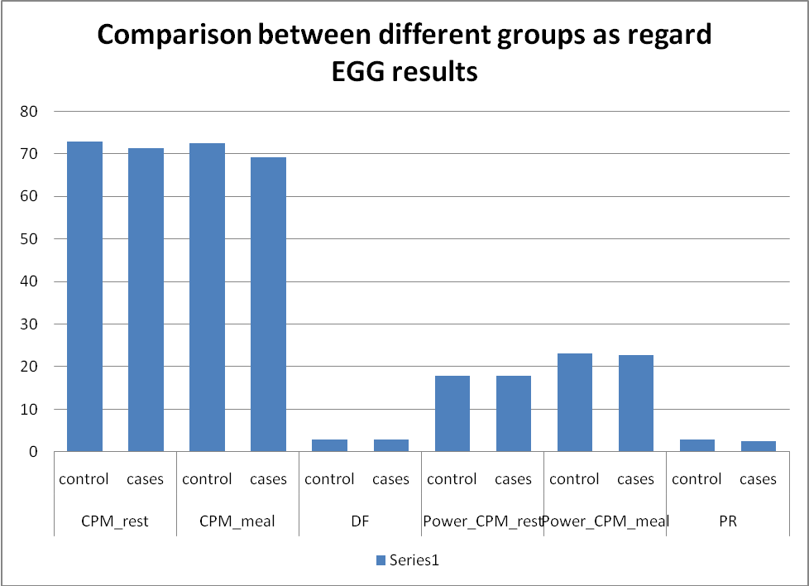

Fig (2)

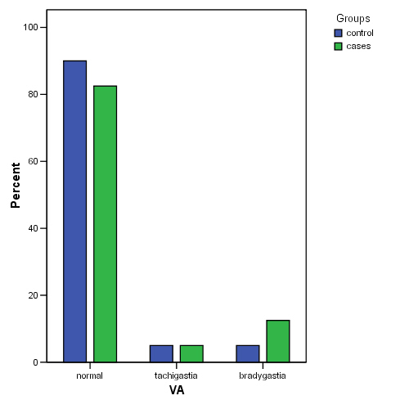

Table 1:Comparison of clinical and thyroid profile in hypothyroid patients and control
Sig. | P-value | t-test | Control |  | Cases
Sig. | P-value | t-test | SD± | mean | SD± | mean
NS | >0.05 | -1.503 | 6.54 | 29.45 | 5.3009 | 31.450 | Age(years)
S | <0.001 | -9.591 | 4.99 | 61.0 | 11.023 | 79.350 | Weight(kg)
NS | >0.05 | 1.221 | 4.18 | 159.65 | 5.80 | 158.27 | Height(m)
S | <0.001 | -11.936 | 2.52 | 23.98 | 2.99 | 31.36 | BMI(kg/m2)
S | <0.001 | 5.351 | 1.051 | 2.387 | 0.349 | 1.45 | T3
NS | >0.05 | 1.752 | 0.4033 | 1.337 | 0.546 | 1.149 | FT4
S | <0.001 | -6.642 | 0.421 | 1.82 | 7.90 | 10.128 | TSH

Table (2) Comparison of H.pylori titre between hypothyroid patients and control
Sig. | P-value | t-test | Control |  | Cases
Sig. | P-value | t-test | SD± | Mean | SD± | Mean | H.P  titer
S | <0.01 | -2.707 | 1.84 | 1.55 | 1.99 | 2.71 | H.P  titer

Table 3: Comparison of helicobacter infection percentage between hypothyroid patients and control
Sig. | Chi-square | Control |  | Cases
Sig. | Chi-square | % | N | % | N
S | 9.956 | 75% | 30 | (37.5%) | 15 | -ve
S | 9.956 | 25% | 10 | (62.5%) | 25 | +ve

Table 4: Comparison of EGG parameters in hypothyroid patients and control
Sig. | P-  value | t-test | Control |  | Cases
Sig. | P-  value | t-test | SD± | Mean | SD± | Mean
NS | >0.05 | 0.262 | 20.99 | 72.90 | 29.31 | 71.408 | CPM  rest
NS | >0.05 | 0.511 | 25.69 | 72.48 | 31.53 | 69.192 | CPM  meal
NS | >0.05 | 0.505 | 0.376 | 2.94 | 0.65 | 2.88 | DF
NS | >0.05 | 0.0817 | 6.22 | 17.899 | 5.7 | 17.79 | Power  CPM rest
NS | >0.05 | 0.22 | 7.22 | 23.05 | 9.33 | 22.64 | Power  CPM meal
NS | >0.05 | -1.290 | 1748.51 | 2061.95 | 2318.61 | 2654.5 | Power  rest DF
NS | >0.05 | 0.894 | 2514.63 | 5085.2 | 2424.74 | 4591.3 | Power  meal DF
NS | >0.05 | 1.132 | 1.49 | 2.94 | 1.35 | 2.58 | PR

EGG: Electrogastrography, CPM: cycle/minute, DF: dominant frequency, PR: power ratio

Table 5: Comparison of visual analysis of EGG between patients and controls

Sig. | Chi-  square | Control | Cases
NS | 1.416 | 36 (90%) | 33 (82.5%) | Normal | VA
NS | 1.416 | 2 (5%) | 2 (5%) | Tachygastria | VA
NS | 1.416 | 2 (5%) | 5 (12.5%) | Bradygastria | VA

Table (6): Correlation between thyroid profile and helicobacter titer
TSH | FT4 | FT3
0.181 | 0.101 | 0.128 | Pearson's  Correlation (r) | Helicobacter  titer
N.S | N.S | N.S | Sig. | Helicobacter  titer

Table (7): Correlation between EGG parameter and Helicobacter titer
PR | Power meal DF | Power rest DF | Power CPM meal | Power  CPM rest | DF | CPM  meal | CPM  rest
0.125 | 0.253 | 0.117 | 0.169 | 0.413 | 0.49 | 0.074 | 0.204 | Pearson's  Correlation (r) | HP  titer
N.S | N.S | N.S | N.S | S | N.S | N.S | N.S | Sig. | HP  titer

Discussion:
Gastrointestinal motor dysfunction has been widely accepted as the main cause of symptoms. Gastric dysmotility is significantly more frequent in hypothyroid patients and is a result of muscles edema and alterated gastric myoelectrical activity. The complex pathophysiology of thyroid hormone action on gastric motility and its mechanism are not fully understood (12). EGG may help in understanding the patho physiology of gastric dysrthymia. In addition to the abnormal myoelectrical signals, other factors such as smooth muscles dysfunction, a dissociation between the electrical signal and muscle response, pylorospasm, or incoordination of the antrum and duodenum which may contribute to the disturbance of gastric emptying (13). In our study when hypothyroid patients compared to control subjects regarding EGG parameters, there was no statistical significant difference (P>0.05) considering all EGG parameters. However, there was a decrease in the dominant frequency (DF) of hypothyroid patients (2.88 ± 0.65) than that of the control (2.94 ± 0.38), although it is statistically non significant. This is in agreement with the result obtained by Ronald et al.,2009 (14), who found a decrease in dominant frequency in preprandial and postprandial hypothyroid patients compared to healthy controls, they explained gastric motility dysmotility by muscle edema and altered myoelectrical activity(14). In the contrary to our results Demircali et al.,2008 who found a significant increase of the dominant electrical frequency in hypothyroid patients comparing to the controls and they found delay gastric emptying. (15) Regarding power ratio (PR), it was low in hypothyroid patients (2.6±1.35) compared to the control subjects (2.9±1.49), but this was not statistically significant (P>0.05). This is in agreement with result obtained by Ronald et al .,2009 , who found a decrease in power ratio in hypothyroid patients comparing to healthy control(14). Also, Qzutemiz et al ., 2006, found that the power ratio in healthy controls was higher than hypothyroid cases (P>0.05) (16).Visual analysis of EGG showed that normogastria was lower in hypothyroid patients (82.5%) than controls (90%). While bradygastria was higher in hypothyroid patients reaching 12.5% than controls (5.0%). While tachygastria was equal in both groups 5% in each group. All of them were statistically insignificant (P>0.05). These results agree with those obtained by Fuly et al.,2004 who found that the percentage of normogastria in hypothyroid patients was 63.3% and was 82% in controls. While, bradygastria in hypothyroid patients was 20.8% and 14.4% in controls but he found that the ratio of tachygastria was higher in hypothyroid patients 12.3% compared to healthy control 4.85%(17). Also, the results were in agreement with Ronald et al.,2009 who found a significant increase of the gastric dysrhythmia through a myoelectrical activity study in hypothyroidism(16).Thyroid autoantigenes have shown some degree of cross reactivity with bacterial antigens. An association of both autoimmune thyroid diseases and Helicobacter pylori infection with mucosa-associated lymphocyte T lymphomas has been reported as well as gastric mucosa-associated lymphoid tissue in auto-immune thyroid disease (18).Comparing both patients and controls regarding helicobacter pylori, there was a statistical significant increase in helicobacter titer among hypothyroid patients, the mean of helicobacter titer was (2.7±1.9U/ml) patients and was (1.55±1.84U/ml) in controls. The percentage of helicobacter infection was 62%in hypothyroid patients and 25% in controls. This means that there is increase rate of infection of helicobacter pylori and helicobacter pylori titer (IgG) in hypothyroid patients comparing with healthy control subjects. These results were in agreement with Zervas et al..,2005 Who found that 63 of 98 patients with hypothyroidism were positive for H.pylori infection (64.28%) but it was statistically insignificant (P>0.05) (19). Also,Checci et al., 2008 reported a higher serological prevalence rate of helicobacter pylori infection in hypothyroid patients comparing to a healthy control subject(20). Again,De Luis et al., 1988 found markedly increased prevalence of H.pylori in patients with autoimmune thyroiditis (85.7%), compared with the controls (40%)(21). Infection by H.pylori resulted in increased levels of gastrin, pepsinogen I, and pepsinogen II in H.pylori positive group. The strong relation between the levels of anti-H.pylori IgG and the levels of microsomal antibodies suggests that H.pylori antigens might be involved in the development of atrophic thyroiditis or that autoimmune function in autoimmune thyroiditis may increase the likelihood of H.pylori infection. (21).Correlation between H.pylori titer and thyroid profile, there were not significant , these results was inagreement with the results obtained by Triantafillidis et al .,2003 who found that there was no relationship between H.pylori infection with thyroid hormone levels but they found significant positive correlation between H.pylori titre and thyroid(microsomal) autoantibodies(22).

References:
- Guyton A and Hall J (2000): General principle of gastrointestinal function motility, nervous control & blood circulation. In Textbook of Medical Physiology. 10th edition. 62:713-726. WB Saunders Company.
- Maser C,Toset A,Roman S(2006): Gastrointestinal manifestations of endocrine disease.World JGastroenterol,12:3174-3179.
- Ch'ng CL,Biswas M,Benton A,Jones MK,Kingham JG (2005): Prospective screening for celiac disease in patients with Graves'hyperthyroidism using anti –gliadin and tissue transglutaminase antibodies. Clin Endocrinol.62:303-306.
- Laukkarinen J, Koobi P,Kalliovalkama J,SandJ, Mattila J, TurjanmaaV,Porsti I,Nordback I(2002): Bile flow to the duodenum is reduced in hypothyreosis and hyperthyreosis. Neurogastronterol Motil,14:183-188.
- Pustorino S,Foti M,Calipari G,PustorinoE,Ferraro R and GermanottaG (2004): Thyroid-intestinal motility interactions summary. Minerva Gastroenterology Dietol. Dec; 50(4):305-15.
- GotoS, BillmireDF, GrosfeldJL (1992): Hypothyroidism impairs colonic motility and function.An experimental study in the rat.Eur J Pediatric Sur2:16-21.
- Shafer RB, Prentiss RA, Bond JH(1984): Gastrointestinal transint in thyroid disease. Gastroenterology 86:852-855
- Erensto Cristiano Lauritano, Anna Lisa Bilotta, Maurizio Gabrielli, Emidio Scarpelli, Andrea Lupascu, Antonio Laginestra, Marialuisa Nov. Michele Serricchio (2005): The Pathogenesis Of gastrointes-tinal Bacterial Overgrowth Chemotherapy. Huse Bye E. 51:1-22.
- Chen JDZ, Lin ZY, and McCallum RW (1998): Current status and future development of the electrogastrogram Motility. 42:14-17.
- Parkman HP, Bonapace ES, and Fisher RS (2004): Edrophonium provocative testing during electrogastrography (EGG)-effects on dyspeptic symptoms and the EGG. Dig Dis Sci. 43:1494-500.
- Jebbink HJ, Van Berge – Henegouwen GP, Bruijs PP, Akkermans LM and Smout AJ (2000): Gastric myoelectrical activity and gastro intestinal motility in patients with functional dyspepsia. Eur J Clin Invest. 25 (6) : 429-37.
- Jones MM, Donthireddy KR, Ailawadhis, et al., (2007): Malignant gastroparesis, patho-gensis and mangment of under recognized disorder. J Support Oncol. Sep.5 (8):355-63.
- Rothstein R,Szomstein S,Avital et al., (2008): Laparoscopic gastric bypass in patients in thyroid replacement therapy for subnormal thyroid function. Prevalence and short term outcome. Obs Surg. Jun.14 (1) :93-7 .
- Ronald Daher, Thierry Yazbeck, Jaoude ,et al., (2009): Gastrointestinal manifestation in thyroid dysfunction. World J Gastroentrol. June .21 ,15 (23) : 2834-2838 .
- Demircali A, Bemay I and Tanyeri F (2008): Gastric emptying in patients with primary hypothyroidism. Eur J Gastro-entrol Hepatol. Sep.9 (9):901-4.
- Ozutemiz, Sevki Cetinkalp and Taylan Kabalak (2005): Electrogastrographic study of gastric myoelectrical activity in patients with un explained nausea and vomiting. Gut. 27:799- 808.
- Fuly Gunsar, Sema Yilmaz, Serhat Bor et al., (2004): Effect of hypothyroidism and hyperthyroidism in gastric myoelectrical activity. Digestive Disease and Science. Vol. 48 April (4): 706-712.
- Jia Wei (2009): Risk factor in autoimmune thyroid disease with helicobacter pylori. Journal of Chinese clinical medicine Vol 41 (6): 9-37.
- Zervas, Athanasios, Katobodi, Anna, et al. (2005): The incidence of helicobacter pylori infection in Greek females patients with autoimmune hypothyroidism. Journal of Clinical Gastroentrology. December. 35 (5): 413-414.
- Checchi S, Montanaro A, Pasqui L et al., (2008) : L-thyroxine requirement in patients with autoimmune hypothyroidism and parietal cell antibodies. J Clin Endocrinal Metab. Feb.93 (2):465-9.
- De Luis DA, Varela C, De La Calle H, et al., (1998): H.pylori infection is markedly increased in patients with autoimmune atrophic thyroiditis. J Clin Gastroenterol., Jun; 26 (4): 259-63.
- Triantafillidis JK, Georgakopoulos D, Gikas A, et al., (2003): Relation between H.pylori infection, thyroid hormone levels and cardiovascular risk factors on blood donors. Hepatogastroenterology, 50, suppl 2.

3/25/2011

