Histological and histochemical Studies of H1N1 Vaccine on Testes of Adult Male Albino Rats

Enas Khalil *and Atif Ibrahim**

*Department of Histology, National Organization for Drug Control &Research
** Department of Histology, Faculty of Medicine Al-Azhier University
enasamk@hotmail.com , narmout @ yahoo com

Abstract: In early 2009,''Swine flu'', a new infectious disease, emerged in Mexico and further spread around the world. To control this new infection, the swine flu vaccine was used. Squalene is used as an immunologic adjuvant in swine vaccine. The reports on the adverse effects of any new vaccine during trials must be declared to the public. Among the world most of respondents believed that the swine flu vaccine was not safe and protective. This research aims to histological study the effect of both swine flu vaccine and squalene on testes of adult male albino rats. 24 adult male albino rats were divided into four groups 6 for each. Control, swine flu vaccine treated, squalene treated and both swine flu vaccine and squalene treated groups. The results indicated that swine flu vaccine treated group showing histological alternation in testes of rats appeared as vacuolated spermatogenic cells and spermatozoa, moderate infiltration of mast cells in interstitial tissue and increase in tubular wall thickness. Squalene treated group showing reduction in the number of germinal epithelium layers with vacuolated spermatogenic cells, reduction the spermatozoa number, together with increase in tubular wall thickness and moderate infiltrated mast cells appeared in interstitial tissues. Vaccine and squalene treated group showing reduction the number of layers of germinal epithelium and of spermatozoa and deposition of the acidophilic materials in the interstitial tissues with marked infiltrated mast cells and increase in tubular wall thickness. In conclusion vaccine H1N1 induces histological and histochemical changes in testes which increased when combined with squalene.
[Enas Khalil and Atif Ibrahim. Histological Studies of H1N1 Vaccine on Testes of Adult Male Albino Rats. Nature and Science 2011;9(6):58-66]. (ISSN: 1545-0740). http://www.sciencepub.net.

Key words: H1N1vaccine, squalene, testes, rat.

1. Introduction
Influenza has been recognized as a human illness since the middle ages. Influenza out breaks occur in 2 distinct patterns: endemic (seasonal) and pandemic. Pandemics typically occur decades apart and are associated with influenza A virus strains harboring novel forms of the hemagglutinin molecule. Influenza virus subtypes that have been associated with pandemics include H1N1, H2N2and H2N3. The most severe influenza pandemic recorded in 1918. It was associated with H1N1 subtype and claimed approximately 50 million lives worldwide (1, 2). The earliest confirmed case of influenza A H1N1 (swine flu) in 2009 was reported in Mixco in March, and the World Health Organization declared the disease to be a pandemic –phase 6 on 11 June (3). In addition, many hundreds of death cases due to swine flu are reported from every region of the world. Due to the nature of respiratory transmittable virus, easy transmission virus from an infected case to the new case can be expected (4). Animal models and clinical observations suggest that, unlike endemic influenza that is detected only in the nasal cavity, novel H1N1 localizes to the lower respiratory tree and the nasal cavity, which may contribute to its virulence (5-7). To get a protective immunity, there are two ways. First, the one must get the infection, survive and then develop immunity. Second, the artificial controlled stimulation process calling vaccination must be used. So research has done to develop novel influenza vaccine that provide long –lasting immunity and broad protection against strain that differ antigentically from vaccine viruses(8).
To obtain stronger response with a lower antigen dose adjuvant vaccines are preferred during pandemics. Squalene, is a natural organic compound originally obtained for commercial purposes primarily from shark liver oil, through plant sources (primarily vegetable oils) are used as well, including amaranth seed, rice bran, wheat germ and olives. All plants and animals produce squalene, including humans. Squalene is a hydrocarbon and triterpene. It is a natural and vital part of the synthesis of cholesterol, steroid hormones, and vitamin D in the human body. It is increasingly used as an immunologic adjuvant in several vaccines, including seasonal and the novel H1N1 influenza vaccine (9). It is reported that about one in ten people have squalene antibodies in their blood (10).
It should be noted that although the swine flu vaccine can pass the registration process and have scientific confirmation on its safety the post marketing adverse effect can still be detected. Several studies pointed out to some serious neurologic conditions (11-13), immunotoxicity and carcinogenicity (14) that might be associated with the influenza vaccine. A neurological disorder induced male sexual dysfunction (15-17). This research aims to histological study the effect of both swine flu vaccine and squalene on testes of adult male albino rats.

2-Materials and Methods:
2.1. Animals
24 adult male albino rats weighing 150-200 Kg were kept under good hygienic environmental conditions at National Organization for Drug Control and Research. The rats were divided into four groups each contain six, control, vaccine treated, squalene treated, vaccine and squalene treated groups.

2.2. Vaccination
Vaccine H1N1 and the adjuvant were manufactured by Quebec City GSK biological Canada GIB 4R8. The manufacture process was the same as those for seasonal influenza vaccines. This H1N1 vaccine was produced from the reassortant strain x-179A (A/California/07/2009/A/PR/8/34), according to the recommendations of the World Health Organization (18). Dilute 10 µ g of antigen suspension of H1 N1 in 2.5 ml saline. Dilute 10 µg of adjuvant emulsion in 2.5 ml saline. The rats were intramuscular injected with 0.5 ml of both diluted vaccine, squalene and of the mixed dose (0.25ml vaccine +0.25ml Squalene) once for a month according to human therapeutic dose (19).

2.3. Histological and histochemical investigation:-
Samples of testes of rats were used for histological studies fixed in formol saline at room temperature for a week, washed, dehydrated, and embedded in paraffin wax. The paraffin sections were cut at 5 µ thickness and stained with haematoxlin and eosin (H&E)(20), Periodic Acid Schiff (PAS) (21)and toluidine blue (22). The quantitative study was done using computer image analyzing system (Leica Model). Estimation of the optical density of thirty cells in each group was made. The data obtained for tubular wall thickness and numbers of mast cells were statistically analyzed (23). Differences between the different groups means were assessed using T-test P≤ 0.05 was considered significant.

3. Histological Results:
Histological and histochemical examination of the testicular sections from the control group showed normal histological structure of seminiferous tubules with different series of spermatogenic layers, spermatozoa and the interstitial tissues with Leydig cells (Figures 1&2). The basement membrane of the tubules appeared thin with PAS (Figure3). Mast cells appeared normal in shape and number (figure4).
Swine flu vaccine treated group showed histological and histochemical alternation in testes of rats in form of variable sized seminefirous tubules, vacuolated spermatogenic cells and spermatozoa. Some tubules appeared with irregular basement membrane and others loss their basement membranes (Figure9). PAS positive reaction in the interstitial tissue, vacuolation in Leydig cells (Figure10a), together with moderate increase in mast cells infiltration interstitial tissue (Figure11). As well as increase in the tubular wall thickness (Figure10) were observed. Squalene treated group displayed reduction in the number of germinal epithelium layers with vacuolated spermatogenic cells and reduction the spermatozoa number. Some tubules were filled with acidophilic materials (Figure5). Deposition of acidophilic materials in the interstitial tissues with dilated congested blood vessels was also observed (Figure6).Moreover increase in the tubular wall thickness (Figure7) was noticed. Vacuolation in interstitial material with an apparent increase in PAS positive reaction (Figure7a) and moderate increase in mast cells infiltration were appeared in interstitial tissues (Figure8). Vaccine and squalene treated group revealed increased the variability of the seminefirous tubules in size and more reduction in layers of germinal epithelium, and of spermatozoa. Some seminefirous tubules showed separation and increased irregularity of their tubular wall with relative widened of the interstitial tissues and deposition of the acidophilic materials in the interstitial tissues were observed (Figure12). Vacuolation with PAS positive reaction (Figure13a), increase the tubular wall thickness (Figure13) together with marked increase in mast cells infiltration (Figure14) were noticed. Figures 7, 10, 13 represent the increase in the tubular wall thickness, which recorded non significant increase in vaccine treated group, meanwhile squalene treated recorded significant increase. Vaccine and squalene treated group recorded highly significant increase Compared to control (table1&histogram1). Figures 8,11, 14 represent increase in mast cells ,which recorded significant increase in vaccine treated group ,highly significant increase in squalene treated group and highly significant increase in vaccine and squalene treated group in comparison with control(table1&histogram1) .

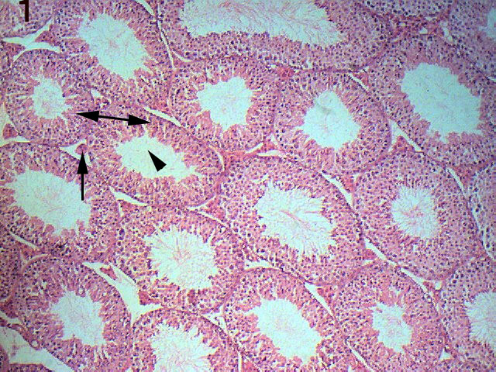 Figure 1: Testis of rat in control group showing the normal histological structure of seminiferous tubules with different series of spermatogenic layers(↔), spermatozoa (▼)and the interstitial tissues(↑)(H&E x200) | 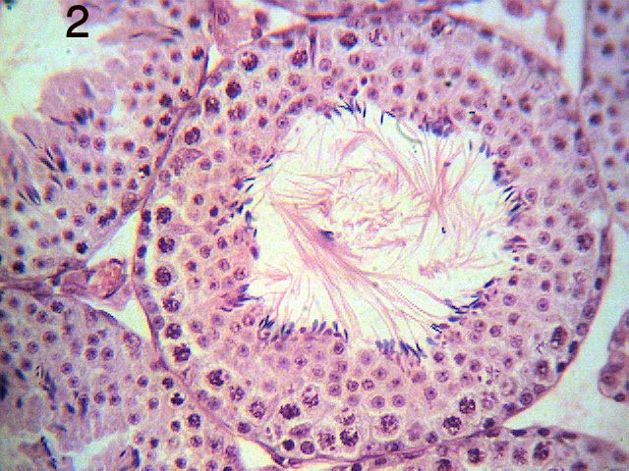  Figure2: Testis of rat in control group showing normal histological structure of seminiferous tubules with different series of spermatogenic layers, spermatozoa and the interstitial tissues (H&E X400).
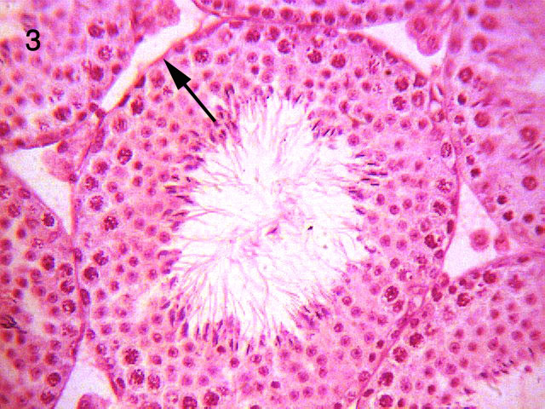figure 3: Testes in control group showing thin basement membrane↑ (PAS x400) | 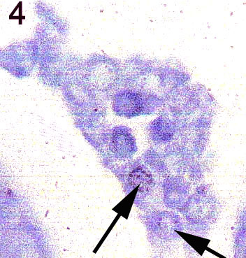 figure4: testes in control group showing normal histological structure of interstitial tissues, with Leydig cells and few number of mast cells ↑ (T.B. X1000)
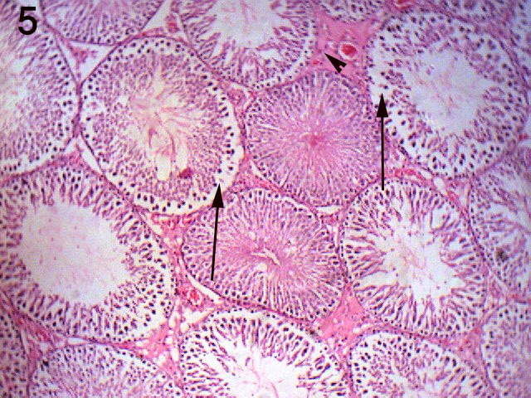Figure 5:Testis of squalene treated group showing alternations of some tubules in the form of reduction the number of layers of the germinal epithelium , spermatozoa with vacuolated spermatogenic cells(↑) ,other tubules filled with acidophilic materials (▼)and deposition of acidophimaterials in the interstitial tissue (H&E xx200). | 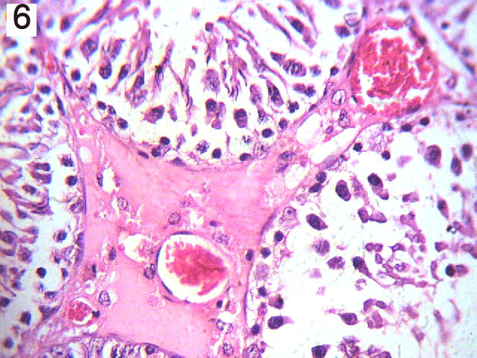Figure6:Testis of sequalene treated group showing deposition of acidophilic materials in the interstitial tissue and dilated congested blood vessels (H&E x400).
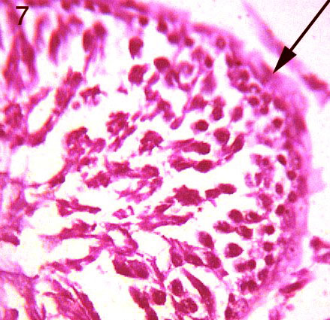 Figure7: Testis of squalene treated group showing the increase in tubular wall thickness (↑) (PAS x400).  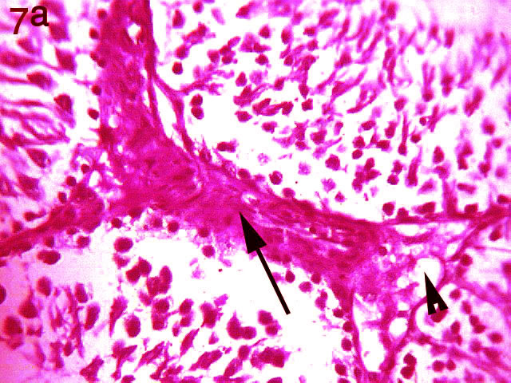Figure7: Testis of squalene treated group showing vacuolation of intrestistial material with PAS positive reaction (PAS x400). | 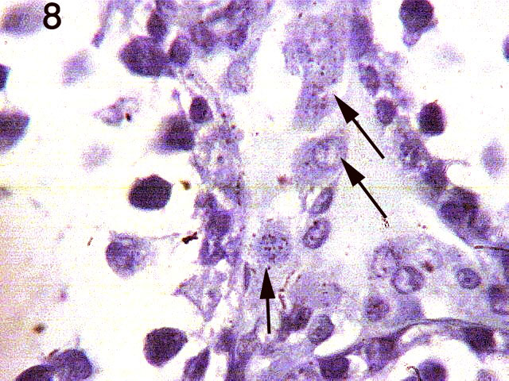  Figure 9: Testis of squalene treated group showing moderate increase of mast cells (↑)(T.B. x1000)
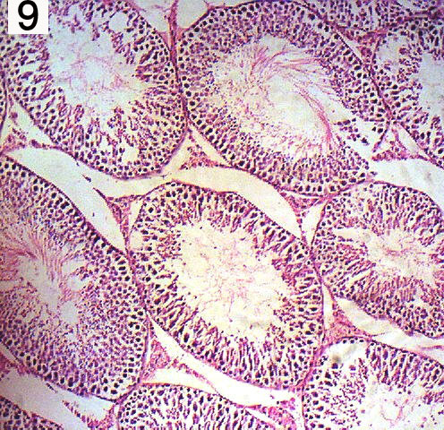Figure 9: Testis of vaccine treated group showing the seminefirous tubules are variable in size, other tubules with vacuolated spermatogenic cells and spermatozoa and reduction in their numbers , other tubules with irregular basement membrane , other loss their basement membrane (H&E x 200). | 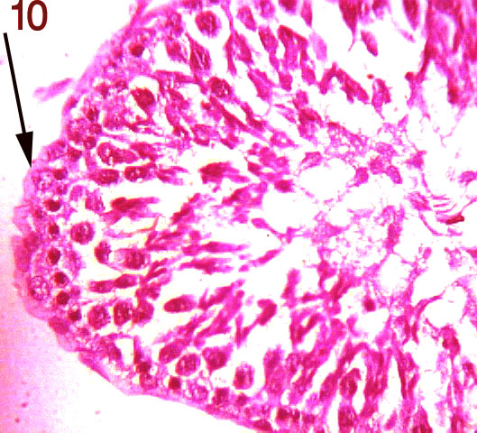Figure 10: Testis of vaccine treated group showing the increase in the tubular wall thickness (PAS x400).  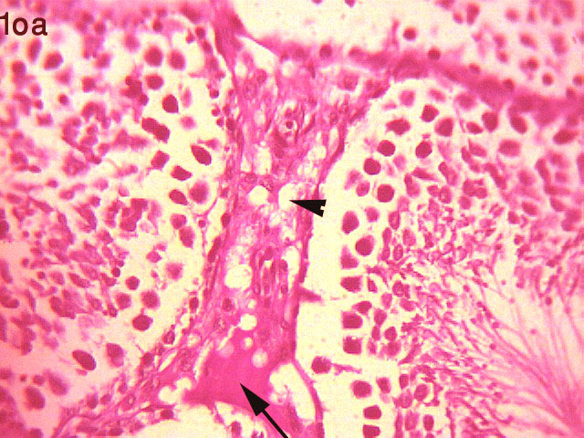Figure 10a: Testis of vaccine treated group showing vaculation of interstitial Leydig cells with PAS positive reaction (PAS x400).
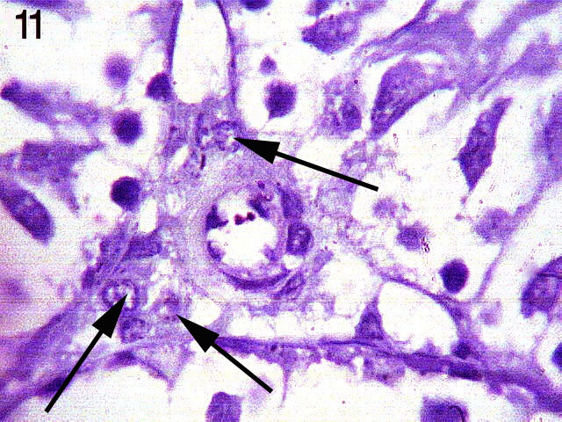  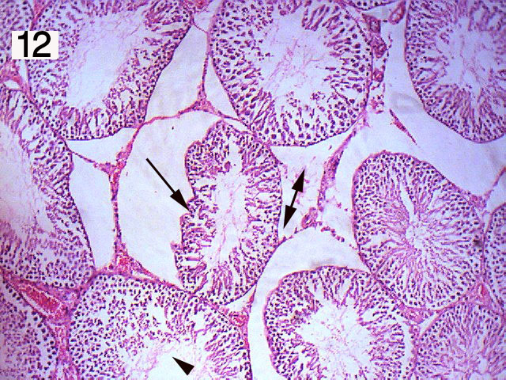 | Figure 11: Testis of vaccine treated group showing the moderate increase in mast cells (T.B. x1000).  Figure12: Testis of squalene and vaccine treated group showing the seminefirous tubules are variable in size , reduction the number of layers of the germinal epithelium , spermatozoa (▼), other with irregular basement membrane ,relative widened of the interstitial tissue (↔)and deposition of acidophilic materials in the interstitial tissue (H&E x 200).
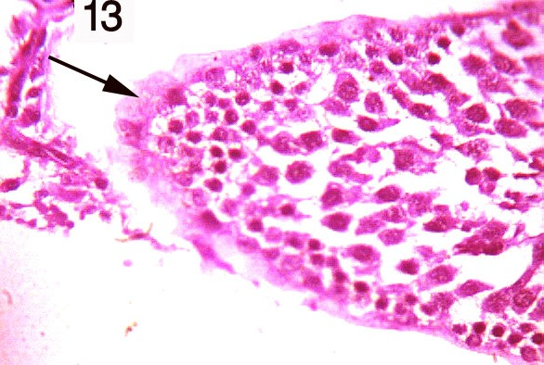Figure 13: Testis of vaccine and squalene treated group showing the increase in tubular wall thickness (PAS x400).  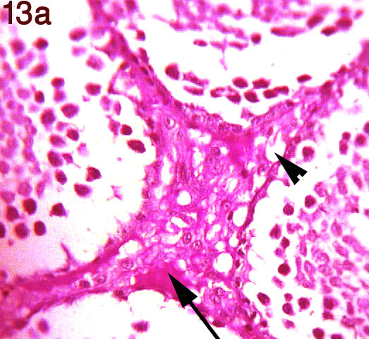  Figure 13a: Testis of vaccine and squalene treated group showing vacuolation of the interstitial material with PAS positive reaction (PAS x400). | 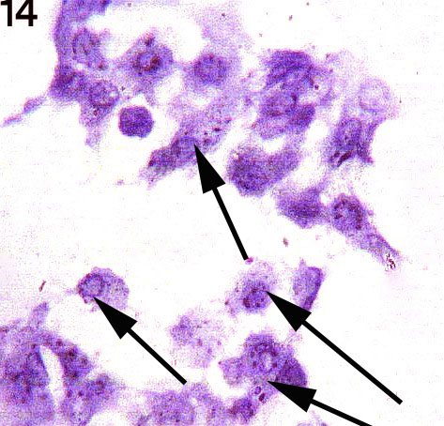Figure 14: Testis of vaccine treated group showing increase in the mast cells infiltration in the interstitial tissues (↑)(T.B. x1000)

Table (1): The quantitative measurements of the color density (pixel) of tubular wall thickness and mast cell numbers in the testes of control and treated groups of male rats.
 | Statistical parameters | Control | Vaccine | Squalene | Vaccine +Squalene
Tubular wall thickness | Average | 0.22 | 1.1 | 1.66 | 1.75
Tubular wall thickness | SD. | 0.15 | 0.38 | 0.4 | 0.3
Tubular wall thickness | Max. | 0.5 | 1.5 | 2 | 2.5
Tubular wall thickness | Min | 0.1 | 0.5 | 1 | 1.5
Tubular wall thickness | t test |  | 1.73 | 2.8 | 4.94
Tubular wall thickness | Probability |  | Non –sig. | Sig↑ | Highly Sig↑↑
Mast cell numbers | Average | 1.5 | 2.33 | 2.67 | 3.17
Mast cell numbers | SD. | 0.55 | 0.52 | 0.52 | 0.75
Mast cell numbers | Max. | 2 | 3 | 3 | 4
Mast cell numbers | Min | 1 | 2 | 2 | 2
Mast cell numbers | t test |  | 2.67 | 3.77 | 4.4
Mast cell numbers | Probability |  | sig↑ | Highlysig↑↑ | Highly sig↑↑

P> 0.01 Highly Significant, P> 0.05 Significant, P< 0.05 Non significant

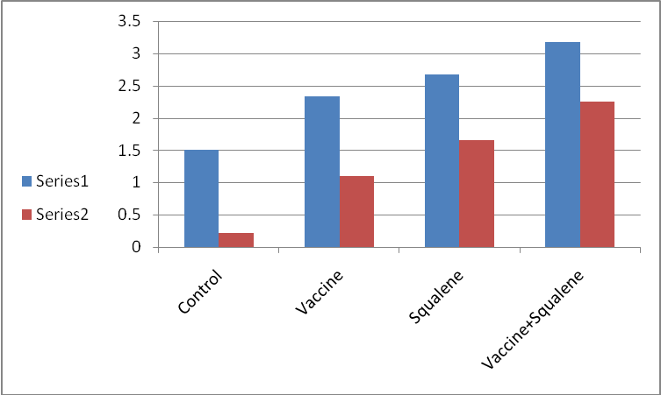

Histogram (1) Quantitative measurements of tubular wall thickness and mast cell numbers of control and treated groups.

4. Discussion:-
Vaccination refusal was mostly related to the vaccine's side effects and disbelieved vaccine's protectiveness (13). Vaccines themselves can be dangerous, especially live, attenuated viral vaccines or the new recombinant nucleic acid vaccines; they have the potential to generate virulent viruses by recombination and the recombinant nucleic acids could cause autoimmune diseases. These extremely dangerous vaccines are classified as bioweapons. A further major source of toxicity in the case of the flu vaccines are the adjuvants, substances added in order to boost the immunogenicity of the vaccines. Most flu vaccines contain dangerous levels of mercury in the form of thimersol, a deadly preservative 50 times more toxic than the mercury itself. At high enough doses, it can cause long–term immune, sensory, neurological, motor, behavioral dysfunctions. Aluminum adjuvant is a known cause of cognitive dysfunction. Squalene adjuvant leads to immune damage, rheumatoid arthritis and multiple sclerosis (14).All vaccine ingredients cause immunotoxicity, neurotoxicity, sterility and carcinogenicity (17).
In this research, vaccine H1N1 treated group showed histological alternation in the testes of rats appeared as variable size seminefirous tubules, vacuolated spermatogenic cells and spermatozoa, some tubules with irregular basement membrane and others loss their basement membranes. Increase was observed in thickness of tubular wall. Vacuolated interstitial material with PAS positive reaction and moderate increase of mast cells infiltration appeared in interstitial tissues. Squalene treated group has displayed reduction in the number of germinal epithelium layers with vacuolated spermatogenic cells and reduction the spermatozoa number. Some tubules were filled with acidophilic materials. Deposition of acidophilic materials in the interstitial tissues and increase in the thickness of tubular wall was observed. Vacuolated interstitial material with PAS positive reaction and moderate increase of mast cells infiltration appeared in interstitial tissues. Vaccine and squalene treated group have shown the seminefirous tubules are variable in size, reduction the number of layers of germinal epithelium, and of spermatozoa. Some seminefirous tubules appeared with irregular basement membrane and relative widened of the interstitial tissues .Also deposition of the acidophilic materials in the interstitial tissues was noticed. Increase was detected in the thickening of tubular wall. Vacuolated interstitial material with PAS positive reaction and marked infiltration of mast cells appeared in interstitial tissues.
The production of sperm in testes is under hormonal control, which is regulated by the hypothalamus and the pituitary gland in the brain. This combination is known as the hypothalamic –pituitary gonadol (HPG) axis. The hypothalamus regulates the activity of the anterior pituitary .Under the influence of LH, the Leydig cells within the testes make testosterone, essential cofactors in spermatogenesis (24). The hypothalamic abnormalities were detected associated with H1N1 influenza infection (25). Also, some neurologic diseases are present with vaccine H1N1 alone (10). The vacuolation in the interstitial material with PAS positive reaction pointed out to the increased activity of Leydig cells correlates to steroids metabolism, biosynthesis and secretion, at the Leydig cells (26). The increase of mast cells in the seminiferous tubule may be a useful marker in histopathological evaluation of testis biopsies in patients with idiopathic infertility (27).The increase in the thickening of tubular wall was positively correlated with the number of mast cells in infertile patients (28). An increase in the number of mast cells is related to spermatogenetic disorders and testicular fibrosis .It means that significant correlations occurred between the number of mast cells and the ratio of tubules with sclerosis (29). Squalene led to multiple sclerosis (30) which is a devastating neurologic disease that attacks young adults and led to sexual dysfunction (15). Vaccine H1 N1 with squalene displaying marked histological alternation in testes.
In conclusion vaccine H1N1 induces histological and histochemical changes in testes which increased when combined with squalene

Corresponding Author
Enas Khalil
Department of Histology National Organization for
Drug Control and Research Cairo Egypt
Email enasamk@hotmail.com
Mobile (+20)0168025803, 0145526966.

5. References
1-Taubenberger JK and Morens DM. The Pathology of influenza virus infections. Annu Rev Pathol 2008; 3; 499-522.
2-Neumann G, Noda T and Kawaoka Y: Emergence and Pandemic Potential of Swine Origen H1N1 influenza virus .Nature ,2009 ; 459; 931-939.
3- World Health Organization Regional office for Europe. Influenza A (H1N): Pandemic alert phase 6 declared, of moderate severity. 2009. http ://www.euro.who.int/influenza/AH1N1/2009. 06 11_11. Accessed July 19, 2009.
4-Wiwanitkit, V. Swine flu vaccine: Present status.
2009Nov; 5(11):777-778.
5-Centers for Disease Control and Prevention. Intensive Care Patients with Severe novel influenza A (H1N1) virus infection. Michigan, June 2009; 58:749-752.
6-MainesTR, Jay araman A, Belser JA,et al . Transmission and Pathologenesis of swine origin 2009; 325; 484-487.
7-Munster VJ, deWit E,Van den Brand JM,etal. Pathogenesis and transmission of swine origin 2009 A(H1N1)influenza virus in ferrets. Science 2009; 325; 481-483.
8-Lippi, G. Targher, G. Franchini ,M. Vaccination, squalene and antisqualene antibodies. Facts or Fiction 2010,Apr; 21(2):703..
9-Harris, K; Maurer J and Kellermann, A .Influenza vaccine safe, effective and mistrusted. The New England Journal of Medicine. 2010, 363; Dec. 23: 2183-2185
10-Jiang Wu; Fujie XU, Li lu, Min lu, etal . : Safety and Effectiveness of a2009 H1N1 Vaccine in Beijing .The New England Journal of Medicine. 2010. 363:2416-2423; Dec.16.
11-Safranek, TJ,Laurence DN, Kurland LT, et al .Reassessment of the association between Guillan – Barre' syndrome and receipt of swine influenza vaccine in 1976-1977: results of a two state study. Am. j. Epidemol 1991; 133. 940-951.
12-Perry HD, Mallen FJ, Gradin RW, Cossari AJ. Reversible blindness in optic neuritis associated with influenza vaccination .Ann Ophthamol 1979; 11:545-550
13-Savas,E and Tanriverdi, D . Knowledddge, attitudes and anxiety towards influenza A/H1N1 vaccination of healthcare workers in Turkey. Infectious Diseases, 2010, 10:281-185
14-Perlingiari IS: Dangers In the Shots-Components of H1N1 Vaccines. They are considered a biodefense agents. August, 4.2009.www.rense.com.
15-Pentyala,S.; Jalali, S.; Park,J, etal. Urologic Problems in multiple Sclerosis. The Open Andrology J. 2010, 2,37-41
16-Kandeel,FR .;Kousa, U.K, and Swertloff,RS. Male Sexual Function and its Disorders. Physiology, Pathophyiology, clinical Investigation, and Treatment .Endocrine Reviews , 2001,22 (3): 342- 388.
17- Devinsky, O. Neurologist –induced Sexual dysfunction. Enzyme –inducing antiepileptic drugs. Neurology. Oct11, 2005, 65: 980-981.
18-CDC Protocol of realtime RTPCR for swine influenza. Geneva: World Health Organization /2009(http://www.who .int/csr/resources/publications/swineflu/CDCrealtime RTPCR protocol 2009 0428.pdf)
19-Laurence, DR and Bacharach AL. Evaluation of Drug Activities: Pharmacometris. Vol.1 1964. Academic Press London and New York p.160-162.
20-Drury, R.A. and Wallington,E.A. Carleton's Histological Techniquies, 5 ^{th} ed . Oxford University Press London, NewYork, Toronto, 1980;1:653-661
21-Copenhaver, WM, Bunge, RD and Bunge, MB. BAILEY'S TEXTBOOK Of HISTOLOGY. SIXTEEN ^{th} ed 1971 WAVERLY PRESS, INC. p.124-125.
22- Drury, R.A. and Wallington, E.A. Carleton's Histological Techniquies ,4 ^{th} ed . Oxford University Press London, NewYork,Toronto. 1967 p214-215
23-Sendecor, G.W. and Coebram, W.G. (1969): In "Statistical Methods" 6th ed. Iowa State Univ. Press. Anes, Iowa, USA, p.70.
24-Lipshultz, L.I.; Howards, S.S. and Louis, ST .Male,3rd Edition, Mosly-Year Book, 1997. P.177
26-Gonzo'lez-Duarte, A, Zaora, LM; Btito cc and Garcia- Ramos, G. Hypothalamic abnormalities and Parkinsonism associated with H1N1 influenza infection. J. Neuroinflammation, ,2010 , 17 August,7:47
26-Orsi, AM, Vicentini, CA, Dias, SM, Michelin Sc and Viatto MJ (1990): Histochemical and structural characteristics of testis of the vampire bat. Rev. Bras. Biological. Feb., 50(1):221-228.
27-Hashimoto, J; Nagai, T; Takaba, H. Yamamoto, M and Miyake,K. Increased mast cells in the limiting of seminiferous tubules in testes of patients with idiopathic infertility. Urol Int.1988;43(3):129-32
28-Meineke V, Frungieari B, Jessberger B, Josef Vogt H and Mayerhofer, A. Human testicular mast cells cotain trypttase: increased mast cell number and altered distribution in the testes of infertile men. Fertility and Sterility , Vol74, Issue 2, Pages 239-244, 2000
29- Yamanak, K; Fujsawa, M; Tanaka H.; Okada, HaraKaw, S and Kamidoono, S: Significance of human testicular mast cells and their subtypes in male infertility .Human Reproduction. 2000, Vol15, No7. PP1543-1547,.
30-Ozturk, S. Swine flu vaccine adjuvants and multiple sclerosis – Is there potential for harmfull effect?.Med Hypothesis. 2010, Jul; 75(1):50-2.

27/4/2011

