Characterization of Escherichia coli using Pulse-Field Gel Electrophoresis

*Hamza. M. Eid , Enany. M. E. and Iman. T.

Bacteriology Department, College of Veterinary Medicine, Suez Canal University, Egypt
*h.eid@scuegypt.edu.eg

Abstract: Twenty six E. coli strains, 11of them are E. coli O157:H7 and 15 of them are E. coli strains of different serotypes were subjected for analysis using pulsed field gel electrophoresis after digestion using restriction enzyme Xba I. The digested DNA products were electrophoresed in 1% agarose in 0.5X TBE buffer and the power supply was adjusted under the following conditions (Initial: 2.2 s/ final 54.2 s, voltage 6V/cm, Run time 19h.). The pulsed field gel electrophoresis (PFGE) patterns of the 11 E. coli O157:H7 are arranged in two clusters A and B which show 65% similarity in banding patterns between the two clusters: while PFGE of the 15 E. coli strains of different serotypes produced seven PFGE types. Pulsed field gel electrophoresis can be used in the determination of genetic relatedness between different E. coli serotypes so it is important in epidemiological surveillance of E.coli as a causative agent of diarrhea in human and animals.
[Hamza. M. Eid, Enany. M. E. and Iman. T. Characterization of Escherichia coli using Pulse-Field Gel Electrophoresis. Nature and Science 2011;9(6):67-71]. (ISSN: 1545-0740). http://www.sciencepub.net.

Keywords: Characterization; Escherichia coli; Pulse-Field; Gel Electrophoresis

1. Introduction:
Six E.coli O157:H7 isolated from (cattle, sheep and pigs) were differentiated into 3 pulse-field gel electrophoresis profiles. (Johnsen et al., 2001).
Pulsed-field gel electrophoresis of EPEC strains showed that EPEC strains harboring cdtB locus are genetically diverse (Pandey et al., 2003).
Pulsed-field gel electrophoresis provided the most discrimination among the techniques, identifying 72 distinct PFGE profiles for E. coli O157: H7 isolated from cattle, food, and infected humans. Rep-PCR elucidated 14 different profiles, whereas MLST generated five profiles ( Foley et al., 2004).
Molecular epidemiology by pulsed-field gel electrophoresis (PFGE). Two or more virulence genes were detected in 109 (90.1%) EAEC isolates (Kahali et al., 2004).
Pulsed-field gel electrophoresis for Diarrheagenic Escherichia coli (DEC). isolated from children and adults from Tunis indicated a large number of DEC clones (five major clones) (Al-Gallas et al., 2007).
Escherichia coli O157:H7 isolated from United States and Japan were differentiated using pulsed-field gel electrophoresis. The profiles showed genomic divergence between the isolates (Feng et al., 2007). They concluded that PFGE is recommended for the epidemiological studies.
Pulsed-field gel electrophoresis (PFGE) analysis with XbaI of 15 E.coli O149:H10 isolated from diarrhoeic calves distinguished 14 types ( Vu-Khac et al., 2007).
Atypical enteropathogenetic Escherichia coli (EPEC) strains were examined using pulsed-field gel electrophoresis (PFGE). The profiles separated the strains into three clusters by overall virulence gene profile (Afset et al., 2008).
Forty-five STEC O157 isolated from cows, buffaloes and goats were examined using pulsed-field gel electrophoresis. The profiles showed 37 distinct restriction patterns, suggesting a heterogeneous clonal diversity (Islam et al., 2008).
VTEC O103:H2 strains isolated from bovine and human sources of North American and European origins were examined by pulsed-field gel electrophoresis, the profiles showed 66 PFGE patterns grouped in 6 clusters (Karama et al., 2008).
The objective of this study is to analyze DNA of different E. coli strains from different origin digested with low cleavage restriction enzyme Xba I using pulsed field gel electrophoresis.

2. Material and methods
Bacterial strains
A total of 26 E coli strains of different origin were analyzed using PFGE. Eleven of them are E coli O157: H7(6 from children, 3 calves and 2 sheep origin). The other fifteen E coli strains are different serotypyes isolated from (7 children, 6 calves, 2 calf camel).

DNA extraction
The DNA was extracted by lysing the bacterial cells using the lysing Buffer, Lysozyme and proteinase K. DNA was separated from the Lysates using phenol-chloroform mixture by centrifugation. DNA was Precipitated by addition of 80% cold ethanol to the supernatant according to Philipp et al. (1994).

Restriction enzyme digestion
Xba I was used for digeston of different DNA samples by incubation at 37^{O}C for at least 2 hours in shaking water bath according to American Society for Microbiology (1991) .

Pulsed field gel electrophoresis (PFGE):
1% Seakem gold Agarose was prepared in 0.5X TBE. The digested DNA samples were loaded and electrophoressed using CHEF – DRLL( initial: 2.25, final: 54.25 voltage 6v/cm/ Run time :19h). according to (Beutin et al., 2005)

Gel visualization:
The gel was stained with ethidium bromide for 20-30 min in covered container. Then Gel was washed using 500 ml reagent grade water for 60-90 min; water was changed every 20 min. The image was captured on Gel Doc 1000.

PFGE data analysis:
The banding pattern generated by PFGE were compared to determine the genetic relatedness of Escherichia coli isolates, Dendgrams were created with molecular analyst (Bio-Rad) by using Dice coefficient, Un weighted group method with arithmetic means (UPGMA), and a position tolerance of 1.3%.

3. Results and Discussion:
Figure (1): A dendrgram based on similarities of XbaI-digested DNA PFGE patterns among E. coli O157:H7 strains were created with the Bionumerics software using Dice similarity indices. PFGE patterns were arranged in two clusters, A to B, which show 65% similarity in their banding patterns. Cluster (A), included three strains, two strains show 75% similarity one from human origin and the other was from calves. The third strain was from human origin with 70% similarity pattern.
Cluster (B), included eight strains either from human, calves or sheep origin with over than 80% similarity banding pattern, which means that they are almost the same.
Figure (2): A dendogram based on the similarity of XbaI-digested DNA PFGE patterns with the Bionumerics software using Dice similarity indices. The pulsed-field gel electrophoresis types (PFTs) were defined by ≥80% similarity. Isolates with PFGE patterns with similarity greater than 95% were considered to belong to the same PFT. Seven PFGE types (PFTs) revealed; A: (n = 2), B: (n = 1) C: (n = 3), D: (n = 2), E: (n =1), F: (n = 4) and G: (n = 2).
PFT (A), includes two strains from calf- camel origin, shared O165:H21 serotype with 90% similarity.
PFT (B), includes one strain from children of O142: HUT, it shared the same serotype with the strain from calves of PFT (E)
PFT (C), it includes three strains from calves shared O86a:H10 serotype, two of them with 80%similarity pattern, and the other 70 % similarity.
PFT (D), includes two strains from calves with similarity pattern 100 %, shared O25:H40 serotype.
PFT (F), includes four strains from children with 95% similarity pattern, they shared O6:H10 serotype.
PFT (G), includes two strains from children with 98 % similarity pattern, shared O55:H10 serotype.

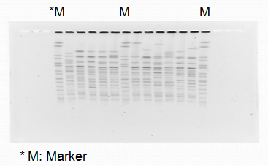
Photo (1): PFGE profiles of E. coli O157:H7 digested using Xba I

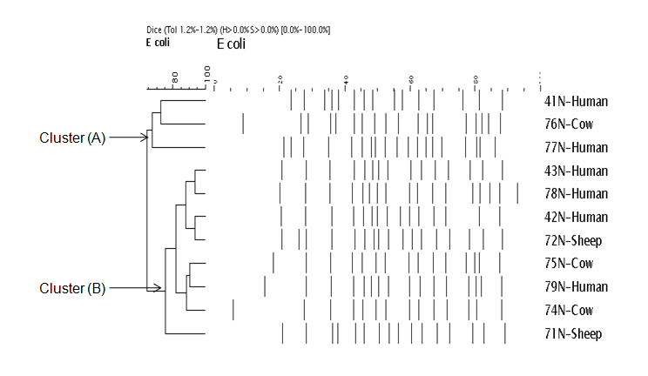
Fig. (1): Pulsed field gel electrophoresis (PFGE) profiles of O157:H7 from different sources

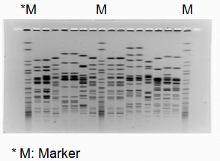

Photo (2): PFGE profiles of different E. coli serotypes digested with Xba I
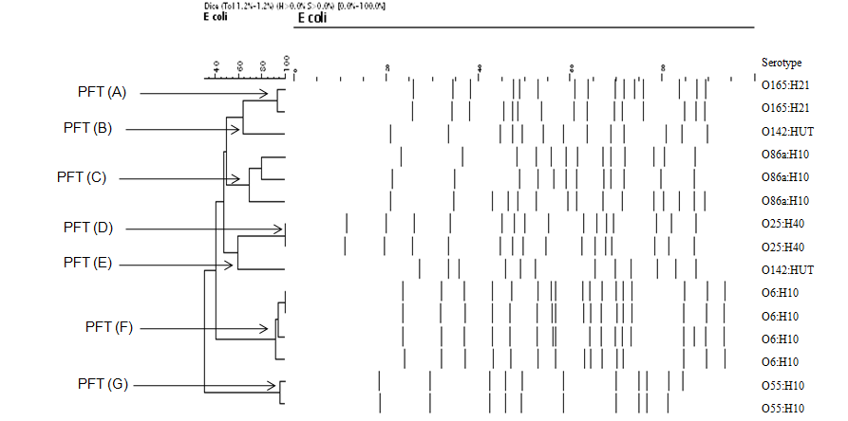

FIG(2).: Dendogram PFGE patterns calculated with Dice coefficient for E.coli strains of the same serotype

Pulsed-field gel electrophoresis (PFGE) currently offers the most expedient means to both analyze genome sizes and construct low-resolution physical maps of bacterial chromosomes. To date, studies of chromosomal variation within E. coli by PFGE have included in the laboratory and clinical isolates but have not used in the examination of the variation within the species (Arbeit et al., 1990; Bőhm and karch 1992; Ott, 1993 and Tschäpe et al. 1993).
To examine the diversity in genome size and the rate of chromosomal evolution in natural populations of E. coli, PFGE was employed in an analysis of natural isolates of E. coli of known genetic relationship. For each strain, genome sizes, as estimated from digestions with different restriction enzymes, were very similar, and the total size variation within the species was estimated to be less than 1 Mb.
Figure (1) showed a genetic diversity between 2 strains of O157:H7 of human origin (similarity 70%) and between one O157:H7 strain of calf origin (75% similarity). These results agreed with Harsono et al. (1993) who reported variations in genome sizes E. coli O157:H7 isolates.
This diversity might be explained as “clonal turnover” which resulted from mutations and rearrangements within the genome or the gain or loss of plasmids, but not because of genetic change in the plasmid as very little variation has been observed. In addition, Osawa et al. (2000) and Watabe et al. (2008) reported that among E. coli O157:H7 strains, there was considerable variation in the Stx2-converting phage DNA found by using PFGE analysis on account of the alteration of phage genomes with those of host genomes and that PFGE- analysis may have the potential to reveal minor changes in the bacterial genome.
Eight strains (O157:H7) either from human, calves or sheep origin with over than 80% similarity banding pattern, which means that they are almost the same. These results revealed the relationships within epidemiologically unrelated isolates. Arbeit et al. (1990) illustrated that PFGE could differentiate epidemiologically independent but evolutionarily related isolates.
PFGE is a powerful tool to reveal inter- and intra-serotype specific genetic differences among pathogenic E. coli (Nagy et al., 1999 and Osek, 2000).
In comparing the similarity between different serotypes of isolated E.coli Fig.(2), it was found that most identical serotypes were similar by using PFGE (90 - 100% similarity) except in PFT (C), it includes three strains from calves shared O86a:H10 serotype, two of them with 80% similarity pattern, and the other 70 % similarity. These results were nearly agreed with Osek (2000) who reported that, although isolates of the same serotype and virulence markers mainly share the same PFGE group, there is a genetic variation

Corresponding author
Hamza. M. Eid
Bacteriology Department, College of Veterinary Medicine, Suez Canal University, Egypt
h.eid@scuegypt.edu.eg

References:
Afset, J.E.; Anderssen, E.; Bruant, G.; Harel, J.; Wieler, L. and Bergh, K. (2008): Phylogenetic backgrounds and virulence profiles of atypical enteropathogenic Escherichia coli strains from a case-control study using multilocus sequence typing and DNA microarray analysis. J Clin Microbiol., 46(7): 2280-90.
Al-Gallas, N.; Abbassi, S.M.; Hassan, A.B. and Aissa, R.B.(2007):Genotypic and phenotypic profiles of enterotoxigenic Escherichia coli associated with acute diarrhea in Tunis. Tunisia: Curr Microbiol., 55(1): 47-55.
American Society for Microbiology (1991): Style manual for Journals and Books P. 35 -38. American society for microbiology, Washington, D. C.
Arbeit, R.; Arthur, M.; Dunn, R.; Kim, C.; Selander, R. K. and Goldstein R.. (1990): Resolution of recent evolutionary divergence among Escherichia coli from related lineages: the application of pulsed field electrophoresis to molecular epidemiology. J. Infect. Dis., 161:230–235
Beutin, L.; Stefan Kaulfuss; Sylvia Herold; Eric Oswald and Herbert Schmidt(2005):Genetic Analysis of Enteropathogenic and Enterohemorrhagic Escherichia coli Serogroup O103 Strains by Molecular.Typing of Virulence and Housekeeping Genes and Pulsed-Field Gel Electrophoresis. Journal of clinical microbiology, p. 1552–1563.
Bőhm, H. and Karch H. (1992): DNA fingerprinting of Escherichia coli O157:H7. J. Clin. Microbiol., 30:2169–2172.
Feng, P.C.; Monday, S.R.; Lacher, D.W.; Allison, L.; Siitonen, A.; Keys, C.; Eklund, M.; Nagano, H.; Karch, H.; Keen, J. and Whittam, T.S.(2007):Genetic diversity among clonal lineages within Escherichia coli O157:H7. stepwise evolutionary model, Emerg Infect Dis.,13(11):1701-6.
Foley, S.L; Simjee, S.; Meng, J.H.; White, D.G; McDermott, P.F. and Hampson, D.J.; Woodwar, J.M. and Connaughton, I.D. (2004): Genetic analysis of porcine postweaning diarrhea. Epidemiol Infect, 110:575-581.

Harsono, K.D.; Kaspar, C.W. and Luchansky, J.B (1993): Comparison and genomic sizing of Escherichia coli O157:H7 isolates by pulsed-field gel electrophoresis.Appl Environ Microbiol., 59(9):3141-4.
Islam, M.A.; Mondol, A.S.; de Boer, E.; Beumer, R.R.; Zwietering, M.H.; Talukder, K.A. and Heuvelink, A.E.(2008): Prevalence and genetic characterization of shiga toxin-producing Escherichia coli isolates from slaughtered animals in Bangladesh. Appl Environ Microbiol., 74(17): 5414-21.
Johnsen, G.; Wasteson, Y.; Heir, E.; Berget, O.I. and Herikstad, H., (2001): Escherichia coli O157:H7 in faeces from cattle, sheep and pigs in the southwest part of Norway during 1998 and 1999. International-Journal-of-Food-Microbiology., 65(3): 193-200.
Kahali, S.; Sarkar, B.; Rajendran, K.; Khanam, J.; Yamasaki, S.; Nandy, R.K.; Bhattacharya, S.K. and Ramamurthy, T.(2004):Virulence characteristics and molecular epidemiology of enteroaggregative Escherichia coli isolates from hospitalized diarrheal patients in Kolkata, India. J Clin Microbiol., 42(9): 4111-20.
Karama, M.; Johnson, R.P.; Holtslander, R. and Gyles, C.L.(2008): Phenotypic and genotypic characterization of verotoxin-producing Escherichia coli O103:H2 isolates from cattle and humans. J Clin Microbiol., 46(11): 3569-75.
Nagy, B.; Wilson, R.A.; Whittam, T.S. (1999):Genetic diversity among Escherichia coli isolates carrying F18 genes from pigs with porcine postweaning diarrhea and edema disease. J Clin Microbiol., 37:1642-1645.
Osawa R.; Iyoda S.; Nakayama SI.; Wada A.; Yamai S.and Watanabe H. (2000): Genotypic variations of Shiga toxin-converting phages from enterohaemorrhagic Escherichia coli O157: H7 isolates. J Med Microbiol., 49(6):565-74
Ott, M. (1993): Dynamics of the bacterial genome: deletions and integrations as mechanisms of bacterial virulence modulation. Zentralbl. Bakteriol., 278: 457–468.
Osek J (2000): Clonal analysis of Escherichia coli strains isolated from pigs with post-weaning diarrhea by pulsed-field gel electrophoresis. FEMS Microbiol Lett., 186:327-331.
Pandey, M., Khan, A., Das, S.C.; Sarkar, B.; Kahali, S., Chakraborty, S.; Chattopadhyay, S.; Yamasaki, S.; Takeda, Y.; Nair, G.B. and Ramamurthy, T.(2003): Association of cytolethal distending toxin locus cdtB with enteropathogenic Escherichia coli isolated from patients with acute diarrhea in Calcutta, India. J Clin Microbiol., 41(11): 5277-81.
1Philipp, G., Murray, R., Willis, A and Krieg, N. (1994):Methods for general and molecular bacteriology. American society for microbiology 1325 massachusetts Ave., N. W. Washington, Dc 2005.
Tschäpe, H. R.; Prager, L.; Bender, M.; Ott, M.; and Hacker, J. (1993):Dissection of pathogenetic determinants and their genomic positions for the evaluation of epidemic strains and infection routes. Zentralbl. Bakteriol. 278:425–435.
Usein, C.R.; Chitoiu, D.T.; Ciontea, S.; Condei, M. and Damian, M. (2009): Escherichia coli pathotypes associated with diarrhea in Romanian children younger than 5 years of age. Jpn J. Infect. Dis., 62,289-293.
Vu-Khac, H.; Holoda, E.; Pilipcinec, E.; Blanco, M.; Blanco, J.E.; Dahbi, G.; Mora, A.; López, C.; González, E.A. and Blanco, J.(2007): Serotypes, virulence genes, intimin types and PFGE profiles of Escherichia coli isolated from calves with diarrhoea in Slovakia. : Vet J.,174(1): 176-87.
Watabe, M.; Hogg G. M.; Millar B. C.; Crothers.; Rooney, P. J.; Loughrey, A.; Goldsmith, C. E.; McMahon, M. A. S.; McDowell, D. A. and Moore1 J. E. (2008): Epidemiological study of E.coli O157:H7 isolated in Northern Ireland using pulsed-field gel electrophoresis (PFGE). Ulster Med J; 77 (3) 168-174.

5/2/2011

